SUPPLEMENTARY DATA:
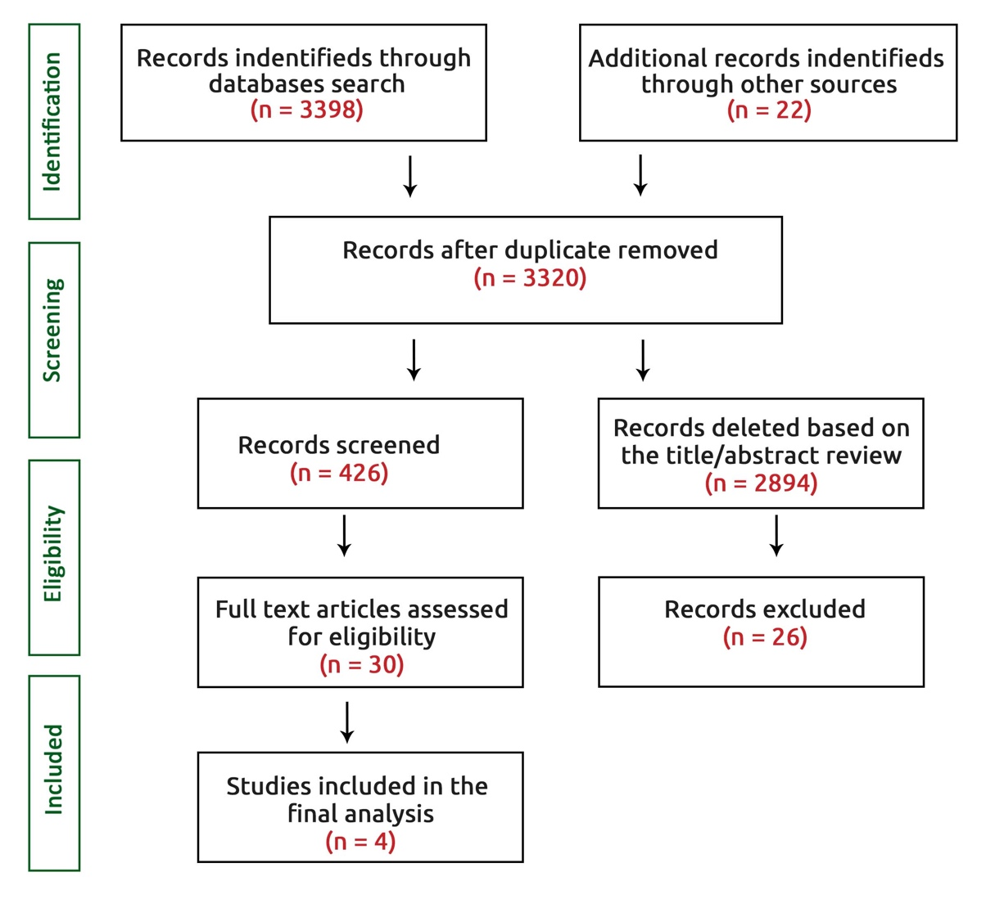

FigureS1. Flow chart of trials

Table S1. Assessment of risk of bias in the included studies using RoB2 for RCTs studies.
Study, year | Randomization | Deviation | Missing | Measurement | Selection | Overall
 | process | from intended | outcome | of the | of the reported
 |  | interventions | data | outcome | results
GLOBAL LEADERS 2018 | L | L | L | L | L | L
STOPDAPT-2 2019 | L | L | L | L | L | L
MASTER DAPT 2021 | L | L | L | L | L | L
ONE MONTH DAPT 2021 | L | L | L | L | L | L
L: Low; S: Some concerns; H: High
Overall risk-of-bias judgement | Criteria
Low risk of bias | The study is judged to be at low risk of bias for all domains for this result.
Some concerns | The study is judged to raise some concerns in at least one domain for this result, but not to be at high risk of bias for any domain.
High risk of bias | The study is judged to be at high risk of bias in at least one domain for this result. The study is judged to have some concerns for multiple domains in a way that substantially lowers confidence in the result.

Table S2. Antiplatelet regimen treatment in patients enrolled among trials included in the study

Study (trial) year | 1-Month DAPT regimen | >1-Month DAPT regimen
GLOBAL LEADERS 2018 | 75–100 mg aspirin daily in combination with 90 mg ticagrelor twice daily for 1 month, followed by 90 mg ticagrelor twice daily for 23 months | 12 months of dual antiplatelet therapy consisting of 75–100 mg aspirin daily in combination with either 75 mg clopidogrel daily (for patients with stable coronary artery disease) or 90 mg ticagrelor twice daily (for patients with acute coronary syndromes)
STOPDAPT-2 2019 | 1 month of DAPT followed by clopidogrel monotherapy | 12 months of DAPT with aspirin and clopidogrel
MASTER DAPT 2021 | 1 month of DAPT followed by single antiplatelet therapy consisted of aspirin or a P2Y12 inhibitor | Continued dual antiplatelet therapy for at least 6 months after the index procedure, or for those receiving clinically indicated oral anticoagulation, for at least 3 months after the index procedure
ONE MONTH DAPT 2021 | 1 month of DAPT followed by aspirin monotherapy | 6-12 months of DAPT followed by aspirin monotherapy

Table S3. Main characteristics of patients enrolled among trials included in the study
Study (trial) year | Groups | Age | Female | HTN | DM | Dyslipidemia | Smoking |  |  | Prior
 |  | year | % | % | % | % | % | MI | PCI |  | CABG | Bleeding
GLOBAL LEADERS 2018 | 1-Month DAPT | 64.5±10 | 76.6 | 74 | 25.7 | 69.3 | 25.9 | 23 | 32.7 |  | 5.6 | 0.6
 | >1-Month DAPT | 64.6±10 | 76.9 | 73.3 | 24.9 | 70 | 26.3 | 23.6 | 32.7 |  | 6.2 | 0.7
STOPDAPT-2 2019 | 1-Month DAPT | 68±10 | 21.1 | 73.7 | 39 | 74.4 | 26.6 | 13.8 | 33.5 |  | 1.1 | 1.3
 | >1-Month DAPT | 69±10 | 23.4 | 74 | 38 | 74.8 | 20.6 | 13.2 | 35.1 |  | 2.8 | 1.9
MASTER DAPT 2021 | 1-Month DAPT | 76 ±8.7 | 38 | 76.9 | 32.9 | 67 | 10 | 18.9 | 25.9 |  | 7.4 | 7.2
 | >1-Month DAPT | 76 ± 8.8 | 30.7 | 78.2 | 34.3 | 68 | 8.1 | 18.8 | 26 |  | 7.5 | 6.8
ONE MONTH DAPT 2021 | 1-Month DAPT | 67 ±10 | 31 | 67 | 37 | 81 | 17 | 4 | 16 |  | 1 | NR
 | >1-Month DAPT | 67 ±10 | 31 | 66 | 38 | 82 | 16 | 4 | 18 |  | 2 | NR
Abbreviations: HTN: hypertension; DM: diabetes mellitus; MI: myocardial infarction; PCI: percutaneous coronary intervention; CABG: coronary artery by-pass grafting; NR: non-reported.

Table S4. Angiographic characteristics of patients enrolled among trials included in the study

Study (trial) year | Groups | Treated vessel per patients |  |  |  |  | No of vessels treated |  |  | Access site
 |  | LM | LAD | LCx | RCA | CABG | One | Two | Three |  | R | F | B | FFR
GLOBAL LEADERS 2018 | 1-Month DAPT | 1.9 | 42 | 24.3 | 31.6 | 1.1 | 74.6 | 20.5 | 5.0 |  | 73.9 | 26.3 | 0.6 | NR
 | >1-Month DAPT | 1.1 | 23.4 | 23.5 | 30.7 | 1.0 | 74.7 | 19.8 | 5.5 |  | 74.2 | 26.1 | 0.6 | NR
STOPDAPT-2 2019 | 1-Month DAPT | 2.9 | 55.2 | 17.9 | 29.1 | 0.2 | NR | NR | NR |  | 82.1 | 13.5 | NR | 14.2
 | >1-Month DAPT | 2.5 | 56.6 | 22.2 | 27.2 | 0.2 | NR | NR | NR |  | 83.3 | 11.9 | NR | 13.4
MASTER DAPT 2021 | 1-Month DAPT | 3.9 | 42.3 | 22.1 | 30.5 | 19.9 | 74.8 | 21 | 4.2 |  | 84.1 | 15.8 | 0.2 | 7.2
 | >1-Month DAPT | 4.0 | 42.9 | 23 | 28.8 | 18.1 | 72.2 | 23.7 | 4.1 |  | 86.9 | 12.8 | 0.3 | 6.8
ONE MONTH DAPT 2021 | 1-Month DAPT | NR | NR | NR | NR | NR | 43 | 33 | 25 |  | NR | 20 | NR | NR
 | >1-Month DAPT | NR | NR | NR | NR | NR | 42 | 31 | 27 |  | NR | 20 | NR | NR

Abbreviations: LM: Left main; LAD: Left atrial descending artery; LCx: Left circumflex; RCA: Right coronary artery; CABG: Coronary artery bypass graft; R: Radial; F: Femoral; B: Brachial; FFR: Fractional flow reserve; NR: Non-reported;

Figure S2. Influence analysis of effect of sample size on MACE; a) MACE in large trial; b) MACE in small trial)


