Multimedia Appendix 3. Sensitivity analyses of pooled effect estimates.

- Pain-free walking
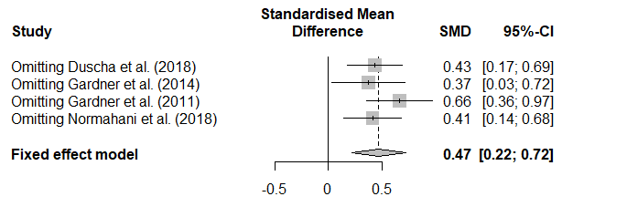
- Maximal walking
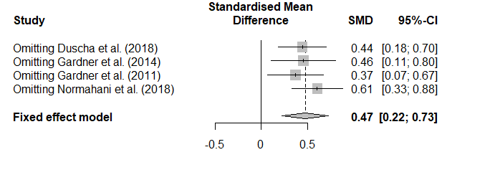
- 6MWT


