Supplemenatry Figure S1: Cascade steps and denominators used for each step. Bubbles represent numerators; connectors point to the corresponding denominator. Original search (upper panel) and new studies (lower panel).
Before 2018
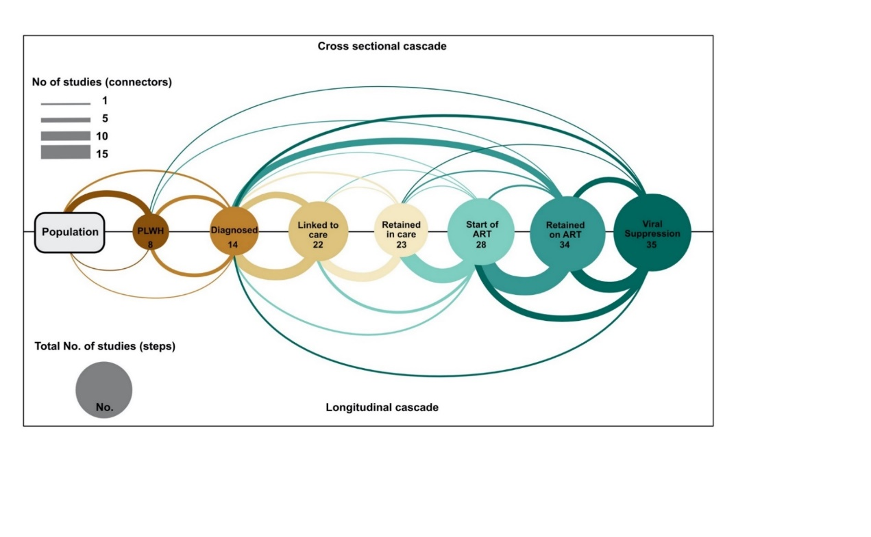
2018-2020


