Supplementary Materials 1
Meta-Analysis - Additional Inclusion/Exclusion Criteria

- Statistic type
Studies were retained if they included at least one of the following statistics:
- Standardised beta (no covariates controlled) from simple (bivariate) linear regression models.
- Unstandardised beta (covariates controlled) from simple (bivariate) linear regression models, provided a mean and standard deviation for the two associated variables were included.
- Partial correlations (covariates controlled).
- Pearson correlation.
- Spearman correlation (covariates controlled).
- Spearman correlation (covariates not controlled).
- Partial coefficient of determination (covariates controlled). Statistic was still retained if there was no indication of the direction of the square root of the coefficient of determination.
- Coefficient of determination from a bivariate model (covariates controlled). Statistic was retained if there was no indication of the direction of the square root of the coefficient of determination.
- t-test statistic (between-subjects).
- Odds ratio (between-subjects).

Additionally, if Pearson and an alternate statistic listed above were reported for the same sample using identical measures/conditions, only the Pearson correlation was retained. If the partial coefficient of determination and coefficient of determination from a bivariate model was reported for the same study, only the coefficient of determination from the bivariate model was retained.

- Samples and Subsamples
If relationships between gaze allocation and global autism symptom severity were examined across the entire sample and a series of subsamples, only the analysis from the entire sample was retained. For example, Rice et al. (2012) reported correlations for the full sample of children with ASD, and also by subgroups generated by IQ profile (e.g., verbal IQ advantage, nonverbal IQ advantage). In this case, only the correlation related to the full sample of children with ASD was retained for the meta-analysis/meta-regression to reduce dependence of estimates.

Supplementary Materials 2
Meta Regression Predictors of Interest

For the face and mouth domain, a total of 10 predictors were investigated to explain the heterogeneity in the relationship between gaze allocation and autism symptom severity measures:

- Autism symptom severity measurement (rater)
Categorical predictor with five categories:
- Clinician/Researcher Rated
- Parent/Caregiver Rated
- Self-Rated
- Teacher Rated
- Self-Conducted

- Females in sample (%)
Continuous predictor.

- Emotion or non-emotional task condition
Categorical predictor with two categories:
- Emotional (i.e., stimuli were specifically created to depict specific emotions).
- Non-emotional (i.e., stimuli were specifically created to depict specific emotions).

- No. people in the scene
Categorical predictor with two categories:
- One person
- More than one person

- Points of calibration
Categorical predictor with three categories (based on Frazier et al., 2017):
- Less than five points
- Five points
- More than five points

- Static or dynamic
Categorical predictor with two categories:
- Static (still image)
- Dynamic (moving image)

- Sampling rate (eyetracker)
Categorical predictor with four categories (based on Frazier et al., 2017):
- Less than 60Hz
- 60-119Hz
- 120Hz
- More than 120Hz

- Unique regions of interest in stimuli
Categorical predictor with six categories (noted below). A region of interest is considered unique if it explores a completely different region (e.g., mouth vs. eyes) or a region nestled within an overarching region (e.g., mouth and face). Two face ROIs (e.g., two faces from different people) in the same frame, however, are not considered unique ROIs.
- One ROI
- Two ROI
- Three ROI
- Four ROI
- Five ROI
- Six ROI

- Total no. trials
Categorical predictor with three categories:
- One trial
- Two-10 trials
- More than 10 trials

- Age (in years)
Continuous predictor.

Supplementary Table 1
Meta Regression and Subgroup Analyses – Predictor Summary

 | Region of Interest
 | Face | Eyes | Mouth
No. Studies | 9 | 8 | 7
No. Outcome Estimates | 16 | 17 | 13
Estimate Type*
Pearson (Unadjusted), n(%) | 12 (75%) | 12 (70.59%) | 7 (53.85%)
Spearman (Adjusted), n(%) | 2 (12.5%) | N/A | 1 (7.69%)
Partial, n(%) | N/A | 4 (23.53%) | 2 (15.38%)
Between-Subjects t-test**, n(%) | N/A | N/A | 2 (15.38%)
Bivariate standardised beta  regression coefficient***, n(%) | 1 (6.25%) | N/A | N/A
Bivariate R squared****, n(%) | 1 (6.25%) | 1 (5.88%) | 1 (7.69%)
Risk of Bias – Newcastle Ottawa Scale
Score = 0 (Unsatisfactory), n(%) | 0 (0%) | 0 (0%) | 0 (0%)
Score = 1 (Unsatisfactory), n(%) | 0 (0%) | 0 (0%) | 0 (0%)
Score = 2 (Unsatisfactory), n(%) | 0 (0%) | 0 (0%) | 0 (0%)
Score = 3 (Unsatisfactory), n(%) | 0 (0%) | 0 (0%) | 0 (0%)
Score = 4 (Unsatisfactory), n(%) | 0 (0%) | 6 (37.5%) | 7 (53.85%)
Score = 5 (Satisfactory), n(%) | 13 (81.25%) | 10 (62.5%) | 6 (46.15%)
Score = 6 (Satisfactory), n(%) | 3 (18.75%) | 0 (0%) | 0 (0%)
Score = 7 (Good), n(%) | 0 (0%) | 0 (0%) | 0 (0%)
Score = 8 (Good), n(%) | 0 (0%) | 0 (0%) | 0 (0%)
Score = 9 (Very Good), n(%) | 0 (0%) | 0 (0%) | 0 (0%)
Age (years)
n (non-missing) | 14 | 12 | 10
Median | 12.83 | 14.88 | 27.6
Minimum, Maximum | 4.47, 21.36 | 4.47, 27.6 | 4.47, 32.9
25th Percentile, 75th Percentile | 11.00, 14.81 | 13.58, 27.6 | 16.24, 27.6
 | Region of Interest
 | Face | Eyes | Mouth
% Female
n (non-missing) | 13 | 17 | 13
Median | 25% | 12.1% | 4.8%
Minimum, Maximum | 10%, 46.7% | 0%, 46.7% | 0%, 27.8%
25th Percentile, 75th Percentile | 17.4%, 25.2% | 0%, 22.9% | 0%, 18.78%
Unique Regions of Interest
n (non-missing) | 16 | 17 | 13
Unique Regions of Interest
One ROI, n(%) | 1 (6.25%) | 0 (0%) | 0 (0%)
Two ROI, n(%) | 7 (43.75%) | 13 (76.47%) | 9 (69.23%)
Three ROI, n(%) | 2 (12.5%) | 0 (0%) | 1 (7.69%)
Four ROI, n(%) | 2 (12.5%) | 2 (11.76%) | 2 (15.38%)
Five ROI, n(%) | 3 (18.75%) | 0 (0%) | 0 (0%)
Six ROI, n(%) | 1 (6.25%) | 2 (11.76%) | 1 (7.69%)
Autism Symptom Severity Measure (Rater)
n (non-missing) | 15 | 17 | 13
Clinician/Researcher Rated, n(%) | 7 (43.75%) | 4 (23.53%) | 3 (23.08%)
Parent/Caregiver Rated, n(%) | 3 (18.75%) | 5 (29.41%) | 2 (15.38%)
Self-Rated, n(%) | 0 (0%) | 5 (29.41%) | 6 (46.15%)
Teacher Rated, n(%) | 5 (31.25%) | 3 (17.65%) | 2 (15.38%)
Emotion vs. Non-Emotional Condition
n (non-missing) | 16 | 17 | 13
Emotional, n(%) | 4 (25%) | 3 (17.65%) | 1 (7.69%)
Non-Emotional, n(%) | 12 (75%) | 14 (82.35%) | 12 (92.31%)
No. People in the Scene
n (non-missing) | 11 | 13 | 12
One Person, n(%) | 5 (31.25%) | 13 (76.47%) | 11 (91.67%)
 | Region of Interest
 | Face | Eyes | Mouth
No. People in the Scene
More than One Person, n(%) | 6 (37.5%) | 0 (0%) | 1 (8.33%)
Points of Calibration
n (non-missing) | 12 | 15 | 10
Five points, n(%) | 7 (43.75%) | 14 (82.35%) | 9 (90%)
More than five points, n(%) | 5 (31.25%) | 1 (5.88%) | 1 (10%)
Static or Dynamic Task
n (non-missing) | 16 | 17 | 13
Static, n(%) | 6 (37.5%) | 9 (52.94%) | 6 (46.15%)
Dynamic, n(%) | 10 (62.5%) | 8 (47.06%) | 7 (53.85%)
Eyetracker Sampling Rate
n (non-missing) | 14 | 16 | 13
Less than 60Hz, n(%) | 8 (50%) | 10 (62.5%) | 9 (69.23%)
60-119Hz, n(%) | 3 (18.75%) | 5 (29.41%) | 2 (15.38%)
120Hz, n(%) | 1 (6.25%) | 1 (5.88%) | 2 (15.38%)
More than 120 Hz, n(%) | 2 (12.5%) | 0 (0%) | 0 (0%)
Total No. Trials
n (non-missing) | 13 | 14 | 12
One Trial | 5 (31.25%) | 9 (52.94%) | 9 (75%)
Two-10 Trials | 5 (31.25%) | 5 (31.25%) | 3 (25%)
More than 10 Trials | 3 (18.75%) | 0 (0%) | 0 (0%)
Note: row level n’s linked to a categorical variable group represent the number of estimates in that category. Meta-regression not performed for eyes. * After application of meta-analysis exclusion/inclusion criteria, actual estimate type included in study prior to conversion for meta-analysis (if applicable), **Converted to point biserial correlation, *** Equivalent to bivariate Pearson correlation, no need for conversion, ****No indication of direction in paper

Supplementary Table 2

Risk of Bias Assessment – Newcastle-Ottawa Scale (Adapted for Cross-Sectional Studies)

 | Selection  (max. 5 points) |  |  |  | Comparability  (max. 1 point) | Outcome  (max. 3 points) |  | Total
 | Representativeness of the sample | Sample size | Non-respondents/missing data | Ascertainment of exposure (social functioning/ ASD symptom severity) | Confounding factors are controlled | Ascertainment of the method (visual processing) | Statistical test | Total
Avni et al. (2020) | * | * | * | ** |  | * |  | 6
Corden et al. (2008) | * |  |  | ** |  | * |  | 4
Del Valle Rubido et al. (2018) | * |  |  | ** |  | * |  | 4
Fedor et al. (2018) | * |  |  | ** | * | * |  | 5
Fujioka et al. (2016) | * |  |  | ** |  | * |  | 4
Fujioka et al. (2020) | * |  |  | ** | * | * |  | 5
Gillespie-Smith, Doherty-Sneddon et al. (2014) | * |  | * | ** |  | * |  | 5
 | Selection  (max. 5 points) |  |  |  | Comparability  (max. 1 point) | Outcome  (max. 3 points) |  | Total
 | Representativeness of the sample | Sample size | Non-respondents/missing data | Ascertainment of exposure (social functioning/ ASD symptom severity) | Confounding factors are controlled | Ascertainment of the method (visual processing) | Statistical test | Total
Grynszpan and Nadel (2014) |  |  | * | ** |  | * | * | 5
Kaliukovich et al. (2020) | * | * |  | ** |  | * | * | 6
Murias et al. (2018) |  |  |  | ** | * | * | * | 5
Nadig et al. (2010) | * |  |  | ** |  | * | * | 5
Plesa-Skwerer et al. (2019) |  |  |  | ** | * | * |  | 4
Riby and Hancock (2009a) | * |  |  | ** |  | * | * | 5
Riby and Hancock (2009b) | * |  |  | ** |  | * | * | 5
Rice et al. (2012) | * |  | * | ** |  | * |  | 5
White et al. (2015) | * |  | * | ** |  | * |  | 5
 | Selection  (max. 5 points) |  |  |  | Comparability  (max. 1 point) | Outcome  (max. 3 points) |  | Total
 | Representativeness of the sample | Sample size | Non-respondents/missing data | Ascertainment of exposure (social functioning/ ASD symptom severity) | Confounding factors are controlled | Ascertainment of the method (visual processing) | Statistical test | Total
Zantinge et al. (2017) | * |  |  | ** |  | * | * | 5

Notes:
- Representativeness of the sample
- Truly representative of the average in the target population (ASD, all subjects or random sampling).*
- Somewhat representative of the average in the target population (non-random sampling).*
(c) No description of the sampling strategy or convenience sample.
- Sample size
- Justified and satisfactory (> 50 participants).*
- Not justified/less than 50 participants.

- Non-respondents/missing data
- The response rate (individuals completed eye tracking) is satisfactory AND comparability between respondents (ASD) and non-respondents (ASD) characteristics is established OR description of the management of missing data described.*
- The response rate is unsatisfactory OR the comparability between respondents and non-respondents is unsatisfactory OR no description about the management of missing data provided.
- No description of the response rate or the characteristics of the responders and the non-responders.
- Ascertainment of the exposure (social function/autism symptom severity)
- Validated measurement tool used.**
- Non-validated measurement tool, but the tool is available or described.*
- No description of the measurement tool.
- Confounding factors are controlled
- The study controls for confounding factors.*
- The study does not control for confounding factors.
- Ascertainment of the method (visual processing)
- Validated measurement tool used.**
- Non-validated measurement tool, but the tool is available or described.*
- No description of the measurement tool.
- Statistical test
- The statistical test used to analyse the data is clearly described and appropriate, and the measurement of the association is presented (has correlation coefficient, name of the test, report p value).*
- The statistical test is not appropriate, not described or incomplete.

Newcastle-Ottawa Scale (Adapted for Cross-Sectional Studies): Categories
- Very good studies (9 points)
- Good studies (7-8 points)
- Satisfactory studies (5-6 points)
- Unsatisfactory studies (0-4 points)

Supplementary Materials 3
Face Region of Interest - Weighted Forest Plot (Fisher Z Units)

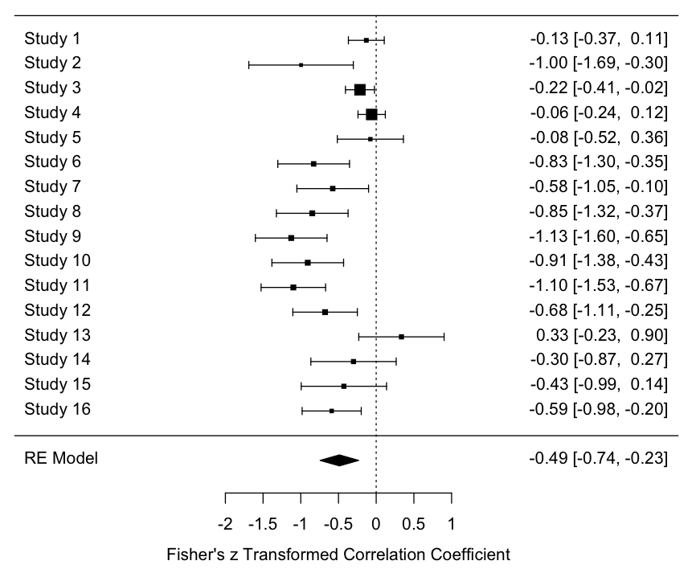

Note:
Study 1: Avni et al. (2020), Study 2: Grynszpan and Nadel (2014), Study 3: Kaliukhovich et al. (2020), Study 4: Kaliukhovich et al. (2020), Study 5: Murias et al. (2018), Study 6: Nadig et al. (2010), Study 7: Nadig et al. (2010), Study 8: Riby and Hancock (2009a), Study 9: Riby and Hancock (2009a), Study 10: Riby and Hancock (2009a), Study 11: Riby and Hancock (2009b), Study 12: Riby and Hancock (2009b), Study 13: White et al. (2015), Study 14: White et al. (2015), Study 15: White et al. (2015), Study 16: Zantinge et al. (2017).

If no letter provided next to author year, this indicates same study.
Supplementary Materials 4
Face Region of Interest - Pearson Correlation Coefficient Forest Plot

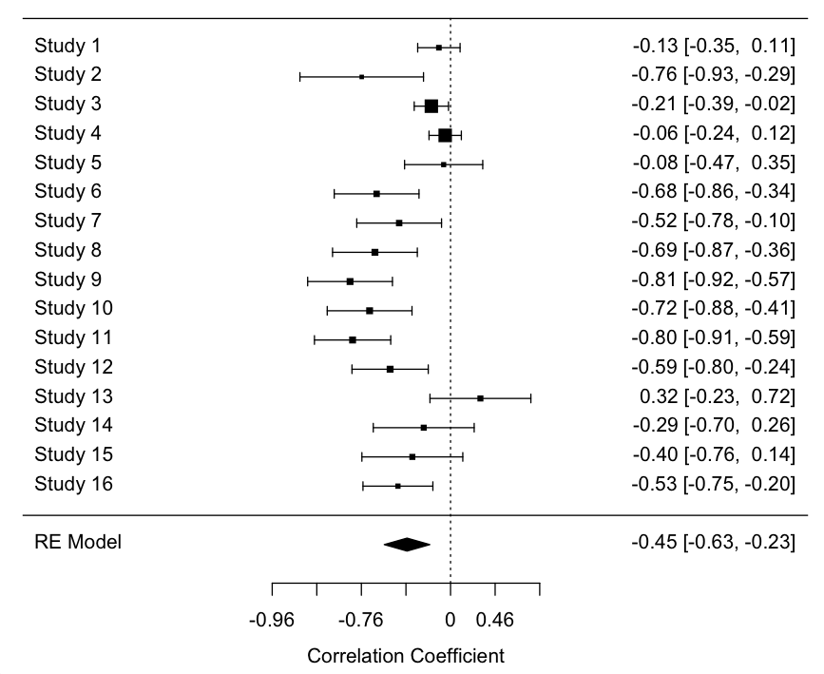

Note:
Study 1: Avni et al. (2020), Study 2: Grynszpan and Nadel (2014), Study 3: Kaliukhovich et al. (2020), Study 4: Kaliukhovich et al. (2020), Study 5: Murias et al. (2018), Study 6: Nadig et al. (2010), Study 7: Nadig et al. (2010), Study 8: Riby and Hancock (2009a), Study 9: Riby and Hancock (2009a), Study 10: Riby and Hancock (2009a), Study 11: Riby and Hancock (2009b), Study 12: Riby and Hancock (2009b), Study 13: White et al. (2015), Study 14: White et al. (2015), Study 15: White et al. (2015), Study 16: Zantinge et al. (2017).

If no letter provided next to author year, this indicates same study.
Supplementary Materials 5
Eye Region of Interest - Weighted Forest Plot (Fisher z Units)

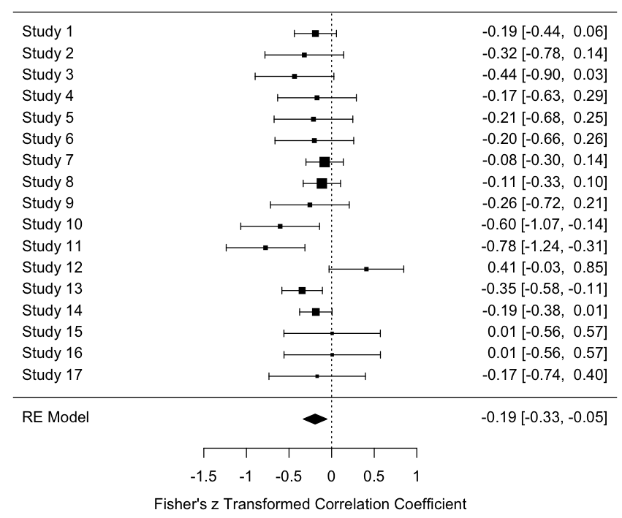

Note:
Study 1: Fedor et al. (2018), Study 2: Fujioka et al. (2016), Study 3: Fujioka et al. (2016), Study 4: Fujioka et al. (2016), Study 5: Fujioka et al. (2016), Study 6: Fujioka et al. (2016), Study 7: Fujioka et al. (2020), Study 8: Fujioka et al. (2020), Study 9: Gillespie-Smith, Doherty-Sneddon et al. (2014), Study 10: Gillespie-Smith, Doherty-Sneddon et al. (2014), Study 11: Gillespie-Smith, Doherty-Sneddon et al. (2014), Study 12: Murias et al. (2018), Study 13: Plesa-Skwerer et al. (2019), Study 14: Rice et al. (2012), Study 15: White et al. (2015), Study 16: White et al. (2015), Study 17: White et al. (2015).

If no letter provided next to author year, this indicates same study.
Supplementary Materials 6
Eye Region of Interest - Pearson Correlation Coefficient Forest Plot

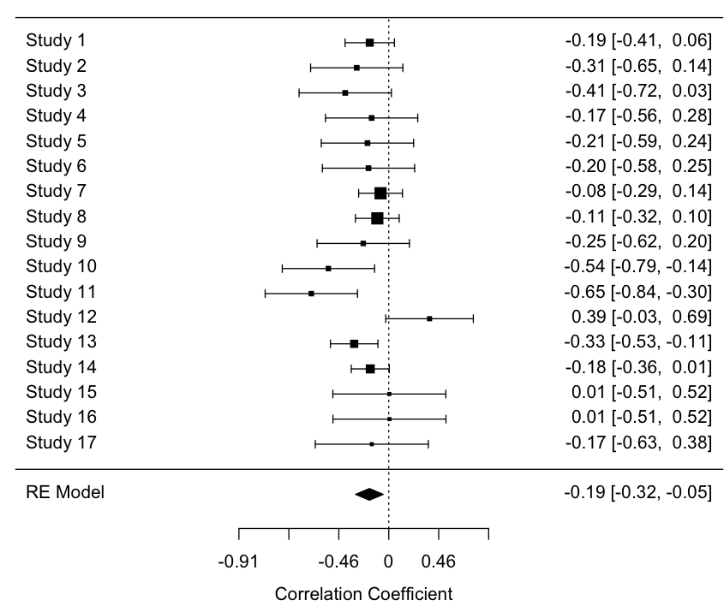

Note:
Study 1: Fedor et al. (2018), Study 2: Fujioka et al. (2016), Study 3: Fujioka et al. (2016), Study 4: Fujioka et al. (2016), Study 5: Fujioka et al. (2016), Study 6: Fujioka et al. (2016), Study 7: Fujioka et al. (2020), Study 8: Fujioka et al. (2020), Study 9: Gillespie-Smith, Doherty-Sneddon et al. (2014), Study 10: Gillespie-Smith, Doherty-Sneddon et al. (2014), Study 11: Gillespie-Smith, Doherty-Sneddon et al. (2014), Study 12: Murias et al. (2018), Study 13: Plesa-Skwerer et al. (2019), Study 14: Rice et al. (2012), Study 15: White et al. (2015), Study 16: White et al. (2015), Study 17: White et al. (2015)

If no letter provided next to author year, this indicates same study.
Supplementary Materials 7
Mouth Region of Interest - Weighted Forest Plot (Fisher Z Units)
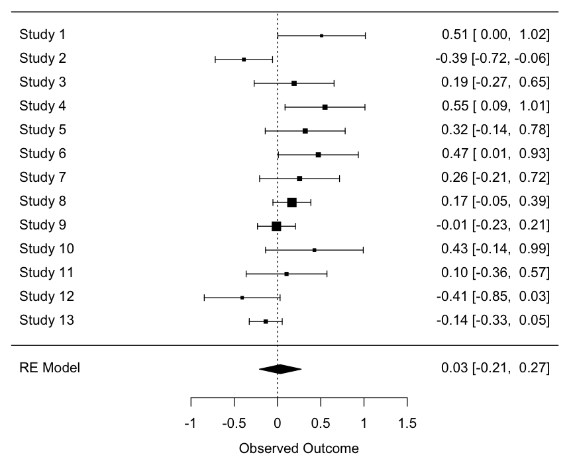

Note:
Study 1: Corden et al. (2008), Study 2: Del Valle Rubido et al. (2018), Study 3: Fujioka et al. (2016), Study 4: Fujioka et al. (2016), Study 5: Fujioka et al. (2016), Study 6: Fujioka et al. (2016), Study 7: Fujioka et al. (2016), Study 8: Fujioka et al. (2016), Study 9: Fujioka et al. (2020), Study 10: Fujioka et al. (2020), Study 11: Gillespie-Smith, Doherty-Sneddon et al. (2014), Study 12: Murias et al. (2018), Study 13: Rice et al. (2012).

If no letter provided next to author year, this indicates same study.

Supplementary Materials 8
Mouth Region of Interest - Pearson Correlation Coefficient Forest Plot
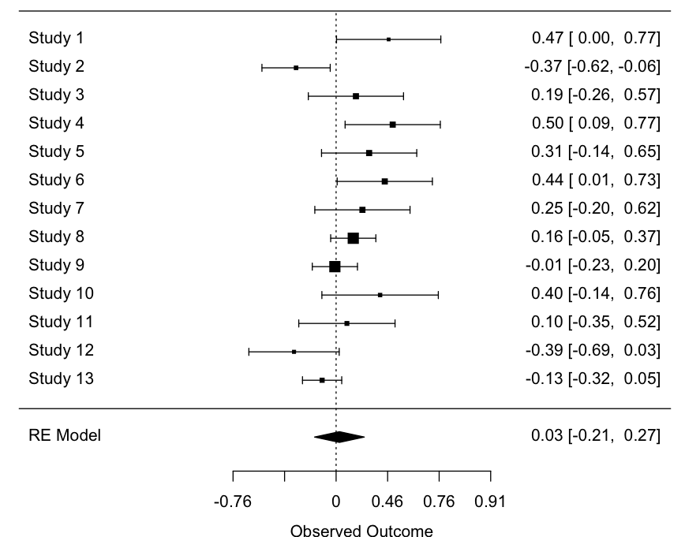

Note:
Study 1: Corden et al. (2008), Study 2: Del Valle Rubido et al. (2018), Study 3: Fujioka et al. (2016), Study 4: Fujioka et al. (2016), Study 5: Fujioka et al. (2016), Study 6: Fujioka et al. (2016), Study 7: Fujioka et al. (2016), Study 8: Fujioka et al. (2016), Study 9: Fujioka et al. (2020), Study 10: Fujioka et al. (2020), Study 11: Gillespie-Smith, Doherty-Sneddon et al. (2014), Study 12: Murias et al. (2018), Study 13: Rice et al. (2012).

If no letter provided next to author year, this indicates same study.

Supplementary Materials 9
Face Region of Interest – Bivariate Meta-Regression Omnibus Predictor results and Fisher Correlation Estimates by Predictor Level

*For a categorical variable included as a predictor in a bivariate meta regression model, Q_{m} is generated from an omnibus chi-square test that evaluates the presence of a significant difference in overall effect estimate amongst at least two categories of a categorical variable.

** For categorical variables, b represents the fisher unit correlation within a category level
*** For continuous variables, b represents the change in estimate (Fisher) for a unit increase in the explanatory variable

- Predictor: Autism Symptom Severity Measurement Rater

*Q_{m} (df = 2) = 10.69, p = .0048

Clinician/researcher rated: b = -0.30, 95% CI (-0.52, -0.081)
Parent/caregiver rated: b = -0.13, 95% CI (-0.64, 0.38)
Teacher rated: b = -0.93, 95% CI (-1.27, -0.58)

- Predictor: % Female in Sample

b = 0.007, p = .59, 95% CI (-0.12, 0.035)

- Predictor: Emotion vs. Non-Emotion Condition

*Q_{m}(df = 1) = 0.28, p = .59

Emotional: b = -0.35, 95% CI (-0.92, 0.22)
Non-emotional: b = -0.53, 95% CI (-0.83, -0.22)

- Predictor: No. People in the Scene

*Q_{m}(df = 1) = 0.12, p = .72

One person: b = -0.58, 95% CI (-1.03, -0.13)
More than one person: b = -0.53, 95% CI (-0.83, -0.12)

- Predictor: Points of Calibration

*Q_{m}(df = 1) = 42.77, p < .001

Five points: b = -0.17, 95% CI (-0.27, -0.06)
Six or more points: b = -0.93, 95% CI (-1.13, -0.72)

- Predictor: Static vs. Dynamic

*Q_{m}(df = 1) = 0.015, p = .90

Static: b = -0.47, 95% CI (-0.88, -0.059)
Dynamic: b = -0.50, 95% CI (-0.79, -0.21)

- Predictor: Sampling Rate

*Q_{m}(df = 3) = 2.78, p = .43

Less than 60Hz: b = -0.70, 95% CI (-1.12, -0.28)
60-119Hz: b = -0.13, 95% CI (-0.95, -0.69)
120Hz: b = -0.077, 95% CI (-0.95, -0.80)
More than 120Hz: b = -0.34, 95% CI (-0.92, -0.24)

- Predictor: No. Unique Regions of Interest (ROI)

*Q_{m}(df = 5) = 5.15, p = .40

One ROI: b = -1.00, 95% CI (-1.96, -0.031)
Two ROI: b = -0.43, 95% CI (-0.80, -0.057)
Three ROI: b = -0.70, 95% CI (-1.45, 0.049)
Four ROI: b = -0.13, 95% CI (-0.82, 0.55)
Five ROI: b = -0.96, 95% CI (-1.69, -0.24)
Six ROI: b = -0.077, 95% CI (-0.88, 0.73)

- Predictor: Total No. Trials

*Q_{m}(df = 2) = 0.14, p = .93

One trial: b = -0.57, 95% CI (-1.00, -0.13)
Two-10 trials: b = -0.49, 95% CI (-0.90, -0.069)
More than 10 trials: b = -0.57, 95% CI (-1.08, -0.057)

- Predictor: Age (in Years)

b = -0.03, p = .31, 95% CI (-0.08, 0.024)

Supplementary Materials 10
Mouth Region of Interest – Bivariate Meta-Regression Omnibus Predictor Results and Fisher Correlation Estimates by Predictor level

*For a categorical variable included as a predictor in a bivariate meta regression model, Q_{m} is generated from an omnibus chi-square test that evaluates the presence of a significant difference in the overall effect estimate amongst at least two categories of a categorical variable.

** b represents the fisher unit correlation within a category level
*** For continuous variables, b represents the change in estimate (fisher) for a unit increase in the explanatory variable

- Predictor: Autism Symptom Severity Measurement Rater

*Q_{m}(df = 3) = 20.21, p < .001

Clinician/researcher rated: b = -0.24, 95% CI (-0.42, -0.061)
Parent/caregiver rated: b = 0.077, 95% CI (-0.13, 0.28)
Self-rated: b = 0.39, 95% CI (0.16, 0.61)
Teacher rated: b = 0.24, 95% CI (-0.15, -0.62)

- Predictor: % Female in Sample

b = 0.001, p = .91, 95% CI (-0.023, 0.026)

- Predictor: Emotion vs. Non-Emotion Condition

*Q_{m}(df = 1) = 1.83, p = .18

Emotional: b = 0.51, 95% CI (-0.22, 1.24)
Non-emotional: b = -0.021, 95% CI (-0.26, 0.22)

- Predictor: No. People in the Scene

*Q_{m}(df = 1) = 2.86, p = .091

One person: b = 0.16, 95% CI (-0.099, 0.42)
More than one person: b = -0.39, 95% CI (-0.83, 0.19)

- Predictor: Points of Calibration

*Q_{m}(df = 1) = 0.97, p = .33

Five points: b = 0.21, 95% CI (0.015, 0.41)
Six or more points: b = 0.51, 95% CI (-0.054, 1.07)

- Predictor: Static vs. Dynamic

*Q_{m}(df = 1) = 0.072, p = .79

Static: b = 0.058, 95% CI (-0.25, 0.37)
Dynamic: b = 0.012, 95% CI (-0.28, 0.30)

- Predictor: Sampling Rate

*Q_{m}(df = 2) = 3.85, p = .15

Less than 60Hz: b = 0.22, 95% CI (-0.071, 0.51)
60-119Hz: b = -0.24, 95% CI (-0.61, 0.12)
120Hz: b = 0.016, 95% CI (-0.44, 0.47)

- Predictor: No. Unique Regions of Interest (ROI)

*Q_{m}(df = 3) = 13.21, p = .004

Two ROI: b = 0.21, 95% CI (0.017, 0.40)
Three ROI: b = 0.51, 95% CI (-0.052, 1.07)
Four ROI: b = -0.23, 95% CI (-0.47, 0.020)
Six ROI: b = -0.41, 95% CI (-0.91, 0.094)

- Predictor: Total No. Trials

*Q_{m}(df = 1) = 0.081, p = .78

One trial: b = -0.054, 95% CI (-0.39, 0.29)
Two-10 trials: b = 0.031, 95% CI (-0.45, 0.51)

- Predictor: Age (in Years)

b = 0.023, p = .21, 95% CI (-0.013, 0.058)

