Supplementary materials 2: Forest Plots

Figure S1a. Anxiety Figure S1b.Vigour
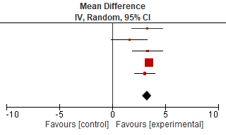
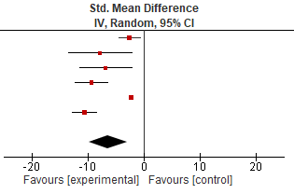

Figure S1c. Depression Figure S1d. Positive Affect
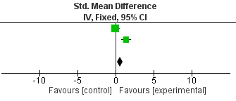
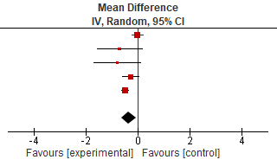

Figure S1e. Anger/hostility Figure S1f. Fatigue
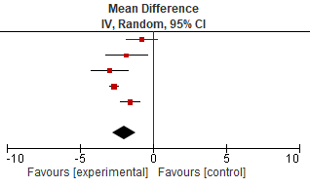
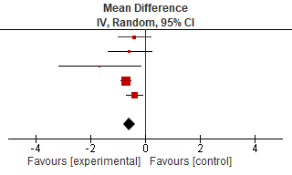

Supplementary Materials Figure S1g. Sub-group analysis Forest Plot

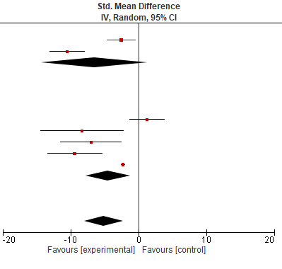

Females

Males

All

