- The details of search strategy

PubMed (120)

((((((((((diabetes mellitus[Title/Abstract]) OR (diabetes[Title/Abstract])) OR (type 2 diabetes mellitus[Title/Abstract])) OR (diabetes mellitus, type 2[Title/Abstract])) OR (T2DM[Title/Abstract])) OR (type 1 diabetes mellitus[Title/Abstract])) OR (diabetes mellitus, type 1[Title/Abstract])) OR (T1DM[Title/Abstract])) OR (DM[Title/Abstract])) AND (((((chronic total occlusion[Title/Abstract]) OR (chronic total coronary occlusion[Title/Abstract])) OR (chronic total occlusions[Title/Abstract])) OR (chronic total coronary occlusions[Title/Abstract])) OR (CTO[Title/Abstract]))) AND ((((((((((((((Percutaneous Coronary Intervention[Title/Abstract]) OR (Coronary Intervention, Percutaneous[Title/Abstract])) OR (Coronary Interventions, Percutaneous[Title/Abstract])) OR (Intervention, Percutaneous Coronary[Title/Abstract])) OR (Interventions, Percutaneous Coronary[Title/Abstract])) OR (Percutaneous Coronary Interventions[Title/Abstract])) OR (Percutaneous Coronary Revascularization[Title/Abstract])) OR (Coronary Revascularization, Percutaneous[Title/Abstract])) OR (Coronary Revascularizations, Percutaneous[Title/Abstract])) OR (Percutaneous Coronary Revascularizations[Title/Abstract])) OR (Revascularization, Percutaneous Coronary[Title/Abstract])) OR (Revascularizations, Percutaneous Coronary[Title/Abstract])) OR (Percutaneous coronary angioplasty[Title/Abstract])) OR (PCI[Title/Abstract]))

Cochrane Library (41)

#1 (diabetes mellitus):ti,ab,kw OR (diabetes):ti,ab,kw OR (type 2 diabetes mellitus):ti,ab,kw OR (diabetes mellitus, type 2):ti,ab,kw OR (T2DM):ti,ab,kw 79289
#2 (type 1 diabetes mellitus):ti,ab,kw OR (diabetes mellitus, type 1):ti,ab,kw OR (T1DM):ti,ab,kw OR (DM):ti,ab,kw 40448
#3 #1 OR #2 87360
#4 (chronic total occlusion):ti,ab,kw OR (chronic total coronary occlusion):ti,ab,kw OR (chronic total occlusions):ti,ab,kw OR (chronic total coronary occlusions):ti,ab,kw OR (CTO):ti,ab,kw 625
#5 (percutaneous coronary intervention):ti,ab,kw OR (coronary intervention, percutaneous):ti,ab,kw OR (coronary interventions, percutaneous):ti,ab,kw OR (intervention, percutaneous coronary):ti,ab,kw OR (interventions, percutaneous coronary):ti,ab,kw 10483
#6 (percutaneous coronary interventions):ti,ab,kw OR (percutaneous coronary revascularization):ti,ab,kw OR (coronary revascularization, percutaneous):ti,ab,kw OR (coronary revascularizations, percutaneous):ti,ab,kw OR (percutaneous coronary revascularizations):ti,ab,kw 4634
#7 (revascularization, percutaneous coronary):ti,ab,kw OR (revascularization, percutaneous coronary):ti,ab,kw OR (percutaneous coronary angioplasty):ti,ab,kw OR (PCI):ti,ab,kw 11569
#8 #5 OR #6 OR #7 13860
#9 #3 AND #4 AND #8 41

Embase (580)

#4. #1 AND #2 AND #3 580
#3. 'percutaneous coronary intervention':ab,ti OR 80,722
'coronary intervention, percutaneous':ab,ti OR
'coronary interventions, percutaneous':ab,ti OR
'intervention, percutaneous coronary':ab,ti OR
'interventions, percutaneous coronary':ab,ti OR
'percutaneous coronary interventions':ab,ti OR
'percutaneous coronary revascularization':ab,ti
OR 'coronary revascularization,
percutaneous':ab,ti OR 'coronary
revascularizations, percutaneous':ab,ti OR
'percutaneous coronary revascularizations':ab,ti
OR 'revascularization, percutaneous
coronary':ab,ti OR 'revascularizations,
percutaneous coronary':ab,ti OR 'percutaneous
coronary angioplasty':ab,ti OR 'pci':ab,ti
#2. 'chronic total occlusion':ab,ti OR 'chronic total 7,546
coronary occlusion':ab,ti OR 'chronic total
occlusions':ab,ti OR 'chronic total coronary
occlusions':ab,ti OR 'cto':ab,ti
#1. 'diabetes mellitus':ab,ti OR 'diabetes':ab,ti OR 838,544
'type 2 diabetes mellitus':ab,ti OR 'diabetes
mellitus, type 2':ab,ti OR 't2dm':ab,ti OR 'type
1 diabetes mellitus':ab,ti OR 'diabetes
mellitus, type 1':ab,ti OR 't1dm':ab,ti OR
'dm':ab,ti

- Supplementary table

Supplementary table 1. Subgroup analysis comparing successful CTO-PCI versus failed CTO-PCI, initial MT in DM patients
Successful CTO-PCI vs failed CTO-PCI | No. of studies | No. of participants | RR (95% CI) | P for heterogeneity | I²(%) | P for test
MACEs | 2 | 675 | 0.71 (0.54, 0.94) | 0.14 | 54 % | 0.02
All-cause death | 4 | 1570 | 0.47 (0.37,0.58) | 0.19 | 38 % | <0.00001
Cardiac death | 3 | 1175 | 0.38 (0.26,0.54) | 0.66 | 0 % | <0.00001
TLR | 1 | 362 | 2.94 (1.19, 7.28) | - | - | 0.02
TVR | 2 | 862 | 0.91 (0.67,1.23) | 0.33 | 0 % | 0.52
MI | 4 | 1570 | 0.97 (0.60, 1.56) | 0.58 | 0 % | 0.89
Successful CTO-PCI vs initial MT | No. of studies | No. of participants | RR (95% CI) | P for heterogeneity | I²(%) | P for test
MACEs | 1 | 755 | 0.64 (0.48, 0.86) | - | - | 0.003
All-cause death | 1 | 542 | 0.36 (0.20,0.66) | - | - | 0.0009
Cardiac death | 2 | 1297 | 0.29 (0.16, 0.53) | 0.89 | 0 % | <0.0001
TLR | 0
TVR | 2 | 1297 | 0.99 (0.75, 1.31) | 0.32 | 0 % | 0.94
MI | 2 | 1297 | 0.72 (0.47, 1.08) | 0.60 | 0 % | 0.11
CTO, chronic total occlusion; PCI, percutaneous coronary intervention; MT, medical treatment; DM, diabetes mellitus; MACEs, major adverse cardiac events; TLR, target lesion revascularization; TVR, target vessel revascularization; MI, myocardial infarction.

Supplementary table 2 . Subgroup analysis comparing successful CTO-PCI versus failed CTO-PCI, initial MT in non-DM patients
Successful CTO-PCI vs failed CTO-PCI | No. of studies | No. of participants | RR (95% CI) | P for heterogeneity | I²(%) | P for test
MACEs | 2 | 1384 | 1.00 (0.81, 1.24) | 0.40 | 0 % | 0.97
All-cause death | 3 | 2731 | 0.94 (0.75, 1.18) | 0.30 | 18 % | 0.59
Cardiac death | 2 | 1384 | 0.93 (0.62, 1.38) | 0.93 | 0 % | 0.70
TLR | 1 | 958 | 1.33 (0.88, 2.03) | - | - | 0.18
TVR | 1 | 958 | 1.14 (0.85, 1.52) | - | - | 0.37
MI | 3 | 2731 | 0.73 (0.35, 1.54) | 0.03 | 71% | 0.41
Successful CTO-PCI vs initial MT | No. of studies | No. of participants | Adjust HR (95% CI) from the original study of Guo et al.
MACEs | 1 | 1260 | [77/469 vs 180/791, 0.85 (0.64, 1.15), p = 0.294]
All-cause death | 0 | - | -
Cardiac death | 1 | 1260 | [18/469 vs 41/791, 0.94 (0.51, 1.70), p = 0.825]
TLR | 0 | - | -
TVR | 1 | 1260 | [46/469 vs 109/791, 0.85(0.59, 1.22), p = 0.389]
MI | 1 | 1260 | [30/469 vs 56/791, 1.01 (0.62, 1.65), p = 0.959]
CTO, chronic total occlusion; PCI, percutaneous coronary intervention; MT, medical treatment; DM, diabetes mellitus; MACEs, major adverse cardiac events; TLR, target lesion revascularization; TVR, target vessel revascularization; MI, myocardial infarction.

- Supplementary Figure
Supplementary Figure 1
Forest plot comparing MACEs following successful CTO-PCI in patients with versus without DM. MACEs, major adverse cardiac events; CTO, chronic total occlusions; PCI, percutaneous coronary intervention; DM, diabetes mellitus.
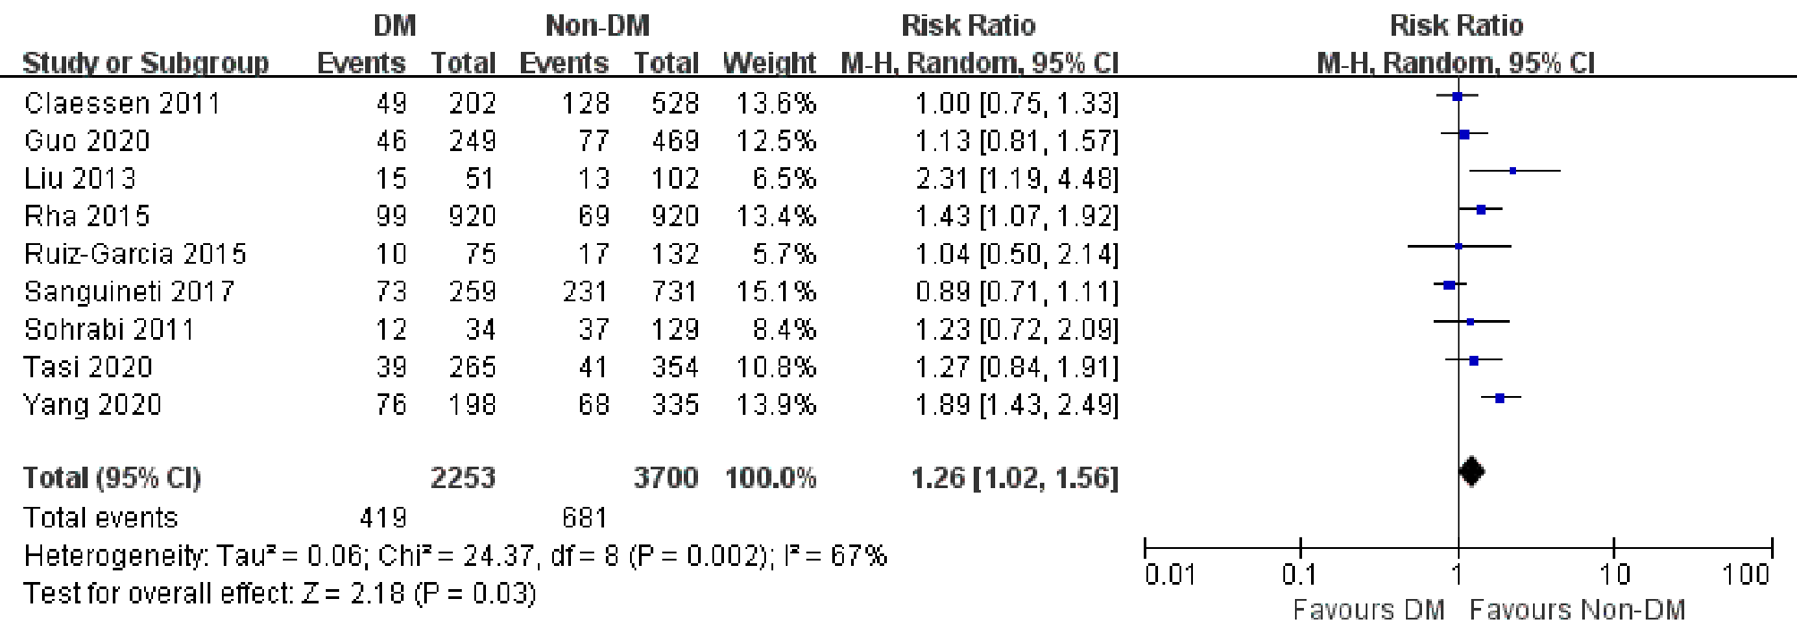

Supplementary Figure 2
Funnel plot assessing the publica bias of the studies reporting risk of MACEs following successful CTO-PCI in patients with or without DM. MACEs, major adverse cardiac events; CTO, chronic total occlusions; PCI, percutaneous coronary intervention; DM, diabetes mellitus.
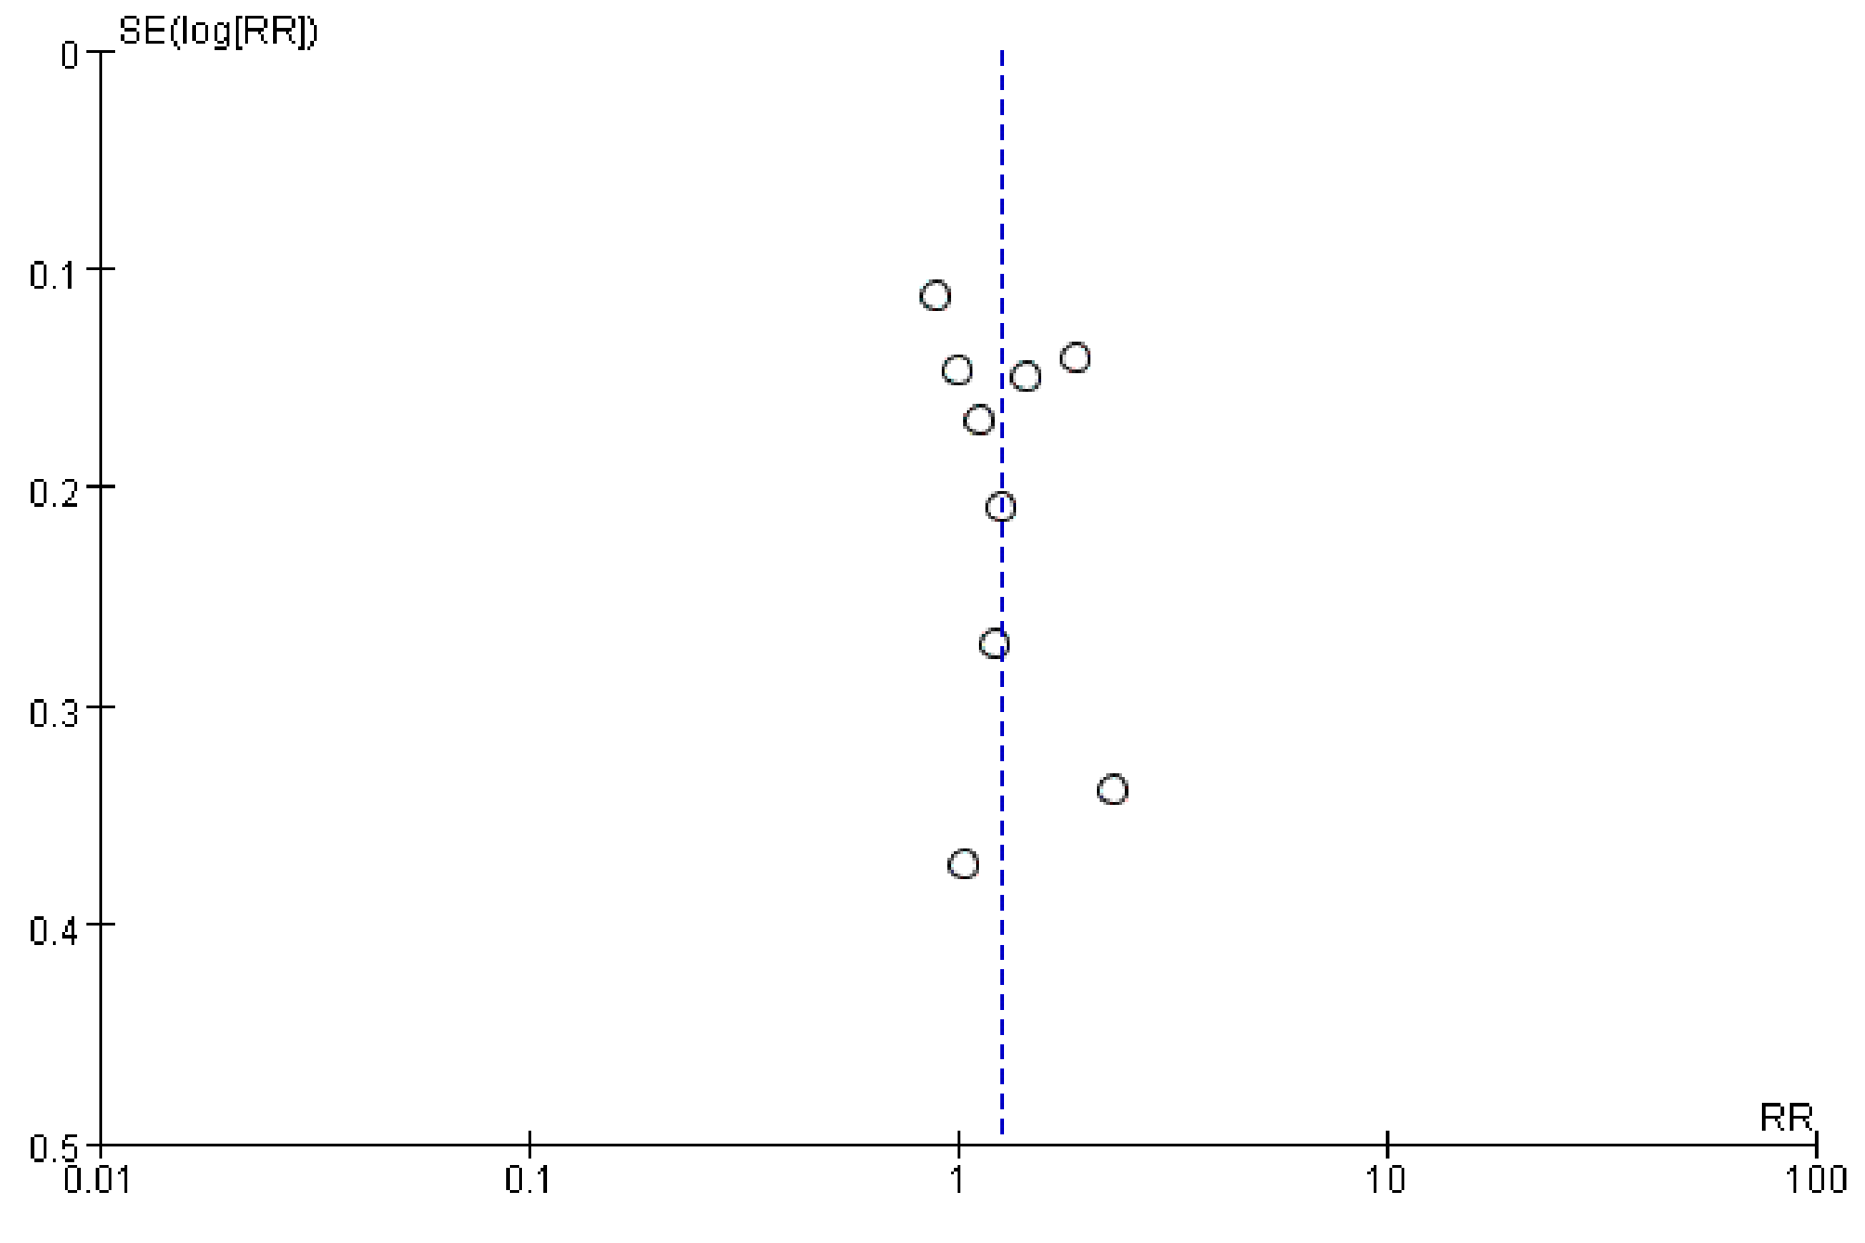

Supplementary Figure 3
Funnel plot assessing the publica bias of the studies reporting risk of MACEs following successful CTO-PCI in patients with or without DM in the subgroups. MACEs, major adverse cardiac events; CTO, chronic total occlusions; PCI, percutaneous coronary intervention; DM, diabetes mellitus.
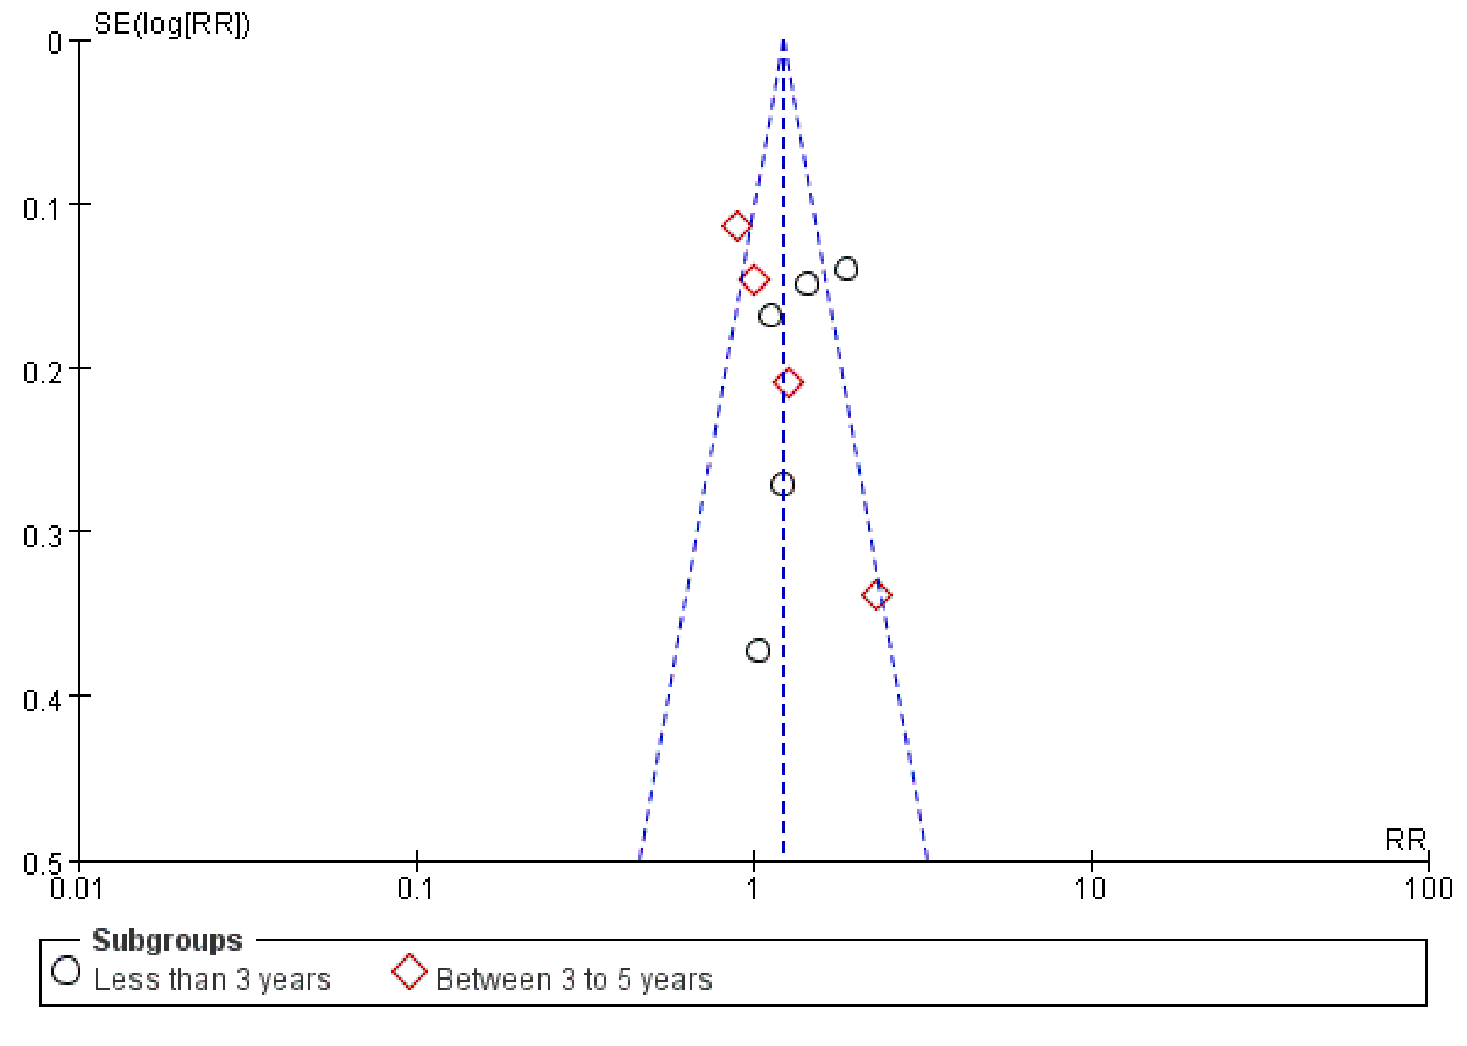

Supplementary Figure 4
Funnel plot assessing the publica bias of studies reporting the risk of secondary endpoints following successful CTO-PCI in patients with versus without DM. MACEs, major adverse cardiac events; CTO, chronic total occlusions; PCI, percutaneous coronary intervention; DM, diabetes mellitus.


