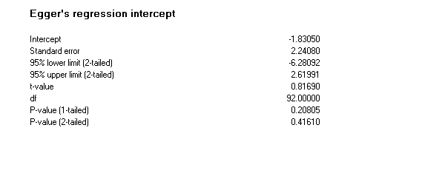
Additional file 4: Egger regression intercept for the prevalence of Schistosoma mansoni in Ethiopia

