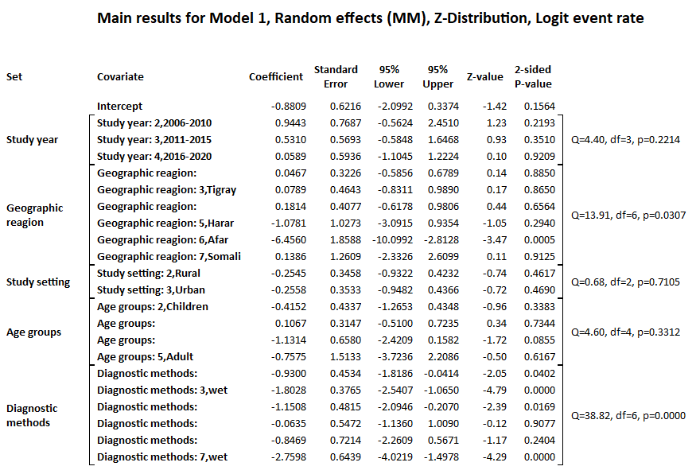

Additional file 5: Meta regration for the prevalence of Schistosoma mansoni in Ethiopia

