Supplementary Figures
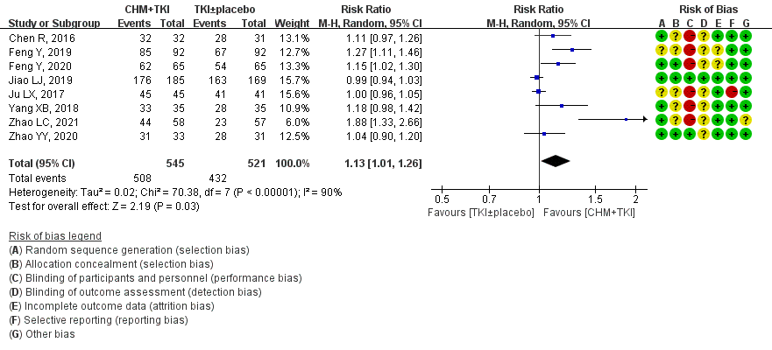Supplementary Figure 1. Forest Plot of DCR
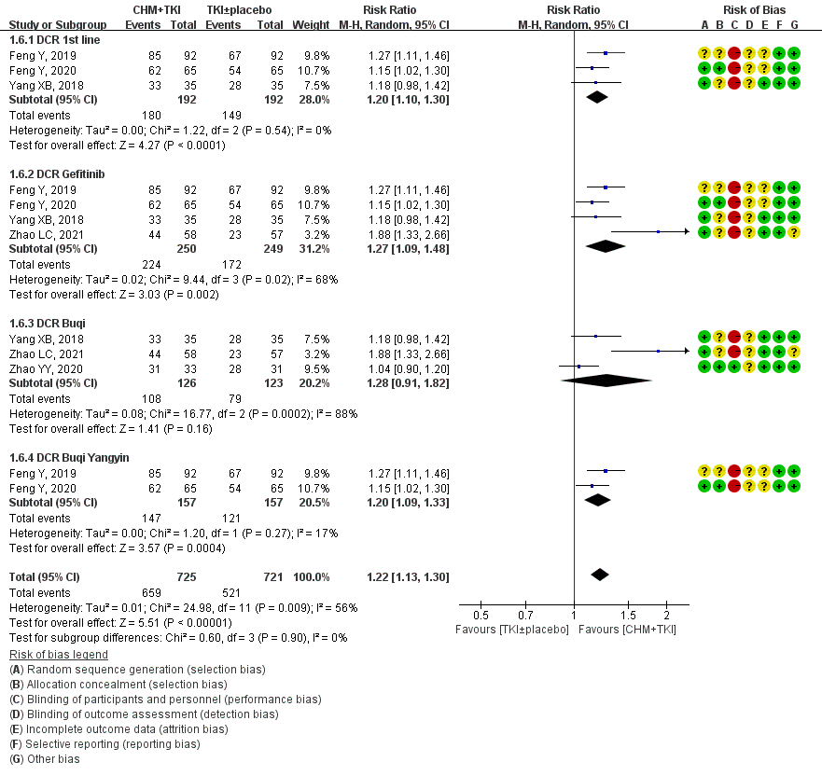Supplementary Figure 2. Forest Plot of Subgroup of DCR

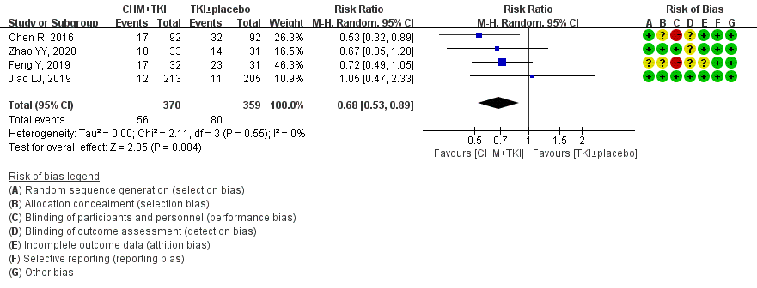Supplementary Figure 3. Forest Plot on incidence of AE

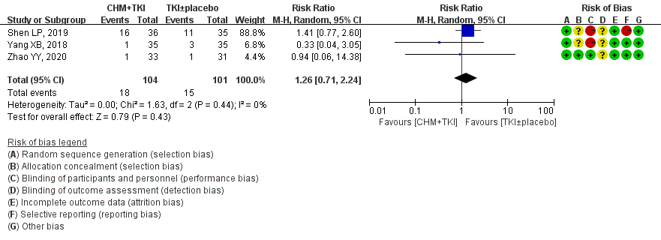Supplementary Figure 4. Forest Plot on incidence of dental ulcer

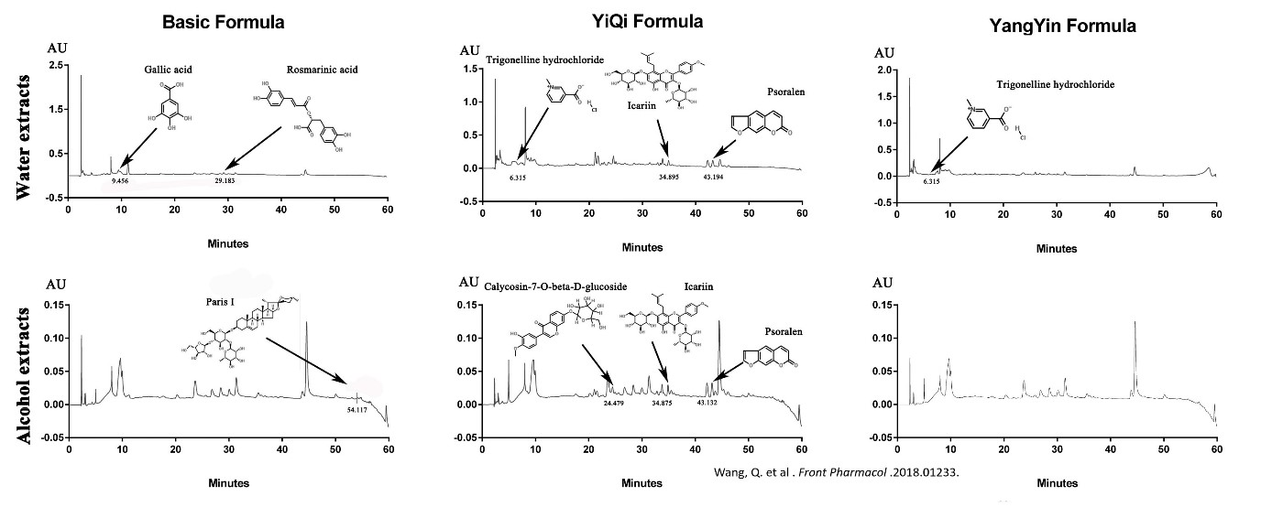
Supplementary Figure 5. Chemical characterisation of “Jiao LJ, 2019” Study

