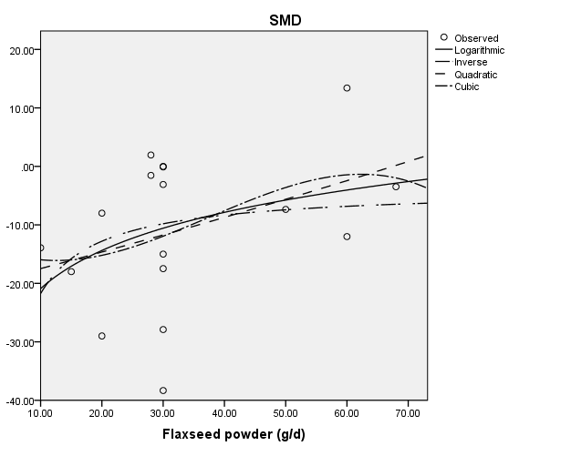
Curvilinear regression on nonlinear relationship between dose of whole flaxseed powder and absolute changes in TC (mg/dL)
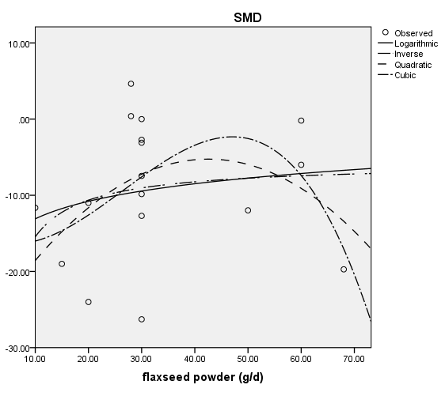
Curvilinear regression on nonlinear relationship between dose of whole flaxseed powder and absolute changes in LDL-C (mg/dL)
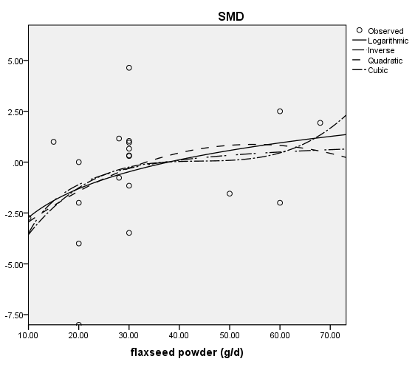
Curvilinear regression on nonlinear relationship between dose of whole flaxseed powder and absolute changes in HDL-C (mg/dL)
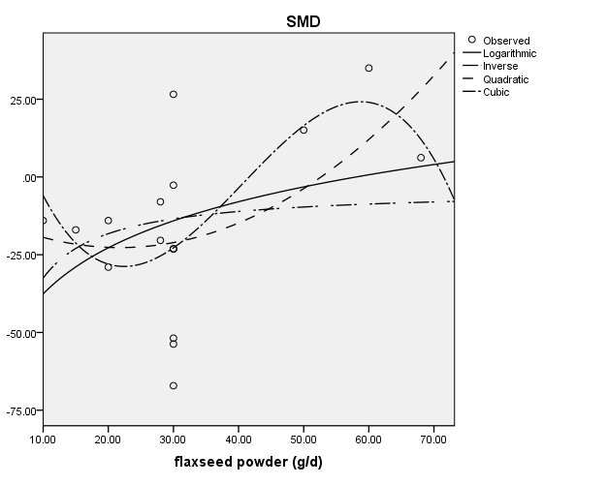
Curvilinear regression on nonlinear relationship between dose of whole flaxseed powder and absolute changes in TG (mg/dL)
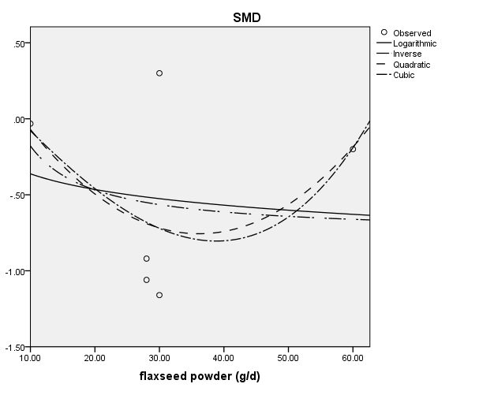
Curvilinear regression on nonlinear relationship between dose of whole flaxseed powder and absolute changes in TNF-α (pg/ml)
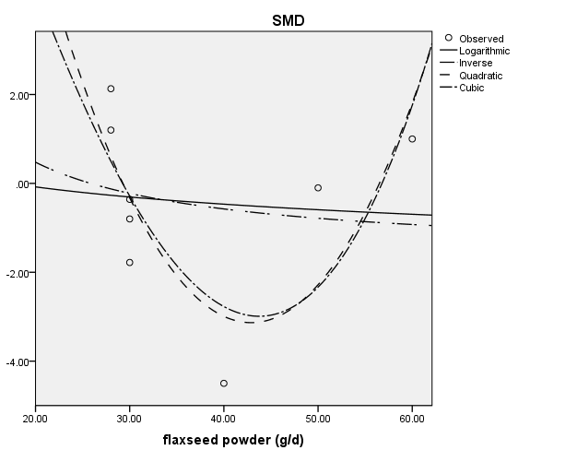
Curvilinear regression on nonlinear relationship between dose of whole flaxseed powder and absolute changes in weight (kg)
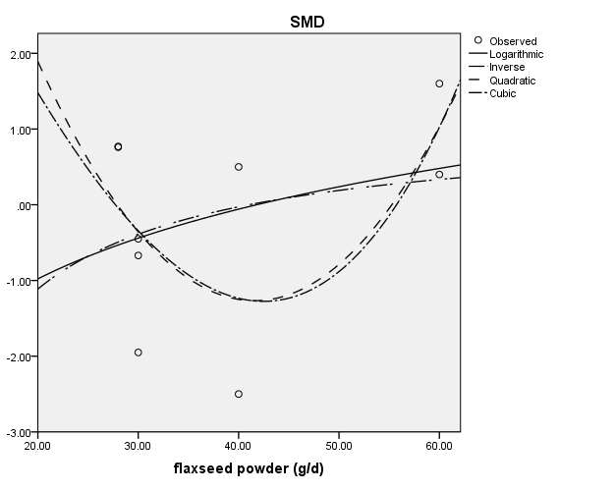
Curvilinear regression on nonlinear relationship between dose of whole flaxseed powder and absolute changes in BMI (kg/cm²)
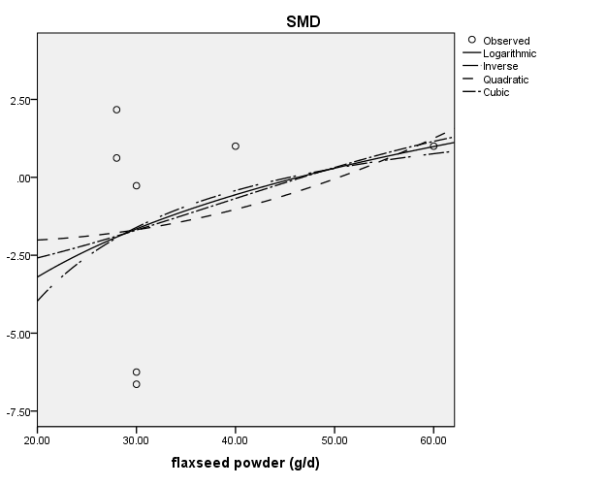
Curvilinear regression on nonlinear relationship between dose of whole flaxseed powder and absolute changes in WC (cm)

