Supplementary Figure 2: Unadjusted Results from Cross-Sectional Studies Reporting Association between Psychosis and Visual Impairment

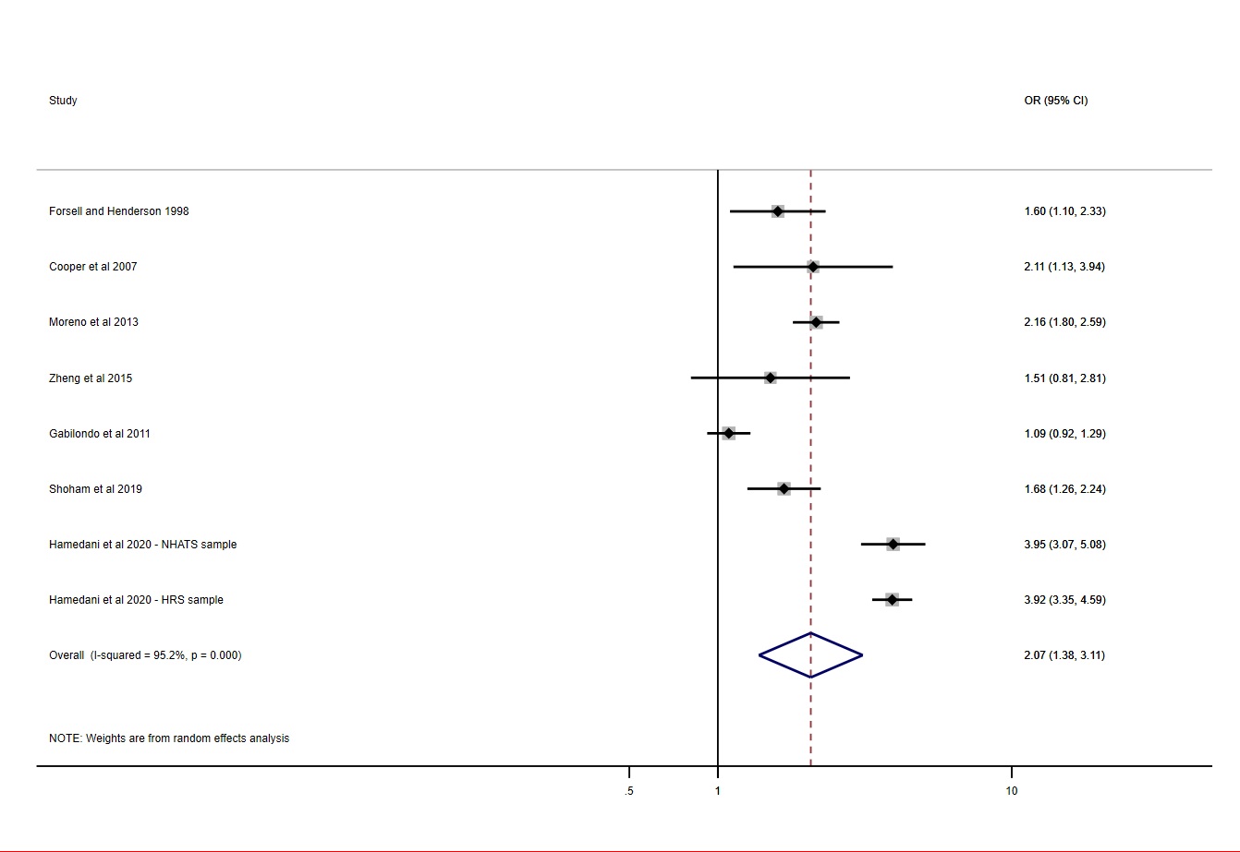
OR = Odds Ratio (unadjusted), 95% CI = 95% Confidence Intervals, NHATS= The National Health and Aging Trends Study, HRS= The Health and Retirement Study

