Supplementary file E

Subgroups and sensitivity analyses

Analysis 1. Subgroup analyses based on MS category (RRMS or SPMS)
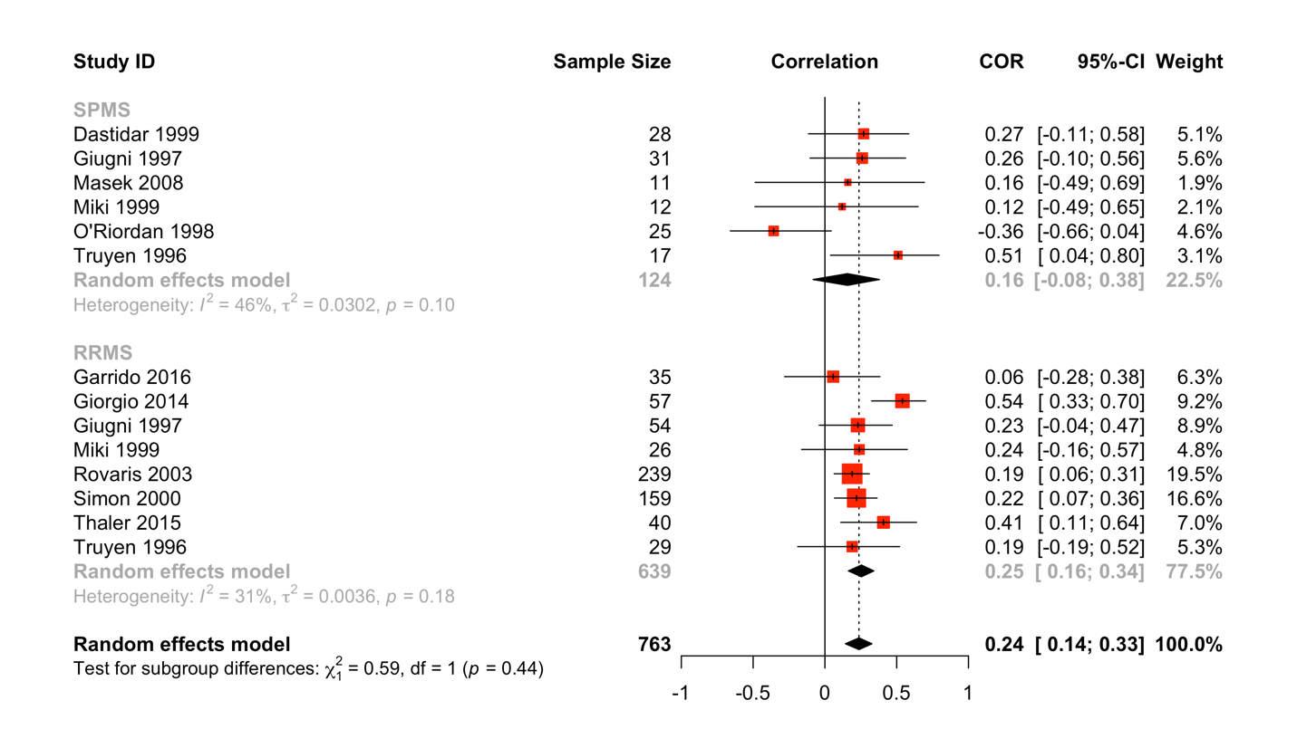

Analysis 2. Subgroup analyses based on diagnostic criteria (Poser or McDonald)

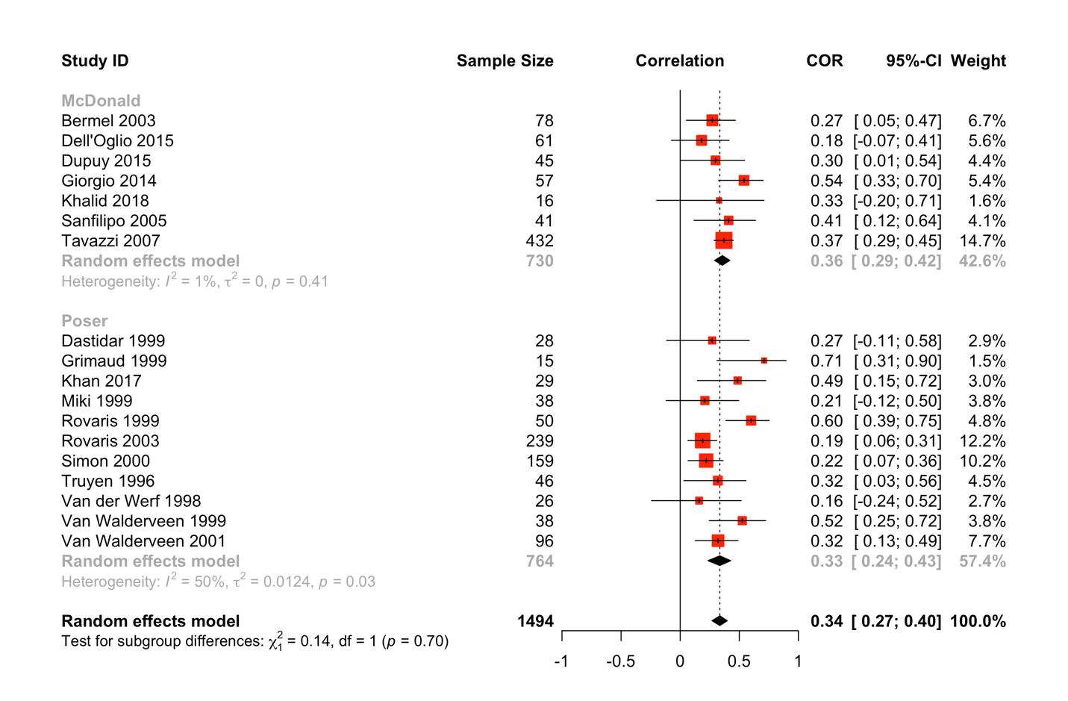

Analysis 3. Subgroup analyses based on SMF (≥1.5T or <1.5T)
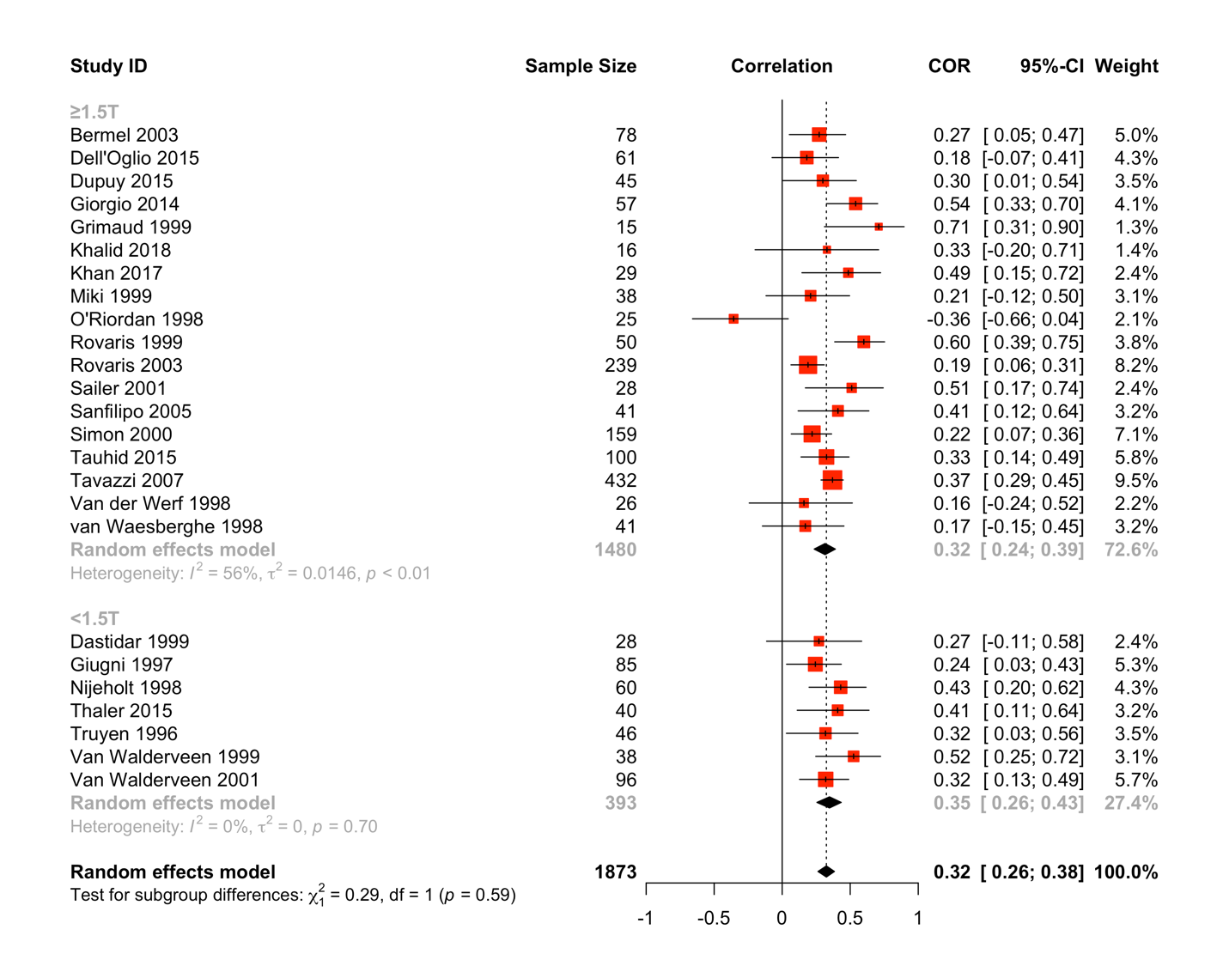

Analysis 4. Sensitivity analysis on studies with a large sample size (>90)
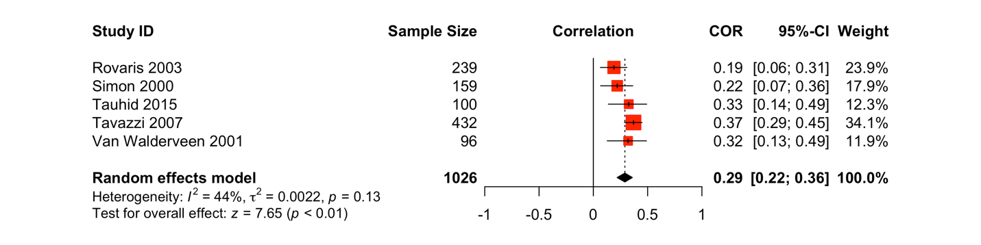

Analysis 5. Sensitivity analysis on studies with the high/unclear risk of bias in the Participation domain
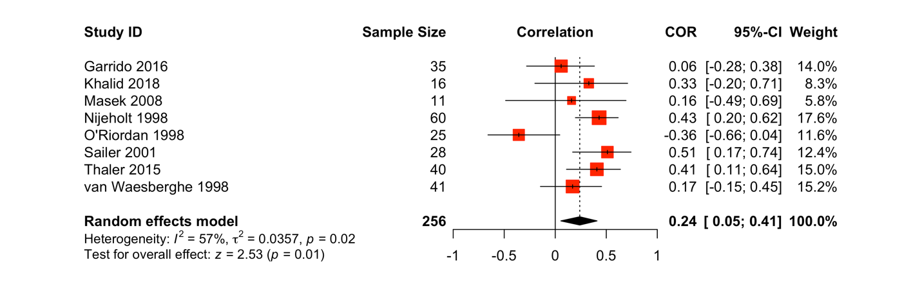

Analysis 6. Sensitivity analysis on studies with the high/unclear risk of bias in the Outcome measurement domain
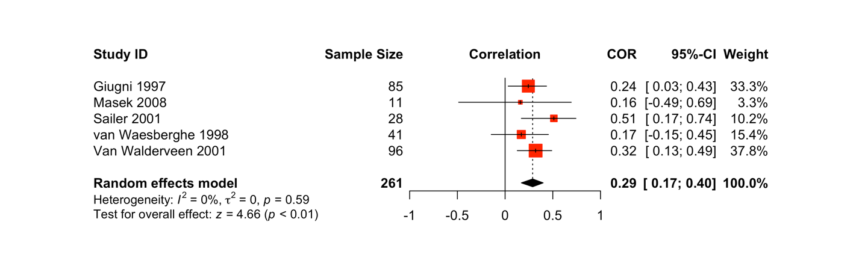

Analysis 7. Sensitivity analysis on studies with the high/unclear risk of bias in the Study confounding domain


