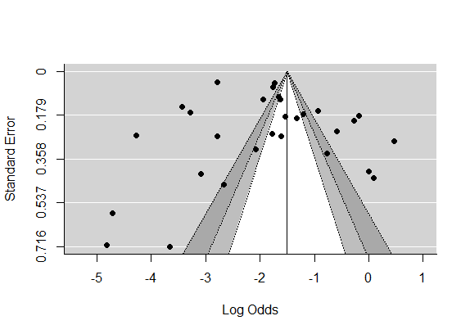Supplemental Fig 2: Funnel plot to assess publication bias. The vertical line indicates the effect size whereas the diagonal line indicates the precision of individual studies with a 95% confidence interval

