Effects of vegan diets on cardiometabolic health: A systematic review and meta-analysis of randomized controlled trials
Anne-Ditte Termannsen^{1,2}, Kim Katrine Bjerring Clemmensen¹, Jonas Mark Thomsen¹, Ole Nørgaard³, Lars Jorge Díaz¹, Signe Sørensen Torekov², Jonas Salling Quist¹, Kristine Færch^{1,2}
¹ Clinical Research, Copenhagen University Hospital – Steno Diabetes Center Copenhagen, Herlev, Denmark
² Department of Biomedical Sciences, University of Copenhagen, Copenhagen, Denmark
³ Department of Education, Danish Diabetes Knowledge Center, Copenhagen University Hospital – Steno Diabetes Center Copenhagen, Herlev, Denmark

Corresponding author: Anne-Ditte Termannsen, ksv271@sund.ku.dk, +45 51 20 99 70.

Contents
Supporting information file 1 Search strategy
Supporting information file 2 GRADE framework
Supporting information Table S1 Macronutrient composition in vegan intervention diets and control diets
Supporting information Figure S1 and Figure S2 Funnel plots for body weight and BMI
Supporting information Figure S3 Sensitivity analysis for HbA_{1c}

Supporting information file 1 Search strategy
The search strategy was based on three concepts that were combined: 1) the intervention (vegan diet) AND 2) the population (people with overweight, prediabetes or type 2 diabetes), AND 3) the study design (randomized controlled trials). We used free-text search as well as the controlled vocabulary provided by each database. For the vegan concept we searched ‘vegetarian’ since our knowledge within this field indicates that some vegan studies may be classified as ‘vegetarian’. By using ‘vegetarian’ in our search strategy, we reduced the risk of missing misclassified vegan intervention studies. Further, ‘vegan diet’ and ‘vegans’ are subgroups of ‘vegetarian diet’ and ‘vegetarians’, respectively, in the controlled vocabularies.

MEDLINE
Date of search: 14 March 2022
# | Searches
1 | exp Diabetes Mellitus, Type 2/
2 | Prediabetic State/
3 | exp Overweight/
4 | (diabet$ or pre-diabet$ or prediabet$ or t2d$ or niddm or non-insulin-dependent$).ti,ab,kw,kf.
5 | (high bmi or obes$ or overweight$).ti,ab,kw,kf.
6 | or/1-5
7 | exp Diet, Vegetarian/
8 | exp Vegetarians/
9 | (vegetarian$ or vegan$ or plantbased$ or plant-based$ or plant-food$).ti,ab,kw,kf.
10 | or/7-9
11 | and/6,10
12 | (randomized controlled trial or controlled clinical trial).pt.
13 | (randomi#ed or placebo or randomly or trial or groups).ab.
14 | drug therapy.fs.
15 | or/12-14
16 | exp Animals/ not Humans/
17 | 15 not 16
18 | and/11,17

CENTRAL
Date of search: 14 March 2022
# | Searches
1 | [mh "Diabetes Mellitus, Type 2"]
2 | [mh "Prediabetic State"]
3 | [mh Overweight]
4 | (diabet* or pre-diabet* or prediabet* or t2d* or niddm or non-insulin-dependent*):ti,ab,kw
5 | (high bmi or obes* or overweight*):ti,ab,kw
6 | #1 or #2 or #3 or #4 or #5
7 | [mh "Diet, Vegetarian"]
8 | [mh Vegetarians]
9 | (vegetarian* or vegan* or plantbased* or plant-based* or plant-food*):ti,ab,kw
10 | #7 or #8 or #9
11 | #6 and #10

Embase
Date of search: 14 March 2022
# | Searches
1 | exp non insulin dependent diabetes mellitus/
2 | impaired glucose tolerance/
3 | exp obesity/
4 | (diabet$ or pre-diabet$ or prediabet$ or t2d$ or niddm or non-insulin-dependent$).ti,ab,kw.
5 | (high bmi or obes$ or overweight$).ti,ab,kw.
6 | or/1-5
7 | exp vegetarian diet/
8 | exp vegetarian/
9 | (vegetarian$ or vegan$ or plantbased$ or plant-based$ or plant-food$).ti,ab,kw.
10 | or/7-9
11 | and/6,10
12 | randomized controlled trial/
13 | controlled clinical study/
14 | random$.ti,ab.
15 | randomization/
16 | intermethod comparison/
17 | placebo.ti,ab.
18 | (compare or compared or comparison).ti.
19 | ((evaluated or evaluate or evaluating or assessed or assess) and (compare or compared or comparing or comparison)).ab.
20 | (open adj label).ti,ab.
21 | ((double or single or doubly or singly) adj (blind or blinded or blindly)).ti,ab.
22 | double blind procedure/
23 | parallel group$1.ti,ab.
24 | (crossover or cross over).ti,ab.
25 | ((assign$ or match or matched or allocation) adj5 (alternate or group$1 or intervention$1 or patient$1 or subject$1 or participant$1)).ti,ab.
26 | (assigned or allocated).ti,ab.
27 | (controlled adj7 (study or design or trial)).ti,ab.
28 | (volunteer or volunteers).ti,ab.
29 | human experiment/
30 | trial.ti.
31 | or/12-30
32 | (rat or rats or mouse or mice or swine or porcine or murine or sheep or lambs or pigs or piglets or rabbit or rabbits or cat or cats or dog or dogs or cattle or bovine or monkey or monkeys or trout or marmoset$1).ti. and animal experiment/
33 | animal experiment/ not (human experiment/ or human/)
34 | or/32-33
35 | 31 not 34
36 | and/11,35
37 | limit 36 to exclude medline journals

CINAHL
Date of search: 14 March 2022
# | Searches
1 | MH "Diabetes Mellitus, Type 2+"
2 | MH "Prediabetic State+"
3 | MH "Obesity+"
4 | TI diabet* OR AB diabet* OR TI pre-diabet* OR AB pre-diabet* OR TI prediabet* OR AB prediabet* OR TI t2d* OR AB t2d* OR TI niddm OR AB niddm OR TI non-insulin-dependent* OR AB non-insulin-dependent*
5 | TI high bmi OR AB high bmi OR TI obes* OR AB obes* OR TI overweight* OR AB overweight*
6 | S1 OR S2 OR S3 OR S4 OR S5
7 | MH "Plant-Based Diet"
8 | MH "Vegetarianism"
9 | TI vegetarian* OR AB vegetarian* OR TI vegan* OR AB vegan* OR TI plantbased* OR AB plantbased* OR TI plant-based* OR AB plant-based* OR TI plant-food* OR AB plant-food*
10 | S7 OR S8 OR S9
11 | S6 AND S10
12 | MH "Randomized Controlled Trials"
13 | MH "Double-Blind Studies"
14 | MH "Single-Blind Studies"
15 | MH "Random Assignment"
16 | MH "Pretest-Posttest Design"
17 | MH "Cluster Sample"
18 | TI (randomised OR randomized)
19 | AB random*
20 | TI trial
21 | MH "Sample Size" AND AB (assigned OR allocated OR control)
22 | MH "Placebos"
23 | PT "Randomized Controlled Trial"
24 | AB (control W5 group)
25 | MH "Crossover Design"
26 | MH "Comparative Studies"
27 | AB (cluster W3 rct)
28 | MH "Animals+"
29 | MH "Animal Studies"
30 | TI animal model*
31 | S28 OR S29 OR S30
32 | MH "Human"
33 | S31 NOT S32
34 | S12 OR S13 OR S14 OR S15 OR S16 OR S17 OR S18 OR S19 OR S20 OR S21 OR S22 OR S23 OR S24 OR S25 OR S26 OR S27
35 | S34 NOT S33
36 | S11 AND S35

Supporting information file 2 GRADE framework
Risk of bias: downgrade by one level if more than 25% of participants are from studies at high risk of bias (i.e. one or more bias domains were judged high-risk).¹
Publication bias: downgrade by one level if a funnel plot suggests the presence of publication bias, or if more than 25% of participants were from small studies (<20 participants per arm).²
Imprecision: downgrade because of very wide confidence intervals or if small effect, no effect or small worsening was observed.³
Inconsistency: downgrade by one level if inspection of point estimates and confidence intervals suggest substantial dissimilarity, and if there are substantial unexplained heterogeneity (I² statistic value >50%).⁴
Indirectness: Systematic reviews are considered as direct evidence, and will only include eligible research regarding population, intervention, comparator, and outcome. Therefore, we will not assess indirectness across the studies.⁵

References:
1. Guyatt GH, Oxman AD, Vist G, et al. GRADE guidelines: 4. Rating the quality of evidence - Study limitations (risk of bias). J Clin Epidemiol. 2011;64(4):407-415.
2. Guyatt GH, Oxman AD, Montori V, et al. GRADE guidelines: 5. Rating the quality of evidence - Publication bias. J Clin Epidemiol. 2011;64(12):1277-1282.
3. Guyatt GH, Oxman AD, Kunz R, et al. GRADE guidelines 6. Rating the quality of evidence - Imprecision. J Clin Epidemiol. 2011;64(12):1283-1293.
4. Guyatt GH, Oxman AD, Kunz R, et al. GRADE guidelines: 7. Rating the quality of evidence - Inconsistency. J Clin Epidemiol. 2011;64(12):1294-1302.
5. Guyatt GH, Oxman AD, Kunz R, et al. GRADE guidelines: 8. Rating the quality of evidence - Indirectness. J Clin Epidemiol. 2011;64(12):1303-1310.

Supporting information Table S1 Macronutrient composition in vegan intervention diets and control diets

Table S1: Macronutrient composition in vegan intervention diets and control diets
Actual intake measured during the study:
 | Vegan intervention diets |  |  |  | Control diets
 | Carbohydrate | Protein | Fat | Alcohol | Carbohydrate | Protein | Fat | Alcohol
Barnard et al., 2005 ¹⁸ | 77 E% | 12 E% | 11 E% | 0 E% | 62 E% | 18 E% | 20 E% | 0 E%
Barnard et al., 2006 ²⁰ | 66 E% | 14 E% | 20 E% | 0 E% | 46 E% | 20 E% | 34 E% | 0 E%
Barnard et al., 2018 ³⁰ | 71 E% | 14 E% | 18 E% | 0 E% | 50 E% | 21 E% | 30 E% | 0 E%
Barnard et al., 2021 ⁴⁹ | 68 E% | 12 E% | 17 E% | 2 E% | 40 E% | 15 E% | 43 E% | 2 E%
Jenkins et al., 2014 ⁵⁰ | 54 E% | 18 E% | 27 E% | 2 E% | 40 E% | 23 E% | 36 E% | 1 E%
Lee et al., 2016 ³¹ | 68 E% | 14 E% | 18 E% | 0 E% | 63 E% | 17 E% | 20 E% | 0 E%
Nicholson et al., 1999 ³² | 75 E% | 14 E% | 11 E% | 0 E% | 51 E% | 18 E% | 31 E% | 0 E%
Turner-McGrievy et al., 2015 ⁴⁰ | 54 E% | 15 E% | 31 E% | 0 E% | 45 E% | 18 E% | 37 E% | 0 E%
Planned intake according to study protocol:
 | Vegan intervention diets |  |  |  | Control diets
 | Carbohydrate | Protein | Fat | Alcohol | Carbohydrate | Protein | Fat | Alcohol
Bunner et al., 2015 ³³ | NA | NA | NA | NA | NA | NA | NA | NA
Kahleova et al., 2020 ¹⁷ | ~75 E% | 15 E% | 10 E% | NA | NA | NA | NA | NA
Wright et al., 2017 ⁵¹ | NA | NA | 7-15 E% | NA | NA | NA | NA | NA
NA=Not available; E%=Energy percent

Supporting information Figure S1 and Figure S2 Funnel plots for body weight and BMI

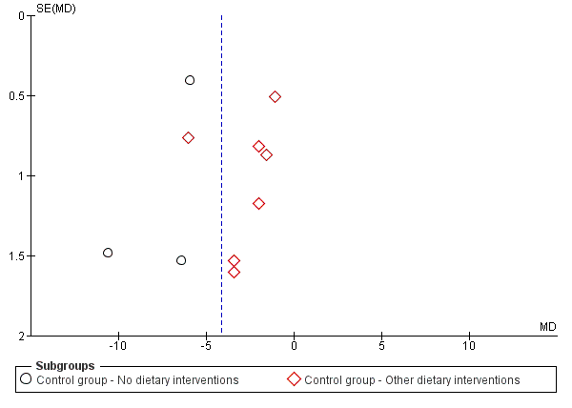
FIGURE S1 Funnel plot depicting the effect of vegan diet intervention on body weight.
SE=standard error; MD=mean difference.

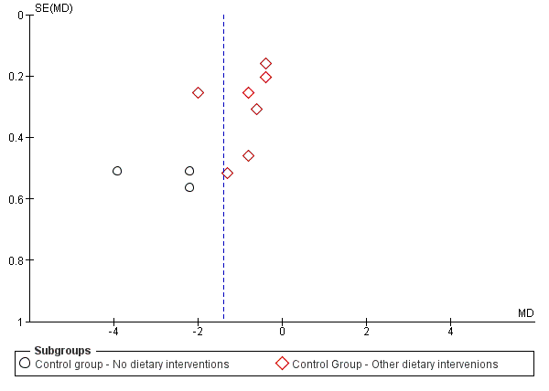
FIGURE S2 Funnel plot depicting the effect of vegan diet intervention on BMI.
SE=standard error; MD=mean difference.

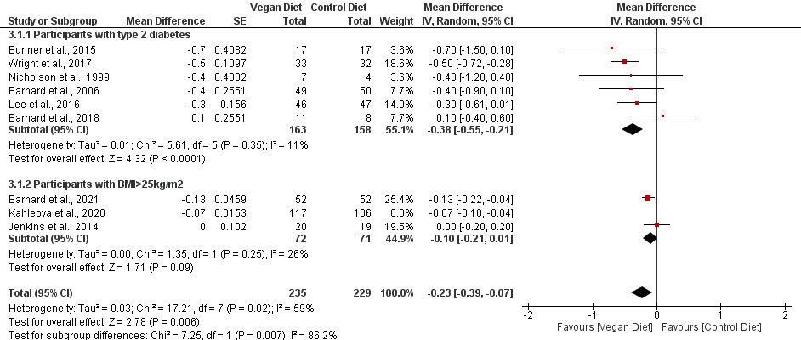
Supporting information Figure S3 Sensitivity analysis for HbA_{1c}
¤

FIGURE S3 Forest plot depicting the effect of vegan diets on glycated hemoglobin (HbA_{1c}) after removal of the study by Kahleova and colleagues.
Plots depict the effect size (mean difference) and 95 % confidence interval for the individual studies and the pooled estimate overall and by subgroups. Studies are ordered by effect size. SE=standard error; CI=confidence interval; IV=inverse variance. ¤The study by Wright and colleagues was placed in the subgroup ‘Participants with type 2 diabetes’. Participants were either obese (BMI≥30 kg/m²) or overweight (BMI≥25 kg/m²) with either a diagnosis of type 2 diabetes or ischemic heart disease or had hypertension or hypercholesterolemia.

