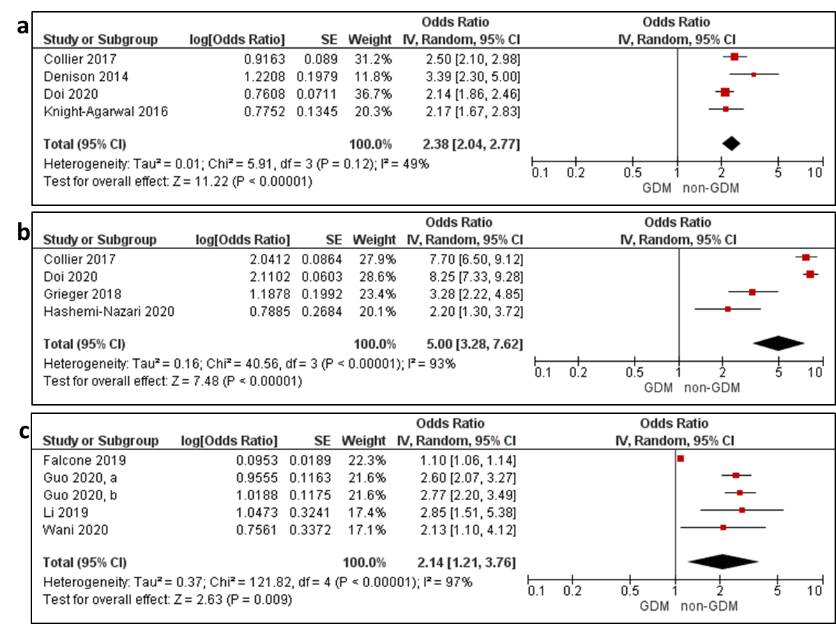
Supplementary Figure 13: Meta-analysis of early pregnancy a) overweight, b) obesity and c) fasting plasma glucose and odds of gestational diabetes (GDM) based on the respective 2013 WHO criteria [1], 2013 WHO/ADA [2] criteria, and 2010 IADPSG [3]/ADA diagnostic criteria for GDM. Values are odds ratios with 95% CIs adjusted for maternal age and BMI.

1. World Health Organization., Definition, Diagnosis and Classification of Diabetes Mellitus and its Complications. 1999. Part 1: Diagnosis and Classification of Diabetes Mellitus. https://apps.who.int/iris/handle/10665/66040.
2. American Diabetes, A., Standards of medical care in diabetes--2010. Diabetes Care, 2010. 33 Suppl 1: p. S11-61.
3. International Association of Diabetes and Pregnancy Study Groups., Recommendations on the Diagnosis and Classification of Hyperglycemia in Pregnancy. Diabetes Care. 2010;33(3):676. doi:10.2337/dc09-1848.

