Supp. Fig.1. Sensitivity analysis including only prospective studies to assess the risk of NMIBC recurrence in ever smokers compared to never smokers.

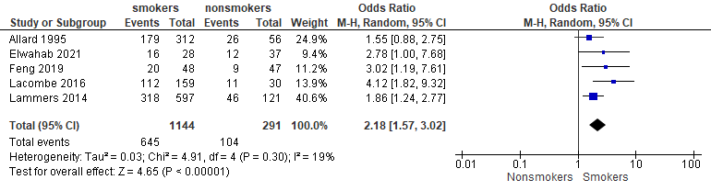
Supp. Fig.2. Sensitivity analysis for the risk of recurrence (A) and progression (B) of NMIBC- comparison between ever smokers and never smokers.
A
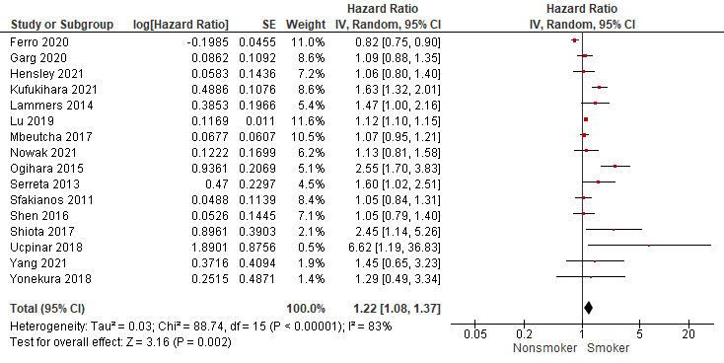
B
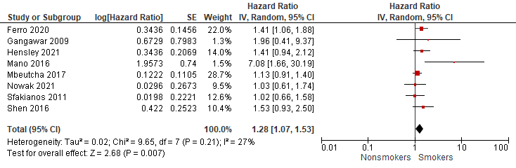
Studies with less reliable reporting on smoking status were excluded.

Supp. Fig.3. The association of smoking with recurrence-free survival in (A) Asian and (B) European or North American patients respectively. The association of smoking with progression-free survival in (C) Asian and (D) European or North American patients with non-muscle invasive bladder cancer.
A
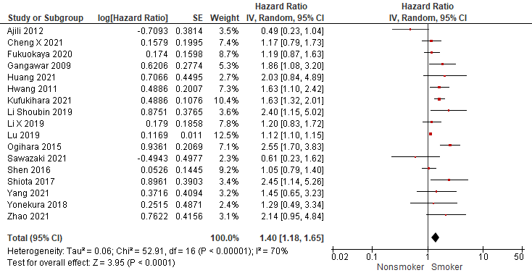
B
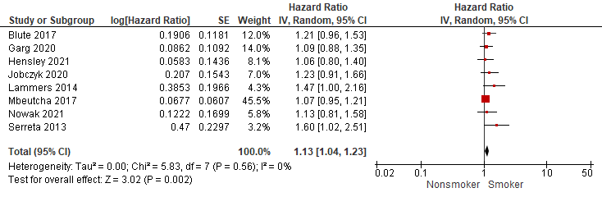
C
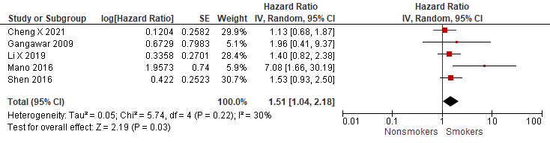
D
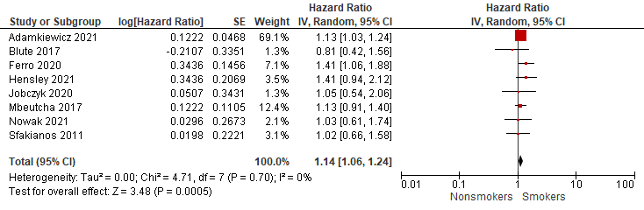

Supp. Fig. 4. Funnel plots of recurrence-free survival in current smokers compared to never smokers (A) and former smokers compared to never smokers (B) in meta-analysis.
A 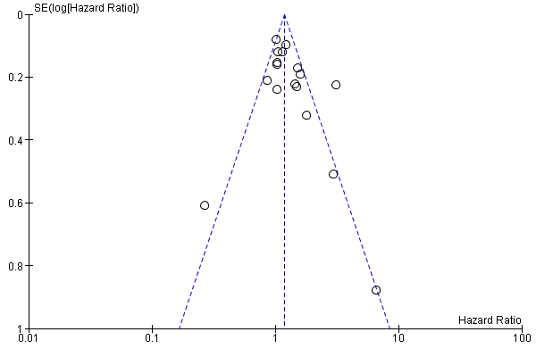
B 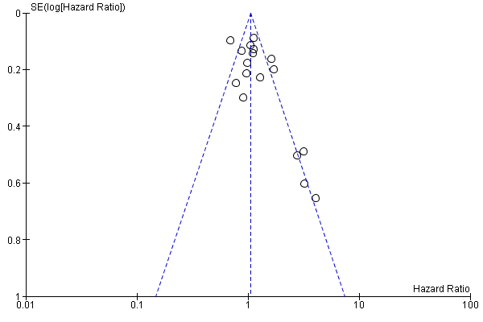
Supp. Fig. 5. Funnel plots of recurrence-free survival (A) and progression-free survival (B) in smokers compared to nonsmokers in meta-analysis.
A 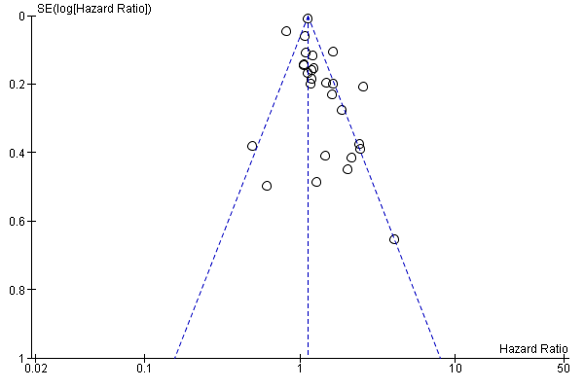
B
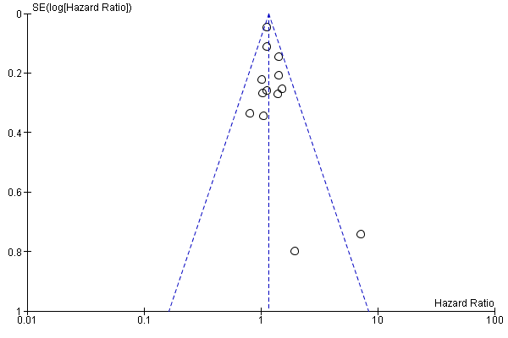
Supp. Fig.6. Funnel plots of recurrence (A) and progression (B) risk in smokers compared to nonsmokers in meta-analysis.
A 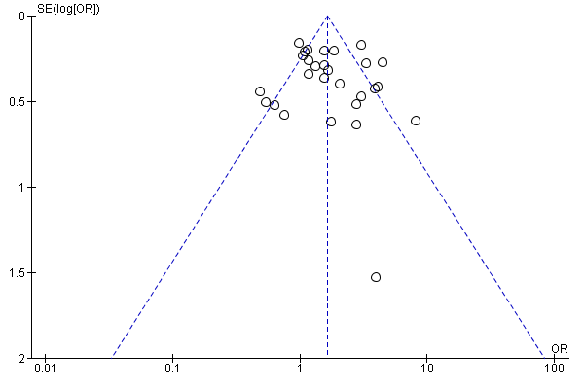

B 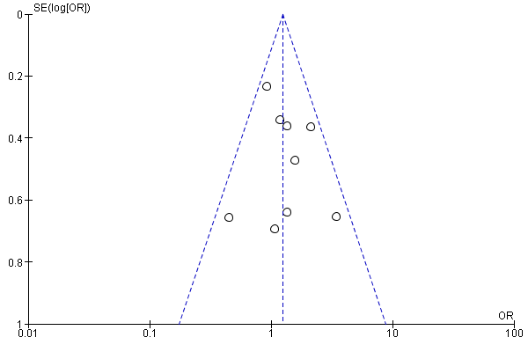
Supp. Fig.7. Funnel plots of recurrence risk in current compared to former smokers (A) and former compared to never smokers (B) in meta-analysis.
A
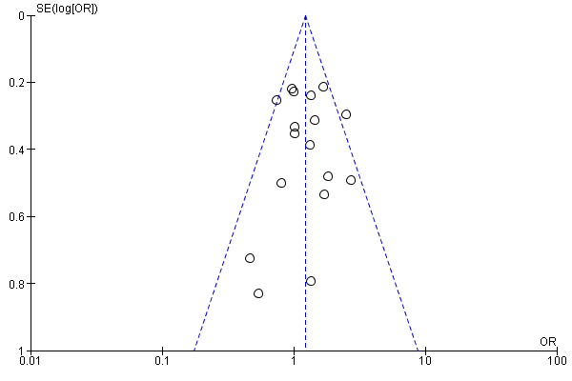
B
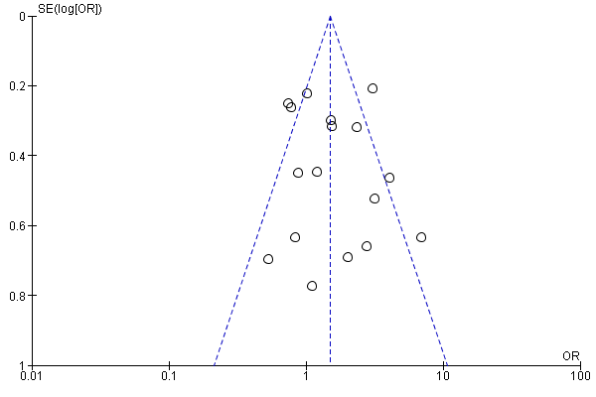
Supp. Fig.8. Funnel plots of recurrence-free survival (A) and progression-free survival (B) in smokers compared to nonsmokers in the subgroup of BCG-treated patients- meta-analysis.
A
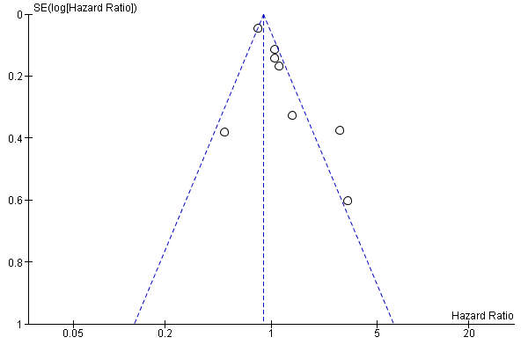
B 

