Online Supplement

Effect of prone versus supine position in COVID patients: a systematic review and meta-analysis
Ee Xin Chua¹, Syed Mohd Ikhmal Syed Mohd Zahir¹, Ka Ting Ng¹, Wan Yi Teoh²
Mohd Shahnaz Bin Hasan¹, Shairil Rahayu Binti Ruslan¹, Mohammed F. Abosamak³

- Department of Anaesthesiology, Faculty of Medicine, University of Malaya, Jalan Universiti, Kuala Lumpur, Malaysia.
- Faculty of Medicine, University of Liverpool, Liverpool L69 3BX, United Kingdom.
- Department of Anaesthesia and Intensive care medicine, Faculty of medicine, Tanta University, Egypt.

Supplemental tables
eTable 1: PICO table
eTable 2: Search strategy
eTable 3: List of excluded studies
eTable 4: Clinical characteristics of ongoing studies
eTable 5: The Newcastle-Ottawa Scale of all the included studies
eTable 6: PRISMA checklist
eTable 7: Forest plots of all measured outcomes
eTable 8: Funnel plots of all measured outcomes

eTable 1 – PICO table

Population | Intervention | Control | Outcome
COVID-19 adult patients (>18 years old) | Prone Positioning | Supine Positioning | Effects on oxygenation  Number of intubated patients  Rate of mortality  Number of patients discharged alive
COVID-19: Coronavirus Disease 2019

eTable 2. Search Strategy

OVID CENTRAL/ EMBASE/ MEDLINE (its inception until March 2021)
Steps | Search String
1. | exp Prone Position/ or prone.mp. [mp=title, abstracts, heading word, drug trade name, original title, device manufacture, drug manufacturer, device trade name, keyword, floating subheading word, candidate term word]
2. | proning.mp. [mp=title, abstracts, heading word, drug trade name, original title, device manufacture, drug manufacturer, device trade name, keyword, floating subheading word, candidate term word]
3. | exp Patient Positioning/ or patient position.mp. [mp=title, abstracts, heading word, drug trade name, original title, device manufacture, drug manufacturer, device trade name, keyword, floating subheading word, candidate term word]
4. | 1 or 2 or 3
5. | exp Coronavirus Infections/ or covid.mp. [mp=title, abstracts, heading word, drug trade name, original title, device manufacture, drug manufacturer, device trade name, keyword, floating subheading word, candidate term word]
6. | exp Coronavirus/ or exp Middle East Respiratory Syndrome Coronavirus/ or coronavirus.mp. [mp=title, abstracts, heading word, drug trade name, original title, device manufacture, drug manufacturer, device trade name, keyword, floating subheading word, candidate term word]
7. | covid 2019.mp. [mp=title, abstracts, heading word, drug trade name, original title, device manufacture, drug manufacturer, device trade name, keyword, floating subheading word, candidate term word]
8. | covid-19.mp. [mp=title, abstracts, heading word, drug trade name, original title, device manufacture, drug manufacturer, device trade name, keyword, floating subheading word, candidate term word]
9. | SARS-CoV-2.mp. [mp=title, abstracts, heading word, drug trade name, original title, device manufacture, drug manufacturer, device trade name, keyword, floating subheading word, candidate term word]
10. | wuhan virus.mp. [mp=title, abstracts, heading word, drug trade name, original title, device manufacture, drug manufacturer, device trade name, keyword, floating subheading word, candidate term word]
11. | 5 or 6 or 7 or 8 or 9 or 10
12. | 4 and 11

eTable 3. List of excluded studies

No | Author | Year | Design | N | Country | Reasons for exclusion
1 | Shakir et al | 2020 | Perspective | - | UK | No comparison between prone vs supine
2 | Aydogdu et al | 2020 | Literature review | - | Turkey | No comparison between prone vs supine
3 | Mary-John et al | 2020 | Review | - | India | No comparison between prone vs supine
4 | De Jong et al | 2020 | Narrative review | - | France | No comparison between prone vs supine
5 | Karlsen et al | 2020 | Systematic review | 611,364 | Denmark | No comparison between prone vs supine
6 | Pan et al | 2020 | Observational study | - | China | No comparison between prone vs supine
7 | Hui Qing et al | 2020 | Retrospective study | 7 | China | No comparison between prone vs supine
8 | Doussot et al | 2020 | Prospective cohort study | 117 | France | No comparison between prone vs supine
9 | Futier et al | 2020 | Letter to editors | - | France | No comparison between prone vs supine
10 | Bagate et al | 2020 | Pilot study | 10 | France | No comparison between prone vs supine
11 | Hallifax et al | 2020 | Retrospective study | 48 | UK | No comparison between prone vs supine
12 | Thorac et al | 2021 | Case Control study | 29 | Italy | Comparison prone and side/lateral positioning vs supine

eTable 4. Clinical characteristics of ongoing studies
Author | Location | Status | Recruitment start date | Estimated Completion Date | Title | Comparator | N | Clinical Trial Number
Morten H Bestle | Denmark | Recruiting | 11/5/2020 | December 2020 | Accelerated Prone Position Ventilation of Patients With COVID-19 | Standard prone position vs Accelerated prone position | 150 | NCT04384900
Waleed Alhazzani | Canada | Recruiting | 10/06/2020 | 30/08/2021 | Awake Prone Position in Hypoxemic Patients with Coronavirus Disease 19 (COVI-PRONE): A Randomized Clinical Trial | Awake proning vs Standard of care | 350 | NCT04350723
Waleed Alhazzani | Saudi Arabia
Ivan Pavlov | Canada | Recruiting | 15/05/2020 | 31/12/2020 | Randomized-controlled Trial of HFNC Alone vs HFNC and Awake Self-proning for Treatment of Severe COVID-19 | Awake prone positioning vs Standard care | 346 | NCT04395144
Dr Jacob Rosén | Sweden | Ongoing | 25/06/2020 | 25/06/2021 | Awake prone positioning with high flow nasal cannula in critically ill COVID-19 patients | Prone positioning vs standard care | 240 | ISRCTN54917435
Todd W Rice | USA | Enrolling by invitation | 27/04/2020 | 06/2021 | COVID-19 Patient Positioning Pragmatic Trial | Usual care vs Prone | 500 | NCT04359797
John Laffey | Ireland | Recruiting | 11/07/2020 | 11/09/2021 | Awake Prone Positioning to Reduce Invasive VEntilation in COVID-19 Induced Acute Respiratory failurE (APPROVE-CARE) | Prone positioning vs standard care | 200 | NCT04347941
Yonatan Perez | France | Recruiting | 27/04/2020 | 24/11/2021 | Prone Position in Patients on High-flow Nasal Oxygen Therapy for COVID-19 (HIGH-PRONE-COVID-19) | Prone decubitus vs usual care | 404 | NCT04358939
Oriol Roca | Spain | Recruiting | 13/05/2020 | 06/2021 | Prone Positioning and High-flow Nasal Cannula in COVID-19 Induced ARDS | Prone position vs standard care | 248 | NCT04391140
Jie Li | USA | Recruiting | 02/04/2020 | 30/06/2021 | Early PP with HFNC Versus HFNC in COVID-19 Induced Moderate to Severe ARDS | HFNC + PP vs HFNC only | 346 | NCT04325906
eTable 5: The Newcastle-Ottawa Scale of all the included studies
Year |  | Newcastle-Ottawa Criteria
Year | Study | Selection | Comparability | Exposure | Total Score |  | Overall
2020 | Astua et al | **** | ** | *** | ********* | 6 | High
2020 | Berrill et al | **** | ** | *** | ********* | 7 | Low
2020 | Burton et al | **** | ** | *** | ********* | 8 | Low
2020 | Caputo et al | **** | ** | *** | ********* | 6 | High
2020 | Coppo et al | **** | ** | *** | ********* | 8 | Low
2020 | Dubosh et al | **** | ** | *** | ********* | 7 | Low
2020 | Doussot et al | **** | ** | *** | ********* | 7 | Low
2020 | Elharrar et al | **** | ** | *** | ********* | 7 | Low
2020 | Ferrando et al | **** | ** | *** | ********* | 8 | Low
2020 | Ishak et al | **** | ** | *** | ********* | 5 | High
2020 | Jagan et al | **** | ** | *** | ********* | 8 | Low
2020 | Kelly et al | **** | ** | *** | ********* | 6 | High
2020 | Khullar et al | **** | ** | *** | ********* | 7 | Low
2020 | Mittermaier et al | **** | ** | *** | ********* | 7 | Low
2020 | Osama et al | **** | ** | *** | ********* | 7 | Low
2020 | Padrao et al | **** | ** | *** | ********* | 8 | Low
2020 | Perrier et al | **** | ** | *** | ********* | 5 | High
2020 | Golesta-nieragh et al | **** | ** | *** | ********* | 5 | High
2020 | Sartini et al | **** | ** | *** | ********* | 6 | High
2020 | Sharp et al | **** | ** | *** | ********* | 6 | High
2020 | Shelhamer et al | **** | ** | *** | ********* | 8 | Low
2020 | Solverson et al | **** | ** | *** | ********* | 7 | Low
2020 | Taboada et al | **** | ** | *** | ********* | 7 | Low
2020 | Taylor et al | **** | ** | *** | ********* | 7 | Low
2020 | Thompson et al | **** | ** | *** | ********* | 7 | Low
2020 | Weiss et al | **** | ** | *** | ********* | 8 | Low
2020 | Wendt et al | **** | ** | *** | ********* | 7 | Low
2020 | Winearls et al | **** | ** | *** | ********* | 7 | Low
2020 | Zang et al | **** | ** | *** | ********* | 8 | Low
2021 | Clarke et al | **** | ** | *** | ********* | 7 | Low
2021 | Douglas et al | **** | ** | *** | ********* | 7 | Low
2021 | Gleissman et al | **** | ** | *** | ********* | 7 | Low
2021 | Sang et al | **** | ** | *** | ********* | 7 | Low
2021 | Pud’homme et al | **** | ** | *** | ********* | 8 | Low
2021 | Wormser et al | **** | ** | *** | ********* | 7 | Low

eTable 6: PRISMA Checklist
Section/topic | # | Checklist item | Reported on page #
TITLE
Title | 1 | Identify the report as a systematic review, meta-analysis, or both. | 1
ABSTRACT
Structured summary | 2 | Provide a structured summary including, as applicable: background; objectives; data sources; study eligibility criteria, participants, and interventions; study appraisal and synthesis methods; results; limitations; conclusions and implications of key findings; systematic review registration number. | 2
INTRODUCTION
Rationale | 3 | Describe the rationale for the review in the context of what is already known. | 3
Objectives | 4 | Provide an explicit statement of questions being addressed with reference to participants, interventions, comparisons, outcomes, and study design (PICOS). | 4
METHODS
Protocol and registration | 5 | Indicate if a review protocol exists, if and where it can be accessed (e.g., Web address), and, if available, provide registration information including registration number. | 5
Eligibility criteria | 6 | Specify study characteristics (e.g., PICOS, length of follow-up) and report characteristics (e.g., years considered, language, publication status) used as criteria for eligibility, giving rationale. | 5
Information sources | 7 | Describe all information sources (e.g., databases with dates of coverage, contact with study authors to identify additional studies) in the search and date last searched. | 5
Search | 8 | Present full electronic search strategy for at least one database, including any limits used, such that it could be repeated. | 5
Study selection | 9 | State the process for selecting studies (i.e., screening, eligibility, included in systematic review, and, if applicable, included in the meta-analysis). | 5, 6
Data collection process | 10 | Describe method of data extraction from reports (e.g., piloted forms, independently, in duplicate) and any processes for obtaining and confirming data from investigators. | 6
Data items | 11 | List and define all variables for which data were sought (e.g., PICOS, funding sources) and any assumptions and simplifications made. | 6
Risk of bias in individual studies | 12 | Describe methods used for assessing risk of bias of individual studies (including specification of whether this was done at the study or outcome level), and how this information is to be used in any data synthesis. | 6
Summary measures | 13 | State the principal summary measures (e.g., risk ratio, difference in means). | 6, 7
Synthesis of results | 14 | Describe the methods of handling data and combining results of studies, if done, including measures of consistency (e.g., I²) for each meta-analysis. | 6
Risk of bias across studies | 15 | Specify any assessment of risk of bias that may affect the cumulative evidence (e.g., publication bias, selective reporting within studies). | 6
Additional analyses | 16 | Describe methods of additional analyses (e.g., sensitivity or subgroup analyses, meta-regression), if done, indicating which were pre-specified. | 6, 7
RESULTS
Study selection | 17 | Give numbers of studies screened, assessed for eligibility, and included in the review, with reasons for exclusions at each stage, ideally with a flow diagram. | 8
Study characteristics | 18 | For each study, present characteristics for which data were extracted (e.g., study size, PICOS, follow-up period) and provide the citations. | 8
Risk of bias within studies | 19 | Present data on risk of bias of each study and, if available, any outcome level assessment (see item 12). | 8
Results of individual studies | 20 | For all outcomes considered (benefits or harms), present, for each study: (a) simple summary data for each intervention group (b) effect estimates and confidence intervals, ideally with a forest plot. | 9
Synthesis of results | 21 | Present results of each meta-analysis done, including confidence intervals and measures of consistency. | 9
Risk of bias across studies | 22 | Present results of any assessment of risk of bias across studies (see Item 15). | 8
Additional analysis | 23 | Give results of additional analyses, if done (e.g., sensitivity or subgroup analyses, meta-regression [see Item 16]). | 9, 10
DISCUSSION
Summary of evidence | 24 | Summarize the main findings including the strength of evidence for each main outcome; consider their relevance to key groups (e.g., healthcare providers, users, and policy makers). | 11-13
Limitations | 25 | Discuss limitations at study and outcome level (e.g., risk of bias), and at review-level (e.g., incomplete retrieval of identified research, reporting bias). | 13, 14
Conclusions | 26 | Provide a general interpretation of the results in the context of other evidence, and implications for future research. | 14
FUNDING
Funding | 27 | Describe sources of funding for the systematic review and other support (e.g., supply of data), role of funders for the systematic review. | 1

eTable 7: Forest plots of all measured outcomes
Forest plot of PaO2/FiO2
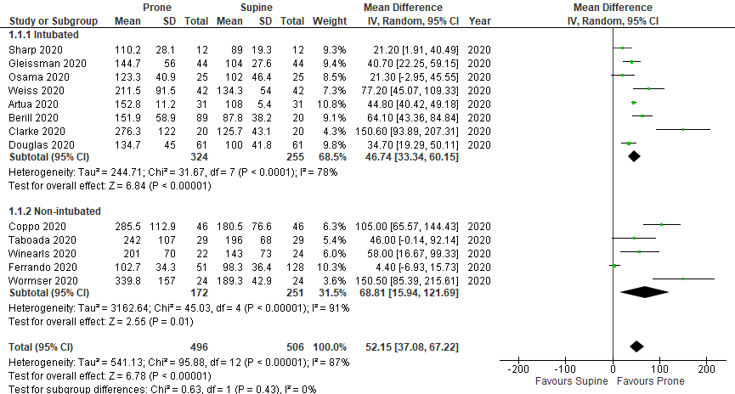

Forest plot of SpO2 (%)
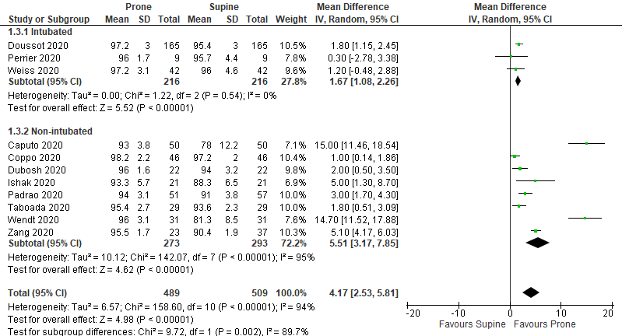

Forest plot of PaCO2 (mmHg)
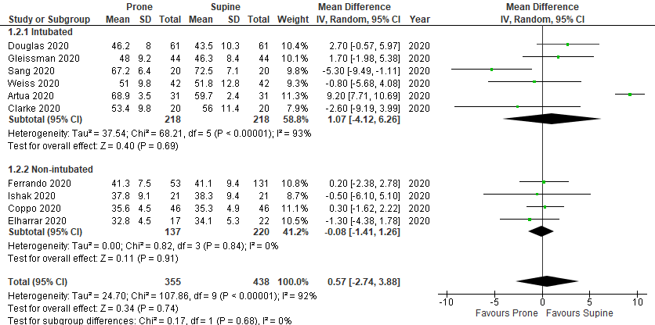
Incidence of Mortality
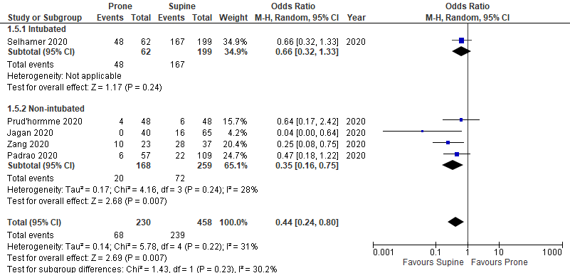

Incidence of intubation
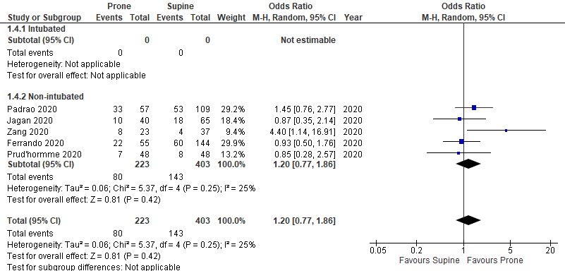

Number of patients discharged alive
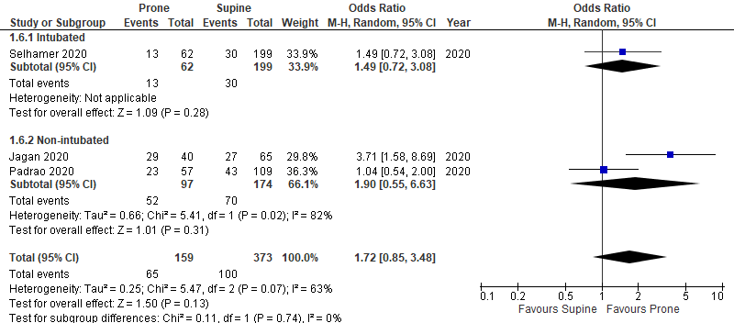

eTable 8: Funnel plots of all measured outcomes
Forest plot of PaO2/FiO2
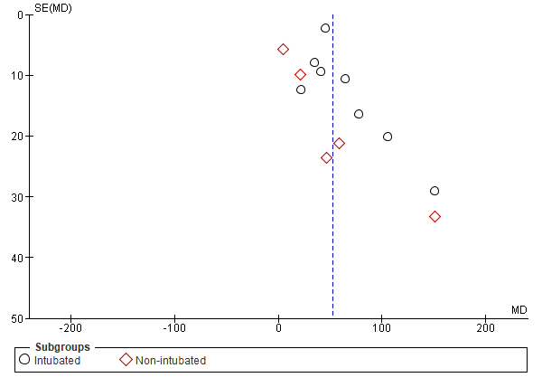
Forest plot of SpO2 (%)
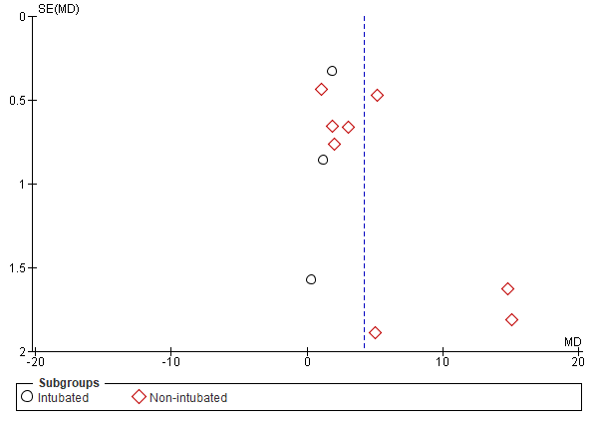

Forest plot of PaCO2 (mmHg)
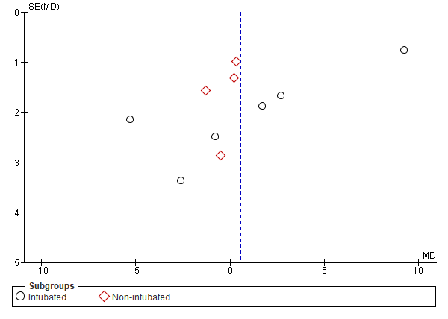
Incidence of Mortality
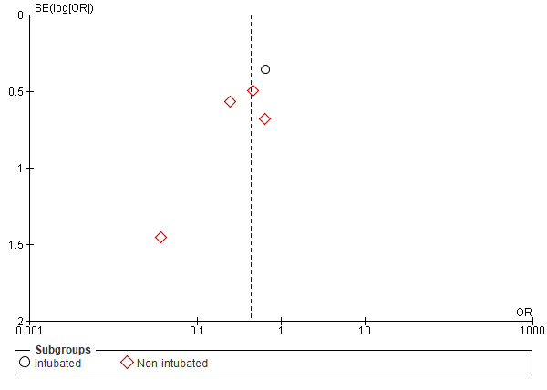

Incidence of intubation
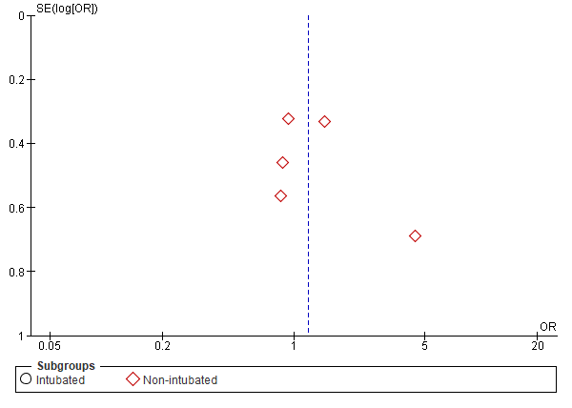

Number of patients discharged alive


