Supplementary Information
SEARCH QUERIES
Database | via | Coverage | References | After deduplication
Embase | Embase.com | 1971 - Present | 3361 | 3325
Medline ALL | Ovid | 1946 - Present | 2367 | 832
Web of Science Core Collection | Web of Knowledge | 1975 - Present | 1638 | 550
Other sources: Google Scholar (top 200) |  |  | 200 | 130
Total |  |  | 7566 | 4837

Embase
('inflammatory bowel disease'/exp OR (IBD OR crohn* OR Terminal-Ileit* OR ((colit* OR colorec* OR procto*) NEAR/6 (ulcer*)) OR ((inflamm*) NEAR/6 (bowel*))):ab,ti,kw) AND ('health care utilization'/exp OR 'cost'/exp OR 'price'/de OR 'prices'/de OR 'absenteeism'/de OR 'presenteeism'/de OR 'productivity'/de OR 'expenditures'/de OR 'unemployment'/de OR 'employability'/de OR 'return to work'/de OR 'work disability'/de OR 'cost of illness'/de OR (((financ* OR expens* OR expendi* OR cost OR costs OR price* OR pricing* OR econom*) NEAR/6 (societ* OR admission* OR hospital* OR disease* OR ill* OR burden* OR indirect*)) OR ((global OR national* OR international*) NEAR/6 (burden)) OR presenteism* OR ((health* OR resource*) NEAR/3 (use OR utilizat* OR utilisat* OR utilit*)) OR ((sick OR disabilit* OR impair* OR capacit* OR return*) NEAR/6 work) OR ((sick* OR work* OR disabil*) NEAR/6 (leave* OR presen* OR absent* OR absence* OR ill OR illness* OR productiv*)) OR unemploy* OR employab*):ab,ti,kw) AND ([ENGLISH]/lim) NOT ([animals]/lim NOT [humans]/lim) NOT ([Conference Abstract]/lim)
Medline
(exp "Inflammatory Bowel Diseases"/ OR (IBD OR crohn* OR Terminal-Ileit* OR ((colit* OR colorec* OR procto*) ADJ6 (ulcer*)) OR ((inflamm*) ADJ6 (bowel*))).ab,ti,kf.) AND (exp "Patient Acceptance of Health Care"/ OR "Costs and Cost Analysis"/ OR "Absenteeism"/ OR "Presenteeism"/ OR exp "Health Expenditures"/ OR "Unemployment"/ OR "Return to Work"/ OR "Cost of Illness"/ OR (((financ* OR expens* OR expendi* OR cost OR costs OR price* OR pricing* OR econom*) ADJ6 (societ* OR admission* OR hospital* OR disease* OR ill* OR burden* OR indirect*)) OR ((global OR national* OR international*) ADJ6 (burden)) OR presenteism* OR ((health* OR resource*) ADJ3 ('use' OR utilizat* OR utilisat* OR utilit*)) OR ((sick OR disabilit* OR impair* OR capacit* OR return*) ADJ6 work) OR ((sick* OR work* OR disabil*) ADJ6 (leave* OR presen* OR absent* OR absence* OR ill OR illness* OR productiv*)) OR unemploy* OR employab*).ab,ti,kf.) AND (english.la.) NOT (exp animals/ NOT humans/) NOT (news OR congres* OR abstract* OR book* OR chapter* OR dissertation abstract*).pt.
Web of Science Core Collection
TS=(((IBD OR crohn* OR Terminal-Ileit* OR ((colit* OR colorec* OR procto*) NEAR/5 (ulcer*)) OR ((inflamm*) NEAR/5 (bowel*)))) AND ((((financ* OR expens* OR expendi* OR cost OR costs OR price* OR pricing* OR econom*) NEAR/5 (societ* OR admission* OR hospital* OR disease* OR ill* OR burden* OR indirect*)) OR ((global OR national* OR international*) NEAR/5 (burden)) OR presenteism* OR ((health* OR resource*) NEAR/2 (use OR utilizat* OR utilisat* OR utilit*)) OR ((sick OR disabilit* OR impair* OR capacit* OR return*) NEAR/5 work) OR ((sick* OR work* OR disabil*) NEAR/5 (leave* OR presen* OR absent* OR absence* OR ill OR illness* OR productiv*)) OR unemploy* OR employab*)) NOT ((animal* OR rat OR rats OR mouse OR mice OR murine OR dog OR dogs OR canine OR cat OR cats OR feline OR rabbit OR cow OR cows OR bovine OR rodent* OR sheep OR ovine OR pig OR swine OR porcine OR veterinar* OR chick* OR zebrafish* OR baboon* OR nonhuman* OR primate* OR cattle* OR goose OR geese OR duck OR macaque* OR avian* OR bird* OR fish*) NOT (human* OR patient* OR women OR woman OR men OR man))) AND LA=(english) AND DT=(article)
Google Scholar
"inflammatory bowel disease" expenses|expense|absenteeism|productivity|"sick leave"|"societal cost"

SUPPLEMENTARY TABLES
Study | Country | Period | Disease | Patients (n) | Men  (%) | Women  (%) | Age  (mean/median) | Currency
Aldeguer¹ | Spain | 2002 - 2012 | UC | 285 | 146 (51) | 139 (49) | ? | Euro 2012
Bahler 1² | Switserland | 2014 | IBD | 4791 | 2107 (44) | 2684 (56) | 56 (IQR 28) | Swiss Francs 2014
Bahler 2³ | Switzerland | 2010, 2012, 2014 | IBD | 4812 | 2153 (44) | 2659 (56) | 55 (SD 16) | Swiss Francs 2016
Balaii⁴ | Iran | 2017 - 2018 | CD/UC | 250 | 110 (45) | 137 (55) | 37 (?) | US Dollar ?
Bassi⁵ | England | 2000 | CD/UC/IBD-U | 479 | 242 (56) | 191 (44) | 50 (SD 17) | UK Pounds ?
Bernstein⁶ | Canada | 2005 - 2006 | CD/UC | 7375 | 3317 (45) | 4058 (55) |  | Canadian Dollar ?
Bickston⁷ | United States | 2000 - 2005 | UC | 15105 | 7008 (46) | 8097 (54) | 44 (SD 14) | US Dollar 2005
Blomqvist 1⁸ | Sweden | 1994 | CD/UC | 39600 | ? | ? | ? | US Dollar 1994
Blomqvist 2⁹ | Sweden | 1988 - 1997 | CD/UC | 39400 | ? | ? | ? | US Dollar 1997
Blumenstein¹⁰ | Germany | 2005 - 2007 | IBD | 523 | ? | ? | ? | Euro ?
Bounthavong¹¹ | United States | 2003 - 2013 | CD | 522064 | 211671 (41) | 310393 (59) | 47 (SE 1,41) | US Dollar 2015
Burisch 1¹² | Europe | 2010 | CD/UC/IBD-U | 1376 | 753 (55) | 614 (45) | 36 (Range 15-89) | Euro 2013
Burisch 2¹³ | Europe and Israel | 2010 | CD/UC | 1289 | 689 (54) | 600 (46) |  | Euro 2015
Chen¹⁴ | Taiwan | 1998 - 2008 | UC | 1087 | 673 (62) | 414 (38) | 47 (SD 15) | New Taiwan Dollar per year
Click¹⁵ | United States | 1998 - 2001, 2006 - 2009, 2012 - 2015 | IBD | 607 | 261 (43) | 346 (57) | 47 (SE 0,99) | US Dollar 2015
Cohen 1¹⁶ | United States | 2005 - 2013 | UC | 4314 | 2745 (63) | 1569 (37) | 45 (SD 10) | US Dollar 2013
Cohen 2¹⁷ | United States | 2000 - 2005 | CD | 13454 | 6021 (45) | 7433 (55) | 42 (?) | US Dollar ?
Colombara¹⁸ | Italy | 2010 - 2012 | CD/UC/IBD-U | 91 | 38 (42) | 53 (58) | 47 (?) | Euro ?
Dunn¹⁹ | United States | 2014 | IBD | ? | ? | ? | ? | US Dollar 2014
Ebinger²⁰ | Germany | 1997 - 2000 | IBD | 272 | ? | ? | ? | Euro ?
Feagan²¹ | United States | 1994 - 1995 | CD | 607 | 261 (43) | 346 (57) | 48 (?) | US Dollar ?
Ganz²² | United States | 1996 - 2012 | CD | 539 | 251 (47) | 288 (53) | 48 (95% CI 46-51) | US Dollar 2014
Gibson²³ | United States | 2000 - 2005 | CD/UC | 15539 | 7002 (45) | 8537 (55) | 44 (SD 14) | US Dollar 2005
Gleason²⁴ | United States | 2008 - 2010 | IBD | 4377 | 2100 (48) | 2277 (52) | ? | US Dollar per year
Gunnarsson 1²⁵ | United States | 1996 - 2006 | CD/UC | 556 | 322 (58) | 234 (42) | 48 (?) | US Dollar 2010
Gunnarsson 2²⁶ | United States | 1996 - 2006 | IBD | 200 | 92 (46) | 108 (54) | ? | US Dollar 2008
Hay²⁷ | United States | 1988 - 1989 | CD/UC | 4982 | 2403 (48) | 2579 (52) | ? | US Dollar 1990
Hillson²⁸ | United States | 2001 - 2005 | UC | 1057 | 425 (40) | 632 (60) | 61 (95% CI 29-93) | US Dollar 2004
Holko²⁹ | Poland | 2015 | CD | 200 | 84 (42) | 116 (56) | 32 (SD 10) | Euro 2015
Jackson³⁰ | Australia | 2014 - 2015 | CD/UC | 183 | 91 (50) | 92 (50) | 42 (SD 16) | Australian Dollar 2015
Juan³¹ | Spain | 1997 | CD | 635 | 304 (48) | 331 (52) | 33 (SD 12) | Euro 1997
Kappelman³² | United States | 2003 - 2004 | CD/UC | 19420 | 8866 (46) | 10554 (54) | 44 (SD 12) | US Dollar 2003-2004
Karve³³ | United States | 2000 - 2006 | IBD | 1174 | 608 (52) | 568 (47) | ? | US Dollar ?
Kawalec 1³⁴ | Poland | 2016 | UC | 147 | 69 (47) | 78 (53) | 39 (SD 13) | Euro 2016
Kawalec 2³⁵ | Poland | 2016 | UC | 202 | 75 (38) | 127 (62) | 33 (SD 10) | Euro 2015
Kim 1³⁶ | South Korea | 2006 - 2015 | CD/UC | 59447 | ? | ? | ? | US Dollar 2015
Kim 2³⁷ | South Korea | 2010 - 2014 | CD/UC | 53433 | 32047 (60) | 21386 (40) | ? | US Dollar 2016
Kohn³⁸ | Italy | 1997 - 2006 | UC | 644 | 332 (52) | 312 (48) | 38 (Range 18-93) | Euro ?
Kostic³⁹ | Serbia | 2014 | CD/UC | 112 | 50 (45) | 62 (55) | 34 (Range 13-59) | Serbia Dinar 2014
Le⁴⁰ | United States | 1999 - 2013 | IBD | 391 | 166 (42) | 225 (58) | ? | US Dollar ?
Lee⁴¹ | South Korea | 2010 - 2015 | CD/UC | 34167 | 20842 (61) | 13325 (39) | 41 (SD 17) | US Dollar 2017
Lo⁴² | Denmark | 2003 - 2015 | CD/UC | 513 | 250 (49) | 263 (51) | 35 (IQR 25-51) | Euro 2018
Longobardi⁴³ | Canada | 1998 - 1999 | IBD | 187 | 59 (32) | 128 (68) | ? | Canadian Dollar 1998
Mak⁴⁴ | Hong Kong | 2010 - 2013 | CD/UC | 435 | 260 (60) | 175 (40) | 41 (SD 17) | US Dollar 2015
Mesterton⁴⁵ | Sweden | 2007 - 2008 | CD | 420 | 192 (46) | 228 (54) | 50 (SD 15) | Euro 2007
Michael⁴⁶ | Hungary | 2012 - 2013 | CD/UC | 443 | 202 (46) | 241 (54) | 37,8 (?) | Euro 2013
Niewiadomski⁴⁷ | Australia | 2007-2008, 2010 - 2013 | CD/UC | 242 | 107 (44) | 135 (56) | 37 (Range 11 - 87) | Australian Dollar ?
Odes⁴⁸ | Europe and Israel | 1991 - 2005 | CD/UC | 1321 | 680 (51) | 641 (49) | 40 (SD 17) | Euro 2004
Park, K 1⁴⁹ | United States | 2011 - 2013 | CD | 5090 | 2197 (43) | 2893 (57) | 42 (?) | US Dollar ?
Park, K 2⁵⁰ | United States | 2007 - 2016 | CD/UC | 52782 | 24200 (46) | 28582 (54) | 48 (SD 18) | US Dollar 2016
Park, M⁵¹ | United States | 1996 - 2011 | CD/UC | 333 | 173 (52) | 160 (48) | 46 (SE 1,3) | US Dollar ?
Pillai⁵² | Switzerland | 2006 - 2016 | CD/UC | 2365 | 1147 (48) | 1218 (52) | 42 (SD 15) | Euro 2017
Pilon⁵³ | United States | 1999 - 2017 | UC | 9353 | 4632 (50) | 4721 (50) | 46 (SD 12) | US Dollar 2017
Pinchbeck⁵⁴ | Canada | 1985 | CD/UC | ? | ? | ? | ? | Canadian Dollar 1985
Prenzler⁵⁵ | Germany | 2006 - 2007 | CD/UC | 1030 | 444 (43) | 586 (57) | 44 (?) | Euro 2007
Sandler⁵⁶ | United States | 1998 | CD/UC | 978000 | ? | ? | ? | US Dollar 1998
Severs⁵⁷ | Netherlands | 2014 - 2015 | CD/UC | 101 | 48 (48) | 52 (52) | 53 (SD 15) | Euro 2014
Stark⁵⁸ | Germany | 2002 - 2004 | CD/UC | 483 | 192 (40) | 291 (60) | 42 (SD 12) | Euro 2004
Vadstrup⁵⁹ | Denmark | 2003 - 2016 | CD/UC | 29932 | ? | ? | ? | Euro 2016
van der Valk 1⁶⁰ | Netherlands | 2011 | CD/UC | 2252 | 972 (43) | 1280 (57) | 49 (SD 14) | Euro 2011
van der Valk 2⁶¹ | Netherlands | 2011 | CD/UC | 1303 | 595 (46) | 708 (54) | 51 (SD 13) | Euro 2011
van Gennep⁶² | Netherlands | 2017 | IBD | 510 | 211 (41) | 299 (59) | 45 (IQR 33 - 53) | Euro ?
Yamabe⁶³ | Japan | 2012 - 2014 | CD/UC | 441 | 272 (62) | 169 (38) | 48 (SD 15) | Yen ?
Zand⁶⁴ | United States | 2013 - 2014 | IBD | 283 | ? | ? | ? | US Dollar ?
Supplementary Table 1: Study characteristics.
IBD: inflammatory bowel disease, CD: Crohn’s disease, UC: ulcerative colitis, UK: United Kingdom, US: United States, NTD: New Taiwan Dollar, IQR: Interquartile range, SE: standard error, SD: standard deviation, CI: 95% confidence interval, ?: not reported.

SUPPLEMENTARY FIGURES
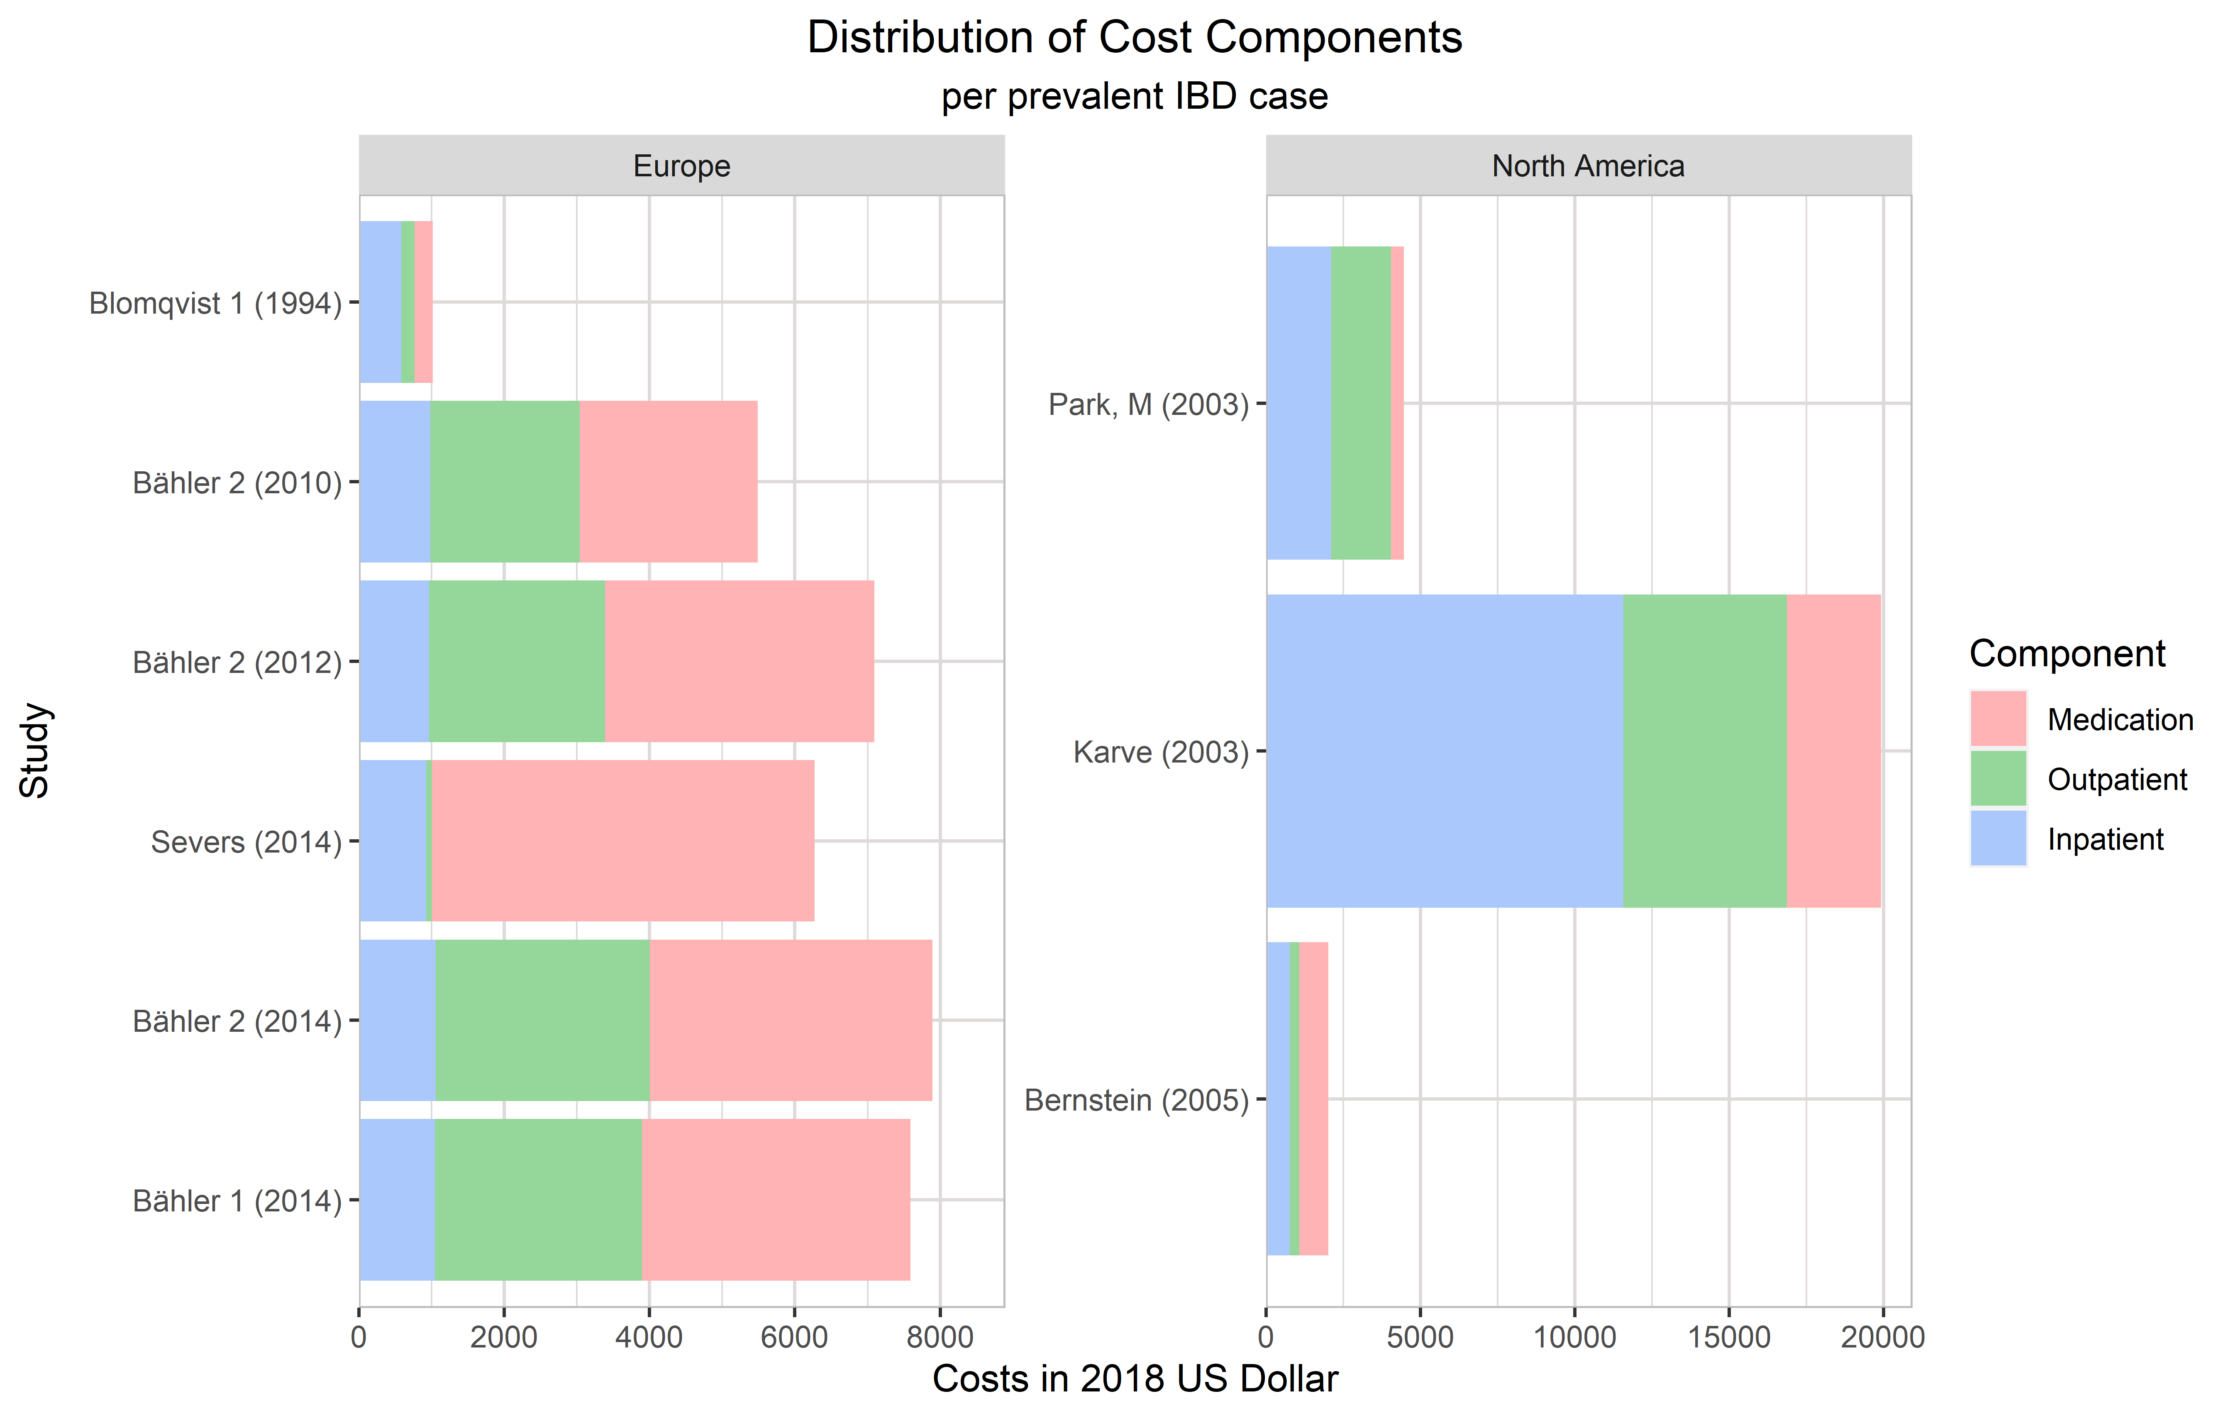
Supplemental Figure 1: Absolute distribution of cost components per prevalent IBD case.
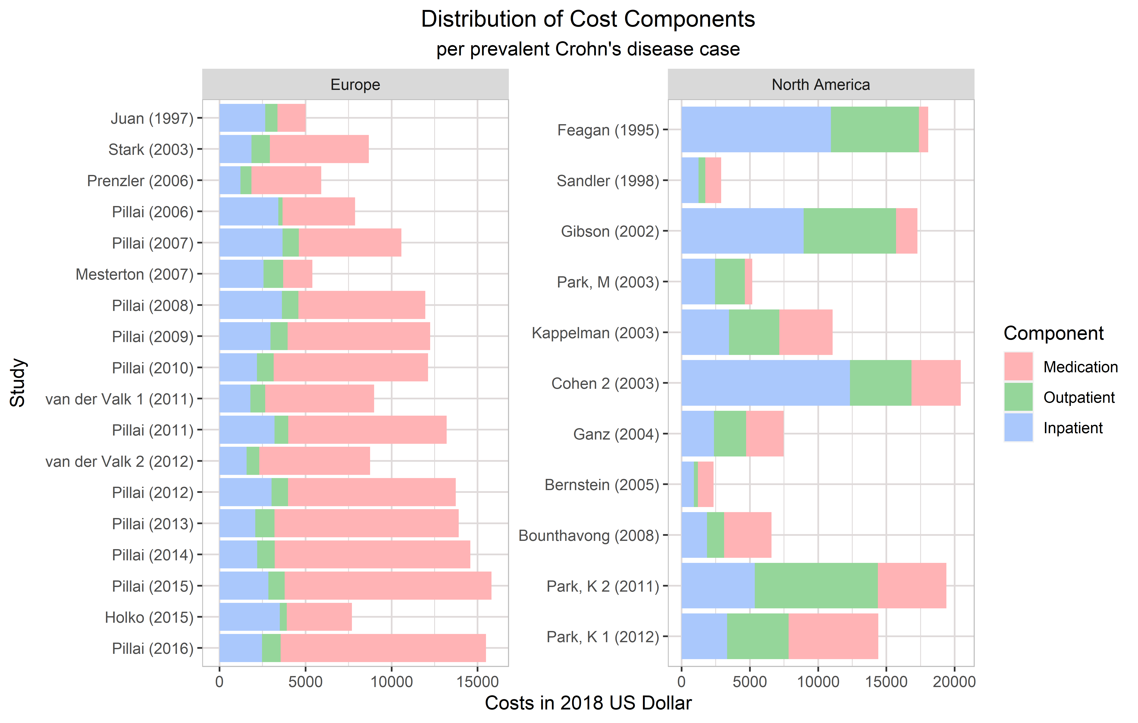
Supplemental Figure 2: Absolute distribution of cost components per prevalent Crohn's disease case.
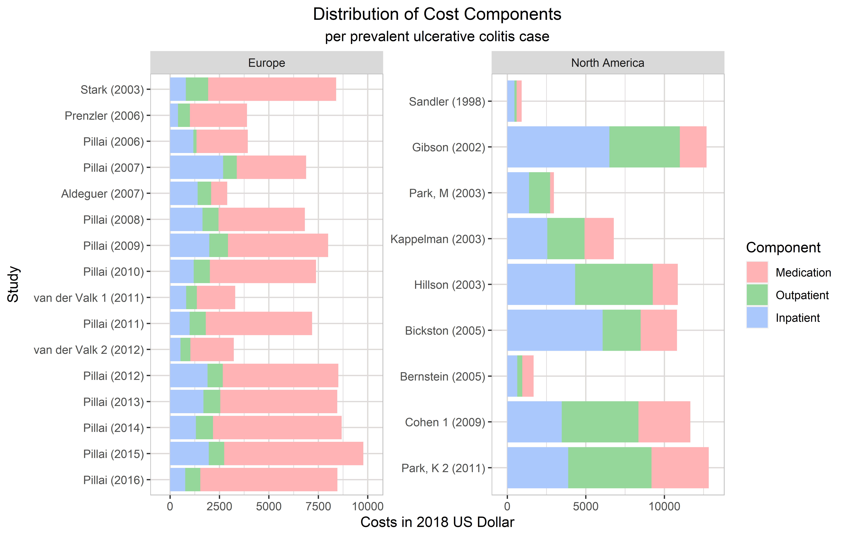
Supplemental Figure 3: Absolute distribution of cost components per prevalent ulcerative colitis case.

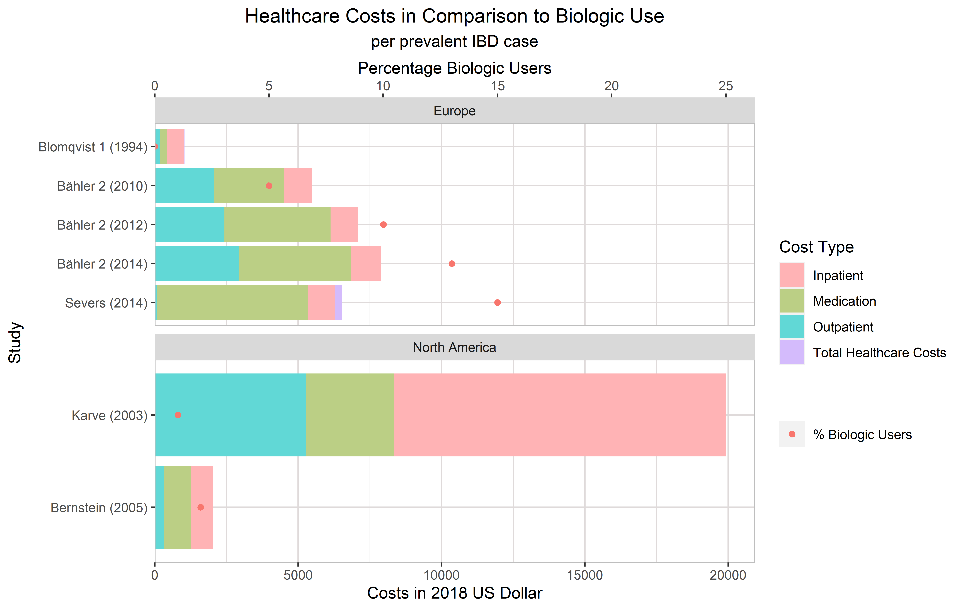
Supplemental Figure 4: Mean annual healthcare costs and percentage biologic use per prevalent IBD case in 2018 US Dollar

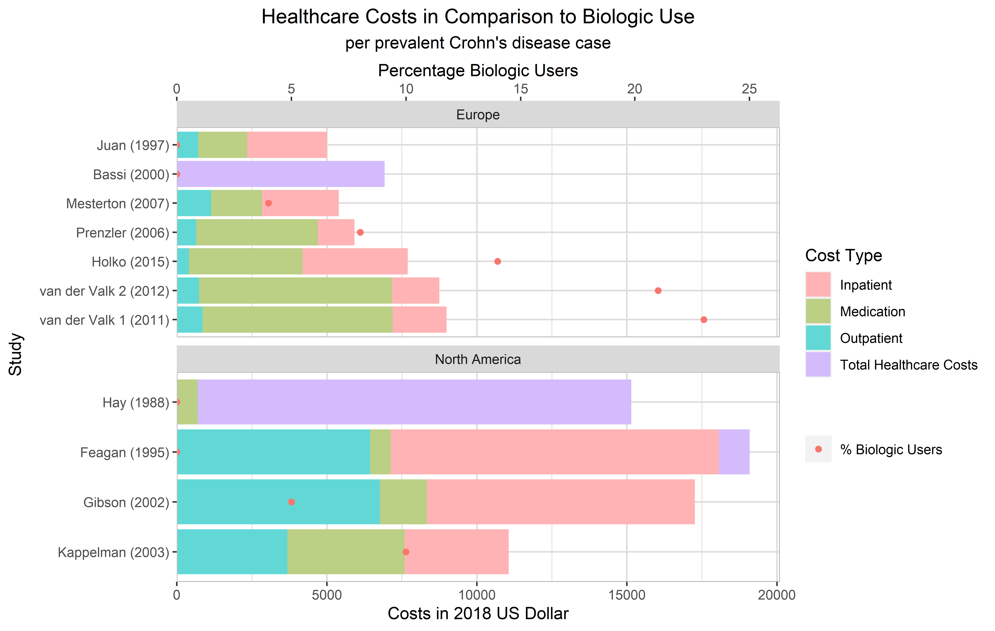 Supplemental Figure 5: Mean annual healthcare costs and percentage biologic use per prevalent Crohn’s disease case in 2018 US Dollar
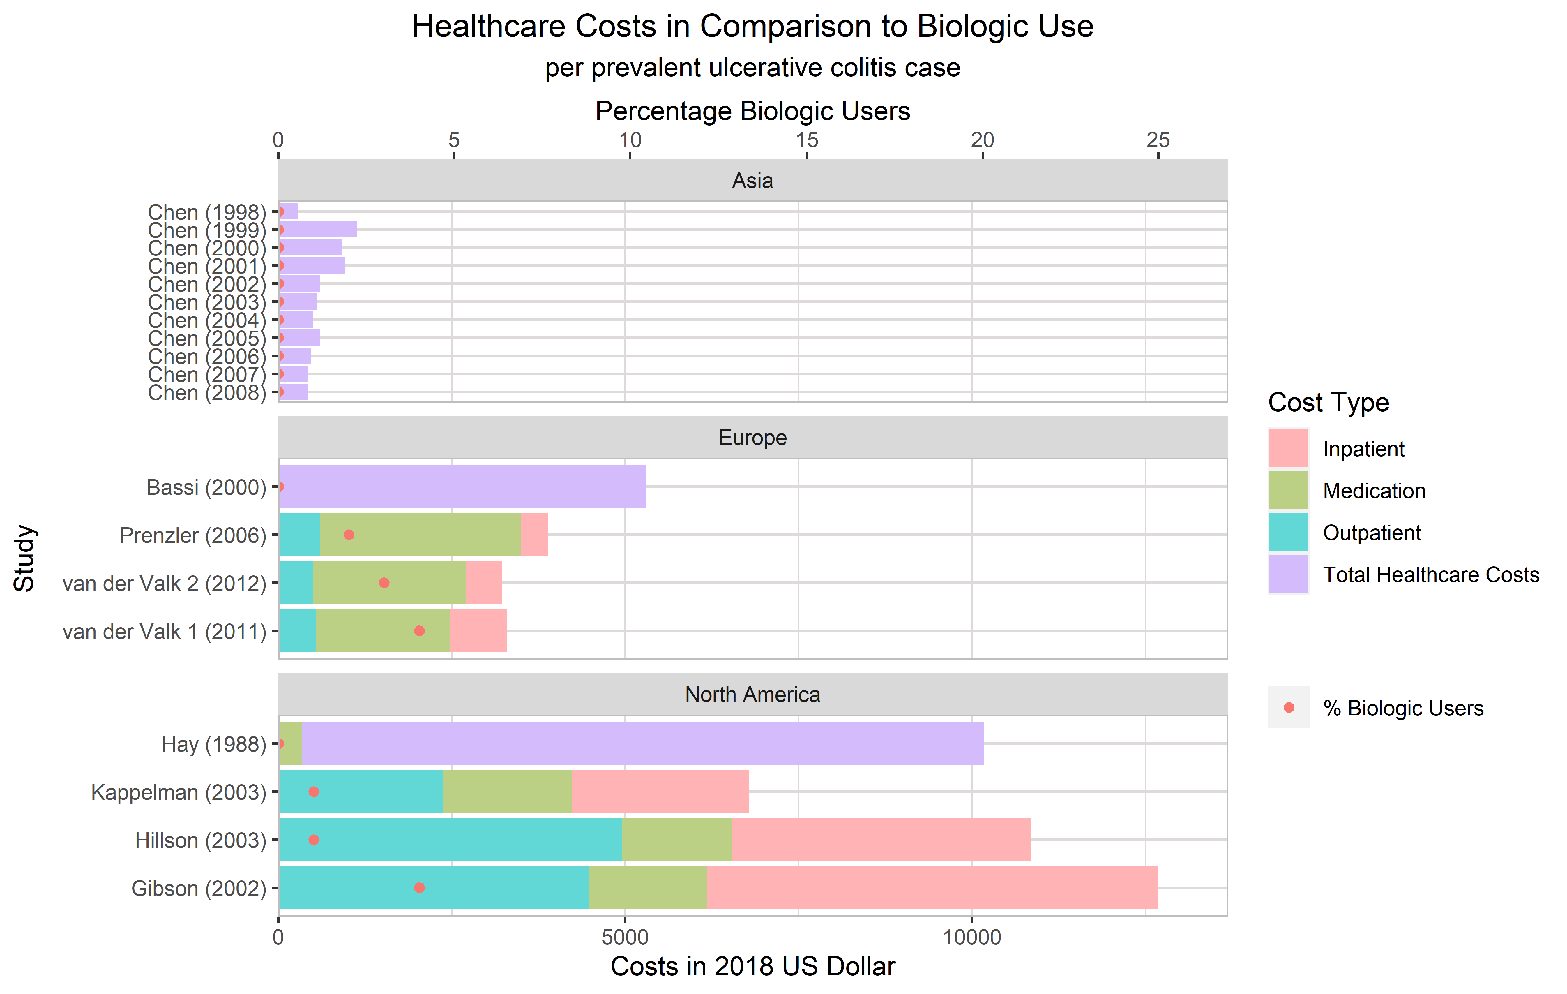
Supplemental Figure 6: Mean annual healthcare costs and percentage biologic use per prevalent ulcerative colitis case in 2018 US Dollar
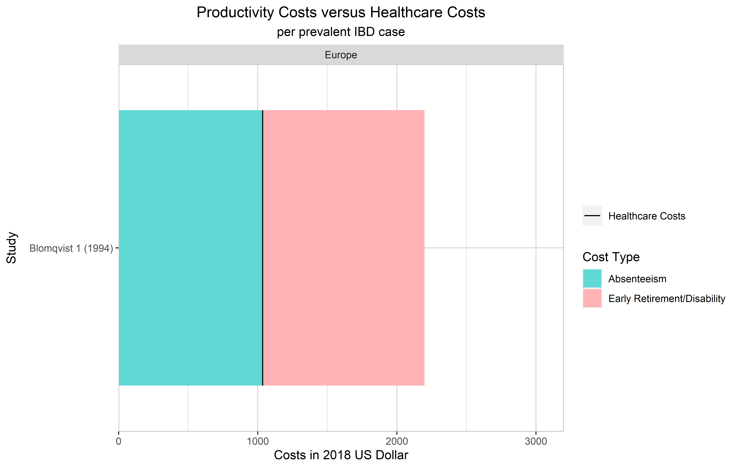
Supplemental Figure 7: Mean productivity costs compared to mean healthcare costs per prevalent IBD case in 2018 US Dollar
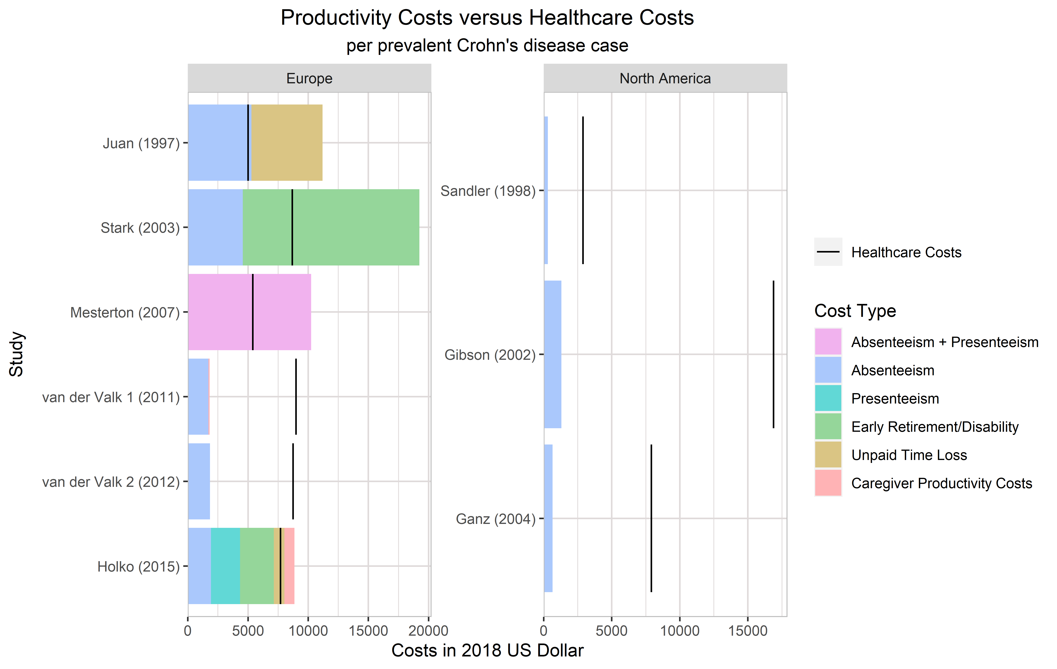
Supplemental Figure 8: Mean productivity costs compared to mean healthcare costs per prevalent Crohn’s disease case in 2018 US Dollar
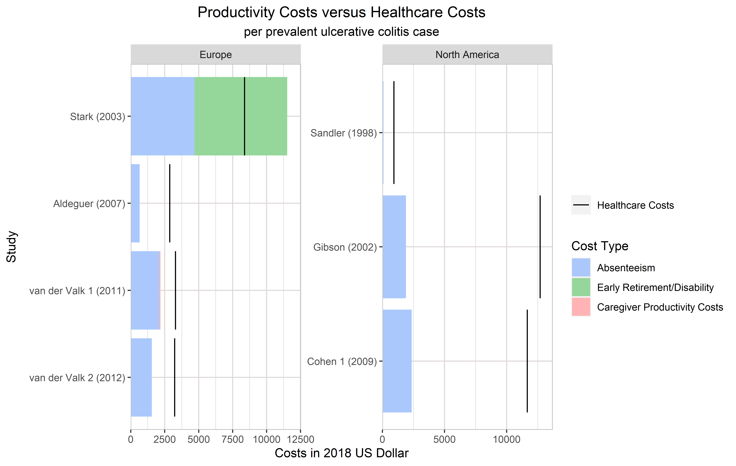
Supplemental Figure 9: Mean productivity costs compared to mean healthcare costs per prevalent ulcerative colitis case in 2018 US Dollar
REFERENCES
1. Aldeguer X, Sicras-Mainar A. Costs of ulcerative colitis from a societal perspective in a regional health care area in Spain: A database study. Gastroenterol Hepatol. 2016;39(1):9-19.
2. Bahler C, Schoepfer AM, Vavricka SR, Brungger B, Reich O. Chronic comorbidities associated with inflammatory bowel disease: prevalence and impact on healthcare costs in Switzerland. Eur J Gastroenterol Hepatol. 2017;29(8):916-925.
3. Bahler C, Vavricka SR, Schoepfer AM, Brungger B, Reich O. Trends in prevalence, mortality, health care utilization and health care costs of Swiss IBD patients: a claims data based study of the years 2010, 2012 and 2014. BMC Gastroenterol. 2017;17(1):138.
4. Balaii H, Olfatifar M, Narab SO, Hosseini AA, Salehi AS, Shahrokh S. Estimation the direct cost of inflammatory bowel disease in Iranian patients; the one-year follow-up. Gastroenterol Hepatol Bed Bench. 2019;12:S87-S93.
5. Bassi A, Dodd S, Williamson P, Bodger K. Cost of illness of inflammatory bowel disease in the UK: a single centre retrospective study. Gut. 2004;53(10):1471-1478.
6. Bernstein CN, Longobardi T, Finlayson G, Blanchard JF. Direct medical cost of managing IBD patients: a Canadian population-based study. Inflamm Bowel Dis. 2012;18(8):1498-1508.
7. Bickston SJ, Waters HC, Dabbous O, B T, Rahman MI. Administrative Claims Analysis of All-Cause Annual Costs of Care and Resource Utilization by Age Category for Ulcerative Colitis Patients. J Manag Care Pharm. 2008;14(4):352-362.
8. Blomqvist P, Ekbom A. Inflammatory bowel diseases: health care and costs in Sweden in 1994. Scand J Gastroenterol. 1997;32(11):1134-1139.
9. Blomqvist P, Feltelius N, Löfberg R, Ekbom A. A 10‐year survey of inflammatory bowel diseases—drug therapy, costs and adverse reactions. Aliment Pharmacol Ther. 2001;15(4):475-481.
10. Blumenstein I, Bock H, Weber C, et al. Health care and cost of medication for inflammatory bowel disease in the Rhein-Main region, Germany: a multicenter, prospective, internet-based study. Inflamm Bowel Dis. 2008;14(1):53-60.
11. Bounthavong M, Li M, Watanabe JH. An evaluation of health care expenditures in Crohn's disease using the United States Medical Expenditure Panel Survey from 2003 to 2013. Res Social Adm Pharm. 2017;13(3):530-538.
12. Burisch J, Vardi H, Pedersen N, et al. Costs and resource utilization for diagnosis and treatment during the initial year in a European inflammatory bowel disease inception cohort: an ECCO-EpiCom Study. Inflamm Bowel Dis. 2015;21(1):121-131.
13. Burisch J, Vardi H, Schwartz D, et al. Health-care costs of inflammatory bowel disease in a pan-European, community-based, inception cohort during 5 years of follow-up: a population-based study. Lancet Gastroenterol Hepatol. 2020;5(5):454-464.
14. Chen CY, Lee KT, Charles Tzu-Chi L, Lai WT, Huang YB. Epidemiology and Disease Burden of Ulcerative Colitis in Taiwan: A Nationwide Population-Based Study. Value Health Reg Issues. 2013;2(1):127-134.
15. Click B, Lopez R, Arrigain S, Schold J, Regueiro M, Rizk M. Shifting Cost-drivers of Health Care Expenditures in Inflammatory Bowel Disease. Inflamm Bowel Dis. 2019.
16. Cohen R, Skup M, Ozbay AB, et al. Direct and indirect healthcare resource utilization and costs associated with ulcerative colitis in a privately-insured employed population in the US. J Med Econ. 2015;18(6):447-456.
17. Cohen RD, Waters HC, Tang B, Rahman MI. Effects of fistula on healthcare costs and utilization for patients with Crohn's disease treated in a managed care environment. Inflamm Bowel Dis. 2008;14(12):1707-1714.
18. Colombara F, Martinato M, Girardin G, Gregori D. Higher levels of knowledge reduce health care costs in patients with inflammatory bowel disease. Inflamm Bowel Dis. 2015;21(3):615-622.
19. Dunn A, Whitmire B, Batch A, Fernando L, Rittmueller L. High Spending Growth Rates For Key Diseases In 2000-14 Were Driven By Technology And Demographic Factors. Health Aff (Millwood). 2018;37(6):915-924.
20. Ebinger M, Leidl R, Thomas S, et al. Cost of outpatient care in patients with inflammatory bowel disease in a German University Hospital. J Gastroenterol Hepatol. 2004;19(2):192-199.
21. Feagan BG, Vreeland MG, Larson LR, Bala MB. Annual cost of care for Crohn’s disease: a payor perspective. Am J Gastroenterol. 2000;95(8):1955-1960.
22. Ganz ML, Sugarman R, Wang R, Hansen BB, Hakan-Bloch J. The Economic and Health-related Impact of Crohn's Disease in the United States: Evidence from a Nationally Representative Survey. Inflamm Bowel Dis. 2016;22(5):1032-1041.
23. Gibson TB, Ng E, Ozminkowski RJ, et al. The direct and indirect cost burden of Crohn's disease and ulcerative colitis. J Occup Environ Med. 2008;50(11):1261-1272.
24. Gleason PP, Alexander GC, Starner CI, et al. Health Plan Utilization and Costs of Specialty Drugs Within 4 Chronic Conditions. J Manag Care Pharm. 2013;19(7):542-548.
25. Gunnarsson C, Chen J, Rizzo JA, Ladapo JA, Lofland JH. Direct health care insurer and out-of-pocket expenditures of inflammatory bowel disease: evidence from a US national survey. Dig Dis Sci. 2012;57(12):3080-3091.
26. Gunnarsson C, Chen J, Rizzo JA, Ladapo JA, Naim A, Lofland JH. The employee absenteeism costs of inflammatory bowel disease: evidence from US National Survey Data. J Occup Environ Med. 2013;55(4):393-401.
27. Hay JW, Hay AR. Inflammatory bowel disease: costs-of-illness. J Clin Gastroenterol. 1992;14(4):309-317.
28. Hillson E, Dybicz S, Waters HC, et al. Health care expenditures in ulcerative colitis: the perspective of a self-insured employer. J Occup Environ Med. 2008;50(8):969-977.
29. Holko P, Kawalec P, Mossakowska M, Pilc A. Health-Related Quality of Life Impairment and Indirect Cost of Crohn's Disease: A Self-Report Study in Poland. PLoS One. 2016;11(12):e0168586.
30. Jackson B, Con D, Ma R, Gorelik A, Liew D, De Cruz P. Health care costs associated with Australian tertiary inflammatory bowel disease care. Scand J Gastroenterol. 2017;52(8):851-856.
31. Juan J, Estiarte R, Colomé E, Artés M, Jiménez FJ, Alonso J. Burden of illness of Crohn’s disease in Spain. Dig Liver Dis. 2003;35(12):853-861.
32. Kappelman MD, Rifas-Shiman SL, Porter CQ, et al. Direct health care costs of Crohn's disease and ulcerative colitis in US children and adults. Gastroenterology. 2008;135(6):1907-1913.
33. Karve S, Candrilli S, Kappelman MD, Tolleson-Rinehart S, Tennis P, Andrews E. Healthcare utilization and comorbidity burden among children and young adults in the United States with systemic lupus erythematosus or inflammatory bowel disease. J Pediatr. 2012;161(4):662-670 e662.
34. Kawalec P, Stawowczyk E. Relationship between physician-based assessment of disease activity, quality of life, and costs of ulcerative colitis in Poland. Prz Gastroenterol. 2018;13(1):61-68.
35. Kawalec P, Stawowczyk E, Mossakowska M, Pilc A. Disease activity, quality of life, and indirect costs of ulcerative colitis in Poland. Prz Gastroenterol. 2017;12(1):60-65.
36. Kim JW, Lee CK, Lee JK, et al. Long-term evolution of direct healthcare costs for inflammatory bowel diseases: a population-based study (2006-2015). Scand J Gastroenterol. 2019;54(4):419-426.
37. Kim JW, Lee CK, Rhee SY, Oh CH, Shim JJ, Kim HJ. Trends in health-care costs and utilization for inflammatory bowel disease from 2010 to 2014 in Korea: A nationwide population-based study. J Gastroenterol Hepatol. 2018;33(4):847-854.
38. Kohn A, Fano V, Monterubbianesi R, et al. Surgical and nonsurgical hospitalization rates and charges for patients with ulcerative colitis in Italy: a 10-year cohort study. Dig Liver Dis. 2012;44(5):369-374.
39. Kostic M, Djakovic L, Sujic R, Godman B, Jankovic SM. Inflammatory Bowel Diseases (Crohn s Disease and Ulcerative Colitis): Cost of Treatment in Serbia and the Implications. Appl Health Econ Health Policy. 2017;15(1):85-93.
40. Le DV, Gupte R, Gabriel MH, Vaidya V. Inflammatory bowel disease: cost-driving factors and impact of cost sharing on outpatient resource utilization. J Pharm Health Serv Res. 2018;9(4):301-307.
41. Lee J, Im JP, Han K, et al. Changes in Direct Healthcare Costs before and after the Diagnosis of Inflammatory Bowel Disease: A Nationwide Population-Based Study. Gut Liver. 2020;14(1):89-99.
42. Lo B, Vind I, Vester-Andersen MK, Bendtsen F, Burisch J. Direct and Indirect Costs of Inflammatory Bowel Disease: Ten Years of Follow-up in a Danish Population-based Inception Cohort. J Crohns Colitis. 2020;14(1):53-63.
43. Longobardi, T. Work losses related to inflammatory bowel disease in Canada: results from a national population health survey. Am J Gastroenterol. 2003;98(4):844-849.
44. Mak LY, Ng SC, Wong IOL, et al. Direct health-care cost utilization in Hong Kong inflammatory bowel disease patients in the initial 2 years following diagnosis. J Gastroenterol Hepatol. 2018;33(1):141-149.
45. Mesterton J, Jonsson L, Almer SH, Befrits R, Friis-Liby I, Lindgren S. Resource use and societal costs for Crohn's disease in Sweden. Inflamm Bowel Dis. 2009;15(12):1882-1890.
46. Michael MD, Balint A, Lovasz BD, et al. Work disability and productivity loss in patients with inflammatory bowel diseases in Hungary in the era of biologics. Eur J Health Econ. 2014;15 Suppl 1:S121-128.
47. Niewiadomski O, Studd C, Hair C, et al. Health Care Cost Analysis in a Population-based Inception Cohort of Inflammatory Bowel Disease Patients in the First Year of Diagnosis. J Crohns Colitis. 2015;9(11):988-996.
48. Odes S, Vardi H, Friger M, et al. Cost analysis and cost determinants in a European inflammatory bowel disease inception cohort with 10 years of follow-up evaluation. Gastroenterology. 2006;131(3):719-728.
49. Park KT, Colletti RB, Rubin DT, Sharma BK, Thompson A, Krueger A. Health Insurance Paid Costs and Drivers of Costs for Patients With Crohn's Disease in the United States. Am J Gastroenterol. 2016;111(1):15-23.
50. Park KT, Ehrlich OG, Allen JI, et al. The Cost of Inflammatory Bowel Disease: An Initiative From the Crohn's & Colitis Foundation. Inflamm Bowel Dis. 2020;26(1):1-10.
51. Park MD, Bhattacharya J, Park K. Differences in healthcare expenditures for inflammatory bowel disease by insurance status, income, and clinical care setting. PeerJ. 2014;2:e587.
52. Pillai N, Dusheiko M, Maillard MH, et al. The Evolution of Health Care Utilisation and Costs for Inflammatory Bowel Disease Over Ten Years. J Crohns Colitis. 2019;13(6):744-754.
53. Pilon D, Ding Z, Muser E, et al. Long-term direct and indirect costs of ulcerative colitis in a privately-insured United States population. Curr Med Res Opin. 2020:1.
54. Pinchbeck BR, Kirdeikis J, Thomson ABR. Economic impact of inflammatory bowel disease in Alberta. J Gastroenterol Hepatol. 1988;2(2):53-56.
55. Prenzler A, Bokemeyer B, von der Schulenburg JM, Mittendorf T. Health care costs and their predictors of inflammatory bowel diseases in Germany. Eur J Health Econ. 2011;12(3):273-283.
56. Sandler RS, Everhart JE, Donowitz M, et al. The burden of selected digestive diseases in the United States. Gastroenterology. 2002;122(5):1500-1511.
57. Severs M, Petersen RE, Siersema PD, Mangen MJ, Oldenburg B. Self-reported Health Care Utilization of Patients with Inflammatory Bowel Disease Correlates Perfectly with Medical Records. Inflamm Bowel Dis. 2016;22(3):688-693.
58. Stark R, König HH, Leidl R. Costs of inflammatory bowel disease in Germany. Pharmacoeconomics. 2006;24(8):797-814.
59. Vadstrup K, Alulis S, Borsi A, et al. Societal costs attributable to Crohn’s disease and ulcerative colitis within the first 5 years after diagnosis: a Danish nationwide cost-of-illness study 2002–2016. Scand J Gastroenterol. 2020;55(1):41-46.
60. van der Valk ME, Mangen M-JJ, Leenders M, et al. Healthcare costs of inflammatory bowel disease have shifted from hospitalisation and surgery towards anti-TNFα therapy: results from the COIN study. Gut. 2014;63(1):72-79.
61. van der Valk ME, Mangen M-JJ, Severs M, et al. Evolution of Costs of Inflammatory Bowel Disease over Two Years of Follow-Up. PLoS One. 2016;11(4):e0142481.
62. van Gennep S, Evers SW, Rietdijk ST, et al. High Disease Burden Drives Indirect Costs in Employed Inflammatory Bowel Disease Patients: The WORK-IBD Study. Inflamm Bowel Dis. 2020.
63. Yamabe K, Liebert R, Flores N, Pashos CL. Health-related quality of life outcomes and economic burden of inflammatory bowel disease in Japan. Clinicoecon Outcomes Res. 2019;11:221-232.
64. Zand A, van Deen WK, Inserra EK, et al. Presenteeism in Inflammatory Bowel Diseases: A Hidden Problem with Significant Economic Impact. Inflamm Bowel Dis. 2015;21(7):1623-1630.

