Supplementary Material
Supplementary Table 1 Quality Assessment Tools used for all reviewed papers on the hospitalisation theme: CASP checklist
CASP tool criteria | Brixner et al. (2016) |  | Epstein et al. (2010) | Perlis et al. (2018)
Observational studies
Are the results of the study valid? (Relates to validity)
- Did the study address a clearly focused issue? (Cohort or Case-control study) | ü |  | ü | ü
- Was the cohort recruited in an acceptable way? (Cohort study) OR  Did the authors use an appropriate method to answer their question? (Case control study) | ü |  | ü | ü
- Was the exposure accurately measured to minimise bias? (Cohort study)  OR  Were the cases recruited in an acceptable way? (Case control study) | ü |  | ü | ü
- Was the outcome accurately measured to minimise bias? (Cohort study)  OR  Were the controls selected in an acceptable way? (Case control study) | ü |  | ü | ü
- A. Have the authors identified all important confounding factors?  B. Have they taken account of the confounding factors in the design and/or analysis? (Cohort study)  OR  Was the exposure accurately measured to minimise bias? (Case control study) | Χ  ü |  | Χ  ü | ü
- A. Was the follow up of subjects complete enough?  B. Was the follow up of subjects long enough? (Cohort study)  OR  - Aside from the experimental intervention, were the groups treated equally? (Case control study)  - Have the authors taken account of the potential confounding factors in the design and/or in their analysis? (Case control study) | ü  Χ |  | ü  ü | ü  ü
What are the results? (Relates to trustworthiness of results)
- What are the results of this study? (Cohort study) OR  How large was the treatment effect? (Case control study) | See figure 5 and table 3 |  | See figure 5 and table 3 | See figure 5 and table 3
- How precise are the results? (Cohort study)  OR  How precise was the estimate of the treatment effect? (Case control study) | Confidence intervals are p<0.05 |  | Confidence intervals are p<0.05 | Confidence intervals are p<0.05
- Do you believe the results? (Both study types) | ü |  | ü | ü
Randomised Controlled Studies |  | Elliott et al. (2017) |  |  | Ruaño et al. (2020)
Is the basic study design valid for a randomised controlled trial?
- Did the study address a clearly focused research question? |  | ü |  |  | ü
- Was the assignment of participants to interventions randomised? |  | ü |  |  | ü
- Were all participants who entered the study accounted for its conclusions? |  | ü |  |  | ü
Was the study methodologically sound?
- -Were the participants ‘blind’ to intervention they were given?  -Were the investigators ‘blind’ to the intervention they were giving to participants?  -Were the people assessing/analysing outcome/s ‘blinded’? |  | Χ  Χ  Χ |  |  | ü  Χ  Χ
- Were the study groups similar at the start of the randomised controlled trial? |  | ü |  |  | ü
- Apart from the experimental intervention, did each study group receive the same level of care (that is, were they treated equally)? |  | ü |  |  | ü
What are the results? (Relates to trustworthiness of results)
- Were the effects of the intervention reported comprehensively? |  | ü |  |  | Χ
- Was the precision of the estimate of the intervention or treatment effect reported? |  | ü |  |  | Χ
- Do the benefits of the experimental intervention outweigh the harms and costs? |  | ü |  |  | -

Supplementary Table 2 Quality Assessment Tools used for all reviewed papers on the medication change theme
CASP tool criteria | Brixner et al. (2016) | Hall-Flavin et al. (2013), US
Observational cohort study
Are the results of the study valid? (Relates to validity)
- Did the study address a clearly focused issue? | ü | ü
- Was the cohort recruited in an acceptable way? | ü | ü
- Was the exposure accurately measured to minimise bias? | ü | ü
- Was the outcome accurately measured to minimise bias? | ü | ü
- A. Have the authors identified all important confounding factors?  B. Have they taken account of the confounding factors in the design and/or analysis? | Χ  ü | Χ  ü
- A. Was the follow up of subjects complete enough?  B. Was the follow up of subjects long enough? | ü  Χ | ü  ü
What are the results? (Relates to trustworthiness of results)
- What are the results of this study? | See figure 4 | See figure 4
- How precise are the results? | Confidence intervals are p<0.05 | Confidence intervals are p<0.0001
- Do you believe the results? | ü | ü
Randomised Controlled Studies |  |  | Thase et al. (2019), US | Tuteja et al. (2020), US | Winner et al. (2013), US
Is the basic study design valid for a randomised controlled trial?
- Did the study address a clearly focused research question? |  |  | ü | ü | ü
- Was the assignment of participants to interventions randomised? |  |  | ü | ü | ü
- Were all participants who entered the study accounted for its conclusions? |  |  | ü | ü | ü
Was the study methodologically sound?
-Were the participants ‘blind’ to intervention they were given?  -Were the investigators ‘blind’ to the intervention they were giving to participants?  -Were the people assessing/analysing outcome/s ‘blinded’? |  |  | ü  ü  ü | Χ  Χ  Χ | ü  Χ  ü
- Were the study groups similar at the start of the randomised controlled trial? |  |  | ü | ü | ü
- Apart from the experimental intervention, did each study group receive the same level of care (that is, were they treated equally)? |  |  | ü | ü | ü
What are the results? (Relates to trustworthiness of results)
- Were the effects of the intervention reported comprehensively? |  |  | ü | ü | ü
- Was the precision of the estimate of the intervention or treatment effect reported? |  |  | ü | ü | ü
- Do the benefits of the experimental intervention outweigh the harms and costs? |  |  | ü | ü | ü

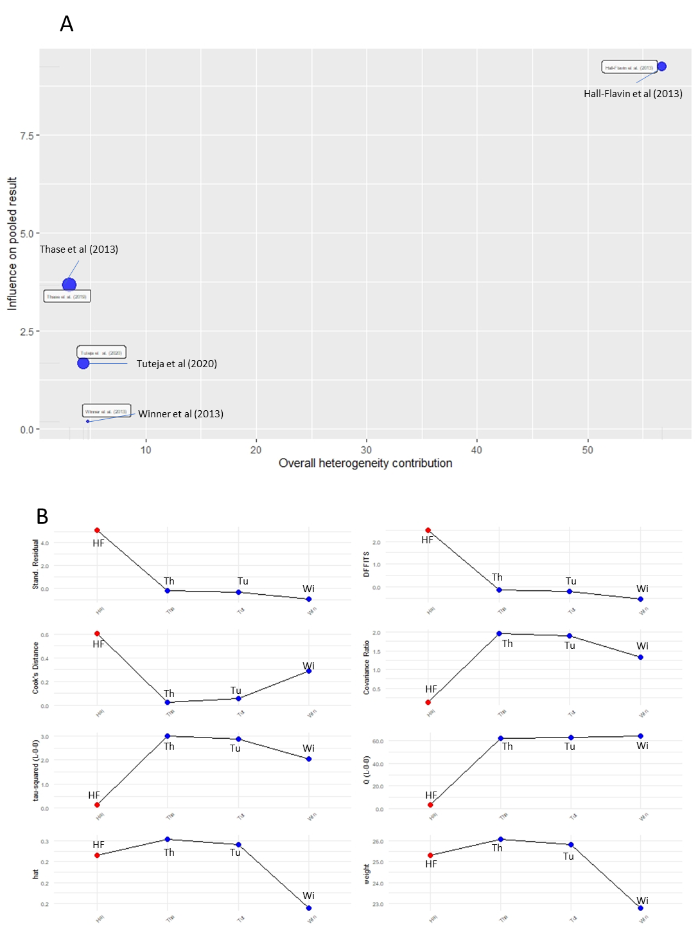
Supplementary figure 1: Medication changes (a) Baujat plot (b) Influence analyses. Included studies and their abbreviations: HF is Hall-Flavin et al.(2013), Th is Thase et al.(2019), Tu is Tuteja et al.(2020) and Wi is Winner et al. (2013).

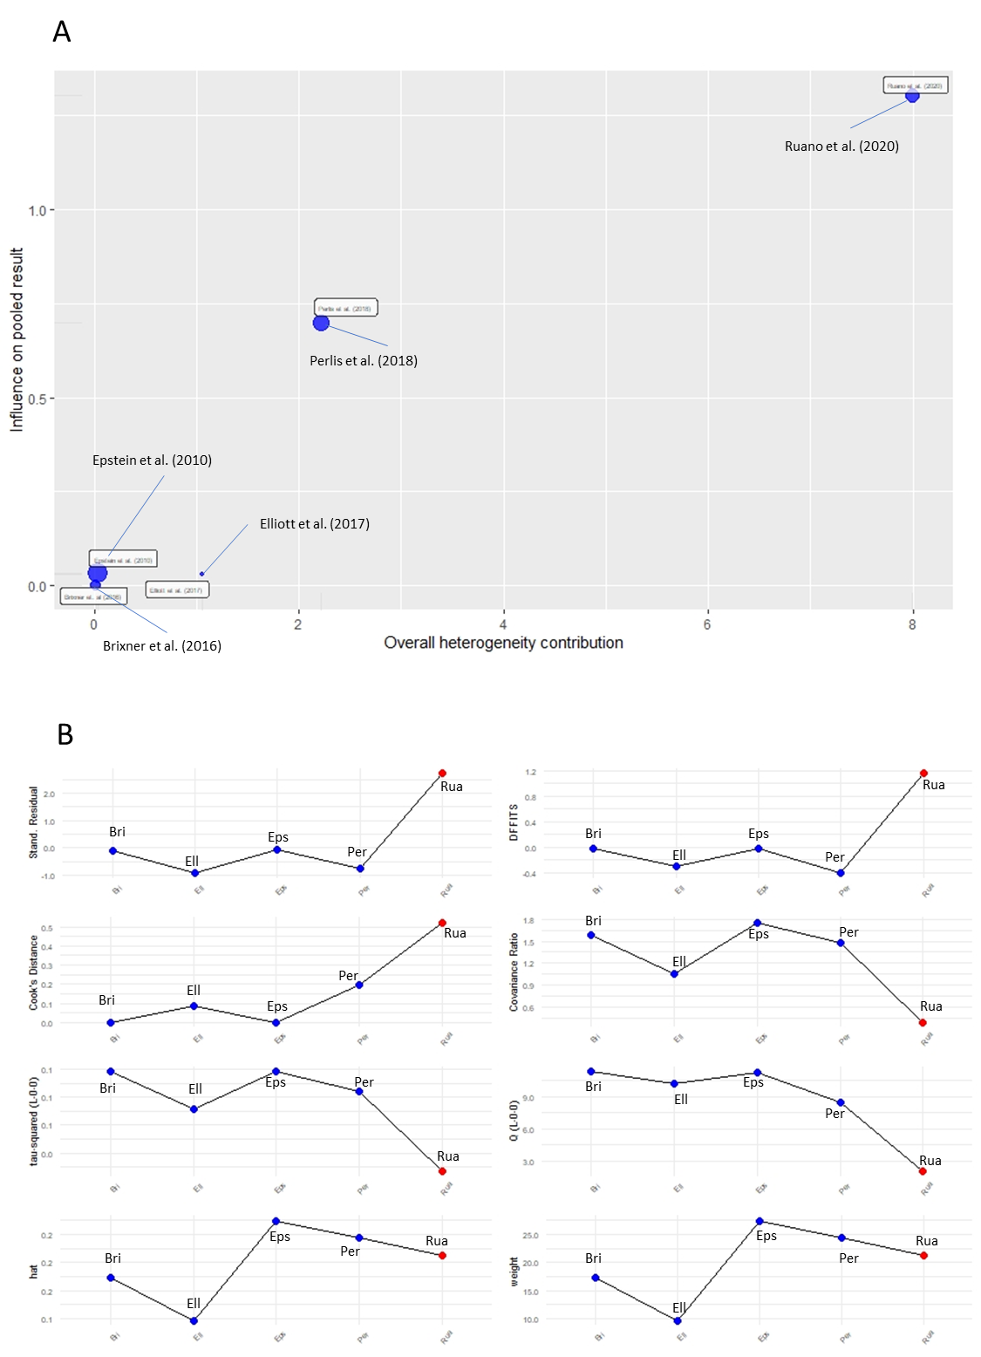
Supplementary Figure 2: Hospitalisation (A) Baujat plot (B) Influence analyses. Included studies and their abbreviations: Bri is Brixner et al. (2016), Ell is Elliott et al. (2017), Eps is Epstein et al.(2010), Per is Perlis et al.(2018) and Rua is Ruano et al.(2020)

