Supplementary file 1: Search protocol, sensitivity test, publication bias test, subgroup analysis and meta-regression.
Appendix 1. Search strategies
Appendix 2. The quality assessment outcomes
Appendix 3. Sensitivity assessment
Appendix 4. Egger’s test and funnel plots (inspection of publication bias)
Appendix 5. Results of meta-regression for ESWT vs. comparatives for pain intensity at 1 month follow-up

Overview online Tables
- Table A. Search strategy and results of literature search.
- Table B Quality assessment of included studies by CBN group risk of bias tool and Jadad score.
- Table C. Quality of evidence assessment by GRADE of the included studies
- Table D. Table of meta-regression results of the variables of pain intensity of 1 month follow-up
- Figure A. Sensitivity analysis: Forrest plots of pain intensity at 1 month follow-up after removing unpublished trials
- Figure B. Publication bias analysis: Egger’s test and funnel plots of pain intensity at 1 month follow-up

Appendix 1. Search strategy and results of literature search
ENGLISH DATABASE
PubMed 67
(SWT[All Fields] OR "shock wave"[All Fields] OR "shock waves"[All Fields] OR "extracorporeal shock wave"[All Fields] OR "shock wave therapy"[All Fields] OR "shockwave"[All Fields] OR "High-Energy Shock Waves"[Mesh] OR "Extracorporeal Shockwave Therapy"[Mesh]) AND ("back disorder"[All Fields] OR "back pain"[All Fields] OR "back ache"[All Fields] OR "backache"[All Fields] OR "lumbar injury"[All Fields] OR "lumbar pain"[All Fields] OR "lumbar ache"[All Fields] OR "lumbar injury"[All Fields] OR "lumbar facet joint pain"[All Fields] OR "lumbar myofascial pain"[All Fields] OR "lumbago"[All Fields] OR "lumbar spondylosis"[All Fields] OR "back pain"[MeSH Terms] OR "spondylosis"[MeSH Terms])
Scopus 144
TITLE-ABS-KEY ( swt OR esw* OR shockwave OR "shock wave" OR "extracorporeal shock wave" OR "shock wave therapy" ) AND TITLE-ABS-KEY ( "back pain" OR backache OR "lumbar pain" OR "lumbar injury" OR "lumbar facet joint pain" OR "lumbar spondylosis" OR "lumbago" OR "back disorder")
Embase 86
(esw*:ab,ti OR swt:ab,ti OR shockwave:ab,ti OR 'shock wave':ab,ti OR 'extracorporeal shock wave':ab,ti OR 'shock wave therapy':ab,ti) AND ('back pain':ab,ti OR backache:ab,ti OR 'lumbar pain':ab,ti OR 'lumbar injury':ab,ti OR 'lumbar facet joint pain':ab,ti OR 'lumbar spondylosis':ab,ti OR 'lumbago':ab,ti OR 'back disorder':ab,ti)
Web of science 131
TS=(swt OR esw* OR shockwave OR “shock wave” OR “extracorporeal shock wave” OR “shock wave therapy”) AND TS=(“back pain” OR backache OR “lumbar pain” OR “lumbar injury” OR “lumbar facet joint pain” OR “lumbar spondylosis” OR “lumbago” OR “back disorder”)
CINAHL: 16
S1: TI (swt OR esw* OR shockwave OR “shock wave” OR “extracorporeal shock wave” OR “shock wave therapy”) OR AB ( swt OR esw* OR shockwave OR “shock wave” OR “extracorporeal shock wave” OR “shock wave therapy” )
S2: TI (“back pain” OR backache OR “lumbar pain” OR “lumbar injury” OR “lumbar facet joint pain” OR “lumbago” OR “spondylosis”) OR AB ( “back pain” OR backache OR “lumbar pain” OR “lumbar injury” OR “lumbar facet joint pain” OR “lumbago” OR “spondylosis”)
S1 AND S2
The Cochrane Library 43
#1 MeSH descriptor: [Spondylosis] explode all trees
#2 MeSH descriptor: [Back Pain] explode all trees
#3 (“back pain” OR backache OR “lumbar pain” OR “lumbar injury” OR “lumbar facet joint pain” OR spondylosis OR lumbago OR “back disorder”):ti,ab,kw (Word variations have been searched)
#4 MeSH descriptor: [Extracorporeal Shockwave Therapy] explode all trees
#5 MeSH descriptor: [High-Energy Shock Waves] explode all trees
#6 (swt OR esw* OR shockwave OR “shock wave” OR “extracorporeal shock wave” OR “shock wave therapy”):ti,ab,kw (Word variations have been searched)
#7 (#1 OR #2 OR #3) AND (#4 OR #5 OR #6)
PEDro 14
Abstract & Title: shock*
Body part: lumbar spine, sacro-illiac joint or pelvis
Match any search term (AND)
ENGLISH DATABASE
CNKI (China National Knowledge Infrastructure, China) -57
Subject: shock wave AND Subject: back pain
J-stage (Japan)-5
Abstract: back pain AND
Abstract: shockwave or shock wave

RISS(Research information sharing service, Korean) -16
Basic search: shock wave back pain
TRIAL REGISTERIES
WHO-ICTRP-11
Basic search: shock wave AND back pain

Clinical trials (USA) 5
Status: All studies
Condition or disease: back pain
Other terms: shock wave
GREY LITERATURE
Google Scholar 22
allintitle: "back pain" "shock wave"
Research square: 21
Abstract: back pain
Title: (shock wave) or shockwave

Table A. Results of literature search.
Data source | Results
English database
Pubmed | 67
Embase | 86
Web of science | 131
Scopus | 144
CINAHL (EBSCO) | 16
The Cochrane Library | 43
PEDro | 14
Non-English database
CNKI (China) | 57
J-Stage (Japan) | 5
RISS (South Korean) | 16
Website search
Google Scholar | 22
Research square (preprint) | 21
Trial registry search
WHO-ICTRP | 11
Clinical trials | 5
IN TOTAL | 638

Appendix 2. The quality assessment outcomes
Table B Quality assessment of included studies by CBN group risk of bias tool and Jadad score.
Assessment tool | Domain | Author year  Questions | Ahmed et al 2018 | Çelik et al 2020 | Eftekharsadat et al 2020 | Elgendy et al 2020 | Guo et al 2020 | Kang et al 2015 | Schneider et al 2018 | Taheri et al 2021 | Walewicz et al 2019 | Zheng et al 2013
Cochrane Sources of Risk of Bias  (Yes/No/Unsure) | Selection | Was the method of randomization adequate? | Unsure | Yes | Yes | Yes | Yes | Unsure | Yes | Yes | Yes | Yes
Cochrane Sources of Risk of Bias  (Yes/No/Unsure) | Selection | Was the treatment allocation concealed? | Unsure | Unsure | Yes | Unsure | Yes | Unsure | No | Yes | Yes | Yes
Cochrane Sources of Risk of Bias  (Yes/No/Unsure) | Performance | Was the patient blinded to the intervention? | No | Yes | No | No | No | No | No | No | Yes | No
Cochrane Sources of Risk of Bias  (Yes/No/Unsure) | Performance | Was the care provider blinded to the intervention? | No | Yes | No | No | No | No | No | No | No | No
Cochrane Sources of Risk of Bias  (Yes/No/Unsure) | Detection | Was the outcome assessor blinded to the intervention? | Unsure | Yes | Yes | Unsure | Yes | Unsure | Unsure | Unsure | Yes | Unsure
Cochrane Sources of Risk of Bias  (Yes/No/Unsure) | Attrition | Was the drop-out rate described and acceptable? | Unsure | Yes | Yes | Unsure | Yes | Unsure | Yes | Yes | Yes | Yes
Cochrane Sources of Risk of Bias  (Yes/No/Unsure) | Attrition | Were all randomized participants analyzed in the group to which they were allocated? | Yes | Yes | Yes | Yes | Yes | Unsure | Yes | Yes | Yes | Yes
Cochrane Sources of Risk of Bias  (Yes/No/Unsure) | Reporting | Are reports of the study free of suggestion of selective outcome reporting? | Unsure | Yes | Unsure | Yes | Unsure | Unsure | Unsure | Unsure | Yes | Unsure
Cochrane Sources of Risk of Bias  (Yes/No/Unsure) | Selection | Were the groups similar at baseline regarding the most important prognostic indicators? | Yes | Yes | Yes | Yes | Yes | Yes | Unsure | Yes | Yes | Yes
Cochrane Sources of Risk of Bias  (Yes/No/Unsure) | Performance | Were cointerventions avoided or similar? | Yes | Yes | Yes | Yes | Yes | Yes | Yes | Yes | Yes | Yes
Cochrane Sources of Risk of Bias  (Yes/No/Unsure) | Performance | Was the compliance acceptable in all groups? | Unsure | Yes | Yes | Unsure | Yes | Unsure | Unsure | Yes | Yes | Unsure
Cochrane Sources of Risk of Bias  (Yes/No/Unsure) | Detection | Was the timing of the outcome assessment similar in all groups? | Yes | Yes | Yes | Yes | Yes | Yes | Yes | Yes | Yes | Yes
Cochrane Sources of Risk of Bias  (Yes/No/Unsure) | Other | Are other sources of potential bias unlikely? | Unsure | Yes | Yes | Unsure | Unsure | Unsure | No | Yes | Yes | Unsure
Jaded scale for reporting randomized controlled trials.  (Numeric Scale) | Randomization | If randomization is mentioned/appropriate? | 1 | 2 | 2 | 2 | 2 | 1 | 2 | 2 | 2 | 2
 | Blinding | If blinding is mentioned/appropriate? | 0 | 2 | 1 | 0 | 2 | 0 | 0 | 1 | 2 | 0
 | An account of all patients | If the fate of all patients in the trial is known or the reason of no data the is stated. | 0 | 1 | 1 | 1 | 1 | 0 | 1 | 1 | 1 | 1
 | In total |  | 1 | 5 | 4 | 3 | 5 | 1 | 3 | 4 | 5 | 3

Table C. Quality of evidence assessment by GRADE of the included studies
 |  | GRADE Quality assessment |  |  |  |  |  |  | Quality
No of studies | Design |  | Risk of bias | Inconsistency | Indirectness | Imprecision | Publication Bias | Other considerations
Pain at 1month (pain scales)
10 | RCTs |  | Serious¹ | Serious² | None | None³ | Undetected⁴ | None | ⊕⊕◯◯  LOW
Pain at 3month (pain scales)
4 | RCTs |  | Serious⁵ | Serious⁶ | None | Very serious⁷ | Undetected⁸ | None | ⊕◯◯◯  VERY LOW
Disability at 1month (ODI)
5 | RCTs |  | Serious⁹ | Serious¹⁰ | None | Serious¹¹ | Undetected¹² | None | ⊕◯◯◯  VERY LOW
Disability at 3month (ODI)
3 | RCTs |  | None¹³ | None¹⁴ | None | Serious¹⁵ | Undetected¹⁶ | None | ⊕⊕⊕◯  MODERATE

Footnotes
¹ Ten studies were included. One study did not have a clear description of drop-outs (attrition bias). Six study did not have a clear description of concealment of allocation (selection bias). Eight studies did not have clear description of patient blinding, 9 studies had problems with blinding of provider (performance bias) and 6 studies did not have a clear description of blinding of outcome assessor (measurement bias). One study was industry-sponsored (other bias). Means Jadad score is 3.4. Serious risk of bias.
2 Heterogeneity: I² = 74%, substantial heterogeneity; Tau² =0.2696 (P < 0.01)
3 Total number of participants is sufficient (n = 455). The 95% CI did not include the no effect line.
4 Publication bias was not found by funnel plot and Egger’ test.
5 Four studies were included. No studies had serious problems with drop-outs (attrition bias). One study did not have a clear description of concealment of allocation (selection bias). Two studies did not have clear description of patient blinding, 3 studies had problems with blinding of provider (performance bias) and 1 study did not have a clear description of blinding of outcome assessor (measurement bias). Means Jadad score is 4.75. Serious risk of bias.
6 Heterogeneity: I² = 74%, substantial heterogeneity; Tau² =0.2252 (P < 0.01)
7 Total number of participants is insufficient (n = 205). The 95% CI included the no effect line.
8 Publication bias undetected.
9 Five studies were included. One study did not have a clear description of drop-outs (attrition bias). Two study did not have a clear description of concealment of allocation (selection bias). Three studies did not have clear description of patient blinding, 4 studies had problems with blinding of provider (performance bias) and 2 studies did not have a clear description of blinding of outcome assessor (measurement bias). Means Jadad score is 3.8. Serious risk of bias.
10 Heterogeneity: I² = 93%, considerable heterogeneity; Tau² =1.8277 (P < 0.01)
11 Total number of participants is insufficient (n = 211). The 95% CI did not include the no effect line.
12 Publication bias undetected.
13 Three studies were included. No studies had serious problems with drop-outs (attrition bias). One study did not have a clear description of concealment of allocation (selection bias). One studies did not have a clear description of patient blinding, 2 studies had problems with blinding of provider (performance bias) and 1 studies did not have a clear description of blinding of outcome assessor (measurement bias). No other issues were noticed besides the blinding and consealment. Means Jadad score is 4.67. Negligible risk of bias.
14 Heterogeneity: I² = 0%, low heterogeneity; Tau² =0 (P =0.37)
15 Total number of participants is insufficient (n = 114). The 95% CI did not include the no effect line.
16 Publication bias undetected.

Appendix 3. Sensitivity assessment
Figure A. Forrest plots of pain intensity at 1 month follow-up after removing unpublished trials
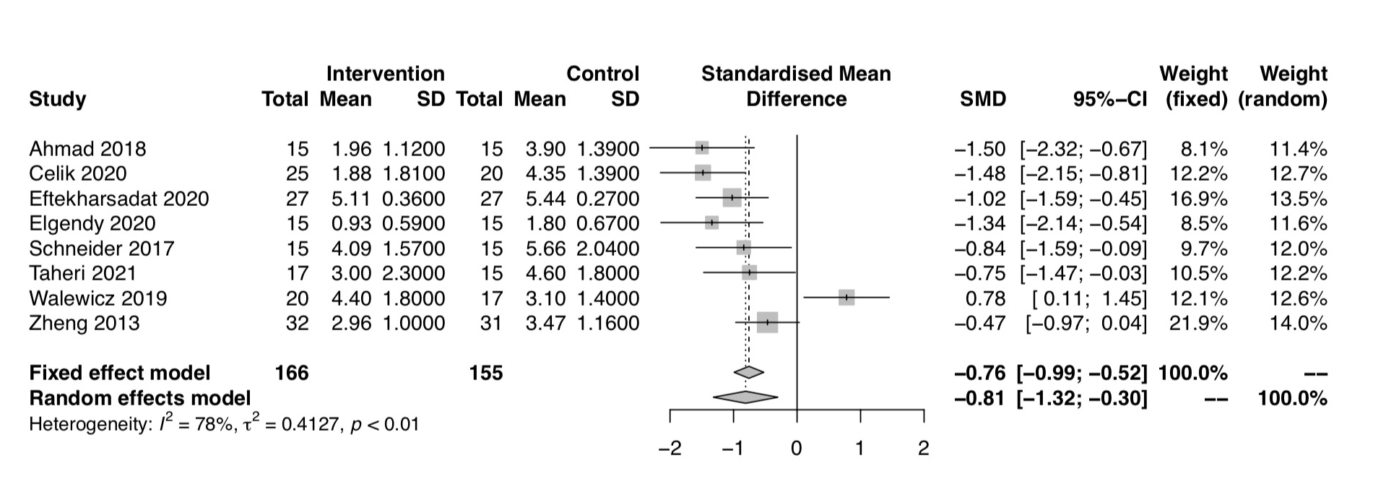

Appendix 4. Egger’s test and funnel plots (inspection of publication bias)
Figure B. Egger’s test and funnel plots of pain intensity at 1 month follow-up
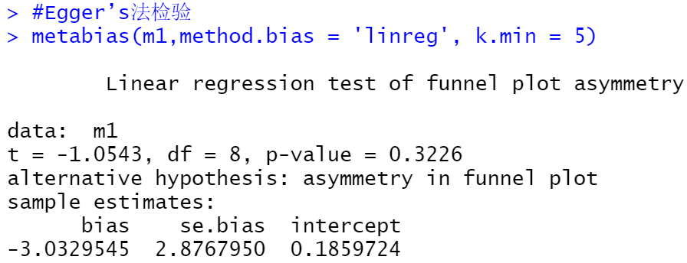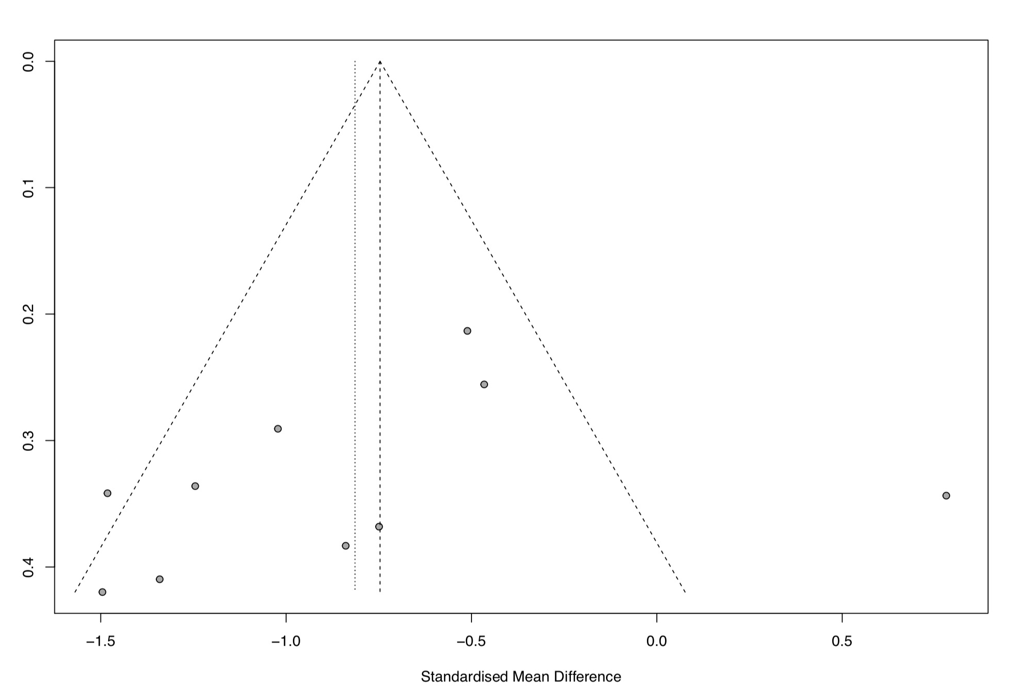
Footnote: Egger’s test (p=0.3226) and funnel plot did not show publication bias (R software package meta).

Appendix 5. Results of meta-regression for ESWT vs. comparatives for pain intensity at 1 month follow-up
Table D. Table of meta-regression results of the variables of pain intensity of 1 month follow-up
VAS at 1 month |  |  | Initial model I² = 74%
Variable(s) | N = 9 | B (95% CI) | P-value | I² = 67% | R² = 27%
Age |  | 0.768 (-0.056 to 1.592) | 0.068
Baseline VAS |  | -0.804 (-1.653 to 0.046) | 0.064
Female ratio |  | 0.232 (-0.617 to 1.080) | 0.593
Footnote: No significant variable was seen to contribute to the heterogeneity of estimated effects of pain intensity of 1 month follow-up.

