Supplementary File
Additional Supporting Information may be found in the online version of this article at the publisher’s website.
SUPPLEMENTARY APPENDIX
Appendix S1. Search strategy.
Table S1. Quality assessment of cohort and case-control studies using the Newcastle-Ottawa scale
Table S2. Sensitivity analysis using the jackknife approach
Table S3. Egger’s test and Begger’s test for publication bias.
Table S4. The summary of other risk factors in included studies.
Figure S1. PRISMA flow diagram of study selection for systematic review and meta-analysis. PRISMA: Preferred Reporting Items for Systematic Reviews and Meta-Analyses.
Figure S2. Sensitivity analysis exclusively including the studies that reported incidence of de novo psoriasis/psoriasiform lesion.
Figure S3. Forest plots of incidence of psoriasiform lesions and/or psoriasis associated with anti-TNF therapy in female IBD patients
Figure S4. Forest plots of incidence of psoriasiform lesions and/or psoriasis associated with anti-TNF therapy in male IBD patients
Figure S5. Forest plots of incidence of psoriasiform lesions and/or psoriasis associated with anti-TNF therapy in CD patients
Figure S6. Forest plots of incidence of psoriasiform lesions and/or psoriasis associated with anti-TNF therapy in UC patients
Figure S7. Forest plots of incidence of psoriasiform lesions and/or psoriasis associated with infliximab therapy in IBD patients
Figure S8. Forest plots of incidence of psoriasiform lesions and/or psoriasis associated with adalimumab therapy in IBD patients.
Figure S9. Forest plots of incidence of psoriasiform lesions and/or psoriasis associated with certolizumab therapy in IBD patients
Figure S10. Forest plots of the odds ratio for female
Figure S11. Forest plots of the odds ratio for age of anti-TNF therapy
Figure S12. Forest plots of the odds ratio for smoking
Figure S13. Forest plots of the odds ratio for white
Figure S14. Forest plots of the odds ratio for obesity
Figure S15. Forest plots of the odds ratio for overweight
Figure S16. Forest plots of the odds ratio for family history of PsO
Figure S17. Forest plots of the odds ratio for CD (vs. UC)
Figure S18. Forest plots of the odds ratio for inflammatory CD
Figure S19. Forest plots of the odds ratio for stricturing CD
Figure S20. Forest plots of the odds ratio for penetrating CD
Figure S21. Forest plots of the odds ratio for stricturing/penetrating CD
Figure S22. Forest plots of the odds ratio for terminal Ileum CD
Figure S23. Forest plots of the odds ratio for colon CD
Figure S24. Forest plots of the odds ratio for ileocolonic CD
Figure S25. Forest plots of the odds ratio for upper tract CD
Figure S26. Forest plots of the odds ratio for perianal CD
Figure S27. Forest plots of the odds ratio for rectum UC
Figure S28. Forest plots of the odds ratio for left sided UC
Figure S29. Forest plots of the odds ratio for extensive UC
Figure S30. Forest plots of the odds ratio for extra-intestinal manifestations
Figure S31. Forest plots of the odds ratio for IBD duration
Figure S32. Forest plots of the odds ratio for adalimumab (vs. infliximab).
Figure S33. Forest plots of the odds ratio for certolizumab (vs. infliximab)
Figure S34. Forest plots of the odds ratio for concomitant immunosuppressants

Appendix S1
Search strategy:
(inflammatory bowel disease* OR Crohn’s disease OR Crohn disease OR ulcerative colitis) and (psoriasis OR psoriasiform OR dermatological OR skin OR cutaneous) and (anti-tumor necrosis factor alpha OR anti-tumor necrosis factor-α OR anti-TNFα OR anti-TNF OR tumor necrosis factor alpha antagonist* OR tumor necrosis factor-α antagonist* OR tumor necrosis factor antagonist* OR TNF-a antagonist* OR TNF antagonist* OR tumor necrosis factor alpha inhibitor* OR tumor necrosis factor-α inhibitor* OR tumor necrosis factor inhibitor* OR TNFi OR infliximab OR Remicade or adalimumab OR Humira OR certolizumab OR Cimzia OR golimumab OR Simponi)

Table S1. Quality assessment of cohort and case-control studies using the Newcastle-Ottawa scale

Study | Selection& |  |  |  | Comparability* | Outcome# |  |  | Total
Study | Representativeness  of exposed cohort | Selection of  nonexposed  cohort | Ascertainment  of exposure | Demonstration  outcome not  present at  study start | Comparability  of cohorts | Assessment  of outcome | Follow-up  enough for  outcomes to occur | Adequacy  Of followup | Total
Fidder | 1 | 1 | 1 | 1 | 2 | 1 | 1 | 0 | 8
Rahier | 1 | 1 | 0 | 1 | 2 | 0 | 1 | 0 | 6
Baumgart | 1 | 1 | 0 | 1 | 2 | 0 | 1 | 0 | 6
Hiremath | 1 | 1 | 0 | 1 | 2 | 0 | 0 | 0 | 5
Guerra | 1 | 1 | 0 | 1 | 2 | 1 | 0 | 0 | 6
Salgueiro | 1 | 1 | 0 | 1 | 2 | 0 | 0 | 0 | 5
Sherlock | 1 | 1 | 0 | 1 | 2 | 0 | 1 | 0 | 6
Afzali | 1 | 1 | 0 | 1 | 2 | 1 | 0 | 0 | 6
Malkonen | 1 | 1 | 1 | 1 | 2 | 0 | 1 | 0 | 7
Tillack | 1 | 1 | 1 | 1 | 2 | 1 | 0 | 0 | 7
Wlodarczyk | 0 | 1 | 0 | 1 | 2 | 1 | 1 | 0 | 6
Pugliese | 1 | 1 | 0 | 1 | 2 | 0 | 1 | 0 | 6
Freling | 1 | 1 | 0 | 1 | 2 | 1 | 1 | 0 | 7
George | 1 | 1 | 1 | 1 | 2 | 1 | 0 | 0 | 7
Huang | 1 | 1 | 0 | 1 | 2 | 1 | 0 | 0 | 6
Soh | 1 | 1 | 1 | 1 | 2 | 1 | 0 | 0 | 7
Cleynen | 1 | 1 | 0 | 1 | 2 | 1 | 1 | 0 | 7
Guerra | 1 | 1 | 0 | 1 | 2 | 0 | 0 | 0 | 5
Hellstrom | 1 | 1 | 0 | 1 | 2 | 0 | 0 | 0 | 5
Protic | 1 | 1 | 0 | 1 | 2 | 0 | 0 | 0 | 5
Vedak | 1 | 1 | 0 | 1 | 2 | 1 | 0 | 0 | 6
Jeyarajah | 1 | 1 | 0 | 1 | 2 | 0 | 0 | 0 | 5
Peer | 1 | 1 | 0 | 1 | 2 | 1 | 0 | 0 | 6
Andrade | 1 | 1 | 0 | 1 | 2 | 0 | 0 | 0 | 5
Bae | 1 | 1 | 0 | 1 | 2 | 0 | 0 | 0 | 5
Sridhar | 1 | 1 | 0 | 1 | 2 | 0 | 0 | 0 | 5
Weizman | 1 | 1 | 0 | 1 | 2 | 1 | 1 | 0 | 7
Courbette | 1 | 1 | 0 | 1 | 2 | 1 | 1 | 0 | 7
Cossio | 1 | 1 | 1 | 1 | 2 | 1 | 0 | 0 | 7
Ya | 1 | 1 | 1 | 1 | 2 | 1 | 0 | 0 | 7
&Representativeness of the exposed cohort:
1: Given if representative of the average patient with IBD in the community or patients were consecutively enrolled.
0: Given if selected from a group of volunteers or derivation of the cohort is not described.
&Selection of the nonexposed cohort:
1: Given if drawn from the same community as the exposed cohort.
0: Given if selected from a group of volunteers or derivation of the cohort is not described.
&Ascertainment of exposure
1: Given if obtained by a secure record or structured interview.
0: Given if no description is given or self-report.
&Demonstration that outcome was not present at start of study:
1: Given if demonstrated.
0: Given if not demonstrated.
*Comparability of cohorts on the basis of design or analysis
2: Given if the general baseline characteristics were comparable, including age, gender, disease duration, etc.
0: Given if not demonstrated.
# Assessment of outcome:
1: Given if obtained by patient and/or physician interview and medical record review, diagnosis code.
(pathology reports), or National Death record linkage.
2: Given if obtained from self-report or not described.
# Was follow-up long enough for outcomes to occur:
1: Given if follow-up was long than 1 year for outcome to occur or the incidence ≥10%.
0: Given if follow-up was not long enough and the incidence less than 10%.
# Adequacy of follow-up of cohorts:
1: Given if complete follow-up is provided or ≥90% of follow-up is provided.

Table S2. Sensitivity analysis using the jackknife approach
Author | Year | Incidence (95% CI) | Study excluded, Pooled incidence (95% CI)
All studies | / | 6.0% (5.0%-7.0%) | Not applicable
Fidder | 2009 | 5.2% (3.6%-6.9%) | 6.0% (5.0%-7.0%)
Rahier | 2010 | 11.0% (8.4%-13.6%) | 5.7% (4.8%-6.7%)
Baumgart | 2011 | 12.0% (3.0%-21.0%) | 5.9% (4.9%-6.9%)
Hiremath | 2011 | 8.2% (1.9%-14.5%) | 5.9% (5.0%-6.9%)
Guerra | 2012 | 1.6% (0.9%-2.3%) | 6.3% (5.2%-7.3%)
Salgueiro | 2013 | 8.3% (3.6%-13.0%) | 5.9% (4.9%-6.9%)
Sherlock | 2013 | 10.5% (5.9%-15.0%) | 5.9% (4.9%-6.8%)
Afzali | 2014 | 2.7% (1.7%-3.7%) | 6.2% (5.2%-7.2%)
Malkonen | 2014 | 29.8% (2.0%-39.5%) | 5.7% (4.8%-6.7%)
Tillack | 2014 | 4.8% (2.8%-6.9%) | 6.0% (5.0%-7.0%)
Wlodarczyk | 2014 | 26.7% (10.8%-42.5%) | 5.9% (4.9%-6.9%)
Pugliese | 2015 | 10.4% (7.5%-13.4%) | 5.8% (4.8%-6.8%)
Freling | 2015 | 10.1% (7.7%-12.6%) | 5.8% (4.8%-6.7%)
George | 2015 | 3.5% (1.9%-5.0%) | 6.1% (5.1%-7.1%)
Huang | 2015 | 2.8% (-1.0%-6.7%) | 6.1% (5.1%-7.1%)
Soh | 2015 | 2.6% (1.2%-4.0%) | 6.2% (5.1%-7.2%)
Cleynen | 2016 | 8.8% (7.0%-10.7%) | 5.8% (4.8%-6.7%)
Guerra | 2016 | 1.7% (1.4%-20.0%) | 6.2% (5.1%-7.2%)
Hellstrom | 2016 | 5.9% (1.7%-10.2%) | 6.0% (5.0%-7.0%)
Protic | 2016 | 8.6% (3.6%-11.9%) | 5.9% (4.9%-6.9%)
Vedak | 2016 | 4.6% (3.1%-6.1%) | 6.0% (5.0%-7.0%)
Jeyarajah | 2017 | 2.0% (0.6%-3.3%) | 6.2% (5.2%-7.2%)
Peer | 2017 | 3.7% (1.5%-6.0%) | 6.1% (5.1%-7.1%)
Andrade | 2018 | 5.3% (3.7%-7.0%) | 6.0% (5.0%-7.0%)
Bae | 2018 | 1.1% (0.9%-1.4%) | 6.5% (5.3%-7.7%)
Sridhar | 2018 | 8.1% (5.4%-10.7%) | 5.9% (4.9%-6.9%)
Weizman | 2018 | 10.7% (8.3%-13.0%) | 5.7% (4.8%-6.7%)
Courbette | 2019 | 13.6% (8.1%-19.1%) | 5.8% (4.8%-6.8%)
Cossio | 2020 | 5.8% (3.4%-8.3%) | 6.0% (5.0%-7.0%)

Table S3. Egger’s test and Begger’s test for publication bias.
Variables | Egger’s test | Begger’s test
Age | 0.776 | 1.000
Female | 0.842 | 1.000
Smoking | 0.277 | 0.108
White | 0.735 | 1.000
Crohn’s diseases | 0.071 | 0.198
ADA | 0.074 | 0.062
IS | 0.592 | 1.000
Inflammatory | 0.036 | 0.452
Stricturing | 0.012 | 0.024
Penetrating | 0.152 | 0.462
Stricturing/ Penetrating | 0.067 | 0.707
Terminal Ileum | 0.510 | 0.462
Colon | 0.965 | 0.806
Ileocolonic | 0.087 | 0.086
Upper tract (CD) | 0.175 | 0.308
Perianal | 0.236 | 0.133
Proctitis | 0.984 | 1.000
Left sided | 0.378 | 1.000
Extensive | 0.123 | 0.308

Table S4. The summary of other risk factors in included studies.
Author | Factors | Effect size (95% CI)
Tillack et al. | Body mass index | 1.12 (1.01-1.24)
Pugliese et al. | Previous exposure to anti-TNF-a | 0.47 (0.50-2.55)?  (wrong original data)
Freling et al. | Onset under first anti-TNF agent | 0.54 (0.31-0.94)
Freling et al. | Dosing of the first anti-TNF (High) | 1.43 (0.89-2.30)
Freling et al. | Duration of involved anti-TNF agent at time of psoriasis | 0.99 (0.98-1.00)
Freling et al. | IBD activity at time of psoriasis | 1.83 (0.78-4.27)
George et al. | Other autoimmune conditions | 2.20 (0.49-9.81)
Courbette et al. | Jejunum and/or 2/3 proxileon, Reasons for starting infliximab, Anoperineal fistulizing disease, Medical treatment  failure, Severe colitis, Ileocaecal valve  stenosis, history of surgical resection | NS
Ya et al. | Alcohol | 0.80 (0.40-1.58)
Ya et al. | Illicit drugs | 1.84 (0.42-8.00)
Ya et al. | Positive ANA | 1.51 (0.79-2.89)
Ya et al. | Elevated WBC | 0.94 (0.42-2.12)
Ya et al. | Peripheral eosinophilia | 1.46 (0.56-3.83)
Ya et al. | Skin or soft tissue infection | 0.93 (0.46-1.87)
Ya et al. | Upper respiratory infection | 0.60 (0.10-3.68)
Ya et al. | Acute psychological stressor | 3.14 (1.10-8.93)
Ya et al. | Gastroenteritis | 0.70 (0.38-1.30)

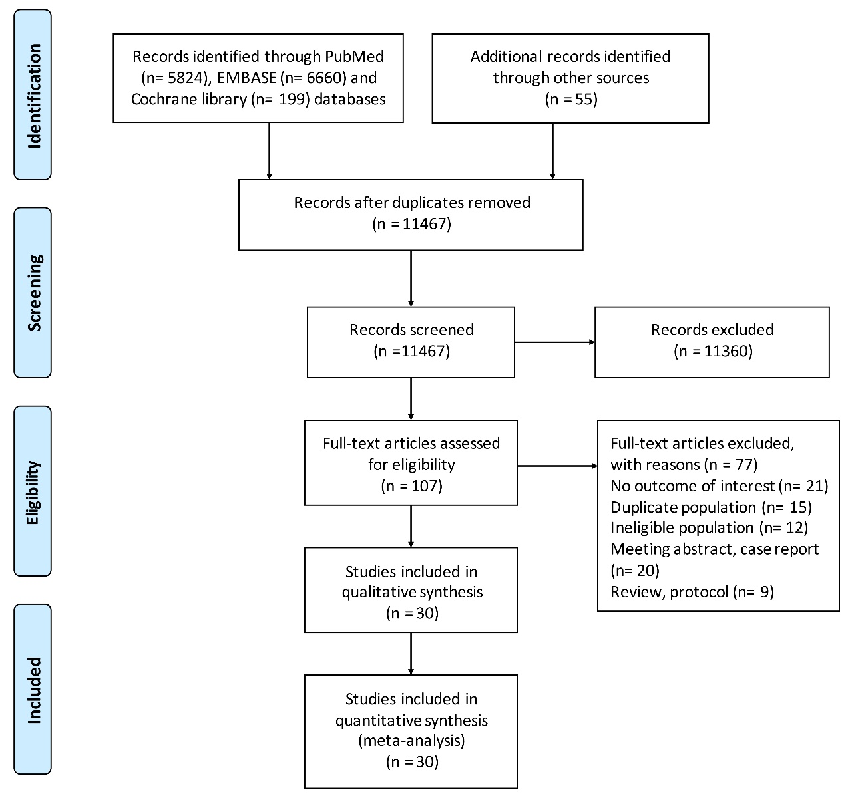Figure S1. PRISMA flow diagram of study selection for systematic review and meta-analysis. PRISMA: Preferred Reporting Items for Systematic Reviews and Meta-Analyses.
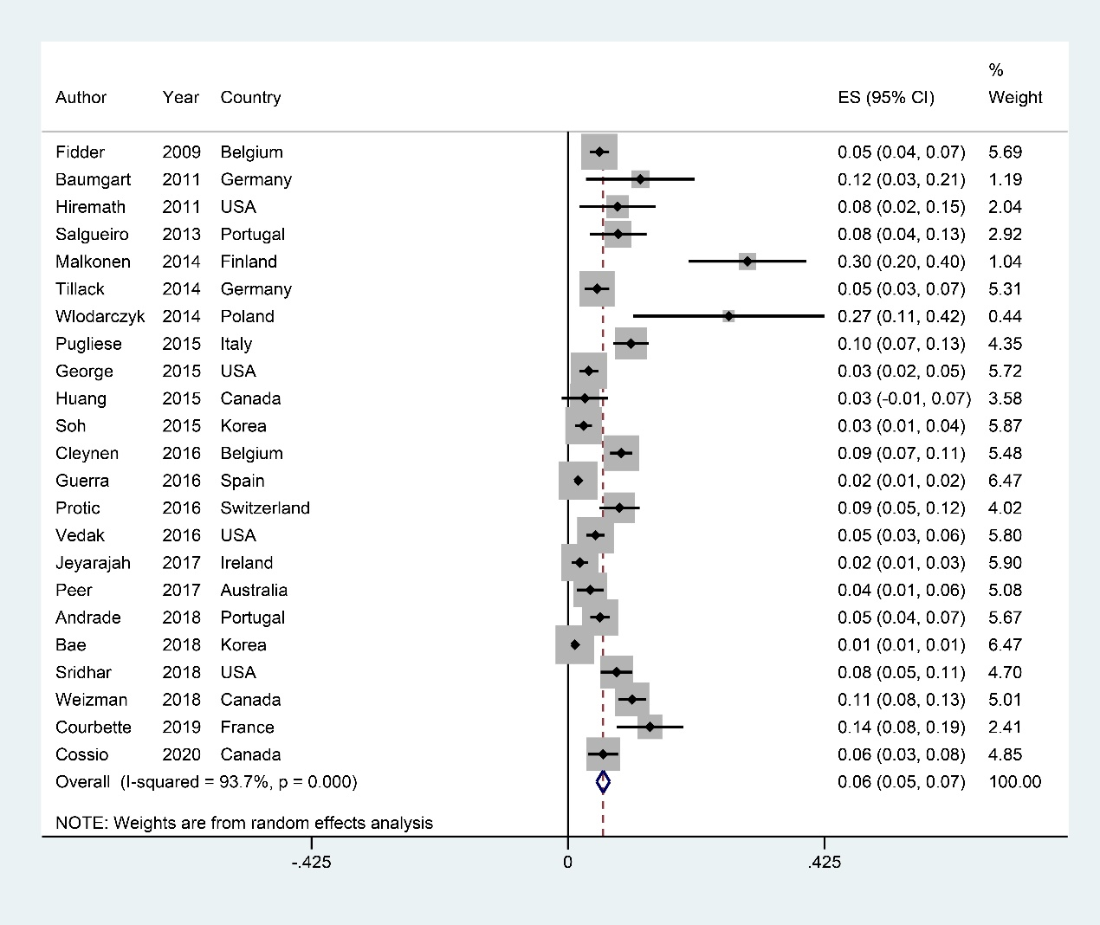Figure S2. Sensitivity analysis exclusively including the studies that reported incidence of de novo psoriasis/psoriasiform lesion.

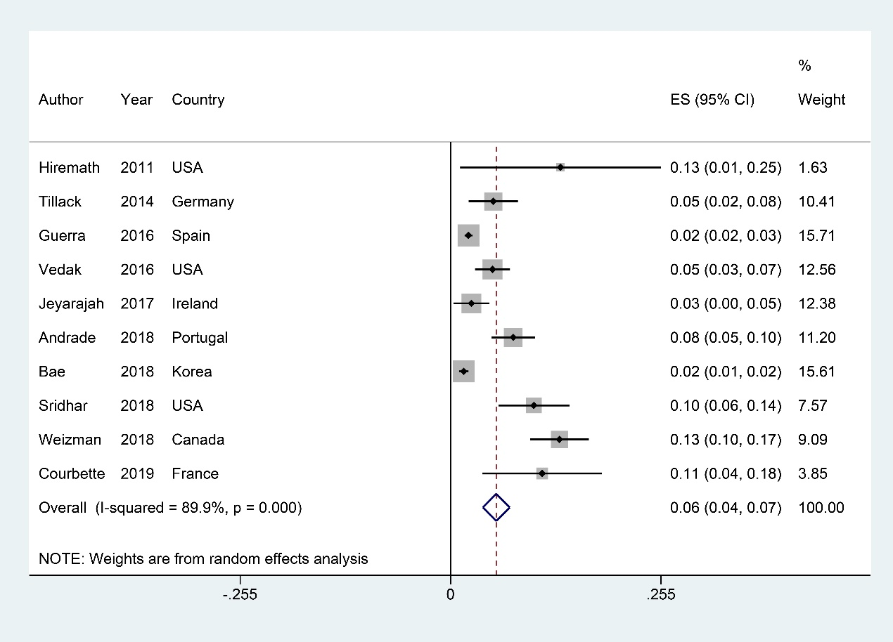Figure S3. Forest plots of incidence of psoriasiform lesions and/or psoriasis associated with anti-TNF therapy in female IBD patients

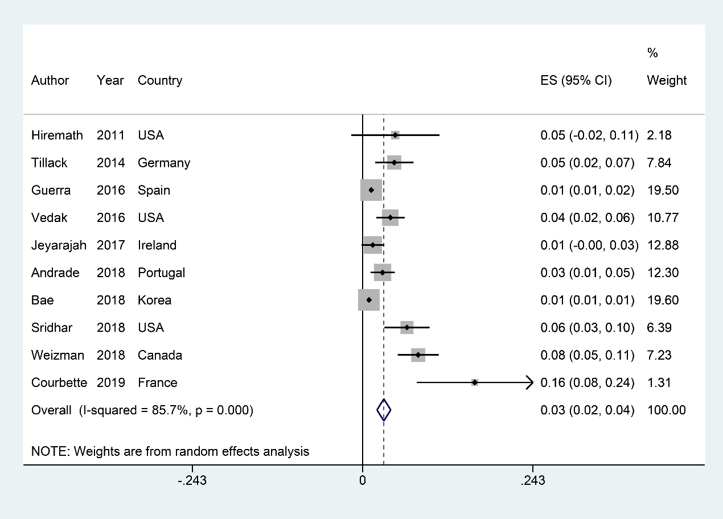Figure S4. Forest plots of incidence of psoriasiform lesions and/or psoriasis associated with anti-TNF therapy in male IBD patients
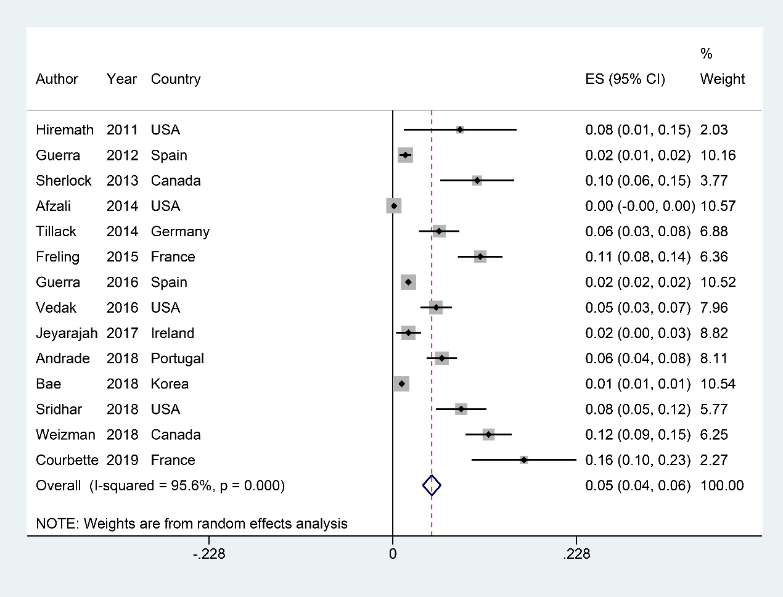Figure S5. Forest plots of incidence of psoriasiform lesions and/or psoriasis associated with anti-TNF therapy in CD patients
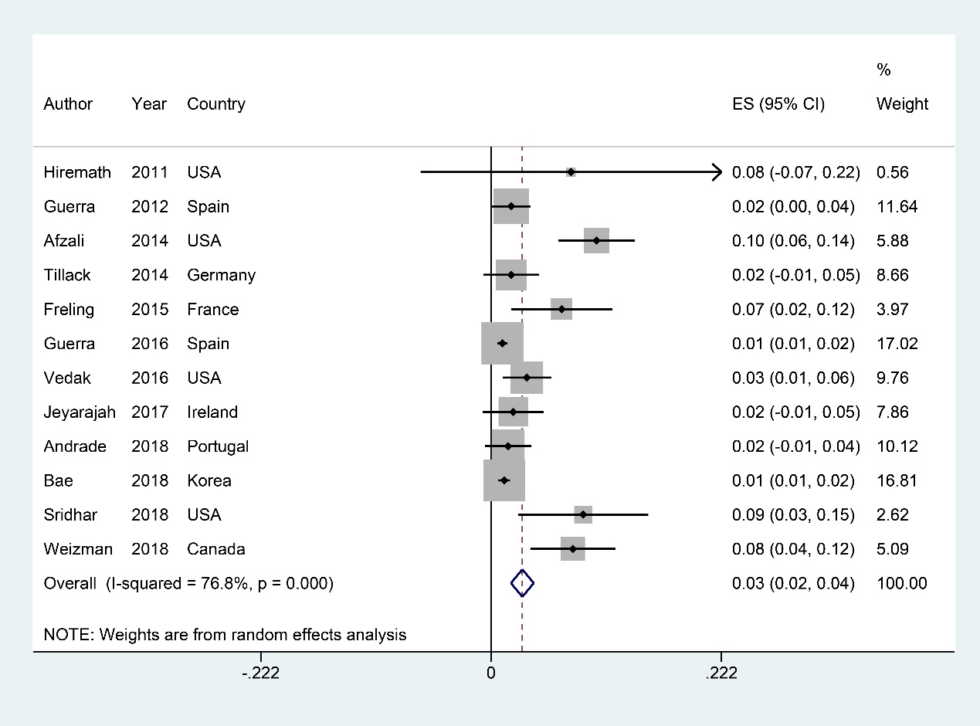Figure S6. Forest plots of incidence of psoriasiform lesions and/or psoriasis associated with anti-TNF therapy in UC patients
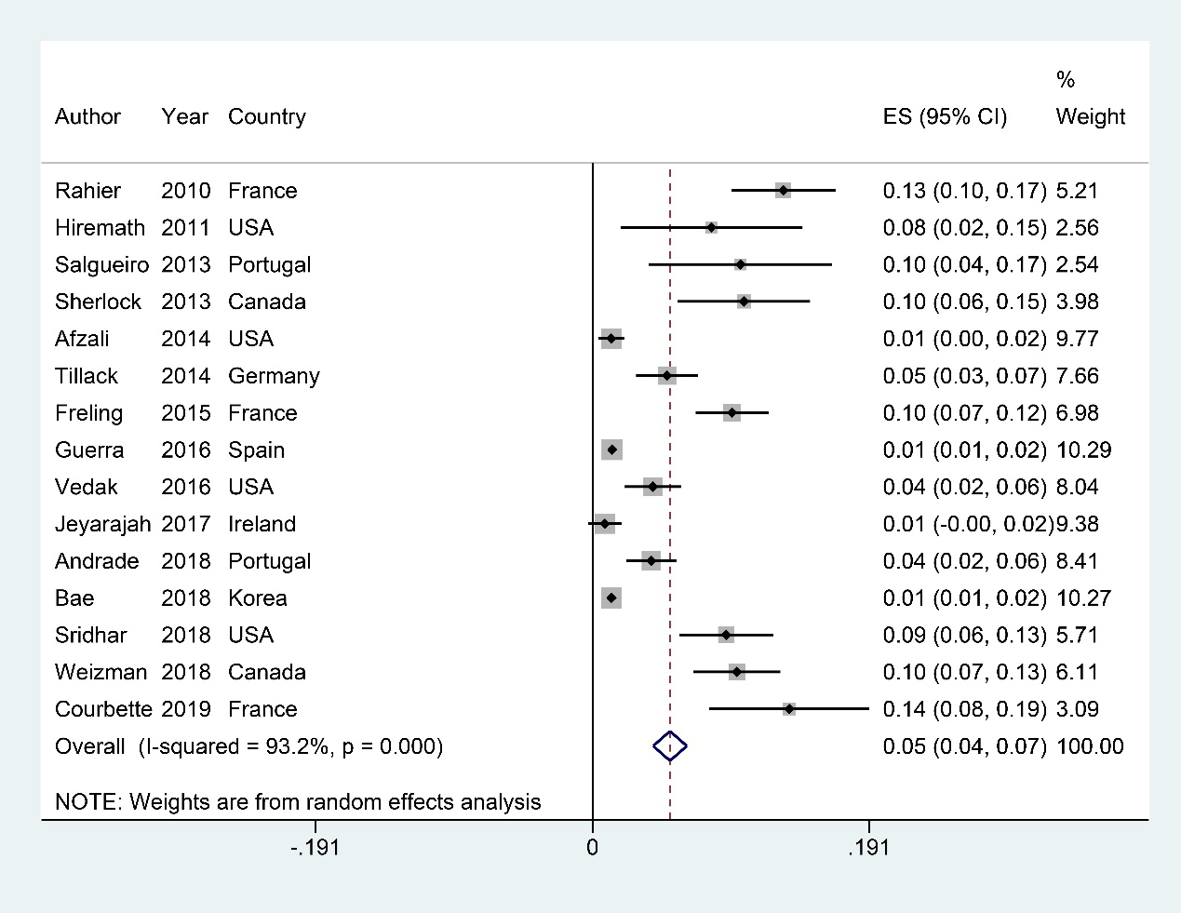Figure S7. Forest plots of incidence of psoriasiform lesions and/or psoriasis associated with infliximab therapy in IBD patients
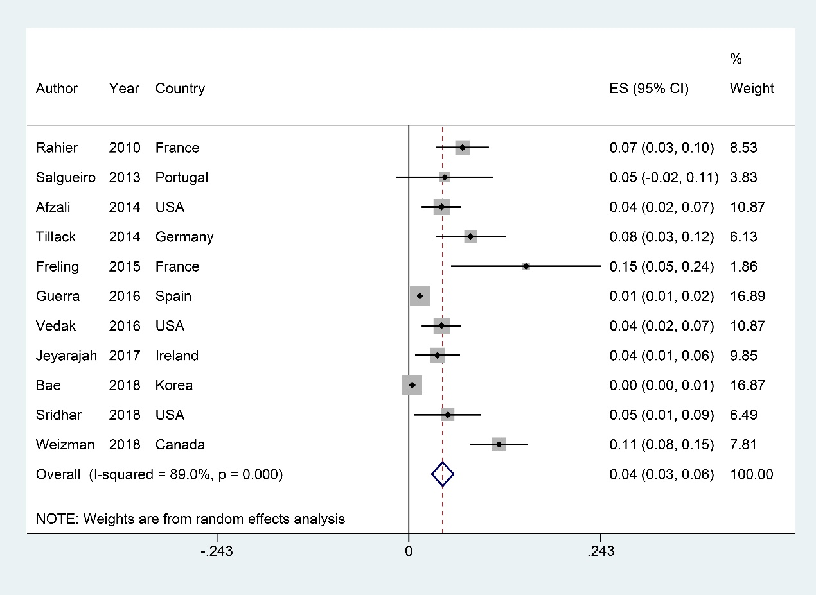Figure S8. Forest plots of incidence of psoriasiform lesions and/or psoriasis associated with adalimumab therapy in IBD patients.
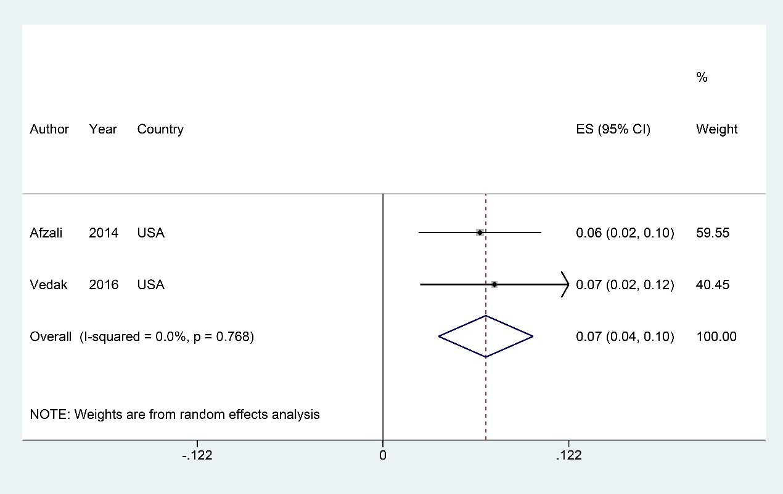Figure S9. Forest plots of incidence of psoriasiform lesions and/or psoriasis associated with certolizumab therapy in IBD patients
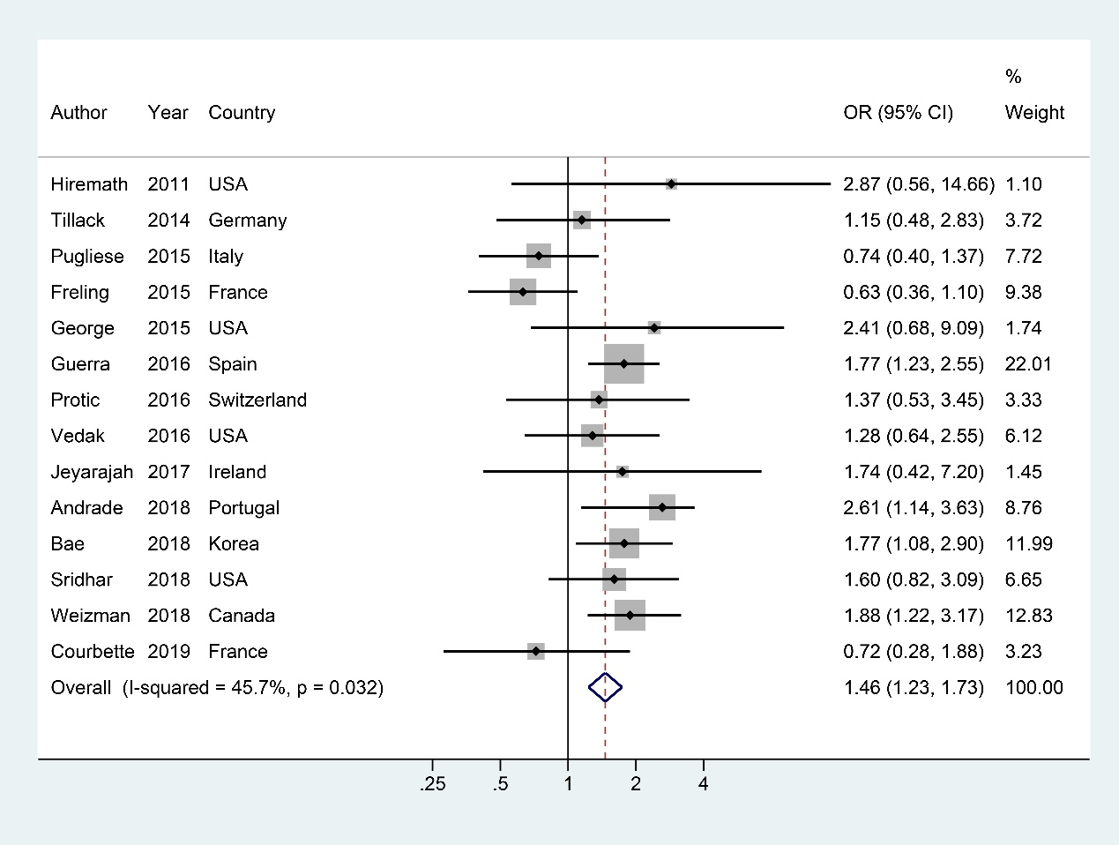Figure S10. Forest plots of the odds ratio for female
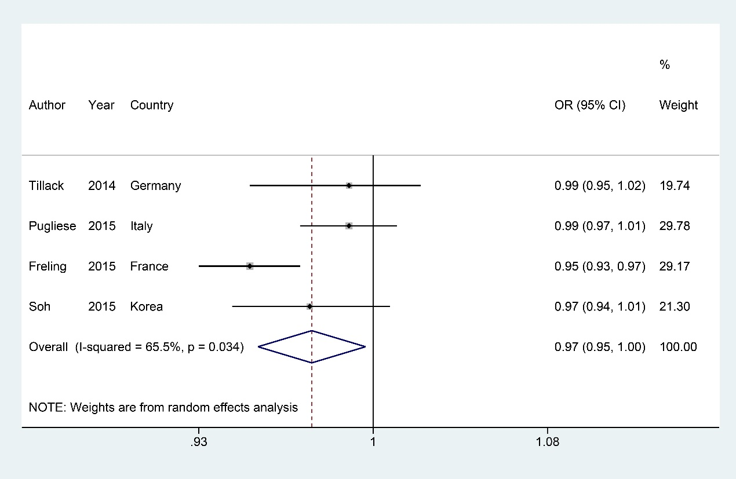Figure S11. Forest plots of the odds ratio for age of anti-TNF therapy
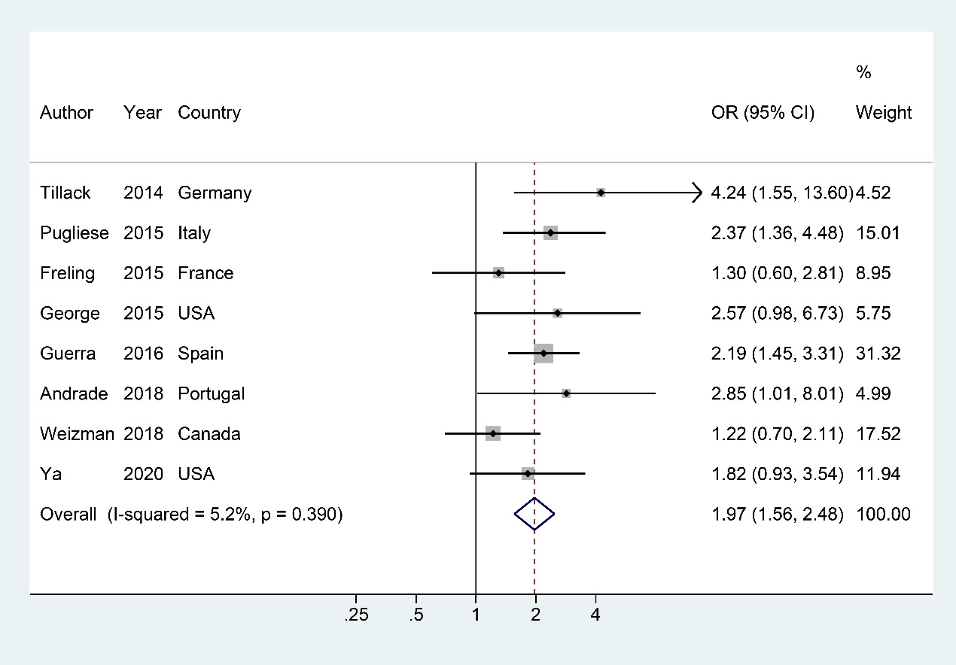Figure S12. Forest plots of the odds ratio for smoking
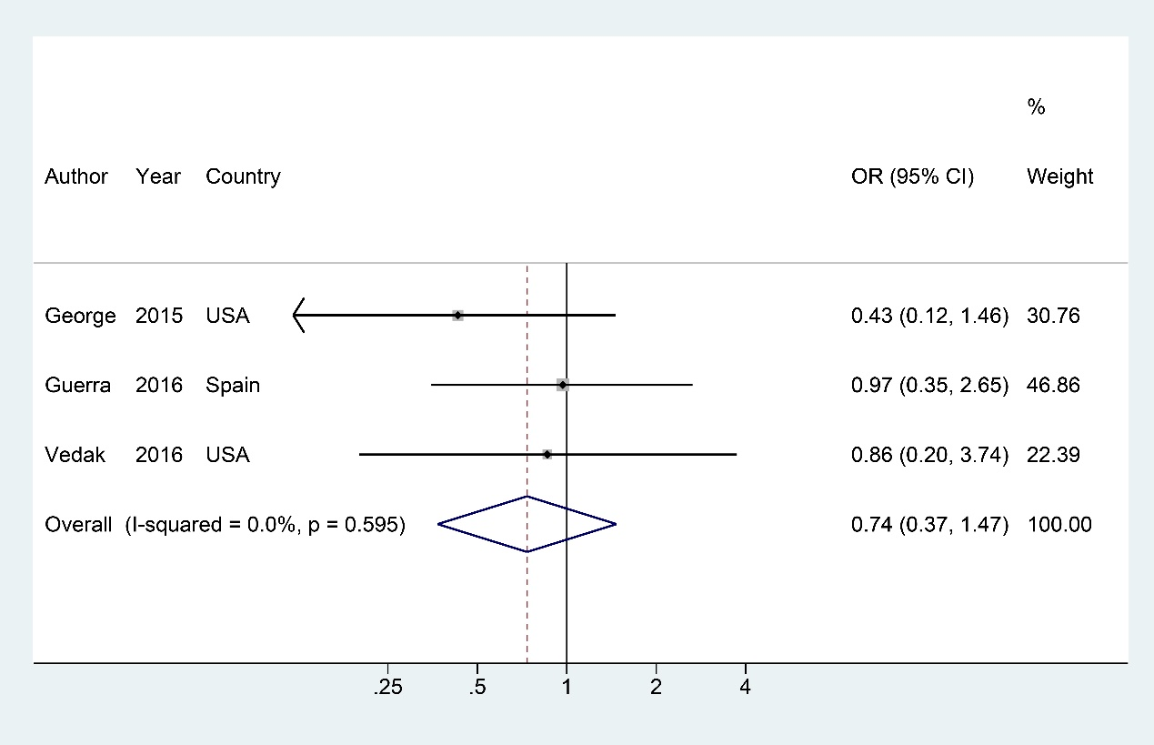Figure S13. Forest plots of the odds ratio for white
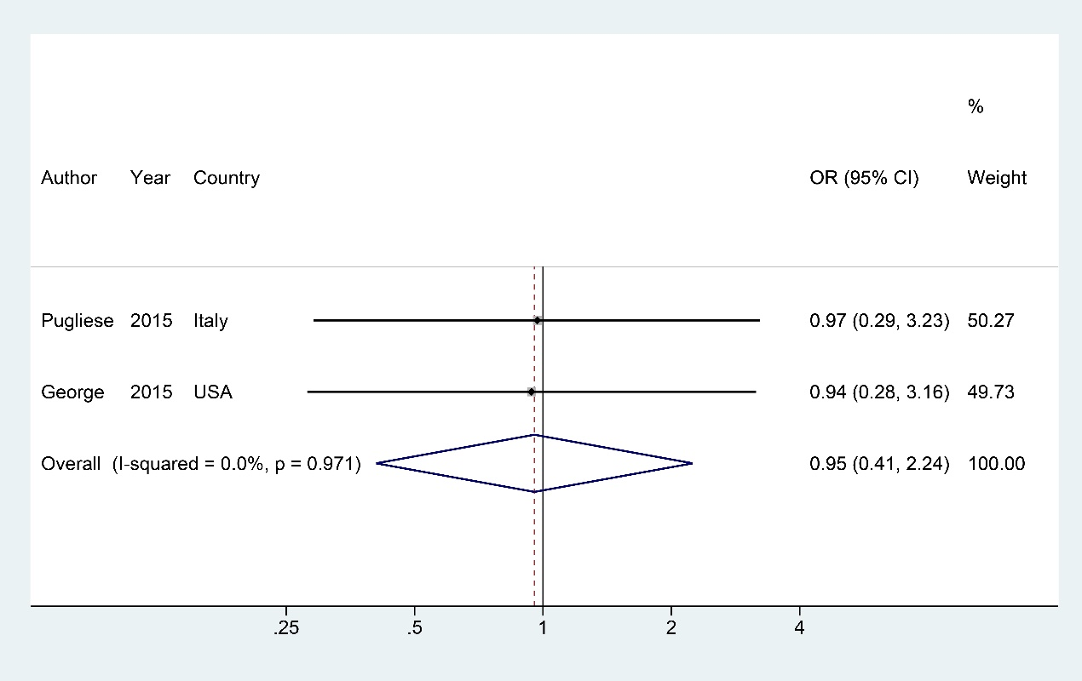Figure S14. Forest plots of the odds ratio for obesity
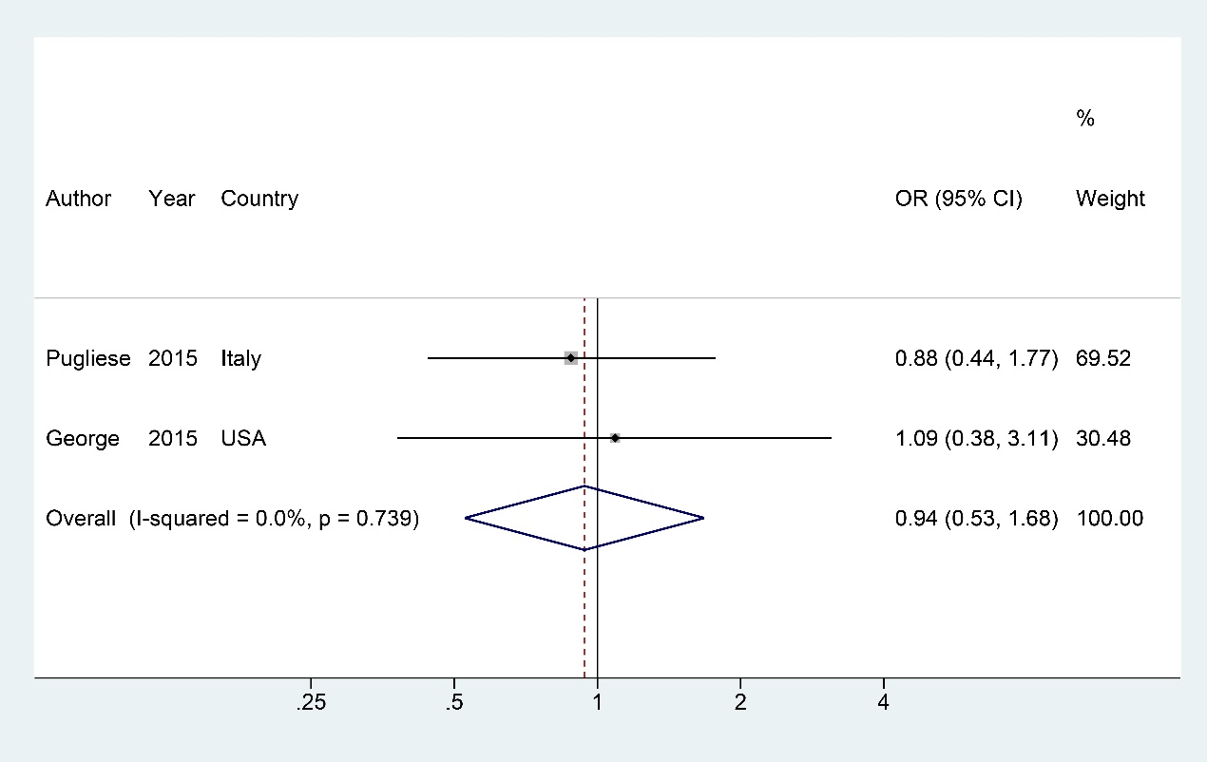Figure S15. Forest plots of the odds ratio for overweight
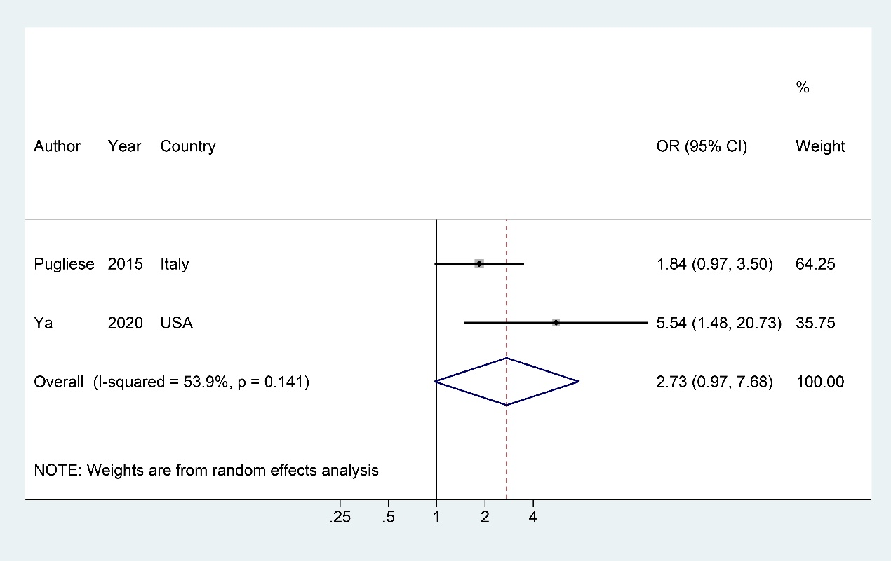Figure S16. Forest plots of the odds ratio for family history of PsO
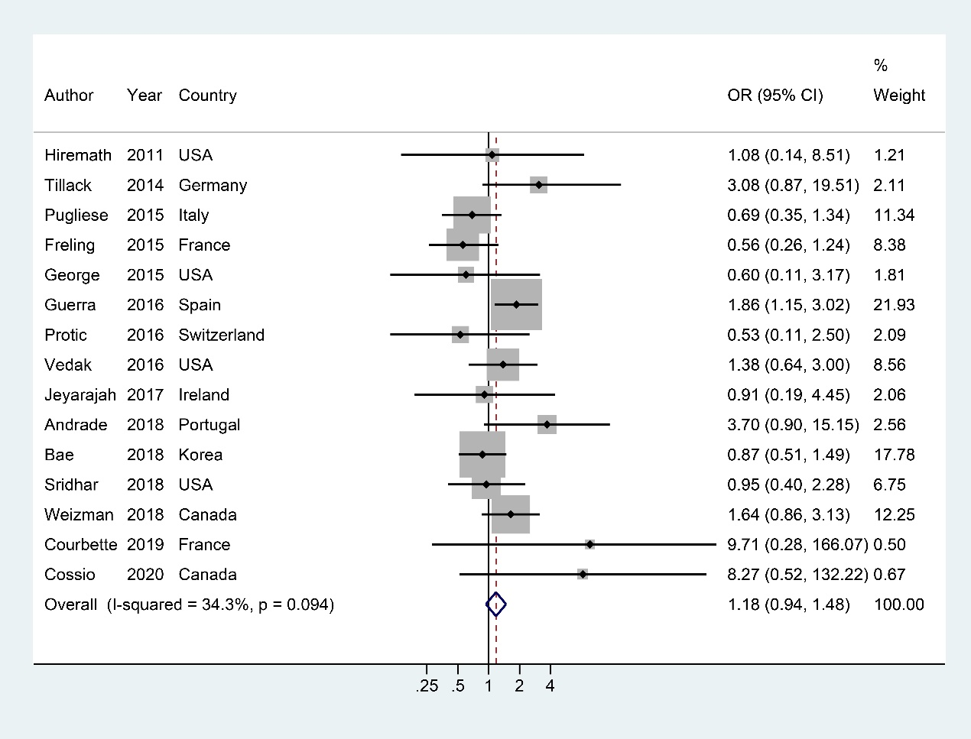Figure S17. Forest plots of the odds ratio for CD (vs. UC)
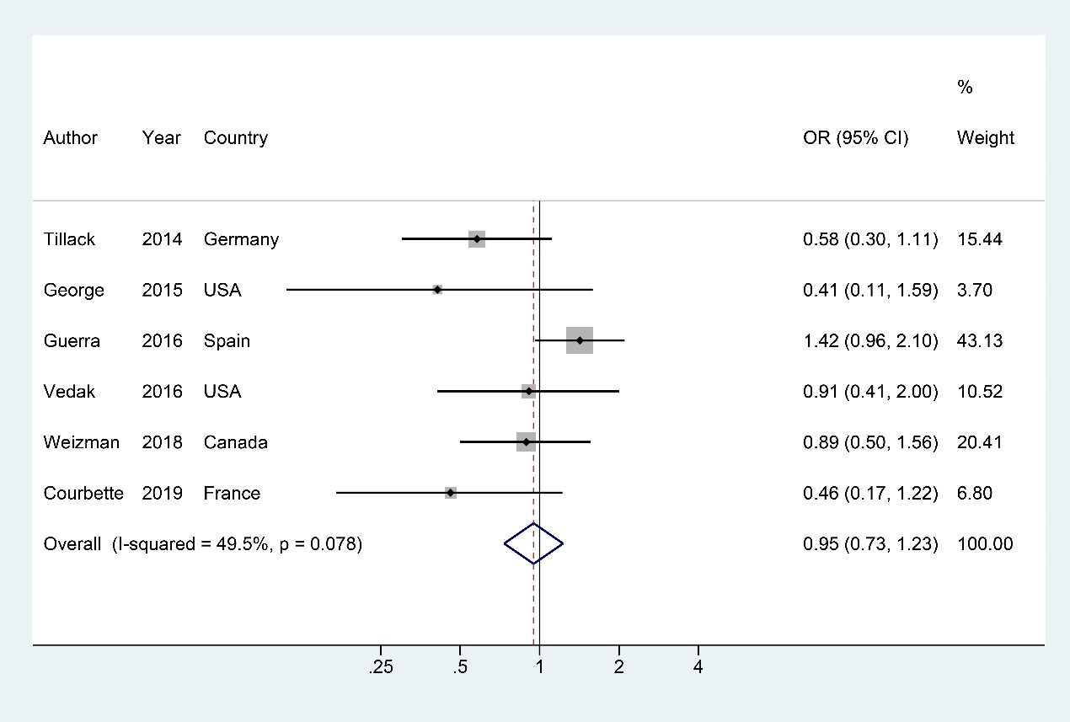Figure S18. Forest plots of the odds ratio for inflammatory CD
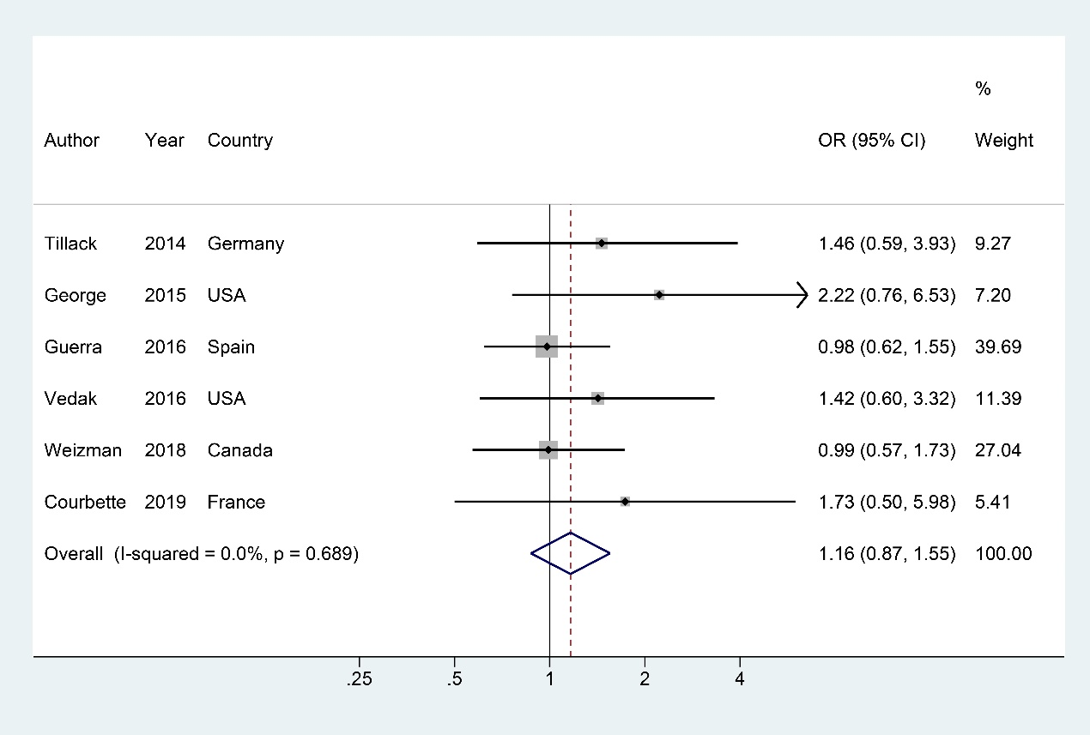Figure S19. Forest plots of the odds ratio for stricturing CD
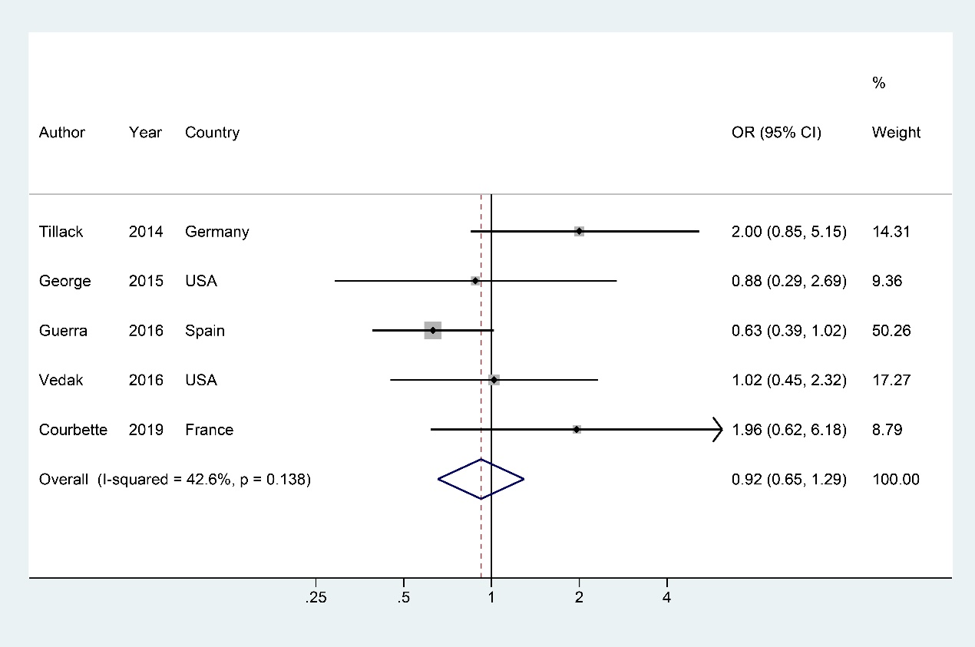Figure S20. Forest plots of the odds ratio for penetrating CD
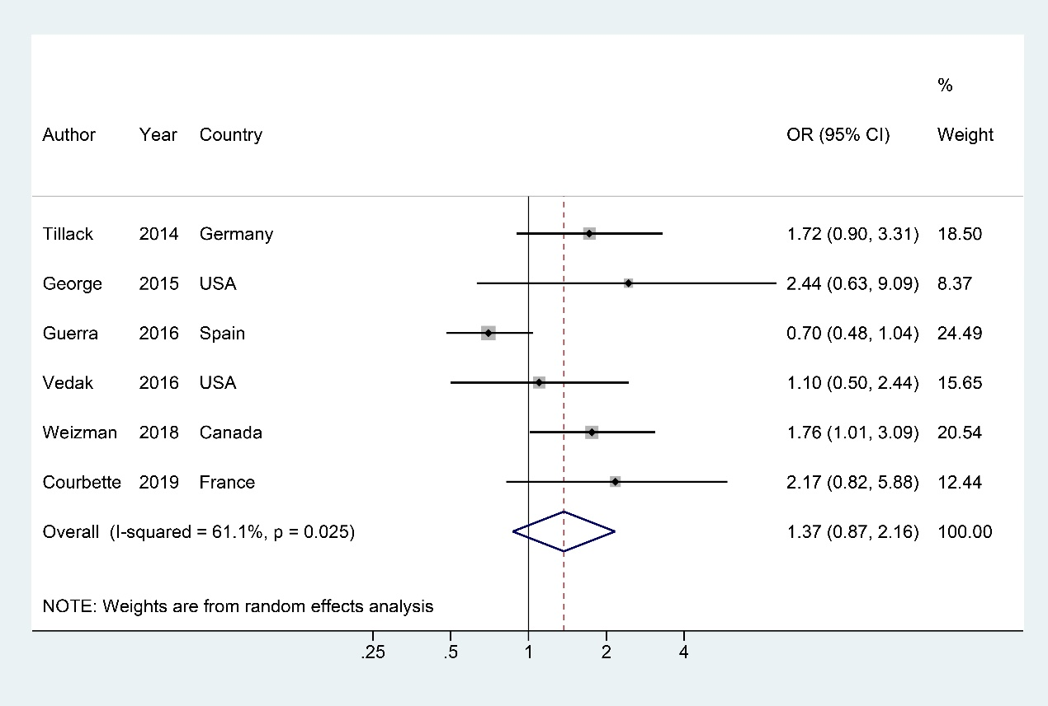Figure S21. Forest plots of the odds ratio for stricturing/penetrating CD
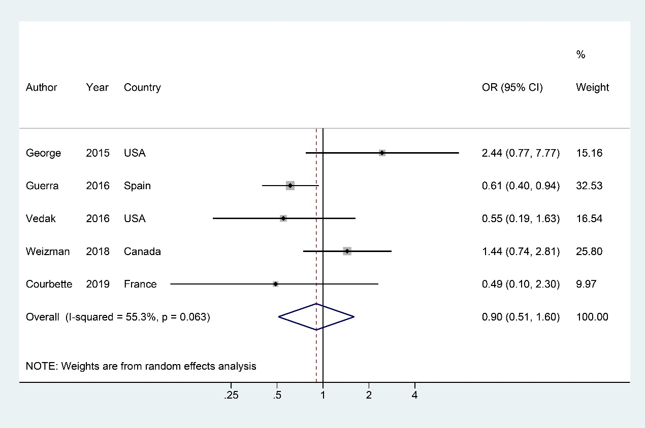Figure S22. Forest plots of the odds ratio for terminal Ileum CD
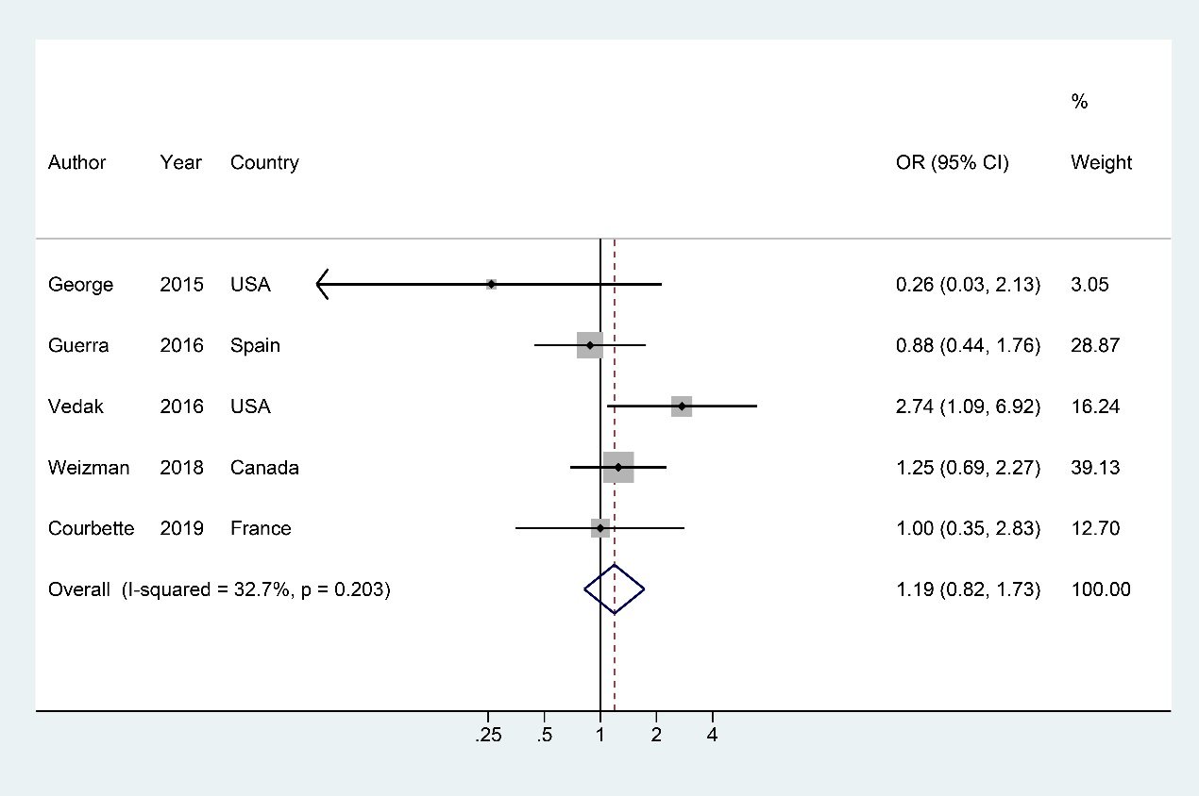Figure S23. Forest plots of the odds ratio for colon CD
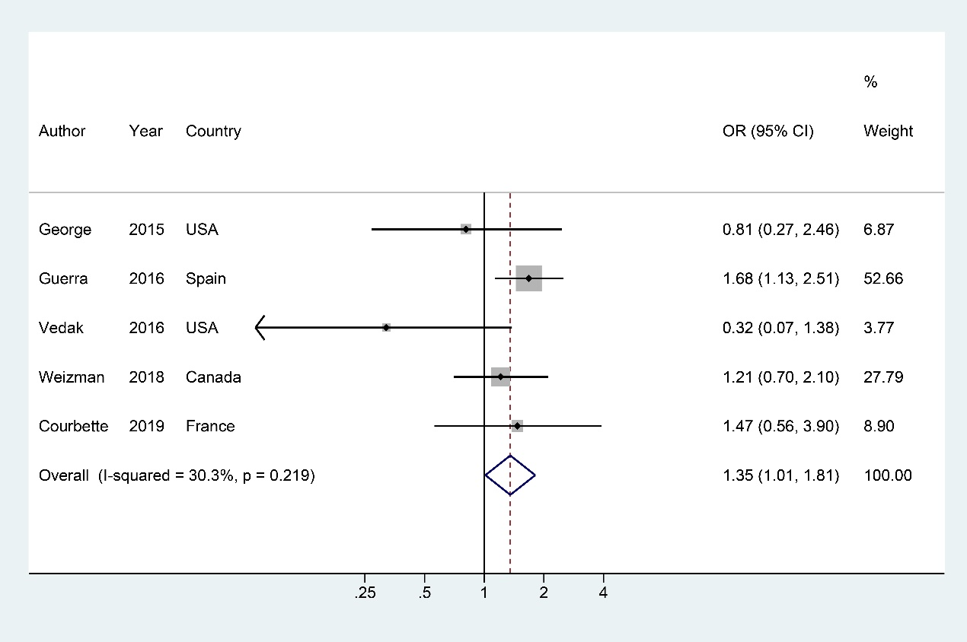Figure S24. Forest plots of the odds ratio for ileocolonic CD
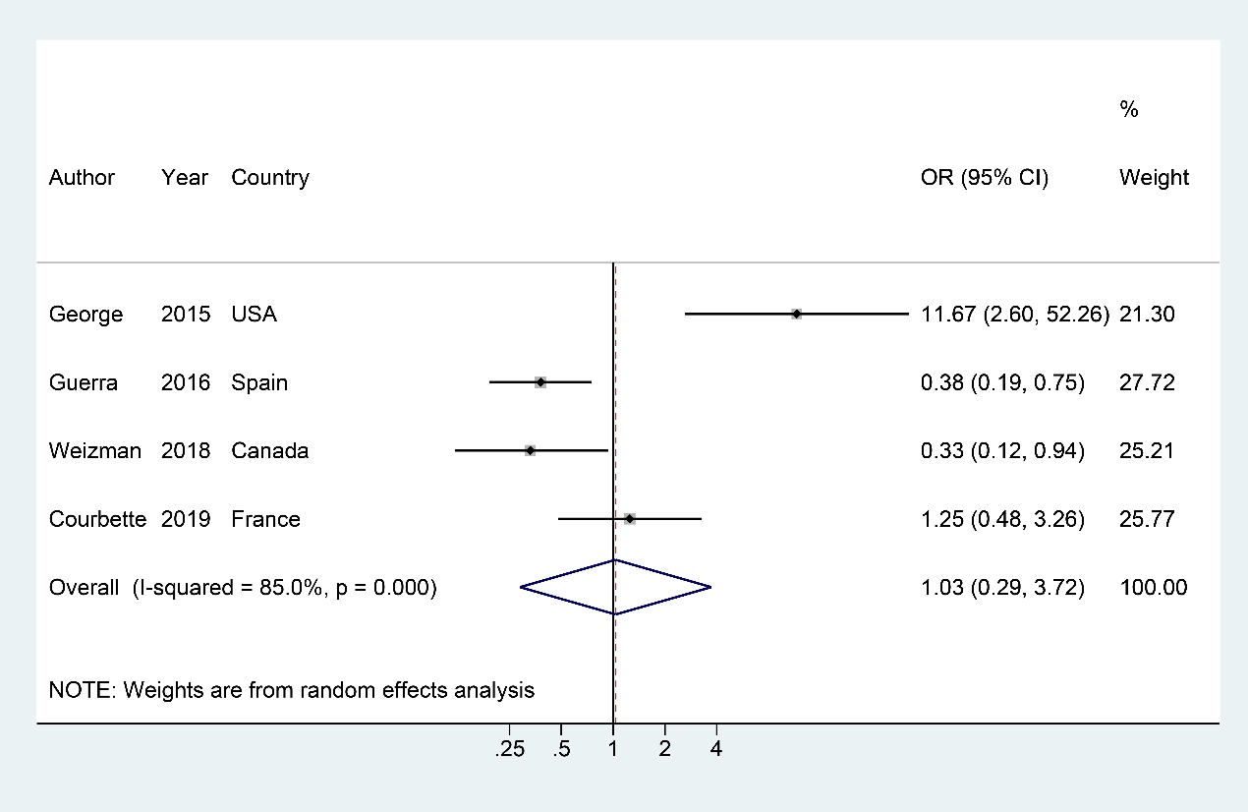Figure S25. Forest plots of the odds ratio for upper tract CD
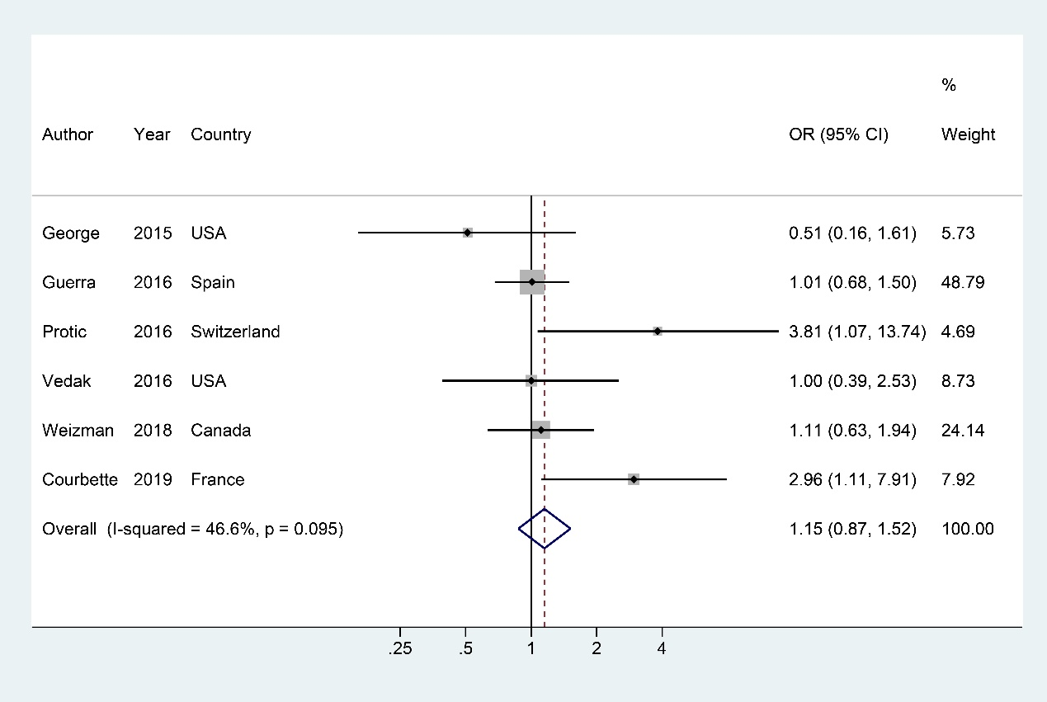Figure S26. Forest plots of the odds ratio for perianal CD
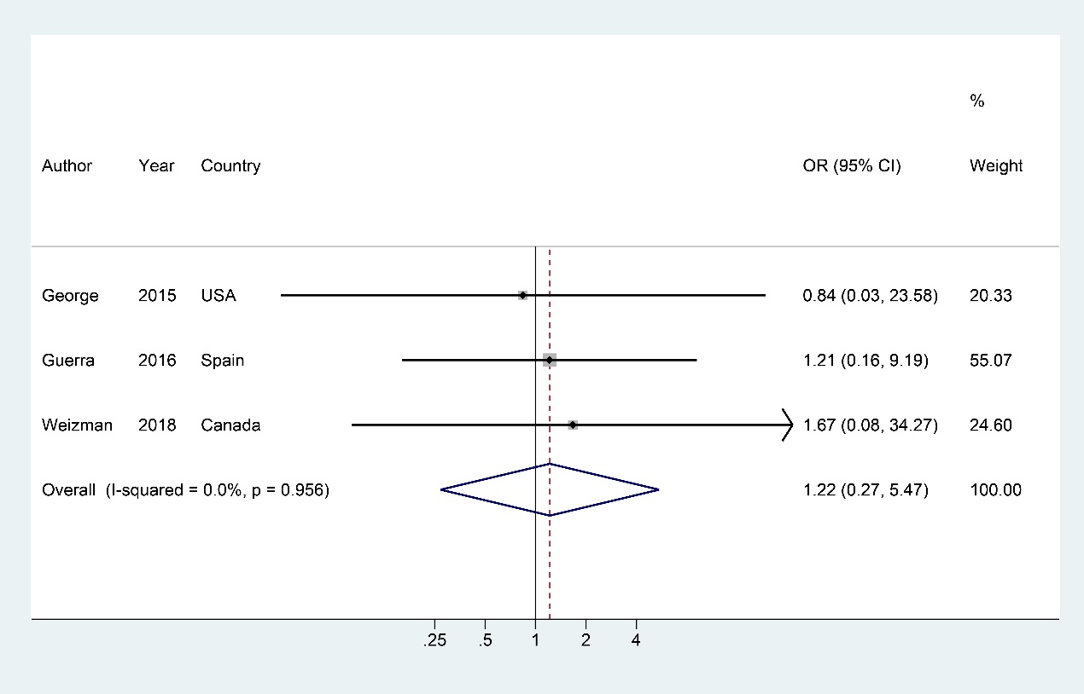Figure S27. Forest plots of the odds ratio for rectum UC
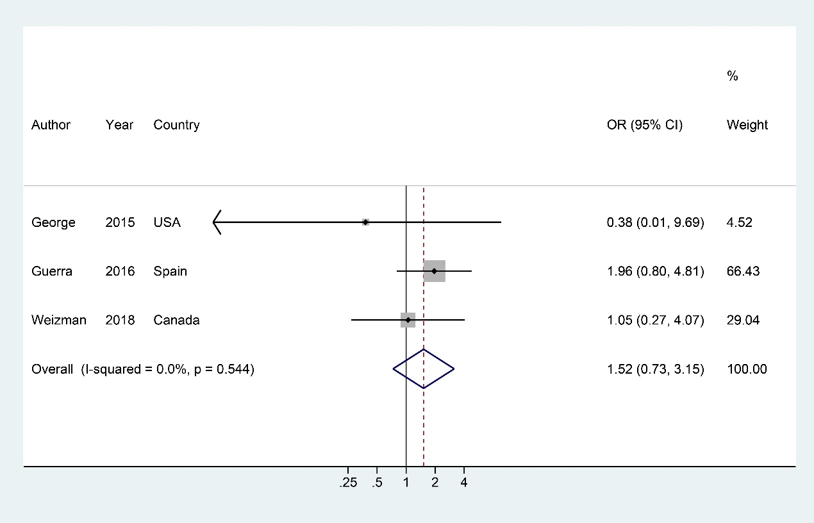Figure S28. Forest plots of the odds ratio for left sided UC
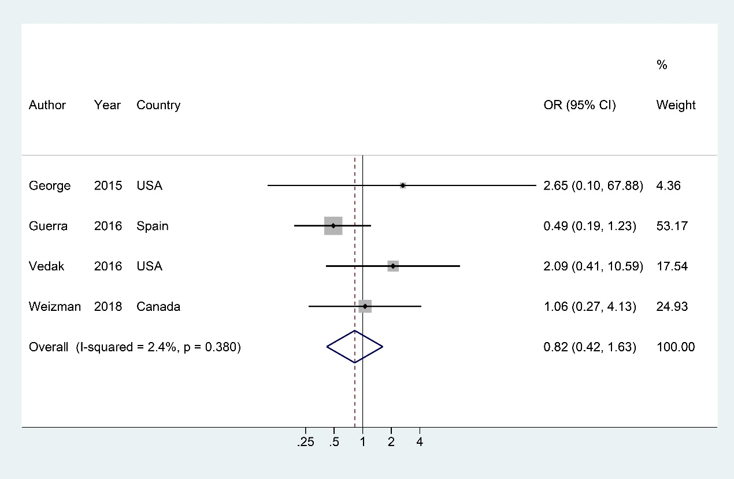Figure S29. Forest plots of the odds ratio for extensive UC
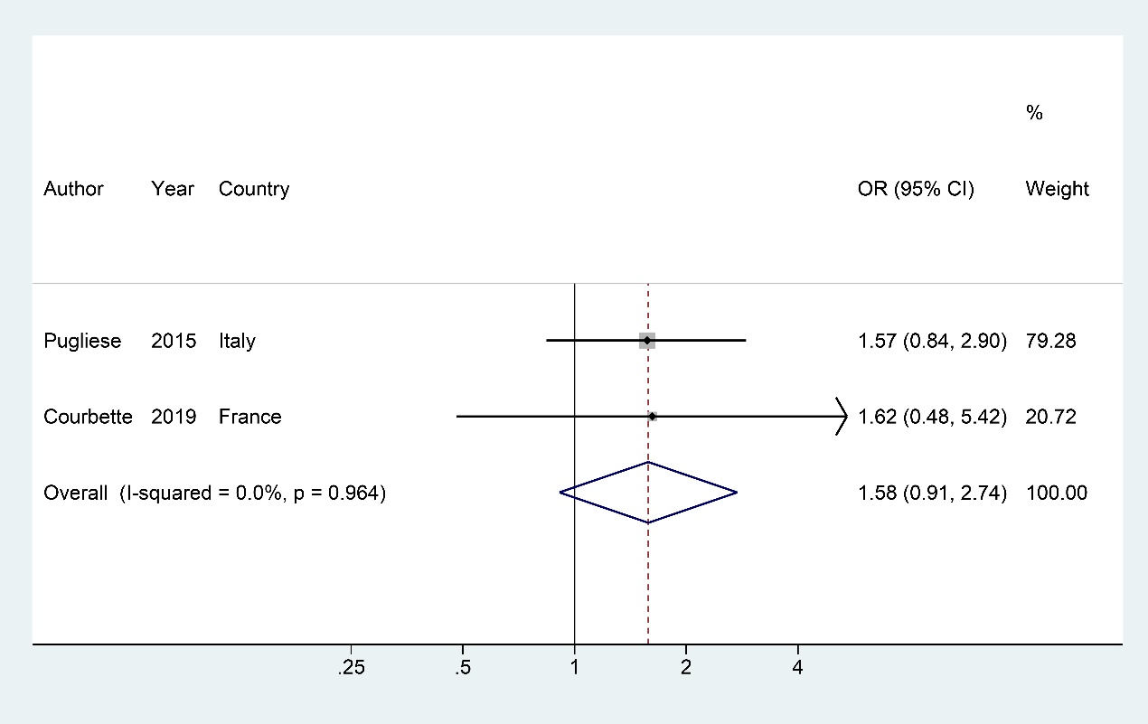Figure S30. Forest plots of the odds ratio for extra-intestinal manifestations
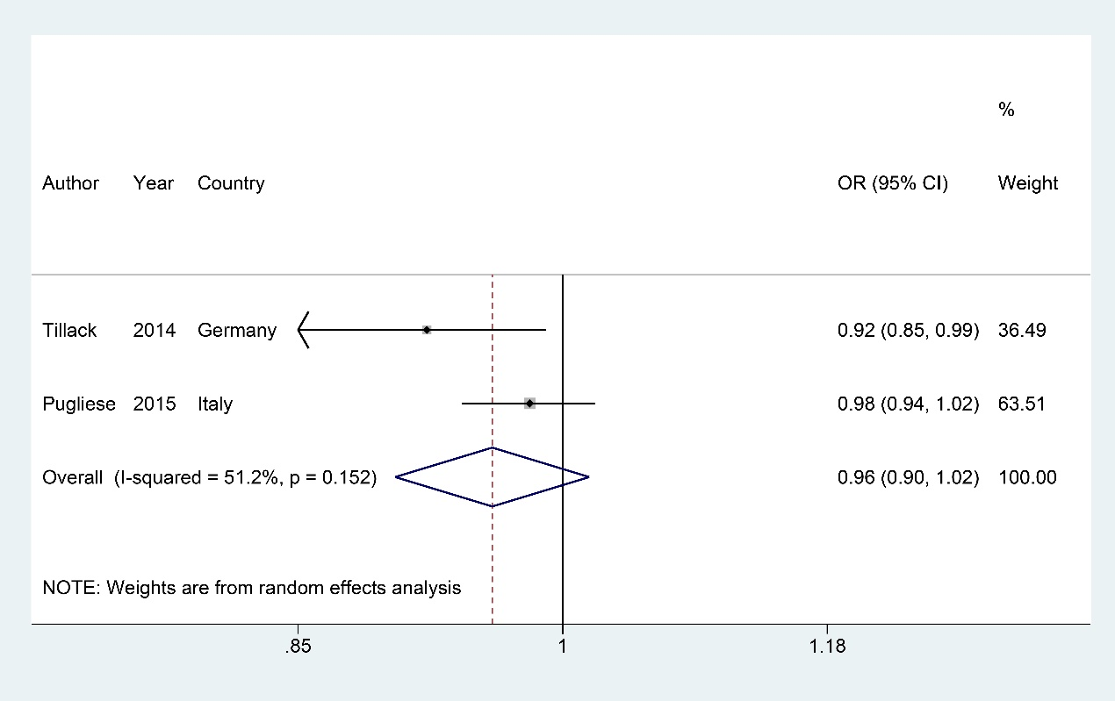Figure S31. Forest plots of the odds ratio for IBD duration
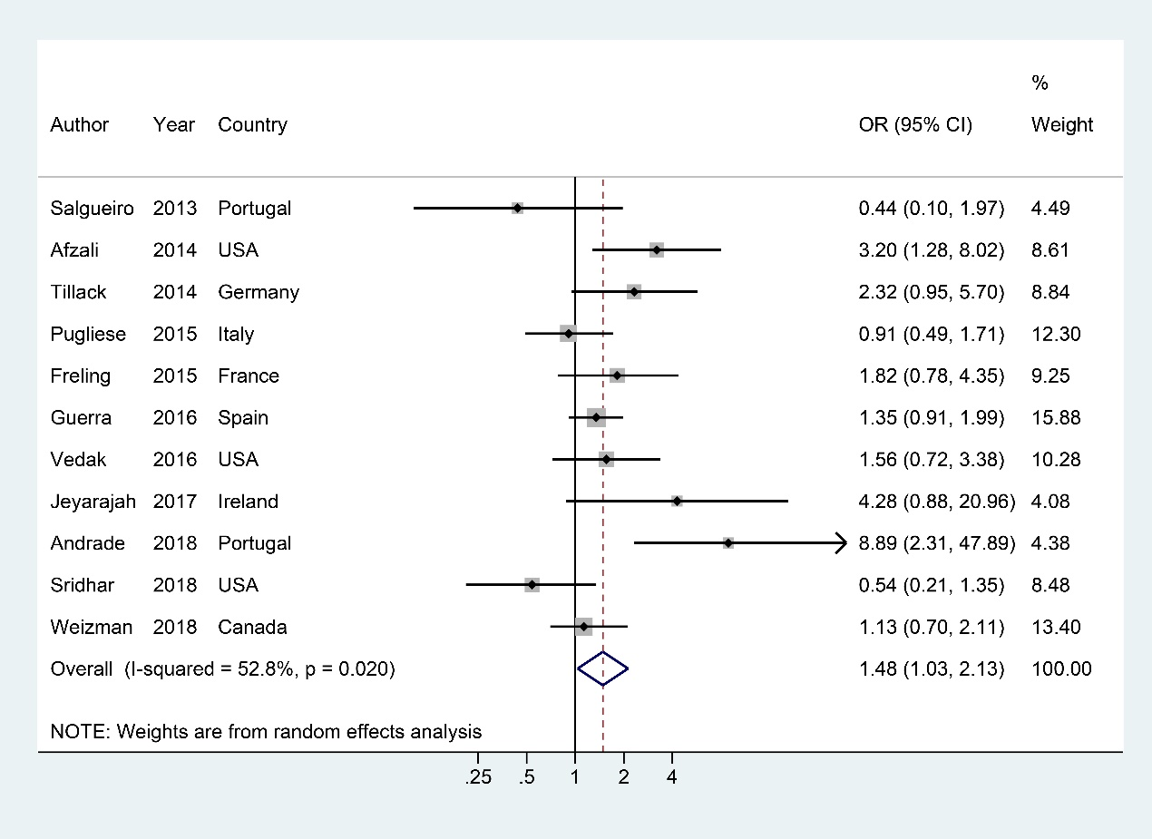Figure S32. Forest plots of the odds ratio for adalimumab (vs. infliximab).
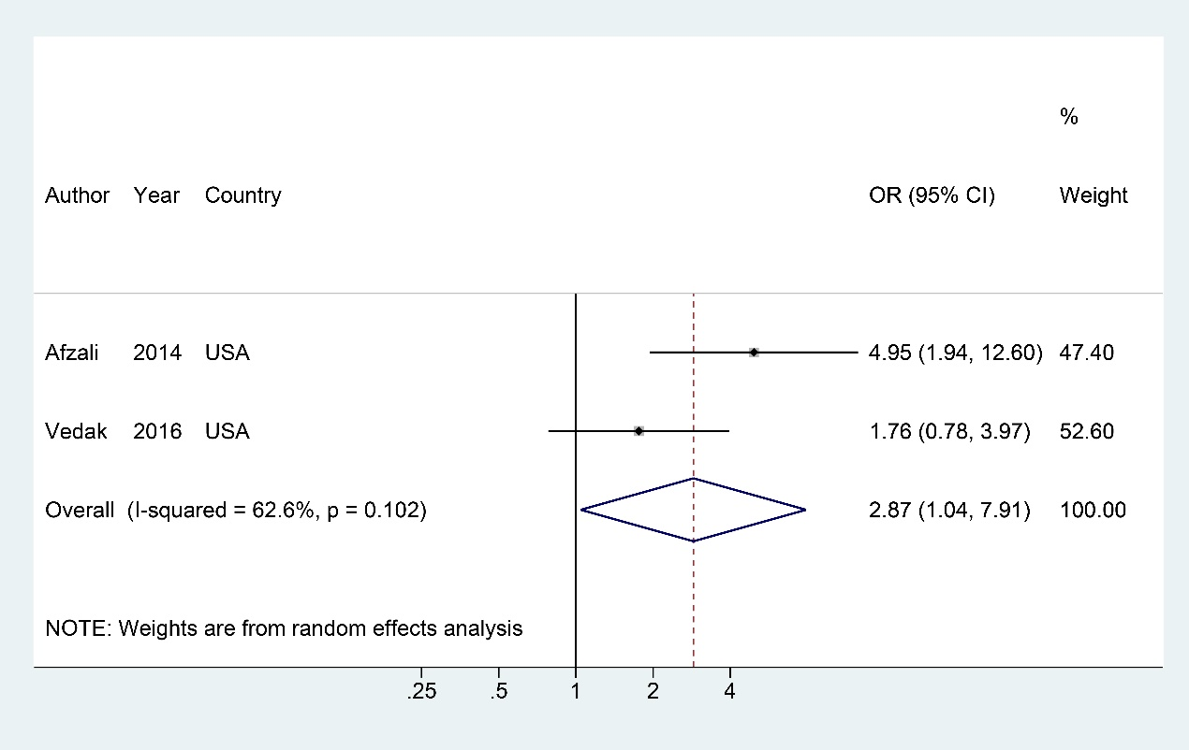Figure S33. Forest plots of the odds ratio for certolizumab (vs. infliximab)
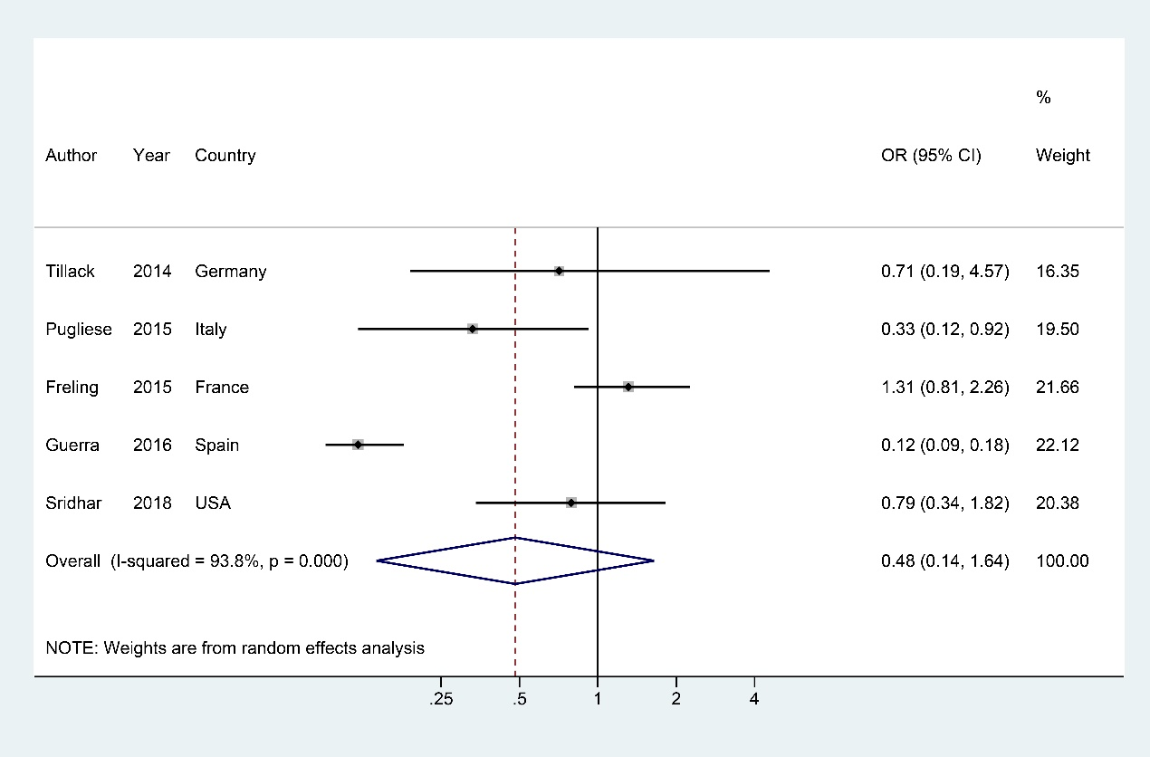Figure S34. Forest plots of the odds ratio for concomitant immunosuppressants

