SUPPLEMENTARY MATERIALS FOR
“Respiratory Syncytial Virus-Associated Hospitalization Rates among US Infants:
A Systematic Review and Meta-Analysis”

Table of Contents

Supplementary Table 1. Literature search algorithm 3
Supplementary Table 2. Ratios used to impute RSV incidence rates for various age groups 3
Supplementary Table 3. Source and calculation methods used for determining annual RSV-associated hospitalization rates among US infants by study estimate and age group (n=31) 4
Supplementary Table 4. Sensitivity analysis comparing estimated annual rates of RSV-associated hospitalization per 1000 when excluding studies that did not directly report a hospitalization rate for US infants <1 year or <6 months of age 8
Supplementary Table 5. Median rate ratios comparing annual rates of RSV-associated hospitalization per 1000 among US infants <6 months vs <1 year of age among studies that directly reported estimates for both age group (n=9) 8

Supplementary Figure 1. Annual RSV-associated hospitalization rates per 1000 among US children <5 years of age (n=31) 9
Supplementary Figure 2. Annual rates of RSV-associated hospitalization per 1000 among US infants <1 year of age over time by study 10
Supplementary Figure 3. Forest plot of annual RSV-associated hospitalization rates per 1000 among US children <5 years of age by study type (n=31) 11
Supplementary Figure 4. Sensitivity analysis: forest plot of annual RSV-associated hospitalization rates per 1000 among US infants <1 year of age by study type (n=20) 13
Supplementary Figure 5. Sensitivity analysis: forest plot of annual RSV-associated hospitalization rates per 1000 among US infants <6 months of age by study type (n=20) 14

References 15

Supplementary Table 1. Literature search algorithm
“RSV Terms” | “Epidemiological Measurement Terms”
respiratory syncytial virus  rsv  respiratory tract infection  respiratory tract infections  rti  respiratory infection | epidemiology, surveillance, monitor, monitoring, incidence, prevalence, rate, rates, burden, hospitalization, hospitalizations, impact, impacts, effect, effects, outcome, outcomes, consequence, consequences, change, changes, changing, trend, trends, trending, difference, differences, increase, increases, decrease, decreases, decreasing, decline, declines, declining, reduction, reduce, evolve, evolving, evolution
PubMed Query

(("respiratory syncytial virus"[title] OR "rsv"[title] OR "respiratory tract infection"[title] OR "respiratory tract infections"[title] OR "rti"[title] OR "respiratory infection"[title]) OR "respiratory infections"[title] AND ("epidemiology"[title] OR "surveillance"[title] OR "monitor"[title] OR "monitoring"[title] OR "incidence"[title] OR "prevalence"[title] OR "rate"[title] OR "rates"[title] OR "burden"[title] OR "hospitalization"[title] OR "hospitalizations"[title] OR "impact"[title] OR "impacts"[title] OR "effect"[title] OR "effects"[title] OR "outcome"[title] OR "outcomes"[title] OR "consequence"[title] OR "consequences"[title] OR "change"[title] OR "changes"[title] OR "changing"[title] OR "trend"[title] OR "trends"[title] OR "trending"[title] OR "difference"[title] OR "differences"[title] OR "increase"[title] OR "increases"[title] OR "increasing"[title] OR "decrease"[title] OR "decreases"[title] OR "decreasing"[title] OR "decline"[title] OR "declines"[title] OR "declining"[title] OR "reduction"[title] OR "reduce"[title] OR "evolve"[title] OR "evolving"[title] OR "evolution"[title])) AND English[lang]
Cochrane Library Query

(("respiratory syncytial virus":ti OR " rsv":ti OR "respiratory tract infection":ti OR "respiratory tract infections":ti OR "rti":ti OR "respiratory infection":ti) AND ("epidemiology":ti OR "surveillance":ti OR "monitor":ti OR "monitoring":ti OR "incidence":ti OR "prevalence":ti OR "rate":ti OR "rates":ti OR "burden":ti OR "hospitalization":ti OR "hospitalizations":ti OR "impact":ti OR "impacts":ti OR "effect":ti OR "effects":ti OR "outcome":ti OR "outcomes":ti OR "consequence":ti OR "consequences":ti OR "change":ti OR "changes":ti OR "difference":ti OR "differences":ti OR "increase":ti OR "increases":ti OR "decrease":ti OR "decreases":ti OR "reduction":ti OR "reduce":ti OR "evolve":ti OR "evolving":ti OR "evolution":ti))

Supplementary Table 2. Ratios used to impute RSV incidence rates for various age groups
Age Group Imputation | Rate Ratio*
Impute age <1 year from age <5 years  Impute age <1 year from age <2 years  Impute age <6 months from age <1 year | 3.70  1.59  1.32
*Ratios are based on Shi et al. This approach uses age-specific median hospitalized incidence rate ratios derived from the literature to impute missing rates and has previously yielded reliable results.¹
Supplementary Table 3. Source and calculation methods used for determining annual RSV-associated hospitalization rates among US infants by study estimate and age group (n=31)
Study Estimate | Rate <5 year | Source <5 year | Rate <1 year | Source <1 year | Rate <6 months | Source <6 months
Boyce et al, 2000² | (11.0) | The reported rate for <1 year-olds of 32.0 was multiplied by 0.27 to estimate the rate for <5 year-olds per the hospitalization ratio reported in the appendix of Shi et al.¹ | 40.8 | Reported in Results, “…corresponding to approximately 40.8 hospitalizations per 1000 children in the first year of life.” | 56.5 | Table 1 reported “Child-years” and “Hospitalizations per 1000 children” by age and risk groups which were used to calculate a weighted average for the overall <6 month age group.
Stockman et al, 2012³ | 8.7 | The reported rate of RSV-coded hospitalizations for <5 year-olds, 6.7, was multiplied by the ratio of modelled excess RSV-associated hospitalizations vs RSV-coded hospitalizations (172,000 / 132,000) | 32.0 | Reported in Results, “…the estimated average annual rate of RSV-associated hospitalizations was 32 per 1000” | (42.2) | The reported rate for <1 year-olds of 32.0 was multiplied by 1.32 to estimate the rate for <6 month olds per the hospitalization ratio reported in the appendix of Shi et al.¹
Johnson et al, 2012⁴ | 7.1 | Reported in Results, Rates by Age, “…rates of hospitalization for RSV…for infants under one year (2,761.4 per 100,000…, as well as those in the one to four-year age group (205.4 per 100,000)”. An average was calculated for 0-1 and 1-4 year age group. | 27.6 | Reported in “Rates by Age” of Results, “The rates of hospitalization for RSV over the study period are significantly higher for infants under one (2,761.4 per 100,000…” which was standardized to a per 1000 rate. | (36.4) | The standardized rate for <1 year-olds of 27.6 was multiplied by 1.32 to estimate the rate for <6 month olds per the hospitalization ratio reported in the appendix of Shi et al.¹
Holman et al, 2004⁵ | (7.4) | The reported rate for <1 year-olds of 27.4 was multiplied by 0.27 to estimate the rate for <5 year-olds per the hospitalization ratio reported in the appendix of Shi et al.¹ | 27.4 | Reported in Results, “The rates for the general US infant population were 27.4 hospitalizations per 1000 births…” | 41.9 | Reported in Table 2 under “RSV No. of Hospitalizations per 1000 Infants” for “Age group <6 mo”
Stockman et al, 2012³ | 6.7 | Table 1 reported the RSV-coded hospitalization rates directly for the “Total (0-59) mo” age group across seasons in the “Annual average” row | 26.0 | Table 1 reported the RSV-coded hospitalization rates by age group across seasons in the “Annual average” row. An average was calculated for “Age, 0-2 mo”, “Age, 3-5 mo”, and “Age, 6-11 mo” | 38.7 | Table 1 reported the RSV-coded hospitalization rates by age group across seasons in the “Annual average” row. An average was calculated for “Age, 0-2 mo” and “Age, 3-5 mo”
Holman et al, 2004⁵ | (6.8) | The reported rate for <1 year-olds of 25.3 was multiplied by 0.27 to estimate the rate for <5 year-olds per the hospitalization ratio reported in the appendix of Shi et al.¹ | 25.3 | Reported in Results, “"...25.3 hospitalizations per 1000 births (95% CI: 19.2-31.4 hospitalizations per 1000 births) for...first-listed RSV hospitalizations..."” | (33.4) | The reported rate for <1 year-olds of 25.3 was multiplied by 1.32 to estimate the rate for <6 month olds per the hospitalization ratio reported in the appendix of Shi et al.¹
Leader et al, 2002⁶ | (6.8) | The reported rate for <1 year-olds of 25.2 was multiplied by 0.27 to estimate the rate for <5 year-olds per the hospitalization ratio reported in the appendix of Shi et al.¹ | 25.2 | Reported in Results, “…RSV discharges of infants younger than the age of 1 year between 1997 and 1999. This represents a rate of 25.2 per 1000 infants.” | (33.3) | The reported rate for <1 year-olds of 25.2 was multiplied by 1.32 to estimate the rate for <6 month olds per the hospitalization ratio reported in the appendix of Shi et al.¹
Leader et al, 2003⁷ | (6.6) | The reported rate for <1 year-olds of 24.3 was multiplied by 0.27 to estimate the rate for <5 year-olds per the hospitalization ratio reported in the appendix of Shi et al.¹ | 24.3 | Reported in “Hospitalization” of Results, “a total of 384,110 (24.3/1000) if both primary and secondary diagnoses of RSV are included” | (32.1) | The reported rate for <1 year-olds of 24.3 was multiplied by 1.32 to estimate the rate for <6 month olds per the hospitalization ratio reported in the appendix of Shi et al.¹
Goldstein et al, 2019⁸ | 7.5 | Table 1 reported “Hospitalizations with a respiratory cause present anywhere in the diagnosis” for “RSV” among “<1y”, “1y”, “2y”, “3y”, and “4y” as 2381, 710.6, 395, 211.3, and 111.1 per 100,000, respectively, which were standardized to per 1000 rates and then averaged | 23.8 | Table 1 reported “Hospitalizations with a respiratory cause present anywhere in the diagnosis” for “RSV” among “<1y” as 2381 per 100,000, which was standardized to a per 1000 rate | (31.4) | The standardized rate for <1 year-olds of 23.6 was multiplied by 1.32 to estimate the rate for <6 month olds per the hospitalization ratio reported in the appendix of Shi et al.¹
Leader et al, 2002⁶ | (6.4) | The reported rate for <1 year-olds of 23.7 was multiplied by 0.27 to estimate the rate for <5 year-olds per the hospitalization ratio reported in the appendix of Shi et al.¹ | 23.7 | Reported in Results, “There were an estimated total of 280,730 discharges of infants younger than the age of 1 year with either a primary or secondary diagnosis of RSV during this 3-year period. This yields a rate of 23.7 per 1000 infants.” | (31.3) | The reported rate for <1 year-olds of 23.7 was multiplied by 1.32 to estimate the rate for <6 month olds per the hospitalization ratio reported in the appendix of Shi et al.¹
Zhou et al, 2012⁹ | 6.0 | Table 3 reported “Respiratory Syncytial Virus-Associated Hospitalization Rates” for “Aged <1 y” and “Aged 1-4y” as 2345.1 and 178.2, respectively, which were standardized to per 1000 rates and then averaged | 23.5 | Table 3 reported “Respiratory Syncytial Virus-Associated Hospitalization Rates” for “Aged <1 y”, which was standardized to a per 1000 rate | (31.0) | The standardized rate for <1 year-olds of 23.5 was multiplied by 1.32 to estimate the rate for <6 month olds per the hospitalization ratio reported in the appendix of Shi et al.¹
Light et al, 2008¹⁰ | (6.2) | The reported rate for <1 year-olds of 23.0 was multiplied by 0.27 to estimate the rate for <5 year-olds per the hospitalization ratio reported in the appendix of Shi et al.¹ | 23.0 | Reported in Results, “…the statewide average (23 per 1000 births)…” | (30.4) | The reported rate for <1 year-olds of 23.0 was multiplied by 1.32 to estimate the rate for <6 month olds per the hospitalization ratio reported in the appendix of Shi et al.¹
Leader et al, 2003⁷ | (6.1) | The reported rate for <1 year-olds of 22.7 was multiplied by 0.27 to estimate the rate for <5 year-olds per the hospitalization ratio reported in the appendix of Shi et al.¹ | 22.7 | Reported in “Hospitalization” of Results, “There were a total of 359,012 infant discharges with a primary diagnosis of RSV (22.7/1000)…” | (30.0) | The reported rate of 22.7 for <1 year-olds was multiplied by 1.32 to estimate the rate for <6 month olds per the hospitalization ratio reported in the appendix of Shi et al.¹
Leader et al, 2002⁶ | (5.9) | The reported rate for <1 year-olds of 22.0 was multiplied by 0.27 to estimate the rate for <5 year-olds per the hospitalization ratio reported in the appendix of Shi et al.¹ | 22.0 | Reported in Results, “In this time period RSV was the primary diagnosis in 259 832 cases for an associated rate of 22 per 1000.” | (29.0) | The reported rate for <1 year-olds of 22.0 was multiplied by 1.32 to estimate the rate for <6 month olds per the hospitalization ratio reported in the appendix of Shi et al.¹
Henrickson et al, 2004¹¹ | 5.8 | Table 5 reported hospitalization rate (“US/1000”) for RSV (“<5) of 5.81 | (21.5)* | Table 5 reported hospitalization rate (“US/1000”) for RSV (“<5) of 5.81 which was then multiplied by 3.70 to estimate the rate for <1 year-olds per the hospitalization ratio reported in the appendix of Shi et al. | (28.4)* | The calculated rate for <1 year-olds of 21.5 was multiplied by 1.32 to estimate the rate for <6 month olds per the hospitalization ratio reported in the appendix of Shi et al.¹
Zachariah et al, 2011¹² | (5.2) | The calculated rate for <1 year-olds of 19.2 was multiplied by 0.27 to estimate the rate for <5 year-olds per the hospitalization ratio reported in the appendix of Shi et al.¹ | (19.2) | Results reported, “In this birth cohort, there were 12,522 total hospitalizations with RSV LRTI within the first 2 years of life (12.12 hospitalizations per 1000 child years).” The rate of 12.12 was multiplied by 1.59 to estimate the rate for <1 year-olds per the hospitalization ratio reported in the appendix of Shi et al. | (25.4) | The calculated rate for <1 year-olds of 19.2 was multiplied by 1.32 to estimate the rate for <6 month olds per the hospitalization ratio reported in the appendix of Shi et al.¹
Goldstein et al, 2015¹³ | 4.7 | Table 1 reported the average annual RSV hospitalization rate among “<1” and “1-4” as 1898.5 and 116.7, respectively, per 100,000, which was standardized to a per 1000 rate and then averaged | 19.0 | Table 1 reported the average annual RSV hospitalization rate among “<1” as 1898.5 per 100,000, which was standardized to a per 1000 rate | (25.1) | The standardized rate for <1 year-olds of 19.0 was multiplied by 1.32 to estimate the rate for <6 month olds per the hospitalization ratio reported in the appendix of Shi et al.¹
Simoes et al, 2013  (reported in Shi et al.)¹ | (4.9) | The reported rate for <1 year-olds of 18.1 was multiplied by 0.27 to estimate the rate for <5 year-olds per the hospitalization ratio reported in the appendix of Shi et al.¹ | 18.1 | Supplementary Table 5 in the appendix of Shi et al. reports the RSV hospitalization rate for “0-11m” in the “Colorado, USA (urban and rural, Jan 2008 - Jun 2013) (Simoes and colleagues)” row | (23.8) | Supplementary Table 5 in the appendix of Shi et al.¹ reports the RSV hospitalization rate for “0-5m” in the “Colorado, USA (urban and rural, Jan 2008 - Jun 2013) (Simoes and colleagues)” row
Zhou et al, 2012⁹ | 4.5 | Table 1 reported RSV hospitalization rates under “RSV (Any Listed); <1 and 1-4” as the Mean across seasons as 1760.7 and 131.3, respectively, which was standardized to a per 1000 rate and then averaged | 17.6 | Table 1 reported RSV hospitalization rates under “RSV (Any Listed); <1” as the Mean across seasons, which was standardized to a per 1000 rate | (23.2) | The standardized rate for <1 year-olds of 17.6 was multiplied by 1.32 to estimate the rate for <6 month olds per the hospitalization ratio reported in the appendix of Shi et al.¹
Paramore et al, 2004¹⁴ | 4.5 | Figure 1 annotations reported RSV hospitalizations (per 100,000) by age in days for 0-90 days, 91-182 days, 183-273 days, 274-364 days, 1-2 years, and 3-4 years. These rates were averaged and then standardized to a per 1000 rate. | 17.4 | Figure 1 annotations reported RSV hospitalizations (per 100,000) by age in days for 0-90 days, 91-182 days, 183-273 days, and 274-364 days. These rates were averaged and then standardized to a per 1000 rate. | 25.6 | Figure 1 annotations reported RSV hospitalizations (per 100,000) by age in days for 0-90 days and 91-182 days. These rates were averaged and then standardized to a per 1000 rate.
Sangare et al, 2006¹⁵ | (4.6) | The reported rate for <1 year-olds of 17.1 was multiplied by 0.27 to estimate the rate for <5 year-olds per the hospitalization ratio reported in the appendix of Shi et al.¹ | 17.1 | Reported in Results, “with a combined rate of 17.1 (95% CI, 16.9 to 17.2) (1999 to 2003)” | (22.6) | The reported rate for <1 year-olds of 17.1 was multiplied by 1.32 to estimate the rate for <6 month olds per the hospitalization ratio reported in the appendix of Shi et al.¹
Foote et al, 2015¹⁶ | 4.7 | Reported in Results, “The 2009-2011 RSV-coded average annual hospitalization rates for …US infants were…16.6 (95% CI: 15.1 – 18.2)” and annotated from Figure 2, “RSV-associated Hospitalizations” for “US 1-4 year”. These rates were then averaged. | 16.6 | Reported in Results, “The 2009-2011 RSV-coded average annual hospitalization rates for …US infants were…16.6 (95% CI: 15.1 – 18.2)” | (21.9) | The reported rate for <1 year-olds of 16.6 was multiplied by 1.32 to estimate the rate for <6 month olds per the hospitalization ratio reported in the appendix of Shi et al.¹
Choudhuri et al, 2006¹⁷ | 4.6 | Reported in Results, “…younger than 1 year…yielded an overall unadjusted rate of hospitalization for RSV at 15.9 per 1000 infants per season…[and] 1.8 per 1000 children [1-4 years] per season” These rates were then averaged. | 15.9 | Reported in Results, “The mid-year 2000 population in Colorado infants who were younger than 1 year was 61 040, which yielded an overall unadjusted rate of hospitalization for RSV at 15.9 per 1000 infants per season.” | (21.0) | The reported rate for <1 year-olds of 15.9 was multiplied by 1.32 to estimate the rate for <6 month olds per the hospitalization ratio reported in the appendix of Shi et al.¹
Lloyd et al, 2014¹⁸ | (3.8) | The reported rate for <1 year-olds of 13.9 was multiplied by 0.27 to estimate the rate for <5 year-olds per the hospitalization ratio reported in the appendix of Shi et al.¹ | 13.9 | Reported in Abstract, “We identified 82,296 RSV-related infant hospital admissions, corresponding to 13.9 per 1000 person-years among infants <12 months of age.” | (18.3) | The reported rate for <1 year-olds of 13.9 was multiplied by 1.32 to estimate the rate for <6 month olds per the hospitalization ratio reported in the appendix of Shi et al.¹
Bennett et al, 2018¹⁹ | (3.7) | The reported rate for <1 year-olds of 13.7 was multiplied by 0.27 to estimate the rate for <5 year-olds per the hospitalization ratio reported in the appendix of Shi et al.¹ | 13.7 | A weighted average of the RSV hospitalization rates reported in Results for infants born with a chronic medical condition and those without, which were then standardized to a per 1000 rate | (18.1) | The reported rate for <1 year-olds of 13.7 was multiplied by 1.32 to estimate the rate for <6 month olds per the hospitalization ratio reported in the appendix of Shi et al.¹
Iwane et al, 2004²⁰ | 3.5 | Table 2 reported hospitalization rates for “RSV” in the “Overall” row. | 12.9 | Table 2 reported hospitalization rates for “RSV” by age group in the “<1 y” row. | 18.5 | Table 2 reported hospitalization rates for RSV by age group in the “0-5 mo” row.
Rha et al, 2020²¹ | 2.9 | Reported in Results, “…RSV-associated hospitalization rates were 2.9 per 1000 children <5 years old…” | 11.4 | Supplemental Table 8 reported “RSV-Associated Hospitalizations” by age group (“Age group (months); 0-2, 3-5, 6-11”) for all sites which were then averaged together | 14.7 | Reported in Results, “Younger infants had the highest rates of hospitalization, with 14.7 (95% CI: 13.6–15.9) hospitalized per 1000 children 6 months old.”
Hall et al, 2009²² | 3.0 | Reported in Results, “Average annual hospitalization rates were…3 per 1000 children under 5 years of age.” | 11.0 | Table 2 reported rates of RSV hospitalizations (“Inpatient; Hospital”) by age group (“Age, in Months; 0-5, 6-11”) which were then averaged together | 16.9 | Table 2 reported rates of RSV hospitalizations (“Inpatient; Hospital”) by age group (“Age, in Months; 0-5”)
Arriola et al, 2019²³ | (2.7) | The reported rate for <1 year-olds of 9.8225 was multiplied by 0.27 to estimate the rate for <5 year-olds per the reported by Shi et al.¹ | 9.8* | Table 3 reported RSV hospitalizations by age group (“Age group, months; 0-2, 3-5, 6-11”) which were then averaged together and standardized per 1000 | 14.3* | Table 3 reported RSV hospitalizations by age group (“Age group, months; 0-2, 3-5”) which were then averaged together and standardized per 1000
Grindeland et al, 2016²⁴ | (2.4) | The calculated rate for <1 year-olds of 8.8 was multiplied by 0.27 to estimate the rate for <5 year-olds per the hospitalization ratio reported in the appendix of Shi et al.¹ | (8.8) | Reported in “RSV Hospitalizations” of the Results, a weighted average of the “pre-2014 guideline period” and “post-2014 guideline period” were calculated which was multiplied by 1.59 to estimate the rate for <1 year-olds per the hospitalization ratio reported in the appendix of Shi et al.¹ | (11.6) | The calculated rate for <1 year-olds of 8.8 was multiplied by 1.32 to estimate the rate for <6 month olds per the hospitalization ratio reported in the appendix of Shi et al.¹
Hall et al, 2013²⁵ | (2.3) | The reported rate for <1 year-olds of 8.4 was multiplied by 0.27 to estimate the rate for <5 year-olds per the hospitalization ratio reported in the appendix of Shi et al.¹ | 8.4 | Table 2 reported RSV hospitalizations by age group (“Age (in months); <1, 1, 2, 3, 4, 5, 6, 7, 8, 9, 10, 11”) which were then averaged together | 13.0 | Table 2 reported RSV hospitalizations by age group which were then averaged together
Rates are per 1000 annually. RSV= Respiratory Syncytial Virus; US= United States. Estimates in parentheses were imputed using RSV-associated hospitalization rates reported for a different age group based on Shi et al.¹ *Authors adjusted their incidence estimate upward by to account for rates of RSV testing (i.e., missed case ascertainment in passive surveillance)
Supplementary Table 4. Sensitivity analysis comparing estimated annual rates of RSV-associated hospitalization per 1000 when excluding studies that did not directly report a hospitalization rate for US infants <1 year or <6 months of age
Estimate | Primary analysis | Sensitivity analysis excluding studies without a reported age-group-specific rate
Among infants <1 year of age*
n | 31 | 28
range | 8.4 – 40.8 | 8.4 – 40.8
mean (95%CI) | 20.0 (17.3 – 22.6) | 20.4 (17.5 – 23.2)
median (IQR) | 19.2 (13.9 – 24.3) | 20.5 (14.9 – 24.8)
summary, pooled meta-analysis estimate (95%CI) | 19.4 (17.9 – 20.9) | 19.7 (18.2 – 21.3)
Among infants <6 months of age†
n | 31 | 9
range | 11.6 – 56.5 | 13.0 – 56.5
mean (95%CI) | 27.1 (23.5 – 30.7) | 26.7 (14.8 – 38.6)
median (IQR) | 25.6 (18.5 – 32.1) | 18.5 (14.7 – 38.7)
summary, pooled meta-analysis estimate (95%CI) | 26.2 (24.2 – 28.2) | 26.1 (19.2, 32.9)
Among children <5 years of age‡
n | 31 | 14
range | 2.3 - 11.0 | 2.9 - 8.7
mean (95%CI) | 5.4 (4.7 – 6.1) | 5.3 (4.3 – 6.3)
median (IQR) | 5.2 (3.8 – 6.7) | 4.7 (4.5 – 6.7)
summary, pooled meta-analysis estimate (95%CI) | 5.2 (4.8 – 5.6) | 5.2 (4.3 – 6.2)
CI = confidence interval; IQR = interquartile range. *3/31 (10%) estimates came from studies that did not directly report rates for infants <1 year of age or where average rates for this age group could not be calculated.^{11,12,24} In these instances, rates for infants <1 year of age were estimated from other reported age group (two estimates were imputed using rates reported for children <2 years of age^{12,24} and one was imputed from rates reported for children <5 years of age¹¹) based on Shi et al.¹. † Rates for children <6 months of age were imputed based on rates in infants <1 year of age for 22/31 (71%)^{3-13,15-19,24} based on Shi et al.¹ ‡Rates for children <5y were imputed based on rates in infants <1y for 17/31 (55%) estimates^{2,5-7,10,12,15,18,19,23-25} based on Shi et al.¹

Supplementary Table 5. Median rate ratios comparing annual rates of RSV-associated hospitalization per 1000 among US infants <6 months vs <1 year of age among studies that directly reported estimates for both age group (n=9)
 | Annual rate of RSV-associated hospitalization per 1000 by age group
Study | <6 months | <1 year | Rate ratio
Boyce et al, 2000² | 56.5 | 40.8 | 1.38
Holman et al, 2000⁵ | 41.9 | 27.4 | 1.53
Stockman et al, 2012³ | 38.7 | 26.0 | 1.49
Paramore et al, 2012¹⁴ | 25.6 | 17.4 | 1.47
Iwane et al, 2004²⁰ | 18.5 | 12.9 | 1.43
Hall et al, 2009²² | 16.9 | 11.0 | 1.54
Rha et al, 2020²¹ | 14.7 | 11.4 | 1.29
Arriola et al, 2019²³ | 14.3 | 9.8 | 1.46
Hall et al, 2013²⁵ | 13.0 | 8.4 | 1.55
median |  |  | 1.47
mean |  |  | 1.46

Supplementary Figure 1. Annual RSV-associated hospitalization rates per 1000 among US children <5 years of age (n=31)
CDC NVSN= Centers for Disease Control and Prevention New Vaccines Surveillance Network; HCUP NIS= Healthcare Cost and Utilization Projection National (Nationwide) Inpatient Sample; ICD-9= International Classification of Diseases, 9th revision; MRR= medical record review; NHDS= National Hospital Discharge Survey; RSV= respiratory syncytial virus; US= United States. Estimates in parentheses were imputed using RSV-associated hospitalization rates reported for a different age group. Active surveillance studies were prospective and required etiologic testing and confirmation of RSV. All active prospective surveillance study estimates came from the CDC NVSN program and identified RSV via culture and reverse transcription polymerase-chain reaction (RT-PCR) of nasal and throat swabs taken from children hospitalized with acute respiratory infection in one of the study catchment sites. Retrospective MRR studies were based on passive surveillance of available standard-of-care medical and laboratory records. Two retrospective MRR studies (*)^{11,23} adjusted their estimated RSV incidence rates upward to account for the estimated number of cases that were missed based on standard-of-care diagnostic and testing practices (ie, missed case ascertainment in passive surveillance). ICD-9 code studies were retrospective analyses of administrative claims data based on RSV-specific ICD-9 codes (466.11, 480.1, and 079.6). Model-based estimates supplemented RSV-specific ICD-9 claims data with etiologic surveillance data. Rates for children <5y were imputed based on rates in infants <1y for 17/31 (55%) estimates ^{2,5-7,10,12,15,18,19,23-25} based on Shi et al.¹

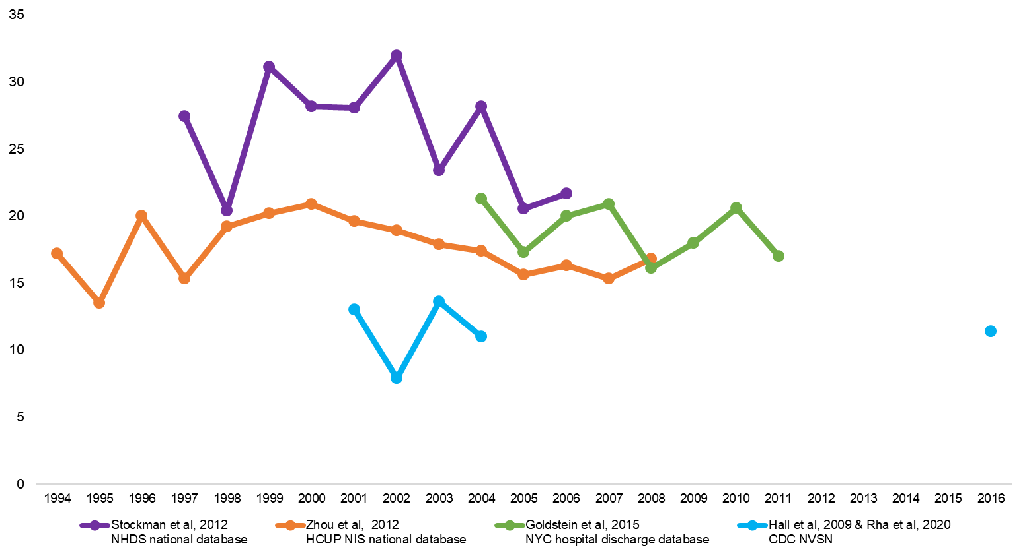

Supplementary Figure 2. Annual rates of RSV-associated hospitalization per 1000 among US infants <1 year of age over time by study
CDC NVSN= Centers for Disease Control and Prevention New Vaccines Surveillance Network; HCUP NIS= Healthcare Cost and Utilization Projection National (Nationwide) Inpatient Sample; ICD-9= International Classification of Diseases, 9th revision; MRR= medical record review; NHDS= National Hospital Discharge Survey; NYC= New York City; RSV= Respiratory Syncytial Virus; US= United States. Rates are shown only for studies identified in our review that reported yearly rates over time.

Supplementary Figure 3. Forest plot of annual RSV-associated hospitalization rates per 1000 among US children <5 years of age by study type (n=31)
ICD-9= International Classification of Diseases, 9th revision; MRR= medical record review; RSV= respiratory syncytial virus; US= United States. The x-axis represents the annual rates of RSV-associated hospitalization per 1000. Active surveillance studies were prospective and required etiologic testing and confirmation of RSV. All active prospective surveillance study estimates came from the Centers for Disease Control and Prevention New Vaccines Surveillance Network program and identified RSV via culture and reverse transcription polymerase-chain reaction (RT-PCR) of nasal and throat swabs taken from children hospitalized with acute respiratory infection in one of the study catchment sites. Retrospective MRR studies were based on passive surveillance of available standard-of-care medical and laboratory records. Two retrospective MRR studies^{11,23} adjusted their estimated RSV incidence rates upward to account for the estimated number of cases that were missed based on standard-of-care diagnostic and testing practices (ie, missed case ascertainment in passive surveillance). ICD-9 code studies were retrospective analyses of administrative claims data based on RSV-specific ICD-9 codes (466.11, 480.1, and 079.6). Model-based estimates supplemented RSV-specific ICD-9 claims data with etiologic surveillance data. Rates for children <5y were imputed based on rates in infants <1y for 17/31 (55%) estimates ^{2,5-7,10,12,15,18,19,23-25} based on Shi et al.¹

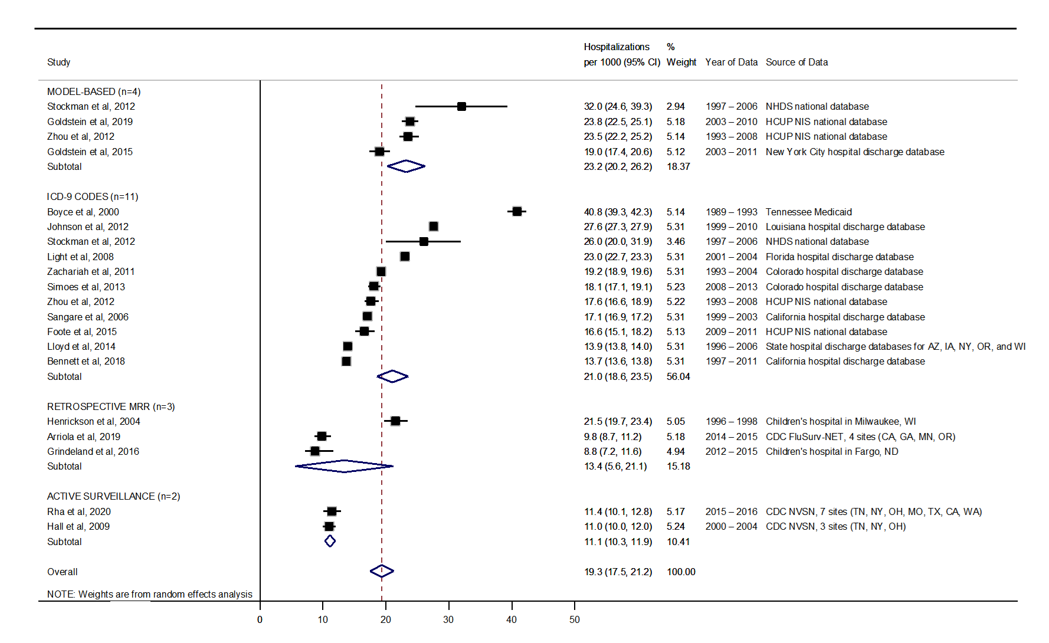
Supplementary Figure 4. Sensitivity analysis: forest plot of annual RSV-associated hospitalization rates per 1000 among US infants <1 year of age by study type (n=20)
CDC NVSN= Centers for Disease Control and Prevention New Vaccines Surveillance Network; HCUP NIS= Healthcare Cost and Utilization Projection National (Nationwide) Inpatient Sample;
ICD-9= International Classification of Diseases, 9th revision; MRR= medical record review; NHDS= National Hospital Discharge Survey; RSV= respiratory syncytial virus; US= United States. Results include estimates only from non-overlapping datasets (i.e., in sensitivity analyses, we excluded published estimates that had the same data source and overlapping time periods as another larger study). The x-axis represents the annual rates of RSV-associated hospitalization per 1000. Active surveillance studies were prospective and required etiologic testing and confirmation of RSV. All active prospective surveillance study estimates came from the CDC NVSN program and identified RSV via culture and reverse transcription polymerase-chain reaction (RT-PCR) of nasal and throat swabs taken from children hospitalized with acute respiratory infection in one of the study catchment sites. Retrospective MRR studies were based on passive surveillance of available standard-of-care medical and laboratory records. Two retrospective MRR studies^{11,23} adjusted their estimated RSV incidence rates upward to account for the estimated number of cases that were missed based on standard-of-care diagnostic and testing practices (i.e., missed case ascertainment in passive surveillance). ICD-9 code studies were retrospective analyses of administrative claims data based on RSV-specific ICD-9 codes (466.11, 480.1, and 079.6). Model-based estimates supplemented RSV-specific ICD-9 claims data with etiologic surveillance data.
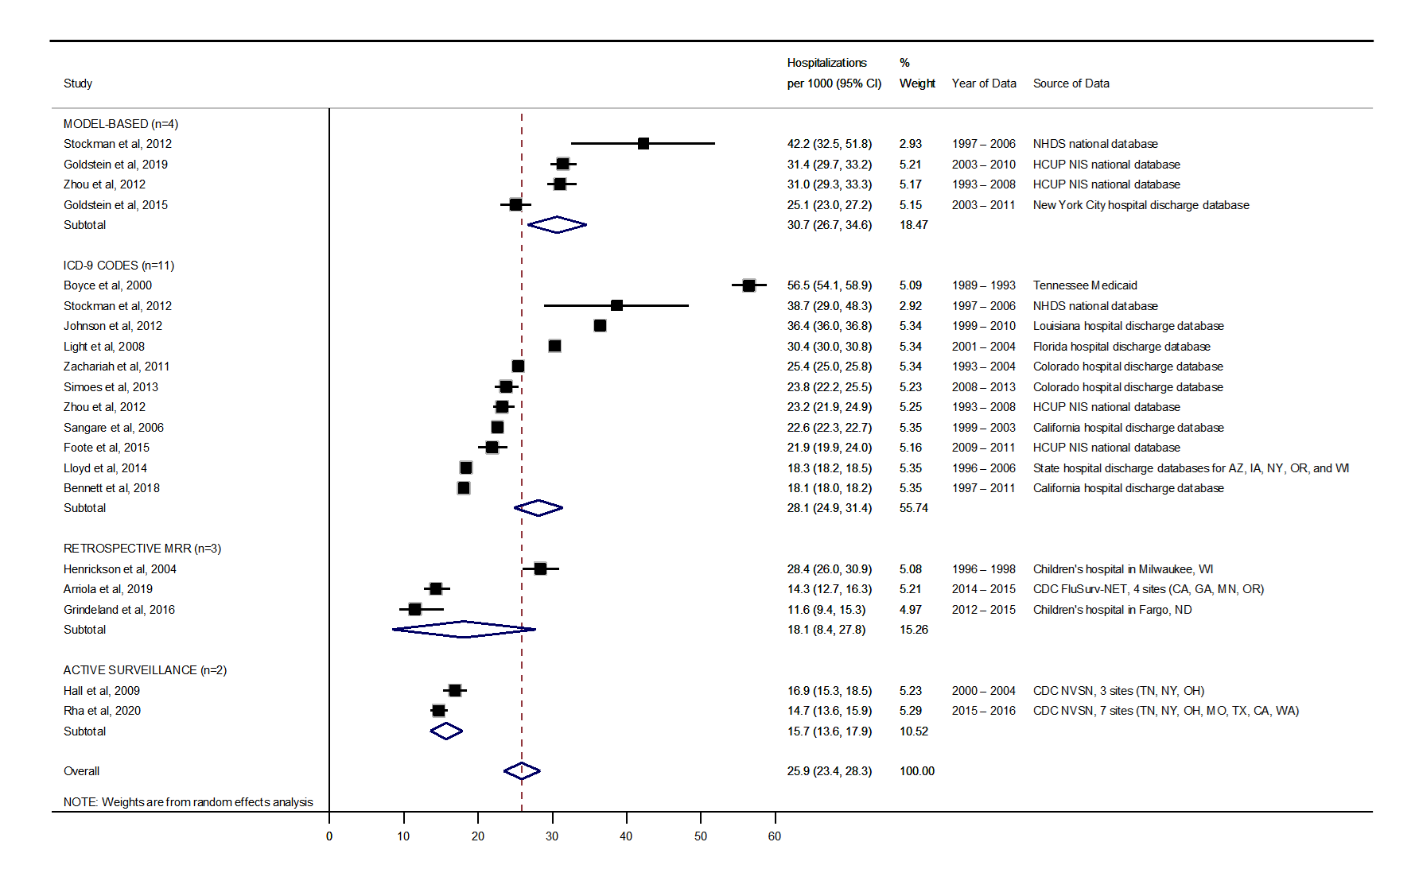
Supplementary Figure 5. Sensitivity analysis: forest plot of annual RSV-associated hospitalization rates per 1000 among US infants <6 months of age by study type (n=20)
CDC NVSN= Centers for Disease Control and Prevention New Vaccines Surveillance Network; HCUP NIS= Healthcare Cost and Utilization Projection National (Nationwide) Inpatient Sample;
ICD-9= International Classification of Diseases, 9th revision; MRR= medical record review; NHDS= National Hospital Discharge Survey; RSV= respiratory syncytial virus; US= United States. Results include estimates only from non-overlapping datasets (i.e., in sensitivity analyses, we excluded published estimates that had the same data source and overlapping time periods as another larger study). The x-axis represents the annual rates of RSV-associated hospitalization per 1000. Active surveillance studies were prospective and required etiologic testing and confirmation of RSV. All active prospective surveillance study estimates came from the CDC NVSN program and identified RSV via culture and reverse transcription polymerase-chain reaction (RT-PCR) of nasal and throat swabs taken from children hospitalized with acute respiratory infection in one of the study catchment sites. Retrospective MRR studies were based on passive surveillance of available standard-of-care medical and laboratory records. Two retrospective MRR studies^{11,23} adjusted their estimated RSV incidence rates upward to account for the estimated number of cases that were missed based on standard-of-care diagnostic and testing practices (i.e., missed case ascertainment in passive surveillance). ICD-9 code studies were retrospective analyses of administrative claims data based on RSV-specific ICD-9 codes (466.11, 480.1, and 079.6). Model-based estimates supplemented RSV-specific ICD-9 claims data with etiologic surveillance data.

References

1. Shi T, McAllister DA, O'Brien KL, et al. Global, regional, and national disease burden estimates of acute lower respiratory infections due to respiratory syncytial virus in young children in 2015: a systematic review and modelling study. Lancet 2017; 390(10098): 946-58.
2. Boyce TG, Mellen BG, Mitchel EF, Jr., Wright PF, Griffin MR. Rates of hospitalization for respiratory syncytial virus infection among children in medicaid. J Pediatr 2000; 137(6): 865-70.
3. Stockman LJ, Curns AT, Anderson LJ, Fischer-Langley G. Respiratory syncytial virus-associated hospitalizations among infants and young children in the United States, 1997-2006. Pediatr Infect Dis J 2012; 31(1): 5-9.
4. Johnson JI, Ratard R. Respiratory syncytial virus-associated hospitalizations in Louisiana. J La State Med Soc 2012; 164(5): 268-73.
5. Holman RC, Curns AT, Cheek JE, et al. Respiratory syncytial virus hospitalizations among American Indian and Alaska Native infants and the general United States infant population. Pediatrics 2004; 114(4): e437-44.
6. Leader S, Kohlhase K. Respiratory syncytial virus-coded pediatric hospitalizations, 1997 to 1999. Pediatr Infect Dis J 2002; 21(7): 629-32.
7. Leader S, Kohlhase K. Recent trends in severe respiratory syncytial virus (RSV) among US infants, 1997 to 2000. J Pediatr 2003; 143(5 Suppl): S127-32.
8. Goldstein E, Finelli L, O'Halloran A, et al. Hospitalizations Associated with Respiratory Syncytial Virus and Influenza in Children, Including Children Diagnosed with Asthma. Epidemiology 2019; 30(6): 918-26.
9. Zhou H, Thompson WW, Viboud CG, et al. Hospitalizations associated with influenza and respiratory syncytial virus in the United States, 1993-2008. Clin Infect Dis 2012; 54(10): 1427-36.
10. Light M, Bauman J, Mavunda K, Malinoski F, Eggleston M. Correlation between respiratory syncytial virus (RSV) test data and hospitalization of children for RSV lower respiratory tract illness in Florida. Pediatr Infect Dis J 2008; 27(6): 512-8.
11. Henrickson KJ, Hoover S, Kehl KS, Hua W. National disease burden of respiratory viruses detected in children by polymerase chain reaction. Pediatr Infect Dis J 2004; 23(1 Suppl): S11-8.
12. Zachariah P, Ruttenber M, Simoes EA. Hospitalizations due to respiratory syncytial virus in children with congenital malformations. Pediatr Infect Dis J 2011; 30(5): 442-5.
13. Goldstein E, Greene SK, Olson DR, Hanage WP, Lipsitch M. Estimating the hospitalization burden associated with influenza and respiratory syncytial virus in New York City, 2003-2011. Influenza Other Respir Viruses 2015; 9(5): 225-33.
14. Paramore LC, Ciuryla V, Ciesla G, Liu L. Economic impact of respiratory syncytial virus-related illness in the US: an analysis of national databases. Pharmacoeconomics 2004; 22(5): 275-84.
15. Sangare L, Curtis MP, Ahmad S. Hospitalization for respiratory syncytial virus among California infants: disparities related to race, insurance, and geography. J Pediatr 2006; 149(3): 373-7.
16. Foote EM, Singleton RJ, Holman RC, et al. Lower respiratory tract infection hospitalizations among American Indian/Alaska Native children and the general United States child population. Int J Circumpolar Health 2015; 74(1): 29256.
17. Choudhuri JA, Ogden LG, Ruttenber AJ, Thomas DS, Todd JK, Simoes EA. Effect of altitude on hospitalizations for respiratory syncytial virus infection. Pediatrics 2006; 117(2): 349-56.
18. Lloyd PC, May L, Hoffman D, Riegelman R, Simonsen L. The effect of birth month on the risk of respiratory syncytial virus hospitalization in the first year of life in the United States. Pediatr Infect Dis J 2014; 33(6): e135-40.
19. Bennett MV, McLaurin K, Ambrose C, Lee HC. Population-based trends and underlying risk factors for infant respiratory syncytial virus and bronchiolitis hospitalizations. PLoS One 2018; 13(10): e0205399.
20. Iwane MK, Edwards KM, Szilagyi PG, et al. Population-based surveillance for hospitalizations associated with respiratory syncytial virus, influenza virus, and parainfluenza viruses among young children. Pediatrics 2004; 113(6): 1758-64.
21. Rha B, Curns AT, Lively JY, et al. Respiratory Syncytial Virus-Associated Hospitalizations Among Young Children: 2015-2016. Pediatrics 2020; 146(1).
22. Hall CB, Weinberg GA, Iwane MK, et al. The burden of respiratory syncytial virus infection in young children. N Engl J Med 2009; 360(6): 588-98.
23. Arriola CS, Kim L, Langley G, et al. Estimated Burden of Community-Onset Respiratory Syncytial Virus-Associated Hospitalizations Among Children Aged <2 Years in the United States, 2014-15. J Pediatric Infect Dis Soc 2019.
24. Grindeland CJ, Mauriello CT, Leedahl DD, Richter LM, Meyer AC. Association Between Updated Guideline-Based Palivizumab Administration and Hospitalizations for Respiratory Syncytial Virus Infections. Pediatr Infect Dis J 2016; 35(7): 728-32.
25. Hall CB, Weinberg GA, Blumkin AK, et al. Respiratory syncytial virus-associated hospitalizations among children less than 24 months of age. Pediatrics 2013; 132(2): e341-8.

