SUPPLEMENTARY DATA

Table S1. Search strategy (January 07, 2021)
PubMed (23 hits)
(“pericarditis, constrictive”[mesh] OR “constrictive pericarditis”[tiab] OR constriction[tiab]) AND (“cardiomyopathy, restrictive”[mesh] OR restrictive[tiab] OR restriction[tiab]) AND (“natriuretic peptides”[mesh] OR “natriuretic peptide, brain”[mesh] OR “natriuretic peptide”[tiab] OR “natriuretic peptides”[tiab] OR BNP[tiab] OR “NT-proBNP”[tiab])
Embase (65 hits)
('constrictive pericarditis'/exp OR 'constrictive pericarditis' OR 'constriction'/exp OR 'constriction') AND ('restrictive' OR 'restriction') AND ('natriuretic peptide'/exp OR 'natriuretic peptide' OR 'natriuretic peptides'/exp OR 'natriuretic peptides' OR 'bnp' OR 'nt-probnp')
Scopus (226 hits)
TITLE-ABS-KEY ((“constrictive pericarditis” OR “constriction”) AND (“restrictive” OR “restriction”) AND (“natriuretic peptide” OR “natriuretic peptides” OR “BNP” OR “NT-proBNP”))
Web of Science (32 hits)
ALL=((“constrictive pericarditis” OR “constriction”) AND (“restrictive” OR “restriction”) AND (“natriuretic peptide” OR “natriuretic peptides” OR “BNP” OR “NT-proBNP”))

Table S2. Newcastle-Ottawa scale for risk of bias assessment of case-control studies
Study | SELECTION |  |  |  | COMPARABILITY | EXPOSURE |  |  | Total (maximum = 9)
Study | Is the case definition adequate | Representativeness of the cases | Selection of Controls | Definition of Controls | COMPARABILITY | Ascertainment of exposure | Same method of ascertainment for cases and controls | Non-Response rate | Total (maximum = 9)
Karaahmet, 2009 | * | - | * | * | - | * | * | * | 6
Parakh, 2015 | * | - | * | - | - | * | * | * | 5

Table S3. Newcastle-Ottawa scale for risk of bias assessment of cohort studies
Study | SELECTION |  |  |  | COMPARABILITY | OUTCOME |  |  | Total (maximum = 9)
Study | Representativeness of the exposed cohort | Selection of the non-exposed cohort | Ascertainment of the exposure | Outcome status at start of study | COMPARABILITY | Assessment of the outcome | Length of follow-up | Adequacy of follow-up | Total (maximum = 9)
Reddy, 2007 | - | * | * | * | - | - | * | * | 5
Mady, 2008 | - | * | * | * | - | * | * | * | 6

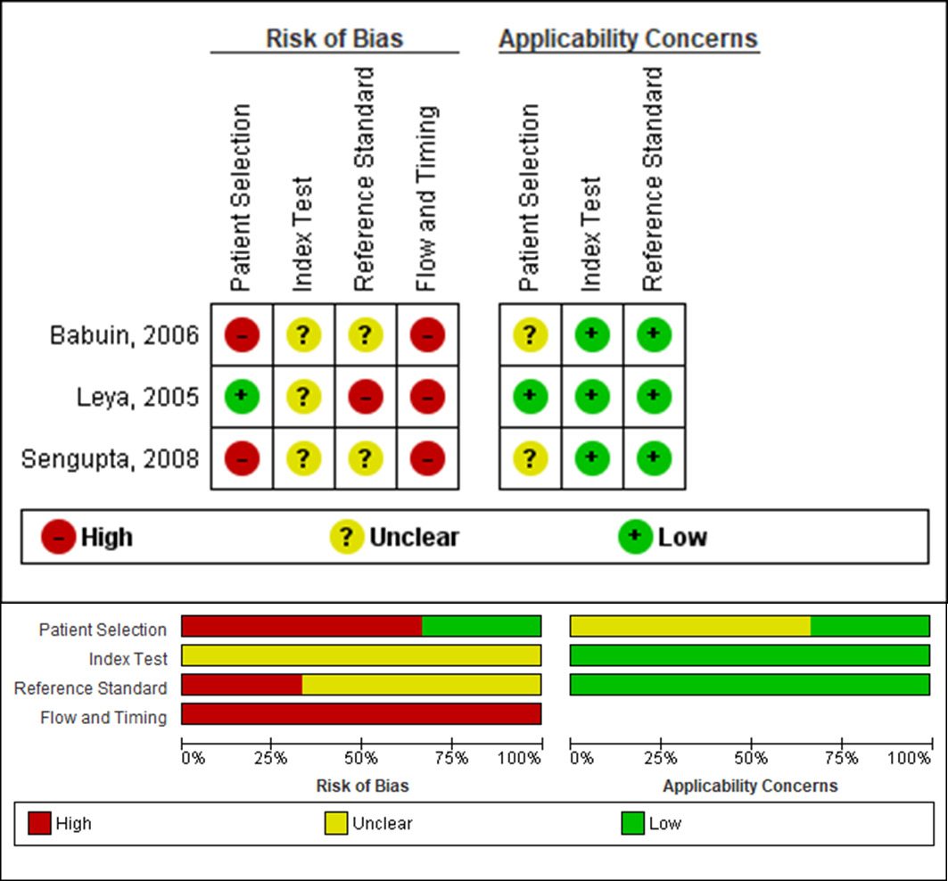
Figure S1. Risk of bias and applicability concerns for each included study using QUADAS-2 tool

