MEDLINE (Ovid)
Population |  | AND Outcome |  | AND Intervention
Title | "Aged care" OR "Assisted living facilit*" OR "Community based aged care" OR "Community based care" OR "Community care" OR "Community support" OR "Elder care" OR "Home care" OR "Home based care" OR "Home health care" OR "home healthcare" OR "Home support" OR "Housing for the elderly" OR "In-home care" OR "Long term care" OR "Nursing care facilit*" OR "Nursing home*" OR "Old age home" OR "Older adult*" OR "Residential care" OR "Residential facilit*" OR "Skilled nursing facilit*" OR "Social care" | Title | Fall* | Title | "Algorithm*" OR "Artificial intelligence" OR "Deep learning" OR "Machine learning" OR "Model*" OR "Predict*" OR "Screen*"
OR Abstract | "Aged care" OR "Assisted living facilit*" OR "Community based aged care" OR "Community based care" OR "Community care" OR "Community support" OR "Elder care" OR "Home care" OR "Home based care" OR "Home health care" OR "home healthcare" OR "Home support" OR "Housing for the elderly" OR "In-home care" OR "Long term care" OR "Nursing care facilit*" OR "Nursing home*" OR "Old age home" OR "Older adult*" OR "Residential care" OR "Residential facilit*" OR "Skilled nursing facilit*" OR "Social care" | OR Abstract | Fall* | OR Abstract | "Algorithm*" OR "Artificial intelligence" OR "Deep learning" OR "Machine learning" OR "Model*" OR "Predict*" OR "Screen*"
OR MeSH terms | Residential facilities/ or assisted living facilities/ or home for the aged/ or nursing homes OR  Home care services/ or home health nursing/ or senior centres OR  Health services for the aged/ OR  Adult day care centres/ | OR MeSH terms | Accidental falls | OR MeSH terms | Models, statistical  OR  Algorithms/ or artificial intelligence/ or machine learning/
Limits | English language  2000-current | Limits | English language  2000-current | Limits | English language  2000-current

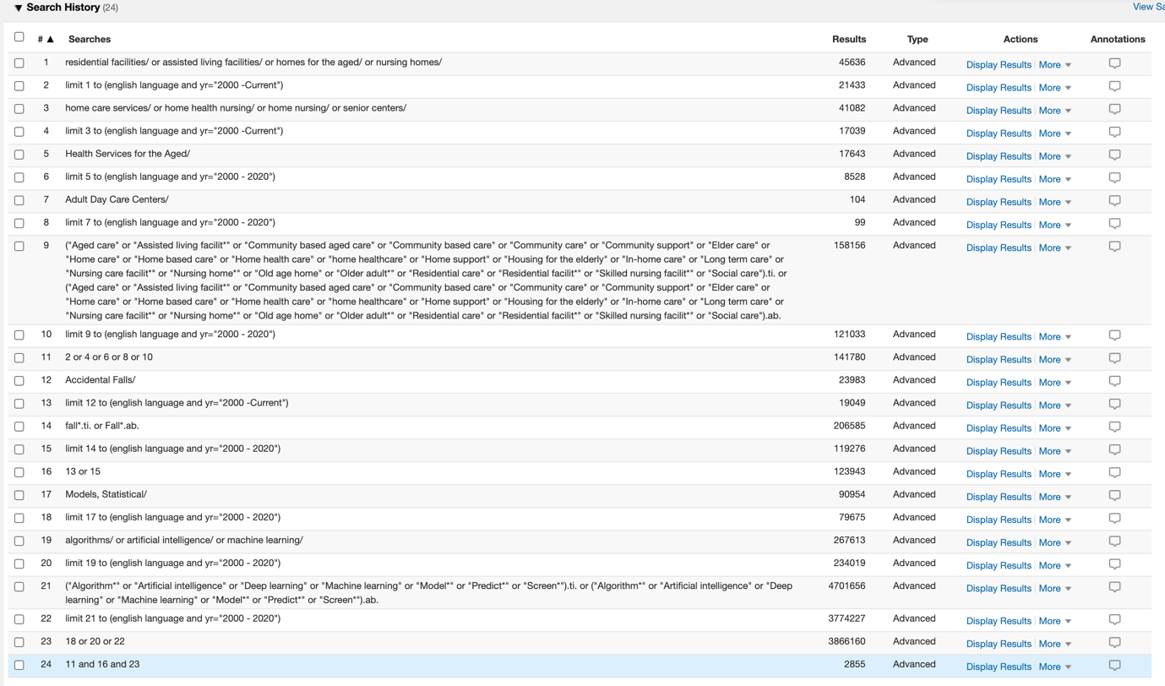

Web of Science Core Collection
Population |  | AND Outcome |  | AND Intervention
Topic | "Aged care" OR "Assisted living facilit*" OR "Community based aged care" OR "Community based care" OR "Community care" OR "Community support" OR "Elder care" OR "Home care" OR "Home based care" OR "Home health care" OR "home healthcare" OR "Home support" OR "Housing for the elderly" OR "In-home care" OR "Long term care" OR "Nursing care facilit*" OR "Nursing home*" OR "Old age home" OR "Older adult*" OR "Residential care" OR "Residential facilit*" OR "Skilled nursing facilit*" OR "Social care" | Topic | Fall* | Topic | "Algorithm*" OR "Artificial intelligence" OR "Deep learning" OR "Machine learning" OR "Model*" OR "Predict*" OR "Screen*"
Limits | English language  2000-2020 | Limits | English language  2000-2020 | Limits | English language  2000-2020

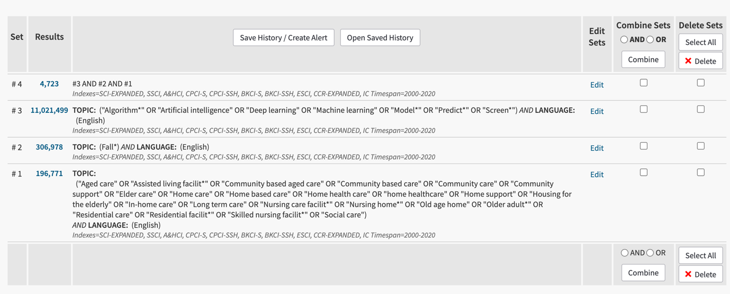
Scopus
Population |  | AND Outcome |  | AND Intervention
Topic | "Aged care" OR "Assisted living facilit*" OR "Community based aged care" OR "Community based care" OR "Community care" OR "Community support" OR "Elder care" OR "Home care" OR "Home based care" OR "Home health care" OR "home healthcare" OR "Home support" OR "Housing for the elderly" OR "In-home care" OR "Long term care" OR "Nursing care facilit*" OR "Nursing home*" OR "Old age home" OR "Older adult*" OR "Residential care" OR "Residential facilit*" OR "Skilled nursing facilit*" OR "Social care"  (Note: terms had to be split over two searches due to limit on number of search terms). | Topic | Fall* | Topic | "Algorithm*" OR "Artificial intelligence" OR "Deep learning" OR "Machine learning" OR "Model*" OR "Predict*" OR "Screen*"
Limits | English language  2000-present | Limits | English language  2000-present | Limits | English language  2000-present

( ( TITLE-ABS-KEY ( "Aged care" OR "Assisted living facilit*" OR "Community based aged care" OR "Community based care" OR "Community care" OR "Community support" OR "Elder care" OR "Home care" OR "Home based care" OR "Home health care" OR "home healthcare" OR "Home support" ) OR TITLE-ABS-KEY ( "Housing for the elderly" OR "In-home care" OR "Long term care" OR "Nursing care facilit*" OR "Nursing home*" OR "Old age home" OR "Older adult*" OR "Residential care" OR "Residential facilit*" OR "Skilled nursing facilit*" OR "Social care" ) ) AND PUBYEAR > 1999 ) AND ( TITLE-ABS-KEY ( fall* ) AND PUBYEAR > 1999 ) AND ( TITLE-ABS-KEY ( "Algorithm*" OR "Artificial intelligence" OR "Deep learning" OR "Machine learning" OR "Model*" OR "Predict*" OR "Screen*" ) AND PUBYEAR > 1999 ) AND ( LIMIT-TO ( LANGUAGE , "English" ) )

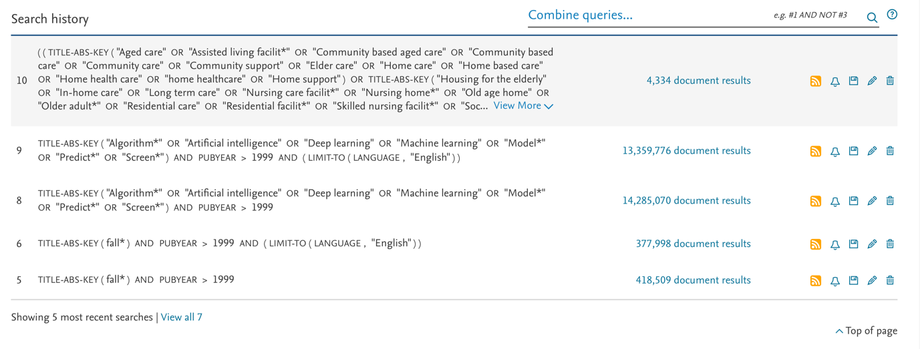
CINAHL
Population |  | AND Outcome |  | AND Intervention
Title | "Aged care" OR "Assisted living facilit*" OR "Community based aged care" OR "Community based care" OR "Community care" OR "Community support" OR "Elder care" OR "Home care" OR "Home based care" OR "Home health care" OR "home healthcare" OR "Home support" OR "Housing for the elderly" OR "In-home care" OR "Long term care" OR "Nursing care facilit*" OR "Nursing home*" OR "Old age home" OR "Older adult*" OR "Residential care" OR "Residential facilit*" OR "Skilled nursing facilit*" OR "Social care" | Title | Fall* | Title | "Algorithm*" OR "Artificial intelligence" OR "Deep learning" OR "Machine learning" OR "Model*" OR "Predict*" OR "Screen*"
OR Abstract | "Aged care" OR "Assisted living facilit*" OR "Community based aged care" OR "Community based care" OR "Community care" OR "Community support" OR "Elder care" OR "Home care" OR "Home based care" OR "Home health care" OR "home healthcare" OR "Home support" OR "Housing for the elderly" OR "In-home care" OR "Long term care" OR "Nursing care facilit*" OR "Nursing home*" OR "Old age home" OR "Older adult*" OR "Residential care" OR "Residential facilit*" OR "Skilled nursing facilit*” OR “social care” | OR Abstract | Fall* | OR Abstract | "Algorithm*" OR "Artificial intelligence" OR "Deep learning" OR "Machine learning" OR "Model*" OR "Predict*" OR "Screen*"
OR Subject terms | Nursing home OR  Nursing home patients OR  Housing for the elderly OR  Home health care OR  Skilled nursing facility OR  Residential care OR  Long term care OR  Older adult care OR  Home nursing, professional OR | OR Subject terms | Accidental falls OR  Falls risk | OR Subject terms | Models, statistical OR  Algorithms OR  Artificial intelligence OR  Machine learning OR  Deep learning
Limits | English language  2000-2020 | Limits | English language  2000-2020 | Limits | English language  2000-2020

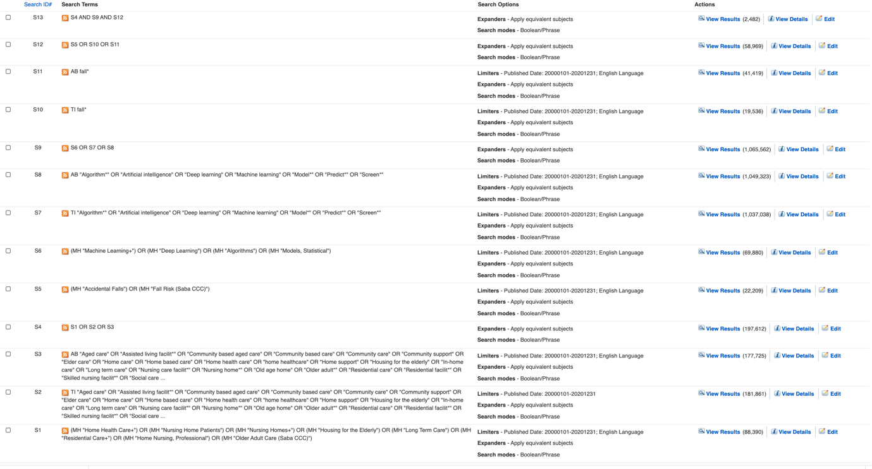

Cochrane
Population |  | AND Outcome |  | AND Intervention
Title | "Aged care" OR "Assisted living facilit*" OR "Community based aged care" OR "Community based care" OR "Community care" OR "Community support" OR "Elder care" OR "Home care" OR "Home based care" OR "Home health care" OR "home healthcare" OR "Home support" OR "Housing for the elderly" OR "In-home care" OR "Long term care" OR "Nursing care facilit*" OR "Nursing home*" OR "Old age home" OR "Older adult*" OR "Residential care" OR "Residential facilit*" OR "Skilled nursing facilit*" OR "Social care" | Title | Fall* | Title | "Algorithm*" OR "Artificial intelligence" OR "Deep learning" OR "Machine learning" OR "Model*" OR "Predict*" OR "Screen*"
OR Abstract | "Aged care" OR "Assisted living facilit*" OR "Community based aged care" OR "Community based care" OR "Community care" OR "Community support" OR "Elder care" OR "Home care" OR "Home based care" OR "Home health care" OR "home healthcare" OR "Home support" OR "Housing for the elderly" OR "In-home care" OR "Long term care" OR "Nursing care facilit*" OR "Nursing home*" OR "Old age home" OR "Older adult*" OR "Residential care" OR "Residential facilit*" OR "Skilled nursing facilit*" OR "Social care" | OR Abstract | Fall* | OR Abstract | "Algorithm*" OR "Artificial intelligence" OR "Deep learning" OR "Machine learning" OR "Model*" OR "Predict*" OR "Screen*"
OR Subject terms | Home care services  Residential facilities OR  Long term care OR | OR Subject terms | Accidental falls | OR Subject terms | Models, statistical OR  Algorithms OR  Machine learning OR
Limits | English language  2000-2020 | Limits | English language  2000-2020 | Limits | English language  2000-2020



