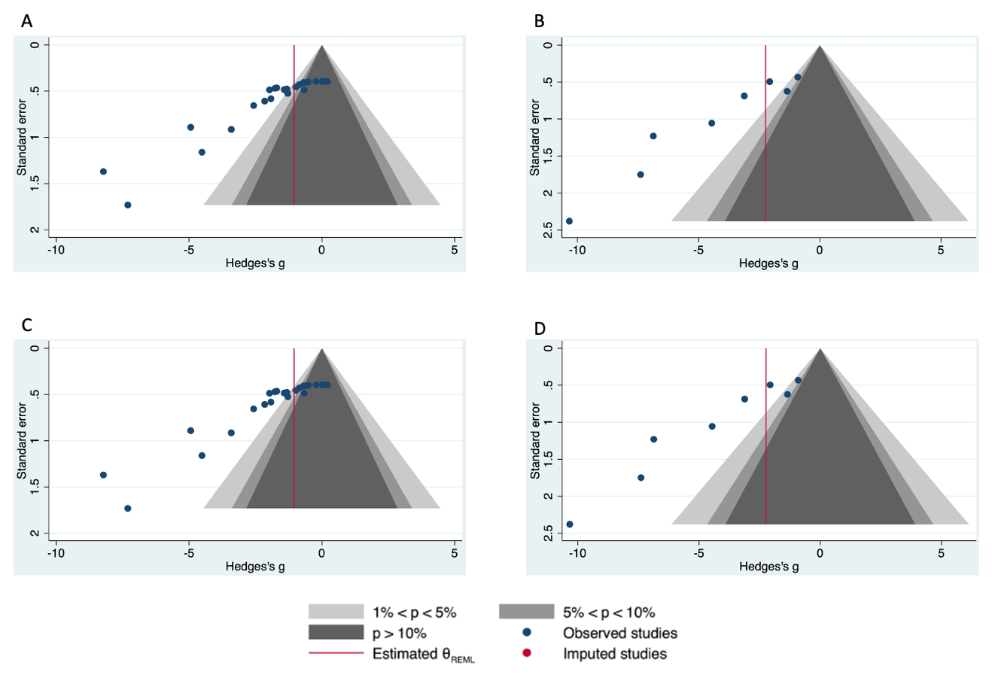
Supplementary Figure 4. Funnel plots for studies greater than 2 weeks in duration. (A) Contour enhanced funnel plot for BV/TV and (B) vBMD. (C) Trim and fill for BV/TV and (D) vBMD. LPS (lipopolysaccharide), vBMD (volumetric bone mineral density). No missing studies were imputed for BV/TV or vBMD. SE (standard error), SMD (standardized mean difference) calculated as Hedge’s g.

