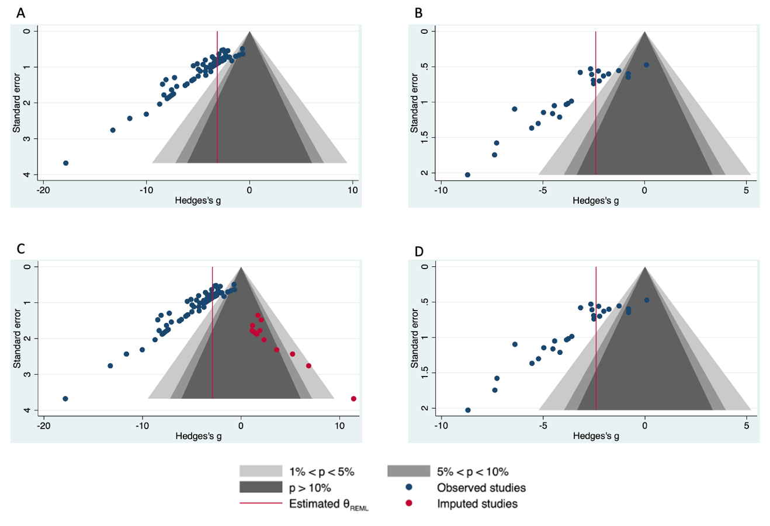
Supplementary Figure 3. Funnel plots for studies shorter than 2 weeks in duration. (A) Contour enhanced funnel plot for studies for BV/TV and (B) vBMD. (C) Trim and fill for BV/TV (23 studies imputed; Observed SMD = -4.106, 95% CI [-4.607, -3.605]; Imputed SMD = -2.979, 95% CI [-3.662, -2.295] and (D) vBMD (no missing studies imputed). LPS (lipopolysaccharide), BV/TV (bone volume fraction), SMD (standardized mean difference) calculated as Hedge’s g, CI (confidence interval).

