Supplementary Information

Contents
Supplementary Table S1. Search strategy for Medical Literature Analysis and Retrieval System Online (MEDLINE)
Supplementary Table S2. Search strategy for Cochrane Central Register of Controlled Trials
Supplementary Table S3. Excluded literature by full-text screening
Supplementary Table S4. Definitions of each index test
Supplementary Table S5. Details of the assessment of QUDAS-2 tool
Supplementary Table S6. HSROC parameters
Supplementary Figure S1. Calculator for the summary point from the HSROC Model
Supplementary Figure S2. Typical high-resolution CT findings in patients with ARDS
* The review protocol was prospectively registered with the University Hospital Medical Information Network Clinical Trials Registry (UMIN000040725).

Supplementary Table S1. Search strategy for Medical Literature Analysis and Retrieval System Online (MEDLINE)

Search number | Query | Results
#1 | Respiratory Distress Syndrome, Adult [mh] | 19,356
#2 | Acute lung injury [mh] | 6,231
#3 | ALI [tiab] OR ARDS [tiab] | 18,076
#4 | Acute lung injur* [tiab] OR Acute respiratory distress [tiab] OR Acute respiratory failure[tiab] | 31,624
#5 | "severe respiratory failure"[tiab] | 1,418
#6 | #1 OR #2 OR #3 OR #4 OR #5 | 47,232
#7 | (High Resolution Computed Tomography[tiab] OR HRCT[tiab] OR high-resolution CT[tiab] OR tomography, x-ray computed[mh]) AND lung[mh] | 15,632
#8 | #6 AND #7 | 426
#9 | animals[mh] NOT humans[mh] | 4,709,914
#10 | #8 NOT #9 | 343

Supplementary Table S2. Search strategy for Cochrane Central Register of Controlled Trials

ID | Search | Results
#1 | [mh "Respiratory Distress Syndrome, Adult"] | 1302
#2 | [mh "Acute lung injury"] | 440
#3 | ALI:ti,ab OR ARDS:ti,ab | 3217
#4 | "Acute lung injury":ti,ab OR "Acute respiratory distress":ti,ab OR "Acute respiratory failure":ti,ab | 2933
#5 | "severe respiratory failure":ti,ab | 121
#6 | {OR #1-#5} | 5388
#7 | ("High Resolution Computed Tomography":ti,ab OR HRCT:ti,ab OR "high-resolution CT":ti,ab OR [mh "tomography, x-ray computed"]) AND [mh lung] | 40
#8 | #6 AND #7 | 1
#9 | [mh animals] NOT [mh humans] | 6792
#10 | #8 NOT #9 | 1

Supplementary Table S3. Excluded literature by full-text screening

Title | Year | Author | Reason
Radiology in the diagnosis of adult respiratory distress syndrome with special reference to pulmonary oedema--its distribution and detection | 1988 | Wegenius, G | Wrong study design
Understanding images: correlation between computerized tomographic scans of lung structure with impaired function in ARDS | 1988 | Zapol, W M | Wrong study design
CT scan in ARDS: clinical and physiopathological insights | 1991 | Gattinoni, L | Wrong study design
Correlative study of adult respiratory distress syndrome by light, scanning, and transmission electron microscopy | 1992 | Anderson, W R | Wrong study design or index test
CT and chest radiography in the evaluation of adult respiratory distress syndrome | 1994 | Tagliabue, M | Wrong study design or population
Computed tomography in established adult respiratory distress syndrome. Correlation with lung injury score | 1994 | Owens, C M | Wrong study design
Acute respiratory distress syndrome: CT abnormalities at long-term follow-up | 1999 | Desai, S R | Wrong study design
Regional distribution of gas and tissue in acute respiratory distress syndrome. I. Consequences for lung morphology. CT Scan ARDS Study Group | 2000 | Puybasset, L; Cluzel | Wrong study design or outcome
Regional distribution of gas and tissue in acute respiratory distress syndrome. III. Consequences for the effects of positive end-expiratory pressure. CT Scan ARDS Study Group. Adult Respiratory Distress Syndrome | 2000 | Puybasset, L; Gusman | Wrong study design
Acute respiratory distress syndrome caused by pulmonary and extrapulmonary injury: a comparative CT study | 2001 | Desai, S R | Wrong study design
Computerised tomography scan imaging in acute respiratory distress syndrome | 2001 | Pesenti, A | Wrong study design
Can the tomographic aspect characteristics of patients presenting with acute respiratory distress syndrome predict improvement in oxygenation-related response to the prone position? | 2002 | Papazian, Laurent | Wrong study design
Measurement of alveolar derecruitment in patients with acute lung injury: computerized tomography versus pressure-volume curve | 2006 | Lu, Qin | Wrong study design
Radiological imaging in acute lung injury and acute respiratory distress syndrome | 2006 | Caironi, Pietro | Wrong study design
Causes and prognosis of diffuse alveolar damage diagnosed on surgical lung biopsy | 2007 | Parambil, Joseph G | Wrong study design
Qualitative and quantitative CT analysis of acute pulmonary failure | 2009 | Reske, A W | Wrong study design or language
Diagnostic contribution from pulmonary biopsies in hematology patients with acute respiratory failure from undetermined etiology | 2013 | Gay, J | Wrong study design or population
Lung inhomogeneity in patients with acute respiratory distress syndrome | 2014 | Cressoni, Massimo | Wrong study design
Detection of fibroproliferation by chest high-resolution CT scan in resolving ARDS | 2014 | Burnham, Ellen L | Wrong study design or outcome
A follow-up study on acute respiratory distress syndrome survivors after extracorporeal membrane oxygenation by pulmonary high-resolution CT | 2015 | Li, Xu-Yan | Wrong study design
Lung inhomogeneities, inflation and [18F]2-fluoro-2-deoxy-D-glucose uptake rate in acute respiratory distress syndrome | 2016 | Cressoni, Massimo | Wrong study design or outcome
Lung Recruitment Assessed by Respiratory Mechanics and Computed Tomography in Patients with Acute Respiratory Distress Syndrome. What Is the Relationship? | 2016 | Chiumello, Davide | Wrong study design
The clinical benefit of a follow-up thoracic computed tomography scan regarding parenchymal lung injury and acute respiratory distress syndrome in polytraumatized patients | 2017 | Negrin, Lukas | Wrong study design or population
Clinical characteristics and prognosis of drug-associated acute respiratory distress syndrome compared with non-drug-associated acute respiratory distress syndrome: a single-centre retrospective study in Japan. | 2017 | Anan, Keisuke | Wrong study design
Automatic quantitative computed tomography segmentation and analysis of aerated lung volumes in acute respiratory distress syndrome-A comparative diagnostic study | 2017 | Klapsing, Philipp | Wrong study design

Supplementary Table S4. Definitions of each index test

Author, Year | Index test | Definition
Nishiyama, 2020 [1] | Well-aerated lung region/pTLC | Lung regions were classified into 4 categories by CT attenuation densities: 1) hyperinflated, density between -1000 and -901 Hounsfield units (HU); 2) normally aerated, density between -900 and -501 HU; 3) poorly aerated, density between -500 and -101 HU; and 4) non-aerated, density between +100 and -100 HU. The volume of each lung region was divided by pTLC to correct for differences in physique among patients. We considered hyperinflated and normally aerated regions (density below -500 HU) as well-aerated lung regions for this study and defined the well-aerated group and less-aerated group based on the median percentage of well-aerated lung region/pTLC.
Kamo, 2019 [2] | HRCT score | HRCT findings were graded on a scale of 1–6 based on the classification system correlating with previously de- scribed pathology: 1, normal attenuation; 2, ground-glass attenuation; 3, consolidation; 4, ground-glass attenuation with traction bronchiolectasis or bronchiectasis; 5, consolidation with traction bronchiolectasis or bronchiectasis and 6, honeycombing. The presence of each of these six abnormalities was assessed independently in three (upper, middle and lower) zones of each lung. The abnormality score for each zone was calculated by multiplying the percentage area by the point value (1–6). The six zone scores were aver- aged to determine the total score for each abnormality in each patient.
Ichikado, 2012 [3] | HRCT score | HRCT findings were graded on a scale of 1–6 based on the classification system correlating with previously described pathology: 1, normal attenuation;2, ground-glass attenuation; 3, consolidation; 4, ground-glass attenuation with traction bronchiolectasis or bronchiectasis; 5, consolidation with traction bronchiolectasis or bronchiectasis and 6, honeycombing. The presence of each of these six abnormalities was assessed independently in three (upper, middle and lower) zones of each lung. The abnormality score for each zone was calculated by multiplying the percentage area by the point value (1–6). The six zone scores were aver- aged to determine the total score for each abnormality in each patient.
Chung, 2011 [4] | Affected lung | Percentage of lung involvement was estimated qualitatively to the nearest 10th percentile (e.g. 10%, 20%, etc.). Ground-glass opacities were defined as lung opacities that did not obscure blood vessels. Consolidation was defined as lung opacities that did obscure blood vessels.
Ichikado, 2006 [5] | CT score | The thin-section CT findings were graded on a scale of 1– 6 on the basis of the classification system previously de- scribed (15): score of 1, normal attenuation; score of 2, ground-glass attenuation; score of 3, consolidation; score of 4, ground-glass attenuation with traction bronchiolectasis or bronchiectasis; score of 5, consolidation with traction bronchiolectasis or bronchiectasis; and score of 6, honeycombing. The presence of each of these six abnormalities was assessed independently in three (upper, middle, and lower) zones of each lung. The ab- normality score for each zone was calculated by multiplying the percentage area by the point value (the score of 1–6). The six zone scores were aver- aged to determine the total score for each abnormality in each patient.
Rouby, 2000 [6] | Diffuse attenuations | Classification of the chest radiograph was as follows: “lobar” if hyperattenuations areas involved essentially the lower lobes; “diffuse” if hyperattenuated areas were equally disseminated within the upper and lower lobes, presenting the characteristic feature of “white lungs”; “patchy” if hyperattenuated areas involved the upper and lower lobes with a persistent aeration of a part of the upper lobes.
HRCT, high-resolution computed tomography; pTLC, predicted total lung capacity

Supplementary Table S5. Details of the assessment of QUDAS-2 tool

 |  | Patients selection |  |  | Index test |  |  | Reference standard |  | Patients flow
Author | Year | Bias | Reason | Applicability | Bias | Reason | Applicability | Bias | Applicability | Bias | Reason
Rouby, et al | 2000 | Low |  | Low concern | High | Not  pre-specified | Low concern | Low | Low concern | Low
Ichikado, et al | 2006 | Low |  | Low concern | High | Not  pre-specified | Low concern | Low | Low concern | Low
Chung, et al | 2011 | Low |  | Low concern | High | Blind was unclear | Low concern | Low | Low concern | Low
Ichikado, et al | 2012 | High | Inappropriate exclusion | Low concern | High | Blind was unclear | Low concern | Low | Low concern | Low
Kamo, et al | 2019 | High | Inappropriate exclusion | Low concern | High | Not pre-specified  Blind was unclear | Low concern | Low | Low concern | High | Inappropriate Exclusion in analysis
Nishiyama, et al | 2020 | High | Inappropriate exclusion | Low concern | High | Not pre-specified and not blind | Low concern | Low | Low concern | Low
QUADAS, Quality Assessment of Diagnostic Accuracy Studies

Supplementary Table S6. HSROC parameters

Parameter name | Value
θ | -0.569
λ | 1.954
β | -0.743
σ_{θ} | 0.334
σ_{α} | 0.000

HSROC, hierarchical summary receiver operating characteristic

SupplementaryFigure S1. Calculator for the summary point from the HSROC Model

A) Probability density plot
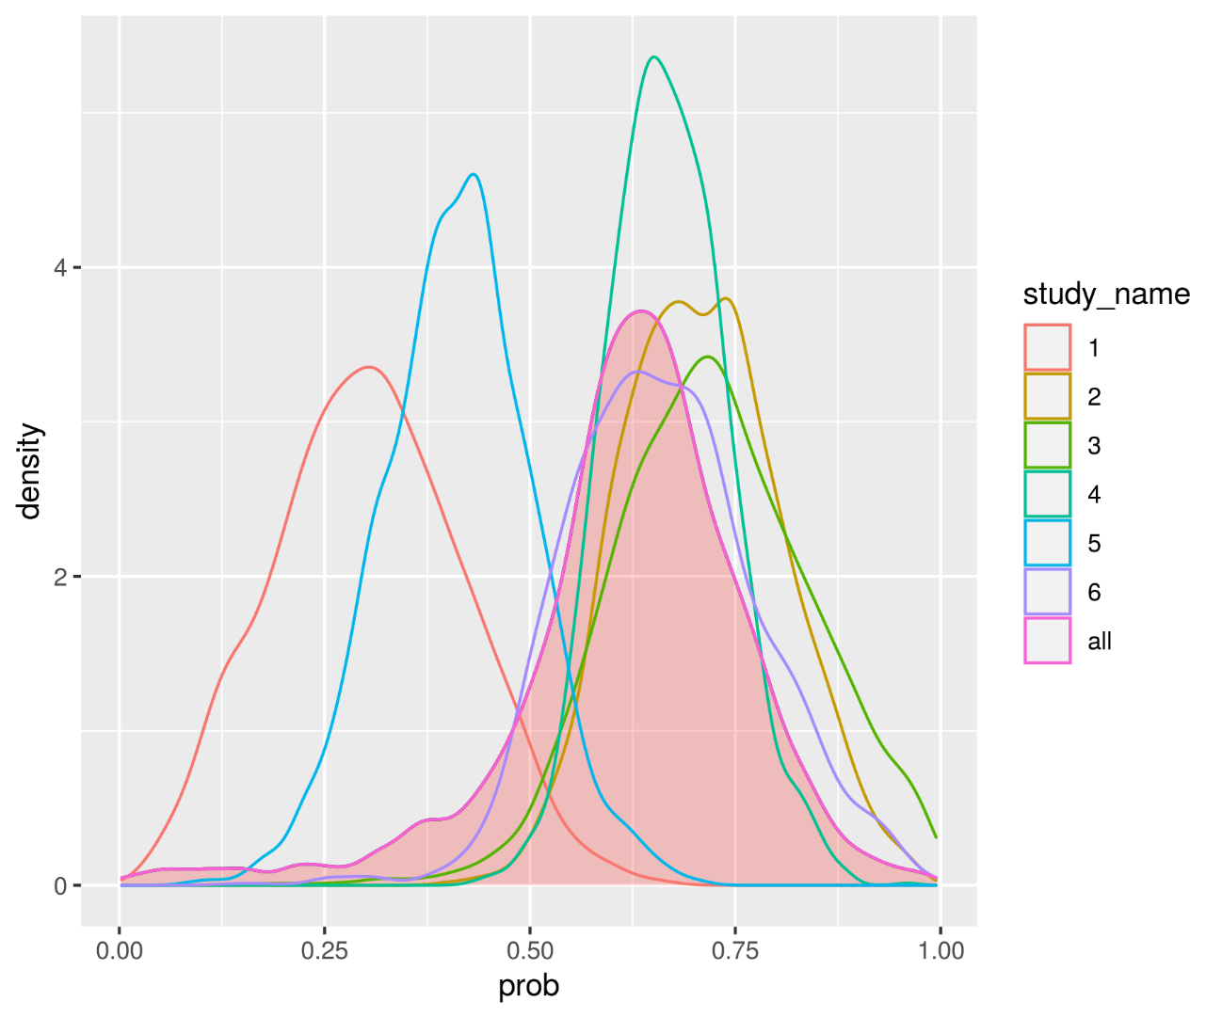
Study_name was followed as:
1, Rouby 2000; 2, Ichikado 2006; 3, Chung 2011; 4, Ichikado 2012; 5, Kamo 2019; 6 Nishiyama 202
* The pooled sensitivity was calculated from the fixed specificity (0.760, as median of all studies).

b) Markov chain trace plot
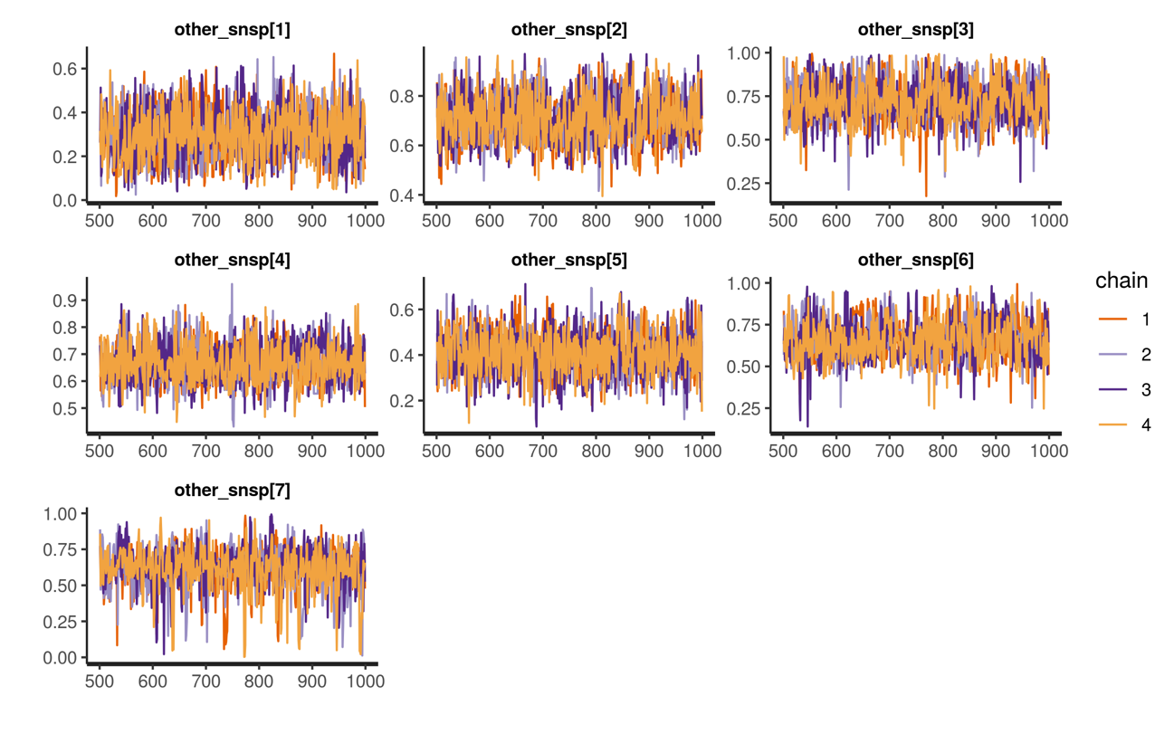
* The pooled sensitivity was calculated from the fixed specificity (0.760, as median of all studies).
HSROC, hierarchical summary receiver operating characteristic

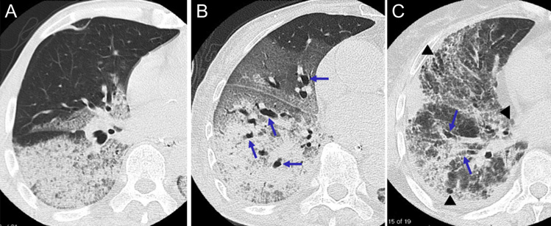
SupplementaryFigure S2. Typical high-resolution CT findings in patients with ARDS
High-resolution CT (HRCT) findings correlated with pathology was cited by a previous study [3].
(A) HRCT findings corresponding to exudative phase of ARDS. HRCT scan at the level of right middle lobe shows dependent airspace consolidation without traction bronchiectasis and nondependent areas of sparing. The patient was a 68-year-old man with ARDS due to Streptococcus pneumonia. (B) HRCT findings corresponding to fibroproliferative phase of ARDS. HRCT scan at the level of right lower lobe shows extensive airspace consolidation and ground-glass attenuation associated with traction bronchiectasis (arrows). The patient was an 84-year-old woman with ARDS due to sepsis. (C) HRCT findings corresponding to fibrotic phase of ARDS. HRCT scan at the level of right inferior pulmonary vein shows extensive ground-glass attenuation associated with traction bronchiectasis (arrows), coarse reticulation and cystic changes (arrowheads). The patient was a 65-year-old woman with ARDS due to viral pneumonia.

1 Nishiyama, A. et al. A predictive factor for patients with acute respiratory distress syndrome: CT lung volumetry of the well-aerated region as an automated method. Eur J Radiol. 122,108748(2020).
2 Kamo, T. et al. Prognostic values of the Berlin definition criteria, blood lactate level, and fibroproliferative changes on high-resolution computed tomography in ARDS patients. BMC Pulm Med. 19,37(2019).
3 Ichikado, K. et al. Fibroproliferative changes on high-resolution CT in the acute respiratory distress syndrome predict mortality and ventilator dependency: a prospective observational cohort study. BMJ Open. 2,e000545(2012).
4 Chung, J. H., Kradin, R. L., Greene, R. E., Shepard, J. A. & Digumarthy, S. R. CT predictors of mortality in pathology confirmed ARDS. Eur Radiol. 21,730-737(2011).
5 Ichikado, K. et al. Prediction of prognosis for acute respiratory distress syndrome with thin-section CT: validation in 44 cases. Radiology. 238,321-329(2006).
6 Rouby, J. J. et al. Regional distribution of gas and tissue in acute respiratory distress syndrome. II. Physiological correlations and definition of an ARDS Severity Score. CT Scan ARDS Study Group. Intensive Care Med. 26,1046-1056(2000).

