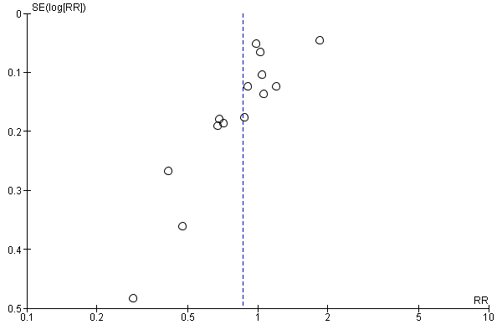
Figure S1. Funnel plot of comparison: Remote support versus standard care/control, outcome: Stopping exclusive breastfeeding at 4-8 weeks.
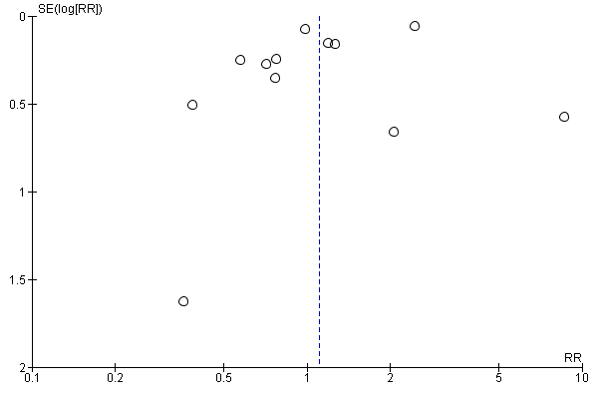
Figure S2. Funnel plot of comparison: Remote support versus standard care/control, outcome: Stopping any breastfeeding at 4-8 weeks.
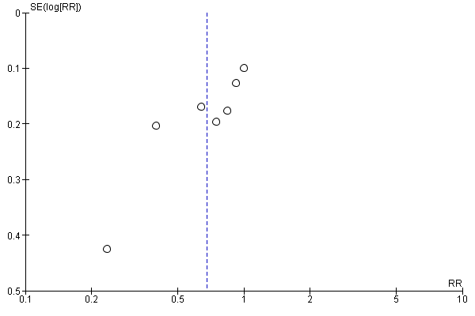
Figure S3. Funnel plot of comparison: Remote support versus standard care/control, outcome: Stopping exclusive breastfeeding at 3 months.
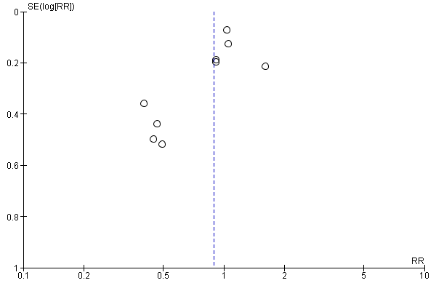
Figure S4. Funnel plot of comparison: Remote support versus standard care/control, outcome: Stopping any breastfeeding at 3 months.
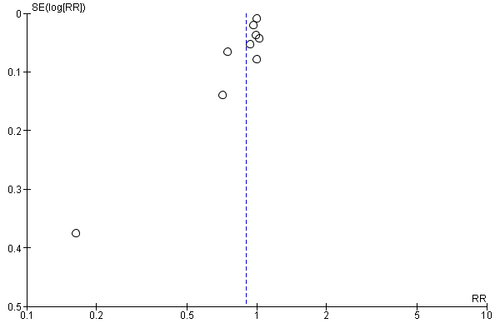
Figure S5. Funnel plot of comparison: Remote support versus standard care/control, outcome: Stopping exclusive breastfeeding at 6 months.
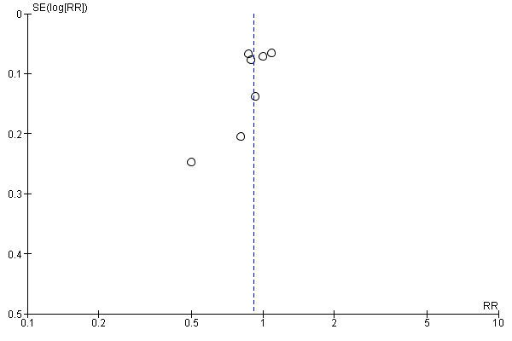
Figure S5. Funnel plot of comparison: Remote support versus standard care/control, outcome: Stopping any breastfeeding at 6 months.

