Supplementary Table 1: Detailed search strategy for the systematic review

PubMed | 17 December 2021
#1 | (COVID-19 OR SARS-COV-2) | 208,776
#2 | (Vaccine OR Vaccination OR Immunisation) | 1,532,372
#3 | Ulcerative colitis OR Crohn's Disease OR Inflammatory Bowel Disease | 127,482
#1 AND #2 AND #3 |  | 242
Embase | 17 December 2021
#1 | 'inflammatory bowel disease' OR 'Crohn disease' OR 'ulcerative colitis' | 203763
#2 | 'coronavirus disease 2019'/exp OR 'coronavirus disease 2019' OR 'severe acute respiratory syndrome coronavirus 2'/exp OR 'severe acute respiratory syndrome coronavirus 2' | 188400
#3 | ('vaccine'/exp OR vaccine OR 'vaccination'/exp OR vaccination OR 'immunization'/exp OR immunization) | 638761
#1 AND #2 AND #3 |  | 187

Supplementary Table 2: Table of the excluded studies with reason of exclusion

Study | Country | Reason for exclusion
Abdullah L et al. ²³ | Lebanon | No relevant data
Alexander JL et al. ²⁴ | UK | No relevant data
Cerna K et al. ²⁵ | Czech Republic | Adverse event data not reported
D’ Amico F et al. ²⁶ | Italy | No relevant data
Doherty J et al.²⁷ | Ireland | No relevant data
Fagni F et al. ²⁸ | Germany | Adverse event data not reported
Festa S et al. ²⁹ | Italy | No relevant data
Garrido HMG et al. ³⁰ | Netherlands | No relevant data
Hadi YB et al. ³¹ | USA | Only special adverse events reported. No data on incidence of local/ systemic adverse events
Kothadia S et al. ³² | USA | Single case report
Kumar R et al. ³³ | USA | Abstract of included full paper
Latypov L et al. ³⁴ | USA | Single case report
Levine I et al. ³⁵ | USA | Adverse event data not reported
Li D et al. ³⁶ | China | Profile after third dose of vaccine
Melmed GY et al. ³⁷ | USA | No relevant data
Murthy SK et al. ³⁸ | Canada | No relevant data
Prentice RE et al. ³⁹ | Australia | No relevant data
Sangha M et al. ⁴⁰ | USA | Case series of 10 cases of IBD flare. Incidence data on adverse events not reported
Shah SRA et al. ⁴¹ | USA | Case series of 3 cases
Siegel CA et al. ⁴² | USA | No relevant data
Spencer EA et al. ⁴³ | USA | Adverse event data not reported
Spiera E et al. ⁴⁴ | USA | No relevant data
Squire JD et al. ⁴⁵ | USA | No relevant data
Tepasse PR et al. ⁴⁶ | Germany | No relevant data
Tse F et al. ⁴⁷ | Canada | No relevant data
Veereman G et al. ⁴⁸ | Belgium | No relevant data

Supplementary Table 3: Assessment of study quality of included studies using New Castle Ottawa quality assessment scale for cohort studies

 |  | Selection |  |  |  | Comparability | Outcome |  |  | Quality
Number | Study | 1 | 2 | 3 | 4 | 1 | 1 | 2 | 3
1 | Dailey J et al. |  |  | ✵ |  |  | ✵ | ✵ |  | Poor
2 | Botwin GJ et al. | ✵ |  | ✵ |  |  |  | ✵ |  | Poor
3 | Wong SY et al. |  |  | ✵ | ✵ | ✵ |  | ✵ | ✵ | Fair
4 | Edelman-Klapper H et al. | ✵ |  | ✵ |  | ✵ | ✵ | ✵ |  | Fair
5 | Garrido I et al. | ✵ |  | ✵ |  |  |  | ✵ | ✵ | Poor
6 | Cannatelli R et al. | ✵ |  | ✵ |  |  |  | ✵ | ✵ | Poor
7 | Weaver KN et al. | ✵ | ✵ | ✵ |  | ✵ |  | ✵ | ✵ | Good
8 | Mujukian A et al. | ✵ | ✵ | ✵ |  | ✵ | ✵ | ✵ |  | Good
9 | Classen JM et al. | ✵ |  | ✵ |  | ✵ | ✵ | ✵ |  | Fair

Good quality: 3 or 4 stars in selection domain AND 1 or 2 stars in comparability domain AND 2 or 3 stars in outcome domain

Fair quality: 2 stars in selection domain AND 1 or 2 stars in comparability domain AND 2 or 3 stars in outcome/exposure domain

Poor quality: 0 or 1 star in selection domain OR 0 stars in comparability domain OR 0 or 1 stars in outcome/exposure domain.

Supplementary Table 4: The included studies with details regarding the included population and vaccination
Author | Local adverse events | Systemic adverse events | Serious adverse events | GI events | IBD flare
Dailey J et al. | Not defined | Not defined | Not defined | Not defined | Not defined
Botwin GJ et al. | Defined as injection site reactions | - fatigue or malaise  - headache, dizziness or lightheadedness  - fever or chills  - muscle, bone, joint or nerve symptoms  - nausea, vomiting, diarrhoea or other digestive symptoms  - sleep changes  - swollen lymph node, skin/nail or face changes  - eye, ear, mouth or throat changes  - cough, chest or breathing symptoms  - memory or mood changes | Severity of adverse events defined as mild, moderate, or severe impact on activities of daily living, or requiring hospitalization | Defined as gastrointestinal symptoms | Not defined
Wong SY et al. | Defined  - local arm pain/swelling/rash | Defined as  - myalgia  - arthralgia  - fatigue  - headache  - fever/subjective fever  - chills  - GI symptoms  - other rash – stomach rash  - other localized pain – pain localized to breast, knee and leg | Not defined | GI symptoms described as nausea, diarrhea, and self-described Crohn’s flare | Definition of self-described Crohn’s flare not mentioned
Edelman-Klapper H et al. | Defined as  - Pain or swelling at injection site | Defined as  - fever  - headache  - shivering  - nausea  - dizziness  - fatigue  - muscle soreness  - joints pain  - allergic reaction  - others: back and neck pain, vaginal bleeding, general weakness, vomiting, throat pain, testicular pain, aphthous stomatitis | Defined as  - anaphylactic reaction  - hospitalization  - death | Not defined | Flare defined as per disease activity:  CD - Harvey-Bradshaw Index  UC - Simple Clinical Colitis Activity Index  Ileal pouch - Pouch Disease Activity Index
Garrido I et al. | Defined as  - pain/redness/swelling | Defined as  - state of sleep/fatigue  - headache  - myalgia  - fever  - joint pain  - nausea/vomiting  - diarrhea  - abdominal pain | Not defined | Not defined | Not defined
Cannatelli R et al. | Defined as  - pain  - tension  - swelling  - itching  - redness  - heat  - bruising  - axillary lymph nodes | Defined as:  - headache  - asthenia  - general malaise  - diarrhea  - fever  - myalgia  - arthralgia  - nausea  - lymphadenopathy | Not defined | Defined as:  - increase in bowel movements  - abdominal pain  - blood in stool  - vomiting | Not defined
Weaver KN et al. | Defined as:  - pain  - redness  - itching  - swelling  - tenderness  - warmth at the injection site | Defined as:  - fever  - chills  - fatigue  - headache  - joint pain  - muscle aches  - nausea  - allergic reaction  - rash  - other | Defined as:  - mild - did not interfere with daily activity  - moderate- interfered with daily activity  - severe - prevented daily activity, required medications, or requiring emergency room visit or hospitalization | Defined as:  - Fatigue  - bowel frequency  - extraintestinal manifestations  - abdominal pain | Defined as worsening of at least 1 of the symptoms of abdominal pain, bowel frequency, rectal bleeding, and extraintestinal manifestation after vaccine and a need to add or change IBD medication due to symptoms within 1 month of vaccination
Mujukian A et al. | Defined as:  - any injection site reaction  - local pain  - local redness  - local swelling  - any symptoms | Defined as:  - fever or chills  - fatigue or malaise  - headache, dizziness, or lightheadedness  - eye, ear, mouth or throat changes  - swollen lymph nodes, skin/nail or face changes  - cough, chest or breathing symptoms  - nausea, vomiting, diarrhea or other GI symptoms  - urinary or genital symptoms  - muscle, bone, joint or nerve pain  - memory or mood changes  - sleep changes | Defined severity as significant symptoms:  - moderate severity - at least some interference with daily activities or greater  - duration lasting ≥2 days | Defined as:  - Nausea  - Vomiting  - Diarrhea  - Other GI symptoms | Not defined
Classen JM et al. | Not defined | Not defined | Not defined | Not defined | Not defined

Supplementary Figure 1: Pooled incidence of local adverse events with respect to vaccine doses
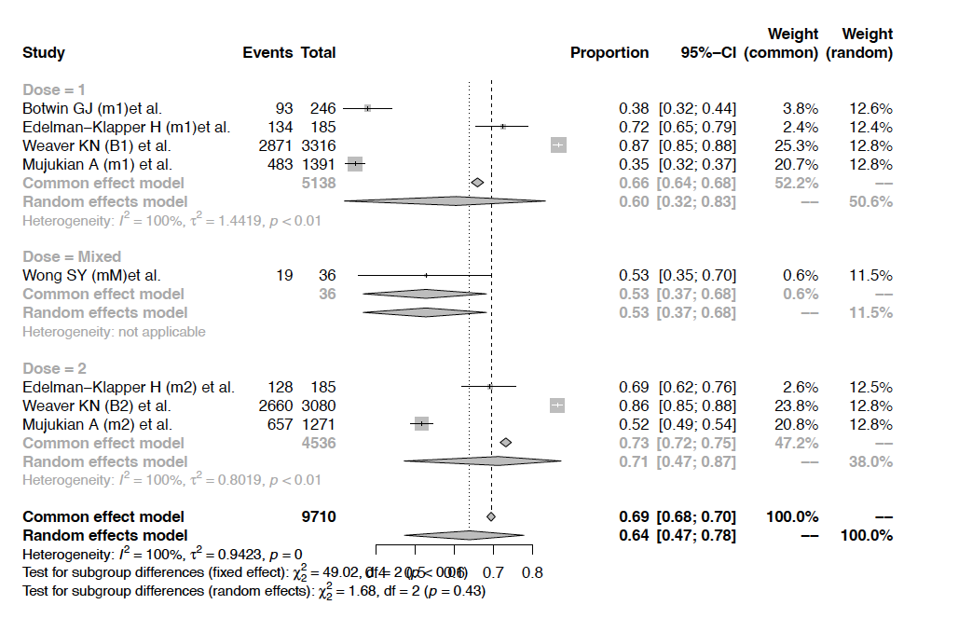

Supplementary Figure 2: Pooled incidence rates of soreness of arm after COVID vaccination
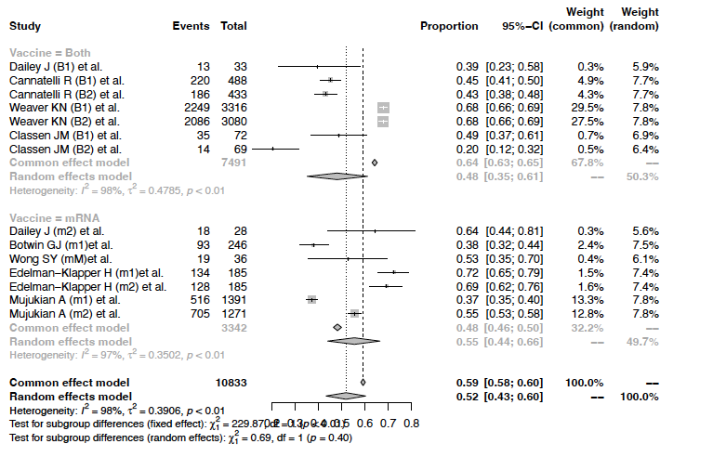
Supplementary Figure 3: Pooled incidence rates of fever after COVID vaccination
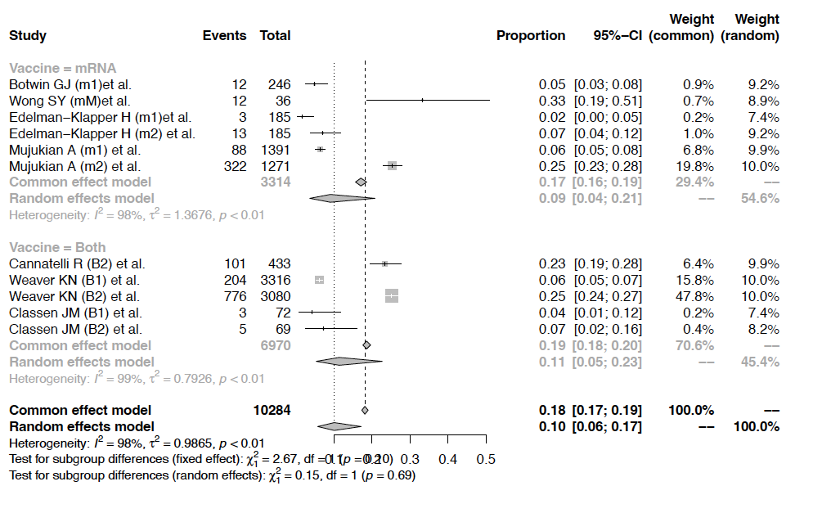
Supplementary Figure 4: Pooled incidence rates of chills after COVID vaccination

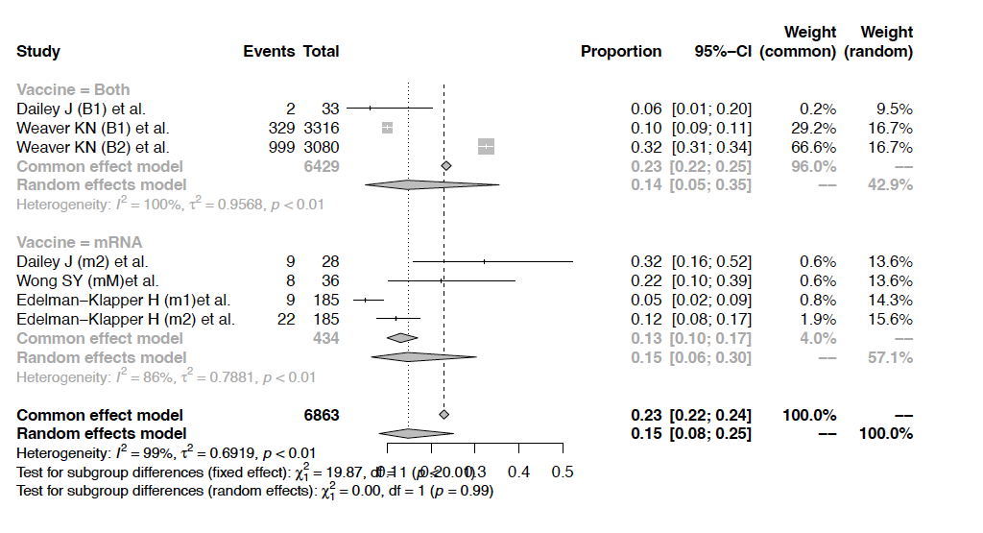

Supplementary Figure 5: Pooled incidence rates of fatigue after COVID vaccination
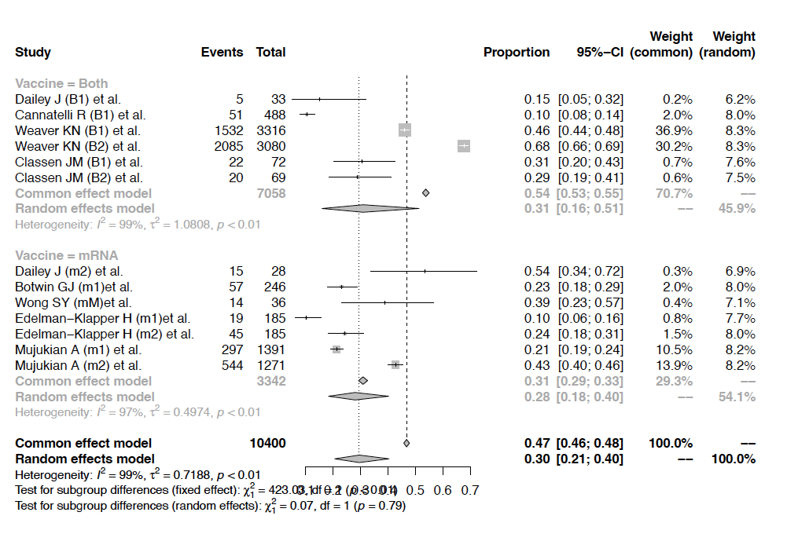

Supplementary Figure 6: Pooled incidence rates of myalgia after COVID vaccination
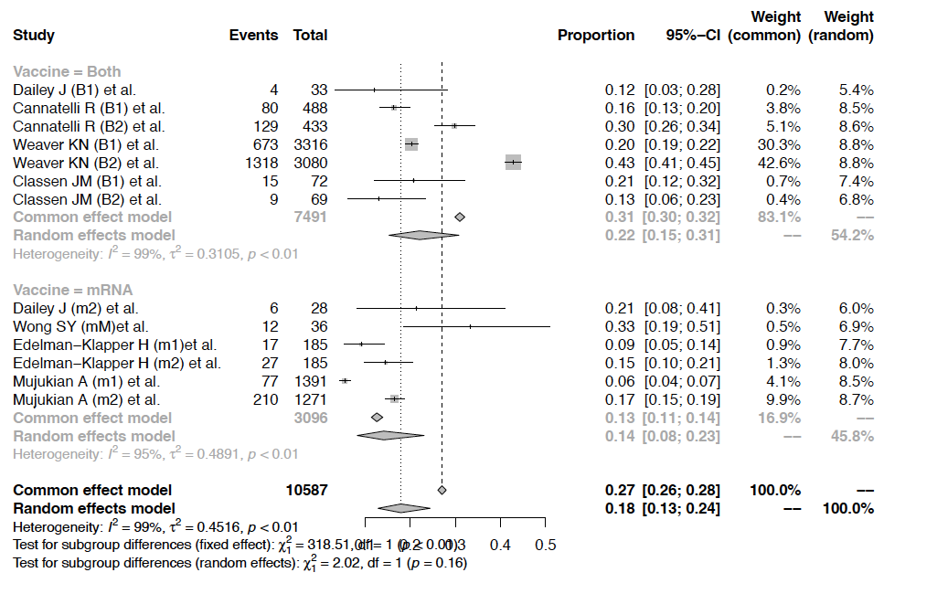

Supplementary Figure 7: Pooled incidence rates of headache after COVID vaccination
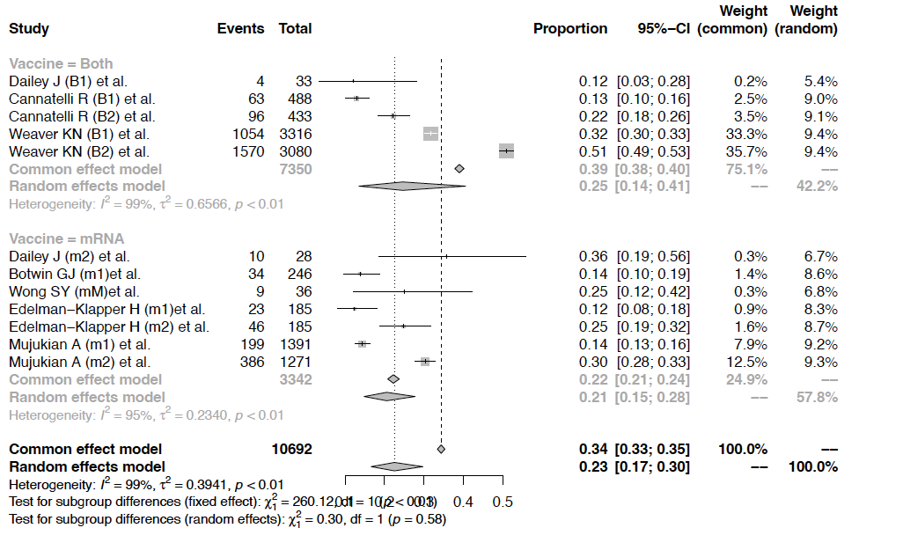
Supplementary Figure 8: Pooled incidence rates of joint pains after COVID vaccination
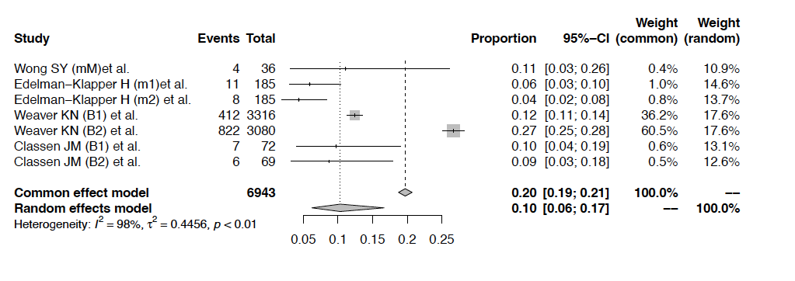
Supplementary Figure 9: Pooled incidence rates of skin rash after COVID vaccination
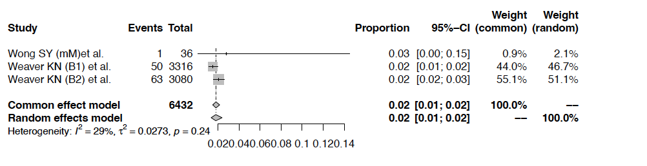
Supplementary Figure 10: Pooled incidence rates of GI adverse events after COVID vaccination



