Appendix

- Figure appx1. Risk of bias summary of 'complications' when using a bone-substitute material (BSM) vs no filling material (NoBSM) 2
- Figure appx2. The weighted summary of 'complications' when using a bone-substitute material (BSM) vs no filling material (NoBSM) 3
- Figure appx3. Risk of bias summary of 'esthetics' when using a bone-substitute material (BSM) vs no filling material (NoBSM) 4
- Figure appx4. The weighted summary of 'esthetics' when using a bone-substitute material (BSM) vs no filling material (NoBSM) 5
- Figure appx5. The weighted summary of 'implant failure' when using a bone-substitute material (BSM) vs no filling material (NoBSM) 6
- Figure appx6. Risk of bias summary of 'vertical crestal buccal bone resorption' when using a bone-substitute material (BSM) vs no filling material (NoBSM) 7
- Figure appx7. The weighted summary of 'vertical crestal buccal bone resorption' when using a bone-substitute material (BSM) vs no filling material (NoBSM) 8
- Figure appx8. The risk of bias summary of 'vertical interproximal bone resorption' when using a bone-substitute material (BSM) vs no filling material (NoBSM) 9
- Figure appx9. The weighted summary of 'vertical interproximal bone resorption' when using a bone-substitute material (BSM) vs no filling material (NoBSM) 10
- Figure appx10. The risk of bias summary of 'horizontal buccal bone resorption' when using a bone-substitute material (BSM) vs no filling material (NoBSM) 11
- Figure appx11. The weighted summary of 'horizontal buccal bone resorption' when using a bone-substitute material (BSM) vs no filling material (NoBSM) 12
- Figure appx12. The risk of bias summary of 'mid-buccal recession' when using a bone-substitute material (BSM) vs no filling material (NoBSM) 13
- Figure appx13. The weighted summary of 'mid-buccal recession' when using a bone-substitute material (BSM) vs no filling material (NoBSM) 14
- Figure appx14. Forest plot of 'implant failure' by duration of follow-up when using a bone-substitute material (BSM) vs no filling material (NoBSM) 15
- Figure appx15. Forest plot of 'implant failure' by surgical approach using a bone-substitute material (BSM) vs no filling material (NoBSM) 16
- Figure appx16. Forest plot of 'implant failure' by membrane-use using a bone-substitute material (BSM) vs no filling material (NoBSM) 17
- Figure appx17. Forest plot of 'vertical buccal bone resorption' (in mm) by the surgical approach using a bone-substitute material (BSM) vs no filling material (NoBSM) 18
- Figure appx18. Forest plot of 'vertical buccal bone resorption' (in mm) by membrane-use using a bone-substitute material (BSM) vs no filling material (NoBSM) 19
- Figure appx19. Forest plot of 'vertical buccal bone resorption'(in mm) by healing protocol using a bone-substitute material (BSM) vs no filling material (NoBSM) 20
- Figure appx20. Forest plot of 'horizontal buccal bone resorption' (in mm) by surgical approach using a bone-substitute material (BSM) vs no filling material (NoBSM). 21
- Figure appx21. Forest plot of 'horizontal buccal bone resorption' (in mm) by healing protocol using a bone-substitute material (BSM) vs no filling material (NoBSM) 22
- Figure appx22. Forest-plot representing the sensitivity analysis of 'overall complications' based on trials at low risk of bias using a bone-substitute material (BSM) vs no filling material (NoBSM) 23

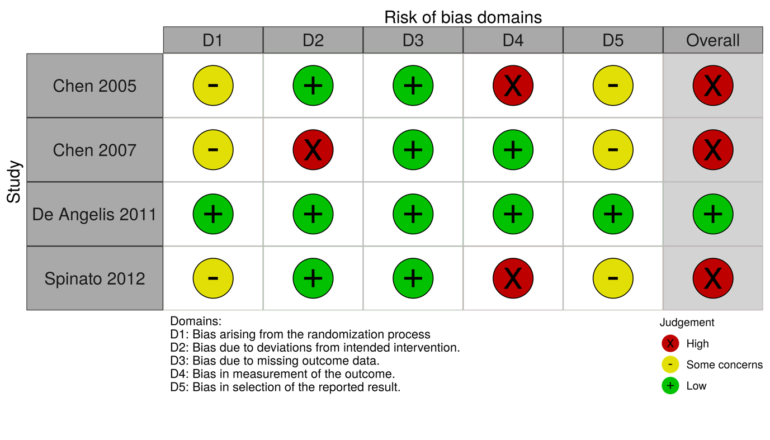
Figure appx1. Risk of bias summary of 'complications' when using a bone-substitute material (BSM) vs no filling material (NoBSM)

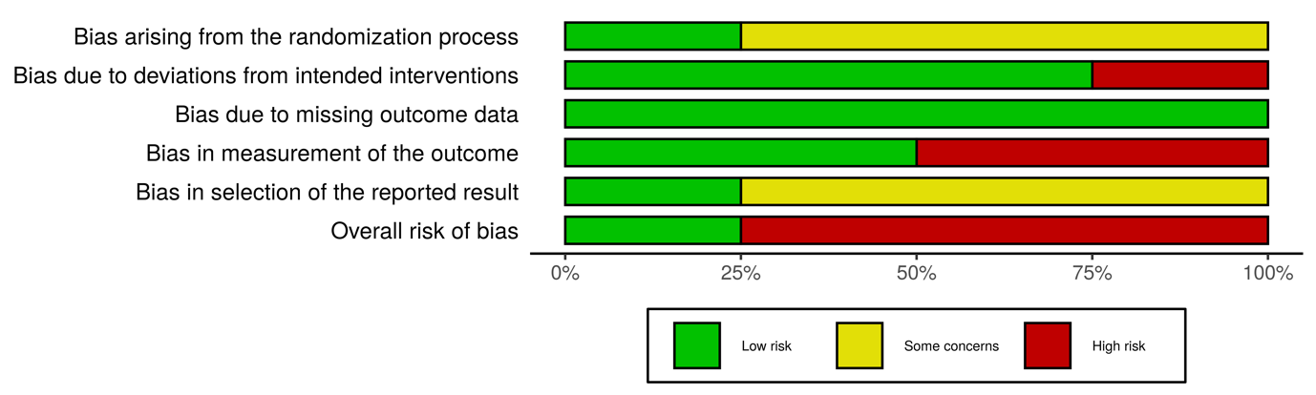
Figure appx2. The weighted summary of 'complications' when using a bone-substitute material (BSM) vs no filling material (NoBSM)

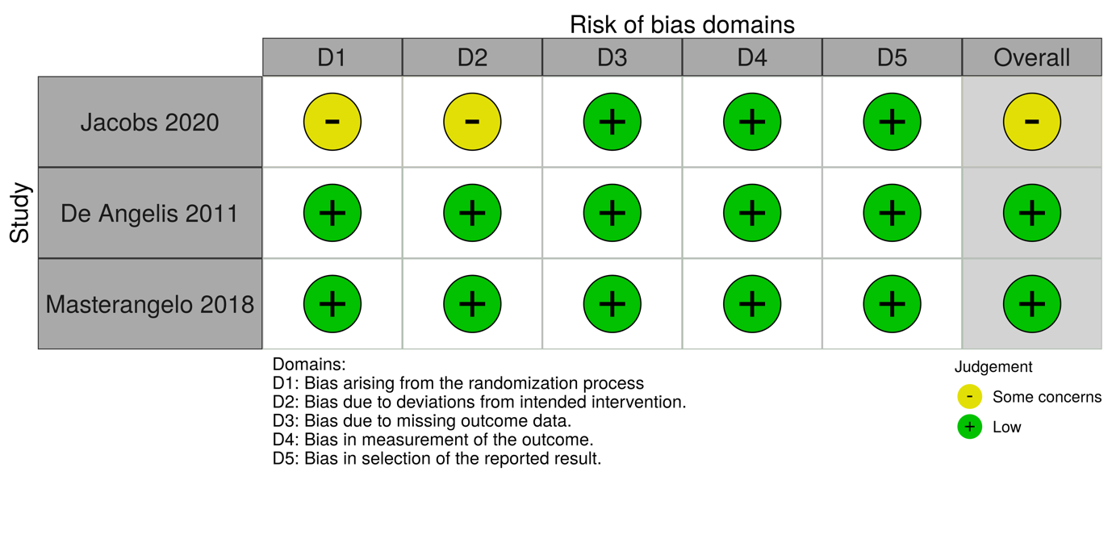
Figure appx3. Risk of bias summary of 'esthetics' when using a bone-substitute material (BSM) vs no filling material (NoBSM)

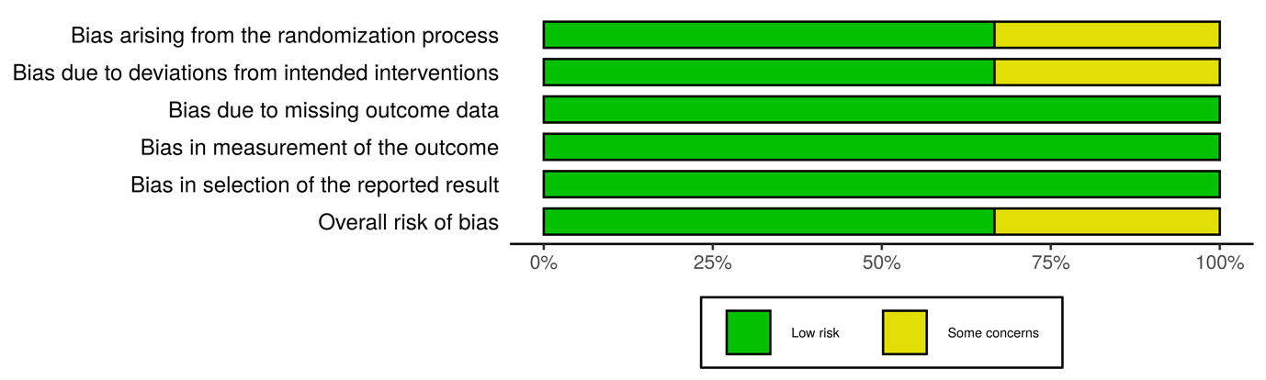
Figure appx4. The weighted summary of 'esthetics' when using a bone-substitute material (BSM) vs no filling material (NoBSM)

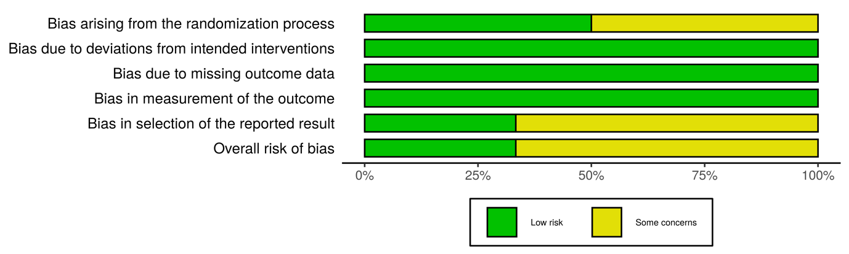
Figure appx5. The weighted summary of 'implant failure' when using a bone-substitute material (BSM) vs no filling material (NoBSM)

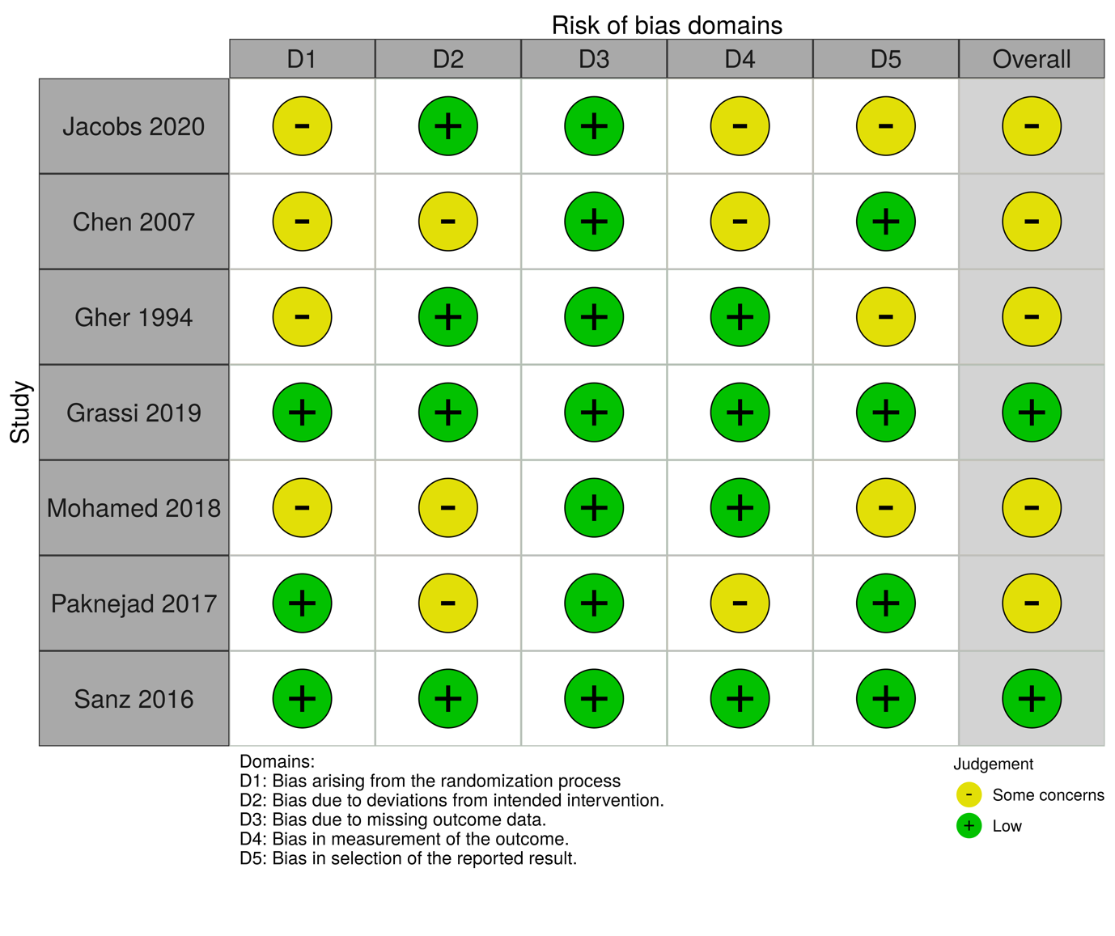
Figure appx6. Risk of bias summary of 'vertical crestal buccal bone resorption' when using a bone-substitute material (BSM) vs no filling material (NoBSM)

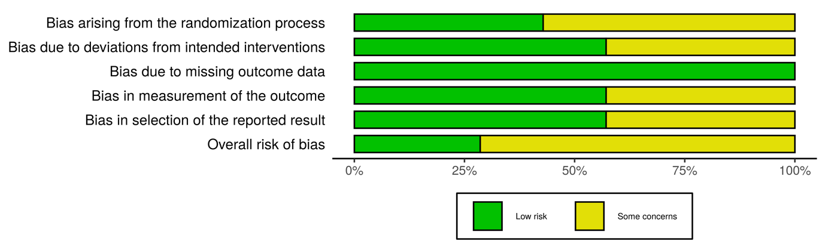
Figure appx7. The weighted summary of 'vertical crestal buccal bone resorption' when using a bone-substitute material (BSM) vs no filling material (NoBSM)

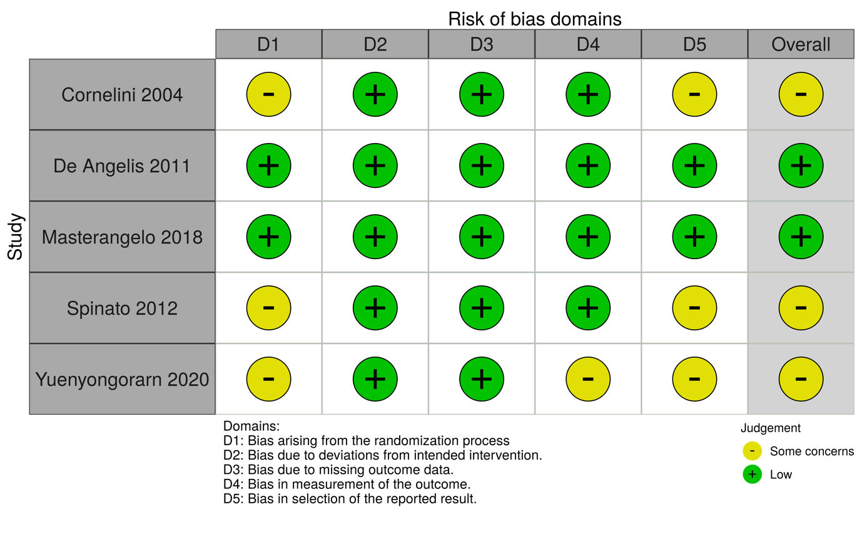
Figure appx8. The risk of bias summary of 'vertical interproximal bone resorption' when using a bone-substitute material (BSM) vs no filling material (NoBSM)

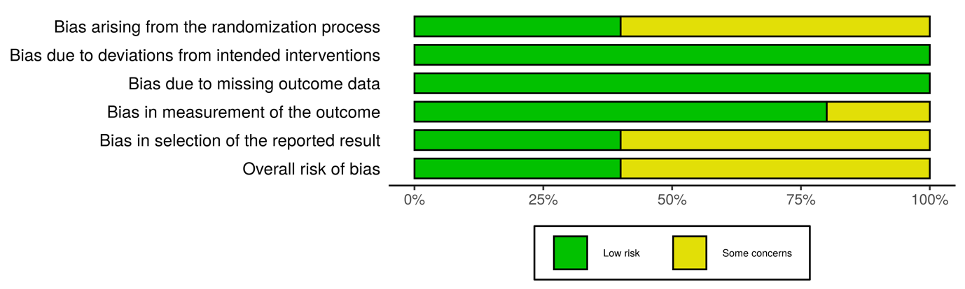
Figure appx9. The weighted summary of 'vertical interproximal bone resorption' when using a bone-substitute material (BSM) vs no filling material (NoBSM)

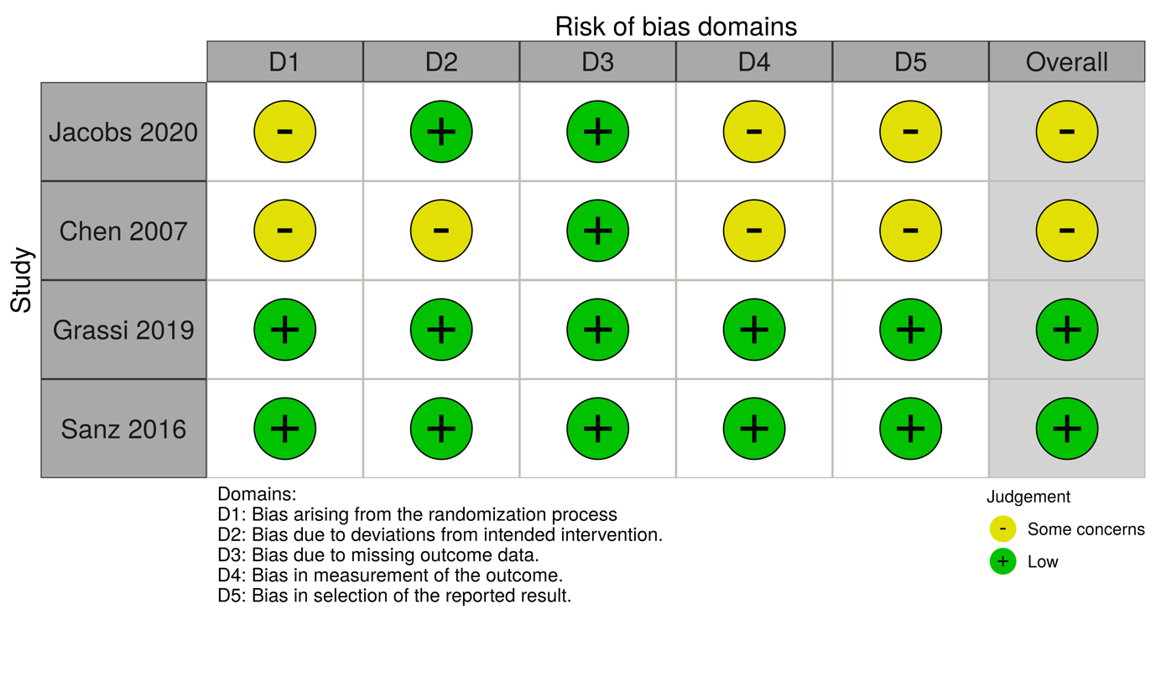
Figure appx10. The risk of bias summary of 'horizontal buccal bone resorption' when using a bone-substitute material (BSM) vs no filling material (NoBSM)

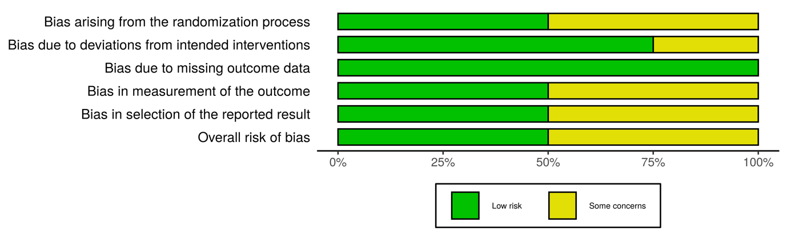
Figure appx11. The weighted summary of 'horizontal buccal bone resorption' when using a bone-substitute material (BSM) vs no filling material (NoBSM)

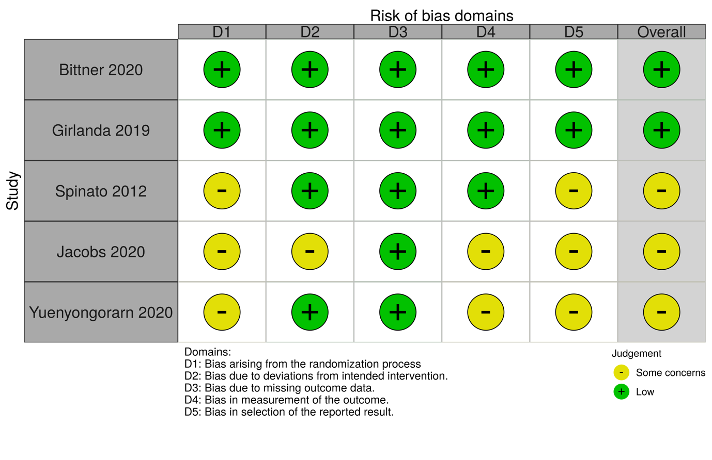
Figure appx12. The risk of bias summary of 'mid-buccal recession' when using a bone-substitute material (BSM) vs no filling material (NoBSM)

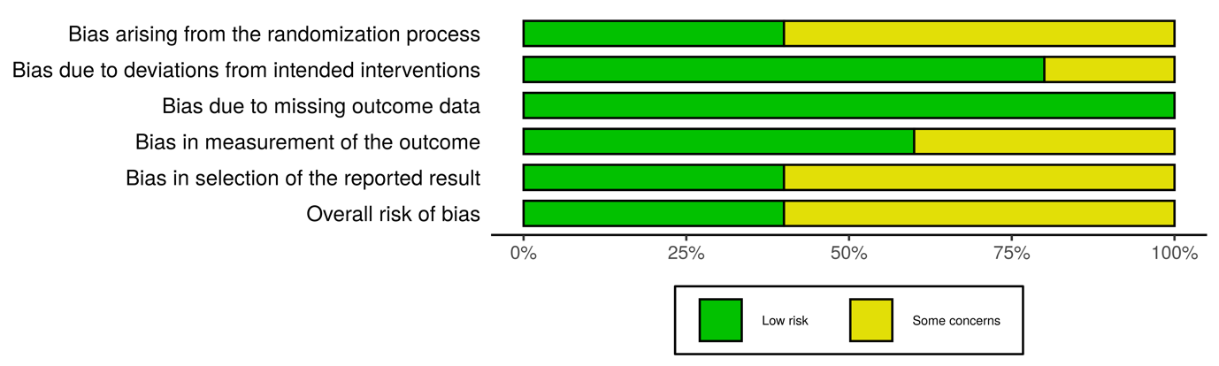
Figure appx13. The weighted summary of 'mid-buccal recession' when using a bone-substitute material (BSM) vs no filling material (NoBSM)

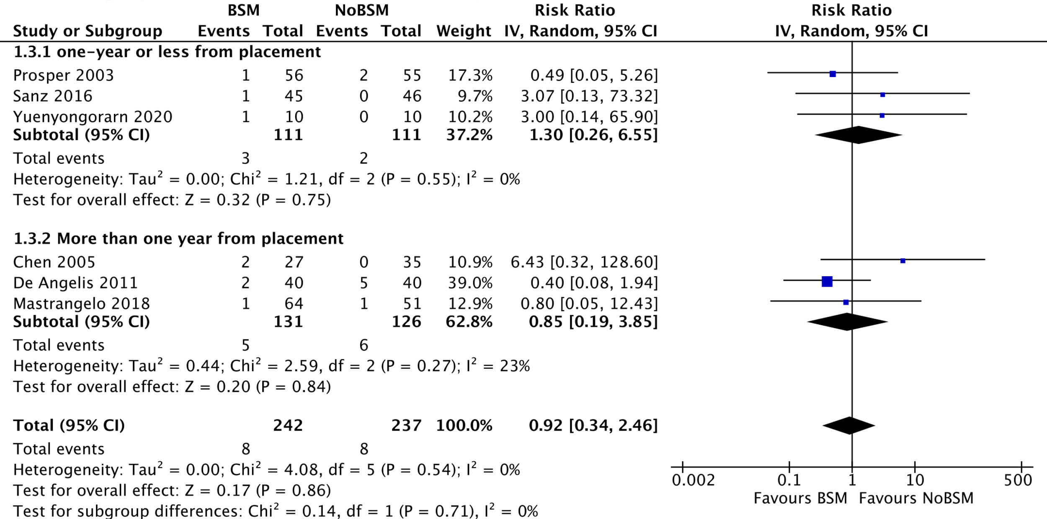
Figure appx14. Forest plot of 'implant failure' by duration of follow-up when using a bone-substitute material (BSM) vs no filling material (NoBSM)

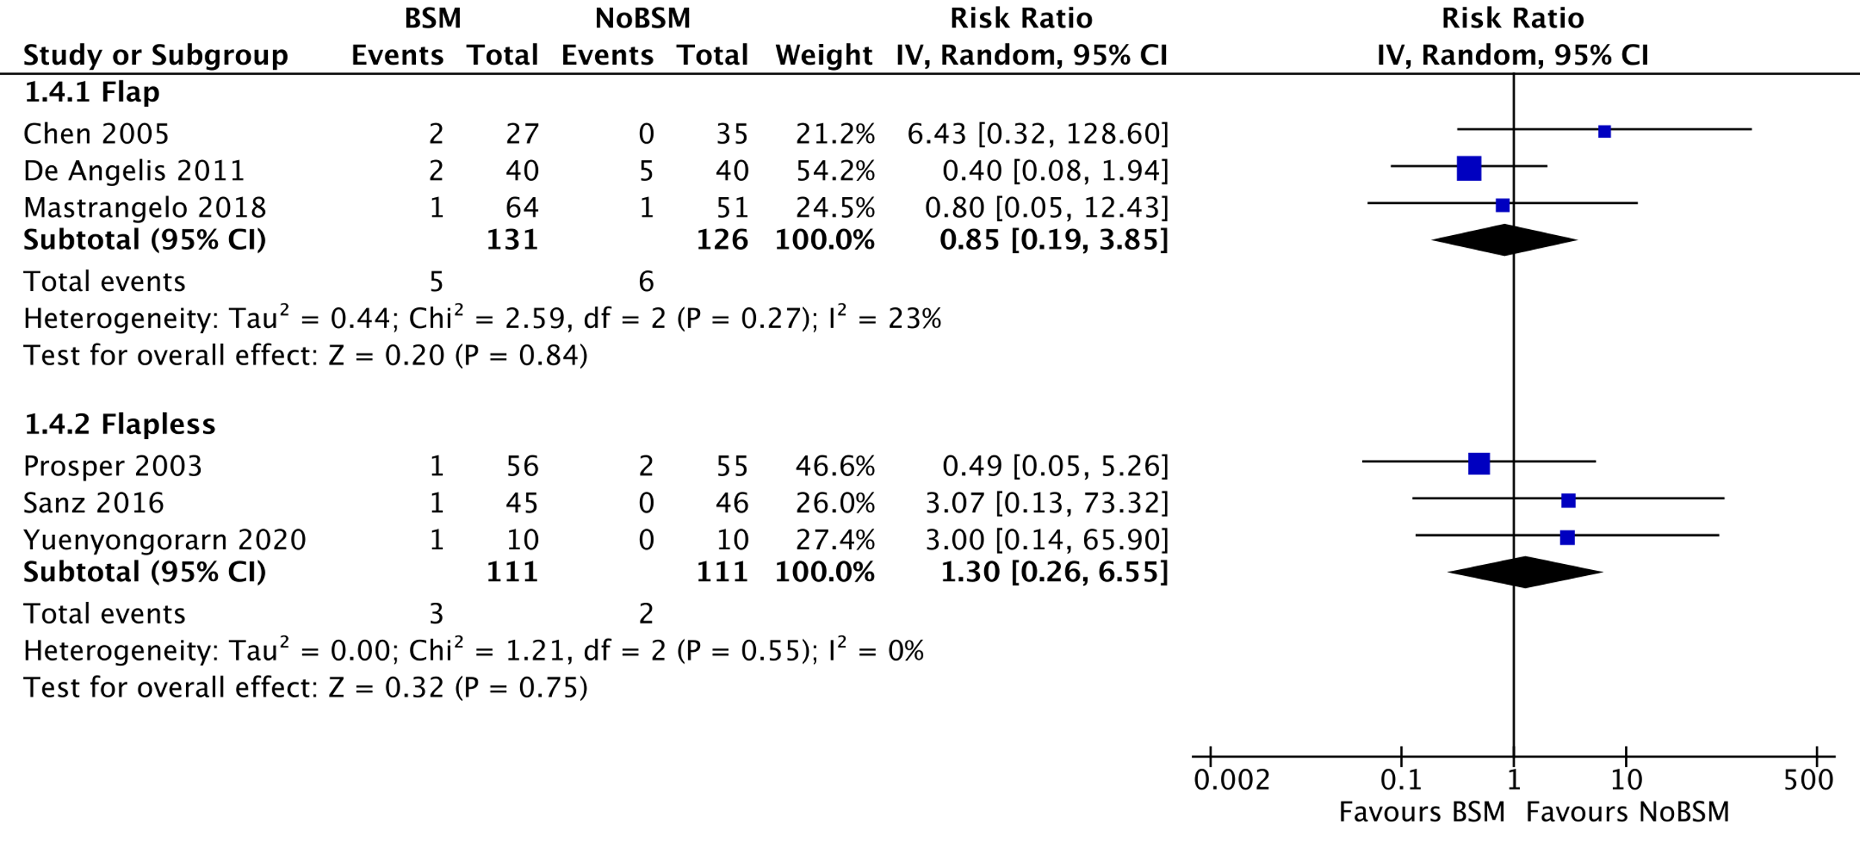
Figure appx15. Forest plot of 'implant failure' by surgical approach using a bone-substitute material (BSM) vs no filling material (NoBSM)

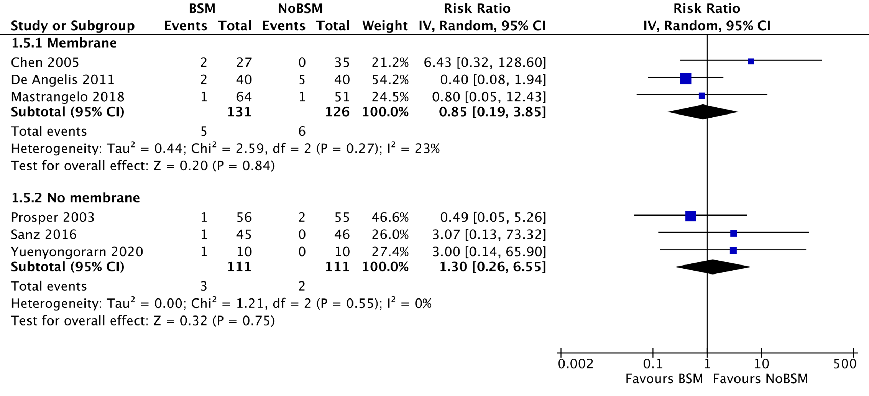
Figure appx16. Forest plot of 'implant failure' by membrane-use using a bone-substitute material (BSM) vs no filling material (NoBSM)

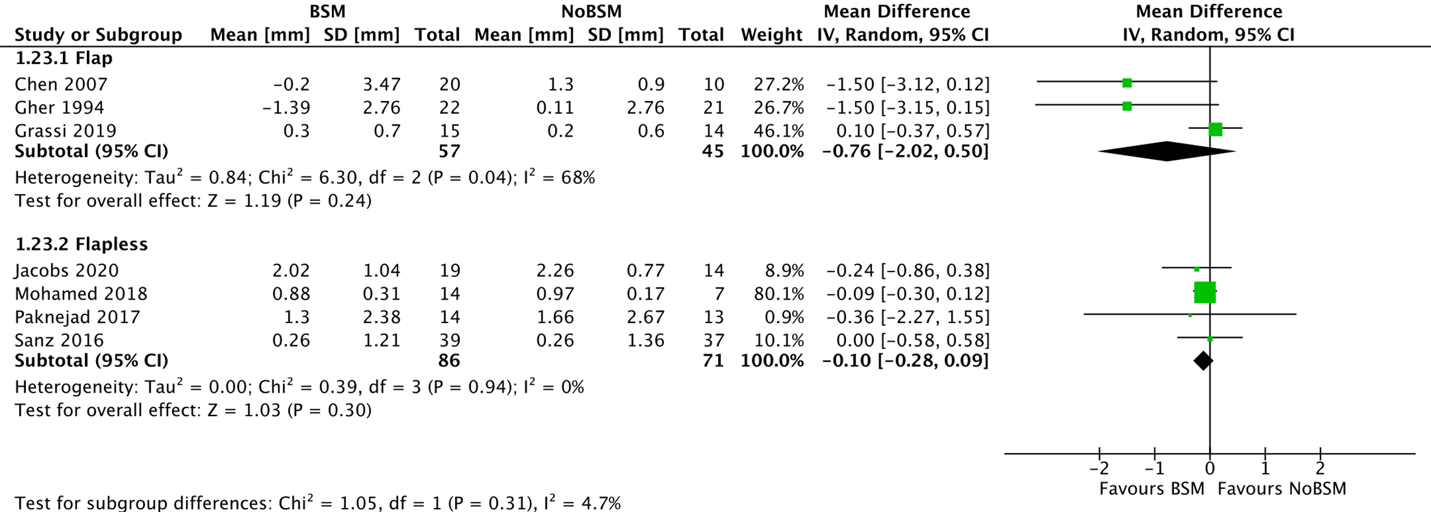
Figure appx17. Forest plot of 'vertical buccal bone resorption' (in mm) by the surgical approach using a bone-substitute material (BSM) vs no filling material (NoBSM)

.
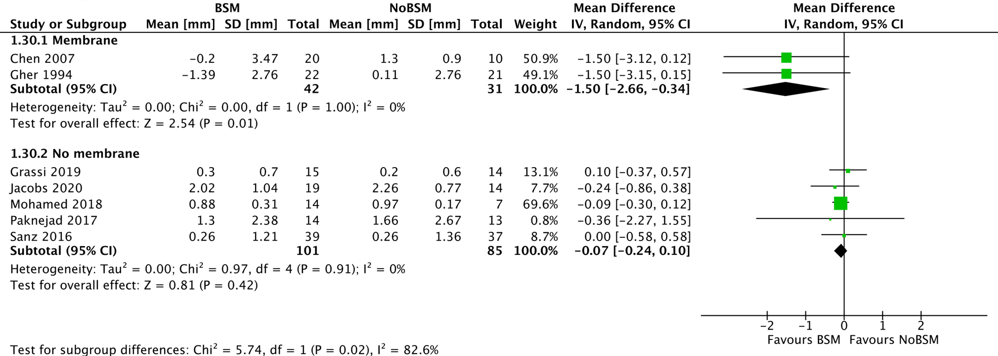
Figure appx18. Forest plot of 'vertical buccal bone resorption' (in mm) by membrane-use using a bone-substitute material (BSM) vs no filling material (NoBSM)

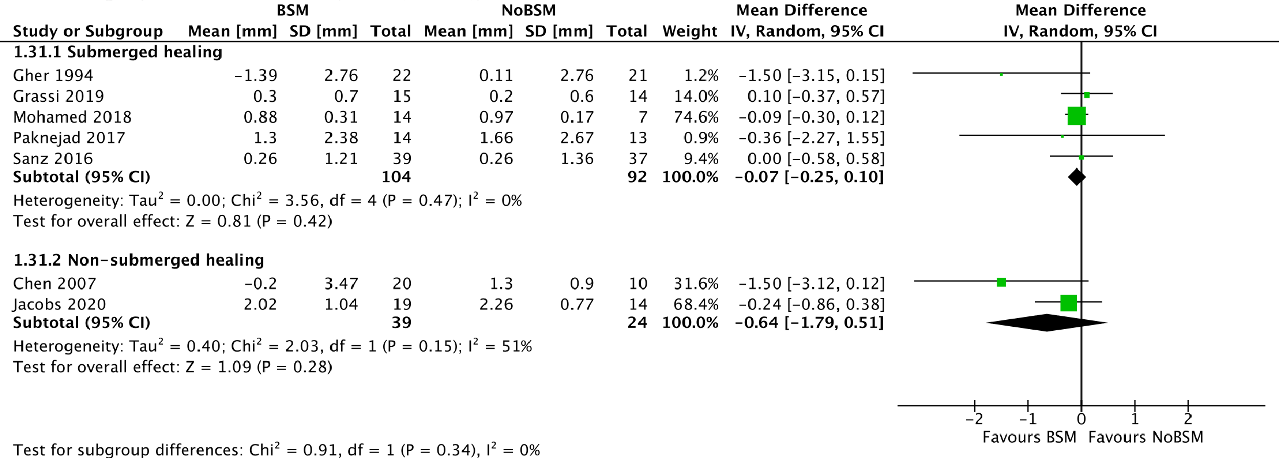
Figure appx19. Forest plot of 'vertical buccal bone resorption'(in mm) by healing protocol using a bone-substitute material (BSM) vs no filling material (NoBSM)

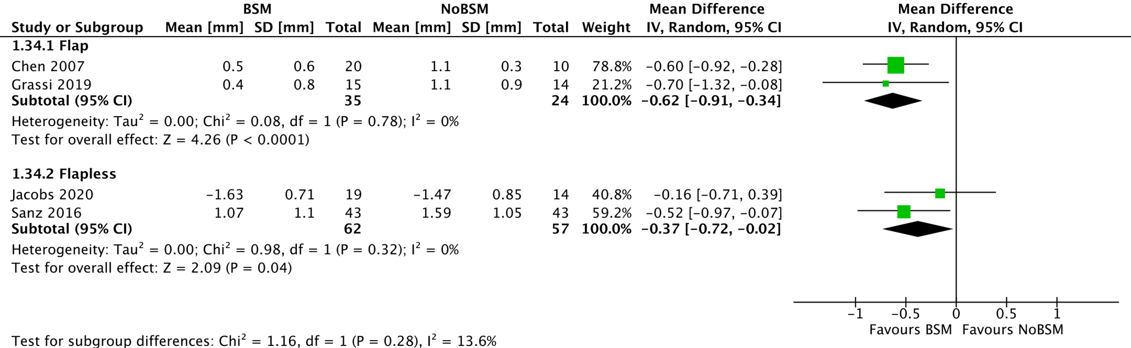
Figure appx20. Forest plot of 'horizontal buccal bone resorption' (in mm) by surgical approach using a bone-substitute material (BSM) vs no filling material (NoBSM).

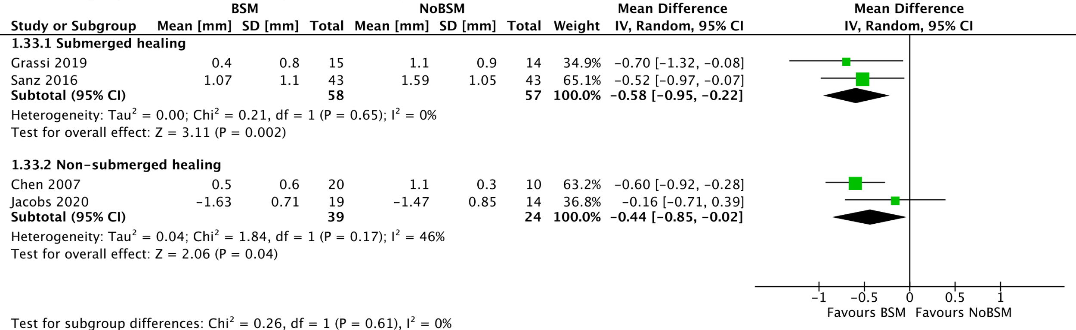
Figure appx21. Forest plot of 'horizontal buccal bone resorption' (in mm) by healing protocol using a bone-substitute material (BSM) vs no filling material (NoBSM)

.
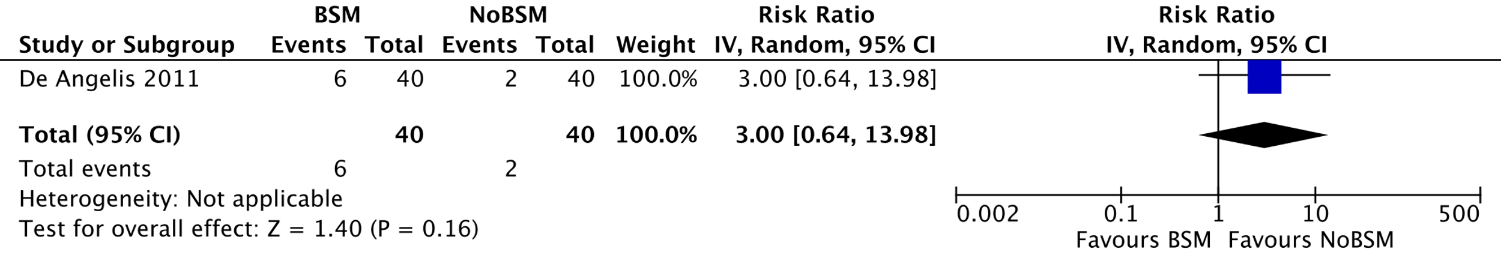

Figure appx22. Forest-plot representing the sensitivity analysis of 'overall complications' based on trials at low risk of bias using a bone-substitute material (BSM) vs no filling material (NoBSM)

