Supplementary APPENDIX
Figure S1. Distribution of grade 3 or above adverse events. Only adverse events with more than 10 cases were included.
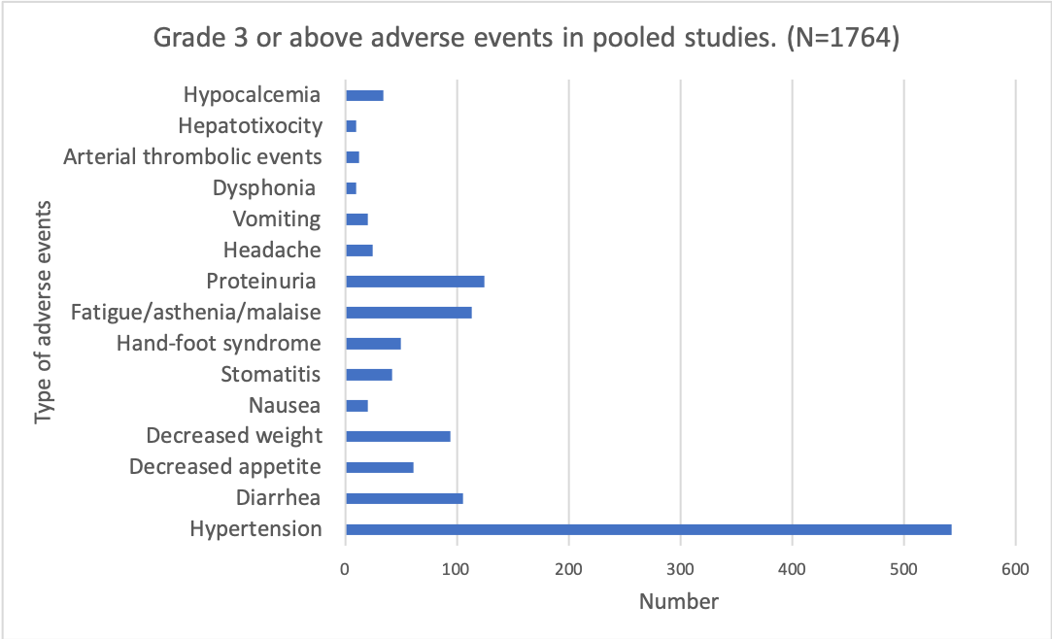

Figure S2. Risk of bias assessment.
- Risk of bias graph
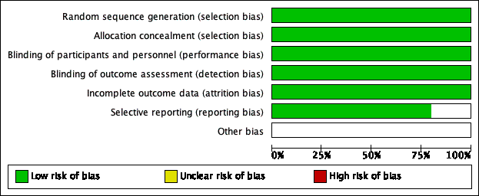

- Risk of bias summary



