Supplementary Table 4. Formulas to calculate effect sizes

Formula by Morris (2008) to calculate Cohen’s d. Means at pre-test (M_{pre}) and post-test (M_{post}) for the intervention condition and control condition are divided by standard deviation at pre-test for the intervention condition (SD_{pre},_{T)} and control condition (SD_{pre,C}).
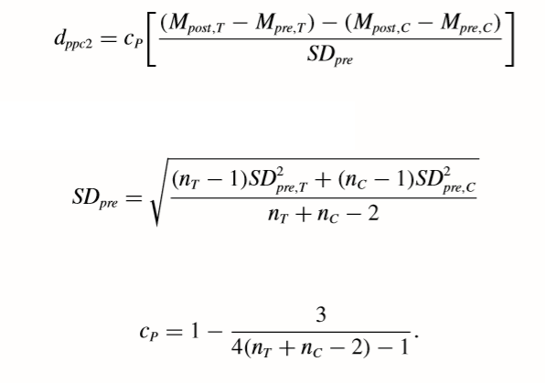

Formulas by Borenstein (2009, chap. 4) to calculate 95%-CI for Cohen’s d by filling in sample size (n) of the intervention condition and control condition with Cohen’s d.

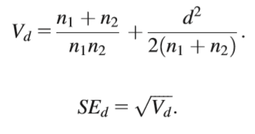

Formula by Borenstein (2009, chap. 19) to calculate if subgroups statistically differ.

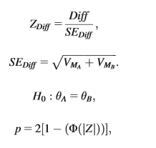

Formula by Chinn (2000) to calculate Cohen’s d from log odds ratio by dividing to PI.



