Contextual factors influencing complex intervention research processes in care homes: a systematic review and framework synthesis

Table of Contents

Appendix 1 2
Table A1.1 MEDLINE via OVID search strategy 2
Table A1.2 Grey literature searches 3
Table A1.3 BeHEMoTh search template on Web of Science combined with AND boolean operator 4
Appendix 2 5
Figure A2.1. PRISMA flow diagram for inclusion of studies 5
Table A2.1. Process Evaluation Summary Characteristics 6
Table A2.2. Critical Appraisal Questions3 11
Table A2.3. Critical Appraisal Results 12
Appendix 3 13
Figure A3.1 Context domains presented according to care home work system and ranked according to reporting frequency across the 33 included papers 13
Figure A3.2. Radar plot displaying the weighting of reported contextual factors influencing trial implementation processes in CHs across work systems. 14
Descriptive Summary of the Work-System Sub-categories 14
Appendix 3 References 17
Appendix 4
Barriers and Enablers Summary Dataset see supplementary data file

Appendix 1

Table A1.1 MEDLINE via OVID search strategy
1 | *Homes for the Aged/ | 28 | Clinical trials as Topic/
2 | *Nursing Homes/ | 29 | "randomi*ed".ab,ti.
3 | *Long-Term Care/ | 30 | randomly.ab,ti.
4 | *Residential Facilities/ | 31 | controlled clinical trial.pt.
5 | *Respite Care/ | 32 | Evaluation Study/
6 | *Intermediate Care/ | 33 | Comparative Study/
7 | "care home$".ab,ti. | 34 | "before and after study".ti,ab,mp.
8 | "nursing home$".ab,ti. | 35 | or/22-34
9 | "residential care".ab,ti. | 36 | "Outcome and Process Assessment (Health Care)"/
10 | ("long term care" or "long-term care" or "longterm care").ab,ti. | 37 | *Implementation Science/
11 | "home$ for the aged".ab,ti. | 38 | "process evaluation".ab,ti.
12 | "care facilit*".ab,ti. | 39 | (process$ adj3 evaluation$).ab,ti.
13 | "old$ people$ home$".ti,ab. | 40 | (program$ adj3 evaluation$).ab,ti.
14 | (retir$ adj2 home$).ab,ti. | 41 | implementation.ab,ti.
15 | ("old$ adult$" adj3 (facilit$ or residential or accommodation)).ab,ti. | 42 | context$.ab,ti.
16 | ("old$ people$" adj3 (facilit$ or residential or accommodation)).ab,ti. | 43 | fidelity.ab,ti.
17 | ("old$ person$" adj3 (facilit$ or residential or accommodation)).ab,ti. | 44 | or/36-43
18 | ((geriatric$ or elder$ or senior$ or retir$) adj3 (facilit$ or residential or accommodation)).ab,ti. | 45 | *Qualitative Research/
19 | "respite care".ti,ab. | 46 | *Focus Groups/
20 | "intermediate care".ti,ab. | 47 | *Interviews as Topic/
21 | or/1-20 | 48 | *Narration/
22 | *Randomized Controlled Trials as Topic/ | 49 | (("semi-structured" or semistructured or unstructured or informal or "in-depth" or "indepth" or "face to face" or structured or guide) adj3 (interview$ or discussion$ or questionnaire$)).ab,ti.
23 | Randomized controlled trial/ | 50 | or/45-49
24 | Random allocation/ | 51 | 44 or 50
25 | Double blind method/ | 52 | 21 and 35
26 | Single blind method/ | 53 | 51 and 52
27 | Clinical Trial/
/ = MeSH term; $ = truncation symbol; * = truncation symbol; ab = abstract; ti = title; adjn = words adjacent

Table A1.2 Grey literature searches

- Alzheimer’s Clinical Trail Consortium (ACTC) | - Association of Directors of Adult Social Services (ADASS) | - Age UK | - Australian Government Department of Health (AGDH)
- Alzheimer's Disease International | - Alzheimer's Prevention Registry | - Agency for Healthcare Research and Quality (AHRQ) | - Bandolier
- Better Caring | - British Geriatrics Society | - Consortium of Canadian Centres for Clinical Cognitive Research (C5R) | - The Canadian Agency for Drugs and Technologies in Health (CADTH)
- Canadian Institutional Repositories | - Care England | - Care Home Research Network | - Care Home Management
- Care Home UK | - Centres for Disease Control and Prevention (CDC) | - Centre for Reviews and Dissemination | - ClinicalTrials.gov
- Centres for Medicare & Medicaid Services (CMS) | - Cochrane Library | - Care Quality Commission (CQC) | - European Clinical Trial Registry
- Enabling Research in Care Homes (ENRICH) | - Institute for Clinical and Economic Review (ICER) | - Figshare | - Georgetown Medical Review
- Grey Literature Report | - Healthcare Improvement Scotland | - Health Evidence | - Health Information and Quality Authority
- Health Economic Research Unit (HERU) | - Health Research Authority | - Housing & Dementia Research Consortium | - Housing & Care For Older People Research Network
- Institute of Health Economics | - International Network of Agencies for Health Technology Assessment (INHATA) | - Irish Health Repository/Lenus | - International Standard Randomised Controlled Trial Number Registry (ISRCTN)
- Kings Fund | - McMaster University | - McMaster University Health Forum | - MedEdPORTAL
- Medicine and Healthcare products Regulatory Agency (MHRA) | - MRC Clinical Trails Unit | - Medical Services Advisory Committee (MSAC) | - Multimedia Educational Resource for Learning and Online Teaching (MERLOT)
- My Aged Care | - My Home Life | - National Health Service | - Nature Proceedings
- Networked Digital Library of Theses and Dissertations (NDLTD) | - National Institute for Health and Care Excellence (NICE) | - National Institute for Health Research (NIHR) | - NIHR School for Social Care Research
- Open Archives Initiative (OIAster) | - Open Directory of Open Access Repositories (OpenDOAR) | - Open Grey | - Ontario Public Health Libraries Association (OPHLA)
- Organisation for Economic Co-operation and Development (OECD) | - Open Science Framework Preprints (OSF Preprints) | - Patient Centred Outcomes Research Institute (PCORI) | - Public Health Agency of Canada (PHAC)
- (International) Prospective Register of Systematic Reviews (PROSPERO) | - ProQuest | - Personal Social Services Rsearch Unit (PSSRU) | - Public Health Europe
- Rian – Pathways to Irish research | - Social Care Institute for Excellence (SCE) | - Scottish Dementia Clinical Research Network | - Scottish Intercollegiate Guidelines Network (SIGN)
- Siren Evidence Library | - Social Care Online | - Social Science Research Group | - Toronto Health Economics and Technology Assessment (THETA)
- Trip | - UK Clinical Research Network (UKCRN) | - UK Department of Health | - UK Government
- Think Tank Search | - Virtual Health Library | - WorldCat | - World Health Organization Health Evidence Network
- World Health Organization | - World Health Organization | - WorldWideScience | - International Clinical Trials Registry Platform

Table A1.3 BeHEMoTh¹ search template on Web of Science combined with AND boolean operator
Be | ‘Behaviour of interest’ | TS= (care)
H | ‘Health Context’ | TS= (systems approach)
E | Exclusions | n/a
MoTh | Models or Theories | TS= ((human factors) AND (model or framework))

¹ Booth A, Carroll C; Systematic searching for theory to inform systematic reviews: is it feasible? Is it desirable? Health Info Libr J 2015;32(3):220-35. doi: 10.1111/hir.12108.

Appendix 2

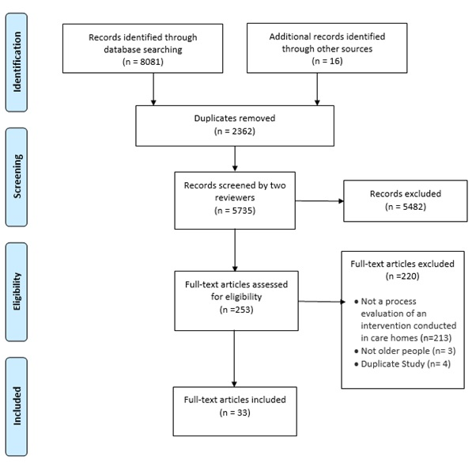

Figure A2.1. PRISMA flow diagram for inclusion of studies ²

^{2.} Moher D, Liberati A, Tetzlaff J, Altman DG, The PG. Preferred Reporting Items for Systematic Reviews and Meta-Analyses: The PRISMA Statement. PLOS Medicine. 2009;6(7):e1000097

Table A2.1. Process Evaluation Summary Characteristics

First author, Date | Country | Intervention Topic | Process Evaluation Care Home Sample Size | Process Evaluation Methods | Process Evaluation Participants
Aasmul, 2018 | Norway | Advance care planning. | n=33 | Patient logs, attendance logs. | Patients (n= 545).
Abraham, 2019 | Germany | Intervention to prevent physical restraints. | n=120 | Observation, focus groups, questionnaires, structured interviews, structured assessment. | Care home (CH) residents (n=12,245), CH managers, key nurses and nursing staff.
Anrys, 2019 | Belgium | Intervention to improve quality of medication prescription. | n=24 (questionnaires)  n=11 (focus groups) | Questionnaires, reports, focus groups. | Healthcare professionals (n=129).
Bamford, 2012 | UK | Implementing nutrition guidelines. | n=5 | Observation, interviews. | Cooks (n=37), senior managers (n=32), other CH staff (n=43).
Barbosa, 2017 | Portugal | Psycho-education intervention for care assistants working with people with dementia. | n=2 | Focus groups, semi-structured interviews. | Care assistants (n=21), managers (n=2).
Bleijlevens, 2013 | Netherlands | Program to reduce the use of restraints. | n=6 (15 wards) | Attendance lists, questionnaires, recording forms, group interviews, telephone interviews, meetings. | CH staff (n=143), nurse implementers (n=2), CH association delegates (4 groups), resident relatives (n=38).
Boersma, 2017 | Netherlands | Veder Contact Method (VCM) in dementia care. | n=4 (6 wards) | Focus groups, interviews. | Professional caregivers (n=42), managers (n=11), VCM Art Director (n= 1), VCM trainers (n=3).
Braun, 2010 | Netherlands | Mental practice intervention for stroke survivors. | n=3 | Registration forms, pre-structured patient files, patient logs, questionnaires. | Stroke patients (n=18), occupational therapists (n=6), physiotherapists (n=8).
Desveaux, 2017 | Canada | Appropriateness of antipsychotic medication prescription. | n=5 | Semi-structured interviews (n=22), patient-level administrative data. | Academic detailers (n=4), CH staff (n=18).
Desveaux, 2019 | Canada | Evidence uptake relating to falls prevention. | n=13 | Semi-structured interviews. | Leaders (n=11), physicians (n=10), direct care providers (n=6), pharmacists (n=2).
Edwards, 2018 | Canada | A participatory and multimodal intervention to improve evidence-based care. | n=12 | Semi-structured interviews. | CH staff. Baseline (n=72), midpoint (n=44), end point (n=69).
Eldh, 2018 | Sweden | Leadership intervention to support implementation of oral care guidelines. | n=4 (5 units) | Semi-structured interviews (n=5), surveys. | Managers (n=5), Registered Nurse (n=5) and nursing staff (n=5).
Ellard, 2014 | UK | Whole home exercise intervention for depression. | n=8 (n=6 intervention, n=2 control) | Quantitative data, field observations, interviews (n=48), focus groups (n=2), questionnaires. | Interviews: Residents (n=11), relatives (n=3), CH staff care n=9, activity co-ordinators (n=4), managers (n=8)  Participant feedback questionnaires n=902.  Focus groups: physiotherapists, recruitment team  * (see doi: 10.3310/hta17180).
Gerritsen, 2019 | Netherlands | Psychotropic medication review for people with dementia. | n=6 (13 units) | Questionnaires, semi-structured interviews, telephone interviews, attendance lists, minutes, evaluation forms. | Intervention: physicians (n=21), pharmacists (n=9), implementation co-ordinators (n=7), nursing staff (n=36); Control: physicians (n=14), nursing staff (n=36).
Griffiths, 2019 | UK | Dementia Care Mapping (DCM). | n=18 | Semi-structured interviews. | CH managers (n=17), trained DCM users (n=25), expert external mappers (n=6), CH staff (n=27), relatives (n=6), residents (n=2).
Guzman, 2017 | UK | Psychomotor dance therapy for behaviour change in dementia. | n=3 | Questionnaires, verbal feedback. | CH residents (n=10), staff (n=32), family members (n=3).
Heaven, 2019 | UK | Evaluation of a complex intervention to prevent delirium. | n=14 | Audits, specialist practitioner logs, working group action plans, interviews, focus groups. | Stakeholders (managers, nursing, care and catering staff, activity co-ordinators) n=25.
Holle, 2019 | Germany | Dementia-specific case conferences to manage behavioural and psychological symptoms of dementia (BPSD). | n=6 (12 units) | Questionnaires, semi-structured telephone interviews, attendance lists, standardised protocols and written self-reports. | Semi-structured interviews: head ward staff (n=6).  Baseline questionnaire. managers (n=6).
Keenen, 2018 | UK | E-learning and e-tools for care home staff. | n=27 | Telephone interviews, stakeholder notes, focus groups, care home feedback. | CH staff (n= 4 care assistants, n= 3 managers), research therapists (n=2).
Leontjevas, 2012 | Netherlands | "Act in Case of Depression" care program to manage depression. | n=23 (33 units) | Personal files, interviews, research database. | Senior managers (n=32), residents (n=883), nursing staff (n=712), physicians (n=49), psychologists (n=42), unit managers (n=44).
Lichtwarck, 2019 | Norway | TIME model to reduce agitation in people with dementia. | n=33 | Survey, focus groups (n=5), performance check list, case conference minutes. | Survey: staff from intervention CHs (n=366/797, at 6 months n=181, at 12 months n=141), lead nurses (n=21).  Focus Groups: CH staff, leaders, physicians (n=32 participants from n=11 intervention CHs).
Masterson-Algar, 2014 | UK | Rehabilitation intervention to increase stroke patients' independence in personal activities of daily living. | Evaluation performed at the visiting clinical therapist level. | Semi structured interviews, critical incident reports (n=20). | Occupational Therapists (n=17).
Quasdorf, 2017 | Germany | Dementia care mapping to develop person-centred care. | n=9 | Interviews (n=27), questionnaires (n=112), resident records (n=81), process documents. | CH staff and residents.
Reynolds, 2004 | USA | Quality Improvement intervention in end of life care. | n=8 | Field notes (n=>60 site visits), attendance sheets, administrative information, interviews. | Interviews with ‘key staff’ (sample size not listed).
Rycroft-Malone, 2018 | Europe  (Sweden, England, Netherlands, Republic of Ireland) | Facilitation to implement urinary continence care recommendation. | n=24 | Observation, interviews, facilitator activity logs. | CH staff (n = 357), residents (n = 152), next of kin (n = 109), other stakeholders (n = 128).
Sales, 2015 | Canada | Staff feedback report intervention. | n=4 (9 units) | Observation (n=2365 behaviours), post-hoc surveys. | Nurses, care unit managers, Health Care Assistants, Allied Health Professionals (accurate survey completion rates not feasible (see Sales et al Additional files).
Slaughter, 2018 | Canada | Knowledge translation interventions in sustaining daily performance of sit-to-stand mobility interventions. | n=3 | Interviews, focus groups, intervention ranking exercise. | CH leaders (n=4), Health Care Assistants (n=27).
Smith, 2012 | Australia | Healthcare-associated infection surveillance program. | n=30 | Infection data reports. | CH staff and consultants (n=83).
Surr, 2019 (A) | UK | Dementia care mapping. | n=31 | Dementia Care Mapping documentation for each CH. | Dementia Care Mappers (up to n=2/CH)..  CH participation across three mapping cycles.  Briefing Sessions (n=28, 12, 6).  Mapping Observation (n=28, 11, 6).  Feedback (n=24, 11, 6).  Action Planning (n=24, 8, 4).
Surr, 2019 (B) | UK | Role of external experts in supporting staff to implement psychosocial interventions (dementia care mapping). | n=18 | Interviews, questionnaires. | External experts (n=7), CH managers (n=17), CH staff (n=25).
van Haeften-van Dijk, 2015 | Netherlands | Living room theatre activities for people with dementia. | n=160 wards  (data from an undisclosed sample) | Semi-structured interviews, focus groups. | Semi-structured interviews: Stakeholders (n=12) including Veder Foundation staff (n=2), trainor/actor (n=1), care home group director (n=2), team managers (n=2), nursing assistants (n=2), activity therapists (n=2), volunteer (n=1).  Focus groups: trained CH staff (n=35).
Walker, 2014 | UK | Risk assessment and decision support tool for falls prevention. | n=6 | Staff interviews, resident records, field notes. | Interviews: CH staff (n=11).
Zwijsen, 2014 | Netherlands | Implementing a behavioural care program within DSCU. | n=17 | Structured questionnaires, semi-structured interviews. | Structured questionnaires:  Questionnaire 1 completed by (n=32/56) nursing assistants.  Questionnaire 2 completed by team leaders, psychologists, and physicians (n=41/48).  Semi-structured interviews:  Nursing staff (n=29), recreational therapist (n=1), physicians (n=12), psychologist (n=15), team leaders (n=7). Some interviews were held with more than one person.

Table A2.2. Critical Appraisal Questions³
1 | Were steps taken to increase rigour/minimize bias and error in the sampling for the process evaluation? | a) Yes, a fairly thorough attempt was made.  b) Yes, several steps were taken.  c) Yes, a few steps were taken.  d) No, not at all/not stated/unclear.
2 | Were steps taken to increase rigour/minimize bias and error in the data collected for the process evaluation? | a) Yes, a fairly thorough attempt was made.  b) Yes, several steps were taken.  c) Yes, a few steps were taken.  d) No, not at all/not stated/unclear.
3 | Were steps taken to increase rigour/minimize bias and error in the analysis of the process data? | a) Yes, a fairly thorough attempt was made.  b) Yes, several steps were taken.  c) Yes, a few steps were taken.  d) No, not at all/not stated/unclear.
4 | Please rate the findings of the process evaluation in terms of their breadth (extent of description) and depth (extent of data transformation/analysis) | a) Very well grounded/supported.  b) Fairly well grounded/supported.  c) Limited grounding/support.
5 | Please rate the findings of the process evaluation in terms of their breadth (extent of description) and depth (extent of data transformation/analysis) | a) Limited breadth or depth.  b) Good/fair breadth but very little depth.  c) Good /fair depth but very little breadth.  d) Good/fair breadth and depth.
6 | To what extent does the process evaluation privilege the perspectives and experiences of frontline care staff and service users? | a) Not at all  b) A little  c) Somewhat  d) A lot
7 | What weight would you assign to this process evaluation in terms of the reliability of its findings? | a) Low  b) Medium  c) High
8 | What weight would you assign to this process evaluation in terms of the usefulness of its findings? | a) Low  b) Medium  c) High

³ Shepherd J, Harden A, Barnett-Page E, Kavanagh J, Picot J, Frampton GK, et al. Using process data to understand outcomes in sexual health promotion: an example from a review of school-based programmes to prevent sexually transmitted infections. Health Educ Res. 2014;29(4):566-82.

Table A2.3. Critical Appraisal Results
First author, Date | Q1 | Q2 | Q3 | Q4 | Q5 | Q6 | Q7 | Q8
Aasmul 2018 | B | B | B | B | B | A/B | Medium | Medium
Abraham 2019 | A | B | B | B | B | B | Medium | Medium
Anrys 2019 | A | A | A | A | D | C | High | High
Bamford 2012 | A | A | A | A | D | C | High | High
Barbosa 2017 | C | C | C | B | B | C | Medium | Medium
Bleijlevens 2013 | B | C | B | B | B | B | Medium | Medium
Boersma 2017 | A | A | A | A | C/D | C | High | High
Braun 2010 | B | B/C | B/C | B | B | C/B | Medium | Medium
Desveaux 2017 | B | B/A | A | B/A | D | C/B | Medium | High
Desveaux 2019 | A | A/B | A | A | D | C/B | High | High
Edwards 2018 | A | C | B | B | D | B | Medium | Medium
Eldh 2018 | B | B | C | B | B | B | Medium | Medium
Ellard 2014 | A | A | B/A | B/A | C | D | High | High
Gerritsen 2019 | B | B | B | A | D | C | Medium | High
Griffiths 2019 | B/A | B | B | B/A | D | D/C | High | High
Guzman 2017 | B | B | B | B | B | B | Medium | Medium
Heaven 2019 | B/C | B | A | A/B | C/D | C | Medium | High
Holle 2019 | A | A | A | B | D | C | High | High
Keenen 2018 | A | B | A | B | D | D | High | High
Leontjevas 2012 | A | A | A | A | C | B | High | Medium
Lichtwarck 2019 | A | A | A/B | A/B | B/C | B/C | Medium | Medium
Masterson-Algar 2014 | B/A | A | A | B | D | D | High | High
Quasdorf 2017 | C | A | A | A | D | C | Medium | High
Reynolds 2004 | B | B | A | B | D | C | Medium | Medium
Rycroft-Malone 2018 | B/A | A | A | A | D | D | High | High
Sales 2015 | B | A | A | B | C | B | Medium | Medium
Slaughter 2018 | C | C/B | B | B | B | C | Medium | Medium
Smith 2012 | A | B | A | A | D | A | High | Medium
Surr 2019 (B) | B | B | B | A/B | B/C | B/C | High | Medium
Surr, 2019 (A) | B | A | A | A | D | D | High | High
van Haeften-van Dijk, 2015 | B | B | A | B | B | C | Medium | Medium
Walker, 2014 | A | B | B | B | D | D | High | High
Zwijsen, 2014 | A | B | B | A | D | C | High | High

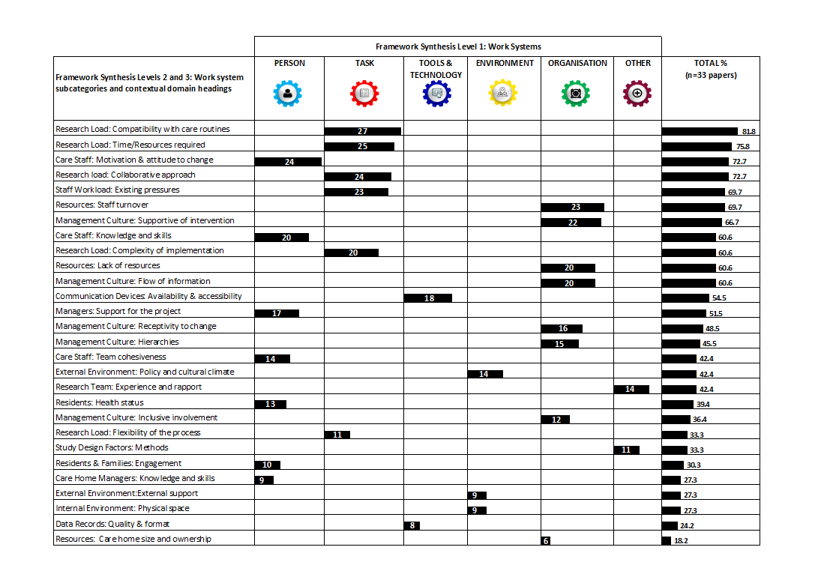
Appendix 3

Figure A3.1 Context domains presented according to care home work system and ranked according to reporting frequency across the 33 included papers

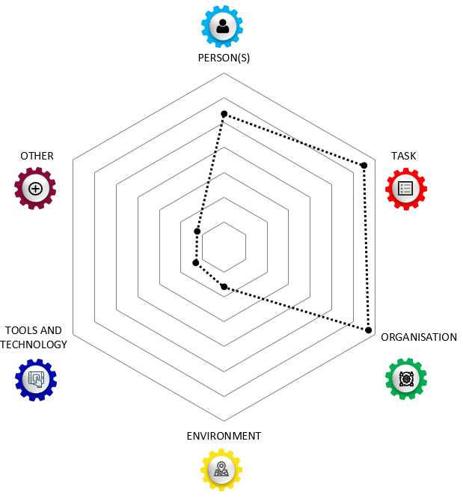

Figure A3.2. Radar plot displaying the weighting of reported contextual factors influencing trial implementation processes in CHs across work systems.

Descriptive Summary of the Work-System Sub-categories

Organisation
Sub-categories of the organisation work system included resources, and management culture. Contextual factors indexed within the organisational work system were the most prevalent across all 28 contextual domains. The data demonstrated that CH organisational factors have a strong mediating effect on research implementation. “Care homes are recognized to be highly variable in terms of their organizational structure and this has been identified as a challenge to research,” [1] (p.979). Not only did attributes of the organisation lend themselves to their state of readiness to host a research study but they also determined whether the organisation was poised to accept and adopt changes to habitual routines. The effects of staffing stability, the management culture, adequate allocation of resources, the influence of internal hierarchies, and the quality of communication within and across teams were all influential factors on successful research implementation. There was a need for, “vertically and horizontally linked teams (involving professional and nonregulated staff from various departments) to identify, instigate, own, and monitor a change process. This precipitated two change mechanisms: managerial support and a disruptive innovation,” [2] (p.365).
“Organizational aspects influenced the ease with which the care program was embraced in... [Dementia Special Care Units]. Staff turnover, high workload, concurrent projects, cancelled meetings and organizational changes were described as barriers for implementing the care program,” [3] (p.9).

Task
The task work system was the second highest in terms of prevalence of contextual factors in the included literature. Sub-categories of the task work system were research load, and staff workload. They represented four out of the top six context domains: congruence of research activities with routine care, the roll of collaboration in supporting research tasks, perceived complexity of the implementation process, and the time and resources the intervention required. Novel research activities were not prioritized in many situations because, “the new routines were seldom accompanied by suggestions as to what routines should be replaced,” [4] (p.90). The additional ‘load’ that staff experienced required extra effort for which their appeared few rewards, unless the benefit to residents’ was clear over the short term. One internal facilitator reported, “…after the residential, I was exhausted. For five days I just sat there, demolished, and like ‘where do I start’,” [5] (p.6).

Person(s)
The person work system was the third most prevalent across the indexed data. Sub-categories within the person work system were care staff, managerial team, and residents and family. The perceived benefit of the intervention, confidence levels of staff, the amount of support from the CH management, and the health status of residents all had significant influences on protocol compliance and implementation success. These factors contributed to dwindling engagement and a loss of momentum of research focussed activities over time. “Mappers were also required to use skills they had not previously had to employ, such as engaging colleagues in discussion of practice development issues and accurate written recording of outcomes,” [6] (p.6). When staff perceived negative elements of the intervention, it tended to spread throughout the organisation. “There was a lot of negative feedback from the staff; they thought it was a stupid project,” [2] (p.364).

Environment
The environment work system had two sub-categories, internal and external. The internal physical environment was highly variable between CHs. Externally, economic constraints at a societal level affected retention of experienced staff and residents’ health status when initially transferring to a CH. “...the care is subject to huge cutbacks, so really good staff members leave because the quality becomes unacceptable. You then have to deal with less professional personnel, making it even more difﬁcult to apply new methods like this one,” [7] (nurse assistant, p.542). These details introduced further heterogeneity between sites and influenced intervention feasibility, fidelity, and staff appraisals of appropriateness across individual CH settings. “… the care home population is older and frailer than anticipated when the OPERA trial was planned, perhaps as a result of a prevailing ethical and financial imperative to maintain frail older people in their own homes with support for as long as possible,” (p.10) [8].

Tools and Technology
This work-system had sub-categories of data records, and communication devices. Approaches to record keeping and archiving were heterogeneous across CHs. These details were also influenced by the varying degrees of digital literacy among staff as well as the degree computers and wireless connections were available to staff. “The relatively low response to some of the questionnaires is also an important limitation. One of the reasons for this is probably that the nursing home staff did not regularly use the e-mail account at work,” [9] (p.13). Due to many staff having English as a second language remote teleconferences enabled inclusion but were also reported to inhibit understanding in some studies. Research teams experienced technological and communication challenges with CHs. “Communication with the care home managers and mappers could be challenging and difficult to maintain for experts. A reliance on telephone and e-mail, meant experts had to call when the appropriate person was on shift and available, or e-mail. This latter method was often ineffective if mappers did not have work e-mail addresses or checked and answered them irregularly,” [10] (p.8).

Other
An additional work system was assigned to the synthesis framework that included research team and trial factors as sub-categories. Reasons for procedural drift were also attributed to aspects of the research process, “the most commonly cited obstacle to coherence did not relate to care home characteristics, but to the procedures required for the cRCT [cluster randomised controlled trial] itself within the care homes: the lengthy gaps between ﬁrst contacts, data collection, intervention activities and adjustments to the intervention all undermining coherence,” [11] (p.9). In addition relational qualities of the research team were important. For example,” When the relationship with the detailer was strong (Intervention Source), homes reported that the intervention had a high perceived value, exceeding their expectations. In contrast, the two homes who reported a negative perception of the detailer noted a lack of perceived value in the overall [Academic Detailing] intervention,” [12] (p9).

Appendix 3 References

1. Walker GM, Armstrong S, Gordon AL, Gladman J, Robertson K, Ward M, et al. The Falls In Care Home study: a feasibility randomized controlled trial of the use of a risk assessment and decision support tool to prevent falls in care homes. Clin Rehabil. 2016;30(10):972-83.
2. Edwards NC, Smith Higuchi K. Process Evaluation of a Participatory, Multimodal Intervention to Improve Evidence‐Based Care in Long‐Term Care Settings. Worldviews on Evidence-Based Nursing. 2018;15(5):361-7.
3. Zwijsen SA, Smalbrugge M, Eefsting JA, et al.; Grip on challenging behavior: Process evaluation of the implementation of a care program. Trials 2014;15(1).
4. Eldh AC, Olai L, Jönsson B, Wallin L, Denti L, Elf M. Supporting first-line managers in implementing oral care guidelines in nursing homes. Nordic Journal of Nursing Research. 2018;38(2):87-95.
5. Rycroft-Malone J, Seers K, Eldh AC, Cox K, Crichton N, Harvey G, et al. A realist process evaluation within the Facilitating Implementation of Research Evidence (FIRE) cluster randomised controlled international trial: an exemplar. Implementation Science. 2018;13(1):138.
6. Surr CA, Griffiths AW, Kelley R, Holloway I, Walwyn REA, Martin A, et al. The Implementation of Dementia Care Mapping in a Randomized Controlled Trial in Long-Term Care: Results of a Process Evaluation. American Journal of Alzheimer's Disease and other Dementias. 2019;34(6):390-8.
7. van Haeften-van Dijk AM, van Weert JCM, Dröes R-M. Implementing living room theatre activities for people with dementia on nursing home wards: a process evaluation study. Aging & Mental Health. 2015;19(6):536-47.
8. Ellard DR, Thorogood M, Underwood M, Seale C, Taylor SJ. Whole home exercise intervention for depression in older care home residents (the OPERA study): a process evaluation. BMC Medicine. 2014;12:1.
9. Lichtwarck B, Myhre J, Selbaek G, Kirkevold Ø, Rokstad AMM, Benth JŠ, et al. TIME to reduce agitation in persons with dementia in nursing homes. A process evaluation of a complex intervention. BMC Health Services Research. 2019;19(1):N.PAG-N.PAG.
10. Surr CA, Shoesmith E, Griffiths AW, Kelley R, McDermid J, Fossey J. Exploring the role of external experts in supporting staff to implement psychosocial interventions in care home settings: results from the process evaluation of a randomized controlled trial. BMC health services research. 2019;19(1):790.
11. Keenan J, Poland F, Manthorpe J, Hart C, Moniz-Cook E. Implementing e-learning and e-tools for care home staff supporting residents with dementia and challenging behaviour: A process evaluation of the ResCare study using normalisation process theory. Dementia. 2018:1471301218803195.
12. Desveaux L, Saragosa M, Rogers J, Bevan L, Loshak H, Moser A, et al. Improving the appropriateness of antipsychotic prescribing in nursing homes: a mixed-methods process evaluation of an academic detailing intervention. Implementation Science. 2017;12(11):71.

