Supplementary Tables
TABLE S1. Reliability analyses for brain regions showing cerebral blood flow alterations in patients with T2DM compared with healthy controls.
Jackknife analyses,  discarded study | Brain regions (MNI coordinates)
Jackknife analyses,  discarded study | Increased CBF |  | Decreased CBF
Jackknife analyses,  discarded study | R supplementary motor area |  | L middle occipital gyrus | R middle occipital gyrus | L caudate nucleus | R superior parietal gyrus | L calcarine fissure/ surrounding cortex
Jackknife analyses,  discarded study | 6,-12,68 |  | -18,-94,-2 | 30,-90,10 | -12,-2,18 | 16,-64,56 | 2,-86,8
Xia et al. (2015) | Yes |  | Yes | Yes | Yes | Yes | Yes
Jansen et al. (2016) | Yes |  | Yes | Yes | Yes | Yes | Yes
Cui et al. (2017) | Yes |  | No | Yes | Yes | Yes | No
Dai et al. (2017) | Yes |  | Yes | Yes | No | Yes | Yes
Shen et al. (2017) | Yes |  | Yes | Yes | Yes | Yes | Yes
Zhang et al. (2019) | No |  | Yes | Yes | Yes | Yes | Yes
Huang et al. (2021) | Yes |  | Yes | Yes | No | Yes | Yes
 | 6/7 |  | 6/7 | 7/7 | 5/7 | 7/7 | 6/7
T2DM, type 2 diabetes mellitus; MNI, Montreal Neurological Institute; CBF, cerebral blood flow; R, right; L, left.

TABLE S2. Heterogeneity analysis for brain regions showing cerebral blood flow alterations in patients with T2DM compared with healthy controls.
Brian regions | MNI coordinates | I² (%)
T2DM > Control
R supplementary motor area | 6,-12,68 | 17.59
T2DM < Control
L middle occipital gyrus | -18,-94,-2 | 22.65
R middle occipital gyrus | 30,-90,10 | 5.49
L caudate nucleus | -12,-2,18 | 9.28
R superior parietal gyrus | 16,-64,56 | 3.37
L calcarine fissure/surrounding cortex | 2,-86,8 | 3.35
T2DM, type 2 diabetes mellitus; MNI, Montreal Neurological Institute; R, right; L, left.

TABLE S3. Funnel plots and Egger test for brain regions showing cerebral blood flow alterations in patients with T2DM compared with healthy controls.
Brian regions | MNI coordinates | Funnel plots | Egger test
T2DM > Control
R supplementary motor area | 6,-12,68 | 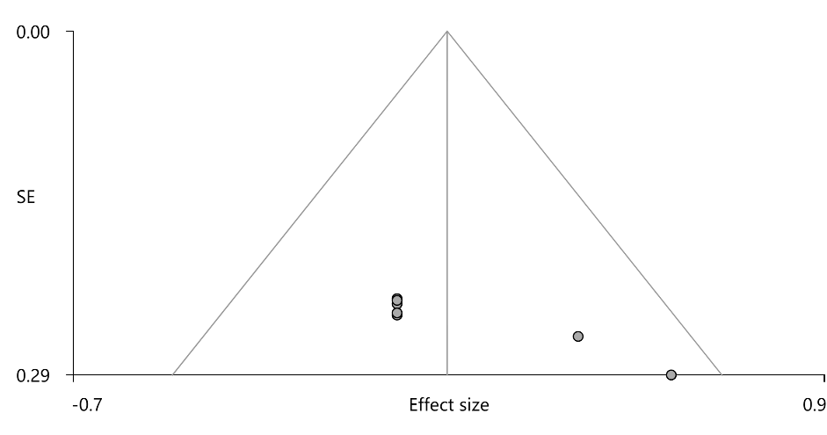 | t = 6.65, p = 0.001
T2DM < Control
L middle occipital gyrus | -18,-94,-2 | 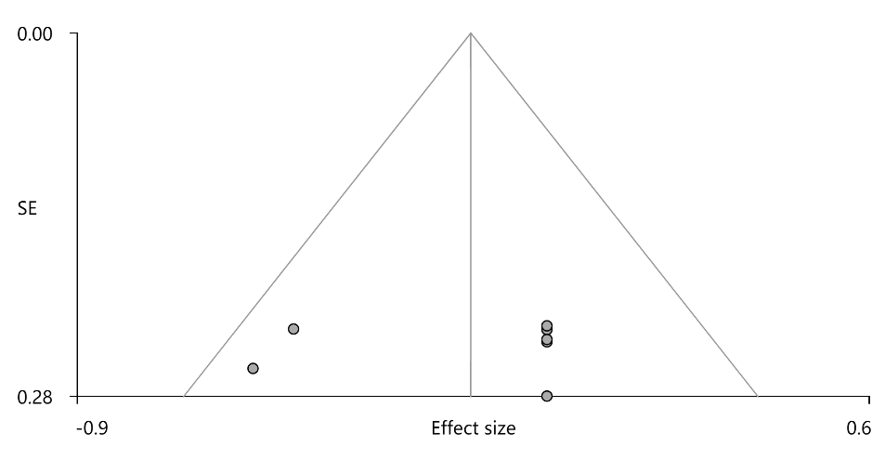 | t = -0.24, p = 0.82
R middle occipital gyrus | 30,-90,10 | 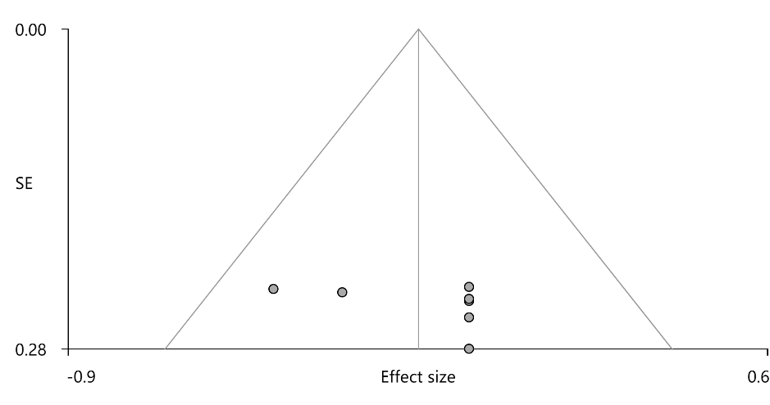 | t = 1.05, p = 0.34
L caudate nucleus | -12,-2,18 | 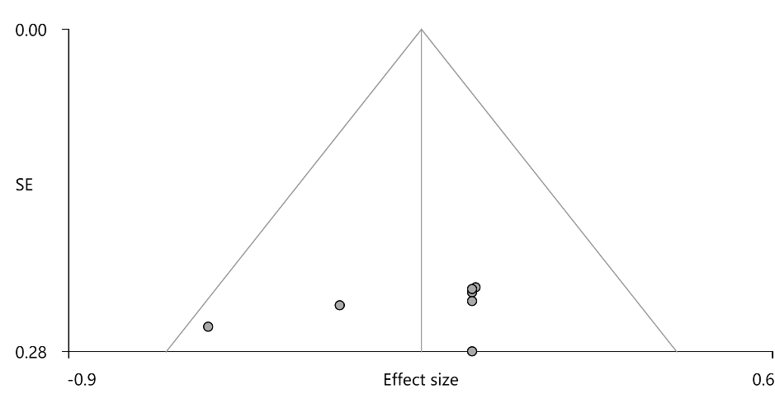 | t = -0.98, p = 0.37
R superior parietal gyrus | 16,-64,56 | 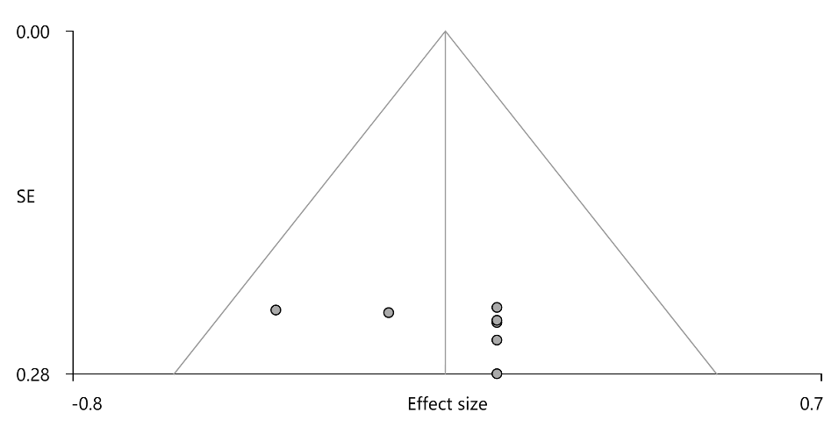 | t = 1.01, p = 0.36
L calcarine fissure/surrounding cortex | 2,-86,8 | 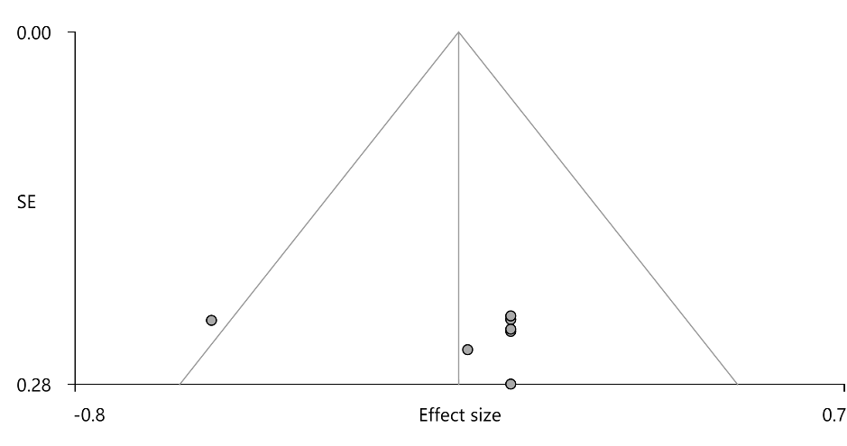 | t = 0.52, p = 0.63
T2DM, type 2 diabetes mellitus; MNI, Montreal Neurological Institute; R, right; L, left.

TABLE S4. Subgroup analyses for brain regions showing cerebral blood flow alterations in patients with T2DM compared with healthy controls.
Subgroup analyses | Brain regions (MNI coordinates)
Subgroup analyses | Increased CBF |  | Decreased CBF
Subgroup analyses | R supplementary motor area |  | L middle occipital gyrus | R middle occipital gyrus | L caudate nucleus | R superior parietal gyrus | L calcarine fissure/ surrounding cortex
Subgroup analyses | 6,-12,68 |  | -18,-94,-2 | 30,-90,10 | -12,-2,18 | 16,-64,56 | 2,-86,8
PASL (n = 3) | No |  | No | Yes | No | Yes | No
PCASL (n = 4) | Yes |  | Yes | No | Yes | No | Yes
Slice thickness = 4 mm (n = 5) | Yes |  | No | Yes | No | Yes | No
PVE correction (n = 4) | Yes |  | Yes | Yes | No | Yes | Yes
T2DM, type 2 diabetes mellitus; MNI, Montreal Neurological Institute; CBF, cerebral blood flow; R, right; L, left; PASL, pulsed arterial spin labeling; PCASL, pseudo-continuous arterial spin labeling; PVE, partial volume effect.

