Figure S1. Association of all-cause dementia risk with different indices of SBPV
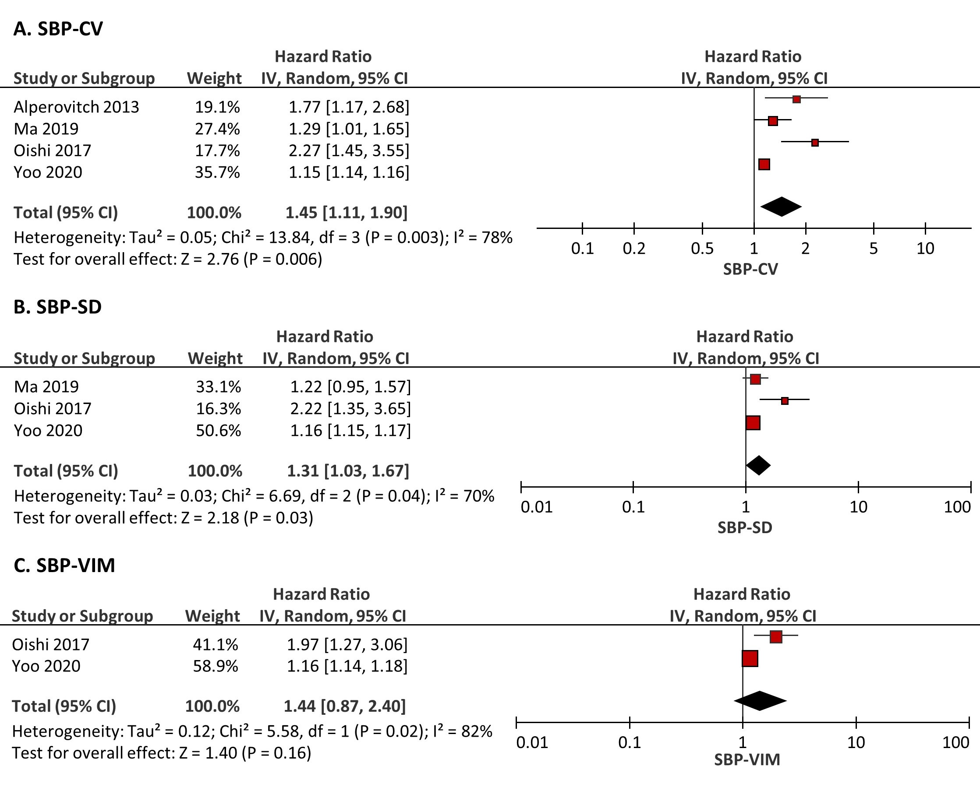
SBP indicates systolic blood pressure; SBPV, variability of systolic blood pressure; CV, coefficient of variation; SD, standard deviation; VIM, variance independent of the mean; and IV, inverse variance. SBP-CV indicates CV of SBP; similar expressions apply to SBP-SD and SBP-VIM. The forest plots were produced with RevMan 5.4 (Cochrane, UK) using the inverse variance method with random effects.
Figure S2. Association of all-cause dementia risk with different indices of DBPV
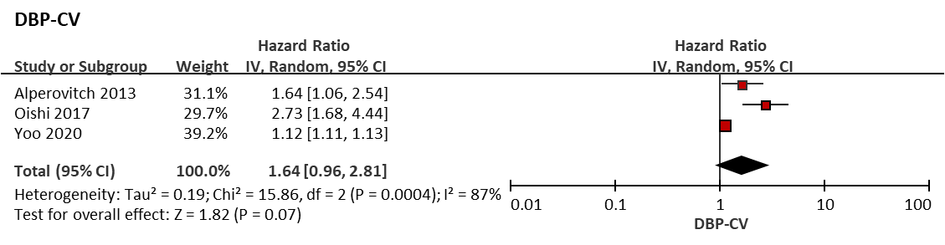
DBP indicates diastolic blood pressure; DBPV, variability of diastolic blood pressure; CV, coefficient of variation; and IV, inverse variance. DBP-CV indicates CV of DBP. The forest plot was produced with RevMan 5.4 (Cochrane, UK) using the inverse variance method with random effects.
Figure S3. Association of Alzheimer’s disease risk with different indices of SBPV
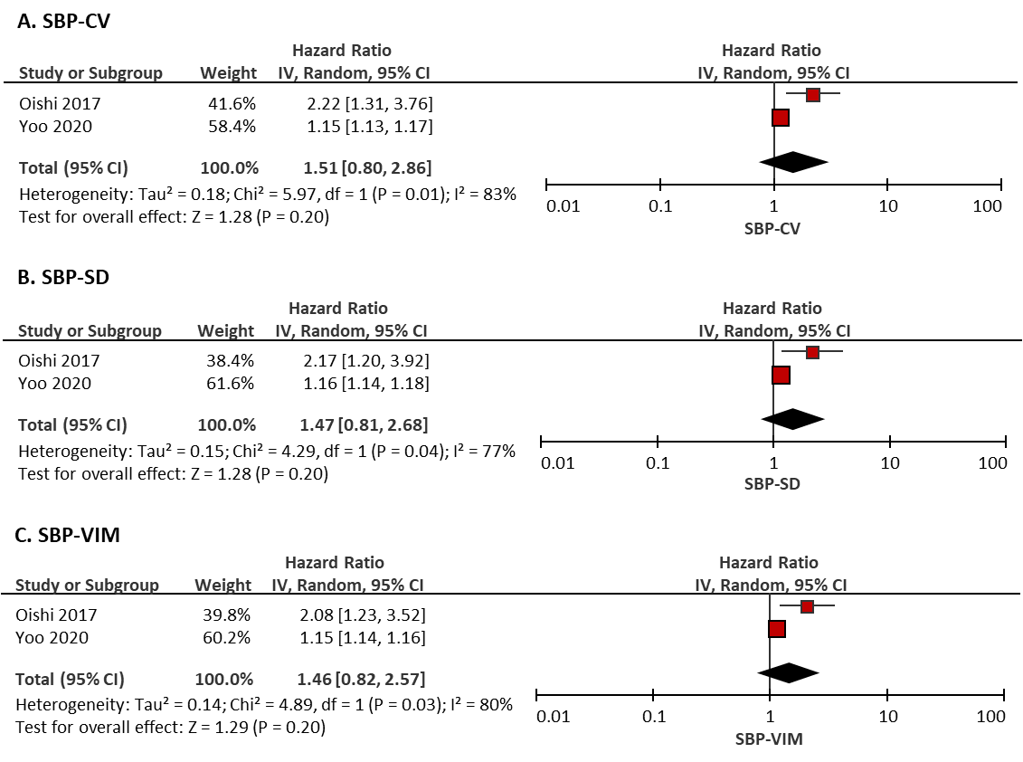
SBP indicates systolic blood pressure; SBPV, variability of systolic blood pressure; CV, coefficient of variation; SD, standard deviation; VIM, variance independent of the mean; and IV, inverse variance. SBP-CV indicates CV of SBP; similar expressions apply to SBP-SD and SBP-VIM. The forest plots were produced with RevMan 5.4 (Cochrane, UK) using the inverse variance method with random effects.

Figure S4. Association of Alzheimer’s disease risk with different indices of DBPV
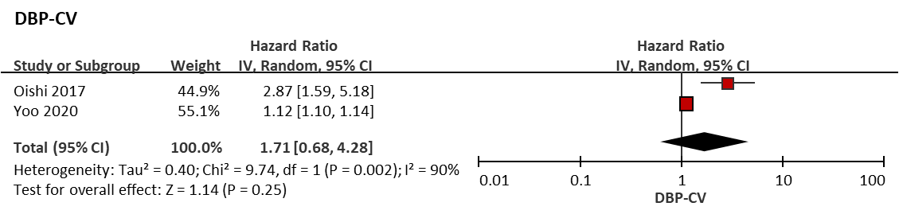
DBP indicates diastolic blood pressure; DBPV, variability of diastolic blood pressure; CV, coefficient of variation; and IV, inverse variance. DBP-CV indicates CV of DBP. The forest plot was produced with RevMan 5.4 (Cochrane, UK) using the inverse variance method with random effects.
Figure S5. Association of vascular dementia risk with different indices of SBPV
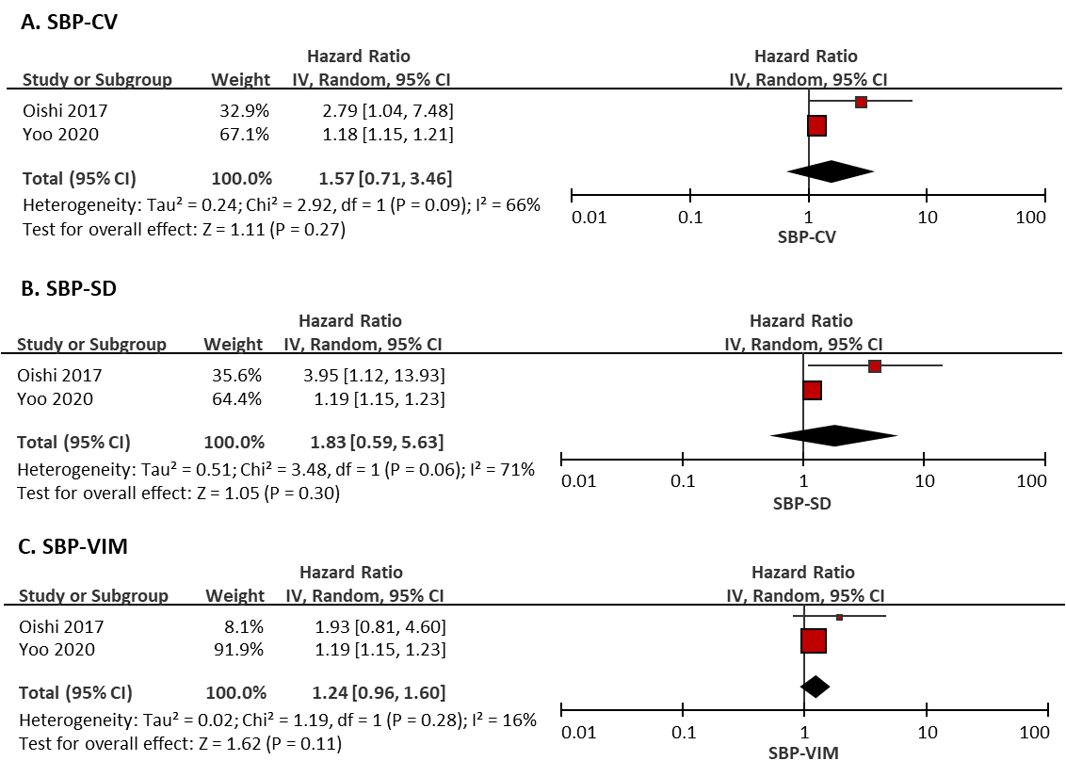
SBP indicates systolic blood pressure; SBPV, variability of systolic blood pressure; CV, coefficient of variation; SD, standard deviation; VIM, variance independent of the mean; and IV, inverse variance. SBP-CV indicates CV of SBP; similar expressions apply to SBP-SD and SBP-VIM. The forest plots were produced with RevMan 5.4 (Cochrane, UK) using the inverse variance method with random effects.

Figure S6. Association of vascular dementia risk with different indices of DBPV
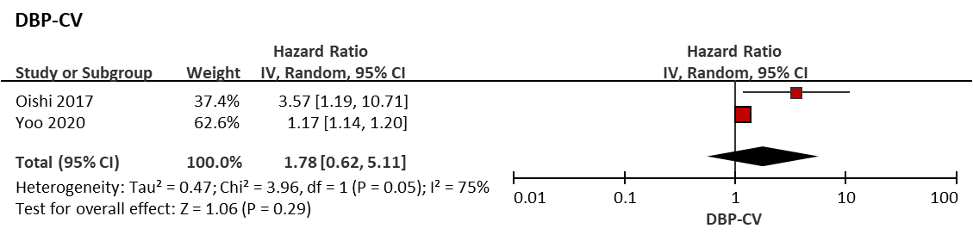
DBP indicates diastolic blood pressure; DBPV, variability of diastolic blood pressure; CV, coefficient of variation; and IV, inverse variance. DBP-CV indicates CV of DBP. The forest plot was produced with RevMan 5.4 (Cochrane, UK) using the inverse variance method with random effects.
Figure S7. Association of incidence of cognitive decline with different indices of SBPV
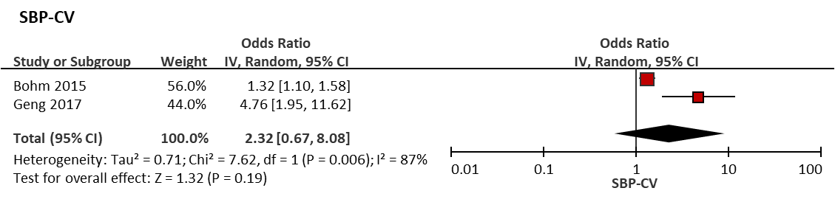
SBP indicates systolic blood pressure; SBPV, variability of systolic blood pressure; CV, coefficient of variation; and IV, inverse variance. SBP-CV indicates CV of SBP. The forest plot was produced with RevMan 5.4 (Cochrane, UK) using the inverse variance method with random effects.

Figure S8. Subgroup analysis between SBP-CV and all-cause dementia risk according to different timeframes of BPV
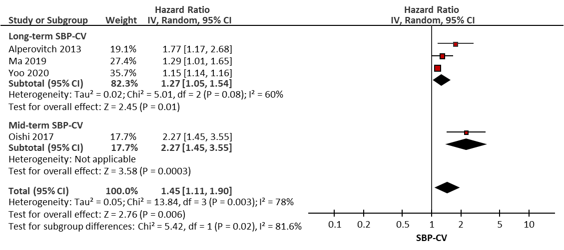
SBP indicates systolic blood pressure; BPV, variability of blood pressure; CV, coefficient of variation; and IV, inverse variance. SBP-CV indicates CV of SBP. The forest plot was produced with RevMan 5.4 (Cochrane, UK) using the inverse variance method with random effects.

Figure S9. Subgroup analysis between SBP-SD and all-cause dementia risk according to different timeframes of BPV
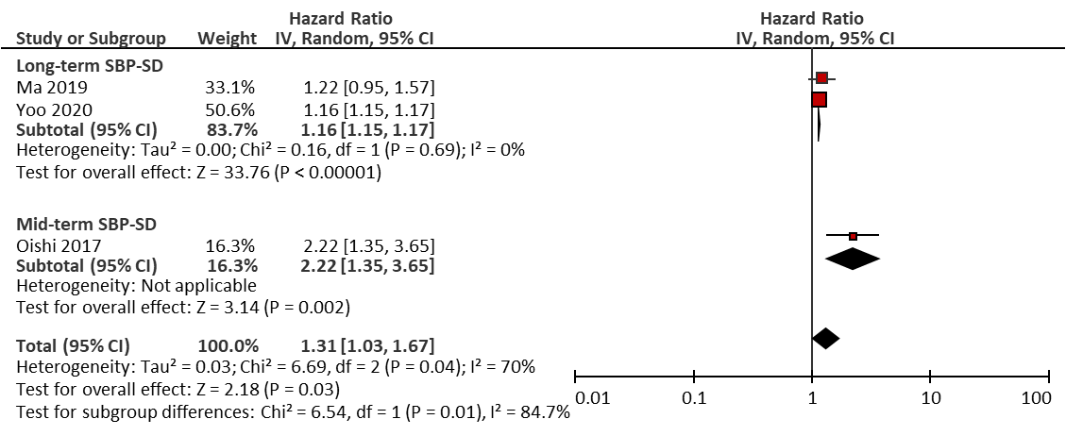
SBP indicates systolic blood pressure; BPV, variability of blood pressure; SD, standard deviation; and IV, inverse variance. SBP-SD indicates SD of SBP. The forest plot was produced with RevMan 5.4 (Cochrane, UK) using the inverse variance method with random effects.

Figure S10. Subgroup analysis between DBP-CV and all-cause dementia risk according to different timeframes of BPV
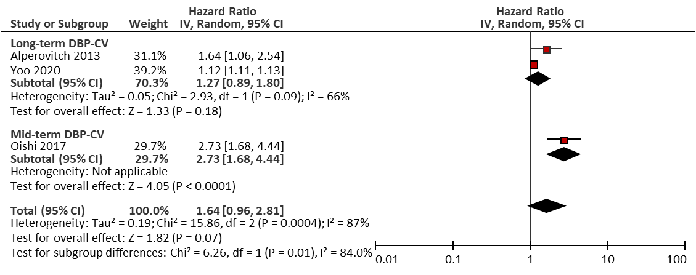
DBP indicates diastolic blood pressure; BPV, variability of blood pressure; CV, coefficient of variation; and IV, inverse variance. DBP-CV indicates CV of DBP. The forest plot was produced with RevMan 5.4 (Cochrane, UK) using the inverse variance method with random effects.
Figure S11. Subgroup analysis between SBP-CV and all-cause dementia risk according to different follow-up durations for cognitive performances
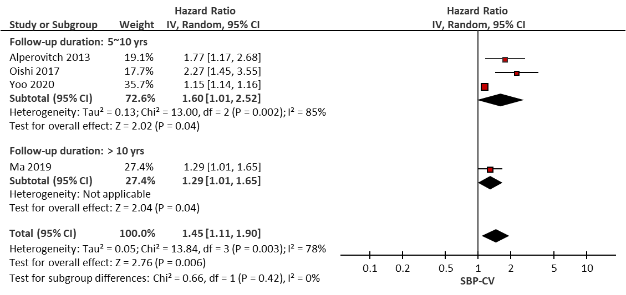
SBP indicates systolic blood pressure; CV, coefficient of variation; and IV, inverse variance. SBP-CV indicates CV of SBP. The forest plot was produced with RevMan 5.4 (Cochrane, UK) using the inverse variance method with random effects.
Figure S12. Subgroup analysis between SBP-SD and all-cause dementia risk according to different follow-up durations for cognitive performances
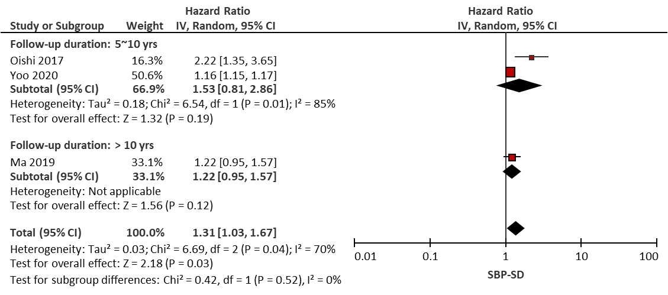
SBP indicates systolic blood pressure; SD, standard deviation; and IV, inverse variance. SBP-SD indicates SD of SBP. The forest plot was produced with RevMan 5.4 (Cochrane, UK) using the inverse variance method with random effects.
Figure S13. Subgroup analysis between SBP-CV and all-cause dementia risk according to the mean age of participants in included studies
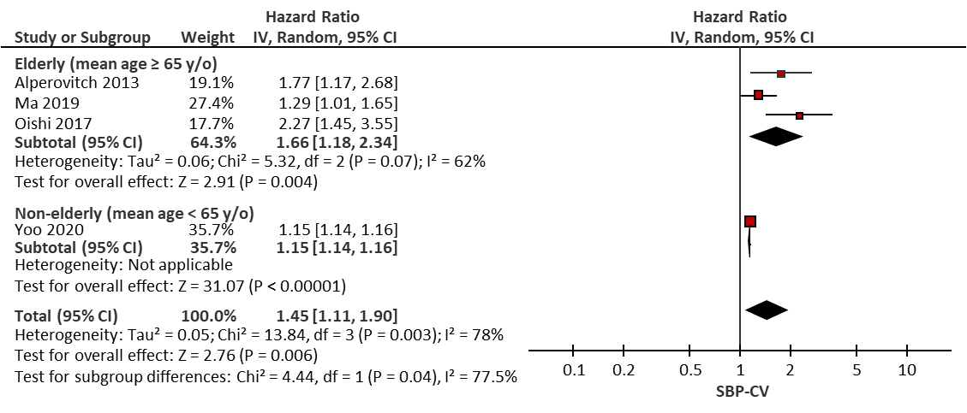
SBP indicates systolic blood pressure; CV, coefficient of variation; and IV, inverse variance. SBP-CV indicates CV of SBP. The forest plot was produced with RevMan 5.4 (Cochrane, UK) using the inverse variance method with random effects.
Figure S14. Subgroup analysis between SBP-SD and all-cause dementia risk according to the mean age of participants in included studies
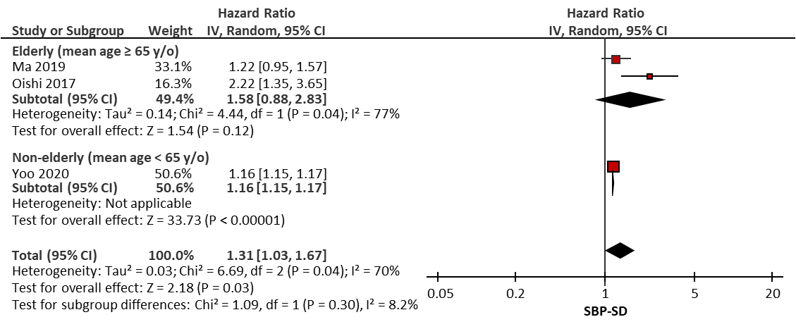
SBP indicates systolic blood pressure; SD, standard deviation; and IV, inverse variance. SBP-SD indicates SD of SBP. The forest plot was produced with RevMan 5.4 (Cochrane, UK) using the inverse variance method with random effects.
Figure S15. Subgroup analysis between DBP-CV and all-cause dementia risk according to the mean age of participants in included studies
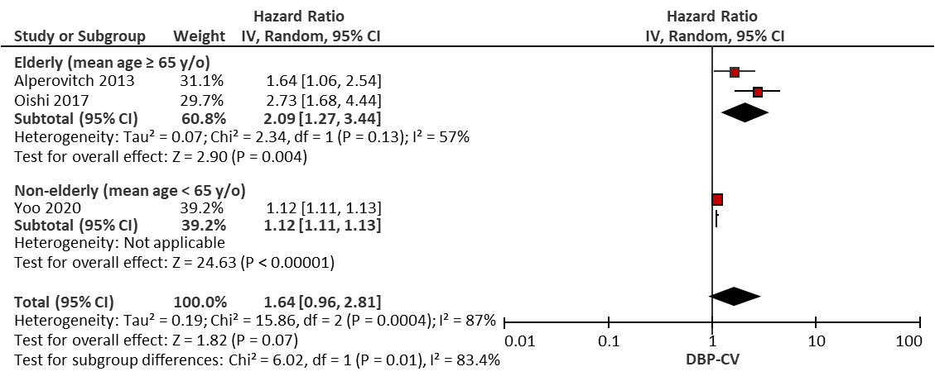
DBP indicates diastolic blood pressure; CV, coefficient of variation; and IV, inverse variance. DBP-CV indicates CV of DBP. The forest plot was produced with RevMan 5.4 (Cochrane, UK) using the inverse variance method with random effects.
Figure S16. Sensitivity analysis between SBP-CV and all-cause dementia risk by leave-one-out meta-analysis
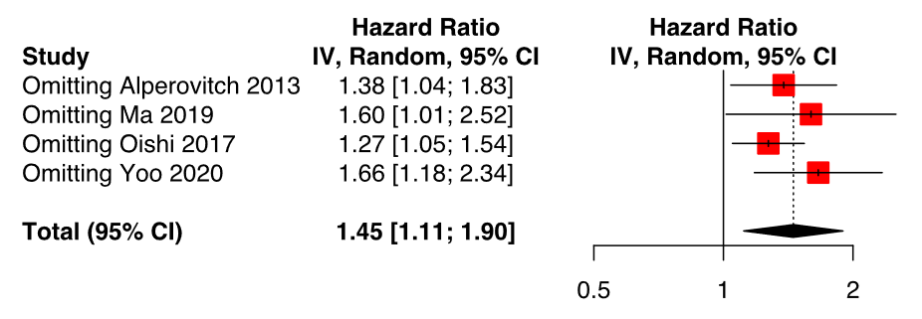
SBP indicates systolic blood pressure; CV, coefficient of variation; and IV, inverse variance. SBP-CV indicates CV of SBP. The forest plot was produced with the meta R package using the inverse variance method with random effects.
Figure S17. Sensitivity analysis between SBP-SD and all-cause dementia risk by leave-one-out meta-analysis
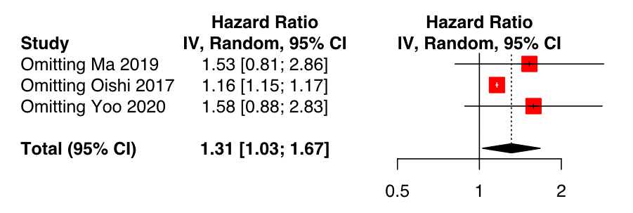
SBP indicates systolic blood pressure; SD, standard deviation; and IV, inverse variance. SBP-SD indicates SD of SBP. The forest plot was produced with the meta R package using the inverse variance method with random effects.
Figure S18. Sensitivity analysis between DBP-CV and all-cause dementia risk by leave-one-out meta-analysis
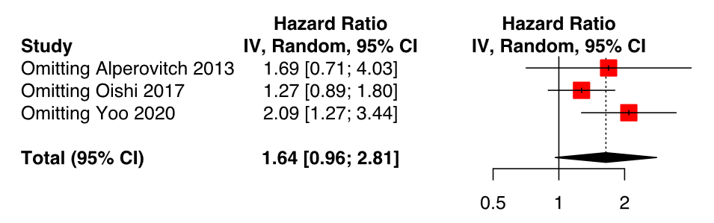
DBP indicates diastolic blood pressure; CV, coefficient of variation; and IV, inverse variance. DBP-CV indicates CV of DBP. The forest plot was produced with the meta R package using the inverse variance method with random effects.
Figure S19. Funnel plots representing publication biases for the analysis with significant results
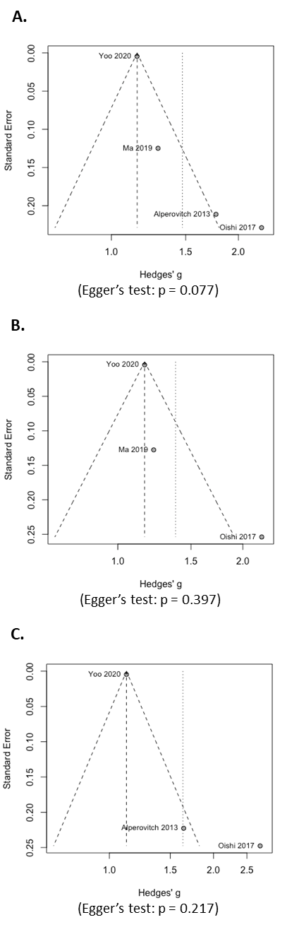
Funnel plots of hazard ratios for all-cause dementia risk attributable to SBP-CV (A), SBP-SD (B), and DBP-CV (C) were produced using the metafor R package, and symmetry was examined with Egger’s test. Since no significance was observed in Egger’s test, no further trim-and-fill procedure was conducted. SBP indicates systolic blood pressure; DBP, diastolic blood pressure; CV, coefficient of variation; and SD, standard deviation. SBP-CV indicates CV of SBP; similar expressions apply to SBP-SD and DBP-CV.

