Supplementary Material

Title: Systematic Review with Network Meta-Analysis: Comparative Efficacy of Outcomes of various ARBs in Hypertensive Patients

Table S1: Details of search strategies
Medline
No. | Search Statement | Hits
1 | exp HYPERTENSION/ | 241,355
2 | hypertens*.mp. [mp=title, abstract, original title, name of substance word, subject heading word, floating sub-heading word, keyword heading word, protocol supplementary concept word, rare disease supplementary concept word, unique identifier, synonyms] | 467,065
3 | blood pressure.mp. [mp=title, abstract, original title, name of substance word, subject heading word, floating sub-heading word, keyword heading word, protocol supplementary concept word, rare disease supplementary concept word, unique identifier, synonyms] | 416,675
4 | 1 or 2 or 3 | 733,296
5 | azilsartan.mp. [mp=title, abstract, original title, name of substance word, subject heading word, floating sub-heading word, keyword heading word, protocol supplementary concept word, rare disease supplementary concept word, unique identifier, synonyms] | 176
6 | olmesartan.mp. [mp=title, abstract, original title, name of substance word, subject heading word, floating sub-heading word, keyword heading word, protocol supplementary concept word, rare disease supplementary concept word, unique identifier, synonyms] | 1,494
7 | candesartan.mp. [mp=title, abstract, original title, name of substance word, subject heading word, floating sub-heading word, keyword heading word, protocol supplementary concept word, rare disease supplementary concept word, unique identifier, synonyms] | 3,071
8 | eprosartan.mp. [mp=title, abstract, original title, name of substance word, subject heading word, floating sub-heading word, keyword heading word, protocol supplementary concept word, rare disease supplementary concept word, unique identifier, synonyms] | 379
9 | irbesartan.mp. [mp=title, abstract, original title, name of substance word, subject heading word, floating sub-heading word, keyword heading word, protocol supplementary concept word, rare disease supplementary concept word, unique identifier, synonyms] | 1,706
10 | valsartan.mp. [mp=title, abstract, original title, name of substance word, subject heading word, floating sub-heading word, keyword heading word, protocol supplementary concept word, rare disease supplementary concept word, unique identifier, synonyms] | 3,362
11 | losartan.mp. [mp=title, abstract, original title, name of substance word, subject heading word, floating sub-heading word, keyword heading word, protocol supplementary concept word, rare disease supplementary concept word, unique identifier, synonyms] | 9,232
12 | telmisartan.mp. [mp=title, abstract, original title, name of substance word, subject heading word, floating sub-heading word, keyword heading word, protocol supplementary concept word, rare disease supplementary concept word, unique identifier, synonyms] | 2,178
13 | (5 and 6) or (5 and 7) or (5 and 8) or (5 and 9) or (5 and 10) or (5 and 11) or (5 and 12) | 70
14 | (6 and 7) or (6 and 8) or (6 and 9) or (6 and 10) or (6 and 11) or (6 and 12) | 303
15 | (7 and 8) or (7 and 9) or (7 and 10) or (7 and 11) or (7 and 12) | 649
16 | (8 and 9) or (8 and 10) or (8 and 11) or (8 and 12) | 143
17 | (9 and 10) or (9 and 11) or (9 and 12) | 508
18 | (10 and 11) or (10 and 12) | 574
19 | 11 and 12 | 311
20 | 13 or 14 or 15 or 16 or 17 or 18 or 19 | 1,579
21 | 4 and 20 | 1,013
22 | limit 21 to randomized controlled trial | 199
Cochrane Library
No. | Search Statement | Hits
#1 | MeSH descriptor: [Hypertension] explode all trees | 16,457
#2 | (hypertension):ti,ab,kw (Word variations have been searched) | 49,824
#3 | (blood pressure):ti,ab,kw | 77,429
#4 | #1 or #2 or #3 | 102,271
#5 | (azilsartan):ti,ab,kw | 102
#6 | (olmesartan):ti,ab,kw | 577
#7 | (candesartan):ti,ab,kw | 967
#8 | (eprosartan):ti,ab,kw | 127
#9 | (irbesartan):ti,ab,kw | 730
#10 | (valsartan):ti,ab,kw | 1,651
#11 | (losartan):ti,ab,kw | 2,038
#12 | (telmisartan):ti,ab,kw | 940
#13 | (#5 and #6) or (#5 and #7) or (#5 and #8) or (#5 and #9) or (#5 and #10) or (#5 and #11) or (#5 and #12) | 46
#14 | (#6 and #7) or (#6 and #8) or (#6 and #9) or (#6 and #10) or (#6 and #11) or (#6 and #12) | 150
#15 | (#7 and #8) or (#7 and #9) or (#7 and #10) or (#7 and #11) or (#7 and #12) | 179
#16 | (#8 and #9) or (#8 and #10) or (#8 and #11) or (#8 and #12) | 33
#17 | (#9 and #10) or (#9 and #11) or (#9 and #12) | 127
#18 | (#10 and #11) or (#10 and #12) | 190
#19 | #11 and #12 | 108
#20 | #13 or #14 or #15 or #16 or #17 or #18 or #19 | 574
#21 | #4 and #20 in Trials | 505
Medline (ARB mono vs. CCB mono)
No. | Search Statement | Hits
1 | exp HYPERTENSION/ | 241,355
2 | hypertens*.mp. [mp=title, abstract, original title, name of substance word, subject heading word, floating sub-heading word, keyword heading word, protocol supplementary concept word, rare disease supplementary concept word, unique identifier, synonyms] | 467,065
3 | blood pressure.mp. [mp=title, abstract, original title, name of substance word, subject heading word, floating sub-heading word, keyword heading word, protocol supplementary concept word, rare disease supplementary concept word, unique identifier, synonyms] | 416,675
4 | 1 or 2 or 3 | 733,296
5 | exp Calcium Channel Blockers/ | 78,682
6 | exp Angiotensin II Type 1 Receptor Blockers/ | 15,764
7 | 5 and 6 | 1,266
8 | 4 and 7 | 1,067
9 | limit 8 to randomized controlled trial | 404
Cochrane Library
No. | Search Statement | Hits
#1 | MeSH descriptor: [Hypertension] explode all trees | 16,457
#2 | (hypertension):ti,ab,kw (Word variations have been searched) | 49,824
#3 | (blood pressure):ti,ab,kw (Word variations have been searched) | 78,115
#4 | #1 or #2 or #3 | 102,823
#5 | MeSH descriptor: [Angiotensin II Type 1 Receptor Blockers] explode all trees | 1,266
#6 | MeSH descriptor: [Calcium Channel Blockers] explode all trees | 2,786
#7 | #4 and #5 and #6 in Trials | 176
CNKI
No. | Search Statement | Hits
#1 | (SU='沙坦' or SU='氨氯地平') and SU='随机' | 267
Wan Fang
No. | Search Statement | Hits
#1 | (主题:("沙坦" )*主题:("血压")*主题:("对照")*全部:("随机")) | 75

Table S2. Risk of bias assessment
 | Kalikar 2017 | Perez 2017 | Flack 2012 | Punzi 2012 | Bakris 2011
Random sequence generation | Low risk | Low risk | Unknown | Unknown | Unknown
Allocation concealment | Low risk | Low risk | Unknown | Unknown | Unknown
Blinding of participants and personnel | High risk | Low risk | Low risk | Low risk | Low risk
Blinding of outcome assessment | High risk | Low risk | Low risk | Low risk | Low risk
Incomplete outcome data | Low risk | Low risk | Low risk | Low risk | Low risk
Selective reporting | Low risk | Low risk | Low risk | Low risk | Low risk
Other sources of bias | Low risk | Low risk | Low risk | Low risk | Low risk
 | Weir 2011 | White 2011 | Chrysant 2008 | Fogari 2008 | Bahadir 2007
Random sequence generation | Unknown | Unknown | Low risk | Low risk | Unknown
Allocation concealment | Unknown | Unknown | Low risk | Low risk | Unknown
Blinding of participants and personnel | Low risk | Low risk | Low risk | High risk | Unknown
Blinding of outcome assessment | Low risk | Low risk | Low risk | High risk | Unknown
Incomplete outcome data | Low risk | Low risk | Low risk | Low risk | Low risk
Selective reporting | Low risk | Low risk | Low risk | Low risk | Low risk
Other sources of bias | Low risk | Low risk | Low risk | Low risk | Low risk
 | Giles 2007 | Phillip 2007 | Baguet 2006 | Zhu 2006 | Destro 2005
Random sequence generation | Unknown | Low risk | Unknown | Low risk | Unknown
Allocation concealment | Unknown | Unknown | Unknown | Unknown | Unknown
Blinding of participants and personnel | Low risk | Low risk | Low risk | Low risk | High risk
Blinding of outcome assessment | Low risk | Low risk | Low risk | Low risk | Low risk
Incomplete outcome data | Low risk | Low risk | Low risk | Low risk | Low risk
Selective reporting | Low risk | Low risk | Low risk | Low risk | Low risk
Other sources of bias | Low risk | Low risk | Low risk | Low risk | Low risk
 | Liau 2005 | Smith 2005 | Calvo 2004 | Ding 2004 | Lee 2004
Random sequence generation | Low risk | Unknown | Low risk | Unknown | Unknown
Allocation concealment | Low risk | Unknown | Low risk | Unknown | Unknown
Blinding of participants and personnel | Low risk | Low risk | High risk | Low risk | Low risk
Blinding of outcome assessment | Low risk | Low risk | Low risk | Low risk | Low risk
Incomplete outcome data | Low risk | Low risk | Low risk | Low risk | Low risk
Selective reporting | Low risk | Low risk | Low risk | Low risk | Low risk
Other sources of bias | Low risk | Low risk | Low risk | Low risk | Low risk
 | White 2004 | Zhu 2004 | Bai 2002 | Bakris 2002 | Elliott 2001
Random sequence generation | Unknown | Low risk | Low risk | Unknown | Unknown
Allocation concealment | Unknown | Unknown | Unknown | Unknown | Unknown
Blinding of participants and personnel | Low risk | Low risk | Low risk | High risk | Low risk
Blinding of outcome assessment | Low risk | Low risk | Low risk | Low risk | Low risk
Incomplete outcome data | Low risk | Low risk | Low risk | Low risk | Low risk
Selective reporting | Low risk | Low risk | Low risk | Low risk | Low risk
Other sources of bias | Low risk | Low risk | Low risk | Low risk | Low risk
 | Bakris 2001 | Vidt 2001 | Monterroso 2000 | Gradman 1999 | Hedner 1999
Random sequence generation | Unknown | Low risk | Low risk | Unknown | Unknown
Allocation concealment | Unknown | Low risk | Low risk | Unknown | Unknown
Blinding of participants and personnel | Low risk | Low risk | Low risk | Low risk | Low risk
Blinding of outcome assessment | Low risk | Low risk | Low risk | Low risk | Low risk
Incomplete outcome data | Low risk | Low risk | Low risk | Low risk | Low risk
Selective reporting | Low risk | Low risk | Low risk | Low risk | Low risk
Other sources of bias | Low risk | Low risk | Low risk | Low risk | Low risk
 | Lacourcière 1999 | Mallion 1999 | Andersson 1998 | Kassler-Taub 1998
Random sequence generation | Low risk | Unknown | Unknown | Low risk
Allocation concealment | Low risk | Unknown | Unknown | Low risk
Blinding of participants and personnel | Low risk | Low risk | Low risk | Low risk
Blinding of outcome assessment | Low risk | Low risk | Low risk | Low risk
Incomplete outcome data | Low risk | Low risk | Low risk | Low risk
Selective reporting | Low risk | Low risk | Low risk | Low risk
Other sources of bias | Low risk | Low risk | Low risk | Low risk

Figure S1. Risk of bias assessment

Figure S2 Mean ranking plot for OBPM

Absolute ranking analysis for systolic blood pressure

Absolute ranking analysis for diastolic blood pressure

Table S3 Relative effects of BP league table between different angiotensin receptor blockers (OBPM)

Relative effects league table comparing all hypertensive against each other for systolic blood pressure

Relative effects league table comparing all hypertensive against each other for diastolic blood pressure

Figure S3. Inconsistency assessment for OBPM SBP

Figure S4. Inconsistency assessment for OBPM DBP

Figure S5. Heterogeneity assessment for OBPM SBP

Figure S6. Heterogeneity assessment for OBPM DBP

Secondary Endpoints – ABPM SBP and DBP

Figure S7. Mean ranking plots of ABPM

Absolute ranking analysis for systolic blood pressure

Absolute ranking analysis for diastolic blood pressure

Table S4. Relative effects of BP league table between different angiotensin receptor blockers (ABPM)

Relative effects league table comparing all hypertensive against each other for ambulatory SBP

Relative effects league table comparing all hypertensive against each other for ambulatory DBP

Figure S8. Inconsistency assessment for ABPM SBP

Figure S9. Inconsistency assessment for ABPM DBP

Figure S10. Heterogeneity assessment for ABPM SBP

Figure S11. Heterogeneity assessment for ABPM DBP

Figure S12. ABPM Daytime/Nighttime SBP/DBP mean changes from baseline compare with Val 80mg
ABPM Daytime SBP/DBP mean changes from baseline compare with Val 80mg
ABPM Daytime SBP | ABPM Daytime DBP
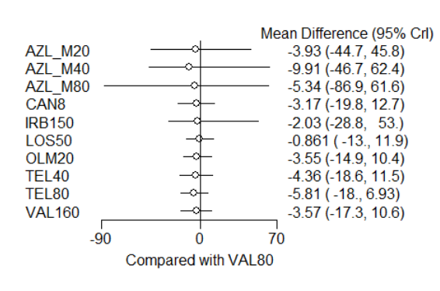 | 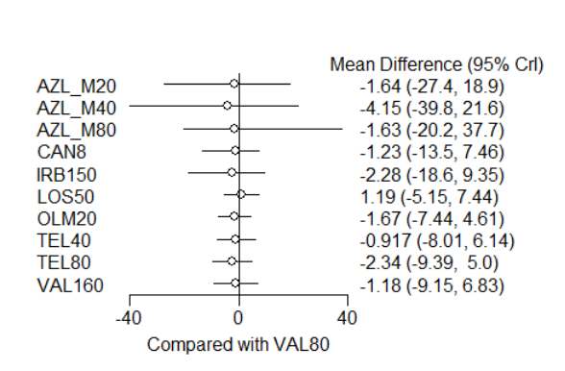
ABPM Nighttime SBP/DBP mean changes from baseline compare with Val 80mg
ABPM Nighttime SBP | ABPM Nighttime DBP
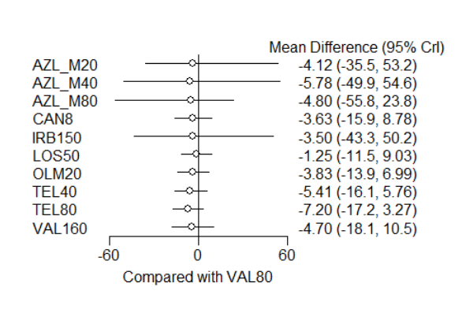 | 

