Supplementary Table 1: Search strategy in PubMed/MEDLINE, adapted for use with other databases.

SET | PubMed
1  2 | retire* [tiab]  retirement [MeSH Terms]
3 | Sets 1-2 were combined with “OR”
4  5  6  7  8 | depression [MeSH Terms]  depression [Title/Abstract]  depressive [Title/Abstract]  depression [Text Word]  depressive [Text Word]
9 | Sets 4-8 were combined with “OR”
10  11  12  13 | review  case reports  letter  editorial
13 | Sets 10-13 were combined with “OR”
14 | Sets 3 and 9 were combined with “AND”
15 | Sets 14 and 13 were combined “NOT”
16 | Set 15 was filtered by: English language, Humans, To 4th March 2021, >19 years old

Supplementary Table 2: Quality assessment of the included studies, using Quality Assessment Question by Shim et al. (2013).

Study | Q1 | Q2 | Q3 | Q4 | Q5 | Q6 | Q7 | Q8 | Q9 | Q10 | Q11 | Q12 | Q13 | Q14 | Total QS
Airagnes, 2015 | No | 1 | 2 | 2 | 1 | 0 | 1 | 1 | 3 | 1 | 0 | 2 | 1 | 3 | 18
Airagnes, 2016 | No | 1 | 2 | 2 | 1 | 0 | 1 | 1 | 3 | 1 | 0 | 2 | 1 | 3 | 18
Alavinia, 2008 | No | 1 | 2 | 2 | 0 | 2 | 0 | 1 | 0 | 1 | 1 | 2 | 0 | 3 | 15
Anxo, 2019 | No | 1 | 2 | 1 | 0 | 2 | 0 | 0 | 0 | 1 | 0 | 2 | 0 | 3 | 12
Arias-de la Torre, 2018 | No | 1 | 2 | 2 | 1 | 0 | 1 | 1 | 0 | 1 | 0 | 2 | 0 | 3 | 14
Augner, 2018 | No | 1 | 2 | 1 | 0 | 0 | 1 | 1 | 0 | 1 | 1 | 2 | 0 | 2 | 12
Behncke, 2012 | No | 1 | 2 | 2 | 1 | 2 | 0 | 1 | 0 | 1 | 0 | 2 | 0 | 3 | 15
Belloni, 2016 | No | 1 | 2 | 2 | 0 | 2 | 0 | 1 | 0 | 1 | 0 | 2 | 0 | 3 | 14
Borson, 1986 | No | 1 | 2 | 2 | 1 | 0 | 1 | 1 | 0 | 1 | 1 | 2 | 0 | 2 | 14
Bretanha, 2015 | No | 1 | 2 | 1 | 0 | 0 | 1 | 1 | 0 | 1 | 0 | 2 | 0 | 3 | 12
Butterworth, 2006 | No | 1 | 2 | 2 | 1 | 2 | 0 | 1 | 0 | 1 | 1 | 2 | 0 | 3 | 16
Buxton, 2005 | No | 1 | 2 | 2 | 0 | 2 | 0 | 1 | 0 | 1 | 1 | 2 | 0 | 3 | 15
Calvó-Perxas, 2016 | No | 1 | 2 | 2 | 0 | 0 | 1 | 1 | 2 | 1 | 0 | 2 | 1 | 3 | 16
Calvo, 2013 | No | 1 | 2 | 2 | 1 | 2 | 0 | 1 | 2 | 1 | 0 | 2 | 1 | 3 | 18
Choi, 2013 | No | 1 | 2 | 2 | 0 | 0 | 1 | 1 | 0 | 1 | 1 | 2 | 0 | 3 | 14
Coursolle, 2010 | No | 1 | 2 | 2 | 1 | 0 | 1 | 1 | 3 | 1 | 1 | 2 | 1 | 3 | 19
Farakhan, 1984 | No | 1 | 2 | 0 | 0 | 2 | 0 | 1 | 0 | 0 | 0 | 0 | 0 | 0 | 6
Fernández-Niño, 2018 | No | 1 | 2 | 2 | 0 | 2 | 0 | 1 | 0 | 1 | 1 | 2 | 0 | 3 | 15
Fernandez, 1998 | No | 1 | 2 | 2 | 1 | 0 | 1 | 1 | 2 | 1 | 1 | 0 | 1 | 2 | 15
Gayman, 2006 | No | 1 | 2 | 2 | 1 | 2 | 0 | 1 | 2 | 1 | 1 | 2 | 0 | 3 | 18
Han, 2021 | No | 1 | 2 | 2 | 0 | 2 | 0 | 1 | 2 | 1 | 1 | 2 | 0 | 3 | 17
Heller-Sahlgren, 2017 | No | 1 | 2 | 2 | 0 | 2 | 0 | 1 | 0 | 1 | 1 | 2 | 0 | 3 | 15
Herzog, 1991 | No | 1 | 2 | 2 | 1 | 0 | 1 | 1 | 0 | 1 | 1 | 2 | 0 | 3 | 15
Kim, 2002 | No | 1 | 2 | 2 | 1 | 0 | 1 | 1 | 0 | 1 | 1 | 2 | 0 | 3 | 15
Kolodziej, 2019 | No | 1 | 2 | 2 | 0 | 2 | 0 | 1 | 0 | 1 | 1 | 2 | 0 | 3 | 15
Leinonen, 2013 | No | 1 | 2 | 1 | 0 | 2 | 0 | 1 | 3 | 1 | 1 | 2 | 1 | 3 | 18
Matta, 2020 | No | 1 | 2 | 2 | 1 | 0 | 1 | 1 | 3 | 1 | 1 | 2 | 0 | 3 | 18
Midanik 1995 | No | 1 | 2 | 2 | 0 | 2 | 0 | 1 | 0 | 1 | 0 | 2 | 0 | 3 | 14
Mojon-Azzi 2007 | No | 1 | 2 | 2 | 1 | 2 | 0 | 0 | 0 | 1 | 1 | 2 | 0 | 3 | 15
Mosca 2014 | No | 1 | 2 | 1 | 0 | 2 | 0 | 1 | 2 | 1 | 1 | 2 | 0 | 3 | 16
Noh 2019 | No | 1 | 2 | 2 | 0 | 2 | 0 | 1 | 2 | 1 | 1 | 2 | 0 | 3 | 17
Olesen 2015 | No | 1 | 2 | 2 | 1 | 2 | 0 | 0 | 3 | 1 | 1 | 2 | 1 | 3 | 19
Pahkala 1992 | No | 1 | 2 | 2 | 0 | 0 | 1 | 1 | 0 | 1 | 0 | 2 | 0 | 2 | 12
Park, 2015 | No | 1 | 2 | 2 | 1 | 2 | 0 | 1 | 2 | 1 | 1 | 2 | 1 | 3 | 19
Reitzes, 1996 | No | 1 | 2 | 1 | 1 | 2 | 0 | 1 | 2 | 1 | 0 | 2 | 1 | 2 | 16
Rhee, 2016 | No | 1 | 2 | 2 | 1 | 2 | 0 | 1 | 2 | 1 | 1 | 2 | 0 | 3 | 18
Schwingel, 2009 | No | 1 | 2 | 2 | 1 | 2 | 0 | 1 | 3 | 1 | 1 | 2 | 0 | 3 | 19
Sheppard, 2018 | No | 1 | 2 | 1 | 0 | 2 | 0 | 0 | 0 | 1 | 1 | 0 | 0 | 3 | 11
Shiba, 2017 | No | 1 | 2 | 2 | 0 | 2 | 0 | 1 | 2 | 1 | 1 | 2 | 0 | 3 | 17
Tuohy, 2005 | No | 1 | 2 | 2 | 0 | 0 | 1 | 1 | 0 | 1 | 1 | 2 | 0 | 3 | 14
van de Bogaard, 2018 | No | 1 | 2 | 2 | 1 | 2 | 0 | 1 | 2 | 1 | 1 | 2 | 1 | 3 | 19
Q1: Is retirement (or type of retirement) grouped together with non-retirement related categories? Yes=exclude
Q2: The primary research question/objective is clearly stated. Yes=1
Q3: Is the primary research question/objective related to the systematic review study question that…type of retirement is a risk factor for depression? Yes=2
Q4: Were study sample methods (including sample size, inclusion/exclusion criteria and power) adequately described? Yes=2
Q5: Was non-response to participation in the study addressed and/or adequately described? Yes=1
Q6: Is retirement the primary exposure or main independent variable in the study? Yes=2
Q7: Is retirement a main effect, co-variable, confounder or interaction in the study? Yes=1
Q8: Is depression a measured outcome in the study? If cause-specific is selected, enter the cause(s) in the text box. Yes=1
Q9: Did the study measure retirement (exposure) before depression (outcome)? Yes=3
Q10: Is the comparison group (or reference group) appropriate? (i.e., does it make sense?) Yes=1
Q11: Did the study make comparisons between similarly employed/retired populations? Yes=1
Q12: Were covariates/potential confounders for depression (e.g., gender, age, pre-existing health conditions) appropriately used to adjust or stratify the analysis and/or adequately described? Yes=2
Q13: Was loss to follow-up appropriately addressed and/or adequately described in the study? Yes=1
Q14: Were statistical methods appropriately used and/or adequately described to examine the retirement/depression relationship? Yes=3

Supplementary Table 3: Sensitivity analysis conducted excluding one dataset at a time for studies with a quality score (QS) equal to or higher than 15 and for longitudinal studies with a QS equal to or higher than 15 and using validated diagnostic tools.

Type of analysis | N. of included datasets | ES | 95% CI,  p-value | N. of participants | Chi²; df | I² | p-value | Intercept* | t-value* | p-value*
Overall | 60 | 0.83 | (0.74; 0.93),  0.001 | 557,111 | 895.19; 59 | 93.41 | <0.001 | 0.53 | 0.78 | 0.439
Sensitivity analysis
QS ≥15 | 47 | 0.79 | (0.68; 0.91),  0.001 | 485,092 | 808.42; 46 | 94.31 | <0.0001 | 0.52 | 0.65 | 0.520
excluding Airagnes (a) 2016 | 46 | 0.79 | 0.86-0.92, 0.002 | 482,902 | 789.27; 45 | 94.30 | <0.0001 | 0.52 | 0.64 | 0.523
excluding Airagnes (b) 2016 | 46 | 0.79 | 0.68-0.92, 0.003 | 478,040 | 744.30; 45 | 93.95 | <0.0001 | 0.26 | 0.33 | 0.745
excluding Airagnes 2015 | 46 | 0.79 | 0.67-0.92, 0.003 | 475,337 | 734.87; 45 | 93.88 | <0.0001 | 0.11 | 0.14 | 0.892
excluding Alavinia 2008 | 46 | 0.77 | 0.66-0.89, <0.0001 | 473,630 | 794.21; 45 | 94.33 | <0.0001 | 0.42 | 0.51 | 0.611
excluding Behncke 2012 | 46 | 0.79 | 0.68-0.91, 0.001 | 483,653 | 808.35; 45 | 94.43 | <0.0001 | 0.53 | 0.64 | 0.525
excluding Butterworth (a) 2006 | 46 | 0.81 | 0.70-0.93, 0.004 | 485,092 | 790.27; 45 | 94.32 | <0.0001 | 0.65 | 0.81 | 0.424
excluding Butterwortj (b) 2006 | 46 | 0.80 | 0.69-0.92, 0.002 | 485,092 | 805.86; 45 | 94.42 | <0.0001 | 0.59 | 0.71 | 0.480
excluding Buxton (a) 2005 | 46 | 0.78 | 0.67-0.89, <0.0001 | 484,132 | 803.16; 45 | 94.40 | <0.0001 | 0.46 | 0.56 | 0.579
excluding Buxton (b) 2005 | 46 | 0.77 | 0.67-0.89, <0.0001 | 484,177 | 795.14; 45 | 94.34 | <0.0001 | 0.42 | 0.51 | 0.614
excluding Calvo 2013 | 46 | 0.82 | 0.71-0.94, 0.005 | 478,468 | 771.24; 45 | 94.17 | <0.0001 | 0.70 | 0.87 | 0.388
excluding Calvó-Perxas (a) 2016 | 46 | 0.78 | 0.67-0.90, 0.001 | 476,599 | 800.83; 45 | 94.38 | <0.0001 | 0.48 | 0.59 | 0.560
excluding Calvó-Perxas (b) 2016 | 46 | 0.78 | 0.67-0.90, 0.001 | 477,666 | 805.21; 45 | 94.41 | <0.0001 | 0.49 | 0.59 | 0.556
excluding Coursolle (a) 2010 | 46 | 0.80 | 0.69-0.92, 0.002 | 483,892 | 803.36; 45 | 94.40 | <0.0001 | 0.60 | 0.74 | 0.466
excluding Coursolle (b)2010 | 46 | 0.80 | 0.70-0.93 | 483,626 | 789.60; 45 | 94.37 | <0.0001 | 0.64 | 0.78 | 0.441
excluding Fernández-Niño (a) 2018 | 46 | 0.78 | 0.67-0.90, 0.001 | 481,238 | 804.97; 45 | 94.41 | <0.0001 | 0.48 | 0.58 | 0.566
excluding Fernández-Niño (b) 2018 | 46 | 0.80 | 0.69-0.92, 0.002 | 481,421 | 803.78; 45 | 94.40 | <0.0001 | 0.61 | 0.74 | 0.462
excluding Fernández-Niño (c) 2018 | 46 | 0.78 | 0.67-0.90, 0.001 | 483,623 | 803.96; 45 | 94.40 | <0.0001 | 0.47 | 0.56 | 0.575
excluding Fernández-Niño (d) 2018 | 46 | 0.79 | 0.69-0.92, 0.002 | 483,718 | 805.64; 45 | 94.41 | <0.0001 | 0.60 | 0.72 | 0.474
excluding Fernández-Niño (e) 2018 | 46 | 0.80 | 0.69-0.92, 0.002 | 483,222 | 801.08; 45 | 94.38 | <0.0001 | 0.64 | 0.77 | 0.443
excluding Fernández-Niño (f) 2018 | 46 | 0.79 | 0.68-0.91, 0.001 | 482,991 | 807.85; 45 | 94.43 | <0.0001 | 0.56 | 0.68 | 0.498
excluding Fernández-Niño (g) 2018 | 46 | 0.79 | 0.68-0.91, 0.001 | 483,947 | 808.08; 45 | 94.43 | <0.0001 | 0.56 | 0.68 | 0.501
excluding Fernández-Niño (h) 2018 | 46 | 0.78 | 0.68-0.91, 0.001 | 483,169 | 808.28; 45 | 94.43 | <0.0001 | 0.52 | 0.64 | 0.529
excluding Fernández-Niño (i) 2018 | 46 | 0.78 | 0.68-0.90, 0.001 | 483,970 | 807.87; 45 | 94.43 | <0.0001 | 0.51 | 0.62 | 0.538
excluding Fernández-Niño (j) 2018 | 46 | 0.79 | 0.69-0.92, 0.002 | 483,828 | 805.53; 45 | 94.41 | <0.0001 | 0.60 | 0.73 | 0.472
excluding Fernández-Niño (k) 2018 | 46 | 0.79 | 0.68-0.91, 0.001 | 484,211 | 808.41; 45 | 94.43 | <0.0001 | 0.53 | 0.65 | 0.521
excluding Gayman (a) 2013 | 46 | 0.78 | 0.67-0.90, 0.001 | 482,327 | 766.60; 45 | 94.13 | <0.0001 | 0.48 | 0.61 | 0.547
excluding Gayman (b) 2013 | 46 | 0.78 | 0.67-0.90, 0.001 | 484,593 | 805.16; 45 | 94.41 | <0.0001 | 0.49 | 0.59 | 0.555
excluding Han 2021 | 46 | 0.79 | 0.68-0.91, 0.002 | 475,745 | 807.58; 45 | 94.43 | <0.0001 | 0.54 | 0.67 | 0.508
excluding Heller-Sahlgren 2017 | 46 | 0.77 | 0.67-0.89, <0.0001 | 480,388 | 789.44; 45 | 94.30 | <0.0001 | 0.43 | 0.53 | 0.599
excluding Kim (a) 2002 | 46 | 0.79 | 0.68-0.91, 0.001 | 484,916 | 807.92; 45; 45 | 94.43 | <0.0001 | 0.57 | 0.69 | 0.497
excluding Kim (b) 2002 | 46 | 0.79 | 0.68-0.91, 0.001 | 484,810 | 807.92; 45 | 94.43 | <0.0001 | 0.57 | 0.68 | 0.497
excluding Kolodziej (a) 2019 | 46 | 0.80 | 0.70-0.93, 0.003 | 467,807 | 798.90; 45 | 94.37 | <0.0001 | 0.63 | 0.77 | 0.444
excluding Kolodziej (b) 2019 | 46 | 0.79 | 0.69-0.92, 0.002 | 465, 082 | 806.51; 45 | 94.42 | <0.0001 | 0.58 | 0.71 | 0.483
excluding Matta 2020 | 46 | 0.83 | 0.73-0.95, 0.008 | 467,437 | 678.19; 45 | 93.36 | <0.0001 | 0.76 | 1.02 | 0.313
excluding Mojon-Azzi 2007 | 46 | 0.78 | 0.67-0.90, 0.001 | 484,535 | 792.36; 45 | 94.32 | <0.0001 | 0.47 | 0.58 | 0.566
excluding Mosca 2014 | 46 | 0.78 | 0.68-0.91, 0.001 | 482,719 | 808.06; 45 | 94.43 | <0.0001 | 0.52 | 0.63 | 0.535
excluding Noh 2019 | 46 | 0.78 | 0.67-0.90, 0.001 | 477,958 | 803.92; 45 | 94.40 | <0.0001 | 0.48 | 0.58 | 0.564
excluding Olesen (a) 2015 | 46 | 0.77 | 0.67-0.90, 0.001 | 363,878 | 790.57; 45 | 94.31 | <0.0001 | 0.45 | 0.55 | 0.583
excluding Olesen (b) 2015 | 46 | 0.78 | 0.67-0.90, 0.001 | 361,224 | 799.01; 45 | 94.37 | <0.0001 | 0.47 | 0.58 | 0.566
excluding Park (a) 2016 | 46 | 0.77 | 0.67-0.89, <0.0001 | 484,390 | 778.42; 45 | 94.22 | <0.0001 | 0.41 | 0.51 | 0.611
excluding Park (b) 2016 | 46 | 0.77 | 0.67-0.89, <0.0001 | 483,462 | 781.57; 45 | 94.24 | <0.0001 | 0.44 | 0.54 | 0.589
excluding Reitzes 1996 | 46 | 0.79 | 0.68-0.91, 0.001 | 484,335 | 808.42; 45 | 94.43 | <0.0001 | 0.54 | 0.65 | 0.520
excluding Rhee 2016 | 46 | 0.78 | 0.67-0.90, 0.001 | 483,897 | 782.15; 45 | 94.25 | <0.0001 | 0.48 | 0.60 | 0.549
excluding Schwingel 2009 | 46 | 0.79 | 0.69-0.92, 0.001 | 483,338 | 774.32; 45 | 94.19 | <0.0001 | 0.49 | 0.61 | 0.544
excluding Shiba (a) 2017 | 46 | 0.77 | 0.67-0.89, <0.0001 | 451,523 | 759.82; 45 | 94.08 | <0.0001 | 0.45 | 0.57 | 0.573
excluding Shiba (b) 2017 | 46 | 0.77 | 0.67-0.89, <0.0001 | 456,224 | 709.26; 45 | 93.66 | <0.0001 | 0.49 | 0.65 | 0.522
excluding van den Bogaard 2018 | 46 | 0.78 | 0.67-0.91, 0.002 | 476,000 | 771.36; 45 | 94.17 | <0.0001 | 0.75 | 0.94 | 0.355
QS ≥15 + validated tool to diagnose depression + longitudinal design | 24 | 0.76 | (0.64; 0.90), 0.001 | 162,004 | 652.18; 23 | 96.47 | <0.001 | 0.85 | 0.52 | 0.607
excluding Airagnes (a) 20016 | 23 | 0.77 | (0.64-0.92), 0.004 | 159,814 | 636.31; 22 | 96.54 | <0.0001 | 0.90 | 0.55 | 0.590
excluding Airagnes (b) 2016 | 23 | 0.77 | (0.63-0.92), 0.005 | 154,952 | 598.97; 22 | 96.33 | <0.0001 | 0.46 | 0.28 | 0.784
excluding Airagnes (2015) | 23 | 0.76 | (0.63-0.92), 0.006 | 152,249 | 592.60; 22 | 96.29 | <0.0001 | 0.18 | 0.11 | 0.915
excluding Calvo 2013 | 23 | 0.80 | (0.68-0.95), 0.012 | 155,380 | 616.23; 22 | 96.43 | <0.0001 | 1.35 | 0.81 | 0.425
excluding Calvó-Perxas (a) 2016 | 23 | 0.75 | (0.63-0.89), 0.001 | 153,511 | 643.42; 22 | 96.58 | <0.0001 | 0.72 | 0.43 | 0.673
excluding Calvó-Perxas (b) 2016 | 23 | 0.75 | (0.63-089), 0.001 | 154,578 | 648.49; 22 | 96.61 | <0.0001 | 0.76 | 0.45 | 0.660
excluding Coursolle (a) 2010 | 23 | 0.78 | (0.65-0.92), 0.004 | 160,804 | 647.43; 22 | 96.60 | <0.0001 | 1.09 | 0.64 | 0.532
excluding Coursolle (b) 2010 | 23 | 0.78 | (0.66-0.93), 0.006 | 160,538 | 642.69; 22 | 96.58 | <0.0001 | 1.19 | 0.69 | 0.497
excluding Gayman (a) 2013 | 23 | 0.74 | (0.62-0.88), 0.001 | 159,239 | 605.98; 22 | 96.37 | <0.0001 | 0.67 | 0.41 | 0.684
excluding Gayman (b) 2013 | 23 | 0.75 | (0.63-0.89), 0.001 | 161,505 | 648.41; 22 | 96.61 | <0.0001 | 0.76 | 0.45 | 0.660
excluding Han 2021 | 23 | 0.76 | (0.64-0.91), 0.003 | 152,657 | 651.63; 22 | 96.62 | <0.0001 | 0.92 | 0.54 | 0.593
excluding Kim (a) 2002 | 23 | 0.76 | (0.64-0.90), 0.002 | 161,828 | 651.69; 22 | 96.62 | <0.0001 | 1.01 | 0.57 | 0.572
excluding Kim (b) 2002 | 23 | 0.76 | (0.64-0.90), 0.002 | 161,722 | 651.68; 22 | 96.62 | <0.0001 | 1.00 | 0.57 | 0.572
excluding Matta 2020 | 23 | 0.82 | (0.70-0.97), 0.018 | 144,349 | 525.75; 22 | 95.82 | <0.001 | 1.55 | 1.03 | 0.315
excluding Mosca 2014 | 23 | 0.76 | (0.64-0.90), 0.001 | 159,631 | 651.79; 22 | 96.62 | <0.0001 | 0.87 | 0.50 | 0.623
excluding Noh 2019 | 23 | 0.75 | (0.63-0.89), 0.001 | 154,870 | 647.22; 22 | 96.60 | <0.0001 | 0.74 | 0.43 | 0.671
excluding Park (a) 2016 | 23 | 0.73 | (0.62-0.87), <0.0001 | 161,302 | 620.35; 22 | 96.45 | <0.0001 | 0.54 | 0.32 | 0.749
excluding Park (b) 2016 | 23 | 0.74 | (0.62-0.88), 0.001 | 160,374 | 623.12; 22 | 96.47 | <0.0001 | 0.60 | 0.36 | 0.722
excluding Reitzes 1996 | 23 | 0.76 | (0.64-0.90), 0.002 | 161,247 | 652.17; 22 | 96.63 | <0.0001 | 0.93 | 0.53 | 0.603
excluding Rhee 2016 | 23 | 0.74 | (0.62-0.89), 0.001 | 160,809 | 622.59; 22 | 96.47 | <0.0001 | 0.70 | 0.42 | 0.677
excluding Schwingel | 23 | 0.77 | (0.64-0.92), 0.004 | 160,250 | 623.04; 22 | 96.47 | <0.0001 | 0.86 | 0.53 | 0.604
excluding Shiba (a) 2017 | 23 | 0.74 | (0.62-0.87), <0.0001 | 128,435 | 599.59; 22 | 96.33 | <0.0001 | 0.60 | 0.37 | 0.718
excluding Shiba (b) 2017 | 23 | 0.74 | (0.62-0.87), <0.0001 | 133,136 | 545.43; 22 | 95.97 | <0.0001 | 0.64 | 0.42 | 0.680
excluding van den Bogaard 2018 | 23 | 0.75 | (0.62-0.90), 0.002 | 152,912 | 604.41; 22 | 96.36 | <0.0001 | 1.30 | 0.80 | 0.435
* Egger’s linear regression test; df= degree of freedom; ES= Effect Size; N.= number; QS= quality score

Supplementary Figure 1: Forest plot of sensitivity analysis for the meta-analysis assessing the association between retirement and depression: a) studies with a quality score (QS) equal to or higher than 15 and b) studies with a quality score (QS) equal to or higher than 15 and using validated diagnostic tools. ES, effect size; CI, confidence interval.
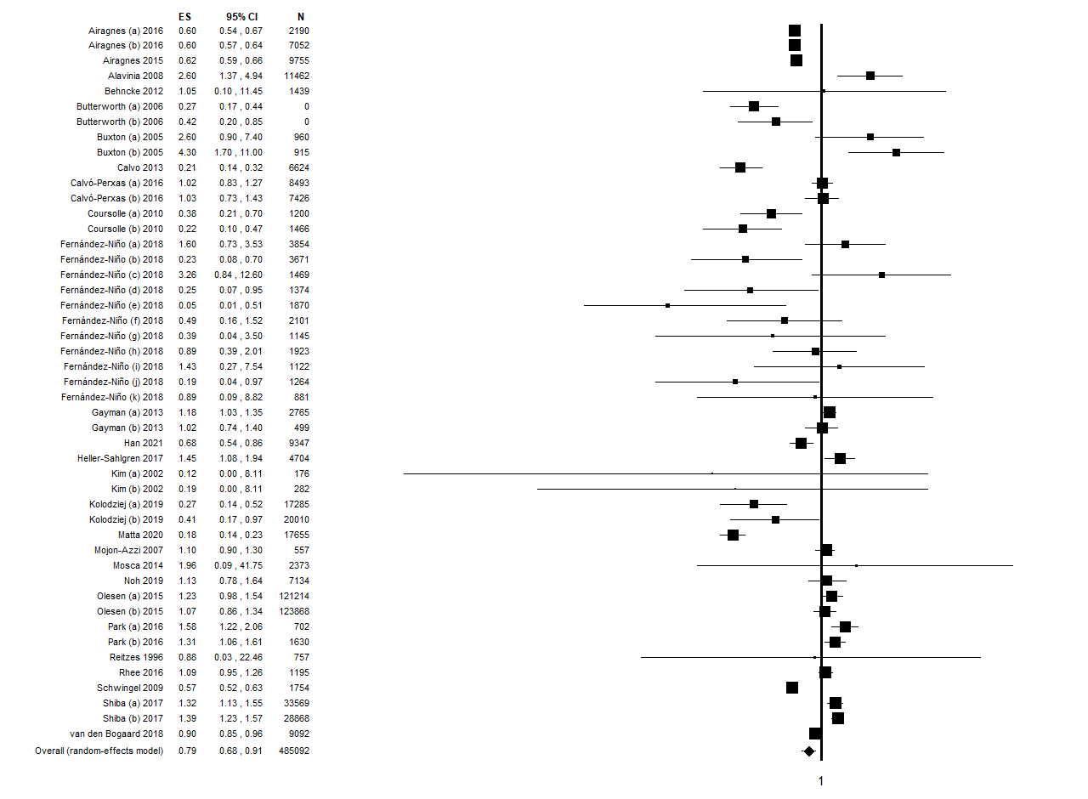
- QS≥15
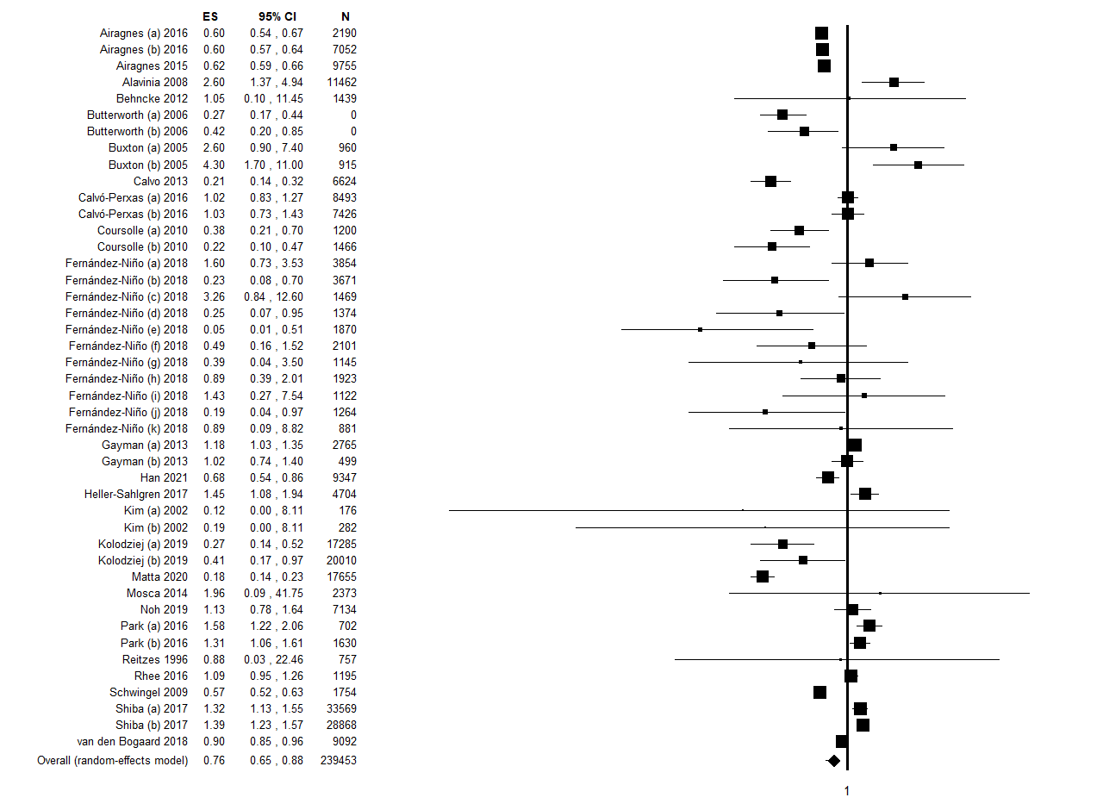
- QS≥15 + validated diagnostic tool

Supplementary Figure 2: Forest plot of subgroups analysis for the meta-analysis assessing the association between retirement and depression: a) cross-sectional studies, b) among women and c) among men. ES, effect size; CI, confidence interval.
- cross-sectional studies
b) women
c) men

