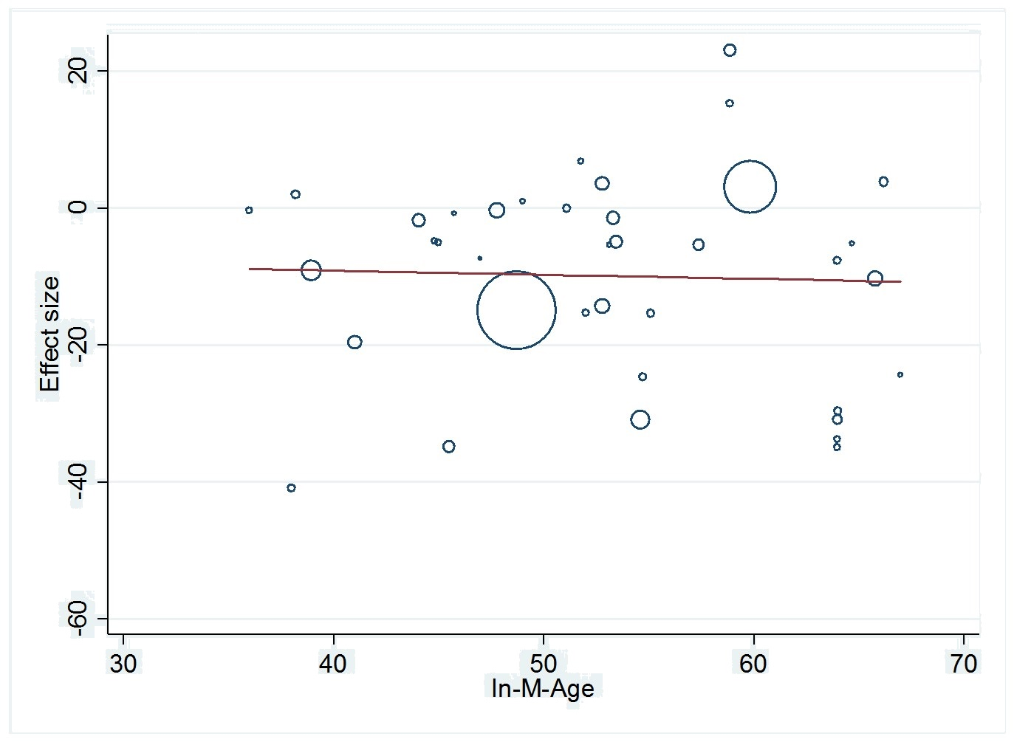

Supplementary Fig. 1 Meta regression for the association between yoga exercise and TC

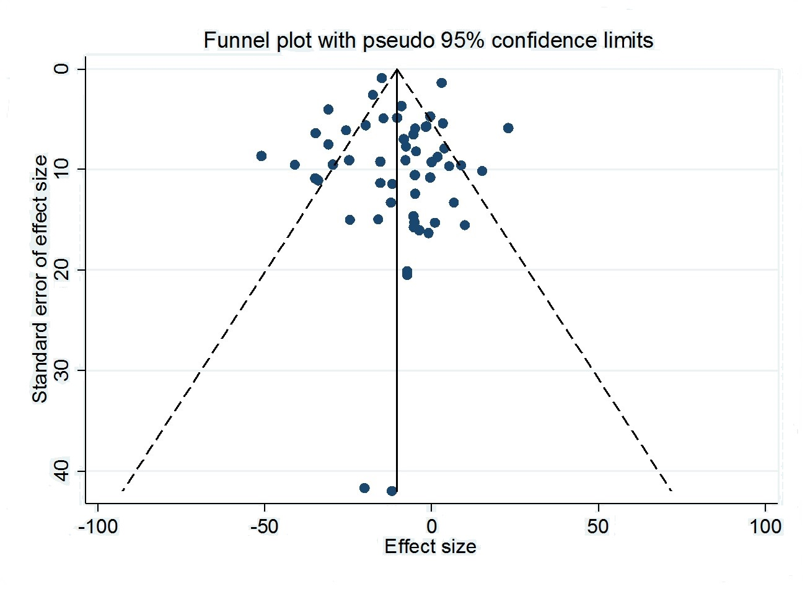
Supplementary Fig. 2 Funnel plot for the association between yoga exercise and TC

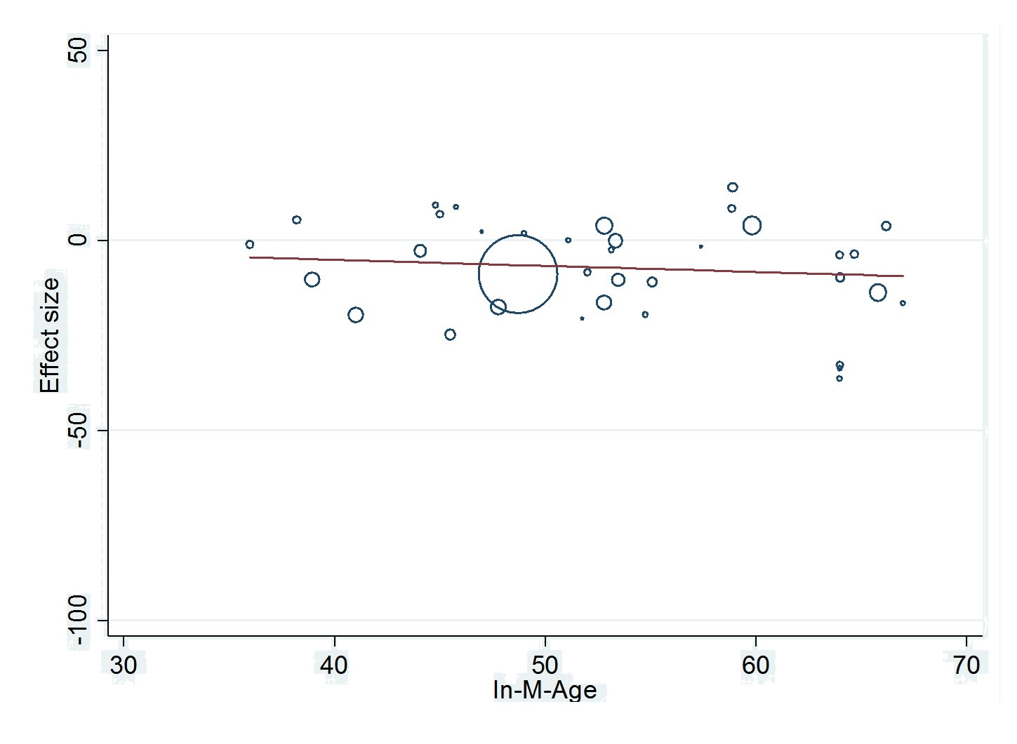
Supplementary Fig. 3 Meta regression for the association between yoga exercise and LDL-C

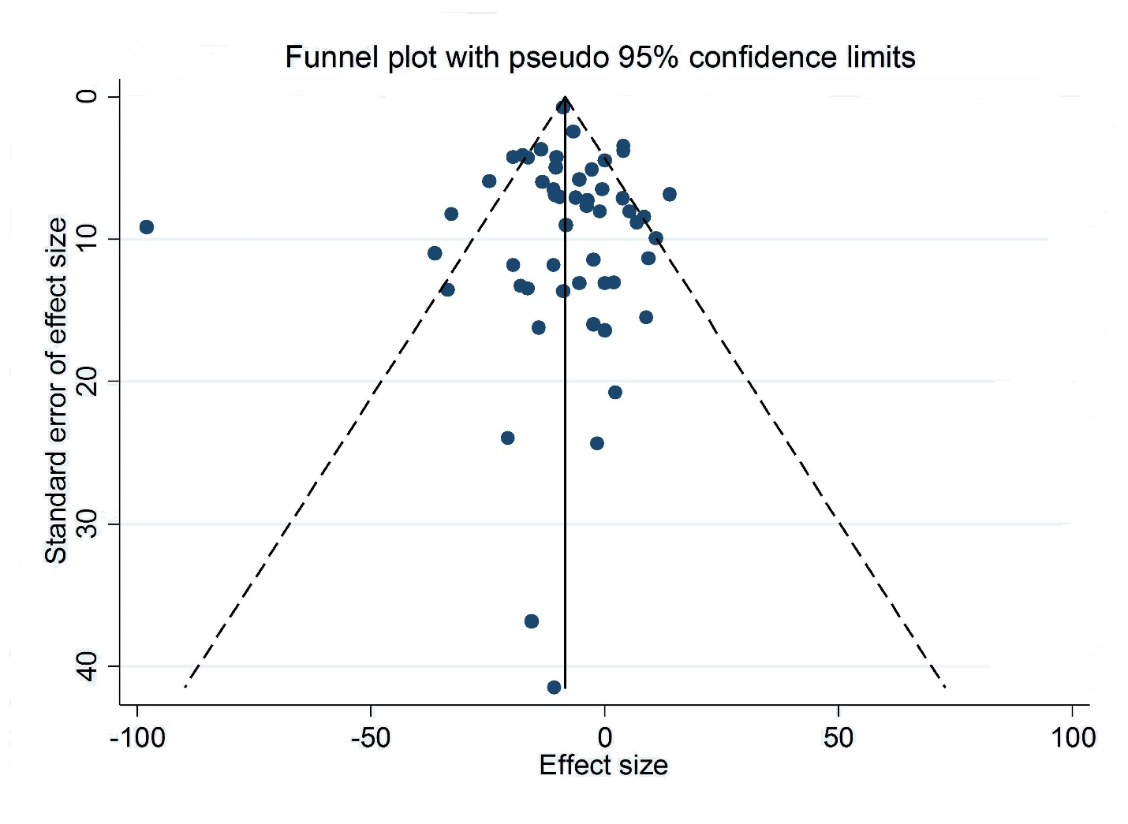
Supplementary Fig. 4 Funnel plot for the association between yoga exercise and LDL-C

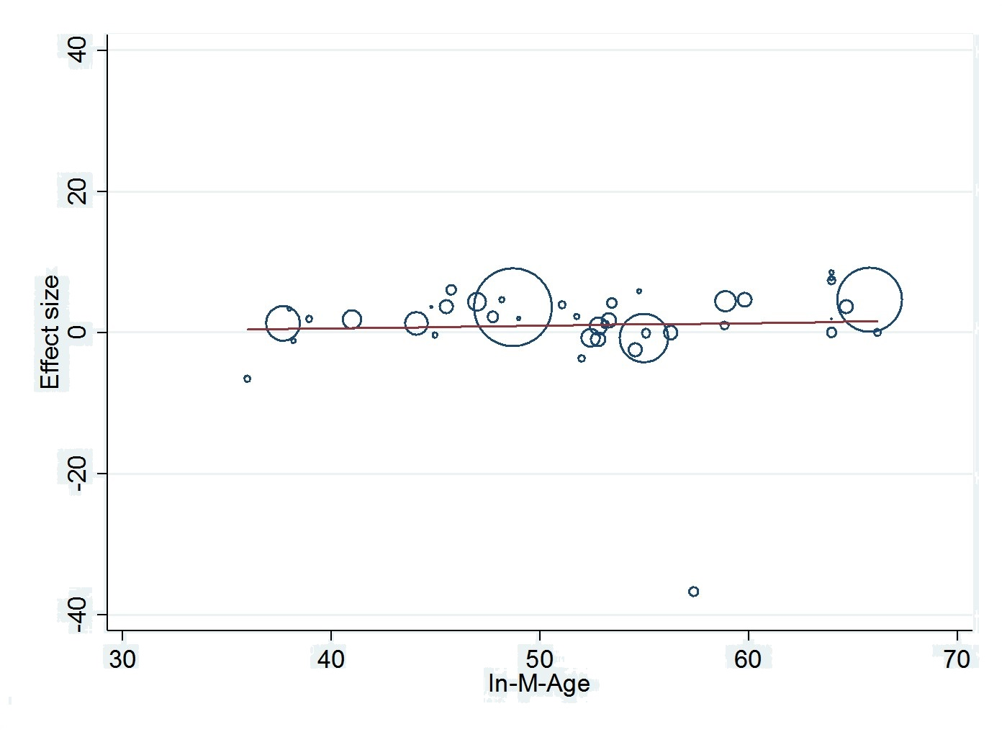
Supplementary Fig. 5 Meta regression for the association between yoga exercise and HDL-C

C

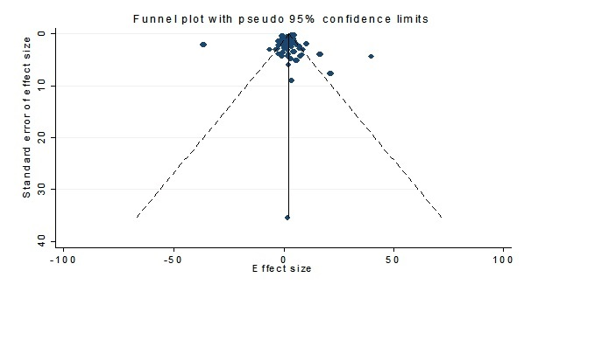
Supplementary Fig. 6 Funnel plot for the association between yoga exercise and HDL-C

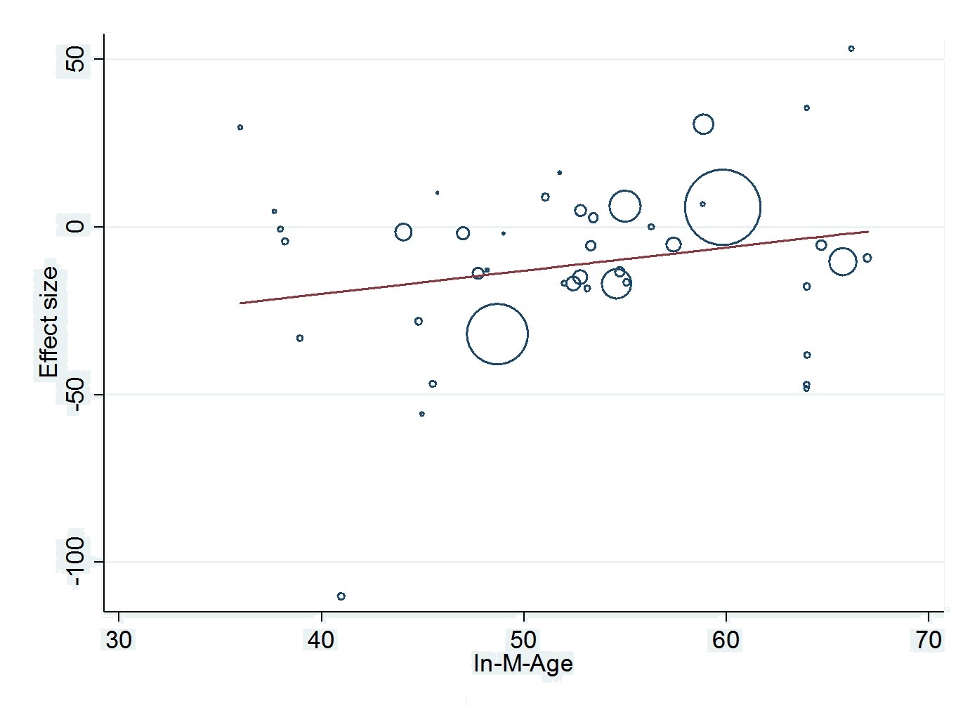
Supplementary Fig. 7 Meta regression for the association between yoga exercise and TG

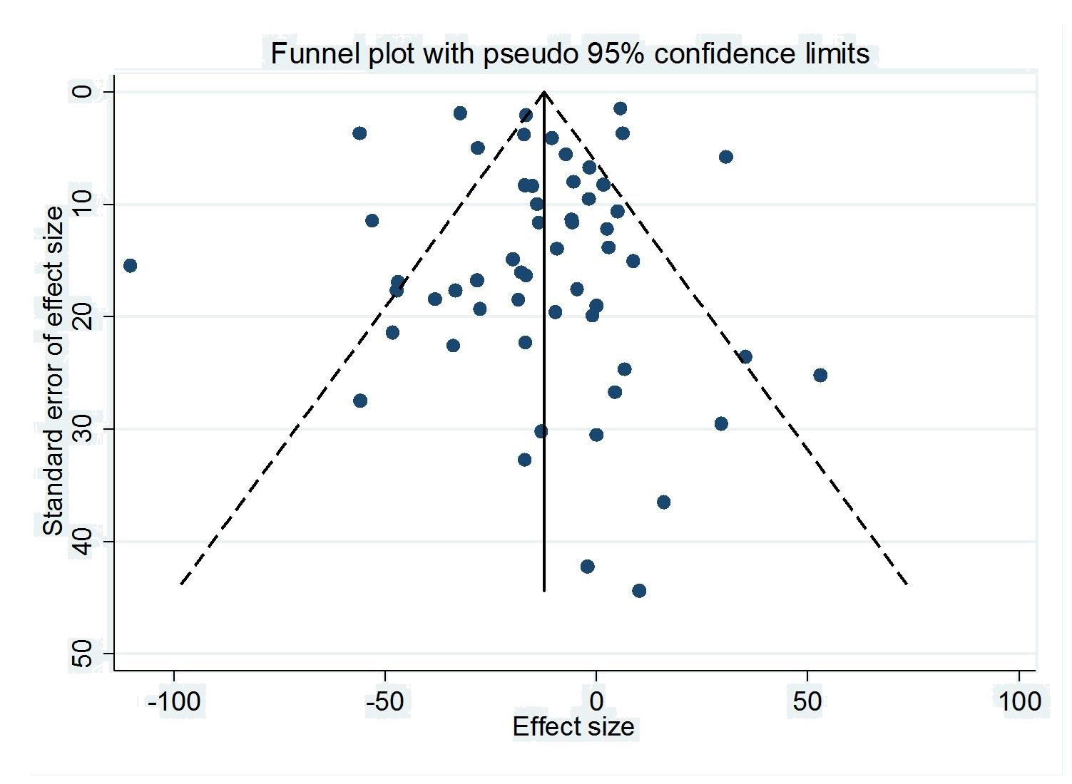
Supplementary Fig. 8 Funnel plot for the association between yoga exercise and TG

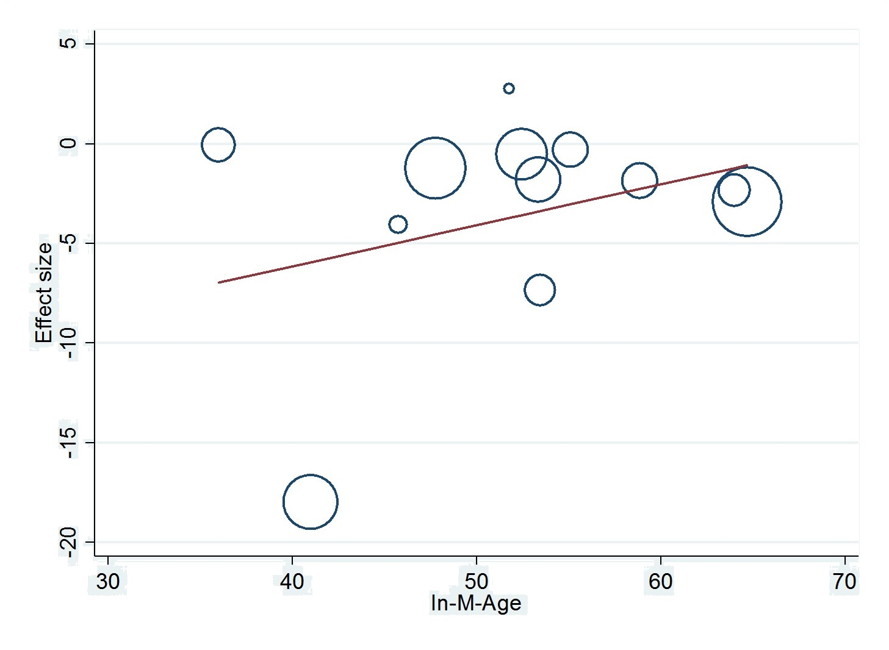
Supplementary Fig. 9 Meta regression for the association between yoga exercise and VLDL-C

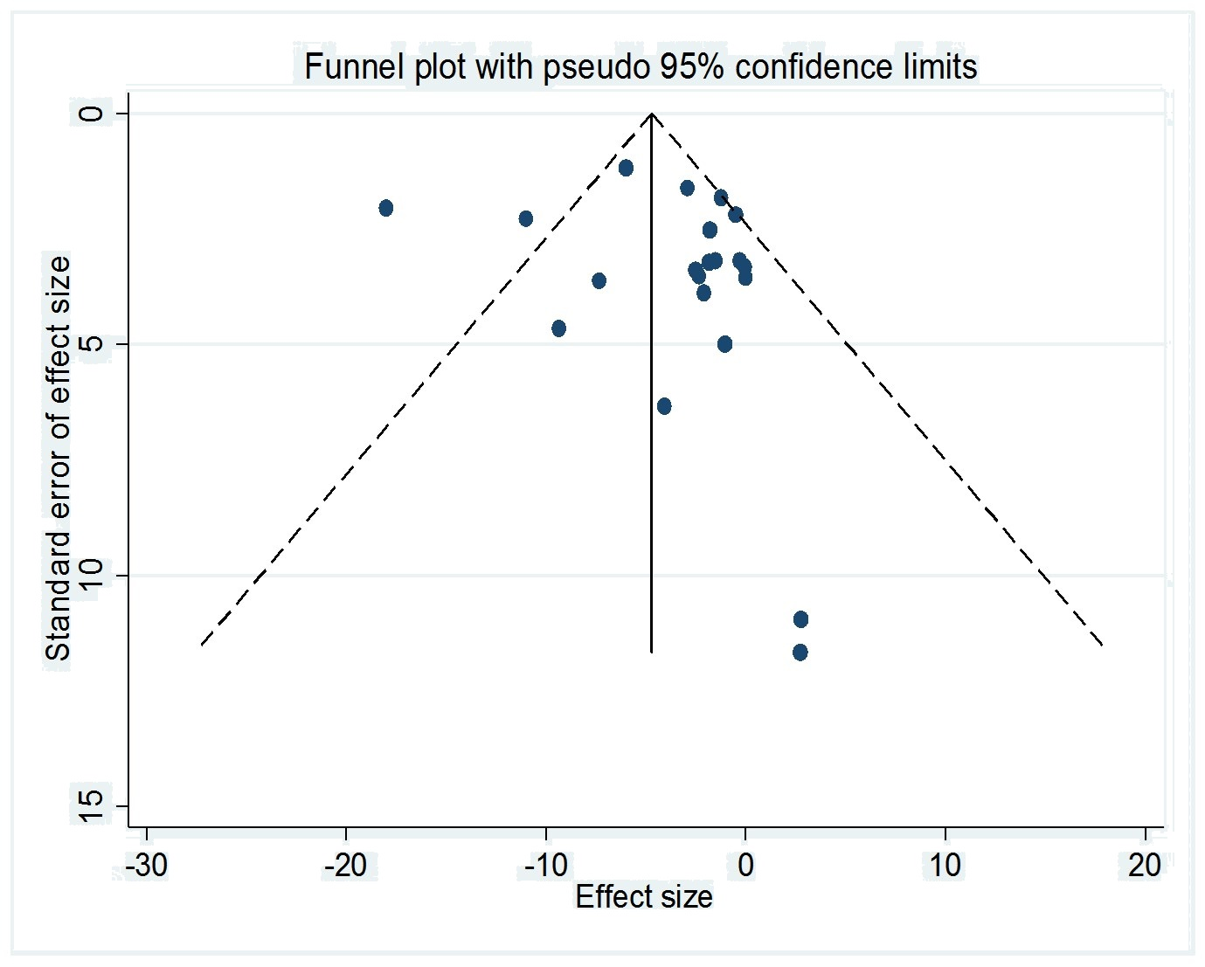
Supplementary Fig. 10 Funnel plot for the association between yoga exercise and VLDL-C

