Supplemental Figures

Supplemental Figure 1. Forest plot for long-term mortality comparing patients with and without cancer who underwent TAVR in adjusted and unadjusted subgroups.

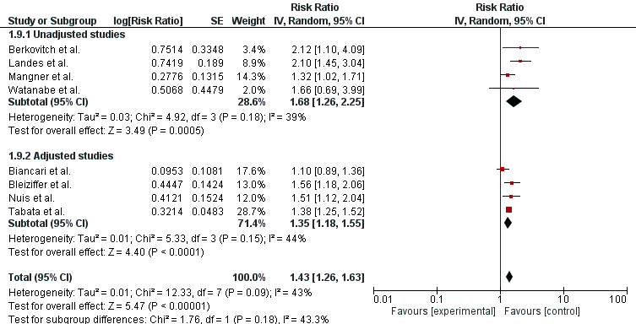

Legend: The pooled risk ratio with 95% confidence intervals were calculated using a random effects model. Weight refers to the contribution of each study to the pooled estimate. Squares and horizontal lines denote the point estimate and 95% confidence interval for each study’s risk ratio. The diamond signifies the pooled risk ratio; the diamond center denotes the point estimate and the width denotes the 95% confidence interval.

Supplemental Figure 2. Forest plot for short-term mortality comparing patients with active cancer versus past cancer who underwent TAVR.
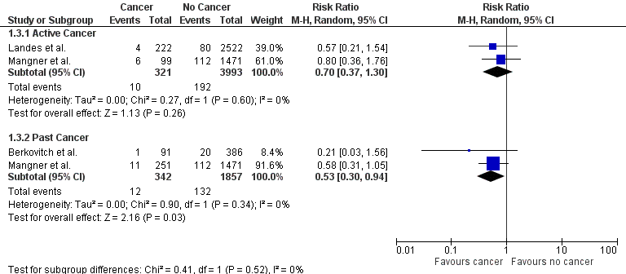

Legend: The pooled risk ratio with 95% confidence intervals were calculated using a random effects model. Weight refers to the contribution of each study to the pooled estimate. Squares and horizontal lines denote the point estimate and 95% confidence interval for each study’s risk ratio. The diamond signifies the pooled risk ratio; the diamond center denotes the point estimate and the width denotes the 95% confidence interval.

Supplemental Figure 3. Forest plot for long-term mortality comparing patients with active cancer versus past cancer who underwent TAVR.
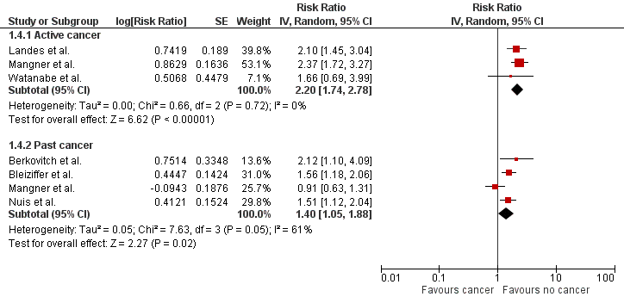

Legend: The pooled risk ratio with 95% confidence intervals were calculated using a random effects model. Weight refers to the contribution of each study to the pooled estimate. Squares and horizontal lines denote the point estimate and 95% confidence interval for each study’s risk ratio. The diamond signifies the pooled risk ratio; the diamond center denotes the point estimate and the width denotes the 95% confidence interval.

Supplemental Figure 4. Forest plot for long-term mortality comparing patients with follow-up of 2 years or less versus follow-up of greater than 2 years who underwent TAVR.
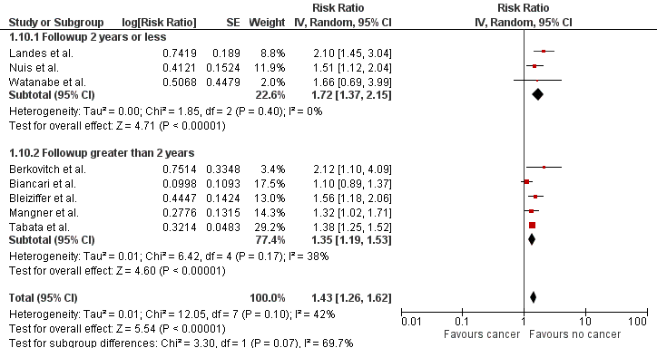

Legend: The pooled risk ratio with 95% confidence intervals were calculated using a random effects model. Weight refers to the contribution of each study to the pooled estimate. Squares and horizontal lines denote the point estimate and 95% confidence interval for each study’s risk ratio. The diamond signifies the pooled risk ratio; the diamond center denotes the point estimate and the width denotes the 95% confidence interval.

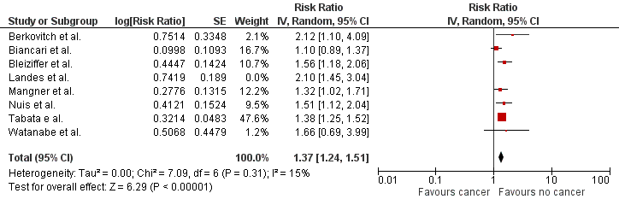
Supplemental Figure 5. Leave one out forest plot for long-term mortality comparing patients with and without cancer who underwent TAVR

Legend: The pooled risk ratio with 95% confidence intervals were calculated using a random effects model. Weight refers to the contribution of each study to the pooled estimate. Squares and horizontal lines denote the point estimate and 95% confidence interval for each study’s risk ratio. The diamond signifies the pooled risk ratio; the diamond center denotes the point estimate and the width denotes the 95% confidence interval.

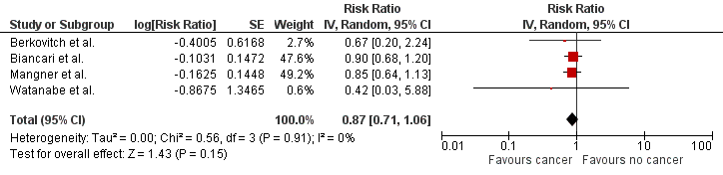
Supplemental Figure 6. Forest plot for long-term cardiac mortality comparing patients with and without cancer who underwent TAVR.

Legend: The pooled risk ratio with 95% confidence intervals were calculated using a random effects model. Weight refers to the contribution of each study to the pooled estimate. Squares and horizontal lines denote the point estimate and 95% confidence interval for each study’s risk ratio. The diamond signifies the pooled risk ratio; the diamond center denotes the point estimate and the width denotes the 95% confidence interval.

Supplemental Figure 7. Forest plot for long-term secondary endpoints comparing patients with and without cancer who underwent TAVR
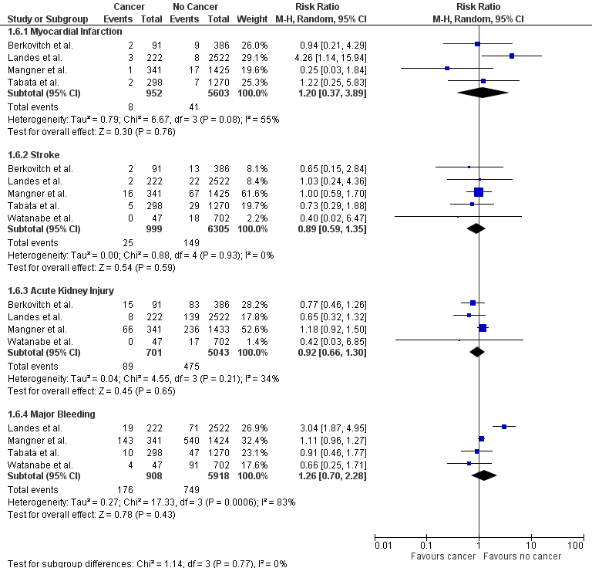

Legend: The pooled risk ratio with 95% confidence intervals were calculated using a random effects model. Weight refers to the contribution of each study to the pooled estimate. Squares and horizontal lines denote the point estimate and 95% confidence interval for each study’s risk ratio. The diamond signifies the pooled risk ratio; the diamond center denotes the point estimate and the width denotes the 95% confidence interval.
Supplemental Figure 8. Funnel plot to assess for publication bias in the studies reporting long term mortality

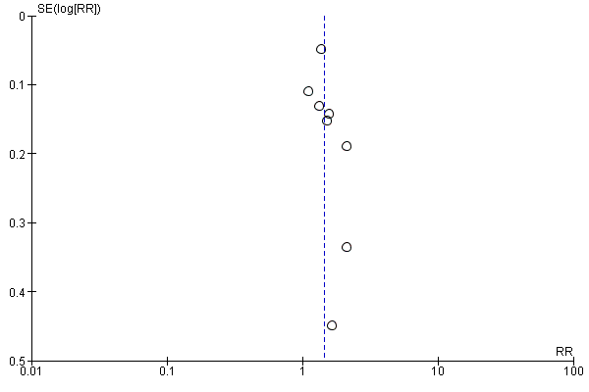
Supplemental Tables

Supplemental Table 1. Risk of bias in the included studies.

Modified Newcastle Ottawa Scale | Studies
Modified Newcastle Ottawa Scale | Mangner et al, 2018 | Watanabe et al, 2016 | Landes et al, 2019 | Berkovitch et al, 2018 | Biancari et al, 2020 | Bleiziffer et al, 2017 | Nuis et al, 2013 | Tabata et al, 2020
Selection | 4 | 4 | 4 | 4 | 4 | 4 | 4 | 4
Comparability | 1 | 1 | 1 | 1 | 2 | 2 | 2 | 2
Adjustment | Unadjusted | Unadjusted | Unadjusted | Unadjusted | Adjusted | Adjusted | Adjusted | Adjusted
Outcome | 3 | 2 | 2 | 3 | 3 | 3 | 2 | 3
Total (maximum score = 9) | 8 | 7 | 7 | 8 | 9 | 9 | 8 | 9

Legend: for selection, the highest score was 4 based on the representativeness of the exposed cohort, selection of the non-exposed cohort, ascertainment of the exposure, and outcome of interest at the start of the study; for comparability, the highest score was 2 based on comparability of the cohort; and for outcome, the highest score was 3 based on assessment of the outcome, follow-up period and adequacy of the follow-up.

Author, Year |  | Group | LVEF | Gender |  |  | Age
 |  |  |  | Male | Female | Both | Mean | SD | Median | Range
Mangner, 2018 | Cancer |  | 57 | 59 | 40 | 99 | 81 | N/A | N/A | 77-84
Mangner, 2018 | No cancer |  | 58 | 628 | 843 | 1471 | 81 | N/A | N/A | 77-84
Watanabe, 2016 | Cancer |  | 65.9 | 21 | 26 | 47 | 83 | N/A | N/A | 80-87
Watanabe, 2016 | No cancer |  | 65.0 | 232 | 470 | 702 | 85 | N/A | N/A | 82-88
Landes, 2019 | Cancer |  | N/A | 138 | 84 | 222 | 78.8 | 7.5 | N/A | N/A
Landes, 2019 | No cancer |  | N/A | 1135 | 1387 | 2522 | 81.3 | 7.1 | N/A | N/A
Berkovitch, 2018 | Cancer |  | N/A | 47 | 44 | 91 | 79.4 | 8.6 | N/A | N/A
Berkovitch, 2018 | No cancer |  | N/A | 201 | 185 | 386 | 81.8 | 7.0 | N/A | N/A
Biancari, 2020 | Cancer |  | N/A | 204 | 213 | 417 | 80.6 | 6.6 | N/A | N/A
Biancari, 2020 | No cancer |  | N/A | 754 | 959 | 1713 | 81.4 | 6.6 | N/A | N/A
Bleiziffer, 2017 | Cancer |  | N/A | N/A | N/A | N/A | N/A | N/A | N/A | N/A
Bleiziffer, 2017 | No cancer |  | N/A | N/A | N/A | N/A | N/A | N/A | N/A | N/A
Nuis, 2013 | Cancer |  | N/A | N/A | N/A | N/A | N/A | N/A | N/A | N/A
Nuis, 2013 | No cancer |  | N/A | N/A | N/A | N/A | N/A | N/A | N/A | N/A
Tabata, 2020 | Cancer |  | 53.9 | 148 | 105 | 253 | 80.8 | 5.7 | N/A | N/A
Tabata, 2020 | No cancer |  | 54.2 | 594 | 676 | 1270 | 81.1 | 6.7 | N/A | N/A
Supplemental Table 2. Age and gender of patients included.

Legend: LVEF: Left Ventricular Ejection Fraction, SD: standard deviation, N/A: not available

Supplemental Table 3. Outcome data from the included studies.

Author, Year | Outcomes | No cancer | Cancer | Active cancer | Past cancer | P Value
Mangner, 2018 | Short-term mortality | 1471(112) | 350(17) | 99(6) | 251(11) | 0.18
Mangner, 2018 | Long-term mortality | 1471(194) | 350(61) | 99(31) | 251(30) | N/A
Mangner, 2018 | Cardiac mortality | 1471(253) | 350(51) | 99(20) | 251(31) | 0.07
Mangner, 2018 | Non-cardiac mortality | 1471(53) | 350(27) | 99(17) | 251(10) | <0.01
Mangner, 2018 | Myocardial infarction | 1425 (17) | 341(1) | 96(1) | 245(0) | 0.23
Mangner, 2018 | Stroke | 1425(67) | 341(16) | 96(4) | 245(12) | 0.96
Mangner, 2018 | Acute kidney Injury | 1433(236) | 341(66) | 96(20) | 246(46) | 0.41
Mangner, 2018 | Major Bleeding | 1424(540) | 341(143) | 96(44) | 245(99) | 0.26
Watanabe, 2016 | Short-term mortality | N/A | N/A | N/A | N/A | N/A
Watanabe, 2016 | Long-term mortality | 702(45) | 47(5) | 47(5) | N/A | N/A
Watanabe, 2016 | Cardiac mortality | 702(5) | 47(0) | 47(0) | N/A | N/A
Watanabe, 2016 | Non-cardiac mortality | 702(40) | 47(3) | 47(3) | N/A | N/A
Watanabe, 2016 | Myocardial infarction | N/A | N/A | N/A | N/A | N/A
Watanabe, 2016 | Stroke | 702(18) | 47(0) | 47(0) | N/A | 0.24
Watanabe, 2016 | Acute kidney Injury | 702(17) | 47(0) | 47(0) | N/A | 0.28
Watanabe, 2016 | Major bleeding | 702(91) | 47(4) | 47(4) | N/A | 0.38
Landes, 2019 | Short-term mortality | 2522(80) | 222(4) | 222(4) | N/A | 0.47
Landes, 2019 | Long-term mortality | 2522(157) | 222(29) | 222(29) | N/A | N/A
Landes, 2019 | Cardiac mortality | N/A | 222(9) | 222(9) | N/A | N/A
Landes, 2019 | Non-cardiac mortality | N/A | 222(24) | 222(24) | N/A | N/A
Landes, 2019 | Myocardial infarction | 2522(8) | 222(3) | 222(3) | N/A | 0.36
Landes, 2019 | Stroke | 2522(22) | 222(2) | 222(2) | N/A | 1
Landes, 2019 | Acute kidney injury | 2522(139) | 222(8) | 222(8) | N/A | 0.28
Landes, 2019 | Major bleeding | 2522(71) | 222(19) | 222(19) | N/A | <0.01
Berkovitch, 2018 | Short-term mortality | 386(20) | 91(1) | N/A | 91(1) | 0.15
Berkovitch, 2018 | Long-term mortality | 386(24) | 91(12) | N/A | 91(12) | N/A
Berkovitch, 2018 | Cardiac mortality | 386(19) | 91(3) | N/A | 91(3) | N/A
Berkovitch, 2018 | Non-cardiac mortality | 386(25) | 91(10) | N/A | 91(10) | N/A
Berkovitch, 2018 | Myocardial infarction | 386(9) | 91(2) | N/A | 91(2) | 0.97
Berkovitch, 2018 | Stroke | 386(13) | 91(2) | N/A | 91(2) | 0.85
Berkovitch, 2018 | Acute kidney injury | 386(83) | 91(15) | N/A | 91(15) | 0.39
Berkovitch, 2018 | Major bleeding | N/A | N/A | N/A | N/A | N/A
Biancari, 2020 | Short-term mortality | 1713(50) | 417(13) | N/A | N/A | 0.78
Biancari, 2020 | Long-term mortality | 1713(1016) | 417(271) | N/A | N/A | N/A
Biancari, 2020 | Cardiac mortality | 1713(719) | 417(188) | N/A | N/A | N/A
Tabata, 2020 | Long-term mortality | 1232(618) | 292(202) | 43(36) | 249(164) | N/A
Tabata, 2020 | Myocardial infarction | 1270(7) | 298(2) | N/A | N/A | N/A
Tabata, 2020 | Major bleeding | 1270(47) | 298(10) | N/A | N/A | N/A
Tabata, 2020 | Stroke | 1270(29) | 298(5) | N/A | N/A | N/A
Bleiziffer, 2017 | Long-term mortality | Risk ratio 1.56, 95% confidence interval 1.18-2.05, p=0.002
Nuis, 2013 | Long-term mortality | Risk ratio 1.51, 95% confidence interval 1.12-2.04. p=0.007

Legend: N/A: Not Available

