Supplementary Figure 1 – Live birth rate sensitivity analysis
CI – confidence interval, df – degrees of freedom, ES – Endometrial Scratch, M-H - Mantel-Haenszel
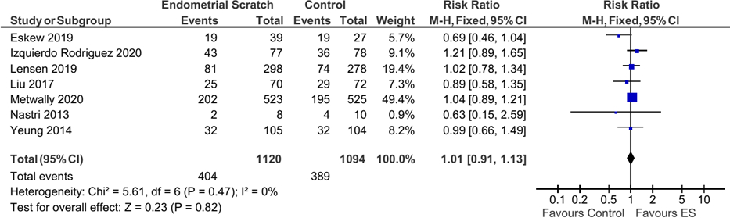

Supplementary Figure 2 – Clinical pregnancy rate sensitivity analysis
CI – confidence interval, df – degrees of freedom, ES – Endometrial Scratch, M-H - Mantel-Haenszel
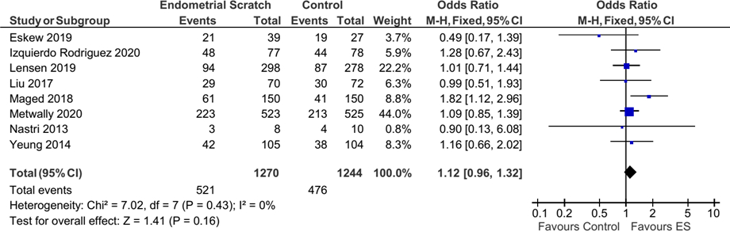

Supplementary Figure 3 – Ongoing pregnancy rate sensitivity analysis
CI – confidence interval, df – degrees of freedom, ES – Endometrial Scratch, M-H - Mantel-Haenszel
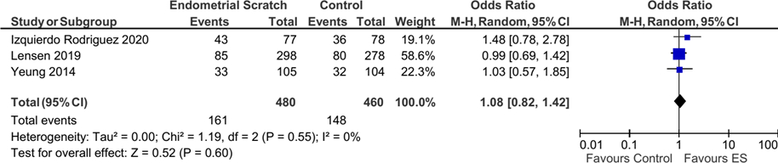

Supplementary Figure 4 - Miscarriage rate sensitivity analysis
CI – confidence interval, df – degrees of freedom, ES – Endometrial Scratch, M-H - Mantel-Haenszel
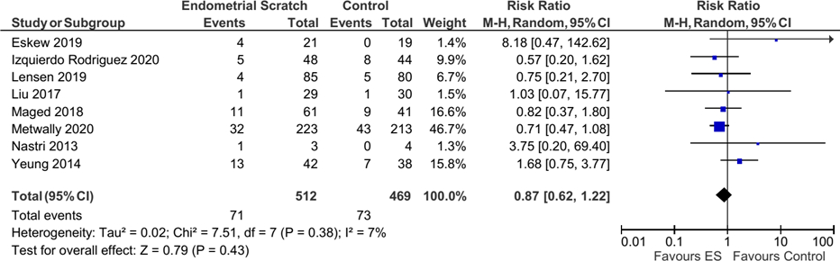

Supplementary Figure 5– Ectopic pregnancy rate sensitivity analysis
CI – confidence interval, df – degrees of freedom, ES – Endometrial Scratch, M-H - Mantel-Haenszel


