Supplementary materials

Searching Strategies
- Pubmed(21)
(((((heparin[MeSH Terms])) OR (unfractioned heparin[Title/Abstract])[All Fields])) AND ((Bivalirudin[Title/Abstract]))) AND (((((((extracorporeal membrane oxygenation[MeSH Terms])) OR (ECMO[Title/Abstract])) OR (ECMO Treatment[Title/Abstract])) OR (Extracorporeal Life Support[Title/Abstract])) OR (ECLS[Title/Abstract])) OR (ECLS Treatment[Title/Abstract]))
- Embase(190)
#12. #9 AND #10 AND #11(101)
#11. #7 OR #8(157,014)
#10. #1 OR #2 OR #3 OR #4 OR #5 OR #6(36,394)
#9. 'bivalirudin':ab(2,435)
#8. 'unfractioned heparin':ab(392)
#7. 'heparin'/exp(156,979)
#6. 'ecls':ab(2,309)
#5. 'ecls treatment':ab(48)
#4. 'extracorporeal life support':ab(2,859)
#3. 'ecmo':ab(17,684)
#2. 'ecmo treatment':ab(569)
#1. 'extracorporeal oxygenation'/exp(29288)
- The Cochrane Library(4)
#1 MeSH descriptor: [Extracorporeal Membrane Oxygenation] explode all trees 184
#2 (ECMO Treatment):ti,ab,kw (Word variations have been searched) 365
#3 (ECMO):ti,ab,kw (Word variations have been searched) 671
#4 (Extracorporeal Life Support):ti,ab,kw (Word variations have been searched) 141
#5 (ECLS Treatment):ti,ab,kw (Word variations have been searched) 87
#6 (ECLS):ti,ab,kw (Word variations have been searched) 178
#7 #1 OR #2 OR #3 OR #4 OR #5 OR #6 990
#8 MeSH descriptor: [Heparin] explode all trees 4879
#9 (unfractioned heparin):ti,ab,kw (Word variations have been searched) 78
#10 #8 OR #9 4937
#11 (Bivalirudin):ti,ab,kw (Word variations have been searched) 566
#12 #7 AND #10 AND #11 4

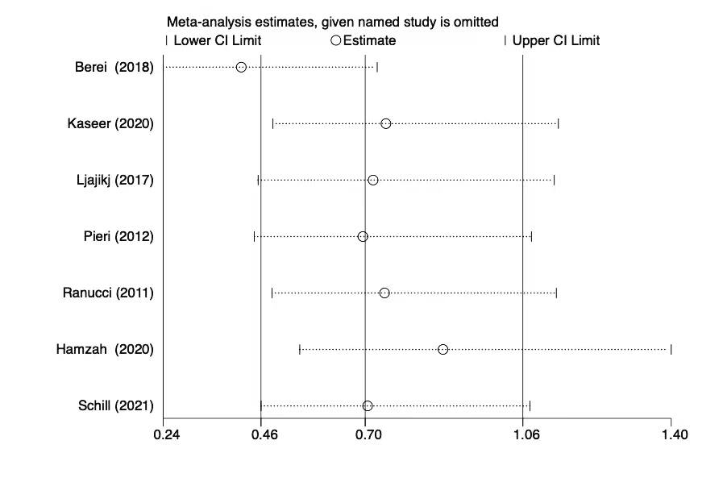
Supplementary Figure 1. Sensitivity analysis of the incidence of major bleeding of the included studies.

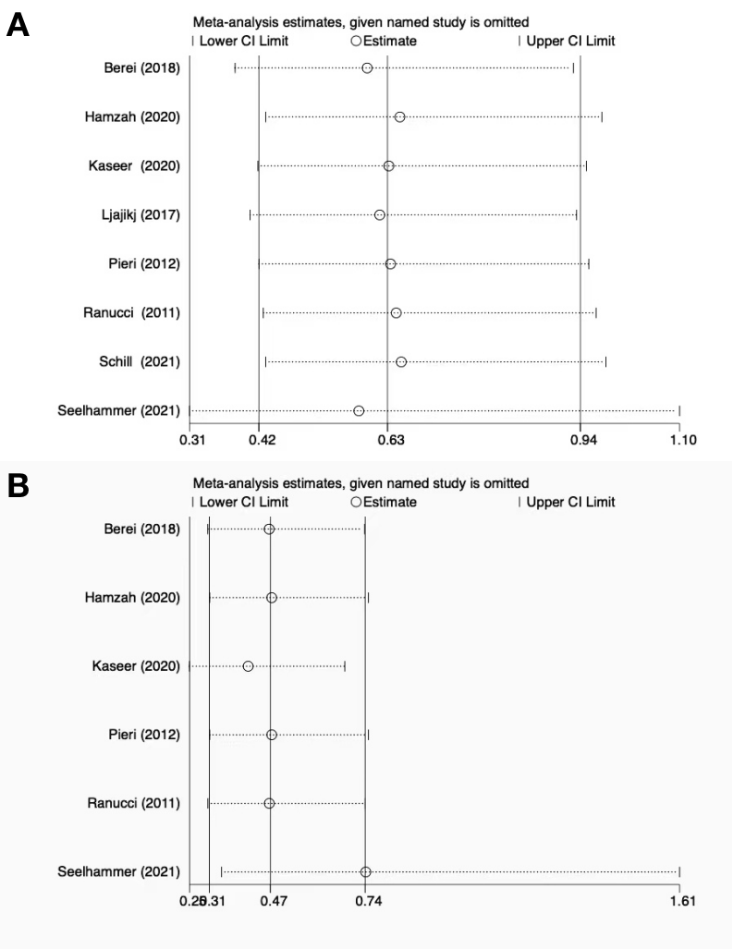
Supplementary Figure 2. Sensitivity analysis of the incidence of thrombosis of the included studies.
A. Incidence of patient thrombosis of ECMO; B. Incidence of in-circuit thrombosis/interventions of ECMO.

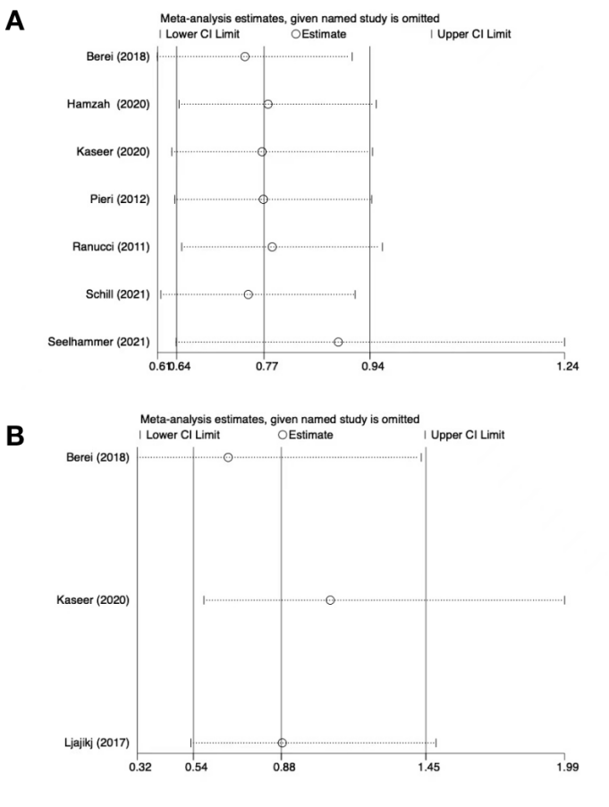
Supplementary Figure 3. Sensitivity analysis of the incidence of mortality of the included studies. A. in-hospital mortality of ECMO; B.30-day mortality of ECMO.

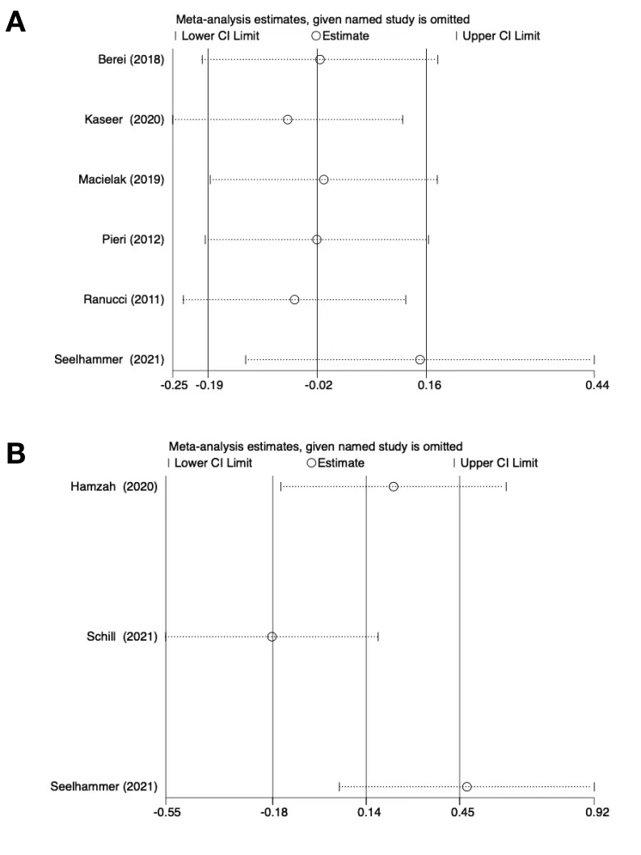
Supplementary Figure 4. Sensitivity analysis of the ECMO duration of the included studies.
A. ECMO duration in adults; B. ECMO duration in children.

Section/topic | # | PRISMA-DTA Checklist Item | Reported on page #
TITLE / ABSTRACT
Title | 1 | Identify the report as a systematic review (+/- meta-analysis) of diagnostic test accuracy (DTA) studies. | 1
Abstract | 2 | Abstract: See PRISMA-DTA for abstracts. | 2
INTRODUCTION
Rationale | 3 | Describe the rationale for the review in the context of what is already known. | 3
Clinical role of index test | D1 | State the scientific and clinical background, including the intended use and clinical role of the index test, and if applicable, the rationale for minimally acceptable test accuracy (or minimum difference in accuracy for comparative design). | 3
Objectives | 4 | Provide an explicit statement of question(s) being addressed in terms of participants, index test(s), and target condition(s). | 3
METHODS
Protocol and registration | 5 | Indicate if a review protocol exists, if and where it can be accessed (e.g., Web address), and, if available, provide registration information including registration number. | 4
Eligibility criteria | 6 | Specify study characteristics (participants, setting, index test(s), reference standard(s), target condition(s), and study design) and report characteristics (e.g., years considered, language, publication status) used as criteria for eligibility, giving rationale. | 4，table 1
Information sources | 7 | Describe all information sources (e.g., databases with dates of coverage, contact with study authors to identify additional studies) in the search and date last searched. | 4
Search | 8 | Present full search strategies for all electronic databases and other sources searched, including any limits used, such that they could be repeated. | 4,Supplementary materials
Study selection | 9 | State the process for selecting studies (i.e., screening, eligibility, included in systematic review, and, if applicable, included in the meta-analysis). | 4
Data collection process | 10 | Describe method of data extraction from reports (e.g., piloted forms, independently, in duplicate) and any processes for obtaining and confirming data from investigators. | 4
Definitions for data extraction | 11 | Provide definitions used in data extraction and classifications of target condition(s), index test(s), reference standard(s) and other characteristics (e.g. study design, clinical setting). | 4
Risk of bias and applicability | 12 | Describe methods used for assessing risk of bias in individual studies and concerns regarding the applicability to the review question. | 4
Diagnostic accuracy measures | 13 | State the principal diagnostic accuracy measure(s) reported (e.g. sensitivity, specificity) and state the unit of assessment (e.g. per-patient, per-lesion). | 4
Synthesis of results | 14 | Describe methods of handling data, combining results of studies and describing variability between studies. This could include, but is not limited to: a) handling of multiple definitions of target condition. b) handling of multiple thresholds of test positivity, c) handling multiple index test readers, d) handling of indeterminate test results, e) grouping and comparing tests, f) handling of different reference standards | 4-5

Page 1 of 2
Section/topic | # | PRISMA-DTA Checklist Item | Reported on page #
Meta-analysis | D2 | Report the statistical methods used for meta-analyses, if performed. | 4-5
Additional analyses | 16 | Describe methods of additional analyses (e.g., sensitivity or subgroup analyses, meta-regression), if done, indicating which were pre-specified. | 5
RESULTS
Study selection | 17 | Provide numbers of studies screened, assessed for eligibility, included in the review (and included in meta-analysis, if applicable) with reasons for exclusions at each stage, ideally with a flow diagram. | 6,Supplementary figure 1
Study characteristics | 18 | For each included study provide citations and present key characteristics including: a) participant characteristics (presentation, prior testing), b) clinical setting, c) study design, d) target condition definition, e) index test, f) reference standard, g) sample size, h) funding sources | Supplementary table 1
Risk of bias and applicability | 19 | Present evaluation of risk of bias and concerns regarding applicability for each study. | 6,supplemental table 3
Results of individual studies | 20 | For each analysis in each study (e.g. unique combination of index test, reference standard, and positivity threshold) report 2x2 data (TP, FP, FN, TN) with estimates of diagnostic accuracy and confidence intervals, ideally with a forest or receiver operator characteristic (ROC) plot. | 5-6,figure 1,2,3,4
Synthesis of results | 21 | Describe test accuracy, including variability; if meta-analysis was done, include results and confidence intervals. | 6-7
Additional analysis | 23 | Give results of additional analyses, if done (e.g., sensitivity or subgroup analyses, meta-regression; analysis of index test: failure rates, proportion of inconclusive results, adverse events). | 6-7
DISCUSSION
Summary of evidence | 24 | Summarize the main findings including the strength of evidence. | 7-8
Limitations | 25 | Discuss limitations from included studies (e.g. risk of bias and concerns regarding applicability) and from the review process (e.g. incomplete retrieval of identified research). | 8-9
Conclusions | 26 | Provide a general interpretation of the results in the context of other evidence. Discuss implications for future research and clinical practice (e.g. the intended use and clinical role of the index test). | 9
FUNDING
Funding | 27 | For the systematic review, describe the sources of funding and other support and the role of the funders. | 1

Adapted From: McInnes MDF, Moher D, Thombs BD, McGrath TA, Bossuyt PM, The PRISMA-DTA Group (2018). Preferred Reporting Items for a Systematic Review and Meta-analysis of Diagnostic Test Accuracy Studies: The PRISMA-DTA Statement. JAMA. 2018 Jan 23;319(4):388-396. doi: 10.1001/jama.2017.19163.
For more information, visit: www.prisma-statement.org.
Page 2 of 2
Supplemental Table 1. NOS score of included studies.
Study | Selection |  |  |  | Comparability  Outcome |  | Exposure |  |  | Total Score
Study | Is the case definition adequate? | Representativeness of the cases | Selection of Controls | Definition of Controls | Select the most important factor | Study controls for any additional factor | Ascertainment of exposure | Same method of ascertainment for cases and controls | Non-Response rate | Total Score
Ranucci2011 | * | * | - | * | * | * | * | * | * | 8
Pieri2012 | * | * | - | * | * | * | * | * | * | 8
Ljajikj2017 | * | * | - | - | * | * | * | * | * | 7
Berei2018 | * | * | - | * | * | * | * | * | * | 8
Macielak2019 | * | * | - | * | * | * | * | * | * | 8
Brown2020 | * | * | - | - | * | - | * | * | * | 6
Hamzah2020 | * | * | - | * | * | * | * | * | * | 7
Kaseer2020 | * | * | - | - | * | * | * | * | * | 7
Schill2021 | * | * | - | * | * | * | * | * | * | 8
Seelhammer2021 | * | * | - | * | * | * | * | * | * | 8

