Supplementary appendix

This supplementary appendix provides:
- Search equation via PubMed, EMBASE, and Cochrane library Flow chart showing Search strategy for studies in China.
- PROSPERO protocol registration.
- Flow chart of study selection for the meta-analysis
- Summary of risks of bias and applicability concern.
- The heterogeneity for 28-day mortality and 90-day KRT dependence
- Hospital mortality and ICU mortality
- ICU stay days and hospital stay days
- Accelerated WWS initiation and adverse events
- 28-day and 90-day dialysis free for accelerated/WWS-KRT initiation
- The outcome of KRT free days, Mechanical ventilator-free days, and Vasopressor free days for accelerated/WWS initiation
- Compared the difference between our study and other meta-analyses
- PRISMA checklist.
- Summary of contextual factor data.
- Quality assessment of the GRADE results.
- Estimated summary receiver operating characteristic(SROC) curves based on serum urea

- Search equation via PubMed, EMBASE, MEDLINE, and Cochrane library

Appendix.
Search strategies for the different databases ran on Apr 06, 2021.

PubMed
#1 ((("acute kidney injury"[MeSH Terms] OR ("acute"[All Fields] AND "kidney"[All Fields] AND "injury"[All Fields]) OR "acute kidney injury"[All Fields] OR ("acute kidney injury"[MeSH Terms] OR ("acute"[All Fields] AND "kidney"[All Fields] AND "injury"[All Fields]) OR "acute kidney injury"[All Fields] OR ("acute"[All Fields] AND "kidney"[All Fields] AND "failure"[All Fields]) OR "acute kidney failure"[All Fields]) OR ("anuria"[MeSH Terms] OR "anuria"[All Fields] OR "anurias"[All Fields] OR ("anuria"[MeSH Terms] OR "anuria"[All Fields] OR "anurias"[All Fields]) OR ("oliguria"[MeSH Terms] OR "oliguria"[All Fields]) OR ("acidosis"[MeSH Terms] OR "acidosis"[All Fields] OR "acidoses"[All Fields] OR ("acidosis"[MeSH Terms] OR "acidosis"[All Fields] OR "acidoses"[All Fields]) OR ("acidosis"[MeSH Terms] OR "acidosis"[All Fields] OR "acidoses"[All Fields])))) AND ("timely"[All Fields] OR "timing"[All Fields] OR "timings"[All Fields] OR ("timely"[All Fields] OR "timing"[All Fields] OR "timings"[All Fields]) OR ("time"[MeSH Terms] OR "time"[All Fields]) OR ("start"[All Fields] OR "started"[All Fields] OR "starting"[All Fields] OR "starts"[All Fields] OR ("start"[All Fields] OR "started"[All Fields] OR "starting"[All Fields] OR "starts"[All Fields]) OR ("start"[All Fields] OR "started"[All Fields] OR "starting"[All Fields] OR "starts"[All Fields]) OR ("start"[All Fields] OR "started"[All Fields] OR "starting"[All Fields] OR "starts"[All Fields])) OR ("initial"[All Fields] OR "initially"[All Fields] OR "initials"[All Fields] OR "initiate"[All Fields] OR "initiated"[All Fields] OR "initiates"[All Fields] OR "initiating"[All Fields] OR "initiation"[All Fields] OR "initiations"[All Fields] OR "initiator"[All Fields] OR "initiators"[All Fields] OR ("initial"[All Fields] OR "initially"[All Fields] OR "initials"[All Fields] OR "initiate"[All Fields] OR "initiated"[All Fields] OR "initiates"[All Fields] OR "initiating"[All Fields] OR "initiation"[All Fields] OR "initiations"[All Fields] OR "initiator"[All Fields] OR "initiators"[All Fields]) OR ("initial"[All Fields] OR "initially"[All Fields] OR "initials"[All Fields] OR "initiate"[All Fields] OR "initiated"[All Fields] OR "initiates"[All Fields] OR "initiating"[All Fields] OR "initiation"[All Fields] OR "initiations"[All Fields] OR "initiator"[All Fields] OR "initiators"[All Fields]) OR ("initial"[All Fields] OR "initially"[All Fields] OR "initials"[All Fields] OR "initiate"[All Fields] OR "initiated"[All Fields] OR "initiates"[All Fields] OR "initiating"[All Fields] OR "initiation"[All Fields] OR "initiations"[All Fields] OR "initiator"[All Fields] OR "initiators"[All Fields]) OR ("initial"[All Fields] OR "initially"[All Fields] OR "initials"[All Fields] OR "initiate"[All Fields] OR "initiated"[All Fields] OR "initiates"[All Fields] OR "initiating"[All Fields] OR "initiation"[All Fields] OR "initiations"[All Fields] OR "initiator"[All Fields] OR "initiators"[All Fields]) OR ("initial"[All Fields] OR "initially"[All Fields] OR "initials"[All Fields] OR "initiate"[All Fields] OR "initiated"[All Fields] OR "initiates"[All Fields] OR "initiating"[All Fields] OR "initiation"[All Fields] OR "initiations"[All Fields] OR "initiator"[All Fields] OR "initiators"[All Fields]) OR ("initial"[All Fields] OR "initially"[All Fields] OR "initials"[All Fields] OR "initiate"[All Fields] OR "initiated"[All Fields] OR "initiates"[All Fields] OR "initiating"[All Fields] OR "initiation"[All Fields] OR "initiations"[All Fields] OR "initiator"[All Fields] OR "initiators"[All Fields]) OR ("initial"[All Fields] OR "initially"[All Fields] OR "initials"[All Fields] OR "initiate"[All Fields] OR "initiated"[All Fields] OR "initiates"[All Fields] OR "initiating"[All Fields] OR "initiation"[All Fields] OR "initiations"[All Fields] OR "initiator"[All Fields] OR "initiators"[All Fields])) OR ("begin"[All Fields] OR "begining"[All Fields] OR "beginning"[All Fields] OR "beginnings"[All Fields] OR "begins"[All Fields] OR ("begin"[All Fields] OR "begining"[All Fields] OR "beginning"[All Fields] OR "beginnings"[All Fields] OR "begins"[All Fields]) OR ("begin"[All Fields] OR "begining"[All Fields] OR "beginning"[All Fields] OR "beginnings"[All Fields] OR "begins"[All Fields]) OR ("begin"[All Fields] OR "begining"[All Fields] OR "beginning"[All Fields] OR "beginnings"[All Fields] OR "begins"[All Fields])) OR ("early"[All Fields] OR "late"[All Fields]))) OR ("commence"[All Fields] OR "commenced"[All Fields] OR "commencement"[All Fields] OR "commencements"[All Fields] OR "commences"[All Fields] OR "commencing"[All Fields] OR ("commence"[All Fields] OR "commenced"[All Fields] OR "commencement"[All Fields] OR "commencements"[All Fields] OR "commences"[All Fields] OR "commencing"[All Fields]) OR ("commence"[All Fields] OR "commenced"[All Fields] OR "commencement"[All Fields] OR "commencements"[All Fields] OR "commences"[All Fields] OR "commencing"[All Fields]) OR ("commence"[All Fields] OR "commenced"[All Fields] OR "commencement"[All Fields] OR "commencements"[All Fields] OR "commences"[All Fields] OR "commencing"[All Fields]) OR ("commence"[All Fields] OR "commenced"[All Fields] OR "commencement"[All Fields] OR "commencements"[All Fields] OR "commences"[All Fields] OR "commencing"[All Fields]) OR ("commence"[All Fields] OR "commenced"[All Fields] OR "commencement"[All Fields] OR "commencements"[All Fields] OR "commences"[All Fields] OR "commencing"[All Fields])) OR ("accelerate"[All Fields] OR "accelerated"[All Fields] OR "accelerates"[All Fields] OR "accelerating"[All Fields] OR "acceleration"[MeSH Terms] OR "acceleration"[All Fields] OR "accelerations"[All Fields] OR "accelerator"[All Fields] OR "accelerator s"[All Fields] OR "accelerators"[All Fields] OR ("accelerate"[All Fields] OR "accelerated"[All Fields] OR "accelerates"[All Fields] OR "accelerating"[All Fields] OR "acceleration"[MeSH Terms] OR "acceleration"[All Fields] OR "accelerations"[All Fields] OR "accelerator"[All Fields] OR "accelerator s"[All Fields] OR "accelerators"[All Fields]) OR ("accelerate"[All Fields] OR "accelerated"[All Fields] OR "accelerates"[All Fields] OR "accelerating"[All Fields] OR "acceleration"[MeSH Terms] OR "acceleration"[All Fields] OR "accelerations"[All Fields] OR "accelerator"[All Fields] OR "accelerator s"[All Fields] OR "accelerators"[All Fields]) OR ("accelerate"[All Fields] OR "accelerated"[All Fields] OR "accelerates"[All Fields] OR "accelerating"[All Fields] OR "acceleration"[MeSH Terms] OR "acceleration"[All Fields] OR "accelerations"[All Fields] OR "accelerator"[All Fields] OR "accelerator s"[All Fields] OR "accelerators"[All Fields]) OR ("accelerate"[All Fields] OR "accelerated"[All Fields] OR "accelerates"[All Fields] OR "accelerating"[All Fields] OR "acceleration"[MeSH Terms] OR "acceleration"[All Fields] OR "accelerations"[All Fields] OR "accelerator"[All Fields] OR "accelerator s"[All Fields] OR "accelerators"[All Fields]) OR ("accelerate"[All Fields] OR "accelerated"[All Fields] OR "accelerates"[All Fields] OR "accelerating"[All Fields] OR "acceleration"[MeSH Terms] OR "acceleration"[All Fields] OR "accelerations"[All Fields] OR "accelerator"[All Fields] OR "accelerator s"[All Fields] OR "accelerators"[All Fields]) OR ("accelerate"[All Fields] OR "accelerated"[All Fields] OR "accelerates"[All Fields] OR "accelerating"[All Fields] OR "acceleration"[MeSH Terms] OR "acceleration"[All Fields] OR "accelerations"[All Fields] OR "accelerator"[All Fields] OR "accelerator s"[All Fields] OR "accelerators"[All Fields]) OR ("accelerate"[All Fields] OR "accelerated"[All Fields] OR "accelerates"[All Fields] OR "accelerating"[All Fields] OR "acceleration"[MeSH Terms] OR "acceleration"[All Fields] OR "accelerations"[All Fields] OR "accelerator"[All Fields] OR "accelerator s"[All Fields] OR "accelerators"[All Fields]))) AND ("dialysance"[All Fields] OR "dialysances"[All Fields] OR "dialysation"[All Fields] OR "dialysator"[All Fields] OR "dialysators"[All Fields] OR "dialyse"[All Fields] OR "dialysed"[All Fields] OR "dialyser"[All Fields] OR "dialysers"[All Fields] OR "dialysing"[All Fields] OR "dialysis solutions"[Pharmacological Action] OR "dialysis solutions"[MeSH Terms] OR ("dialysis"[All Fields] AND "solutions"[All Fields]) OR "dialysis solutions"[All Fields] OR "dialysate"[All Fields] OR "dialysates"[All Fields] OR "dialyzate"[All Fields] OR "dialyzates"[All Fields] OR "dialysis"[MeSH Terms] OR "dialysis"[All Fields] OR "dialyses"[All Fields] OR "dialyzability"[All Fields] OR "dialyzable"[All Fields] OR "dialyzation"[All Fields] OR "dialyze"[All Fields] OR "dialyzed"[All Fields] OR "dialyzer"[All Fields] OR "dialyzer s"[All Fields] OR "dialyzers"[All Fields] OR "dialyzing"[All Fields] OR "renal dialysis"[MeSH Terms] OR ("renal"[All Fields] AND "dialysis"[All Fields]) OR "renal dialysis"[All Fields] OR ("dialysance"[All Fields] OR "dialysances"[All Fields] OR "dialysation"[All Fields] OR "dialysator"[All Fields] OR "dialysators"[All Fields] OR "dialyse"[All Fields] OR "dialysed"[All Fields] OR "dialyser"[All Fields] OR "dialysers"[All Fields] OR "dialysing"[All Fields] OR "dialysis solutions"[Pharmacological Action] OR "dialysis solutions"[MeSH Terms] OR ("dialysis"[All Fields] AND "solutions"[All Fields]) OR "dialysis solutions"[All Fields] OR "dialysate"[All Fields] OR "dialysates"[All Fields] OR "dialyzate"[All Fields] OR "dialyzates"[All Fields] OR "dialysis"[MeSH Terms] OR "dialysis"[All Fields] OR "dialyses"[All Fields] OR "dialyzability"[All Fields] OR "dialyzable"[All Fields] OR "dialyzation"[All Fields] OR "dialyze"[All Fields] OR "dialyzed"[All Fields] OR "dialyzer"[All Fields] OR "dialyzer s"[All Fields] OR "dialyzers"[All Fields] OR "dialyzing"[All Fields] OR "renal dialysis"[MeSH Terms] OR ("renal"[All Fields] AND "dialysis"[All Fields]) OR "renal dialysis"[All Fields]) OR ("dialysance"[All Fields] OR "dialysances"[All Fields] OR "dialysation"[All Fields] OR "dialysator"[All Fields] OR "dialysators"[All Fields] OR "dialyse"[All Fields] OR "dialysed"[All Fields] OR "dialyser"[All Fields] OR "dialysers"[All Fields] OR "dialysing"[All Fields] OR "dialysis solutions"[Pharmacological Action] OR "dialysis solutions"[MeSH Terms] OR ("dialysis"[All Fields] AND "solutions"[All Fields]) OR "dialysis solutions"[All Fields] OR "dialysate"[All Fields] OR "dialysates"[All Fields] OR "dialyzate"[All Fields] OR "dialyzates"[All Fields] OR "dialysis"[MeSH Terms] OR "dialysis"[All Fields] OR "dialyses"[All Fields] OR "dialyzability"[All Fields] OR "dialyzable"[All Fields] OR "dialyzation"[All Fields] OR "dialyze"[All Fields] OR "dialyzed"[All Fields] OR "dialyzer"[All Fields] OR "dialyzer s"[All Fields] OR "dialyzers"[All Fields] OR "dialyzing"[All Fields] OR "renal dialysis"[MeSH Terms] OR ("renal"[All Fields] AND "dialysis"[All Fields]) OR "renal dialysis"[All Fields]) OR ("dialysance"[All Fields] OR "dialysances"[All Fields] OR "dialysation"[All Fields] OR "dialysator"[All Fields] OR "dialysators"[All Fields] OR "dialyse"[All Fields] OR "dialysed"[All Fields] OR "dialyser"[All Fields] OR "dialysers"[All Fields] OR "dialysing"[All Fields] OR "dialysis solutions"[Pharmacological Action] OR "dialysis solutions"[MeSH Terms] OR ("dialysis"[All Fields] AND "solutions"[All Fields]) OR "dialysis solutions"[All Fields] OR "dialysate"[All Fields] OR "dialysates"[All Fields] OR "dialyzate"[All Fields] OR "dialyzates"[All Fields] OR "dialysis"[MeSH Terms] OR "dialysis"[All Fields] OR "dialyses"[All Fields] OR "dialyzability"[All Fields] OR "dialyzable"[All Fields] OR "dialyzation"[All Fields] OR "dialyze"[All Fields] OR "dialyzed"[All Fields] OR "dialyzer"[All Fields] OR "dialyzer s"[All Fields] OR "dialyzers"[All Fields] OR "dialyzing"[All Fields] OR "renal dialysis"[MeSH Terms] OR ("renal"[All Fields] AND "dialysis"[All Fields]) OR "renal dialysis"[All Fields]) OR ("dialysance"[All Fields] OR "dialysances"[All Fields] OR "dialysation"[All Fields] OR "dialysator"[All Fields] OR "dialysators"[All Fields] OR "dialyse"[All Fields] OR "dialysed"[All Fields] OR "dialyser"[All Fields] OR "dialysers"[All Fields] OR "dialysing"[All Fields] OR "dialysis solutions"[Pharmacological Action] OR "dialysis solutions"[MeSH Terms] OR ("dialysis"[All Fields] AND "solutions"[All Fields]) OR "dialysis solutions"[All Fields] OR "dialysate"[All Fields] OR "dialysates"[All Fields] OR "dialyzate"[All Fields] OR "dialyzates"[All Fields] OR "dialysis"[MeSH Terms] OR "dialysis"[All Fields] OR "dialyses"[All Fields] OR "dialyzability"[All Fields] OR "dialyzable"[All Fields] OR "dialyzation"[All Fields] OR "dialyze"[All Fields] OR "dialyzed"[All Fields] OR "dialyzer"[All Fields] OR "dialyzer s"[All Fields] OR "dialyzers"[All Fields] OR "dialyzing"[All Fields] OR "renal dialysis"[MeSH Terms] OR ("renal"[All Fields] AND "dialysis"[All Fields]) OR "renal dialysis"[All Fields]) OR ("dialysance"[All Fields] OR "dialysances"[All Fields] OR "dialysation"[All Fields] OR "dialysator"[All Fields] OR "dialysators"[All Fields] OR "dialyse"[All Fields] OR "dialysed"[All Fields] OR "dialyser"[All Fields] OR "dialysers"[All Fields] OR "dialysing"[All Fields] OR "dialysis solutions"[Pharmacological Action] OR "dialysis solutions"[MeSH Terms] OR ("dialysis"[All Fields] AND "solutions"[All Fields]) OR "dialysis solutions"[All Fields] OR "dialysate"[All Fields] OR "dialysates"[All Fields] OR "dialyzate"[All Fields] OR "dialyzates"[All Fields] OR "dialysis"[MeSH Terms] OR "dialysis"[All Fields] OR "dialyses"[All Fields] OR "dialyzability"[All Fields] OR "dialyzable"[All Fields] OR "dialyzation"[All Fields] OR "dialyze"[All Fields] OR "dialyzed"[All Fields] OR "dialyzer"[All Fields] OR "dialyzer s"[All Fields] OR "dialyzers"[All Fields] OR "dialyzing"[All Fields] OR "renal dialysis"[MeSH Terms] OR ("renal"[All Fields] AND "dialysis"[All Fields]) OR "renal dialysis"[All Fields]) OR ("dialysance"[All Fields] OR "dialysances"[All Fields] OR "dialysation"[All Fields] OR "dialysator"[All Fields] OR "dialysators"[All Fields] OR "dialyse"[All Fields] OR "dialysed"[All Fields] OR "dialyser"[All Fields] OR "dialysers"[All Fields] OR "dialysing"[All Fields] OR "dialysis solutions"[Pharmacological Action] OR "dialysis solutions"[MeSH Terms] OR ("dialysis"[All Fields] AND "solutions"[All Fields]) OR "dialysis solutions"[All Fields] OR "dialysate"[All Fields] OR "dialysates"[All Fields] OR "dialyzate"[All Fields] OR "dialyzates"[All Fields] OR "dialysis"[MeSH Terms] OR "dialysis"[All Fields] OR "dialyses"[All Fields] OR "dialyzability"[All Fields] OR "dialyzable"[All Fields] OR "dialyzation"[All Fields] OR "dialyze"[All Fields] OR "dialyzed"[All Fields] OR "dialyzer"[All Fields] OR "dialyzer s"[All Fields] OR "dialyzers"[All Fields] OR "dialyzing"[All Fields] OR "renal dialysis"[MeSH Terms] OR ("renal"[All Fields] AND "dialysis"[All Fields]) OR "renal dialysis"[All Fields]) OR ("dialysance"[All Fields] OR "dialysances"[All Fields] OR "dialysation"[All Fields] OR "dialysator"[All Fields] OR "dialysators"[All Fields] OR "dialyse"[All Fields] OR "dialysed"[All Fields] OR "dialyser"[All Fields] OR "dialysers"[All Fields] OR "dialysing"[All Fields] OR "dialysis solutions"[Pharmacological Action] OR "dialysis solutions"[MeSH Terms] OR ("dialysis"[All Fields] AND "solutions"[All Fields]) OR "dialysis solutions"[All Fields] OR "dialysate"[All Fields] OR "dialysates"[All Fields] OR "dialyzate"[All Fields] OR "dialyzates"[All Fields] OR "dialysis"[MeSH Terms] OR "dialysis"[All Fields] OR "dialyses"[All Fields] OR "dialyzability"[All Fields] OR "dialyzable"[All Fields] OR "dialyzation"[All Fields] OR "dialyze"[All Fields] OR "dialyzed"[All Fields] OR "dialyzer"[All Fields] OR "dialyzer s"[All Fields] OR "dialyzers"[All Fields] OR "dialyzing"[All Fields] OR "renal dialysis"[MeSH Terms] OR ("renal"[All Fields] AND "dialysis"[All Fields]) OR "renal dialysis"[All Fields]) OR ("dialysance"[All Fields] OR "dialysances"[All Fields] OR "dialysation"[All Fields] OR "dialysator"[All Fields] OR "dialysators"[All Fields] OR "dialyse"[All Fields] OR "dialysed"[All Fields] OR "dialyser"[All Fields] OR "dialysers"[All Fields] OR "dialysing"[All Fields] OR "dialysis solutions"[Pharmacological Action] OR "dialysis solutions"[MeSH Terms] OR ("dialysis"[All Fields] AND "solutions"[All Fields]) OR "dialysis solutions"[All Fields] OR "dialysate"[All Fields] OR "dialysates"[All Fields] OR "dialyzate"[All Fields] OR "dialyzates"[All Fields] OR "dialysis"[MeSH Terms] OR "dialysis"[All Fields] OR "dialyses"[All Fields] OR "dialyzability"[All Fields] OR "dialyzable"[All Fields] OR "dialyzation"[All Fields] OR "dialyze"[All Fields] OR "dialyzed"[All Fields] OR "dialyzer"[All Fields] OR "dialyzer s"[All Fields] OR "dialyzers"[All Fields] OR "dialyzing"[All Fields] OR "renal dialysis"[MeSH Terms] OR ("renal"[All Fields] AND "dialysis"[All Fields]) OR "renal dialysis"[All Fields]) OR ("dialysis solutions"[Pharmacological Action] OR "dialysis solutions"[MeSH Terms] OR ("dialysis"[All Fields] AND "solutions"[All Fields]) OR "dialysis solutions"[All Fields]) OR ("dialysance"[All Fields] OR "dialysances"[All Fields] OR "dialysation"[All Fields] OR "dialysator"[All Fields] OR "dialysators"[All Fields] OR "dialyse"[All Fields] OR "dialysed"[All Fields] OR "dialyser"[All Fields] OR "dialysers"[All Fields] OR "dialysing"[All Fields] OR "dialysis solutions"[Pharmacological Action] OR "dialysis solutions"[MeSH Terms] OR ("dialysis"[All Fields] AND "solutions"[All Fields]) OR "dialysis solutions"[All Fields] OR "dialysate"[All Fields] OR "dialysates"[All Fields] OR "dialyzate"[All Fields] OR "dialyzates"[All Fields] OR "dialysis"[MeSH Terms] OR "dialysis"[All Fields] OR "dialyses"[All Fields] OR "dialyzability"[All Fields] OR "dialyzable"[All Fields] OR "dialyzation"[All Fields] OR "dialyze"[All Fields] OR "dialyzed"[All Fields] OR "dialyzer"[All Fields] OR "dialyzer s"[All Fields] OR "dialyzers"[All Fields] OR "dialyzing"[All Fields] OR "renal dialysis"[MeSH Terms] OR ("renal"[All Fields] AND "dialysis"[All Fields]) OR "renal dialysis"[All Fields]) OR ("dialysance"[All Fields] OR "dialysances"[All Fields] OR "dialysation"[All Fields] OR "dialysator"[All Fields] OR "dialysators"[All Fields] OR "dialyse"[All Fields] OR "dialysed"[All Fields] OR "dialyser"[All Fields] OR "dialysers"[All Fields] OR "dialysing"[All Fields] OR "dialysis solutions"[Pharmacological Action] OR "dialysis solutions"[MeSH Terms] OR ("dialysis"[All Fields] AND "solutions"[All Fields]) OR "dialysis solutions"[All Fields] OR "dialysate"[All Fields] OR "dialysates"[All Fields] OR "dialyzate"[All Fields] OR "dialyzates"[All Fields] OR "dialysis"[MeSH Terms] OR "dialysis"[All Fields] OR "dialyses"[All Fields] OR "dialyzability"[All Fields] OR "dialyzable"[All Fields] OR "dialyzation"[All Fields] OR "dialyze"[All Fields] OR "dialyzed"[All Fields] OR "dialyzer"[All Fields] OR "dialyzer s"[All Fields] OR "dialyzers"[All Fields] OR "dialyzing"[All Fields] OR "renal dialysis"[MeSH Terms] OR ("renal"[All Fields] AND "dialysis"[All Fields]) OR "renal dialysis"[All Fields]) OR ("dialysance"[All Fields] OR "dialysances"[All Fields] OR "dialysation"[All Fields] OR "dialysator"[All Fields] OR "dialysators"[All Fields] OR "dialyse"[All Fields] OR "dialysed"[All Fields] OR "dialyser"[All Fields] OR "dialysers"[All Fields] OR "dialysing"[All Fields] OR "dialysis solutions"[Pharmacological Action] OR "dialysis solutions"[MeSH Terms] OR ("dialysis"[All Fields] AND "solutions"[All Fields]) OR "dialysis solutions"[All Fields] OR "dialysate"[All Fields] OR "dialysates"[All Fields] OR "dialyzate"[All Fields] OR "dialyzates"[All Fields] OR "dialysis"[MeSH Terms] OR "dialysis"[All Fields] OR "dialyses"[All Fields] OR "dialyzability"[All Fields] OR "dialyzable"[All Fields] OR "dialyzation"[All Fields] OR "dialyze"[All Fields] OR "dialyzed"[All Fields] OR "dialyzer"[All Fields] OR "dialyzer s"[All Fields] OR "dialyzers"[All Fields] OR "dialyzing"[All Fields] OR "renal dialysis"[MeSH Terms] OR ("renal"[All Fields] AND "dialysis"[All Fields]) OR "renal dialysis"[All Fields]) OR ("dialysance"[All Fields] OR "dialysances"[All Fields] OR "dialysation"[All Fields] OR "dialysator"[All Fields] OR "dialysators"[All Fields] OR "dialyse"[All Fields] OR "dialysed"[All Fields] OR "dialyser"[All Fields] OR "dialysers"[All Fields] OR "dialysing"[All Fields] OR "dialysis solutions"[Pharmacological Action] OR "dialysis solutions"[MeSH Terms] OR ("dialysis"[All Fields] AND "solutions"[All Fields]) OR "dialysis solutions"[All Fields] OR "dialysate"[All Fields] OR "dialysates"[All Fields] OR "dialyzate"[All Fields] OR "dialyzates"[All Fields] OR "dialysis"[MeSH Terms] OR "dialysis"[All Fields] OR "dialyses"[All Fields] OR "dialyzability"[All Fields] OR "dialyzable"[All Fields] OR "dialyzation"[All Fields] OR "dialyze"[All Fields] OR "dialyzed"[All Fields] OR "dialyzer"[All Fields] OR "dialyzer s"[All Fields] OR "dialyzers"[All Fields] OR "dialyzing"[All Fields] OR "renal dialysis"[MeSH Terms] OR ("renal"[All Fields] AND "dialysis"[All Fields]) OR "renal dialysis"[All Fields]) OR ("dialysance"[All Fields] OR "dialysances"[All Fields] OR "dialysation"[All Fields] OR "dialysator"[All Fields] OR "dialysators"[All Fields] OR "dialyse"[All Fields] OR "dialysed"[All Fields] OR "dialyser"[All Fields] OR "dialysers"[All Fields] OR "dialysing"[All Fields] OR "dialysis solutions"[Pharmacological Action] OR "dialysis solutions"[MeSH Terms] OR ("dialysis"[All Fields] AND "solutions"[All Fields]) OR "dialysis solutions"[All Fields] OR "dialysate"[All Fields] OR "dialysates"[All Fields] OR "dialyzate"[All Fields] OR "dialyzates"[All Fields] OR "dialysis"[MeSH Terms] OR "dialysis"[All Fields] OR "dialyses"[All Fields] OR "dialyzability"[All Fields] OR "dialyzable"[All Fields] OR "dialyzation"[All Fields] OR "dialyze"[All Fields] OR "dialyzed"[All Fields] OR "dialyzer"[All Fields] OR "dialyzer s"[All Fields] OR "dialyzers"[All Fields] OR "dialyzing"[All Fields] OR "renal dialysis"[MeSH Terms] OR ("renal"[All Fields] AND "dialysis"[All Fields]) OR "renal dialysis"[All Fields]) OR ("dialysance"[All Fields] OR "dialysances"[All Fields] OR "dialysation"[All Fields] OR "dialysator"[All Fields] OR "dialysators"[All Fields] OR "dialyse"[All Fields] OR "dialysed"[All Fields] OR "dialyser"[All Fields] OR "dialysers"[All Fields] OR "dialysing"[All Fields] OR "dialysis solutions"[Pharmacological Action] OR "dialysis solutions"[MeSH Terms] OR ("dialysis"[All Fields] AND "solutions"[All Fields]) OR "dialysis solutions"[All Fields] OR "dialysate"[All Fields] OR "dialysates"[All Fields] OR "dialyzate"[All Fields] OR "dialyzates"[All Fields] OR "dialysis"[MeSH Terms] OR "dialysis"[All Fields] OR "dialyses"[All Fields] OR "dialyzability"[All Fields] OR "dialyzable"[All Fields] OR "dialyzation"[All Fields] OR "dialyze"[All Fields] OR "dialyzed"[All Fields] OR "dialyzer"[All Fields] OR "dialyzer s"[All Fields] OR "dialyzers"[All Fields] OR "dialyzing"[All Fields] OR "renal dialysis"[MeSH Terms] OR ("renal"[All Fields] AND "dialysis"[All Fields]) OR "renal dialysis"[All Fields]) OR ("dialysance"[All Fields] OR "dialysances"[All Fields] OR "dialysation"[All Fields] OR "dialysator"[All Fields] OR "dialysators"[All Fields] OR "dialyse"[All Fields] OR "dialysed"[All Fields] OR "dialyser"[All Fields] OR "dialysers"[All Fields] OR "dialysing"[All Fields] OR "dialysis solutions"[Pharmacological Action] OR "dialysis solutions"[MeSH Terms] OR ("dialysis"[All Fields] AND "solutions"[All Fields]) OR "dialysis solutions"[All Fields] OR "dialysate"[All Fields] OR "dialysates"[All Fields] OR "dialyzate"[All Fields] OR "dialyzates"[All Fields] OR "dialysis"[MeSH Terms] OR "dialysis"[All Fields] OR "dialyses"[All Fields] OR "dialyzability"[All Fields] OR "dialyzable"[All Fields] OR "dialyzation"[All Fields] OR "dialyze"[All Fields] OR "dialyzed"[All Fields] OR "dialyzer"[All Fields] OR "dialyzer s"[All Fields] OR "dialyzers"[All Fields] OR "dialyzing"[All Fields] OR "renal dialysis"[MeSH Terms] OR ("renal"[All Fields] AND "dialysis"[All Fields]) OR "renal dialysis"[All Fields]) OR ("dialysance"[All Fields] OR "dialysances"[All Fields] OR "dialysation"[All Fields] OR "dialysator"[All Fields] OR "dialysators"[All Fields] OR "dialyse"[All Fields] OR "dialysed"[All Fields] OR "dialyser"[All Fields] OR "dialysers"[All Fields] OR "dialysing"[All Fields] OR "dialysis solutions"[Pharmacological Action] OR "dialysis solutions"[MeSH Terms] OR ("dialysis"[All Fields] AND "solutions"[All Fields]) OR "dialysis solutions"[All Fields] OR "dialysate"[All Fields] OR "dialysates"[All Fields] OR "dialyzate"[All Fields] OR "dialyzates"[All Fields] OR "dialysis"[MeSH Terms] OR "dialysis"[All Fields] OR "dialyses"[All Fields] OR "dialyzability"[All Fields] OR "dialyzable"[All Fields] OR "dialyzation"[All Fields] OR "dialyze"[All Fields] OR "dialyzed"[All Fields] OR "dialyzer"[All Fields] OR "dialyzer s"[All Fields] OR "dialyzers"[All Fields] OR "dialyzing"[All Fields] OR "renal dialysis"[MeSH Terms] OR ("renal"[All Fields] AND "dialysis"[All Fields]) OR "renal dialysis"[All Fields]) OR ("dialysance"[All Fields] OR "dialysances"[All Fields] OR "dialysation"[All Fields] OR "dialysator"[All Fields] OR "dialysators"[All Fields] OR "dialyse"[All Fields] OR "dialysed"[All Fields] OR "dialyser"[All Fields] OR "dialysers"[All Fields] OR "dialysing"[All Fields] OR "dialysis solutions"[Pharmacological Action] OR "dialysis solutions"[MeSH Terms] OR ("dialysis"[All Fields] AND "solutions"[All Fields]) OR "dialysis solutions"[All Fields] OR "dialysate"[All Fields] OR "dialysates"[All Fields] OR "dialyzate"[All Fields] OR "dialyzates"[All Fields] OR "dialysis"[MeSH Terms] OR "dialysis"[All Fields] OR "dialyses"[All Fields] OR "dialyzability"[All Fields] OR "dialyzable"[All Fields] OR "dialyzation"[All Fields] OR "dialyze"[All Fields] OR "dialyzed"[All Fields] OR "dialyzer"[All Fields] OR "dialyzer s"[All Fields] OR "dialyzers"[All Fields] OR "dialyzing"[All Fields] OR "renal dialysis"[MeSH Terms] OR ("renal"[All Fields] AND "dialysis"[All Fields]) OR "renal dialysis"[All Fields]) OR ("dialysance"[All Fields] OR "dialysances"[All Fields] OR "dialysation"[All Fields] OR "dialysator"[All Fields] OR "dialysators"[All Fields] OR "dialyse"[All Fields] OR "dialysed"[All Fields] OR "dialyser"[All Fields] OR "dialysers"[All Fields] OR "dialysing"[All Fields] OR "dialysis solutions"[Pharmacological Action] OR "dialysis solutions"[MeSH Terms] OR ("dialysis"[All Fields] AND "solutions"[All Fields]) OR "dialysis solutions"[All Fields] OR "dialysate"[All Fields] OR "dialysates"[All Fields] OR "dialyzate"[All Fields] OR "dialyzates"[All Fields] OR "dialysis"[MeSH Terms] OR "dialysis"[All Fields] OR "dialyses"[All Fields] OR "dialyzability"[All Fields] OR "dialyzable"[All Fields] OR "dialyzation"[All Fields] OR "dialyze"[All Fields] OR "dialyzed"[All Fields] OR "dialyzer"[All Fields] OR "dialyzer s"[All Fields] OR "dialyzers"[All Fields] OR "dialyzing"[All Fields] OR "renal dialysis"[MeSH Terms] OR ("renal"[All Fields] AND "dialysis"[All Fields]) OR "renal dialysis"[All Fields]) OR ("dialysance"[All Fields] OR "dialysances"[All Fields] OR "dialysation"[All Fields] OR "dialysator"[All Fields] OR "dialysators"[All Fields] OR "dialyse"[All Fields] OR "dialysed"[All Fields] OR "dialyser"[All Fields] OR "dialysers"[All Fields] OR "dialysing"[All Fields] OR "dialysis solutions"[Pharmacological Action] OR "dialysis solutions"[MeSH Terms] OR ("dialysis"[All Fields] AND "solutions"[All Fields]) OR "dialysis solutions"[All Fields] OR "dialysate"[All Fields] OR "dialysates"[All Fields] OR "dialyzate"[All Fields] OR "dialyzates"[All Fields] OR "dialysis"[MeSH Terms] OR "dialysis"[All Fields] OR "dialyses"[All Fields] OR "dialyzability"[All Fields] OR "dialyzable"[All Fields] OR "dialyzation"[All Fields] OR "dialyze"[All Fields] OR "dialyzed"[All Fields] OR "dialyzer"[All Fields] OR "dialyzer s"[All Fields] OR "dialyzers"[All Fields] OR "dialyzing"[All Fields] OR "renal dialysis"[MeSH Terms] OR ("renal"[All Fields] AND "dialysis"[All Fields]) OR "renal dialysis"[All Fields]) OR ("dialysance"[All Fields] OR "dialysances"[All Fields] OR "dialysation"[All Fields] OR "dialysator"[All Fields] OR "dialysators"[All Fields] OR "dialyse"[All Fields] OR "dialysed"[All Fields] OR "dialyser"[All Fields] OR "dialysers"[All Fields] OR "dialysing"[All Fields] OR "dialysis solutions"[Pharmacological Action] OR "dialysis solutions"[MeSH Terms] OR ("dialysis"[All Fields] AND "solutions"[All Fields]) OR "dialysis solutions"[All Fields] OR "dialysate"[All Fields] OR "dialysates"[All Fields] OR "dialyzate"[All Fields] OR "dialyzates"[All Fields] OR "dialysis"[MeSH Terms] OR "dialysis"[All Fields] OR "dialyses"[All Fields] OR "dialyzability"[All Fields] OR "dialyzable"[All Fields] OR "dialyzation"[All Fields] OR "dialyze"[All Fields] OR "dialyzed"[All Fields] OR "dialyzer"[All Fields] OR "dialyzer s"[All Fields] OR "dialyzers"[All Fields] OR "dialyzing"[All Fields] OR "renal dialysis"[MeSH Terms] OR ("renal"[All Fields] AND "dialysis"[All Fields]) OR "renal dialysis"[All Fields]) OR ("dialysance"[All Fields] OR "dialysances"[All Fields] OR "dialysation"[All Fields] OR "dialysator"[All Fields] OR "dialysators"[All Fields] OR "dialyse"[All Fields] OR "dialysed"[All Fields] OR "dialyser"[All Fields] OR "dialysers"[All Fields] OR "dialysing"[All Fields] OR "dialysis solutions"[Pharmacological Action] OR "dialysis solutions"[MeSH Terms] OR ("dialysis"[All Fields] AND "solutions"[All Fields]) OR "dialysis solutions"[All Fields] OR "dialysate"[All Fields] OR "dialysates"[All Fields] OR "dialyzate"[All Fields] OR "dialyzates"[All Fields] OR "dialysis"[MeSH Terms] OR "dialysis"[All Fields] OR "dialyses"[All Fields] OR "dialyzability"[All Fields] OR "dialyzable"[All Fields] OR "dialyzation"[All Fields] OR "dialyze"[All Fields] OR "dialyzed"[All Fields] OR "dialyzer"[All Fields] OR "dialyzer s"[All Fields] OR "dialyzers"[All Fields] OR "dialyzing"[All Fields] OR "renal dialysis"[MeSH Terms] OR ("renal"[All Fields] AND "dialysis"[All Fields]) OR "renal dialysis"[All Fields]) OR ("dialysance"[All Fields] OR "dialysances"[All Fields] OR "dialysation"[All Fields] OR "dialysator"[All Fields] OR "dialysators"[All Fields] OR "dialyse"[All Fields] OR "dialysed"[All Fields] OR "dialyser"[All Fields] OR "dialysers"[All Fields] OR "dialysing"[All Fields] OR "dialysis solutions"[Pharmacological Action] OR "dialysis solutions"[MeSH Terms] OR ("dialysis"[All Fields] AND "solutions"[All Fields]) OR "dialysis solutions"[All Fields] OR "dialysate"[All Fields] OR "dialysates"[All Fields] OR "dialyzate"[All Fields] OR "dialyzates"[All Fields] OR "dialysis"[MeSH Terms] OR "dialysis"[All Fields] OR "dialyses"[All Fields] OR "dialyzability"[All Fields] OR "dialyzable"[All Fields] OR "dialyzation"[All Fields] OR "dialyze"[All Fields] OR "dialyzed"[All Fields] OR "dialyzer"[All Fields] OR "dialyzer s"[All Fields] OR "dialyzers"[All Fields] OR "dialyzing"[All Fields] OR "renal dialysis"[MeSH Terms] OR ("renal"[All Fields] AND "dialysis"[All Fields]) OR "renal dialysis"[All Fields]) OR ("dialysance"[All Fields] OR "dialysances"[All Fields] OR "dialysation"[All Fields] OR "dialysator"[All Fields] OR "dialysators"[All Fields] OR "dialyse"[All Fields] OR "dialysed"[All Fields] OR "dialyser"[All Fields] OR "dialysers"[All Fields] OR "dialysing"[All Fields] OR "dialysis solutions"[Pharmacological Action] OR "dialysis solutions"[MeSH Terms] OR ("dialysis"[All Fields] AND "solutions"[All Fields]) OR "dialysis solutions"[All Fields] OR "dialysate"[All Fields] OR "dialysates"[All Fields] OR "dialyzate"[All Fields] OR "dialyzates"[All Fields] OR "dialysis"[MeSH Terms] OR "dialysis"[All Fields] OR "dialyses"[All Fields] OR "dialyzability"[All Fields] OR "dialyzable"[All Fields] OR "dialyzation"[All Fields] OR "dialyze"[All Fields] OR "dialyzed"[All Fields] OR "dialyzer"[All Fields] OR "dialyzer s"[All Fields] OR "dialyzers"[All Fields] OR "dialyzing"[All Fields] OR "renal dialysis"[MeSH Terms] OR ("renal"[All Fields] AND "dialysis"[All Fields]) OR "renal dialysis"[All Fields]) OR ("dialysance"[All Fields] OR "dialysances"[All Fields] OR "dialysation"[All Fields] OR "dialysator"[All Fields] OR "dialysators"[All Fields] OR "dialyse"[All Fields] OR "dialysed"[All Fields] OR "dialyser"[All Fields] OR "dialysers"[All Fields] OR "dialysing"[All Fields] OR "dialysis solutions"[Pharmacological Action] OR "dialysis solutions"[MeSH Terms] OR ("dialysis"[All Fields] AND "solutions"[All Fields]) OR "dialysis solutions"[All Fields] OR "dialysate"[All Fields] OR "dialysates"[All Fields] OR "dialyzate"[All Fields] OR "dialyzates"[All Fields] OR "dialysis"[MeSH Terms] OR "dialysis"[All Fields] OR "dialyses"[All Fields] OR "dialyzability"[All Fields] OR "dialyzable"[All Fields] OR "dialyzation"[All Fields] OR "dialyze"[All Fields] OR "dialyzed"[All Fields] OR "dialyzer"[All Fields] OR "dialyzer s"[All Fields] OR "dialyzers"[All Fields] OR "dialyzing"[All Fields] OR "renal dialysis"[MeSH Terms] OR ("renal"[All Fields] AND "dialysis"[All Fields]) OR "renal dialysis"[All Fields]) OR ("renal dialysis"[MeSH Terms] OR ("renal"[All Fields] AND "dialysis"[All Fields]) OR "renal dialysis"[All Fields] OR ("renal replacement therapy"[MeSH Terms] OR ("renal"[All Fields] AND "replacement"[All Fields] AND "therapy"[All Fields]) OR "renal replacement therapy"[All Fields]) OR ("haemodialysis"[All Fields] OR "renal dialysis"[MeSH Terms] OR ("renal"[All Fields] AND "dialysis"[All Fields]) OR "renal dialysis"[All Fields] OR "hemodialysis"[All Fields]) OR ("haemodialysis"[All Fields] OR "renal dialysis"[MeSH Terms] OR ("renal"[All Fields] AND "dialysis"[All Fields]) OR "renal dialysis"[All Fields] OR "hemodialysis"[All Fields]) OR ("haemofiltration"[All Fields] OR "hemofiltration"[MeSH Terms] OR "hemofiltration"[All Fields] OR "hemofiltrated"[All Fields] OR "hemofiltrations"[All Fields]) OR ("haemofiltration"[All Fields] OR "hemofiltration"[MeSH Terms] OR "hemofiltration"[All Fields] OR "hemofiltrated"[All Fields] OR "hemofiltrations"[All Fields]) OR ("haemofiltration"[All Fields] OR "hemofiltration"[MeSH Terms] OR "hemofiltration"[All Fields] OR "hemofiltrated"[All Fields] OR "hemofiltrations"[All Fields]) OR ("haemofiltration"[All Fields] OR "hemofiltration"[MeSH Terms] OR "hemofiltration"[All Fields] OR "hemofiltrated"[All Fields] OR "hemofiltrations"[All Fields]) OR ("haemofiltration"[All Fields] OR "hemofiltration"[MeSH Terms] OR "hemofiltration"[All Fields] OR "hemofiltrated"[All Fields] OR "hemofiltrations"[All Fields]) OR ("haemodiafiltration"[All Fields] OR "hemodiafiltration"[MeSH Terms] OR "hemodiafiltration"[All Fields]) OR ("haemodiafiltration"[All Fields] OR "hemodiafiltration"[MeSH Terms] OR "hemodiafiltration"[All Fields]) OR ("haemodiafiltration"[All Fields] OR "hemodiafiltration"[MeSH Terms] OR "hemodiafiltration"[All Fields])))

Cochrane library
#1 MeSH descriptor: [Acute Kidney Injury] explode all trees
#2 MeSH descriptor: [Acute renal failure] explode all trees
#3 MeSH descriptor: [Oliguria] explode all trees
#4 MeSH descriptor: [Acidosis] explode all trees
#5 #1 or #2 or #3 or #4
#6 MeSH descriptor: [Renal Replacement Therapy] explode all trees
#7 MeSH descriptor: [Renal Dialysis] explode all trees
#8 MeSH descriptor: [Dialysis] explode all trees
#9 MeSH descriptor: [Hemofiltration] explode all trees
#10 MeSH descriptor: [Hemodiafiltration] explode all trees
#11 #6 or #7 or #8 or #9 or #10
#12 timing or time or beginning or start or commencement or initiate or initiated or initiation or standard or early or late or optimal
#13 #5 and #11 and #12

EMBASE
#1 'acute kidney injury'/de AND ('renal replacement therapy'/de OR 'hemodialysis'/de OR 'hemofiltration'/de OR 'hemodiafiltration'/de OR 'dialysis'/exp OR 'dialysis'/de) AND ('timing'/exp OR timing OR time OR begin OR beginning OR commencement OR start OR early OR late OR optimal OR accelerated OR standard OR initiation OR initiated OR delayed)

- PROSPERO protocol registration
1. * Review title.
Give the title of the review in English
Accelerated strategy versus watchful waiting strategy of kidney replacement therapy for critically ill patients with acute kidney injury-a systemic review of update randomized clinical trials and meta-analysis with trial sequential analysis

2. Original language title.
For reviews in languages other than English, give the title in the original language. This will be displayed with the English language title.
Accelerated strategy versus watchful waiting strategy of kidney replacement therapy for critical ill patients with acute kidney injury-a systemic review of update randomized clinical trials and meta-analysis with trial sequential analysis

3. * Anticipated or actual start date.
Give the date the systematic review started or is expected to start.
01/01/2020

4. * Anticipated completion date.
Give the date by which the review is expected to be completed.
30/04/2021

5. * Stage of review at time of this submission.
Tick the boxes to show which review tasks have been started and which have been completed. Update this field each time any amendments are made to a published record.
Reviews that have started data extraction (at the time of initial submission) are not eligible for
inclusion in PROSPERO. If there is later evidence that incorrect status and/or completion date has been supplied, the published PROSPERO record will be marked as retracted.
This field uses answers to initial screening questions. It cannot be edited until after registration.
The review has not yet started: No

Review stage Started Completed
Preliminary searches Yes No
Piloting of the study selection process Yes No
Formal screening of search results against eligibility criteria Yes No
Data extraction No No
Risk of bias (quality) assessment No No
Data analysis No No
Provide any other relevant information about the stage of the review here.

6. * Named contact.
The named contact is the guarantor for the accuracy of the information in the register record. This may be any member of the review team.
Yun-Ting Huang
Email salutation (e.g. "Dr Smith" or "Joanne") for correspondence:
Miss Huang

7. * Named contact email.
Give the electronic email address of the named contact.
yuntin222426lala@gmail.com

8. Named contact address
Give the full institutional/organisational postal address for the named contact.
No. 901, Zhonghua Rd., Yongkang Dist., Tainan City 710, Taiwan (R.O.C.)

9. Named contact phone number.
Give the telephone number for the named contact, including the international dialing code.
886-917652658

10. * Organisational affiliation of the review.
The full title of the organizational affiliations for this review and website address if available. This field may be completed as 'None' if the review is not affiliated with any organization.
Division of Nephrology, Department of Internal Medicine, Chi Mei Medical Center, Tainan, Taiwan

Organisation web address:
http://www.chimei.org.tw/main/cmh_department/54220/english/

11. * Review team members and their organizational affiliations.
Give the personal details and the organizational affiliations of each member of the review team. Affiliation refers to groups or organizations to which review team members belong. NOTE: email and country now MUST be entered for each person unless you are amending a published record.
Miss Yun-Ting Huang. Division of Nephrology, Department of Internal Medicine, Chi Mei Medical Center, Tainan, Taiwan

Mr Jui-Yi Chen. Division of Nephrology, Department of Internal Medicine, Chi Mei Medical Center, Tainan, Taiwan

Dr Vin-Cent Wu. Department of Internal Medicine, National Taiwan University Hospital, Taiwan

12. * Funding sources/sponsors.
Details of the individuals, organizations, groups, companies or other legal entities who have funded or sponsored the review.
nil
Grant number(s)
State the funder, grant, or award number and the date of award
Nil

13. * Conflicts of interest.
List actual or perceived conflicts of interest (financial or academic).
None

14. Collaborators.
Give the name and affiliation of any individuals or organizations working on the review but who are not listed as review team members. NOTE: email and country must be completed for each person unless you are amending a published record.
Dr. VIN-CENT WU. National Taiwan University Hospital: Taipei, TW

15. * Review question.
State the review question(s) clearly and precisely. It may be appropriate to break very broad questions down
into a series of related, more specific questions. Questions may be framed or refined using PI(E)COS or similar where relevant.
Watchful waiting strategy of kidney replacement therapy, compared with the accelerated strategy for critically ill patients with acute kidney injury, will have a worse prognosis?

16. * Searches.
State the sources that will be searched (e.g., Medline). Give the search dates and any restrictions (e.g.language or publication date). Do NOT enter the full search strategy (it may be provided as a link or attachment below.)
PubMed, Embase, Cochrane, MEDLINE

17. URL to search strategy.
Upload a file with your search strategy or an example of a search strategy for a specific database (including the keywords) in pdf or word format. In doing so, you are consenting to the file being made publicly accessible. Or provide a URL or link to the strategy. Do NOT provide links to your search results.
Alternatively, upload your search strategy to CRD in pdf format. Please note that by doing so, you are consenting to the file being made publicly accessible.
Do not make this file publicly available until the review is complete

18. * Condition or domain being studied.
Give a short description of the disease, condition, or healthcare domain being studied in your systematic review.
Acute kidney injury, watchful waiting strategy

19. * Participants/population.
Specify the participants or populations being studied in the review. The preferred format includes details of both inclusion and exclusion criteria.
The inclusion criteria as follows: 1. human studies aged more than 18 years or older were randomized into control or experimental study group 2. critical illness patients with acute kidney injury and were not previous on dialysis, 3. clear definite the accelerated and WWS-KRT initiation, 4. Comparison of the relevant outcomes between two groups, including mortality and relevant adverse events. The papers were not RCT, or those were not critical illness patients with AKI were excluded.

20. * Intervention(s), exposure(s).
Give full and clear descriptions or definitions of the interventions or the exposures to be reviewed. The preferred format includes details of both inclusion and exclusion criteria.
A watchful waiting strategy indicated dialysis until azotemia, hyperkalemia, severe pulmonary edema, fluid overload with refractory to diuretics, severe metabolic acidosis, or persistent AKI.

21. * Comparator(s)/control.
Where relevant, give details of the alternatives against which the intervention/exposure will be compared (e.g., another intervention or a nonexposed control group). The preferred format includes details of both inclusion and exclusion criteria.
Accelerated kidney replacement therapy initiation

22. * Types of study to be included.
Give details of the study designs (e.g., RCT) eligible for inclusion in the review. The preferred format includes both inclusion and exclusion criteria. If there are no restrictions on the types of study, this should be stated.
RCT

23. Context.
Give summary details of the setting or other relevant characteristics, which help define the inclusion or exclusion criteria.
Critically ill patients with acute kidney injury

24. * Main outcome(s).
Give the pre-specified main (most important) outcomes of the review, including details of how the outcome is defined and measured and when these measurements are made if these are part of the review inclusion criteria.
28-day mortality and the secondary outcome are hospital, intensive care unit (ICU)mortality, KRT number, 90-day dialysis dependence, ICU, hospital stay days, 28-day mechanical ventilator(MV) free, 28-day KRT free, 28-day vasopressor free

* Measures of effect
Please specify the effect measure(s) for your primary outcome(s) e.g., relative risks, odds ratios, risk difference, and/or 'number needed to treat.
odds ratios

25. * Additional outcome(s).
List the pre-specified additional outcomes of the review, with a similar level of detail to that required for main outcomes. Where there are no additional outcomes, please state ‘None’ or ‘Not applicable’ as appropriate to the review
potentially adverse events about the KRT were recorded, like hypotension, infection, arrhythmia, or bleeding episode

* Measures of effect
Please specify the effect measure(s) for your additional outcome(s) e.g., relative risks, odds ratios, risk difference, and/or 'number needed to treat.
odds ratio

26. * Data extraction (selection and coding).
Describe how studies will be selected for inclusion. State what data will be extracted or obtained. State how this will be done and recorded.
The following data were extracted from the full-text articles: the first author name, year of publication, sample size, study design, patient inclusion criteria, patient demographics, clinical outcome, and adverse events.

27. * Risk of bias (quality) assessment.
State which characteristics of the studies will be assessed and/or any formal risk of bias/quality assessment tools that will be used.
Newcastle-Ottawa Scale was used to assess the risk of bias of included studies. The following 8 domains were evaluated for included observational studies: the representativeness of exposed cohort, selection of nonexposed cohort, ascertainment of exposure, the outcome of the interest not present at the start of the study, comparability of cohorts, assessment of outcome, follow-up duration, and adequacy of follow-up of cohorts.

28. * Strategy for data synthesis.
Describe the methods you plan to use to synthesize data. This must not be generic text but should be specific to your review and describe how the proposed approach will be applied to your data. If meta-analysis is planned, describe the models to be used, methods to explore statistical heterogeneity, and software package to be used.
Between-trial heterogeneity was determined by using I² tests, and values > 50% were regarded as considerable heterogeneity.

29. * Analysis of subgroups or subsets.
State any planned investigation of ‘subgroups’. Be clear and specific about which type of study or
participant will be included in each group or covariate investigated. State the planned analytic approach.
We performed subgroup analysis for primary outcome about 28-Day mortality for each study: study population(Surgery or Mixed/Medical), disease severity with SOFA(Sequential Organ Failure Assessment) score at admission(>11 or ≤11)
KRT modality(continuous arteriovenous hemofiltration (CKRT)/mixed with CKRT or intermittent hemodialysis(IHD) ), time to dialysis discrepancy(TD)(high TD>24 hrs/low TD≤ 24 hrs), patients from the single-center or multiple centers, and sepsis prevalence.

30. * Type and method of review.
Select the type of review, review method, and health area from the lists below.
Type of review
Cost-effectiveness: No
Diagnostic: No
Epidemiologic: No
Individual patient data (IPD) meta-analysis: Yes
Intervention: Yes
Meta-analysis: Yes
Methodology: No
Narrative synthesis: No
Network metaanalysis: No
Pre-clinical: No
Prevention: No
Prognostic: No
Prospective meta-analysis (PMA): No
Review of reviews: No
Service delivery: No
Synthesis of qualitative studies: No
Systematic review: Yes
Other: No

Health area of the review
Alcohol/substance misuse/abuse: No
Blood and the immune system: No
Cancer: No
Cardiovascular: No
Care of the elderly: No
Child health: No
Complementary therapies: No
COVID-19: No
Crime and justice: No
Dental: No
Digestive system: No
Ear, nose, and throat: No
Education: No
Endocrine and metabolic disorders: No
Eye disorders: No
General interest: No
Genetics: No
Health inequalities/health equity: No
Infections and infestations: No
International development: No
Mental health and behavioral conditions: No
Musculoskeletal: No
Neurological: No
Nursing: No
Obstetrics and gynecology: No
Oral health: No
Palliative care: No
Perioperative care: No
Physiotherapy: No
Pregnancy and childbirth: No
Public health (including social determinants of health): No
Rehabilitation: No
Respiratory disorders: No
Service delivery: No
Skin disorders: No
Social care: No
Surgery: No
Tropical Medicine: No
Urological: No
Wounds, injuries, and accidents: No
Violence and abuse: No

31. Language.
Select each language individually to add it to the list below, use the bin icon to remove any added error.
English
There is not an English language summary

32. * Country.
Select the country in which the review is being carried out. For multinational collaborations, select all the countries involved.
Taiwan

33. Other registration details.
Name any other organization where the systematic review title or protocol is registered (e.g., Campbell or The Joanna Briggs Institute) together with any unique identification number assigned by them. If extracted data are stored and made available through a repository such as the Systematic Review Data Repository(SRDR), details and links should be included here. If none, leave blank.

34. Reference and/or URL for published protocol.
If the protocol for this review is published, provide details (authors, title, and journal details, preferably in Vancouver format)
Add a web link to the published protocol.
Or, upload your published protocol here in pdf format. Note that the upload will be publicly accessible.
No, I do not make this file publicly available until the review is complete
Please note that the information required in the PROSPERO registration form must be completed in full, even if access to a protocol is given.

35. Dissemination plans.
Do you intend to publish the review on completion?
No
Give brief details of plans for communicating review findings.?

36. Keywords.
Give words or phrases that best describe the review—separate keywords with a semicolon or newline.
Keywords help PROSPERO users find your review (keywords do not appear in the public record but are included in searches). Be as specific and precise as possible. Avoid acronyms and abbreviations unless these are in wide use.
acute kidney injury, watchful waiting strategy, accelerated strategy

37. Details of any existing review of the same topic by the same authors.
If you are registering an update of an existing review, give details of the earlier versions and include a full bibliographic reference, if available.

38. * Current review status.
Update review status when the review is completed and when it is published. New registrations must be ongoing.
Please provide the anticipated publication date
Review ongoing

39. Any additional information.
Provide any other information relevant to the registration of this review.

40. Details of final report/publication(s) or preprints if available.
Leave empty until publication details are available, OR you have a link to a preprint. List authors, title, and journal details, preferably in Vancouver format.
Give the link to the published review or preprint.

- (sFig 1a) Flow chart of study selection for the meta-analysis
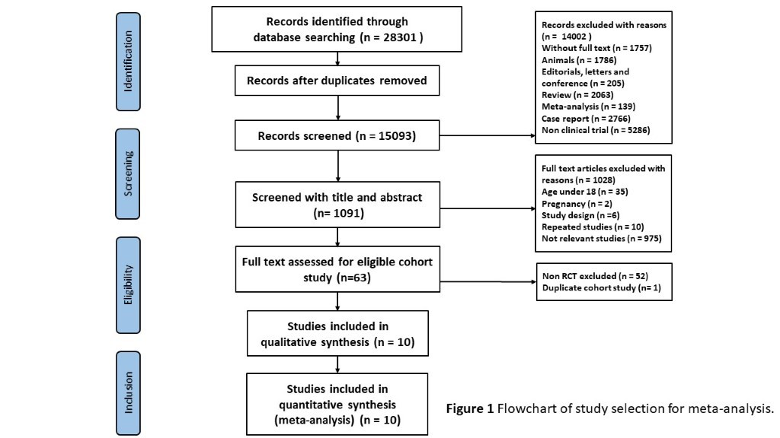

(sFig 1b) Flow chart showing Search strategy for studies in China.

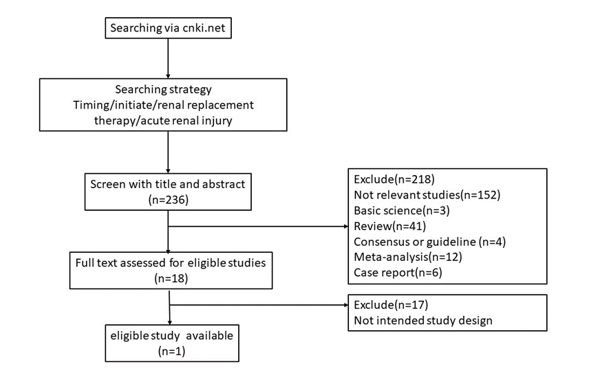

- sFigure 2. Risk of bias assessment denotes risks of bias and applicability concern
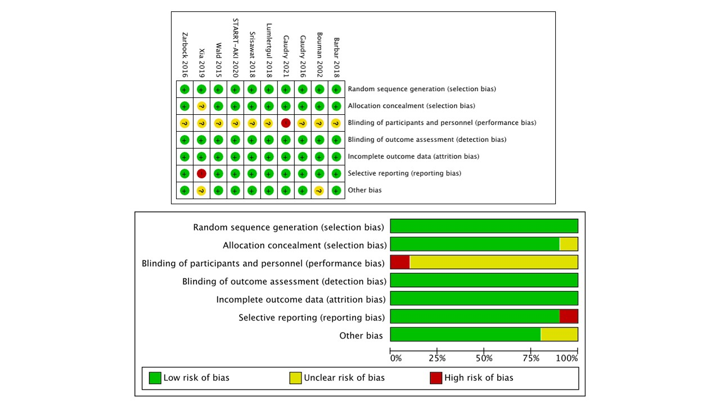

- sFigure 3.The heterogeneity for 28-day mortality and 28-day KRT dependence

sFigure 3a. The funnel plot shows the visual check for publication bias on the risk of 28-day mortality by pooling the adjusted odds ratios.
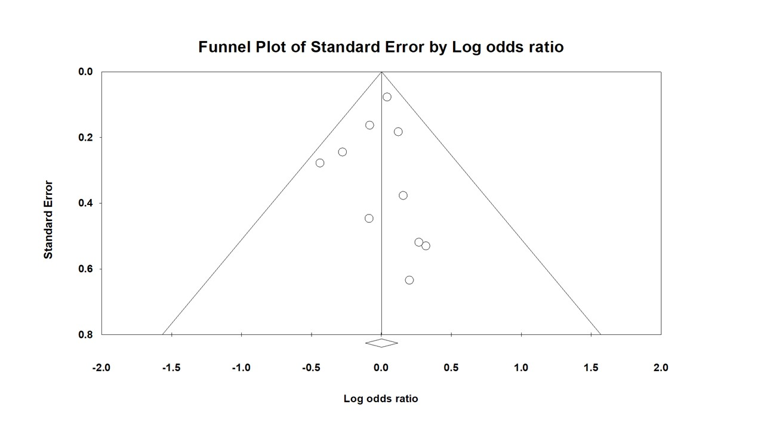

sFigure 3b. The funnel plot shows the visual check for publication bias on the risk of 28-day KRT dependence by pooling the adjusted odds ratios.

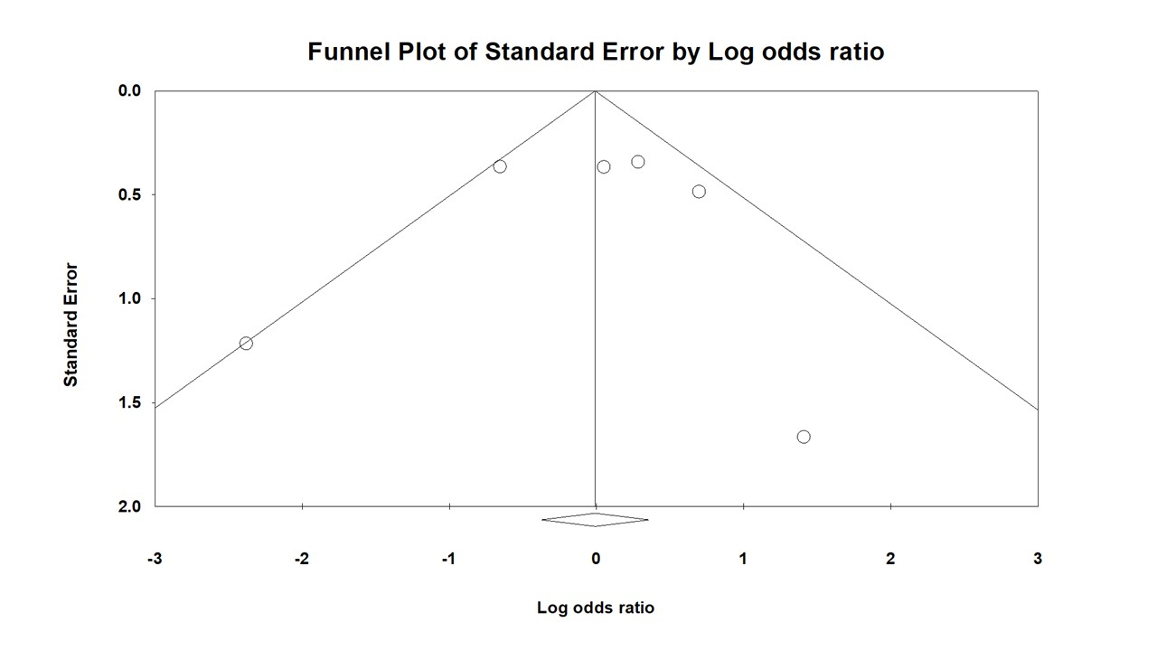

- Hospital mortality and ICU mortality
There are no significant differences in Hospital mortality and ICU mortality between the accelerated KRT versus WWS-KRT initiation. (Hospital mortality: OR:0.989, CI:0.873-1.120, p=0.861, I²:10.41%; ICU mortality: OR:0.957, CI:0.828-1.105, p=0.547, I²< 0.01%)

sFigure 4. Forest plot for comparison accelerated KRT versus WWS-KRT for hospital mortality
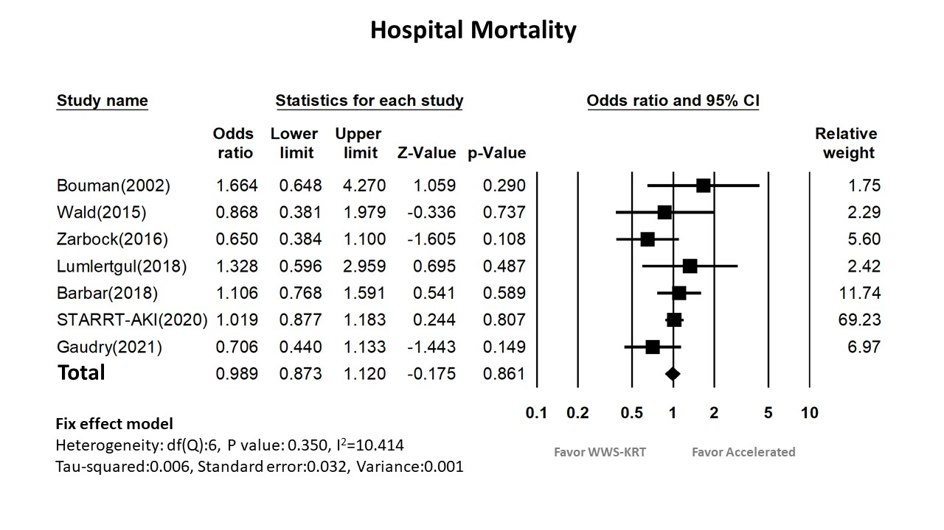
sFigure 5. Forest plot for comparison accelerated KRT versus WWS-KRT initiation for ICU mortality

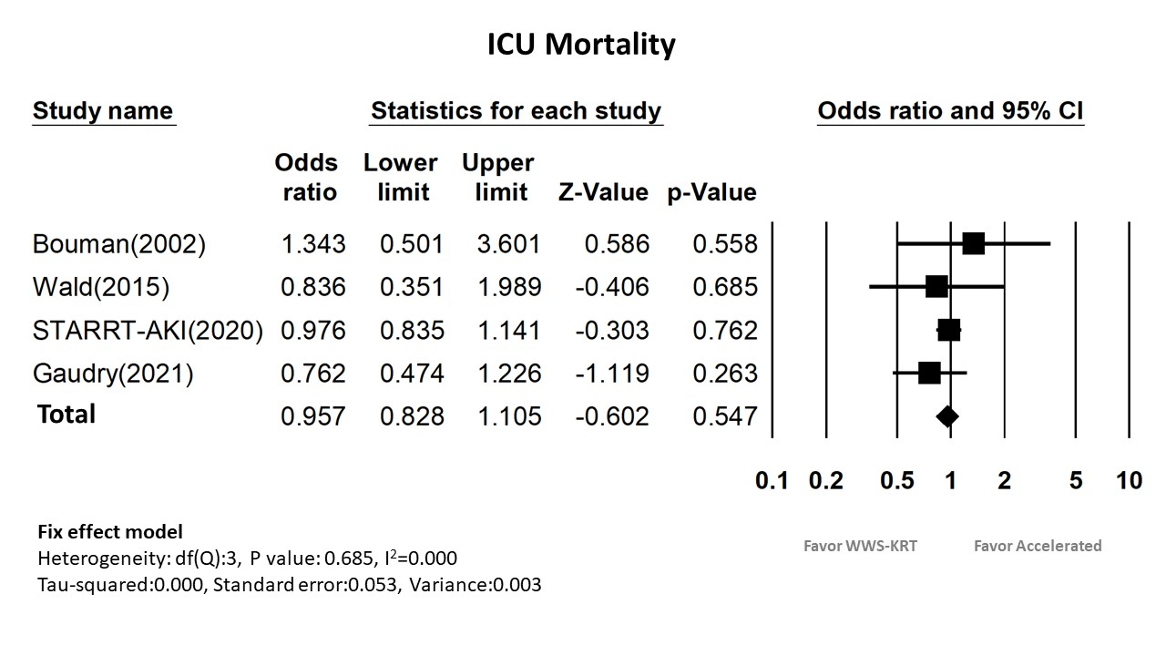
- ICU stay days and Hospital stay days
There are 5 included studies for ICU stay days, however, no significant difference between accelerated KRT versus WWS-KRT initiation. [SMD: -0.026; 95% CI − 0.150 to 0.097; P = 0.674; I² <1%](sFigure 6). Additionally, 6 studies were included for hospital stay days analysis and showed similar result of the two groups. ([SMD: -0.083; 95% CI − 0.18 to 0.015; P = 0.096; I² =46%](sFigure7)

sFigure 6. Forest plot for comparison accelerated KRT versus WWS-KRT initiation for ICU stay days
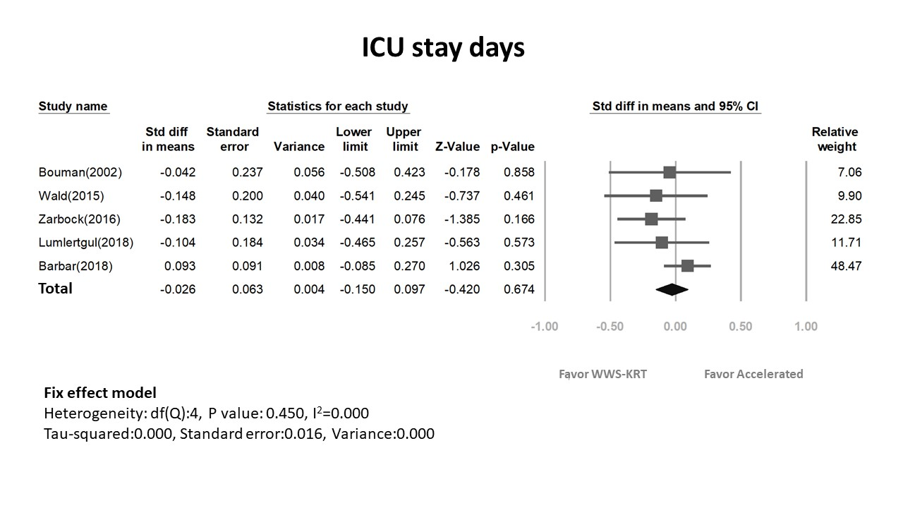
sFigure 7. Forest plot for comparison accelerated KRT versus WWS-KRT initiation for hospital stay days
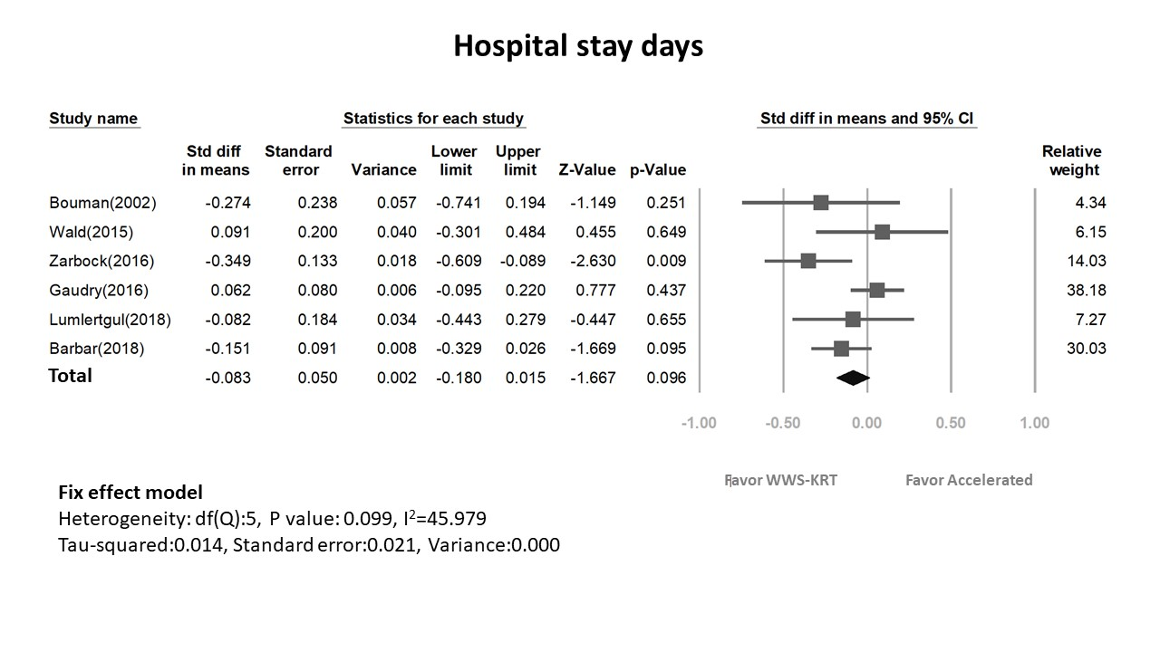
- Accelerated KRT versus WWS-KRT initiation and adverse events
The risk of arrhythmia and bleeding events, there were similar results between two groups, (arrhythmia:fixed-effect log OR:1.185, 95% confidence interval (CI):[0.918 to 1.530], p=0.193); (bleeding: fixed-effect log OR:0.903, 95% confidence interval (CI):[0.673 to 1.211], p=0.497).( sfigure 8.)
sFigure 8. Forest plot for comparison accelerated KRT versus WWS-KRT initiation for adverse events
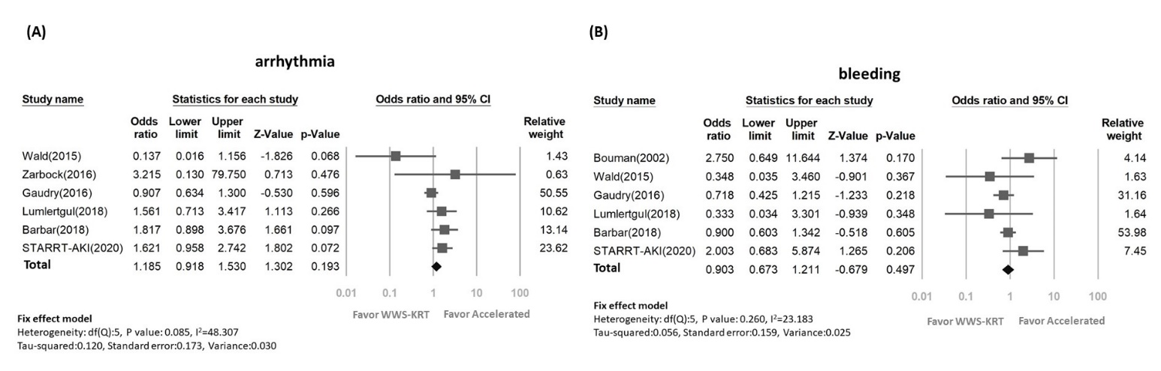

- Forest plot for comparison accelerated KRT versus WWS-KRT initiation for 28-day (A) and 90-day (B) dialysis free.
The patients without dialysis and weaning from the dialysis was believed to be dialysis free. There was similar 28-day (Figure 10a) and 90-day (Figure 10b) dialysis free between accelerated and WWS-KRT initiation groups. (28-day dialysis free: fixed-effect log OR:1.002, 95% confidence interval (CI):[0.893 to 1.124], p=0.971 ( sfigure 9a.); 90-day dialysis free: fixed-effect log OR:1.074, 95% confidence interval(CI):[0.946 to 1.220], p=0.269 ).( sfigure 9b.)

sFigure 9a Forest plot for comparison accelerated KRT versus WWS-KRT initiation for 28-day dialysis free
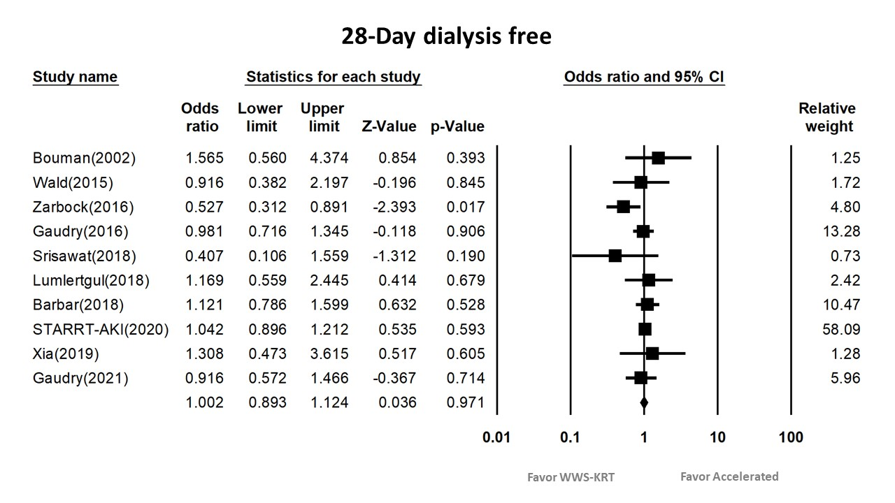
sFigure 9b Forest plot for comparison accelerated KRT versus WWS-KRT initiation for 90-day dialysis free

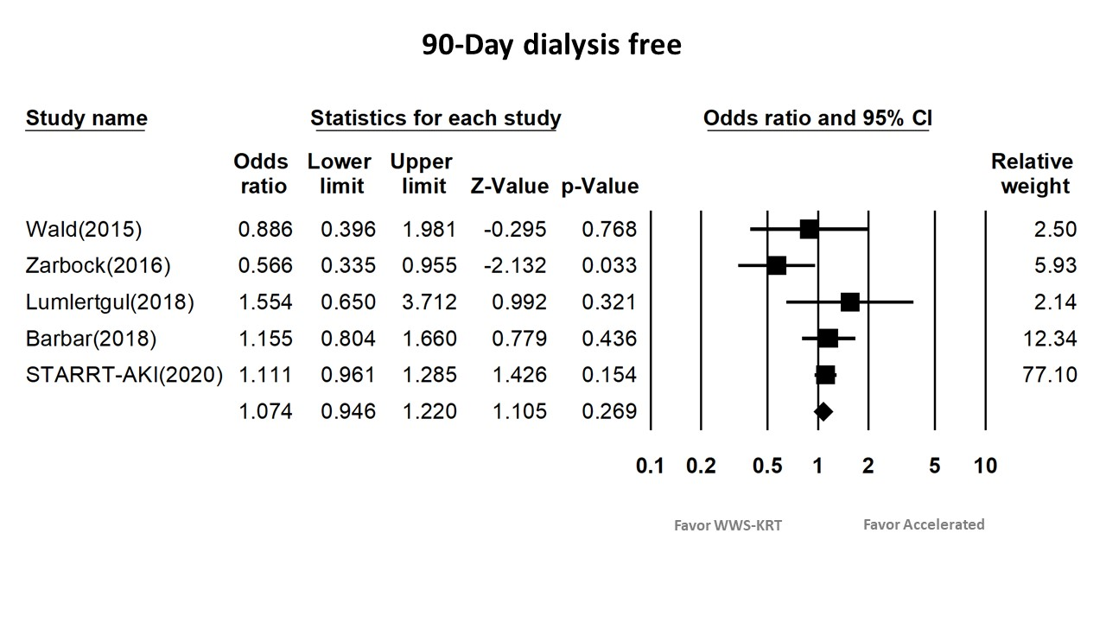

- Forest plot showing the risk of KRT free days, Mechanical ventilator-free days, and Vasopressor free days comparing accelerated KRT initiation group versus WWS-KRT initiation group
There are 5 studies reported 28-day KRT free days outcome (sFigure 10a.), 7 studies for 28-day mechanical ventilator (MV) free days(sFigure 10b.), and 3 studies or 28-day vasopressor free days(sFigure 10c). The pooled percentage between the accelerated group and the WWS-KRT group showed no significant difference for 28-day KRT- free days[SMD(Standard difference in means): -0.071; 95% CI − 0.178 to 0.035; P = 0.188; I² <1%], 28-day mechanical ventilator(MV) -free days[SMD: 0.047; 95% CI − 0.011 to 0.106; P = 0.113; I² = 31%], and 28-day vasopressor- free days[SMD: 0.038; 95% CI − 0.024 to 0.100; P = 0.228; I² <1%].
sFigure 10a. Forest plot for comparison accelerated KRT initiation group versus WWS-KRT initiation group for 28-day KRT free days
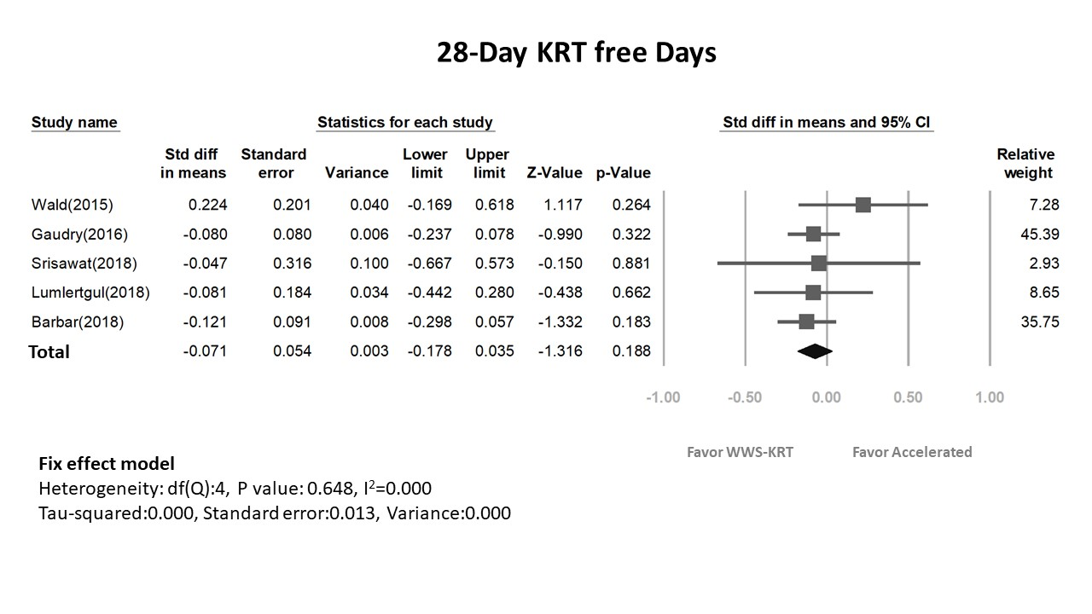
sFigure 10b. Forest plot for comparison accelerated KRT initiation group versus WWS-KRT initiation group for 28-day MV free days
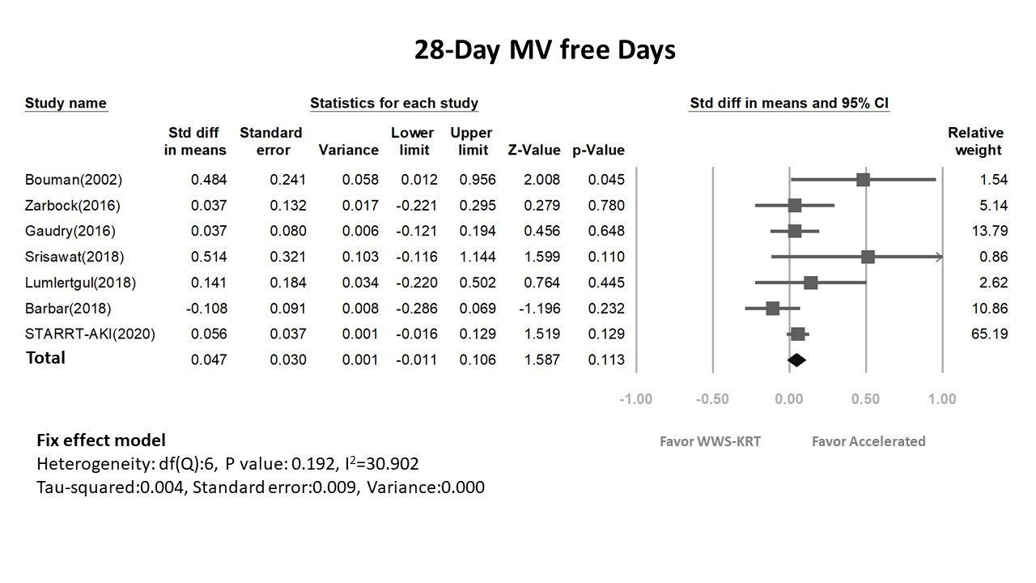
sFigure 10c. Forest plot for comparison accelerated KRT initiation group versus WWS-KRT initiation group for 28-day vasopressor free days
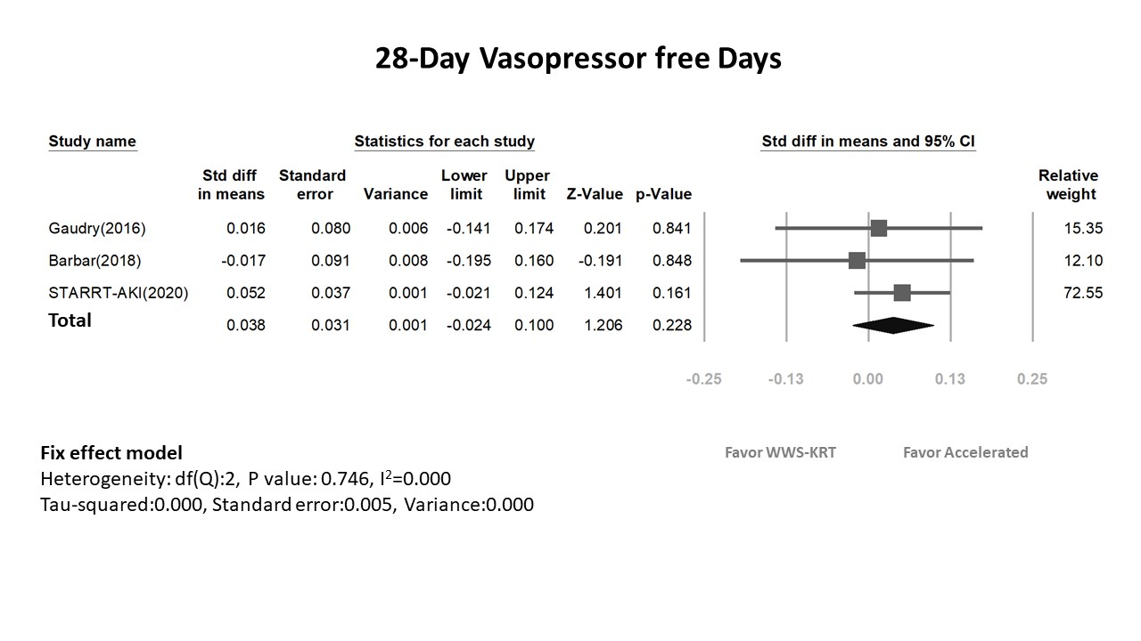
- Compared the difference between the index study and other meta-analyses
Recent results were conducted by the meta-analysis for the different KRT strategies, but Gaudry et al. only enrolled the trials until Dec 20, 2019. We make the comparison between the accelerated group and WWS-KRT, but Pan et al. did not investigate the impact of WWS-KRT. Moreover, (STARRT-AKI) study and AKIKI2 were also included in our meta-analysis, which was not included by Chen et al. Although Li et al. conducted a meta-analysis for the timing of KRT initiation for critically ill patients, we excluded two studies, e.g., Jamale et al. and Combes et al. Because not all AKI patients from Combes et al. were AKI patients. In contrast, the patients enrolled by Jamale et al. were considered community-acquired AKI. Additionally, for the first time, we enrolled AKIKI-2 study.
- PRISMA checklist

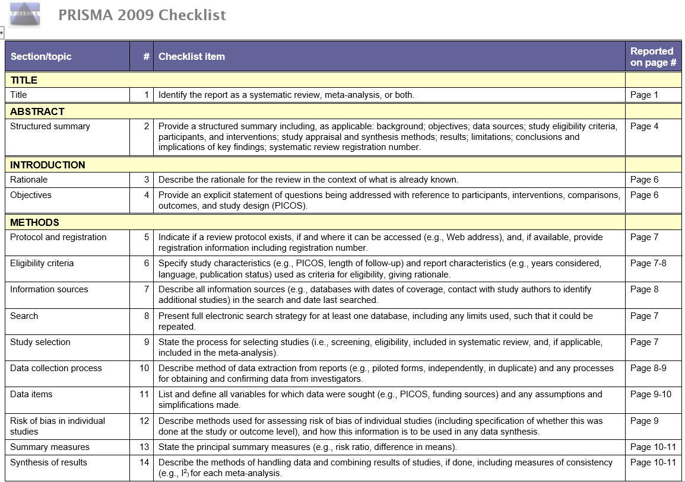
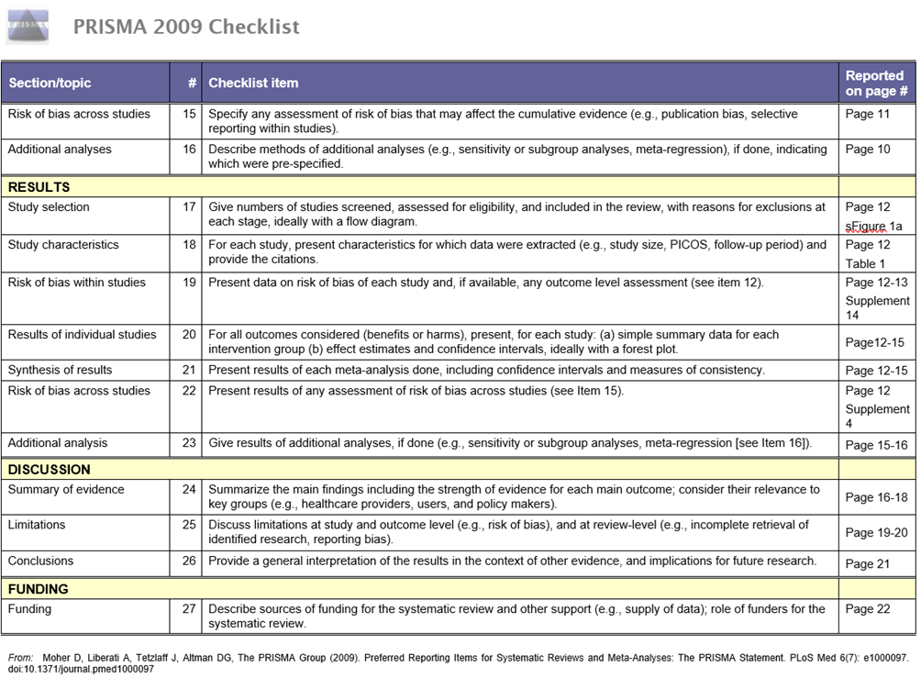
- Summary of contextual factor data
In the study, we included a total of 10 RCTs, and 4,932 patients were analyzed. Bouman(2002) et al. had 106 ventilated severely ill patients who were oliguria, kidney failure, but accelerated initiation or higher ultrafiltration volume hemofiltration did not improve the 28-day survival and recovery kidney function. Wald(2015) et al. conducted a randomized control trial with 101 critically ill patients with AKI. There was no difference in the mortality, dialysis dependence, and duration of ICU and hospital stay between the two groups. Zarbock et al.(ELAIN Study, 2016) had 231 critically ill patients with KDIGO stage 2, plasma NGAL higher than 150 ng/mL, and accelerated KRT compared with delayed initiation of KRT reduced mortality over the first 90 days(p=0.03), KRT duration(p=0.04), and hospital stay (p<0.001). Additionally, Gaudry et al. (AKIKI study, 2016) assigned 620 AKI patients with KDIGO stage 3 from multicenter, but it showed no significant difference of an accelerated and delayed strategy in mortality (p=0.79). Srisawat(A feasibility study, 2018) et al. included 40 patients with high pNGAL, and there was no difference in 28-day mortality (p=0.72) and dialysis dependence (p=0.062) between the accelerated and standard group. Moreover, Lumlertgul(the FST trial, 2018) et al. included 118 FST-nonresponsive patients, and they observed no differences in 28-day mortality (p = 0.68), 7-day fluid balance, or KRT dependence at day 28. Barbar (IDEAL-ICU Trial, 2018) et al. enrolled 488 patients with septic shock who had severe acute kidney injury, and there was no difference for 90-day mortality (p=0.38) between accelerated and delayed KRT strategy. STARRT-AKI(2020) conducted a multinational, randomized, controlled trial involving critically ill patients with severe AKI. An accelerated kidney replacement strategy was not associated with a lower risk of death 90 days than a standard strategy. Xia(2019) et al. had 60 patients with high urine NGAL, and there was no statistically significant difference in mortality between the accelerated CKRT group and the standard treatment group at 28 days (p=0.796). Finally, recently published AKIKI-2 by Gaudry et al. conducted 278 patients who underwent randomization and concluded postponing KRT initiation did not have an additional benefit and was associated with potential harm.

From most of the references above, our data revealed the WWS-KRT initiation had more possibility of dialysis-free than the accelerated group, but there was no difference in 90-day mortality between the two groups. However, more frequent adverse events, like hypotension and infection, were found in the accelerated group. However, several limitations were as following: diverse definition of the KRT timing; unclear AKI definition in the obsolete studies; different definitions of the accelerated and WWS-KRT group.

In conclusion, critically ill patients with AKI benefited from the WWS regarding dialysis-free and fewer adverse events (hypotension, infection) compared with the accelerated KRT initiation group. All the literature in this meta-analysis was highly heterogeneous and potentially subject to low biases.

- The GRADE results
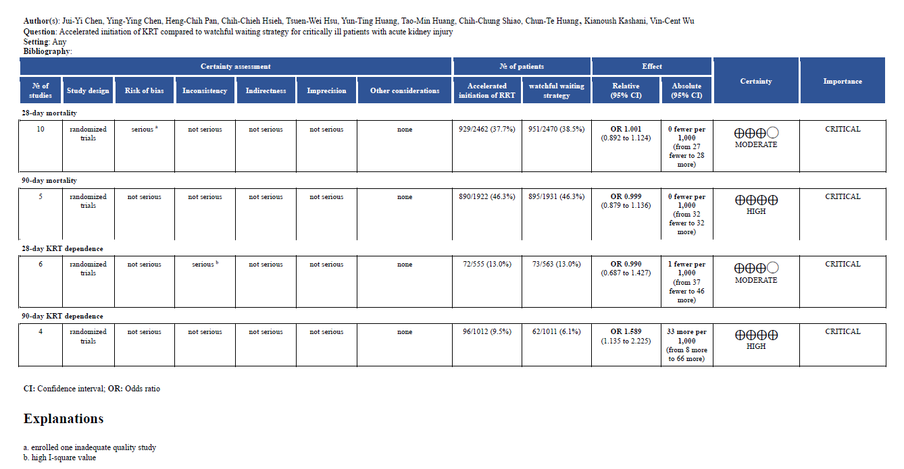

- Summary receiver operating characteristic (SROC) curves based on serum urea
Individual studies are shown as open circles. Summary point is shown as a star key sign, representing sensitivity estimates pooled by using bivariate random-effects regression model.
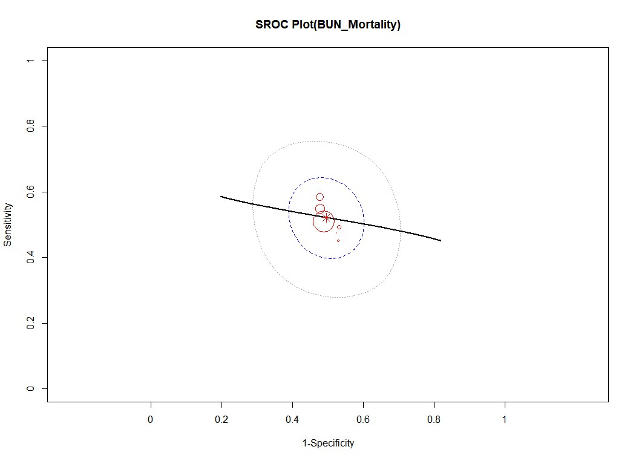
Figure 11a. Summary receiver operating characteristic curves based on serum urea for 28-day mortality

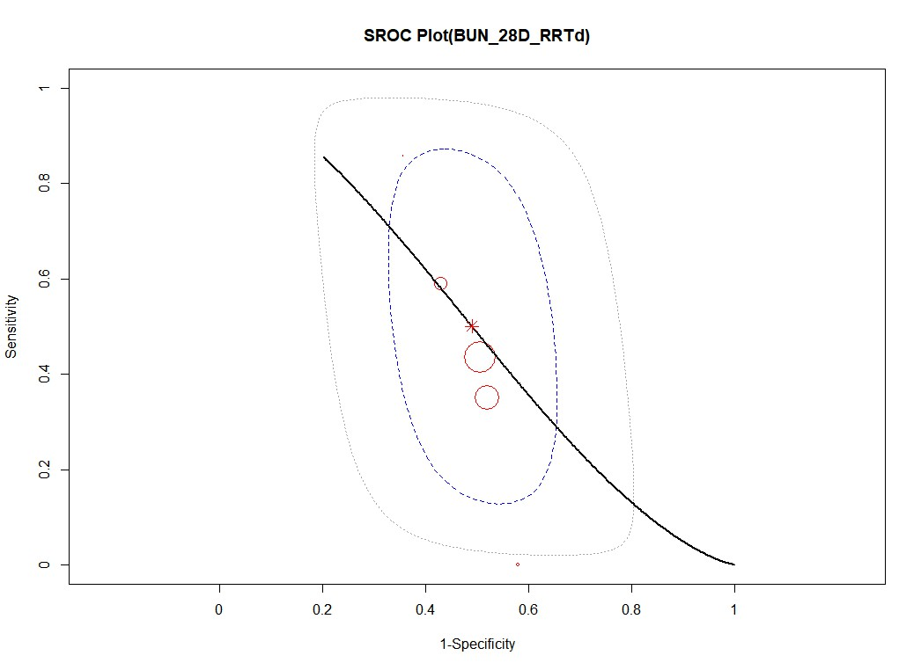
Figure 11b. Summary receiver operating characteristic curves based on serum urea for 28-day kidney replacement therapy dependence

