Table S1. The quality assessment of included studies.
Study | Study type | Selection | Comparability | Outcome/Exposure
Cavender, 2009 | Observational | *** | * | ***
Van der schaaf, 2010 | Observational | *** | * | ***
Bauer, 2012 | Observational | *** | * | ***
Cavender, 2013 | Observational | *** | * | ***
Yang, 2013 | Observational | *** | * | ***
Mylotte, 2013 | Observational | *** | * | ***
Zeymer, 2014 | Observational | *** | * | ***
Park, 2015 | Observational | *** | * | ***
Zeymer, 2016 | Observational | *** | * | ***
Jager, 2014 | Observational | *** | * | ***
McNeice, 2018 | Observational | *** | * | ***
Lee, 2018 | Observational | *** | * | ***
Jaguszawski, 2013 | Observational | *** | * | **
Hambraeus, 2016 | Observational | *** | * | ***
Thiele, 2017 | RCT | NA | NA | NA

Figure S1. Funnel plot for short-term mortality. Comparing the odds ratio (x axis) of individual studies to standard error of odds ratio (y-axis) on logarithmic scale. Visual inspection shows the studies are not evenly distributed around no effect line, thus favoring exist of selection bias.
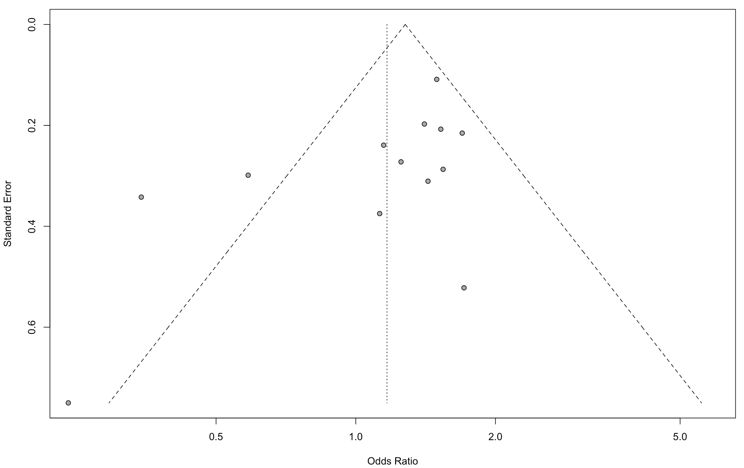
Figure S2. Funnel plot for long-term mortality. Comparing the odds ratio (x axis) of individual studies to standard error of odds ratio (y-axis) on logarithmic scale. Visual inspection shows the studies are evenly distributed around no effect line, thus favoring lack of selection bias.
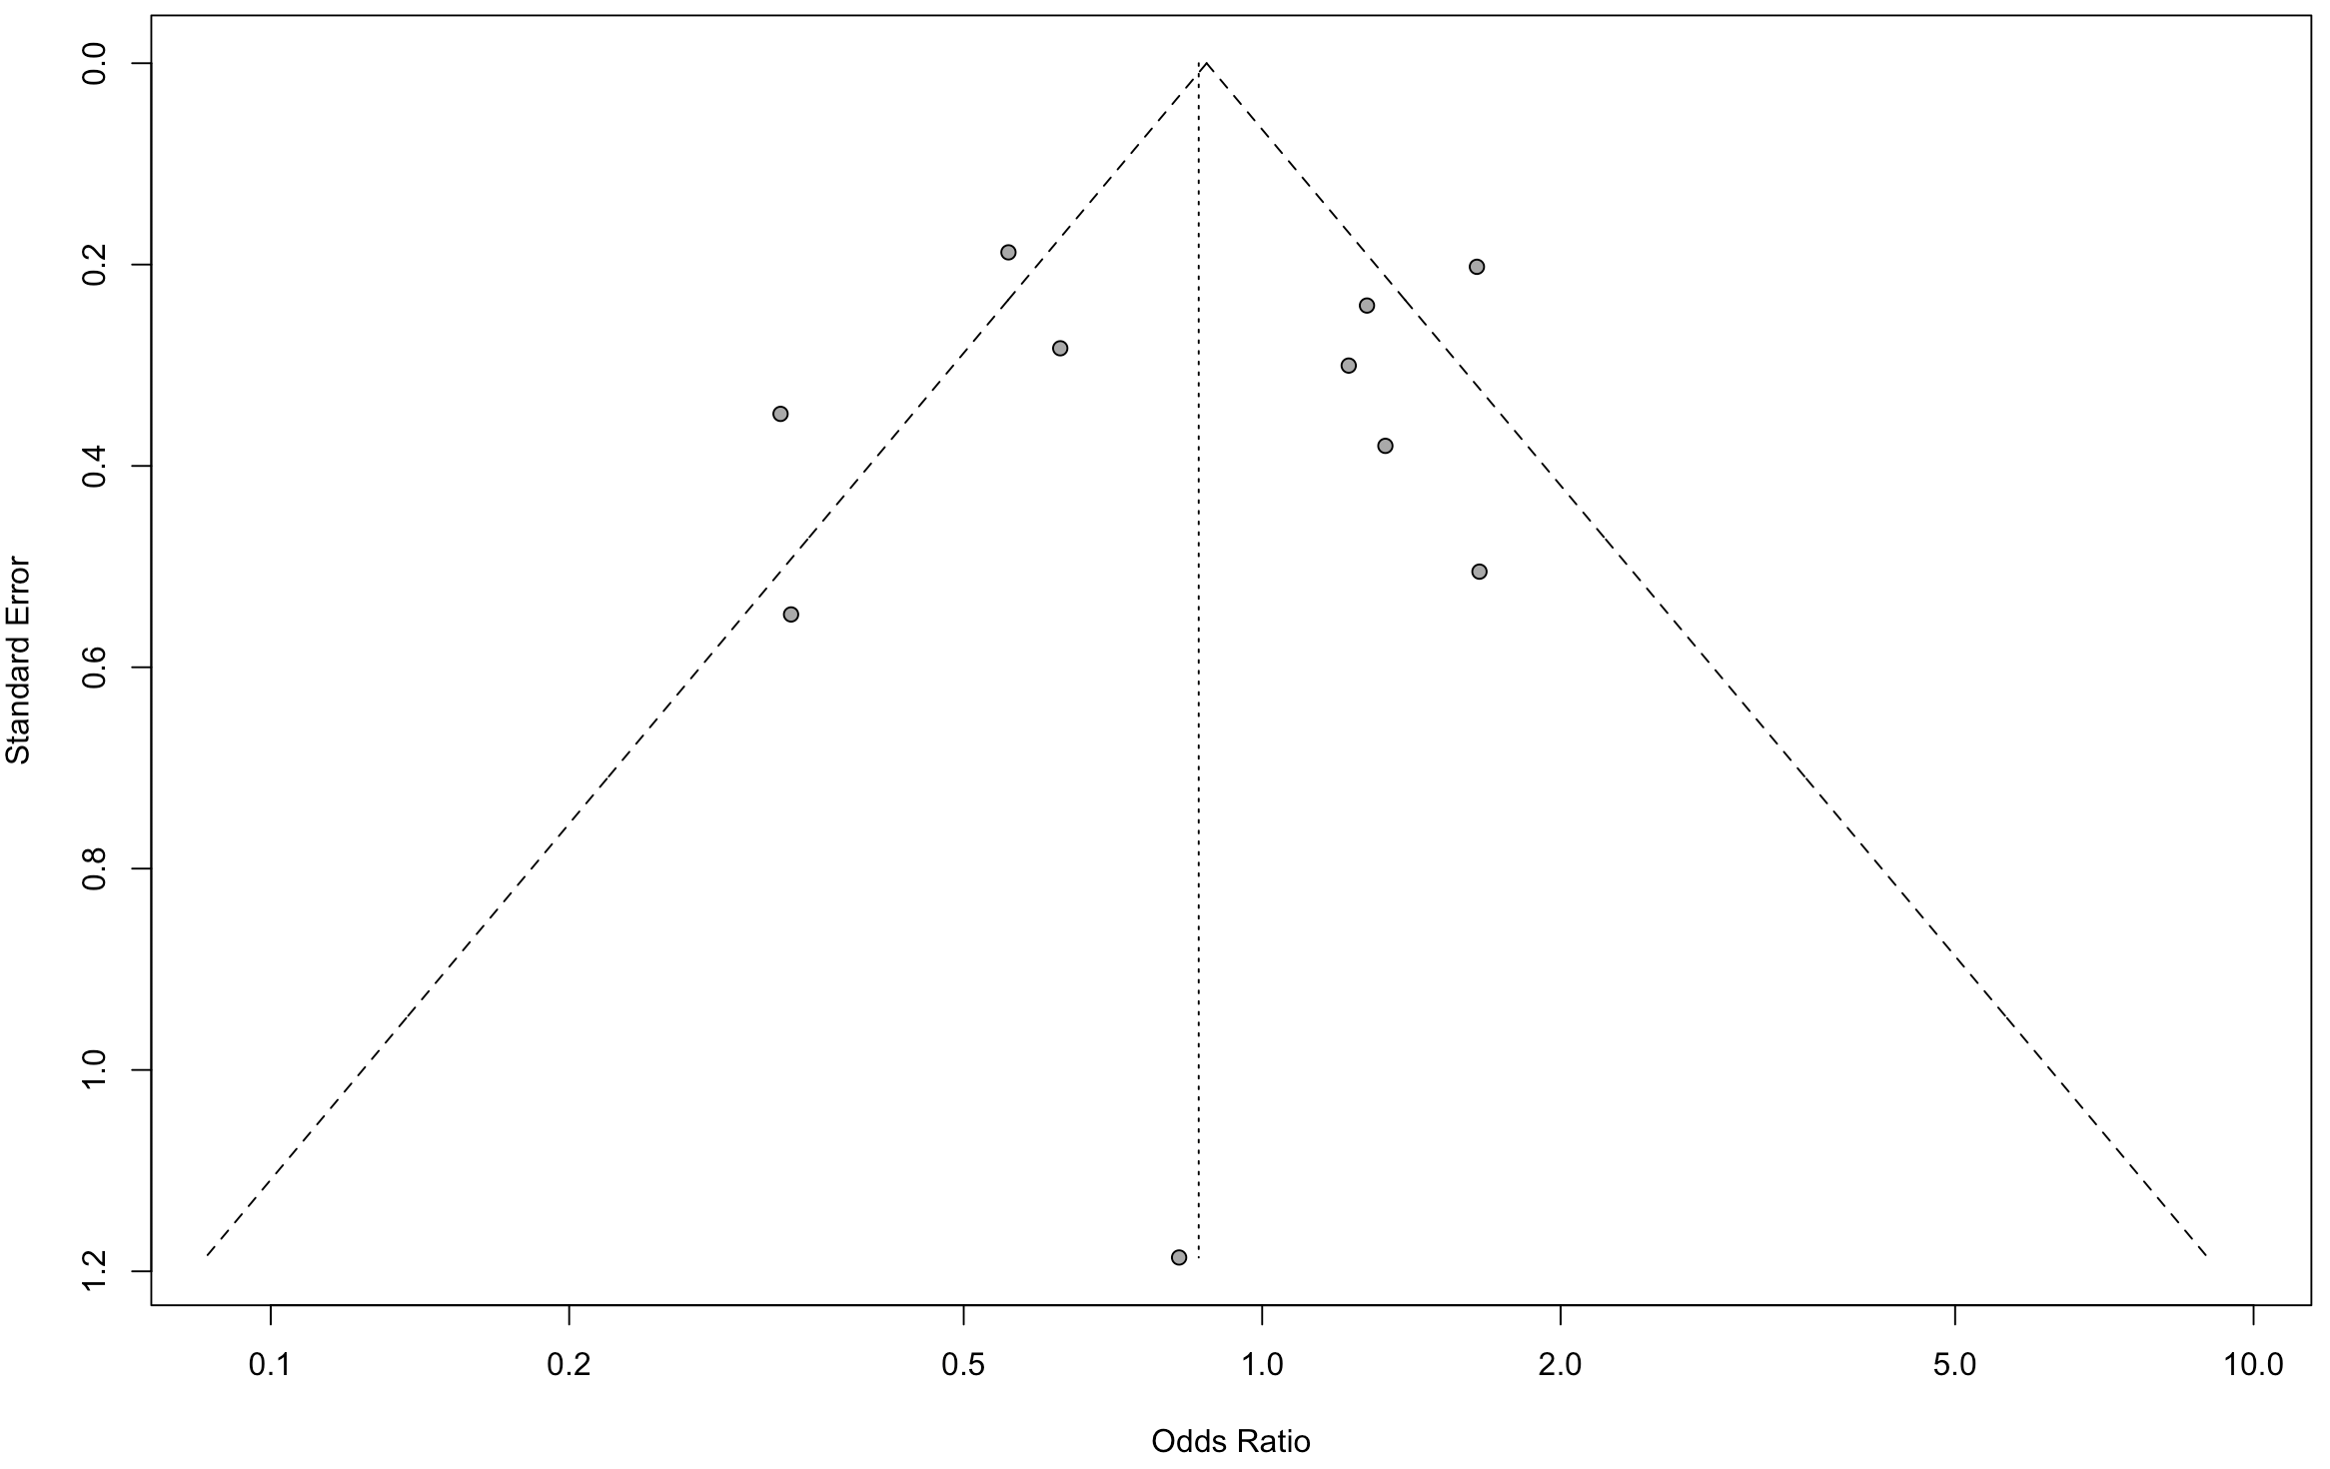
Figure S3. Funnel plot for myocardial reinfarction. Comparing the odds ratio (x axis) of individual studies to standard error of odds ratio (y-axis) on logarithmic scale. Visual inspection shows the studies are evenly distributed around no effect line, thus favoring lack of selection bias.
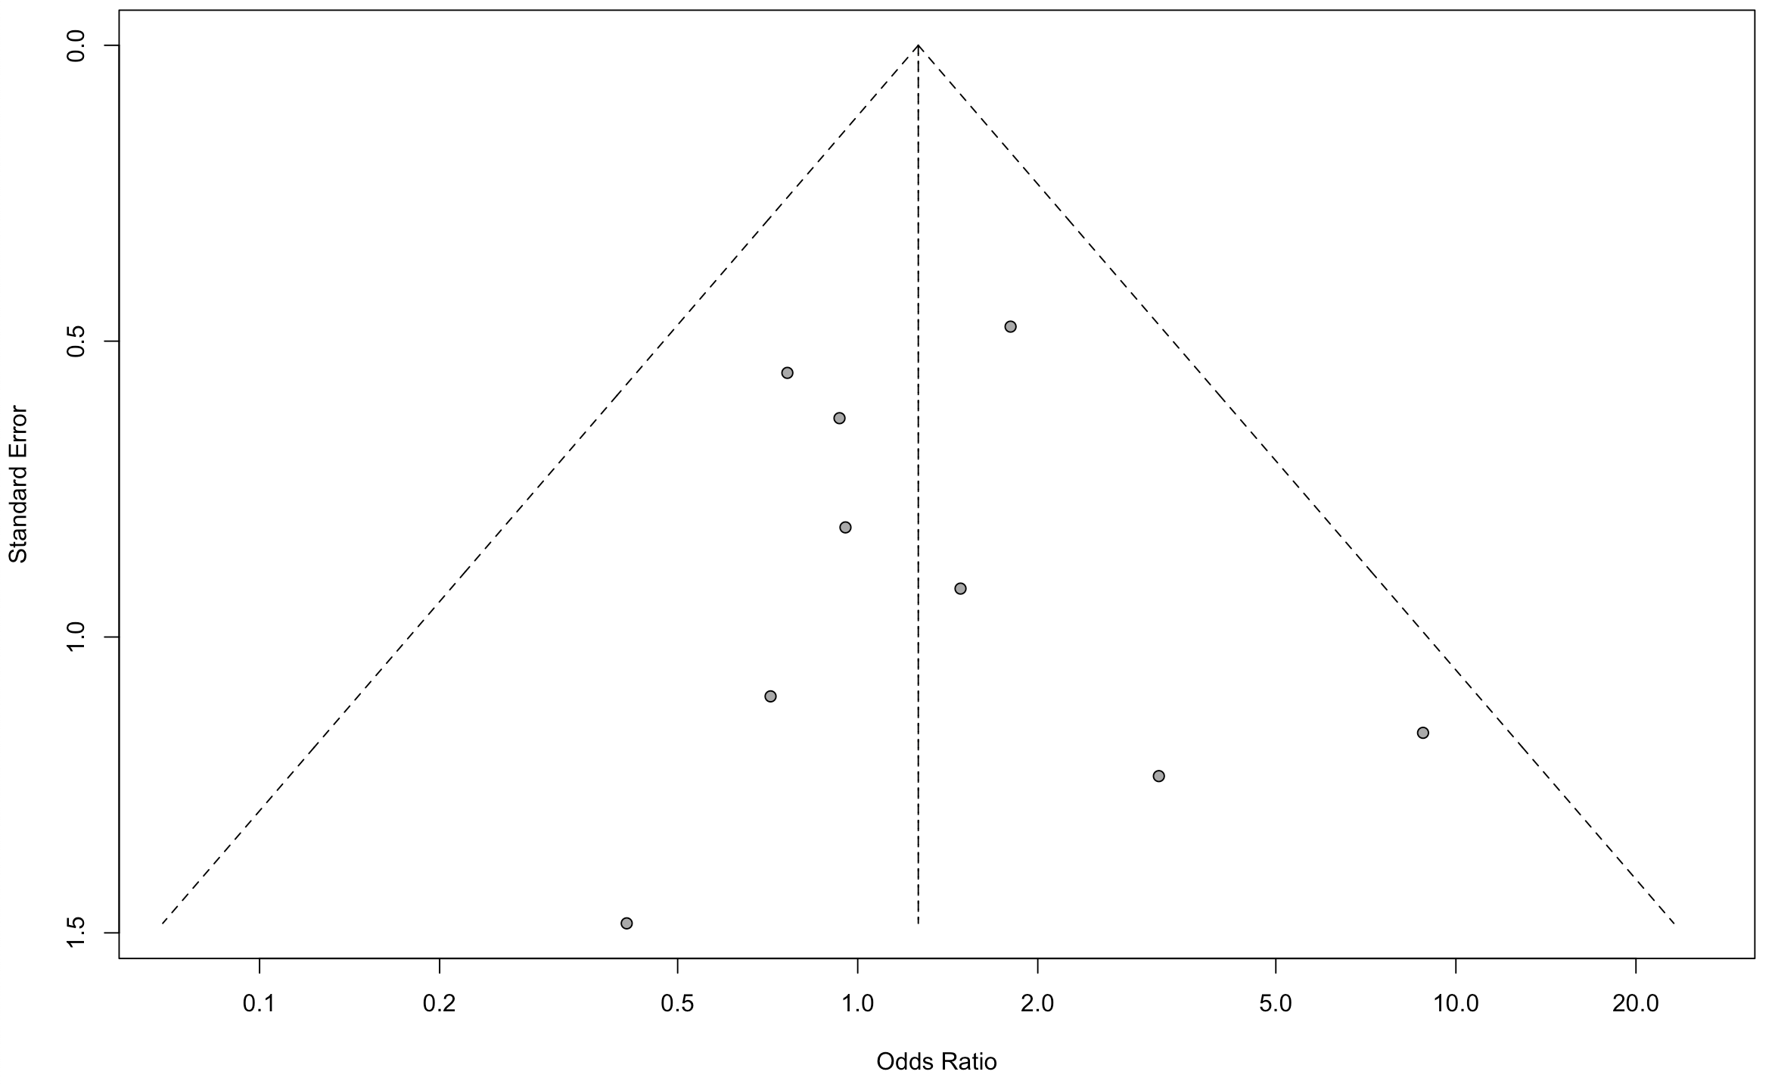
Figure S4. Funnel plot for repeat revascularization. Comparing the odds ratio (x axis) of individual studies to standard error of odds ratio (y-axis) on logarithmic scale. Visual inspection shows the studies are not evenly distributed around no effect line, thus favoring exist of selection bias.
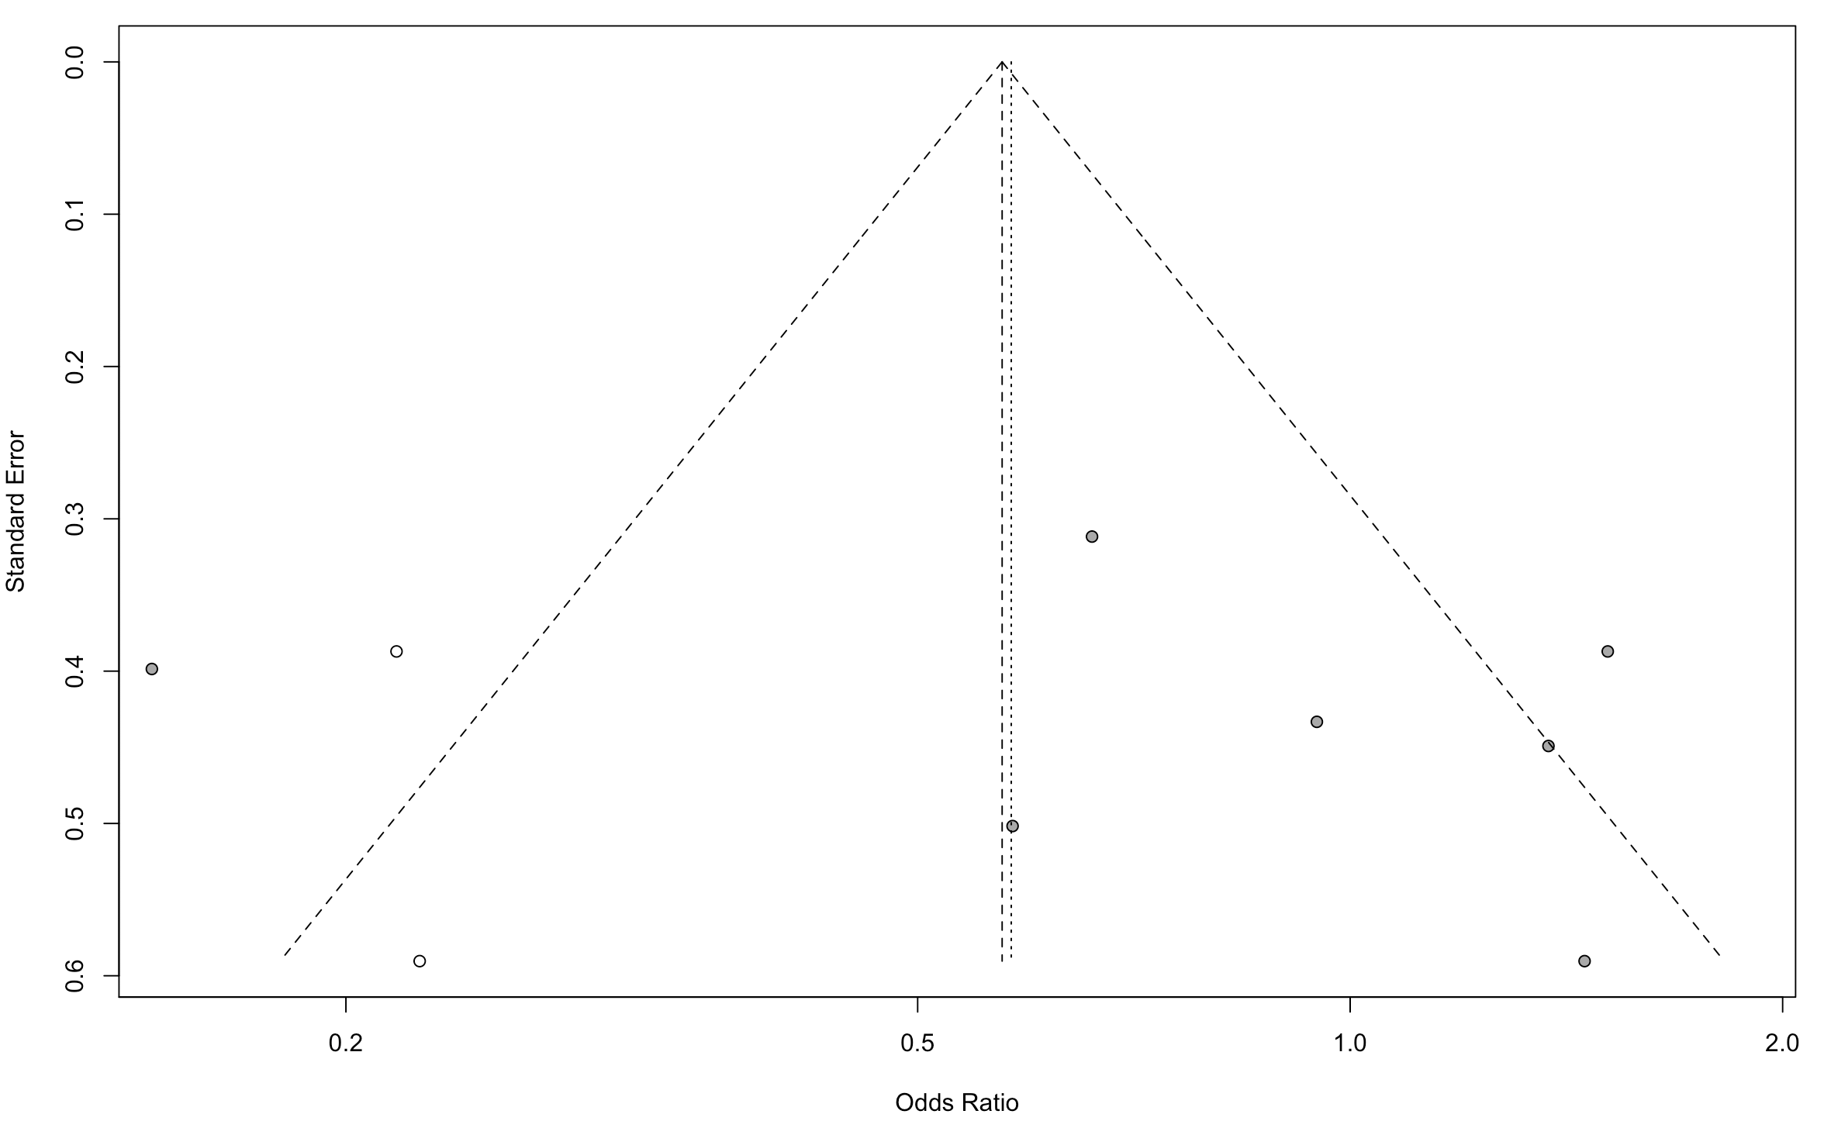
Figure S5. Funnel plot for cardiac death. Comparing the odds ratio (x axis) of individual studies to standard error of odds ratio (y-axis) on logarithmic scale. Visual inspection shows the studies are not evenly distributed around no effect line, thus favoring exist of selection bias.
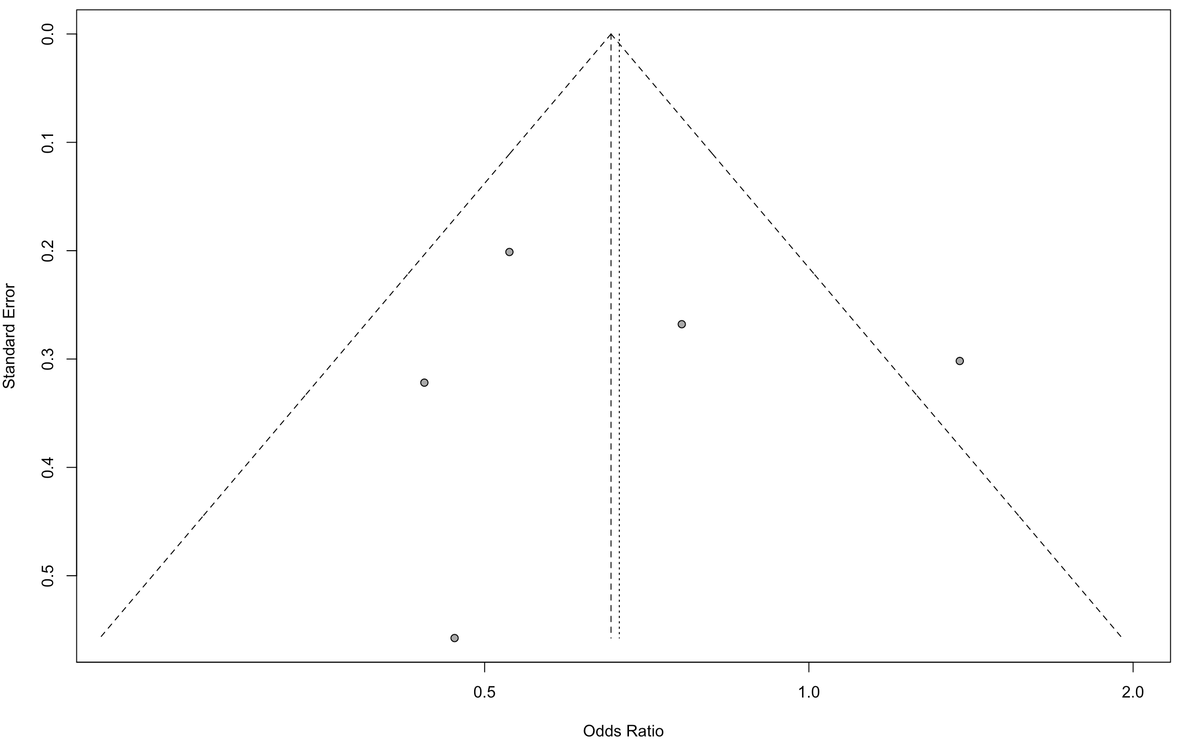
Figure S6. Sensitivity analysis for short-term mortality.

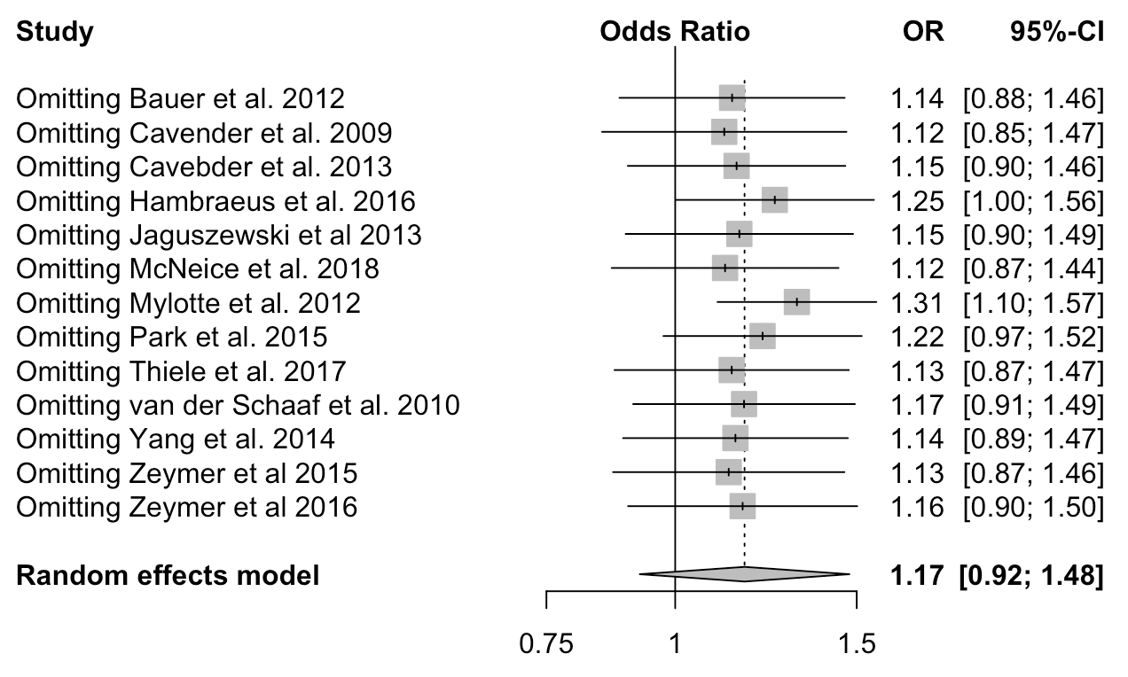$
Figure S7. Sensitivity analysis for long-term mortality.
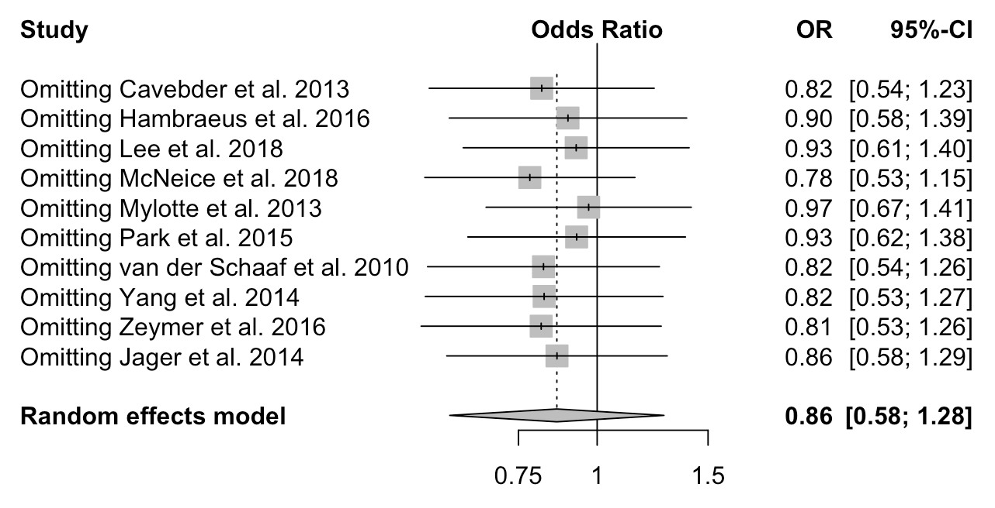

Figure S8. Sensitivity analysis for cardiac death.
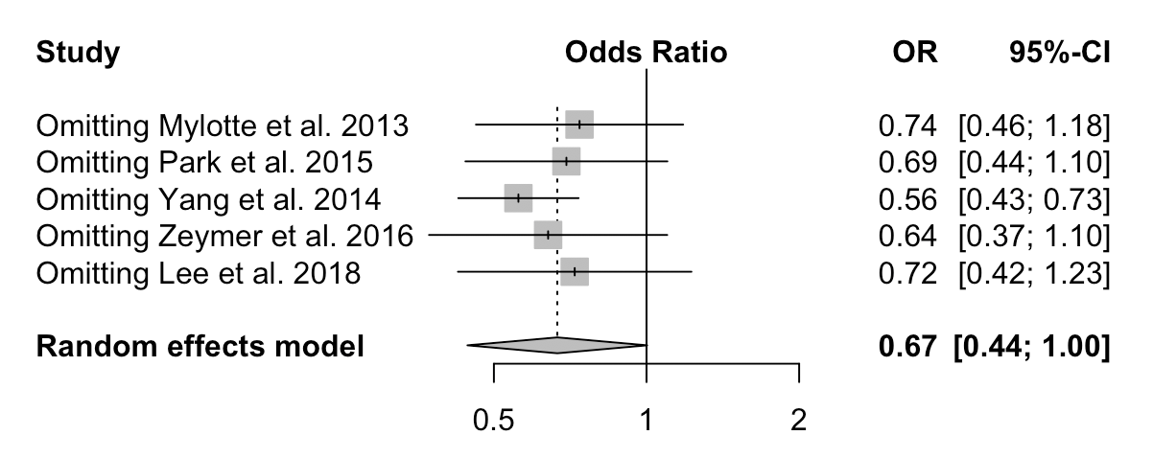

Figure S9. Sensitivity analysis for myocardial reinfarction.
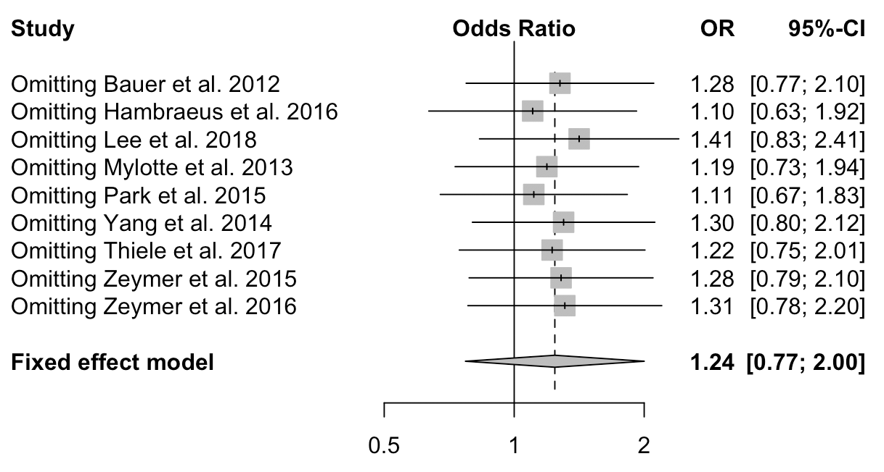

Figure S10. Sensitivity analysis for repeat revascularization.
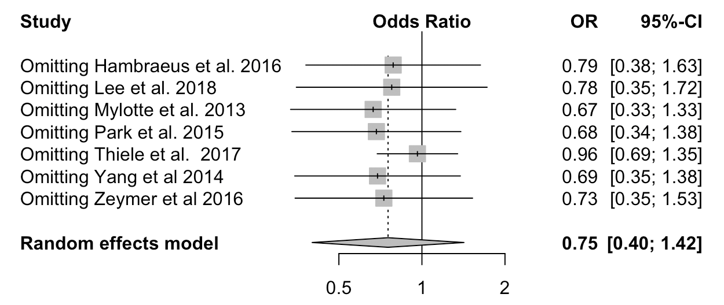

Figure S11. Funnel plot for bleeding. Comparing the odds ratio (x axis) of individual studies to standard error of odds ratio (y-axis) on logarithmic scale. Visual inspection shows the studies are not evenly distributed around no effect line, thus favoring exist of selection bias.
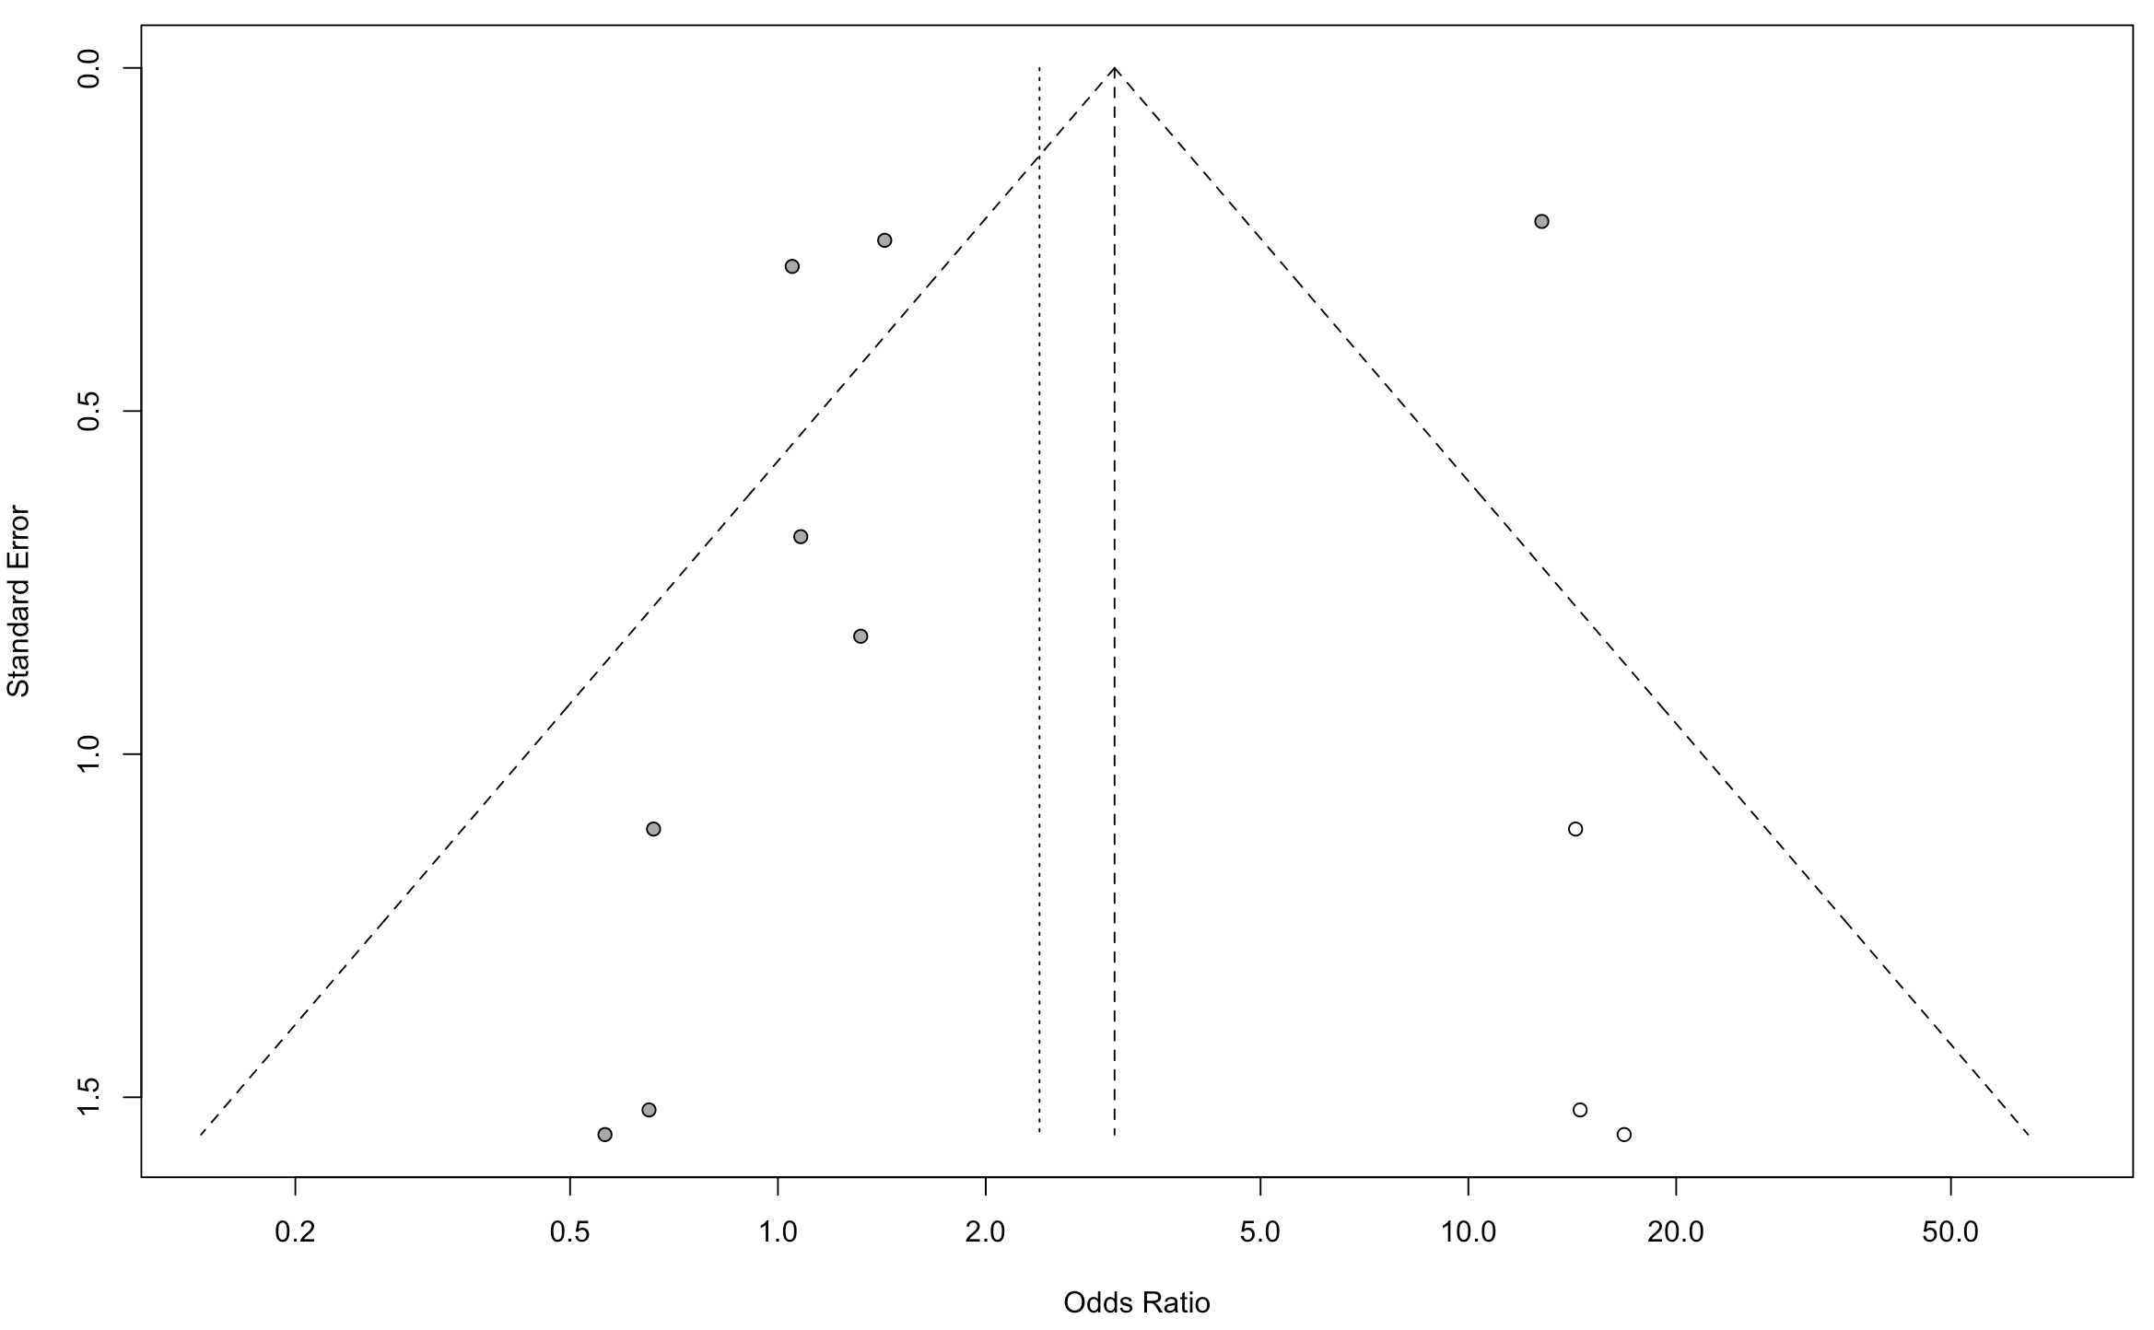

Figure S12. Funnel plot for renal failure. Comparing the odds ratio (x axis) of individual studies to standard error of odds ratio (y-axis) on logarithmic scale. Visual inspection shows the studies are evenly distributed around no effect line, thus favoring lack of selection bias. 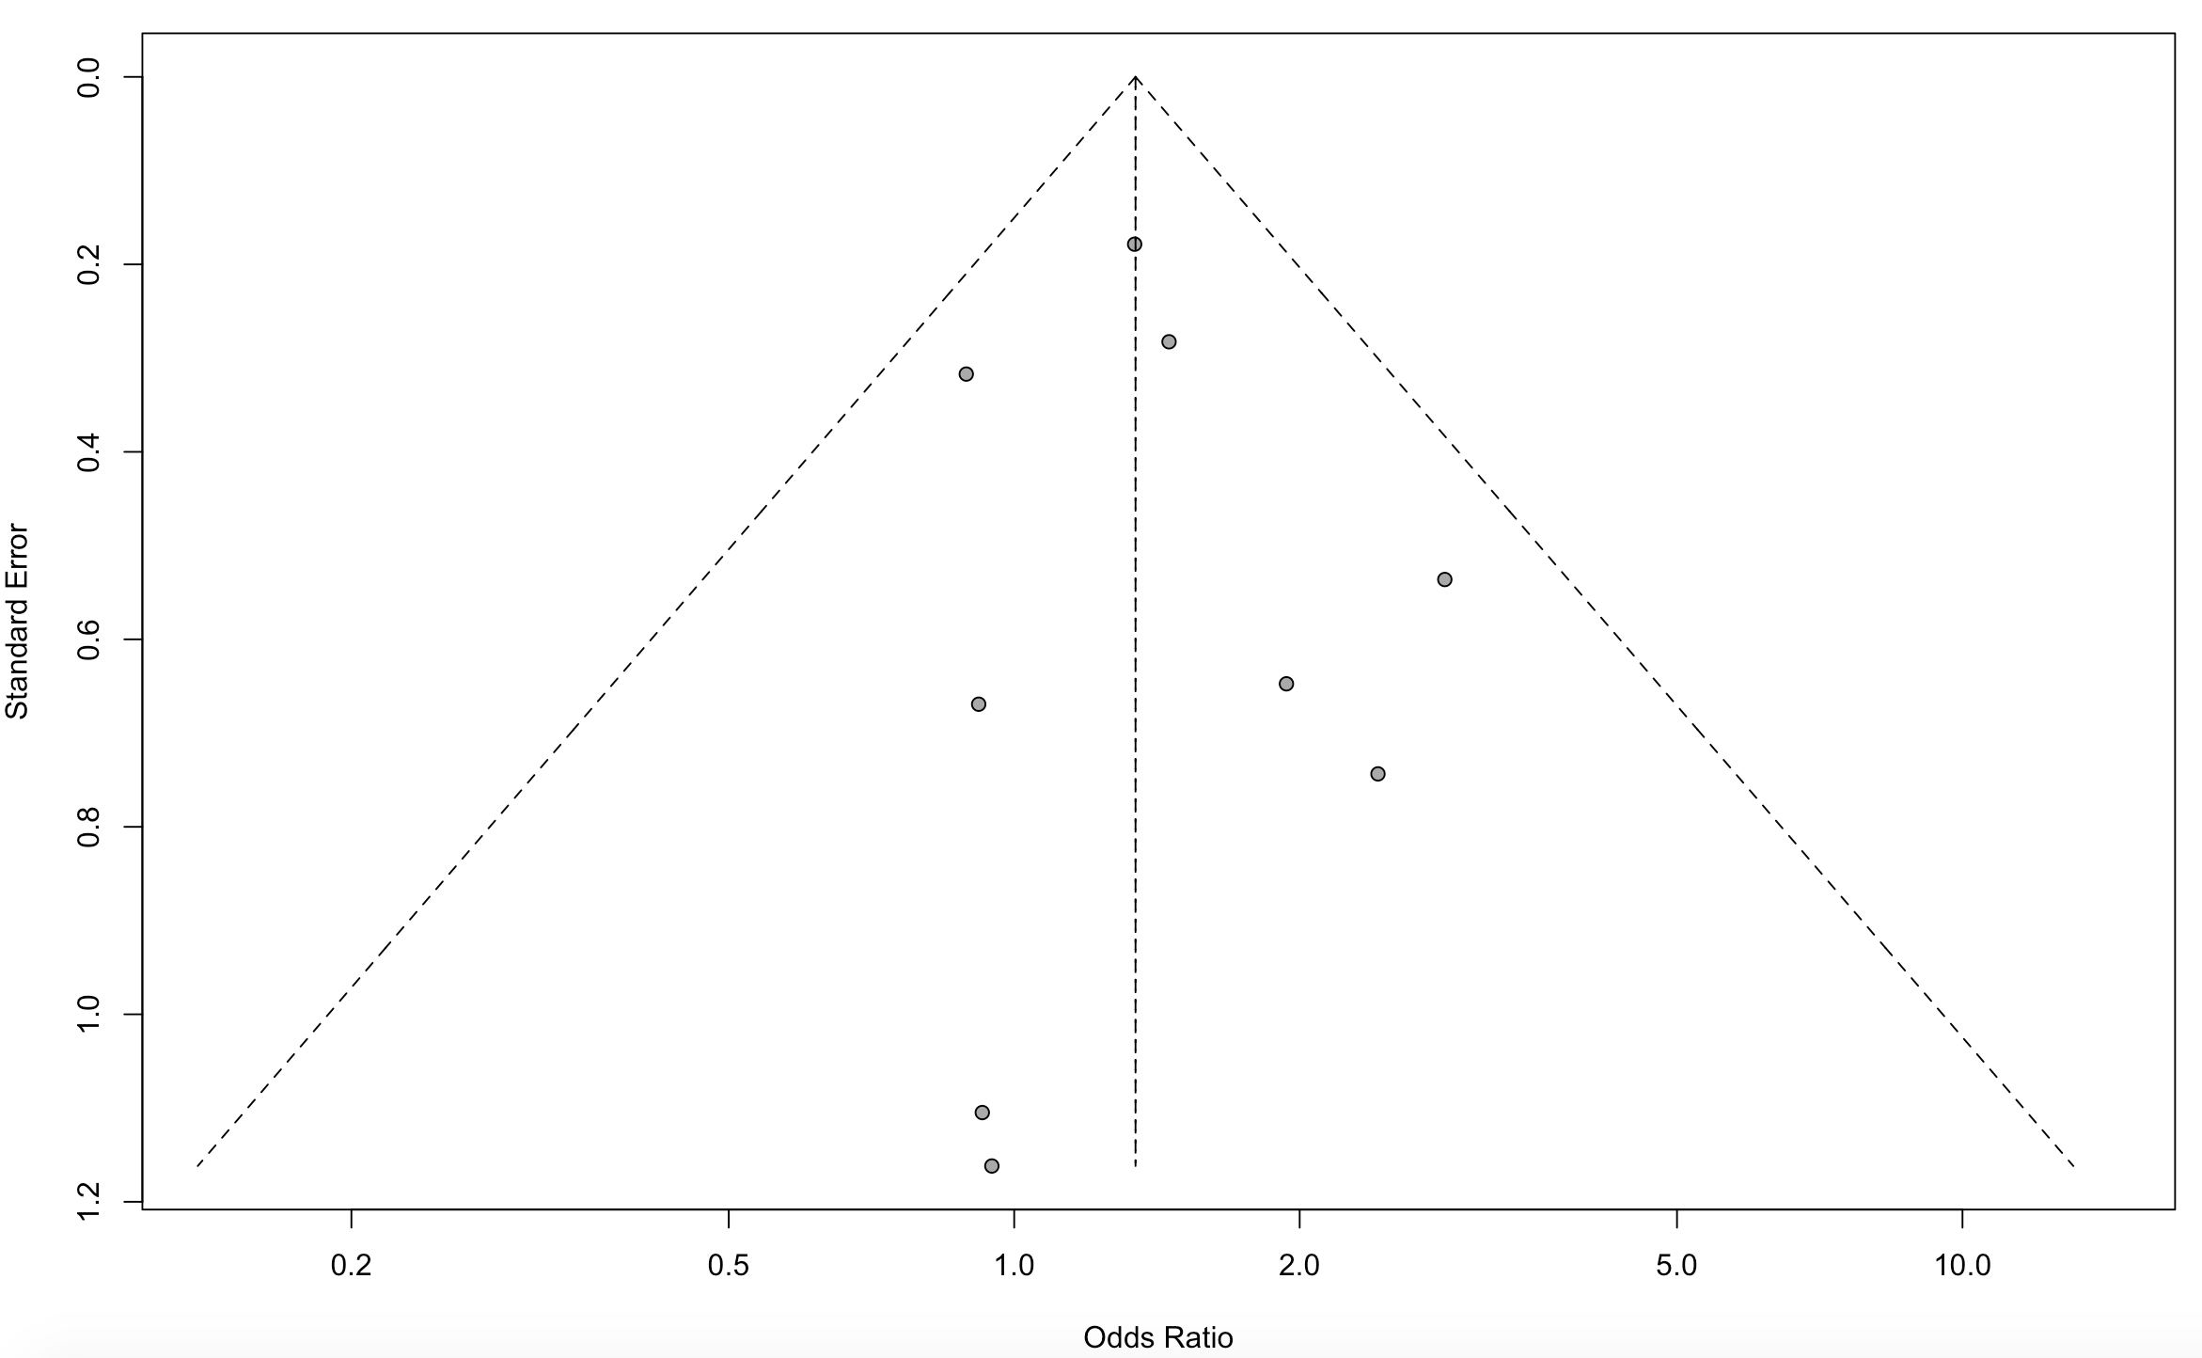
Figure S13. Funnel plot for stroke. Comparing the odds ratio (x axis) of individual studies to standard error of odds ratio (y-axis) on logarithmic scale. Visual inspection shows the studies are evenly distributed around no effect line, thus favoring lack of selection bia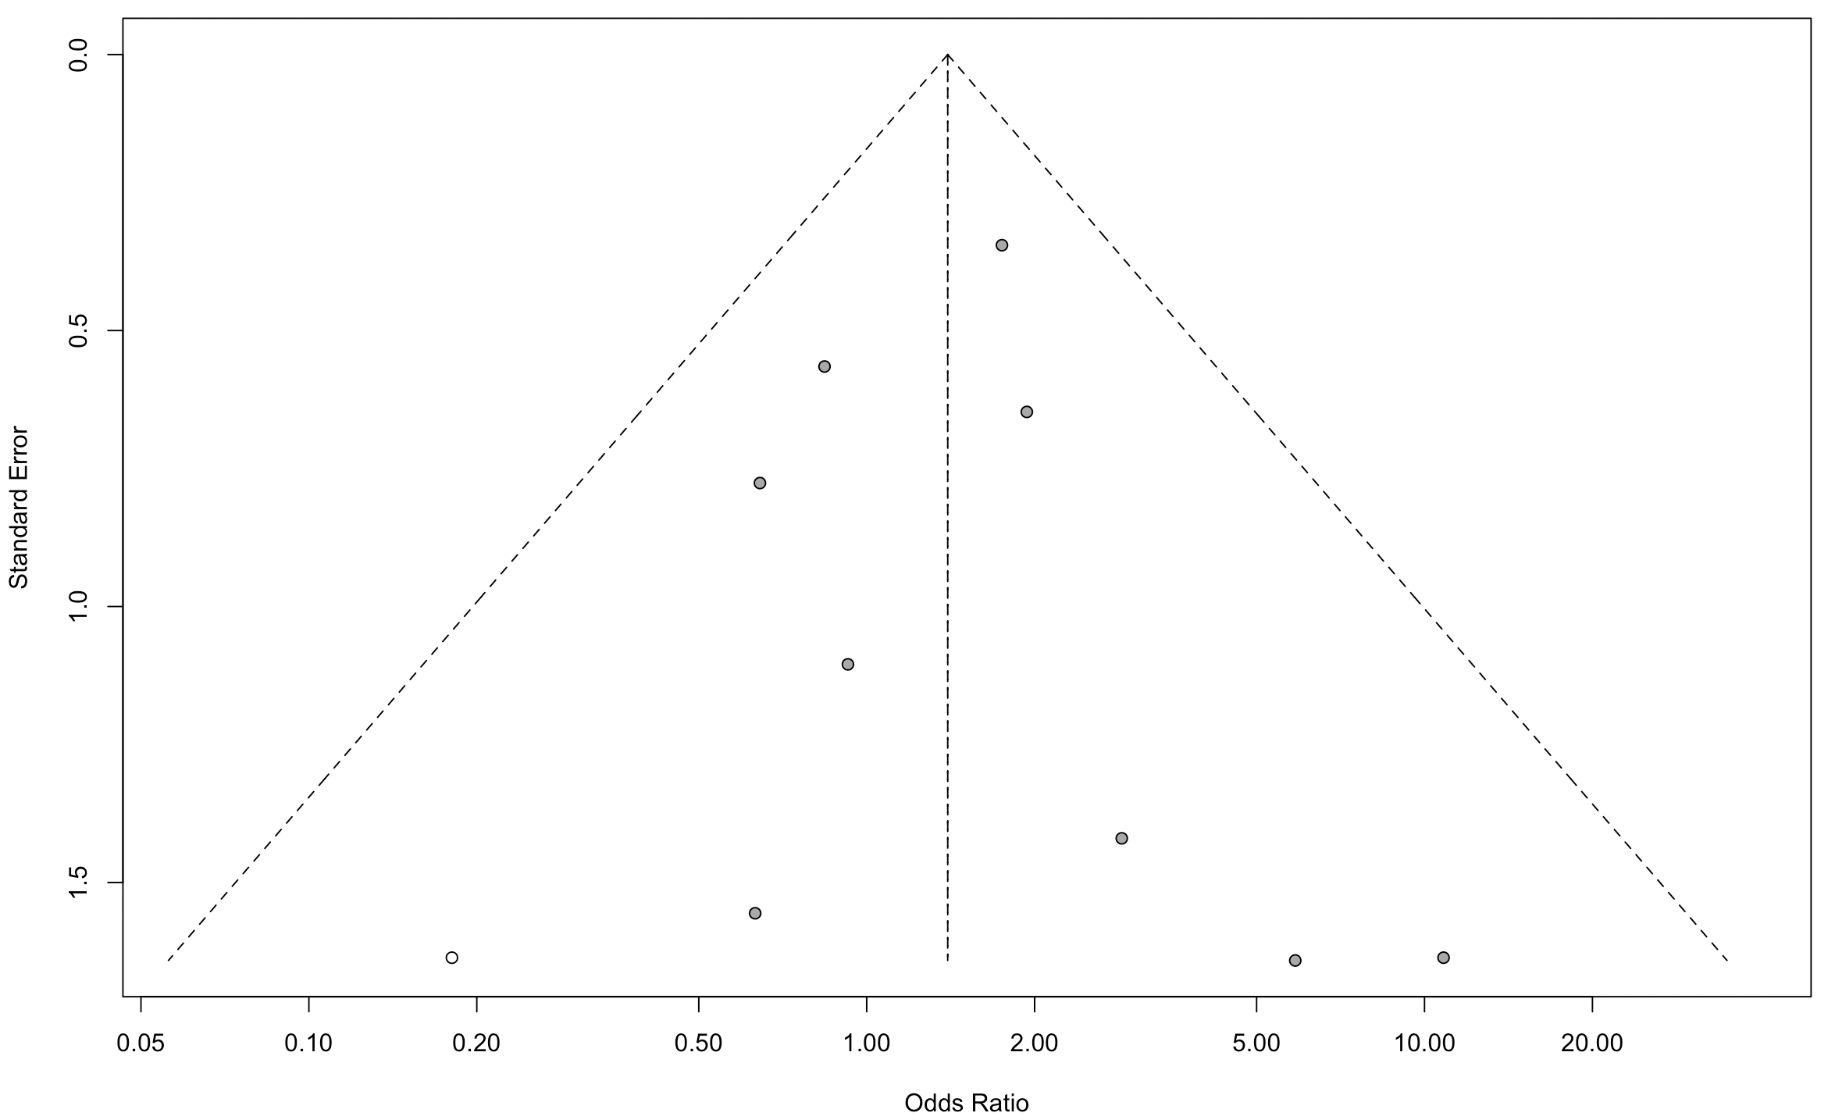、
Figure S14. Sensitivity analysis for renal failure.
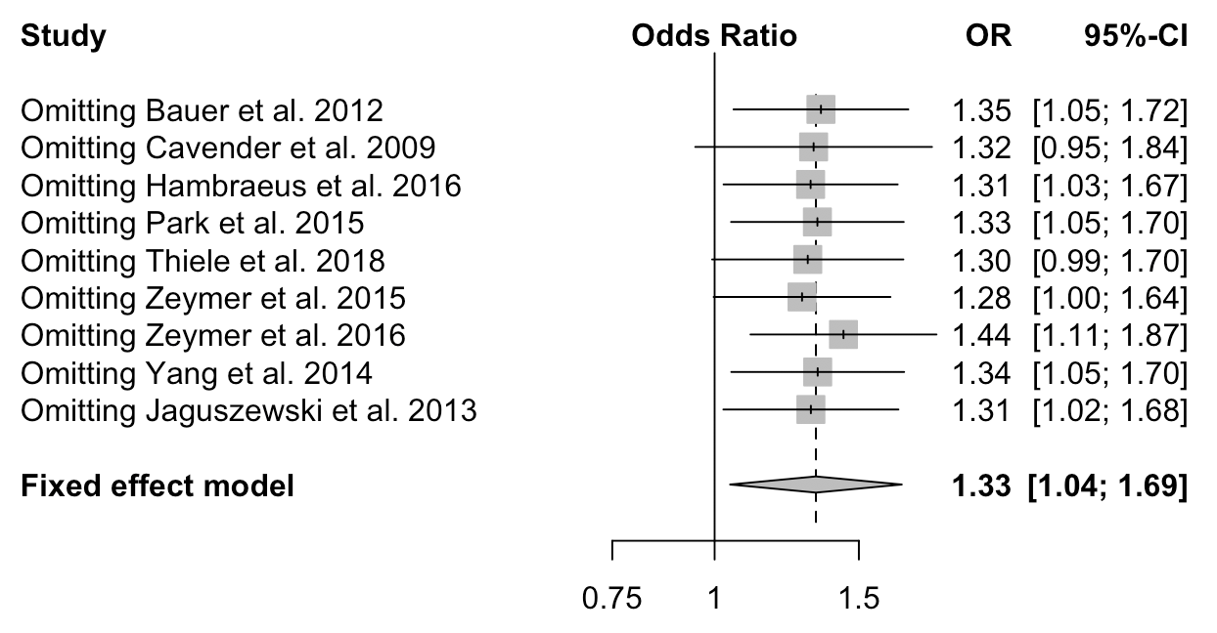

Figure S15. Sensitivity analysis for bleeding.
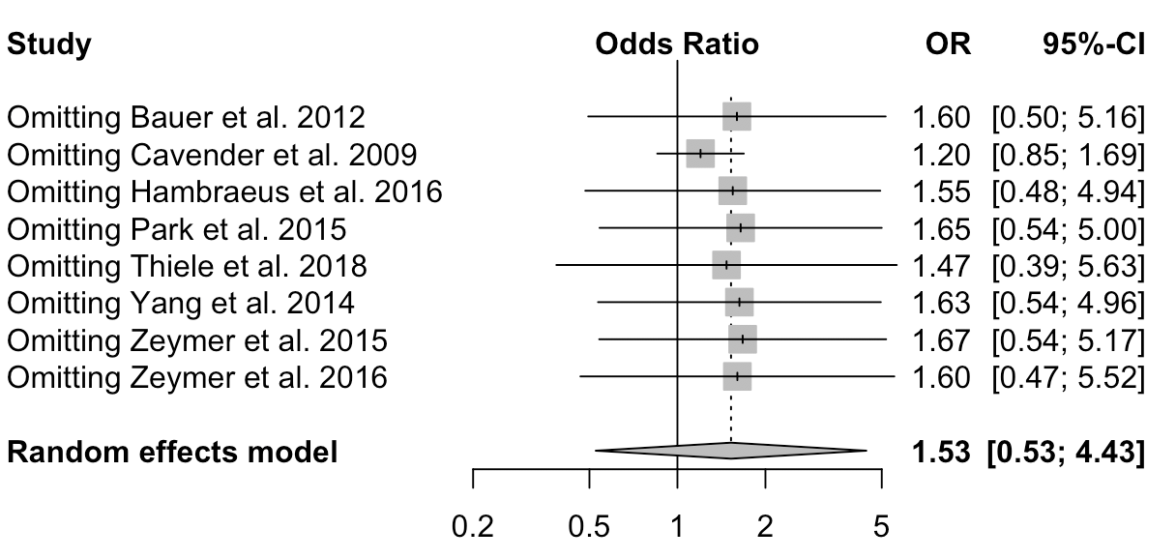

Figure S16. Sensitivity analysis for stroke.


