Supplementary Material

Supplementary Text
Search strategies of the associations between plaza dancing and psychological well-being and ill-being.
1) English:
(square danc*[Title/Abstract] OR square fitness danc*[Title/Abstract] ) AND (mental health[Title/Abstract] OR mental hygiene[Title/Abstract] OR self concept[Title/Abstract] OR self-perception[Title/Abstract] OR self-esteem[Title/Abstract] OR self efficacy[Title/Abstract] OR body image*[Title/Abstract] OR body representation*[Title/Abstract] OR body schema[Title/Abstract] OR happiness[Title/Abstract] OR affect[Title/Abstract] OR optimism[Title/Abstract] OR anxiety[Title/Abstract] OR depression[Title/Abstract] OR pessimism[Title/Abstract] OR positive affect*[Title/Abstract] OR negative affect*[Title/Abstract] OR mood*[Title/Abstract] OR hypervigilance[Title/Abstract] OR nervousness[Title/Abstract] OR depressive symptom*[Title/Abstract] OR emotional depression*[Title/Abstract] OR psychological stress*[Title/Abstract] OR life stress* [Title/Abstract]
2) Chinese:
( 广场舞) AND (心理健康[Title/Abstract] OR心理卫生[Title/Abstract] OR 自我认知[Title/Abstract] OR身体形象 [Title/Abstract] OR幸福 [Title/Abstract] OR乐观 [Title/Abstract] OR 悲观[Title/Abstract] OR抑郁[Title/Abstract] OR焦虑 [Title/Abstract] OR积极影响 [Title/Abstract] OR消极影响[Title/Abstract] OR情绪 [Title/Abstract] OR紧张[Title/Abstract] OR压抑 [Title/Abstract] OR生活压力 [Title/Abstract] OR心理压力 [Title/Abstract]

Supplementary Figures and Tables

Supplementary Figures
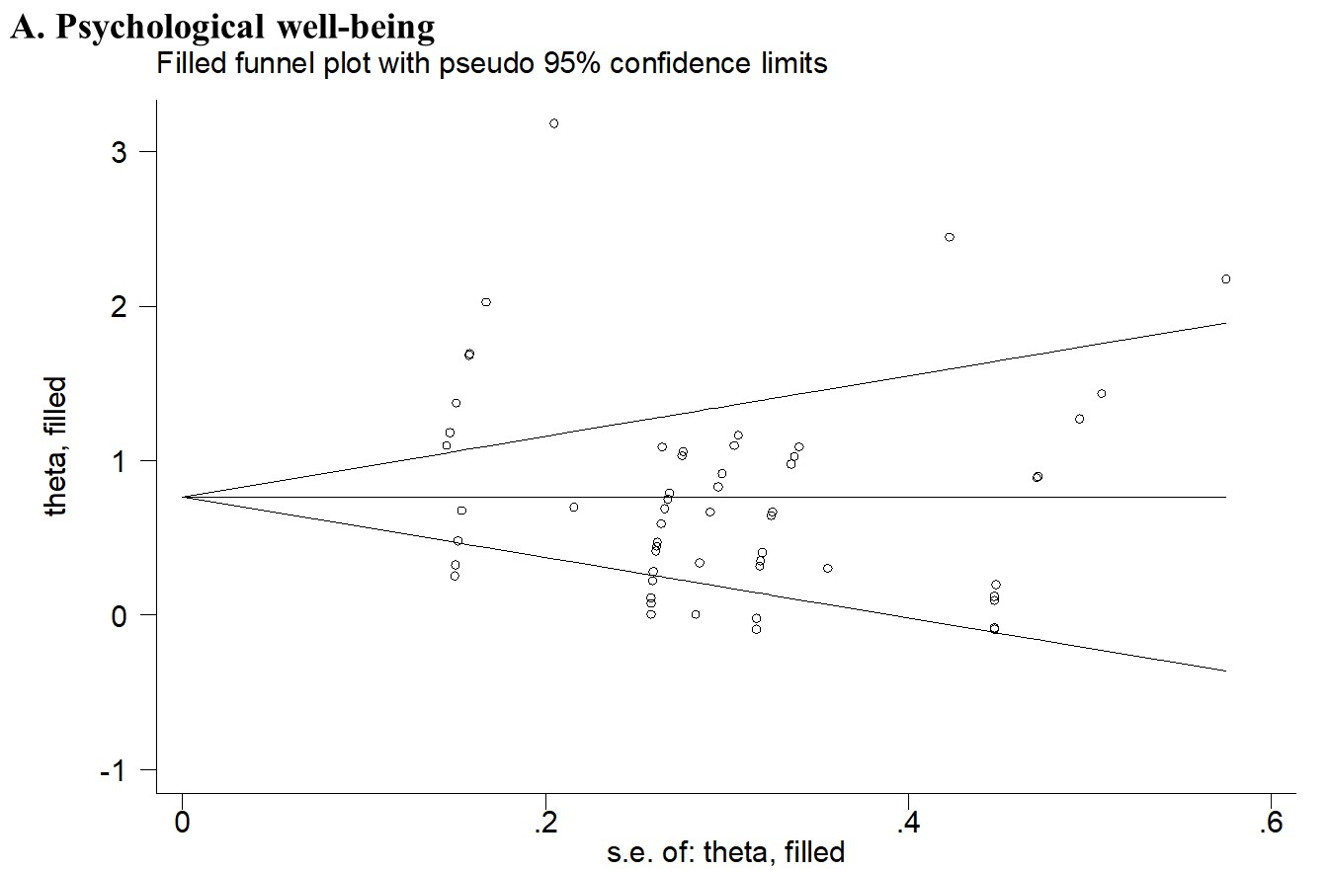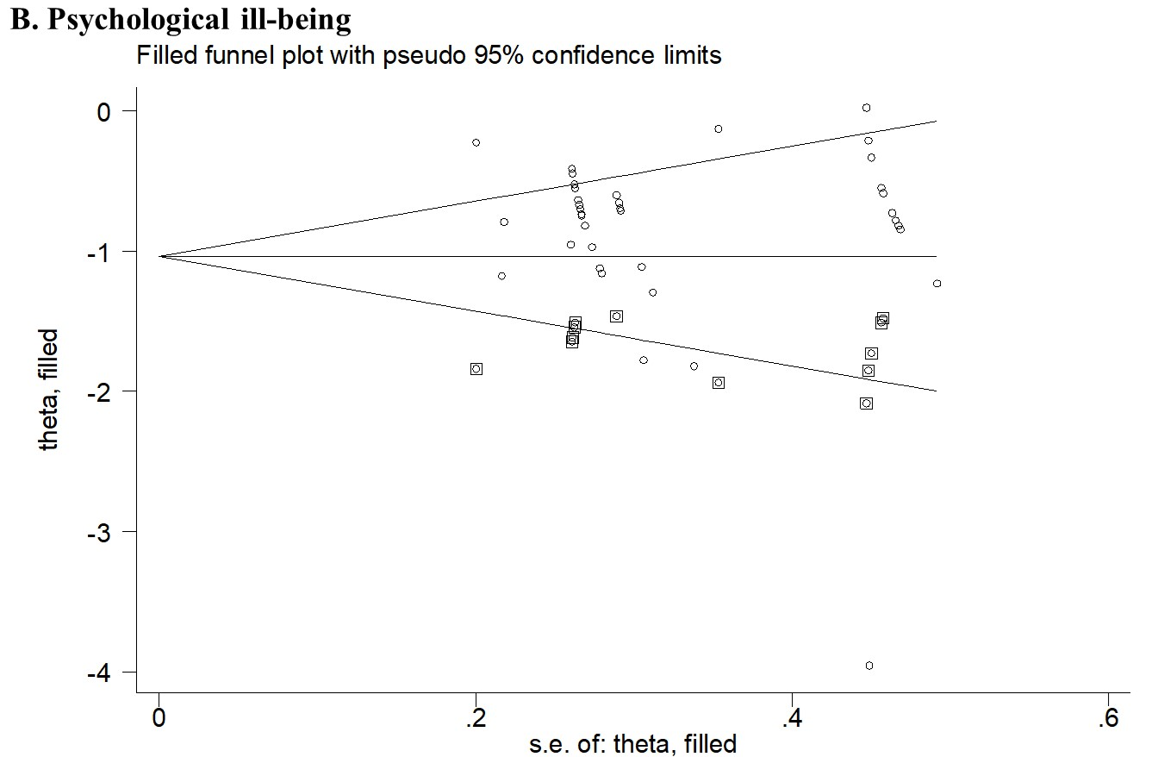
Supplementary Figure 1. Funnel plot for publication bias. Seven studies reported the results of psychological well-being, three studies reported the results of psychological ill-being, and seven studies reported the results of both psychological well-being and ill-being. Results from fourteen studies (reported 56 analyses, including for different related outcomes) in psychological well-being, and ten studies (reported 39 analyses, including for different related outcomes) in psychological ill-being were included, respectively. We used the trim method to make the funnel plot.

Supplementary Tables
Supplementary Table 1. Study quality assessment for the included studies
Study ID/ NIH Criteria | 1 | 2 | 3 | 4 | 5 | 6 | 7 | 8 | 9 | 10 | 11 | 12 | 13 | 14 | 15 | 16 | 17 | 18 | 19 | 20 | 21 | 22 | 23 | 24 | 25
1 | Y | N | N | N | N | N | Y | N | Y | Y | N | Y | Y | N | N | Y | N | N | N | Y | Y | Y | Y | Y | N
2 | Y | N | N | N | N | N | Y | N | Y | Y | N | Y | Y | N | N | Y | N | N | N | Y | Y | Y | Y | Y | N
3 | NR | N | N | N | N | N | Y | N | NR | Y | N | NR | NR | N | N | NR | N | N | N | NR | NR | NR | NR | NR | N
4 | NR | N | N | N | N | N | N | N | NR | N | N | NR | NR | N | N | NR | N | N | N | NR | NR | NR | NR | NR | N
5 | NR | N | N | N | N | N | Y | N | NR | NR | N | NR | NR | N | N | NR | N | N | N | NR | NR | NR | NR | NR | N
6 | Y | Y | Y | Y | Y | Y | Y | Y | Y | Y | Y | Y | Y | Y | Y | Y | Y | Y | Y | NR | Y | Y | NR | Y | Y
7 | Y | Y | Y | Y | Y | Y | Y | Y | Y | Y | Y | Y | Y | Y | Y | Y | Y | Y | Y | Y | Y | Y | Y | Y | Y
8 | Y | Y | Y | Y | Y | Y | Y | Y | Y | Y | Y | Y | Y | Y | Y | Y | Y | Y | Y | Y | Y | Y | Y | Y | Y
9 | Y | NR | NR | NR | NR | Y | Y | NR | NR | NR | NR | Y | NR | NR | NR | NR | Y | NR | NR | Y | Y | Y | NR | Y | Y
10 | Y | Y | Y | Y | Y | Y | Y | Y | Y | Y | Y | Y | Y | Y | Y | Y | Y | Y | Y | Y | Y | Y | Y | Y | Y
11 | Y | Y | Y | Y | Y | Y | Y | Y | Y | Y | Y | Y | Y | Y | Y | Y | Y | Y | Y | Y | Y | Y | Y | Y | Y
12 | N | N | N | N | N | Y | N | N | N | N | N | N | N | N | N | Y | N | N | N | Y | Y | Y | N | N | Y
13 | Y | Y | Y | Y | Y | Y | Y | Y | Y | Y | Y | Y | Y | Y | Y | Y | Y | Y | Y | Y | Y | Y | Y | Y | Y
14 | N | Y | Y | Y | Y | Y | Y | Y | Y | Y | Y | Y | Y | Y | Y | Y | Y | Y | Y | N | Y | Y | Y | Y | Y
Total score | 9 | 7 | 7 | 7 | 7 | 9 | 12 | 7 | 9 | 10 | 7 | 10 | 9 | 7 | 7 | 10 | 8 | 7 | 7 | 9 | 11 | 11 | 8 | 10 | 9
Mean score | 8.56
Abbreviations: NR, Not Report; Y, Yes; N, No. This study quality assessment tool was adopted from the National Institutes of Health’s Quality Assessment Tool for Controlled Intervention Studies. For each criterion, a score of one was assigned if “Y” was the response, whereas a score of zero was assigned otherwise (i.e., an answer of “no”, “not applicable”, “not reported”, or “cannot determine”). A study-specific global score, ranging from zero to 14, was calculated by summing up scores across all 14 criteria.

Supplementary Table 2. Sensitivity analysis on the associations between plaza dancing and psychological well-being and ill-being
Study omitted | Instruments | Outcome | Effect Size (95% CI) | I² (%) | χ² | P value
A. Psychological well-being
Yongsheng Wang (2021) | LSIA | Life satisfaction | 0.77 (0.58, 0.95) | 87.1 | 419.00 | <0.001
Yi Yu (2021) | GWB | Energy | 0.77 (0.58, 0.95) | 87.1 | 419.15 | <0.001
Yi Yu (2021) | GWB | Life satisfaction | 0.74 (0.55, 0.92) | 86.7 | 405.58 | <0.001
Yi Yu (2021) | GWB | Happiness | 0.77 (0.58, 0.96) | 87.0 | 416.61 | <0.001
Yi Yu (2021) | GWB | Positive affect | 0.76 (0.57, 0.95) | 87.1 | 419.41 | <0.001
Yi Yu (2021) | GWB | Relaxation | 0.78 (0.59, 0.96) | 86.9 | 411.64 | <0.001
Jun Zeng (2020) | POMS | Energy | 0.77 (0.58, 0.96) | 87.1 | 418.53 | <0.001
Jun Zeng (2020) | POMS | Self-esteem | 0.78 (0.59, 0.96) | 86.8 | 408.20 | <0.001
Meize Sun (2019) | GWB | Energy | 0.76 (0.57, 0.95) | 87.1 | 417.01 | <0.001
Meize Sun (2019) | GWB | Life satisfaction | 0.76 (0.56, 0.95) | 87.0 | 414.83 | <0.001
Meize Sun (2019) | GWB | Happiness | 0.75 (0.56, 0.94) | 86.8 | 408.02 | <0.001
Meize Sun (2019) | GWB | Positive affect | 0.74 (0.56, 0.93) | 86.2 | 391.24 | <0.001
Meize Sun (2019) | GWB | Relaxation | 0.74 (0.56, 0.92) | 85.4 | 369.72 | <0.001
Meize Sun (2019) | GWB | General well-being | 0.72 (0.56, 0.88) | 81.3 | 288.41 | <0.001
Meize Sun (2019) | PSPP | Self-image | 0.74 (0.56, 0.93) | 86.2 | 391.92 | <0.001
Shou Wang (2019) | SF-36 | Quality of life | 0.76 (0.57, 0.95) | 87.1 | 418.94 | <0.001
Xiaolin Wu (2019) | GWB | Energy | 0.76 (0.57, 0.95) | 87.1 | 419.62 | <0.001
Xiaolin Wu (2019) | GWB | Life satisfaction | 0.76 (0.57, 0.95) | 87.1 | 419.05 | <0.001
Xiaolin Wu (2019) | GWB | Happiness | 0.76 (0.57, 0.95) | 87.1 | 419.61 | <0.001
Xiaolin Wu (2019) | GWB | Positive affect | 0.78 (0.59, 0.96) | 86.8 | 410.13 | <0.001
Xiaolin Wu (2019) | GWB | Relaxation | 0.77 (0.58, 0.96) | 87.0 | 416.15 | <0.001
Qingfang Guo (2017) | SES | Self-esteem | 0.77 (0.58, 0.96) | 87.1 | 417.06 | <0.001
Shiqi Li (2017) | PSPP | Self-image | 0.76 (0.58, 0.95) | 87.1 | 419.45 | <0.001
Shiqi Li (2017) | GWB | Energy | 0.78 (0.59, 0.96) | 86.9 | 410.92 | <0.001
Shiqi Li (2017) | GWB | Life satisfaction | 0.76 (0.57, 0.95) | 87.1 | 419.15 | <0.001
Shiqi Li (2017) | GWB | Happiness | 0.77 (0.59, 0.96) | 86.9 | 413.32 | <0.001
Shiqi Li (2017) | GWB | Positive affect | 0.77 (0.58, 0.96) | 87.0 | 416.98 | <0.001
Shiqi Li (2017) | GWB | Relaxation | 0.76 (0.57, 0.95) | 87.1 | 419.29 | <0.001
Ying Pang (2017) | PSPP | Self-image | 0.76 (0.57, 0.95) | 87.1 | 419.21 | <0.001
Ying Pang (2017) | GWB | Life satisfaction | 0.76 (0.57, 0.95) | 87.1 | 419.52 | <0.001
Ying Pang (2017) | GWB | Energy | 0.77 (0.58, 0.96) | 87.1 | 417.50 | <0.001
Ying Pang (2017) | GWB | Happiness | 0.77 (0.58, 0.96) | 87.1 | 417.01 | <0.001
Ying Pang (2017) | GWB | Positive affect | 0.78 (0.59, 0.97) | 86.8 | 410.37 | <0.001
Ying Pang (2017) | GWB | Relaxation | 0.77 (0.58, 0.95) | 87.1 | 419.25 | <0.001
Wei Wang (2017) | GWB | Energy | 0.78 (0.59, 0.96) | 86.8 | 410.06 | <0.001
Wei Wang (2017) | GWB | Life satisfaction | 0.77 (0.58, 0.96) | 87.1 | 417.34 | <0.001
Wei Wang (2017) | GWB | Happiness | 0.77 (0.58, 0.95) | 87.1 | 419.18 | <0.001
Wei Wang (2017) | GWB | Positive affect | 0.77 (0.58, 0.96) | 87.0 | 416.55 | <0.001
Wei Wang (2017) | GWB | Relaxation | 0.77 (0.59, 0.96) | 87.0 | 414.47 | <0.001
Wei Wang (2017) | GWB | General well-being | 0.76 (0.58, 0.95) | 87.1 | 419.54 | <0.001
Lili Han (2016) | POMS | Energy | 0.76 (0.57, 0.94) | 87.1 | 418.69 | <0.001
Lili Han (2016) | POMS | Self-esteem | 0.77 (0.58, 0.95) | 87.1 | 419.15 | <0.001
Jiayan Li (2016) | EIEQ | Energetic stimulation | 0.78 (0.59, 0.96) | 87.0 | 415.11 | <0.001
Jiayan Li (2016) | EIEQ | Calm mind and body | 0.78 (0.59, 0.96) | 87.0 | 415.00 | <0.001
Jiayan Li (2016) | EIEQ | Active involvement | 0.77 (0.59, 0.96) | 87.0 | 416.61 | <0.001
Jiayan Li (2016) | CSS | Self-concept | 0.77 (0.59, 0.96) | 87.1 | 417.38 | <0.001
Lin Shen (2016) | GWB | Life satisfaction | 0.76 (0.57, 0.94) | 87.1 | 418.39 | <0.001
Lin Shen (2016) | GWB | Energy | 0.76 (0.58, 0.95) | 87.1 | 419.63 | <0.001
Lin Shen (2016) | GWB | Happiness | 0.76 (0.57, 0.94) | 87.1 | 418.96 | <0.001
Lin Shen (2016) | GWB | Positive affect | 0.76 (0.58, 0.95) | 87.1 | 419.63 | <0.001
Lin Shen (2016) | GWB | Relaxation | 0.77 (0.59, 0.96) | 87.0 | 416.83 | <0.001
Lin Shen (2016) | GWB | General well-being | 0.75 (0.56, 0.93) | 87.0 | 414.44 | <0.001
Hongyu Wang (2016) | SF-36 | Vitality | 0.78 (0.59, 0.96) | 86.6 | 401.97 | <0.001
Hongyu Wang (2016) | SF-36 | Social functioning | 0.77 (0.58, 0.96) | 86.9 | 412.87 | <0.001
Hongyu Wang (2016) | SF-36 | Role-emotional | 0.77 (0.58, 0.96) | 87.1 | 418.03 | <0.001
Hongyu Wang (2016) | SF-36 | Mental health | 0.77 (0.59, 0.96) | 86.7 | 406.10 | <0.001
B. Psychological ill-being
Yongsheng Wang (2021) | PEES | Negative affect | -0.84 (-1.01, -0.68) | 65.7 | 107.96 | <0.001
Jun Zeng (2020) | SCL-90 | Somatization | -0.84 (-1.01, -0.68) | 65.7 | 107.90 | <0.001
Jun Zeng (2020) | SCL-90 | Compulsive symptoms | -0.85 (-1.02, -0.69) | 65.1 | 105.90 | <0.001
Jun Zeng (2020) | SCL-90 | Interpersonal sensitivity | -0.84 (-1.01, -0.67) | 65.6 | 107.63 | <0.001
Jun Zeng (2020) | SCL-90 | Depression | -0.85 (-1.01, -0.68) | 65.6 | 107.65 | <0.001
Jun Zeng (2020) | SCL-90 | Anxiety | -0.85 (-1.01, -0.68) | 65.7 | 107.77 | <0.001
Jun Zeng (2020) | SCL-90 | Hostility | -0.83 (-1.00, -0.67) | 65.3 | 106.73 | <0.001
Jun Zeng (2020) | SCL-90 | Terror | -0.83 (-1.00, -0.67) | 65.2 | 106.41 | <0.001
Jun Zeng (2020) | SCL-90 | Paranoid | -0.83 (-1.00, -0.67) | 65.2 | 106.40 | <0.001
Jun Zeng (2020) | SCL-90 | Psychosis | -0.85 (-1.02, -0.68) | 65.6 | 107.50 | <0.001
Jun Zeng (2020) | POMS | Nervousness | -0.85 (-1.01, -0.68) | 65.7 | 107.88 | <0.001
Jun Zeng (2020) | POMS | Anger | -0.85 (-1.02, -0.69) | 65.3 | 106.67 | <0.001
Jun Zeng (2020) | POMS | Fatigue | -0.85 (-1.01, -0.68) | 65.7 | 107.88 | <0.001
Jun Zeng (2020) | POMS | Panic | -0.85 (-1.02, -0.68) | 65.4 | 106.95 | <0.001
Jun Zeng (2020) | POMS | Depression | -0.85 (-1.02, -0.69) | 64.9 | 105.50 | <0.001
Jun Zeng (2020) | POMS | TMD | -0.84 (-1.01, -0.68) | 65.7 | 107.97 | <0.001
Shou Wang (2019) | GDS-15 | Depression | -0.84 (-1.01, -0.67) | 65.6 | 107.68 | <0.001
Qingfang Guo (2017) | BDI | Depression | -0.86 (-1.02, -0.70) | 64.5 | 104.09 | <0.001
Ziyao Guan (2017) | SAS | Anxiety | -0.83 (-1.00, -0.66) | 64.8 | 105.01 | <0.001
Ziyao Guan (2017) | SDS | Depression | -0.86 (-1.02, -0.70) | 62.5 | 98.77 | <0.001
Lei Gao (2016) | SDS | Depression | -0.83 (-0.99, -0.66) | 64.9 | 105.55 | <0.001
Lili Han (2016) | POMS | Nervousness | -0.85 (-1.01, -0.68) | 65.7 | 107.80 | <0.001
Lili Han (2016) | POMS | Anger | -0.82 (-0.98, -0.66) | 62.6 | 98.99 | <0.001
Lili Han (2016) | POMS | Fatigue | -0.85 (-1.01, -0.68) | 65.6 | 107.65 | <0.001
Lili Han (2016) | POMS | Depression | -0.85 (-1.02, -0.68) | 65.5 | 107.39 | <0.001
Lili Han (2016) | POMS | Panic | -0.85 (-1.01, -0.68) | 65.7 | 107.85 | <0.001
Lili Han (2016) | POMS | TMD | -0.83 (-1.00, -0.67) | 65.4 | 106.98 | <0.001
Jiayan Li (2016) | EIEQ | Physical exhaustion | -0.85 (-1.02, -0.69) | 65.1 | 106.13 | <0.001
Lin Shen (2016) | SCL-90 | Somatization | -0.84 (-1.01, -0.68) | 65.7 | 107.93 | <0.001
Lin Shen (2016) | SCL-90 | Compulsive symptoms | -0.85 (-1.02, -0.69) | 65.4 | 106.81 | <0.001
Lin Shen (2016) | SCL-90 | Interpersonal sensitivity | -0.86 (-1.02, -0.70) | 64.6 | 104.40 | <0.001
Lin Shen (2016) | SCL-90 | Depression | -0.85 (-1.01, -0.68) | 65.6 | 107.63 | <0.001
Lin Shen (2016) | SCL-90 | Anxiety | -0.84 (-1.01, -0.68) | 65.7 | 107.97 | <0.001
Lin Shen (2016) | SCL-90 | Hostility | -0.84 (-1.01, -0.68) | 65.7 | 107.97 | <0.001
Lin Shen (2016) | SCL-90 | Terror | -0.84 (-1.01, -0.68) | 65.7 | 107.97 | <0.001
Lin Shen (2016) | SCL-90 | Paranoid | -0.85 (-1.01, -0.68) | 65.7 | 107.72 | <0.001
Lin Shen (2016) | SCL-90 | Psychosis | -0.84 (-1.00, -0.67) | 65.5 | 107.25 | <0.001
Xinan Zhang (2014) | HAMA | Anxiety | -0.78 (-0.91, -0.66) | 36.7 | 58.48 | 0.014
Xinan Zhang (2014) | HAMD | Depression | -0.82 (-0.97, -0.66) | 62.2 | 97.88 | <0.001
Note: Seven studies reported the results of psychological well-being, three studies reported the results of psychological ill-being, and seven studies reported the results of both psychological well-being and ill-being. Results from fourteen studies (reported 56 analyses, including for different related outcomes) in psychological well-being, and ten studies (reported 39 analyses, including for different related outcomes) in psychological ill-being were included, respectively.
Abbreviation: BDI, Beck depression rating scale; CSS, Core Self-evaluation Scale; EIEQ, Exercise Induced Emotion Questionnaire; GDS-15, 15-item Geriatric Depression Scale; GWB, General Well-Being Schedule; HAMA, Hamilton Anxiety Scale; HAMD, Hamilton Depression Scale; LSIA, Life Satisfaction Index A; PEES, Post-exercise Emotional Experience Scale; POMS, Profile of Mood States; PSPP, Platform Sizing and Performance Program; SAS, Self-Rating Anxiety Scale; SCL-90, Symptom Check List 90; SDS, Self-Rating Depression Scale; SES, Self-esteem scale; SF-36, the MOS item short from health survey; TMD, Total of motional disturb.

Supplementary Table 3. The Egger’s and Begg’s test for publication bias of the included studies
 | Psychological well-being | Psychological ill-being
P (Egger’s test) | 0.075 | 0.304
P (Begg’s test) | 0.227 | 0.056
Note: Seven studies reported the results of psychological well-being, three studies reported the results of psychological ill-being, and seven studies reported the results of both psychological well-being and ill-being. Results from fourteen studies (reported 56 analyses, including for different related outcomes) in psychological well-being, and ten studies (reported 39 analyses, including for different related outcomes) in psychological ill-being were included, respectively.

