Supplementary materials
Supplementary table 1: Step-wise approach to developing a full, objective search strategy

Ovid Medline (1946 to September 14, 2020)
1 | exp Coronavirus/
2 | exp Coronavirus Infections/
3 | coronavirus$.tw.
4 | ('2019 nCoV$' or 2019-nCoV$ or 2019nCoV$ or 'n CoV$' or n-CoV$ or nCoV$ or '2019 novel' or 2019-novel or 2019novel or CoV).tw.
5 | ('covid 19' or covid-19 or covid19).tw.
6 | (severe adj1 acute adj1 respiratory adj1 syndrome adj1 'coronavirus 2').tw.
7 | ('SARS CoV 2' or 'SARS CoV2' or SARSCoV 2' or SARSCoV2 or SARS-CoV-2 or SARS-CoV2 or SARSCoV-2).tw.
8 | 1 or 2 or 3 or 4 or 5 or 6 or 7
9 | exp Nursing Homes/
10 | exp Homes for the Aged/
11 | (nursing adj2 (home$ or facilit$)).tw.
12 | (care adj2 home$).tw.
13 | (rest adj2 home$).tw.
14 | (((long adj1 term) or long-term or longterm) adj2 care).tw.
15 | (resident$ adj2 care).tw.
16 | (assist$ adj2 living).tw.
17 | 9 or 10 or 11 or 12 or 13 or 14 or 15 or 16
18 | 8 and 17
19 | limit 18 to yr="2019 - 2020"

Supplementary figure 1. Forest plot of COVID-19 symptoms among aged care residents

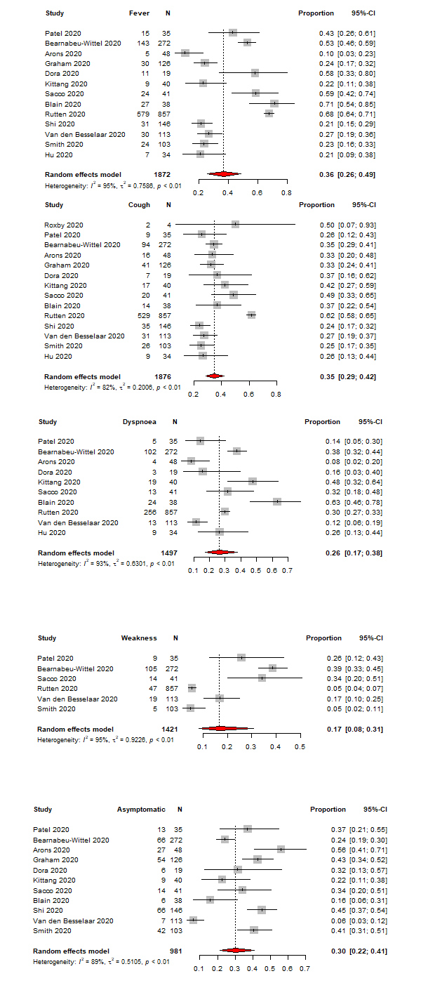
Horizontal lines represent the 95% CIs around the point estimates for each study, and the grey shaded areas are proportional to the weight given to each study.

Supplementary figure 2. Forest plot of the attack rate of residents in aged care homes based on regional distribution
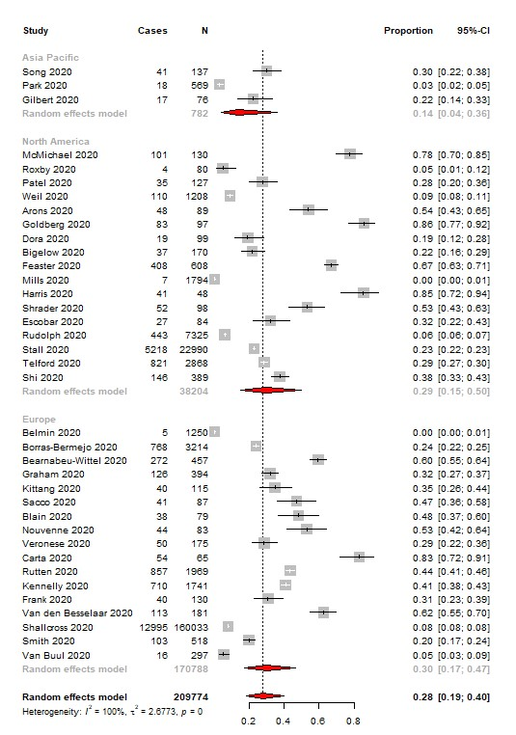

Horizontal lines represent the 95% CIs around the point estimates for each study, and the grey shaded areas are proportional to the weight given to each study.

Supplementary figure 3a. Forest plot of the attack rate of residents in aged care homes based on countries
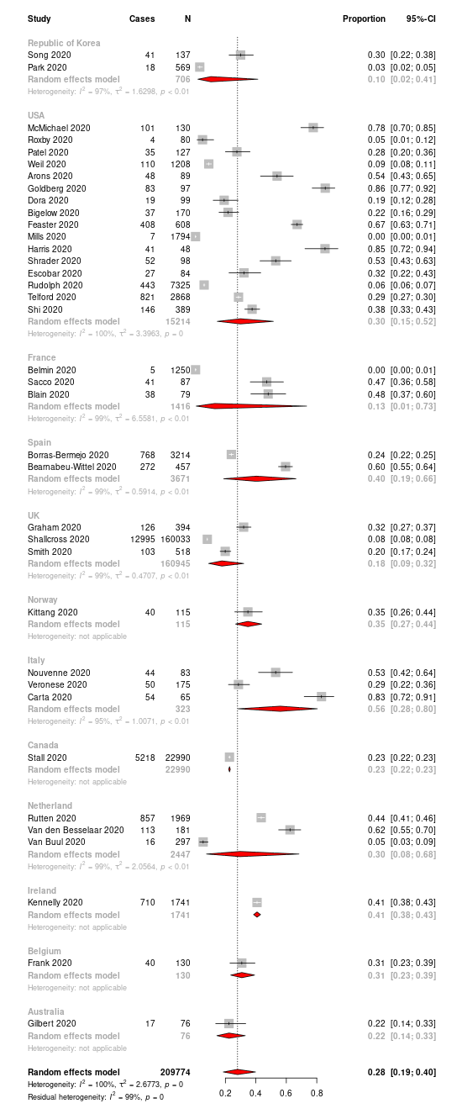
Horizontal lines represent the 95% CIs around the point estimates for each study, and the grey shaded areas are proportional to the weight given to each study.

Supplementary figure 3b. Forest plot of the attack rate of residents in aged care homes based on facility type
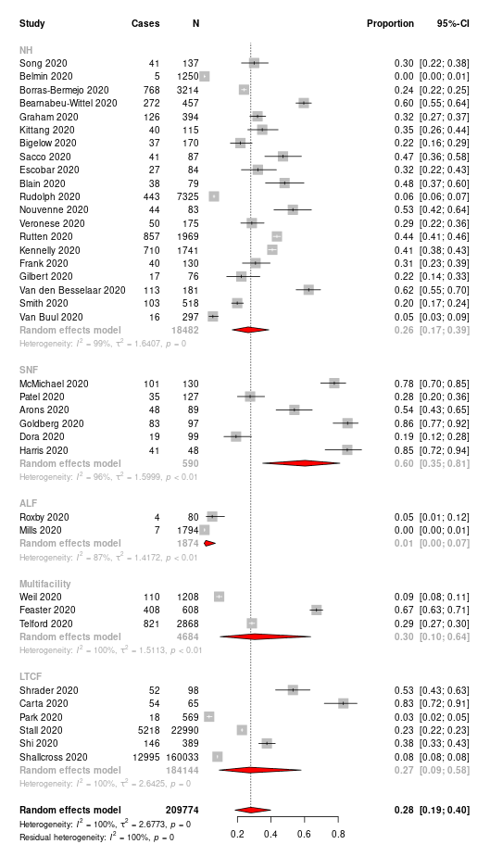
Horizontal lines represent the 95% CIs around the point estimates for each study, and the grey shaded areas are proportional to the weight given to each study. NH=Nursing home, SNF=Skilled nursing facility, ALF=Assisted living facility, LTCF=Long term care facility

Supplementary figure 4a. Forest plot of the case fatality rate of residents in aged care homes based on region
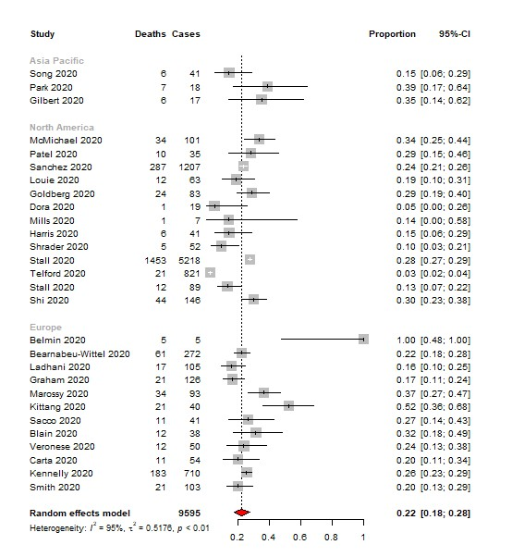
Horizontal lines represent the 95% CIs around the point estimates for each study, and the grey shaded areas are proportional to the weight given to each study.

Supplementary figure 4b. Forest plot of the case fatality rate of residents in aged care homes based facility type
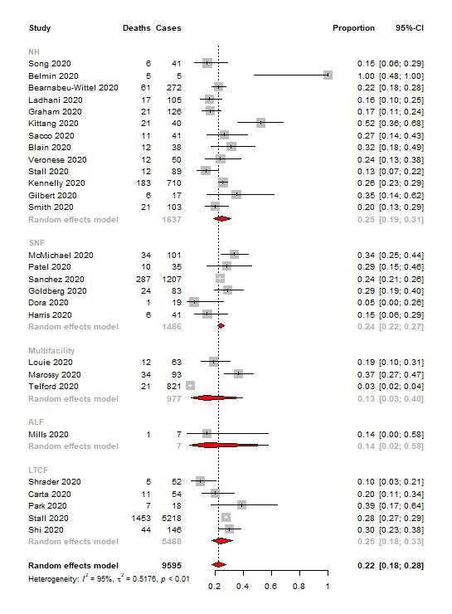
Horizontal lines represent the 95% CIs around the point estimates for each study, and the grey shaded areas are proportional to the weight given to each study. NH=Nursing home, SNF=Skilled nursing facility, ALF=Assisted living facility, LTCF=Long term care facility

Supplementary figure 5a. Forest plot of the mortality rate of residents in aged care homes (all studies)
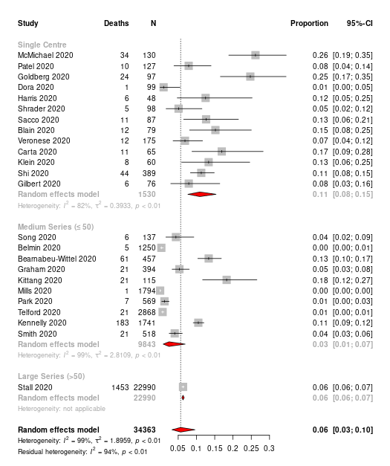
Horizontal lines represent the 95% CIs around the point estimates for each study, and the grey shaded areas are proportional to the weight given to each study.

Supplementary figure 5b. Forest plot of the mortality rate of residents in aged care homes based on region
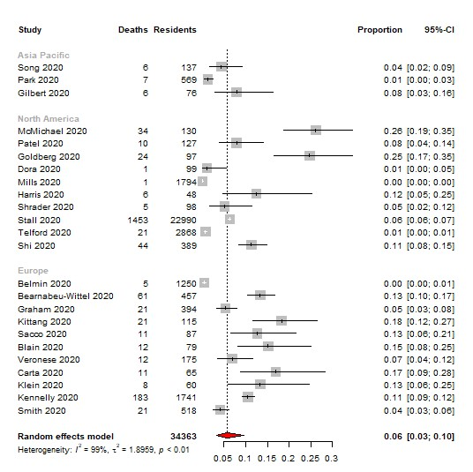
Horizontal lines represent the 95% CIs around the point estimates for each study, and the grey shaded areas are proportional to the weight given to each study.

Supplementary table 2. Quality assessment of the selected studies
Author, Country | Relevancy |  | Reliability |  |  | Validity |  |  |  |  |  | Applicability
Author, Country | Overall assessment | Quality score | Overall assessment | Quality score |  | Overall assessment | Quality score |  |  |  |  | Overall assessment | Quality score
Author, Country | Total score£ | 4  (A1–A4) |  | 7  (B1–B7) | 5  (C1–C5) |  | 2  (D1–D2) | 5  (E1–E5) | 5  (F1–F5) | 3  (G1–G3) | 2  (H1–H2) |  | 5  (I1–I5)
Gilbert, Australia | Yes | 3 | Unclear | 4 | 1 | Yes | 0 | 3 | 5 | 2 | 2 | Unclear | 2
Frank, Belgium | Yes | 4 | Yes | 7 | 5 | Yes | 0 | 5 | 5 | 3 | 2 | Yes | 5
Stall, Canada | Yes | 4 | Yes | 7 | 5 | Yes | 1 | 4 | 4 | 3 | 2 | Yes | 5
Stall, Canada | Yes | 4 | Yes | 7 | 4 | Yes | 0 | 5 | 5 | 3 | 2 | Yes | 5
Hu, China | Yes | 4 | Yes | 7 | 5 | Yes | 2 | 5 | 5 | 3 | 2 | Yes | 5
Blain, France | Yes | 4 | Yes | 7 | 5 | Yes | 0 | 5 | 5 | 3 | 2 | Yes | 5
Belmin, France | Yes | 4 | Yes | 7 | 4 | Yes | 1 | 5 | 5 | 3 | 2 | Unclear | 3
Sacco, France | Yes | 4 | Yes | 7 | 5 | Yes | 2 | 5 | 5 | 3 | 2 | Yes | 5
Guery, France | Unclear | 2 | Unclear | 4 | 1 | No | 0 | 0 | 1 | 0 | 0 | No | 1
Klein, Germany | Yes | 4 | Yes | 3 | 2 | Unclear | 0 | 1 | 1 | 2 | 1 | Unclear | 2
Kennelly, Ireland | Yes | 4 | Yes | 7 | 5 | Yes | 2 | 5 | 5 | 3 | 2 | Yes | 5
Nouvenne, Italy | Yes | 4 | Yes | 7 | 5 | Yes | 1 | 5 | 4 | 3 | 1 | Yes | 5
Veronese, Italy | Yes | 4 | Yes | 7 | 5 | Yes | 2 | 4 | 2 | 2 | 0 | Unclear | 3
Carta, Italy | Yes | 4 | Yes | 7 | 5 | Yes | 2 | 5 | 5 | 3 | 2 | Yes | 5
Rutten, Netherlands | Yes | 4 | Unclear | 4 | 1 | Unclear | 0 | 3 | 1 | 1 | 0 | Unclear | 1
Van Den Besselaar, Netherlands | Unclear | 2 | Unclear | 4 | 1 | No | 0 | 0 | 1 | 0 | 0 | Unclear | 1
Van Buul, Netherlands | No | 3 | Yes | 3 | 5 | Unclear | 2 | 2 | 3 | 2 | 0 | No | 0
Kittang, Norway | Yes | 4 | Yes | 7 | 5 | Yes | 2 | 5 | 5 | 3 | 2 | Yes | 5
Park, Republic of Korea | Yes | 4 | Yes | 7 | 5 | Yes | 0 | 5 | 5 | 3 | 2 | Yes | 5
Song, Republic of Korea | Yes | 4 | Yes | 7 | 4 | Unclear | 0 | 4 | 2 | 2 | 0 | Unclear | 1
Borras-Bermejo, Spain | Yes | 4 | Unclear | 2 | 2 | Unclear | 0 | 3 | 1 | 1 | 1 | No | 0
Bearnabeu-Wittel, Spain | Yes | 4 | Yes | 7 | 5 | Yes | 2 | 5 | 5 | 3 | 2 | Yes | 5
Ladhani, UK | Yes | 4 | Yes | 7 | 5 | Yes | 0 | 5 | 5 | 3 | 2 | Yes | 5
Graham, UK | Yes | 4 | Yes | 7 | 5 | Yes | 1 | 5 | 5 | 3 | 2 | Yes | 5
Shallcross, UK | Yes | 4 | Yes | 7 | 5 | Yes | 2 | 5 | 5 | 3 | 2 | Yes | 5
Smith, UK | Yes | 4 | Yes | 7 | 5 | Yes | 1 | 4 | 2 | 2 | 0 | Unclear | 2
McMichael, USA | Yes | 4 | Yes | 7 | 5 | Yes | 0 | 5 | 5 | 3 | 2 | Yes | 5
Roxby, USA | Yes | 4 | Yes | 7 | 5 | Yes | 0 | 5 | 5 | 3 | 2 | Yes | 5
Patel, USA | Yes | 4 | Yes | 7 | 5 | Yes |  | 5 | 5 | 3 | 2 | Yes | 5
Temkin-Greener, USA | Yes | 4 | Yes | 7 | 5 | Unclear | 0 | 4 | 1 | 2 | 1 | Unclear | 2
Weil, USA | Yes | 4 | Yes | 6 | 5 | Yes | 1 | 4 | 5 | 3 | 2 | Yes | 5
Sanchez, USA | Yes | 4 | Yes | 6 | 5 | Yes | 1 | 5 | 2 | 2 | 2 | Yes | 4
Louie, USA | Yes | 4 | Yes | 7 | 5 | Yes | 0 | 4 | 3 | 3 | 1 | Yes | 5
Arons, USA | Yes | 4 | Yes | 7 | 5 | Yes | 0 | 5 | 5 | 3 | 2 | Yes | 5
Goldberg, USA | Yes | 4 | Yes | 7 | 5 | Yes | 2 | 4 | 2 | 2 | 0 | Unclear | 3
Dora, USA | Yes | 4 | Yes | 7 | 5 | Yes | 0 | 4 | 1 | 3 | 1 | Unclear | 2
Bigelow, USA | Yes | 4 | Yes | 6 | 5 | Unclear | 0 | 4 | 2 | 2 | 1 | Unclear | 2
Feaster, USA | Yes | 4 | Yes | 6 | 5 | Yes | 0 | 5 | 5 | 3 | 2 | Yes | 5
Mills, USA | Yes | 4 | Yes | 7 | 4 | Yes | Unclear | 4 | 2 | 2 | 0 | Unclear | 2
Harris, USA | Yes | 4 | Yes | 5 | 5 | Yes | Unclear | 3 | 1 | 1 | 1 | Unclear | 2
Shrader, USA | Yes | 4 | Yes | 7 | 5 | Yes | 1 | 4 | 3 | 3 | 1 | Unclear | 2
Jatt, USA | Yes | 4 | Yes | 7 | 5 | Yes | 0 | 5 | 2 | 2 | 1 | Unclear | 2
Escobar, USA | Yes | 4 | Unclear | 4 | 1 | Unclear | 0 | 3 | 2 | 2 | 0 | Unclear | 2
Rudolph, USA | Yes | 4 | Yes | 7 | 5 | Unclear | 1 | 4 | 1 | 2 | 0 | Unclear | 3
Eckardt, USA | Yes | 4 | Yes | 5 | 4 | Unclear | 0 | 4 | 2 | 2 | 0 | Unclear | 2
Quicke, USA | Yes | 3 | Yes | 6 | 5 | Yes | 2 | 5 | 5 | 3 | 2 | Yes | 5
Telford, USA | Yes | 4 | Yes | 7 | 5 | Yes | 0 | 5 | 5 | 3 | 2 | Yes | 5
Shi, USA | Yes | 4 | Yes | 7 | 5 | Yes | 2 | 5 | 5 | 3 | 2 | Yes | 5

£= Quality assessment metric score description
Relevancy assessment: A1–A4; 1 score each.
A1. Was the justification for the study clearly stated? (For example, does it address a gap in the existing literature?) A2. Do the results of the study apply to the issue under consideration? A3. How similar or different is the study population or setting to yours? Is a difference likely to matter for the issue at hand? A4. Is the research design appropriate for the methodology you are considering? (For example, if you are considering a systematic review, you will be reviewing only certain types of publications.)
Reliability assessment: B1–B7; 1 score each; C1–C5; 1 score each.
B1. Is the rationale for study clearly stated, and does the study focus on a clearly defined issue? B2. Is the conduct of the study clearly described and easy to follow? B3. Can you identify the research design? B4. Are all relevant results included? B5. Are the findings presented and discussed within the appropriate context? B6. Is there a conflict of interest statement? B7. Can the study be reproduced with the information provided?
C1. Does the methodology describe the population studied, the intervention given, and the outcomes? C2. Are all sources of information clearly identified? C3. Are inclusion and exclusion criteria defined? C4. Are the statistical and/or analytical methods described? If applicable, are the results reported in data tables consistent with those described in the results section? C5. Could the methods be reproduced based on the information provided?
Validity assessment: D1–D2: 1 score each; E1–E5: 1 score each; F1–F5: 1 score each; G1–G3: 1 score each; H1–H2: 1 score each.
D1. Was appropriate informed consent obtained? D2. Was the study approved by an ethics review board?
E1. Is the research question congruent with the study design? E2. Does the methodology match the theory or the conceptual model? E3. Are appropriate controls considered if applicable? E4. Are the statistical/analytic methods appropriate for the design and/or the question? E5. Are important theoretical factors accounted for in the analysis?
F1. Were there major sources of bias with respect to: Study design? Study participant’s inclusion/exclusion? Measurement of exposure/outcome or important confounders/predictors? Data sources? Analysis? Selection of studies? F2. Are all comprehensive factors included in the research? I.e. were important factors not measured that are critical to interpretation? F3. Are the results consistent within the study? F4. Can chance findings be ruled out? F5. Were the analyses carried out appropriately?
G1. Are the results conclusive? G2. Are the authors’ conclusions clearly derived from the results (transparent)? G3. Are potential discrepancies discussed?
H1. Are there any major methodological flaws that limit the validity of the findings? (These may have been identified in a) or b).) H2. Are the study’s results similar to those of the existing body of literature? If not, are the reasons for the difference clearly explained?
Applicability assessment: I1–I5: 1 score each.
I1. Can the study results be interpreted and analysed within the context of public health? I2. Are there other important public health outcomes to be considered that were not included? I3. Can the results be applied to public health practice, based on the validity of the article and its relevance? I4. Are harms and benefits discussed? I5. Were the relevant stakeholders considered?

Supplementary table 3. Effect size of explanatory variables for the meta-regression of pooled attack rate and case fatality rate
Co-efficient | Pooled attack rate |  | Pooled case fatality rate
 | Effect size (95% CI) | p-value | Effect size (95% CI) | p-value
Medium size facilities (<=50) | 0·24 (-1·40–1·89) | 0.77 | -0·30 (-1·95–1·34) | 0·71
Single centre | 1·67 (0·07–3·28) | 0·04* | -0·26 (-1·89–1·36) | 0·75
Europe | 0·96 (-1·07–2·99) | 0·35 | 0·08 (-1·06–1·21) | 0·89
North America | 0·98 (-1·04–3·01) | 0·34 | -0·59 (-1·74–0·55) | 0·30
Low fidelity | -1·38 (-2·62– -0·15) | 0·02 | 0·56 (-0·47–1·58) | 0·28
Cross-sectional | 0·23 (-3·29–3·75) | 0·89 | -0·36 (-2·3–1·58) | 0·71
Prospective cohort | 0·32 (-3·09–3·72) | 0·85 | -1·07 (-2·83–0·68) | 0·23
Retrospective cohort | 0·34 (-3·08–3·76) | 0·84 | -0·29 (-2·03–1·45) | 0·74
p-value<0.05 = *statistically significant; 95% CI = 95% confidence interval.

