Appendix 1
Sensitivity analysis for the included papers
Among the included 49 articles, a total of 5 articles were from the pre-print databases. We contacted the corresponding authors of each of those pre-print publications to know the current stage of their manuscript. Based on e-mail responses from the corresponding authors, we have finally identified 3 articles (Smith_UK, Van den Besselaar_Netherland, Hu_China) that are still in the pre-print databases and the reported data has not been yet peer-reviewed. The other 2 articles (Shallcross_UK, Frank_Belgium) are already available online or in press following journal acceptance. After critically reviewing the peer-reviewed content of these 2 articles (Shallcross_UK, Frank_Belgium), we did not find any change in the reported data.
Therefore, to address this concern, a leave-one-out sensitivity analysis was performed to assess if any of the pre-print articles had an undue influence on the attack rate, case-fatality rate and mortality rate. We excluded Hu_China article since the initial version of our analysis as authors did not report the total number of residents (denominator) from the facilities to avoid overestimation of the key outcome metrics. For the single centre attack rate, the largest shift occurred after omitting Roxby 2020, with a 3% shift from 45% to 48%. For the overall case fatality rate, the largest shift occurred when omitting Telford 2020, shifting the case fatality rate from 22% to 24%. For the mortality rate, no shift was greater than one percentage point.
Secondly, a sensitivity analysis was performed by omitting two pre-print articles reporting the attack rate (Smith 2020, Van den Besselaar 2020). The changes in the single centre attack rate (with p-values from meta-regression) was -1 percentage points (p=0.648). A sensitivity analysis removing the sole preprint Smith 2020 found that the case fatality rate increases by one percentage point (p=0.843). A sensitivity analysis removing the sole preprint Smith 2020 found no change in the mortality rate (p=0.809)
Here are the explored sensitivity analysis figures as followed:

Appendix figure 1: Forest plot of the attack rate of residents in aged care homes based on countries
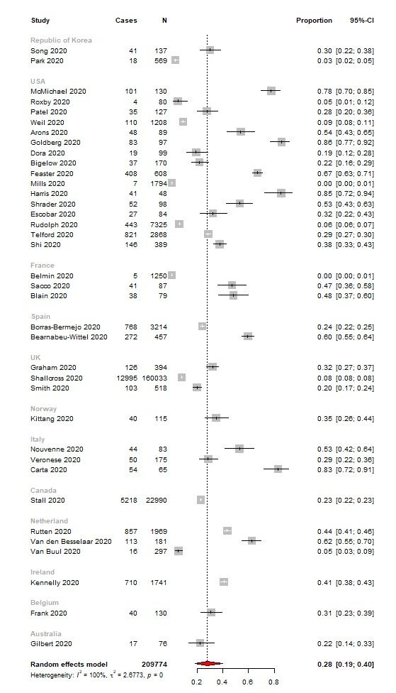
Horizontal lines represent the 95% CIs around the point estimates for each study, and the grey shaded areas are proportional to the weight given to each study.

Appendix figure 2: Leave-one-out sensitivity forest plot of the attack rate of residents in aged care homes based on countries
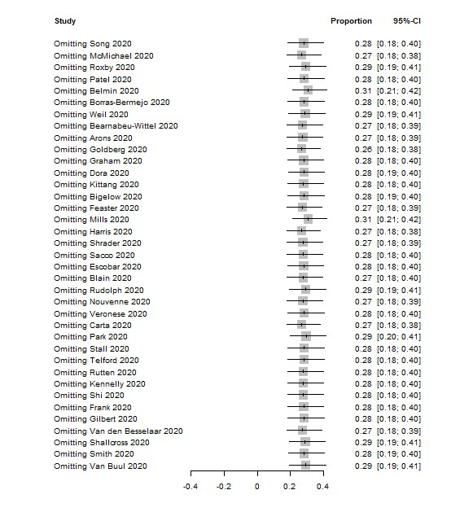
Horizontal lines represent the 95% CIs around the point estimates for each study, and the grey shaded areas are proportional to the weight given to each study.

Appendix figure 3: Forest plot of the attack rate of residents in aged care homes based on countries excluding pre-prints
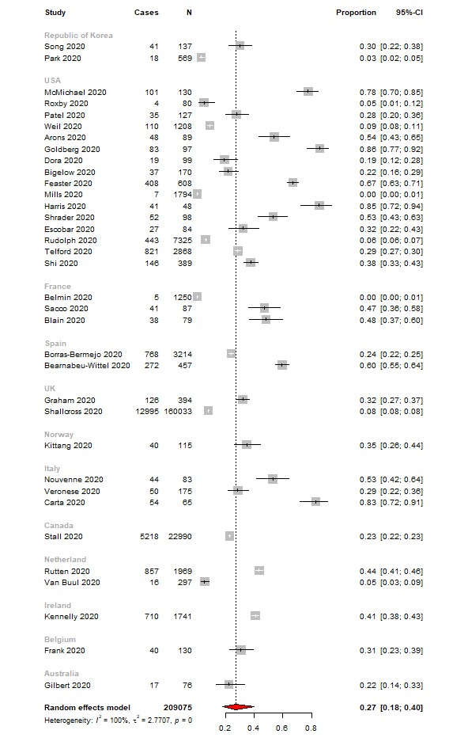
Horizontal lines represent the 95% CIs around the point estimates for each study, and the grey shaded areas are proportional to the weight given to each study.

Appendix figure 4: Forest plot of the attack rate of residents in aged care homes (single-centre studies)
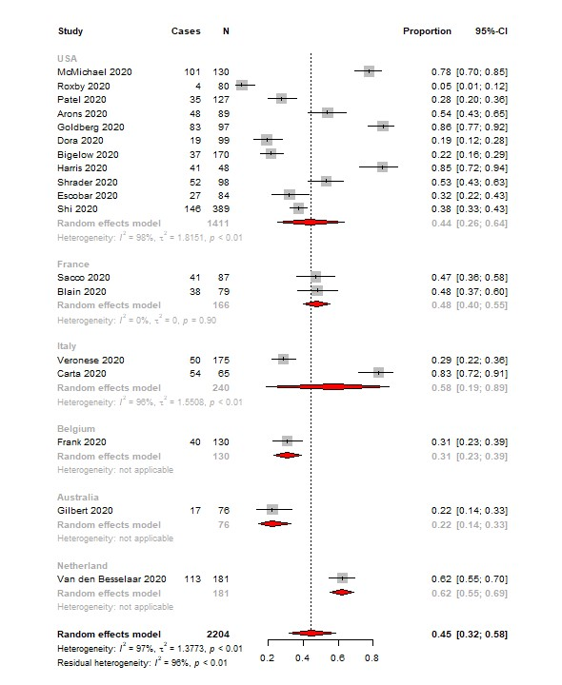
Horizontal lines represent the 95% CIs around the point estimates for each study, and the grey shaded areas are proportional to the weight given to each study.

Appendix figure 5: Leave-one-out sensitivity forest plot of the attack rate of residents in aged care homes (single-centre studies)
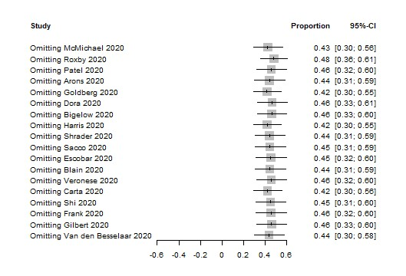
Horizontal lines represent the 95% CIs around the point estimates for each study, and the grey shaded areas are proportional to the weight given to each study.

Appendix figure 6: Forest plot of the attack rate of residents in aged care homes excluding pre-prints (single-centre studies)
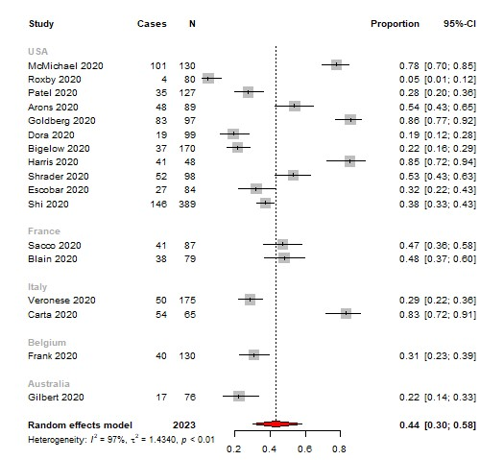
Horizontal lines represent the 95% CIs around the point estimates for each study, and the grey shaded areas are proportional to the weight given to each study.

Appendix figure 7: Forest plot of the case fatality rate of residents in aged care homes (all studies)
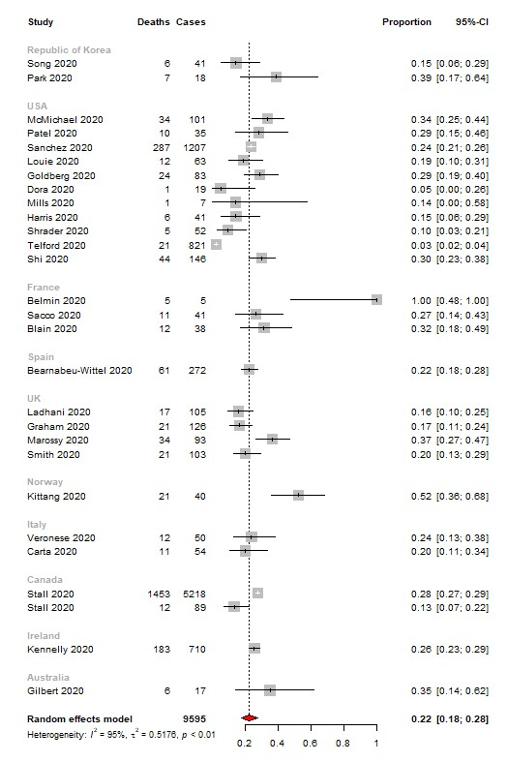
Horizontal lines represent the 95% CIs around the point estimates for each study, and the grey shaded areas are proportional to the weight given to each study.
Appendix figure 8: Leave-one-out sensitivity forest plot of the case fatality rate of residents in aged care homes (all studies)
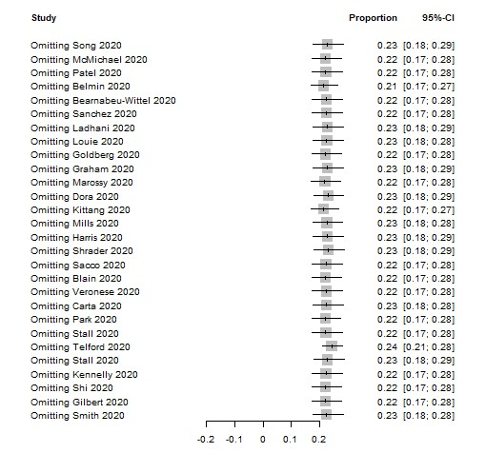
Horizontal lines represent the 95% CIs around the point estimates for each study, and the grey shaded areas are proportional to the weight given to each study.

Appendix figure 9: Forest plot of the case fatality rate of residents in aged care homes excluding pre-prints (all studies)
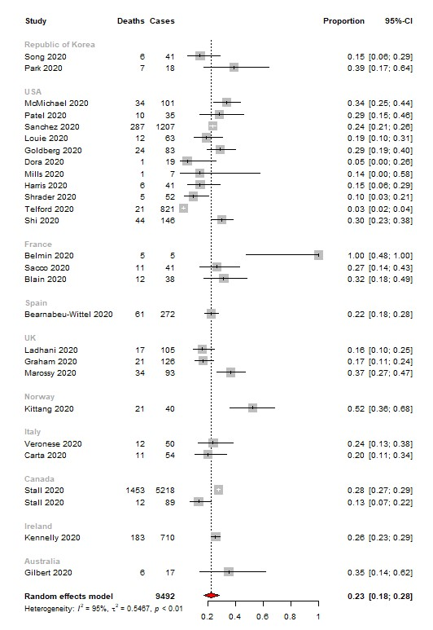
Horizontal lines represent the 95% CIs around the point estimates for each study, and the grey shaded areas are proportional to the weight given to each study.
Appendix figure 10: Forest plot of the mortality rate of residents in aged care homes (all studies)
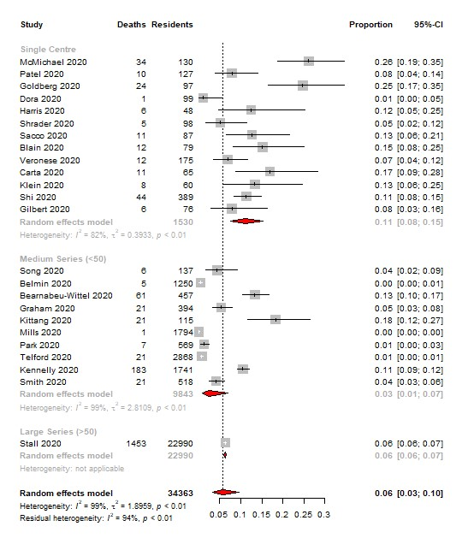
Horizontal lines represent the 95% CIs around the point estimates for each study, and the grey shaded areas are proportional to the weight given to each study.

Appendix figure 11: Leave-one-out sensitivity forest plot of the mortality rate of residents in aged care homes (all studies)
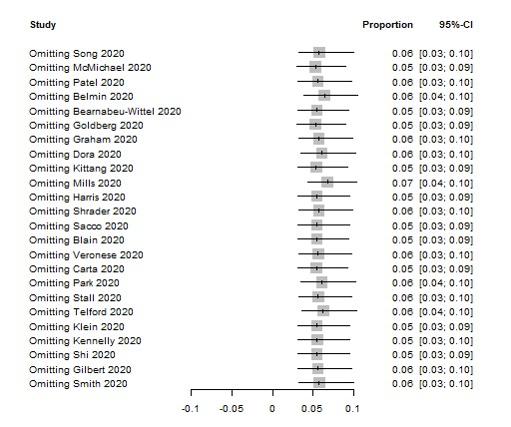
Horizontal lines represent the 95% CIs around the point estimates for each study, and the grey shaded areas are proportional to the weight given to each study.

Appendix figure 12: Forest plot of the mortality rate of residents in aged care homes excluding pre-prints (all studies)
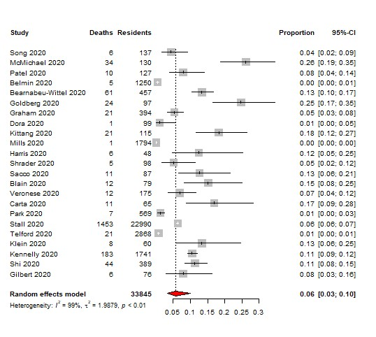
Horizontal lines represent the 95% CIs around the point estimates for each study, and the grey shaded areas are proportional to the weight given to each study.

