SUPPORTING INFORMATION
Figure S1. Study selection process. PRISMA flow diagram identifying studies included in the meta-analysis. PRISMA, Preferred Reporting Items for Systematic Review and Meta-Analysis.
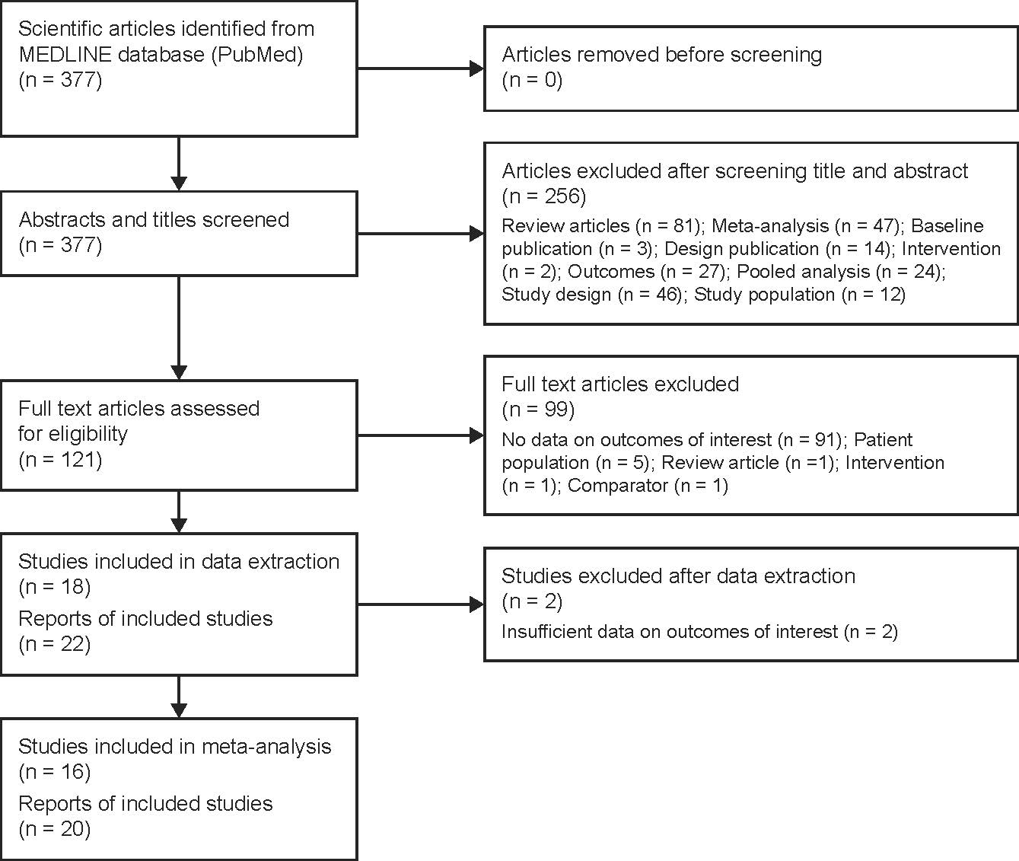

Figure S2. Risk of bias assessment.
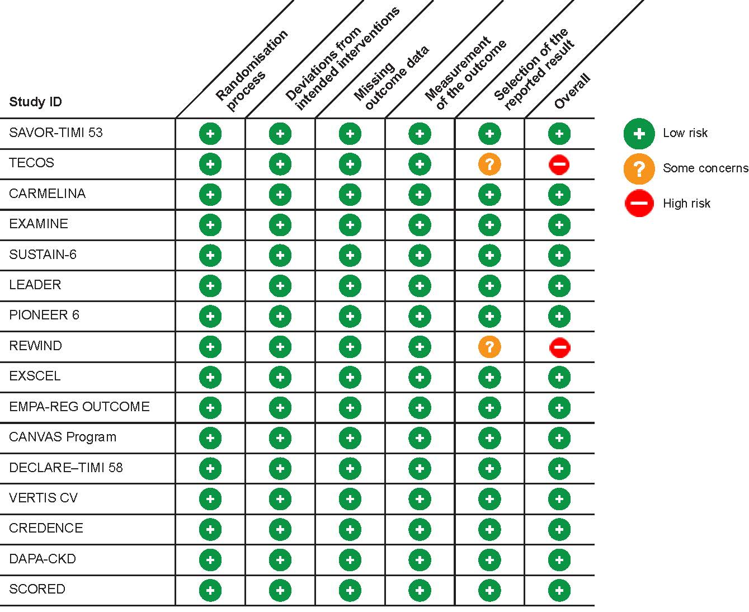
Figure S3. Funnel plots for (A) kidney-specific composite outcome, (B) kidney disease progression, (C) MACE, (D) CV death and (E) HHF.
CV, cardiovascular; DPP4i, dipeptidyl peptidase-4 inhibitor; GLP-1 RA, glucagon-like peptide-1 receptor agonists; HHF, hospitalisation for heart failure; MACE, major adverse cardiovascular events; SGLT2i, sodium-glucose co-transporter 2 inhibitor.
Figure S4. Rankograms showing the estimated probabilities of each treatment being the best at reducing risks of (A) kidney-specific outcome, (B) MACE, (C) CV death and (D) HHF.
CV, cardiovascular; DPP4i, dipeptidyl peptidase-4 inhibitor; GLP-1 RA, glucagon-like peptide-1 receptor agonist; HHF, hospitalisation for heart failure; MACE, major adverse cardiovascular events; SGLT2i, sodium-glucose co-transporter 2 inhibitor.
Figure S5. Forest plot comparing the risk of kidney disease progression with SGLT2 inhibitors compared to placebo.
SGLT2, sodium-glucose co-transporter 2.
Figure S6. Forest plots comparing the risks of (A) MACE and (B) HHF with different antidiabetic drug classes compared to placebo, in an analysis that included outcomes for MACE and HHF from the DAPA-CKD study.
DPP4i, dipeptidyl peptidase-4 inhibitor; GLP-1 RA, glucagon-like peptide-1 receptor agonist; HHF, hospitalisation for heart failure; MACE, major adverse cardiovascular events; SGLT2i, sodium-glucose co-transporter 2 inhibitor.

Figure S7. Comparison between treatments for (A) MACE and (B) HHF, in an analysis that included outcomes for MACE and HHF from the DAPA-CKD study
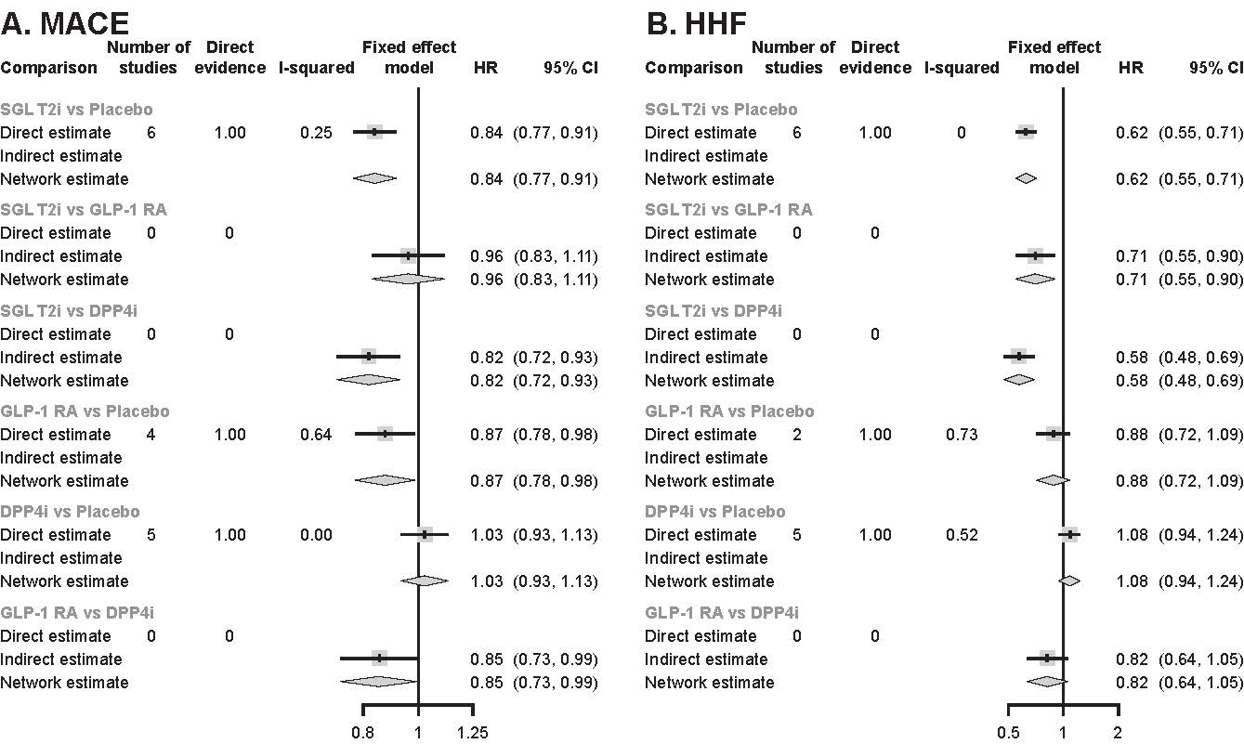
DPP4i, dipeptidyl peptidase-4 inhibitor; GLP-1 RA, glucagon-like peptide-1 receptor agonist; HHF, hospitalisation for heart failure; MACE, major adverse cardiovascular events; SGLT2i, sodium-glucose co-transporter 2 inhibitor.
Figure S8. Rankograms showing the estimated probabilities of each treatment being the best at reducing risks of (A) MACE and (B) HHF in an analysis that included outcomes for MACE and HHF from the DAPA-CKD study.
CV, cardiovascular; DPP4i, dipeptidyl peptidase-4 inhibitor; GLP-1 RA, glucagon-like peptide-1 receptor agonist; HHF, hospitalisation for heart failure; MACE, major adverse cardiovascular events; SGLT2i, sodium-glucose co-transporter 2 inhibitor.

Figure S9. Network plots for (A) kidney-specific outcome, (B) MACE, (C) CV death and (D) HHF by Bayesian analyses.
CV, cardiovascular; DPP4i, dipeptidyl peptidase-4 inhibitor; GLP-1 RA, glucagon-like peptide-1 receptor agonists; HHF, hospitalisation for heart failure; MACE, major adverse cardiovascular events; SGLT2i, sodium-glucose co-transporter 2 inhibitor.

Figure S10. Rankograms by Bayesian analysis showing the estimated probabilities of each treatment being the best at reducing risks of (A) kidney-specific outcome, (B) MACE, (C) CV death and (D) HHF.
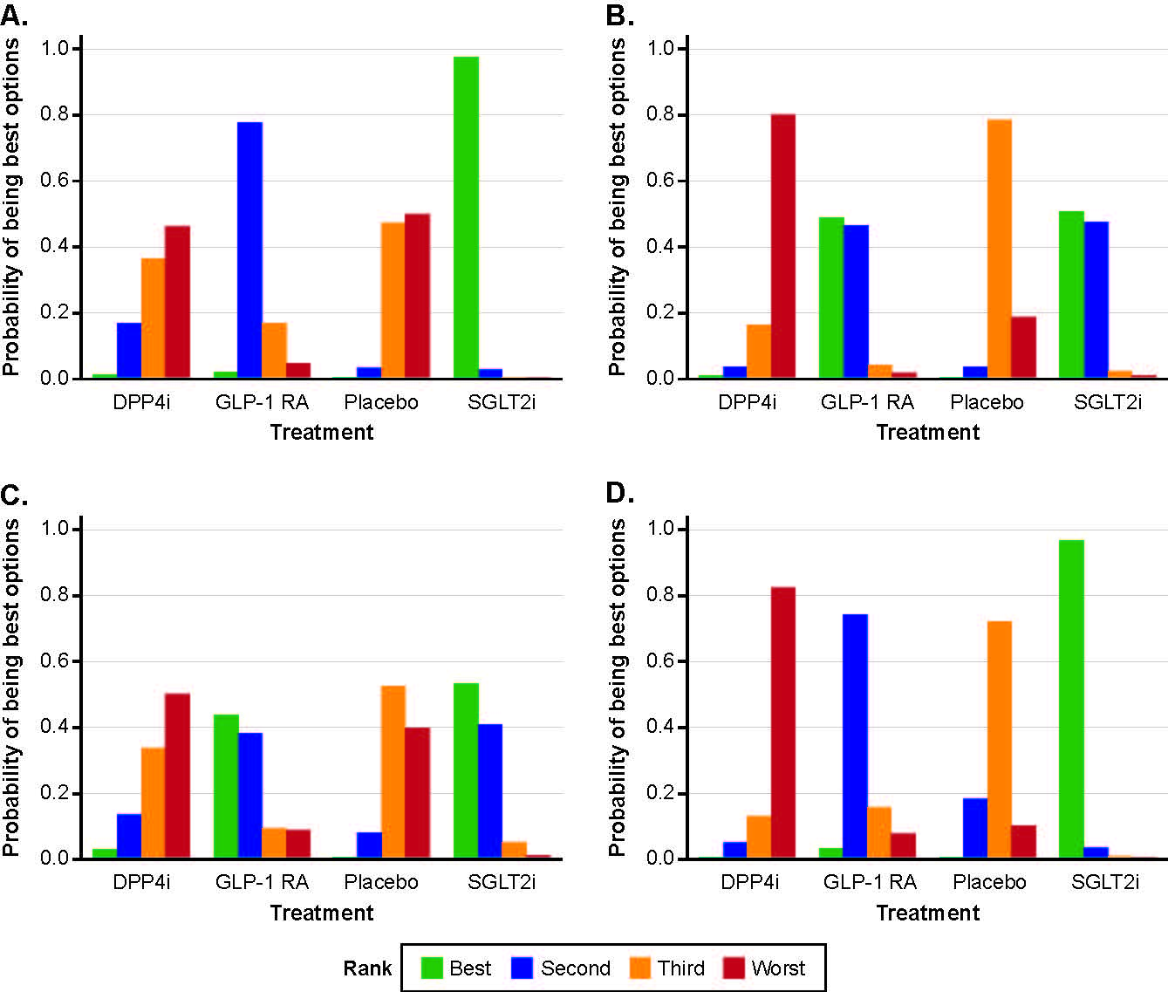
CV, cardiovascular; DPP4i, dipeptidyl peptidase-4 inhibitor; GLP-1 RA, glucagon-like peptide-1 receptor agonists; HHF, hospitalisation for heart failure; MACE, major adverse cardiovascular events; SGLT2i, sodium-glucose co-transporter 2 inhibitor.
Table S1. Search strategy on PubMed
Search Date: July 2021
Database: MEDLINE (via PubMed)

Search number | Search query | Search Details | Results
1 | ("Sodium-Glucose Transporter 2 Inhibitors" [Pharmacological Action] OR "Sodium-Glucose Transporter 2 Inhibitors"[Mesh]) OR (Canagliflozin OR dapagliflozin OR empagliflozin OR ertugliflozin OR ipragliflozin OR luseogliflozin OR licogliflozin OR sotagliflozin tofogliflozin OR remogliflozin) | "Sodium-Glucose Transporter 2 Inhibitors"[Pharmacological Action] OR "Sodium-Glucose Transporter 2 Inhibitors"[MeSH Terms] OR ("canagliflozin"[MeSH Terms] OR "canagliflozin"[All Fields] OR ("dapagliflozin"[Supplementary Concept] OR "dapagliflozin"[All Fields]) OR ("empagliflozin"[Supplementary Concept] OR "empagliflozin"[All Fields]) OR ("ertugliflozin"[Supplementary Concept] OR "ertugliflozin"[All Fields]) OR ("ipragliflozin"[Supplementary Concept] OR "ipragliflozin"[All Fields]) OR ("1 5 anhydro 1 5 4 ethoxybenzyl 2 methoxy 4 methylphenyl 1 thioglucitol"[Supplementary Concept] OR "1 5 anhydro 1 5 4 ethoxybenzyl 2 methoxy 4 methylphenyl 1 thioglucitol"[All Fields] OR "luseogliflozin"[All Fields]) OR ("licogliflozin"[Supplementary Concept] OR "licogliflozin"[All Fields]) OR (("2s 3r 4r 5s 6r 2 4 chloro 3 4 ethoxybenzyl phenyl 6 methylthio tetrahydro 2h pyran 3 4 5 triol"[Supplementary Concept] OR "2s 3r 4r 5s 6r 2 4 chloro 3 4 ethoxybenzyl phenyl 6 methylthio tetrahydro 2h pyran 3 4 5 triol"[All Fields] OR "sotagliflozin"[All Fields]) AND ("6 4 ethylphenyl methyl 3 4 5 6 tetrahydro 6 hydroxymethyl spiro isobenzofuran 1 3h 2 2h pyran 3 4 5 triol"[Supplementary Concept] OR "6 4 ethylphenyl methyl 3 4 5 6 tetrahydro 6 hydroxymethyl spiro isobenzofuran 1 3h 2 2h pyran 3 4 5 triol"[All Fields] OR "tofogliflozin"[All Fields])) OR "remogliflozin"[All Fields]) | 5651
2 | ( "Dipeptidyl-Peptidase IV Inhibitors"[Mesh] OR "Dipeptidyl-Peptidase IV Inhibitors" [Pharmacological Action] ) OR (alogliptin OR anagliptin OR Linagliptin OR vildagliptin OR saxagliptin OR Sitagliptin) | "Dipeptidyl-Peptidase IV Inhibitors"[MeSH Terms] OR "Dipeptidyl-Peptidase IV Inhibitors"[Pharmacological Action] OR ("alogliptin"[Supplementary Concept] OR "alogliptin"[All Fields] OR ("anagliptin"[Supplementary Concept] OR "anagliptin"[All Fields]) OR ("linagliptin"[MeSH Terms] OR "linagliptin"[All Fields]) OR ("vildagliptin"[MeSH Terms] OR "vildagliptin"[All Fields]) OR ("saxagliptin"[Supplementary Concept] OR "saxagliptin"[All Fields]) OR ("sitagliptin phosphate"[MeSH Terms] OR ("sitagliptin"[All Fields] AND "phosphate"[All Fields]) OR "sitagliptin phosphate"[All Fields] OR "sitagliptin"[All Fields] OR "sitagliptine"[All Fields])) | 7229
3 | ("Glucagon-Like Peptide 1"[Mesh]) OR (liraglutide OR dulaglutide OR exenatide OR semaglutide) OR (GLP-1 RA) | "Glucagon-Like Peptide 1"[MeSH Terms] OR ("liraglutid"[All Fields] OR "liraglutide"[MeSH Terms] OR "liraglutide"[All Fields] OR "liraglutide s"[All Fields] OR ("dulaglutide"[Supplementary Concept] OR "dulaglutide"[All Fields]) OR ("exenatide"[MeSH Terms] OR "exenatide"[All Fields] OR "exenatide s"[All Fields]) OR ("semaglutide"[Supplementary Concept] OR "semaglutide"[All Fields])) OR (("Glucagon-Like Peptide 1"[MeSH Terms] OR "Glucagon-Like Peptide 1"[All Fields] OR "glp 1"[All Fields]) AND "RA"[All Fields]) | 13302
4 | #1 OR #2 OR #3 |  | 23707
5 | ("Diabetic Nephropathies"[Mesh]) OR (CKD OR "chronic kidney disease" OR "kidney disease" OR "renal impairment" OR "kidney failure" OR CKF OR "chronic kidney failure" OR "renal failure" OR CRF OR CRD OR "chronic renal disease" OR "end stage renal disease" OR "renal failure" OR "kidney failure" OR ESRD OR "renal death" OR "albuminuria" OR "urine albumin" OR "proteinuria" OR "urine protein") | "Diabetic Nephropathies"[MeSH Terms] OR ("CKD"[All Fields] OR "chronic kidney disease"[All Fields] OR "kidney disease"[All Fields] OR "renal impairment"[All Fields] OR "kidney failure"[All Fields] OR "CKF"[All Fields] OR "chronic kidney failure"[All Fields] OR "renal failure"[All Fields] OR "CRF"[All Fields] OR "CRD"[All Fields] OR "chronic renal disease"[All Fields] OR "end stage renal disease"[All Fields] OR "renal failure"[All Fields] OR "kidney failure"[All Fields] OR ("kidney failure, chronic"[MeSH Terms] OR ("kidney"[All Fields] AND "failure"[All Fields] AND "chronic"[All Fields]) OR "chronic kidney failure"[All Fields] OR "esrd"[All Fields]) OR "renal death"[All Fields] OR "albuminuria"[All Fields] OR "urine albumin"[All Fields] OR "proteinuria"[All Fields] OR "urine protein"[All Fields]) | 347961
6 | ("Diabetes Mellitus, Type 2"[Mesh]) OR (diabetes OR T2DM OR "diabetes mellitus") | "diabetes mellitus, type 2"[MeSH Terms] OR ("diabete"[All Fields] OR "diabetes mellitus"[MeSH Terms] OR ("diabetes"[All Fields] AND "mellitus"[All Fields]) OR "diabetes mellitus"[All Fields] OR "diabetes"[All Fields] OR "diabetes insipidus"[MeSH Terms] OR ("diabetes"[All Fields] AND "insipidus"[All Fields]) OR "diabetes insipidus"[All Fields] OR "diabetic"[All Fields] OR "diabetics"[All Fields] OR "diabets"[All Fields] OR "T2DM"[All Fields] OR "diabetes mellitus"[All Fields]) | 826134
7 | #5 AND #6 |  | 71357
8 | (Randomized controlled) | ("random allocation"[MeSH Terms] OR ("random"[All Fields] AND "allocation"[All Fields]) OR "random allocation"[All Fields] OR "random"[All Fields] OR "randomization"[All Fields] OR "randomized"[All Fields] OR "randomisation"[All Fields] OR "randomisations"[All Fields] OR "randomise"[All Fields] OR "randomised"[All Fields] OR "randomising"[All Fields] OR "randomizations"[All Fields] OR "randomize"[All Fields] OR "randomizes"[All Fields] OR "randomizing"[All Fields] OR "randomness"[All Fields] OR "randoms"[All Fields]) AND "controlled"[All Fields] | 818026
9 | #4 AND #7 AND #8 |  | 377

Table S2. Data extracted from the sixteen trials included in this network meta-analysis.
Table S2 is provided as a separate file.

