Supplementary Appendix
_______________________________________________________________________________
Supplementary Table 1. Quality assessment of bias of included studies according to Jadad score.
Author and Year | Was study Randomised | Was randomisation described and appropriate? | Was the study double blinded? | Was the method of double blinding described and appropriate? | Was a description of dropout and withdrawal provided? | Total
Bergenstal 2010²⁴ | 1 | 1 | 1 | 2 | 1 | 6
Zhang 2012²⁸ | 1 | 0 | 0 | 0 | 1 | 2
Derosa 2013²¹ | 1 | 0 | 1 | 0 | 1 | 3
Davies 2015²⁷ | 1 | 2 | 1 | 1 | 1 | 6
Miyagawa 2015³⁰ | 1 | 2 | 1 | 2 | 1 | 7
Pfeffer 2015⁹ | 1 | 1 | 1 | 0 | 1 | 4
Von Scholten 2015²⁹ | 1 | 1 | 1 | 0 | 1 | 4
Davies 2016²⁵ | 1 | 2 | 1 | 1 | 1 | 6
Tonneijick 2016¹⁸ | 1 | 2 | 1 | 2 | 1 | 7
Tonneijick renal 2016³³ | 1 | 2 | 1 | 0 | 1 | 5
Bouchi 2017³² | 1 | 1 | 0 | 0 | 1 | 3
Mann 2017¹⁰ | 1 | 2 | 1 | 2 | 1 | 7
Tonneijick 2017³¹ | 1 | 2 | 0 | 0 | 1 | 4
Von Scholten 2017²⁰ | 1 | 1 | 1 | 1 | 1 | 5
Tuttle 2018¹⁹ | 1 | 2 | 0 | 0 | 1 | 4
Mosenzon 2019²⁶ | 1 | 2 | 1 | 2 | 1 | 7
Wang 2019²³ | 1 | 0 | 1 | 0 | 1 | 3
Nakaguchi 2020²² | 1 | 2 | 0 | 0 | 1 | 4
Gerstein 2021¹³ | 1 | 2 | 0 | 0 | 1 | 4
Gerstein 2019¹² | 1 | 2 | 1 | 2 | 1 | 7
Van Ruiten 2021³⁵ | 1 | 2 | 1 | 2 | 1 | 7
Man 2020 SUSTAIN 1³⁴ | 1 | 2 | 1 | 2 | 1 | 7
Man 2020 SUSTAIN 2³⁴ | 1 | 2 | 1 | 2 | 1 | 7
Man 2020 SUSTAIN 3³⁴ | 1 | 2 | 0 | 0 | 1 | 4
Man 2020 SUSTAIN 4³⁴ | 1 | 2 | 0 | 0 | 1 | 4
Man 2020 SUSTAIN 5³⁴ | 1 | 2 | 1 | 2 | 1 | 7
Man 2020 SUSTAIN 6³⁴ | 1 | 2 | 1 | 2 | 1 | 7

Studies were scored as follows: 1 point for describing the study as randomised, 1 point for describing a randomisation process, 1 point for an appropriate randomisation process, 1 point for describing the study as double blinded, 1 point for describing the double blinding process, 1 point for point for an appropriate process of double blinding and 1 point for providing descriptions of all withdrawals and dropouts from the trial or all initial participants completed the study.

__________________________________________________________________________________
Supplementary Table 2. Subgroup analysis of the effects of GLP-1 receptor agonists on albuminuria
Variable (number of cohorts) | Pooled Reduction (%) | 95% Confidence Interval and p-value for reduction | p-value for subgroup differences
Type of GLP-1RA
Exenatide (5) | -11.74 | -15.93 to -7.55; p< 0.0001 | 0.14
Liraglutide (8) | -16.52 | -21.28 to -11.75; p<0.0001 | 0.14
Type of GLP-1RA
Exenatide (5) | -11.74 | -15.93 to -7.55; p< 0.0001 | 0.03
Dulaglutide (4) | -18.45 | -22.67 to -11.75; p<0.00001 | 0.03
Type of GLP-1RA
Exenatide (5) | -11.74 | -15.93 to -7.55; p< 0.0001 | 0.21
Oral Semaglutide (1) | -33.00 | -65.83 to -0.17; p=0.05 | 0.21
Type of GLP-1RA
Exenatide (5) | -11.74 | -15.93 to -7.55; p< 0.0001 | 0.58
Subcutaneous semaglutide (6) | -15.70 | -28.93 to -2.48; p = 0.02 | 0.58
Type of GLP-1RA
Exenatide (5) | -11.74 | -15.93 to -7.55; p< 0.0001 | 0.02
Efpeglenatide (1) | -18.00 | -20.87 to -15.13; p<0.00001 | 0.02
Type of GLP-1RA
Liraglutide (8) | -16.52 | -21.28 to -11.75; p<0.0001 | 0.55
Dulaglutide (4) | -18.45 | -22.67 to -11.75; p<0.00001 | 0.55
Type of GLP-1RA
Liraglutide (8) | -16.52 | -21.28 to -11.75; p<0.0001 | 0.33
Oral Semaglutide (1) | -33.00 | -65.83 to -0.17; p=0.05 | 0.33
Type of GLP-1RA
Liraglutide (8) | -16.52 | -21.28 to -11.75; p<0.0001 | 0.91
Subcutaneous semaglutide (6) | -15.70 | -28.93 to -2.48; p = 0.02 | 0.91
Type of GLP-1RA
Liraglutide (8) | -16.52 | -21.28 to -11.75; p<0.0001 | 0.6
Efpeglenatide (1) | -18.00 | -20.87 to -15.13; p<0.00001 | 0.6
Type of GLP-1RA
Dulaglutide (4) | -18.45 | -22.67 to -11.75; p<0.00001 | 0.39
Oral Semaglutide (1) | -33.00 | -65.83 to -0.17; p=0.05 | 0.39
Type of GLP-1RA
Dulaglutide (4) | -18.45 | -22.67 to -11.75; p<0.00001 | 0.86
Efpeglenatide (1) | -18.00 | -20.87 to -15.13; p<0.00001 | 0.86
Type of GLP-1RA
Dulaglutide (4) | -18.45 | -22.67 to -11.75; p<0.00001 | 0.70
Subcutaneous semaglutide (6) | -15.70 | -28.93 to -2.48; p = 0.02 | 0.70
Type of GLP-1RA
Efpeglenatide (1) | -18.00 | -20.87 to -15.13; p<0.00001 | 0.37
Oral Semaglutide (1) | -33.00 | -65.83 to -0.17; p=0.05 | 0.37
Type of GLP-1RA
Efpeglenatide (1) | -18.00 | -20.87 to -15.13; p<0.00001 | 0.74
Subcutaneous semaglutide (6) | -15.70 | -28.93 to -2.48; p = 0.02 | 0.74
Type of GLP-1RA
Oral Semaglutide (1) | -33.00 | -65.83 to -0.17; p=0.05 | 0.34
Subcutaneous semaglutide (6) | -15.70 | -28.93 to -2.48; p = 0.02 | 0.34
Albuminuria Status
Normoalbuminuria (16) | -16.41 | -19.25 to -13.58; p<0.00001 | 0.45
Microalbuminuria (7) | -14.07 | -22.57 to -5.57; p=0.001 | 0.45
Macroalbuminuria (3) | -23.66 | -36.07 to -11.26, p=0.0002 | 0.45
eGFR level
>90 (7) | -13.89 | -27.09 to -0.69; p = 0.04 | 0.87
60 - ≤90 (11) | -17.50 | -19.46 to -15.54; p<0.00001 | 0.87
≤30 - ≤60 (3) | -17.57 | -22.95 to -12.20; <0.00001 | 0.87
Follow-up Duration
≤26 weeks (11) | -18.03 | -23.66 to -12.41; p<0.00001 | 0.52
26-≤52weeks (8) | -11.66 | -21.30 to -2.02; p =0.02 | 0.52
>52 weeks (8) | -15.78 | -18.66 to -12.90; p<0.00001 | 0.52
Age
>60 (16) | -17.53 | -19.37 to -15.69; p<0.00001 | 0.09
≤60 (11) | -14.56 | -17.51 to -11.60; p<0.00001 | 0.09
HbA_{1c}
>8.0 (16) | -16.46 | -19.57 to -13.34; p<0.00001 | 0.80
≤8.0 (11) | -15.89 | -18.97 to -12.81; p<0.00001 | 0.80
BMI
>30 (22) | -15.45 | -17.57 to -13.32; p<0.00001 | 0.03
≤30 (5) | -22.36 | -28.06 to -16.66; p<0.00001 | 0.03
Jadad Score
>3 (23) | -16.33 | -18.74 to -13.91; p<0.00001 | 0.41
≤3 (4) | -10.74 | -23.89 to 2.400; p=0.11 | 0.41
SBP
>130mmHg (22) | -17.45 | -19.27 to -15.62; p<0.00001 | <0.0001
≤130mmHg (4) | -13.49 | -13.81 to -13.17; p<0.00001 | <0.0001
Duration of Diabetes
>9 years (13) | -17.52 | -19.36 to -15.68; p<0.00001 | 0.13
≤9 years (12) | -14.69 | -17.90 to -11.47; p<0.00001 | 0.13
Measurement method
UAE (4) | -24.25 | -42.06 to -6.44; p=0.008 | 0.37
UACR (23) | -16.14 | -18.22 to -13.76; p<0.00001 | 0.37
Sample Size
<30 | -18.58 | -140.94 to 104.78; p=0.88 | 0.96
30-300 | -17.04 | -24.04 to -10.05; p<0.00001 | 0.96
>300 | -15.99 | -18.54 to -13.45; p<0.00001 | 0.96
GLP-1RA, glucagon-like peptide 1 receptor agonist; eGFR, estimated glomerular filtration rate; HbA_{1c}, haemoglobin A_{1c}; BMI, body mass index; SBP, systolic blood pressure; UAE, urine albumin excretion; UACR, urine albumin creatinine ratio
_______________________________________________________
Supplementary Figure 1. Funnel plot for assessing publication bias

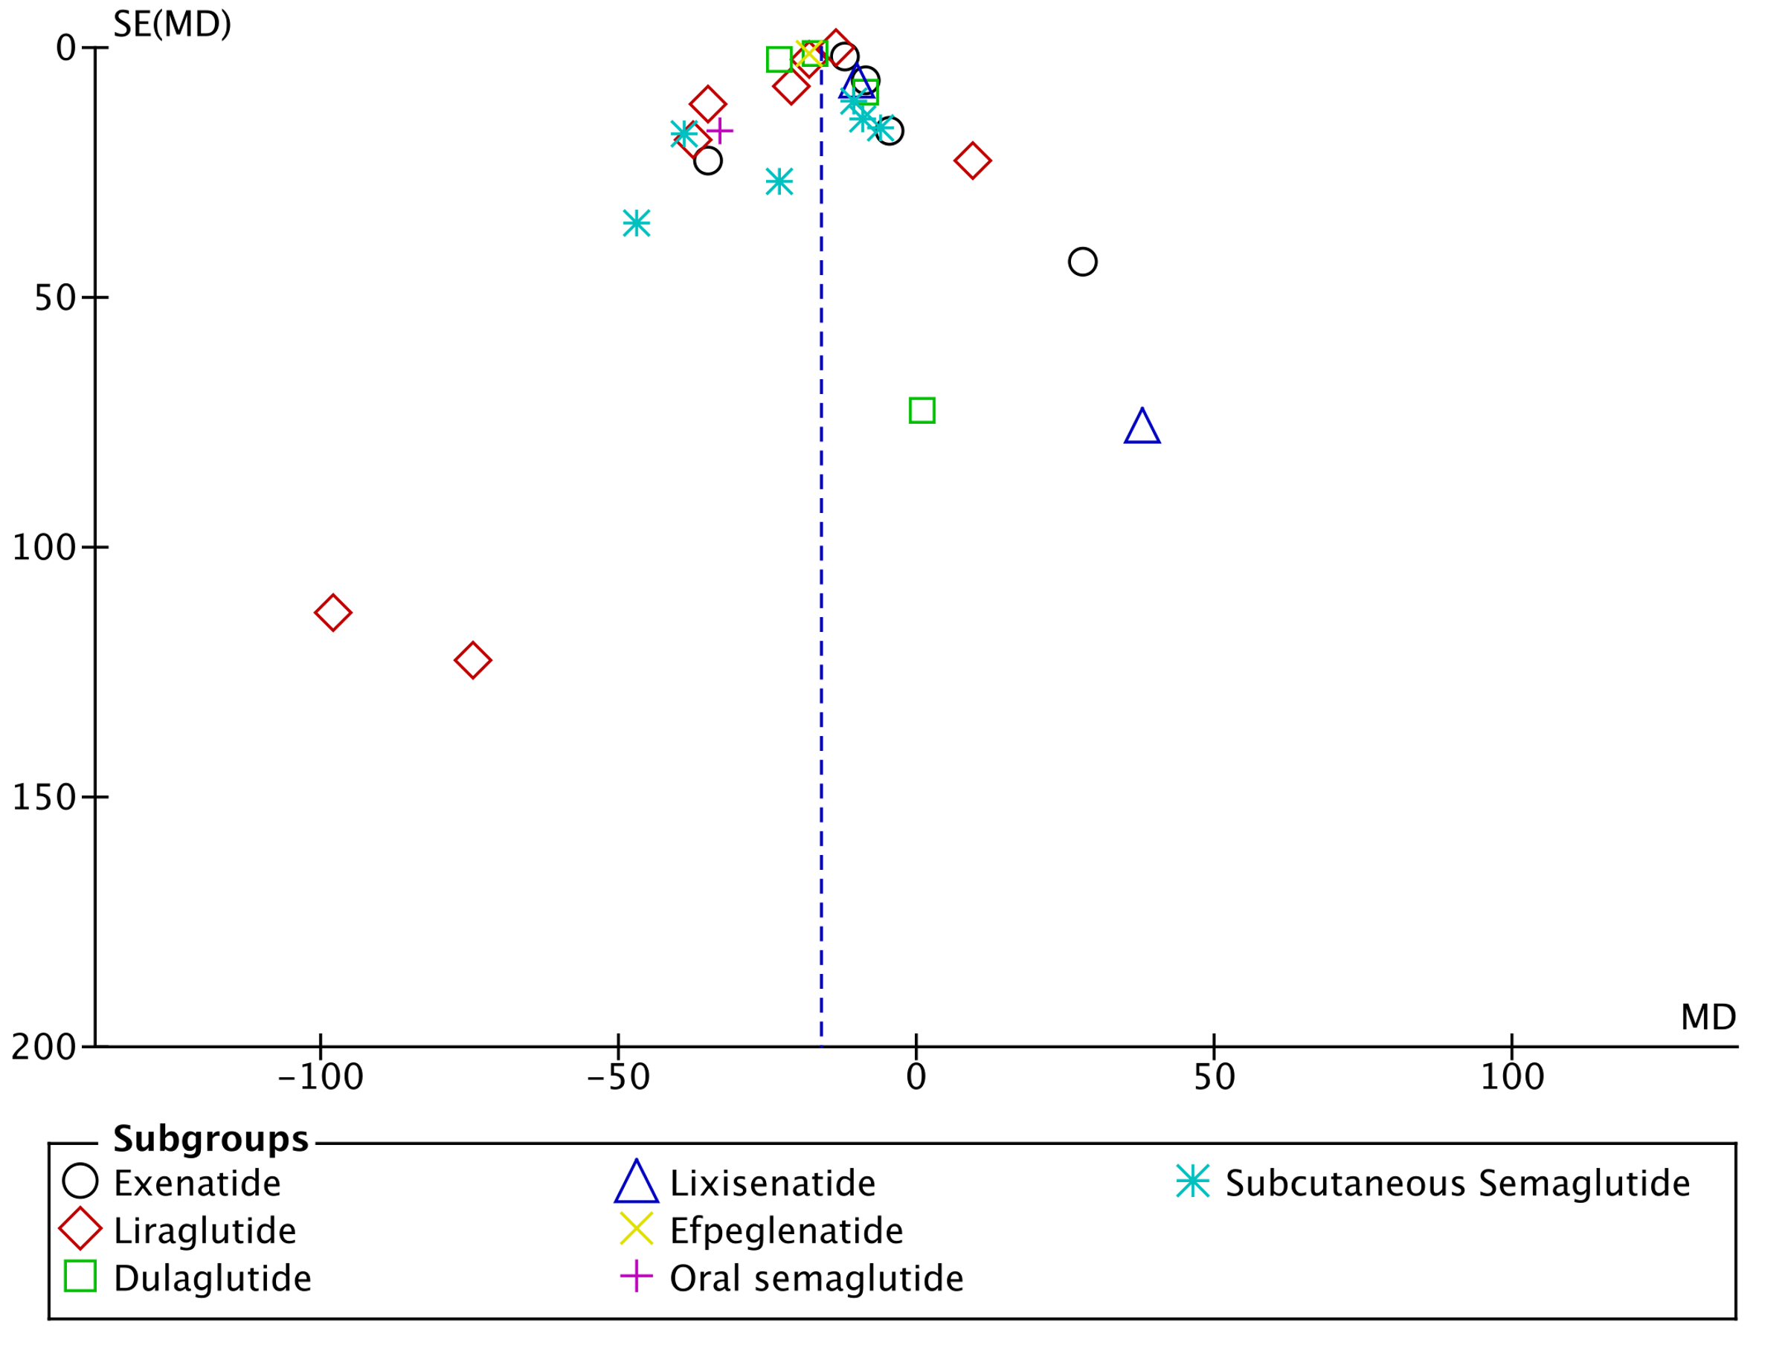
SE, standard error; MD, mean difference

