Effect of Divergent Continuous Glucose Monitoring Technologies on Glycaemic Control in Type 1 Diabetes Mellitus: A Systematic Review and Meta-analysis of Randomised Controlled Trials
Mona Elbalshy¹ MBChB, MSc, Jillian Haszard⁴PhD, Hazel Smith¹, Sarahmarie Kuroko¹ MSc, Barbara Galland¹ PhD, Nick Oliver³, Viral Shah MD⁴, Martin I de Bock⁵PhD and Benjamin J Wheeler^{1,6} PhD.

¹ Department of Women’s and Children’s Health, Dunedin School of Medicine, University of Otago, New Zealand. 201 Great King St, 9016, Dunedin, Otago, New Zealand
² Division of Sciences, University of Otago, New Zealand. University of Otago. PO Box 56. Dunedin 9054, New Zealand.
³ Department of Metabolism, Digestion and Reproduction, Faculty of Medicine, Imperial College, London, UK
⁴ Barbara Davis Center for Diabetes, University of Colorado Anschutz Medical Campus, Aurora, CO 80045, USA
⁵ Department of Paediatrics, University of Otago Christchurch, New Zealand. 2 Riccarton Avenue. PO Box 4345, Christchurch 8140, New Zealand.
⁶ Paediatric Endocrinology, Southern District Health Board, Dunedin, New Zealand.

Corresponding author details:
Associate Professor Benjamin J Wheeler
Department of Women’s and Children’s Health, Dunedin School of Medicine, University of Otago, New Zealand. 201 Great King St, 9016, Dunedin, Otago, New Zealand
Ben.wheeler@otago.ac.nz

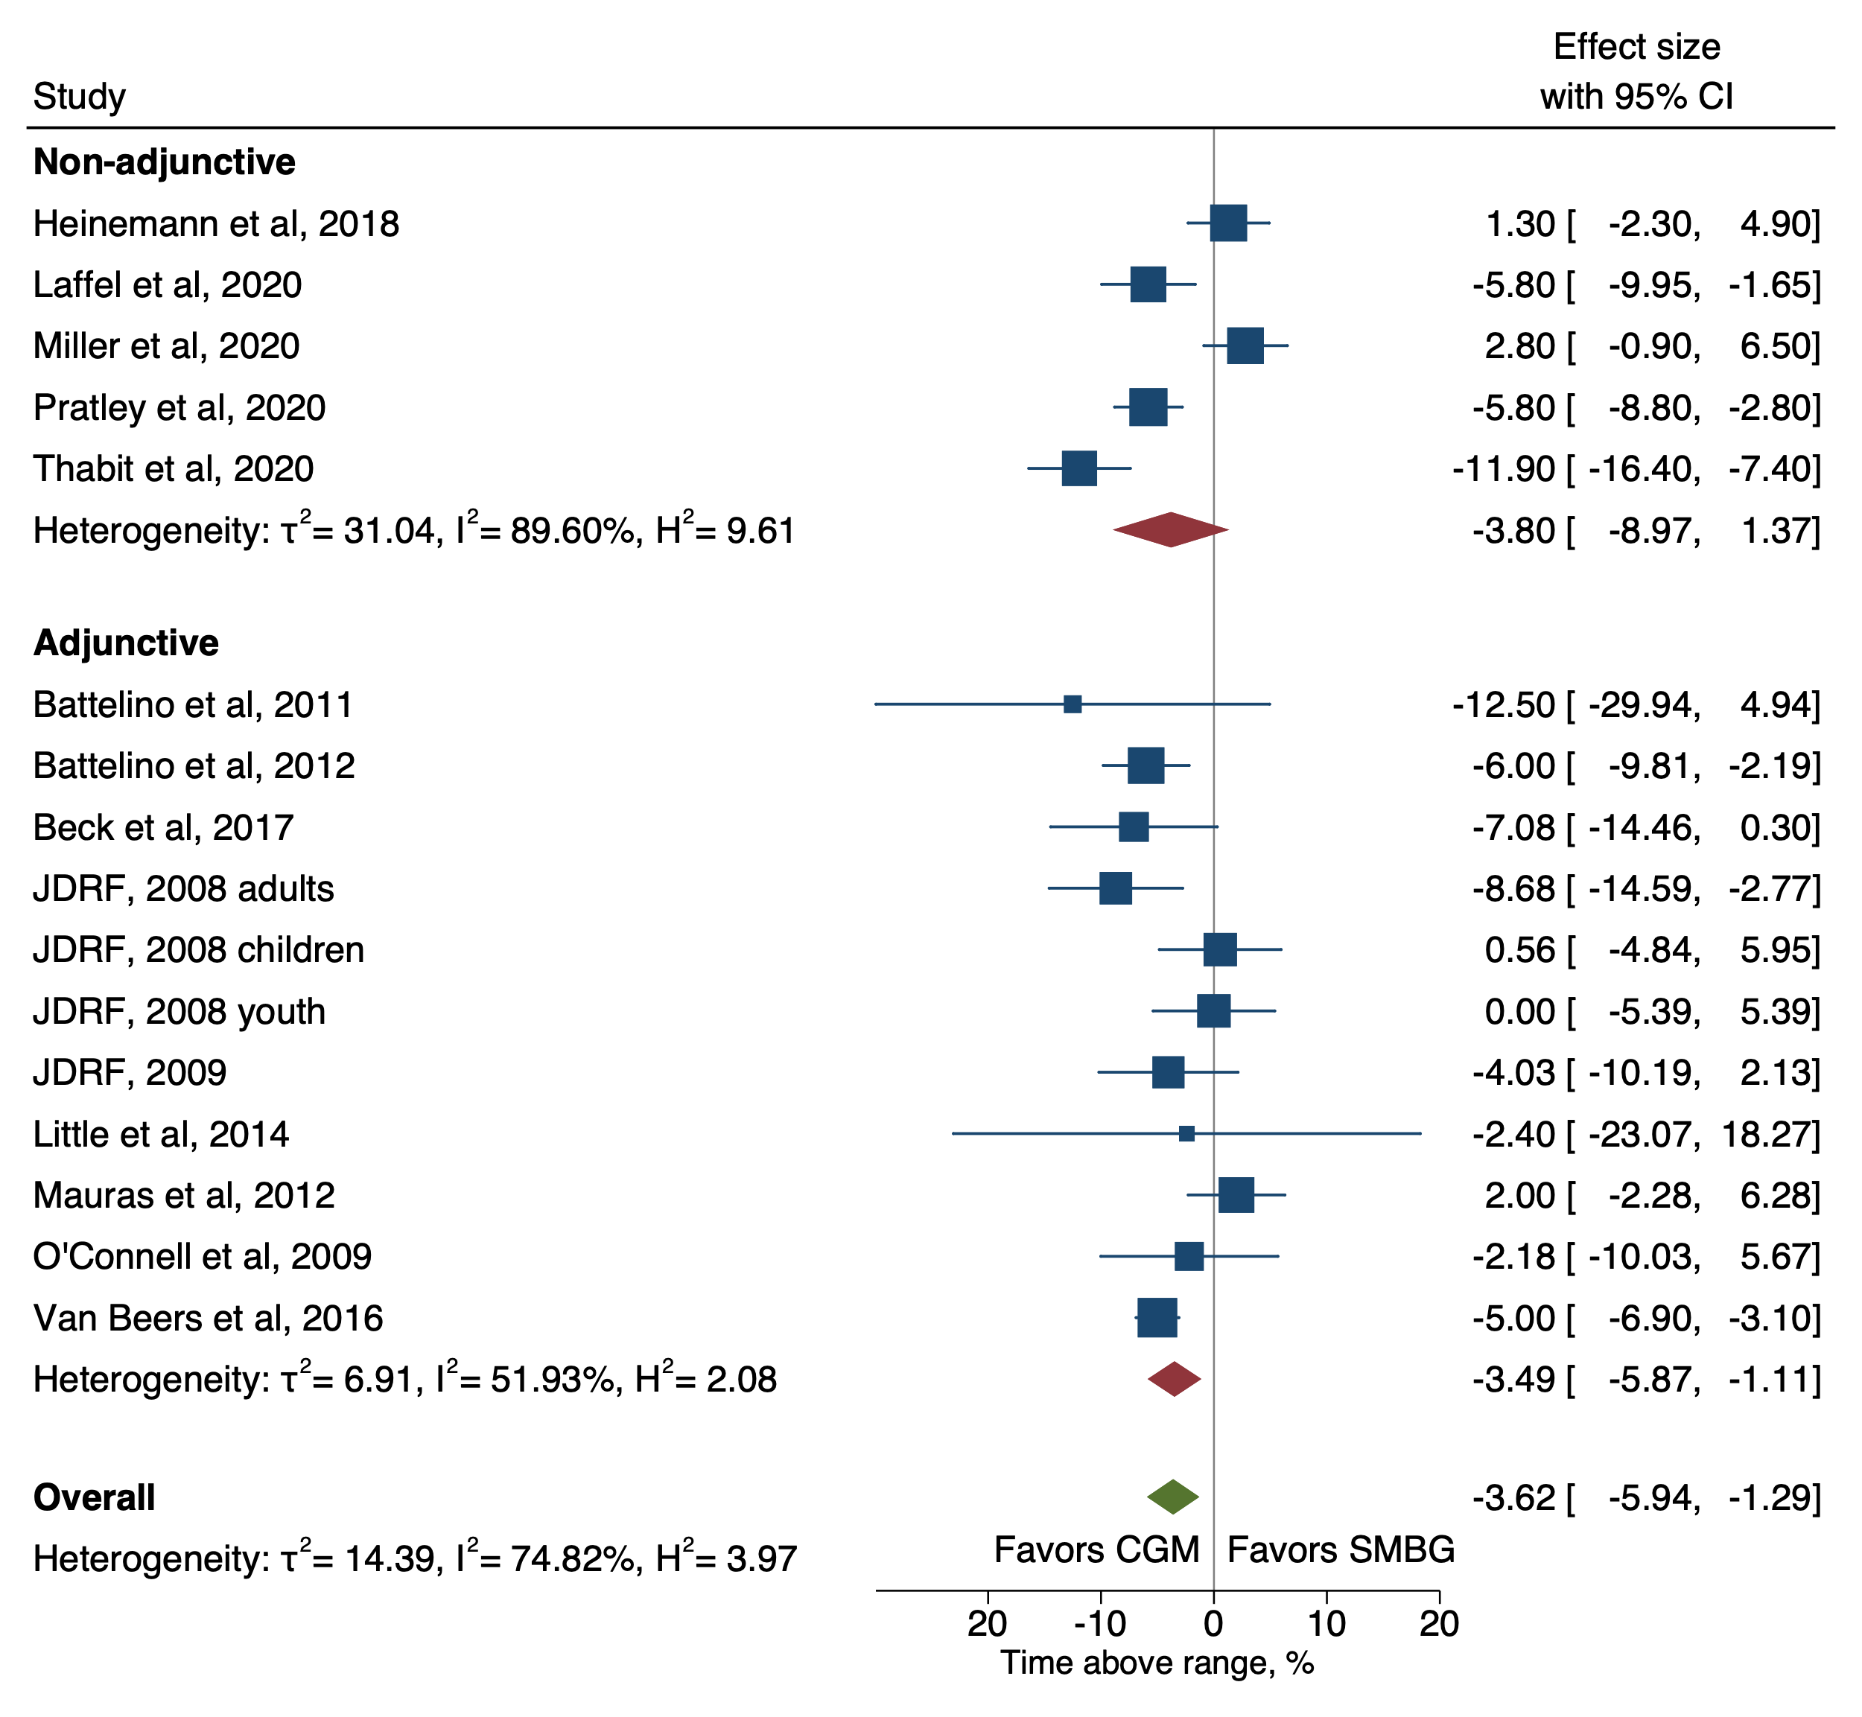
Supplementary Figure 1. Forest plot of meta-analysis of RCTs for time above range (TAR; >10 mmol/L) by non-adjunctive and adjunctive RT-CGM (there were no intermittent scanning studies that reported this outcome).

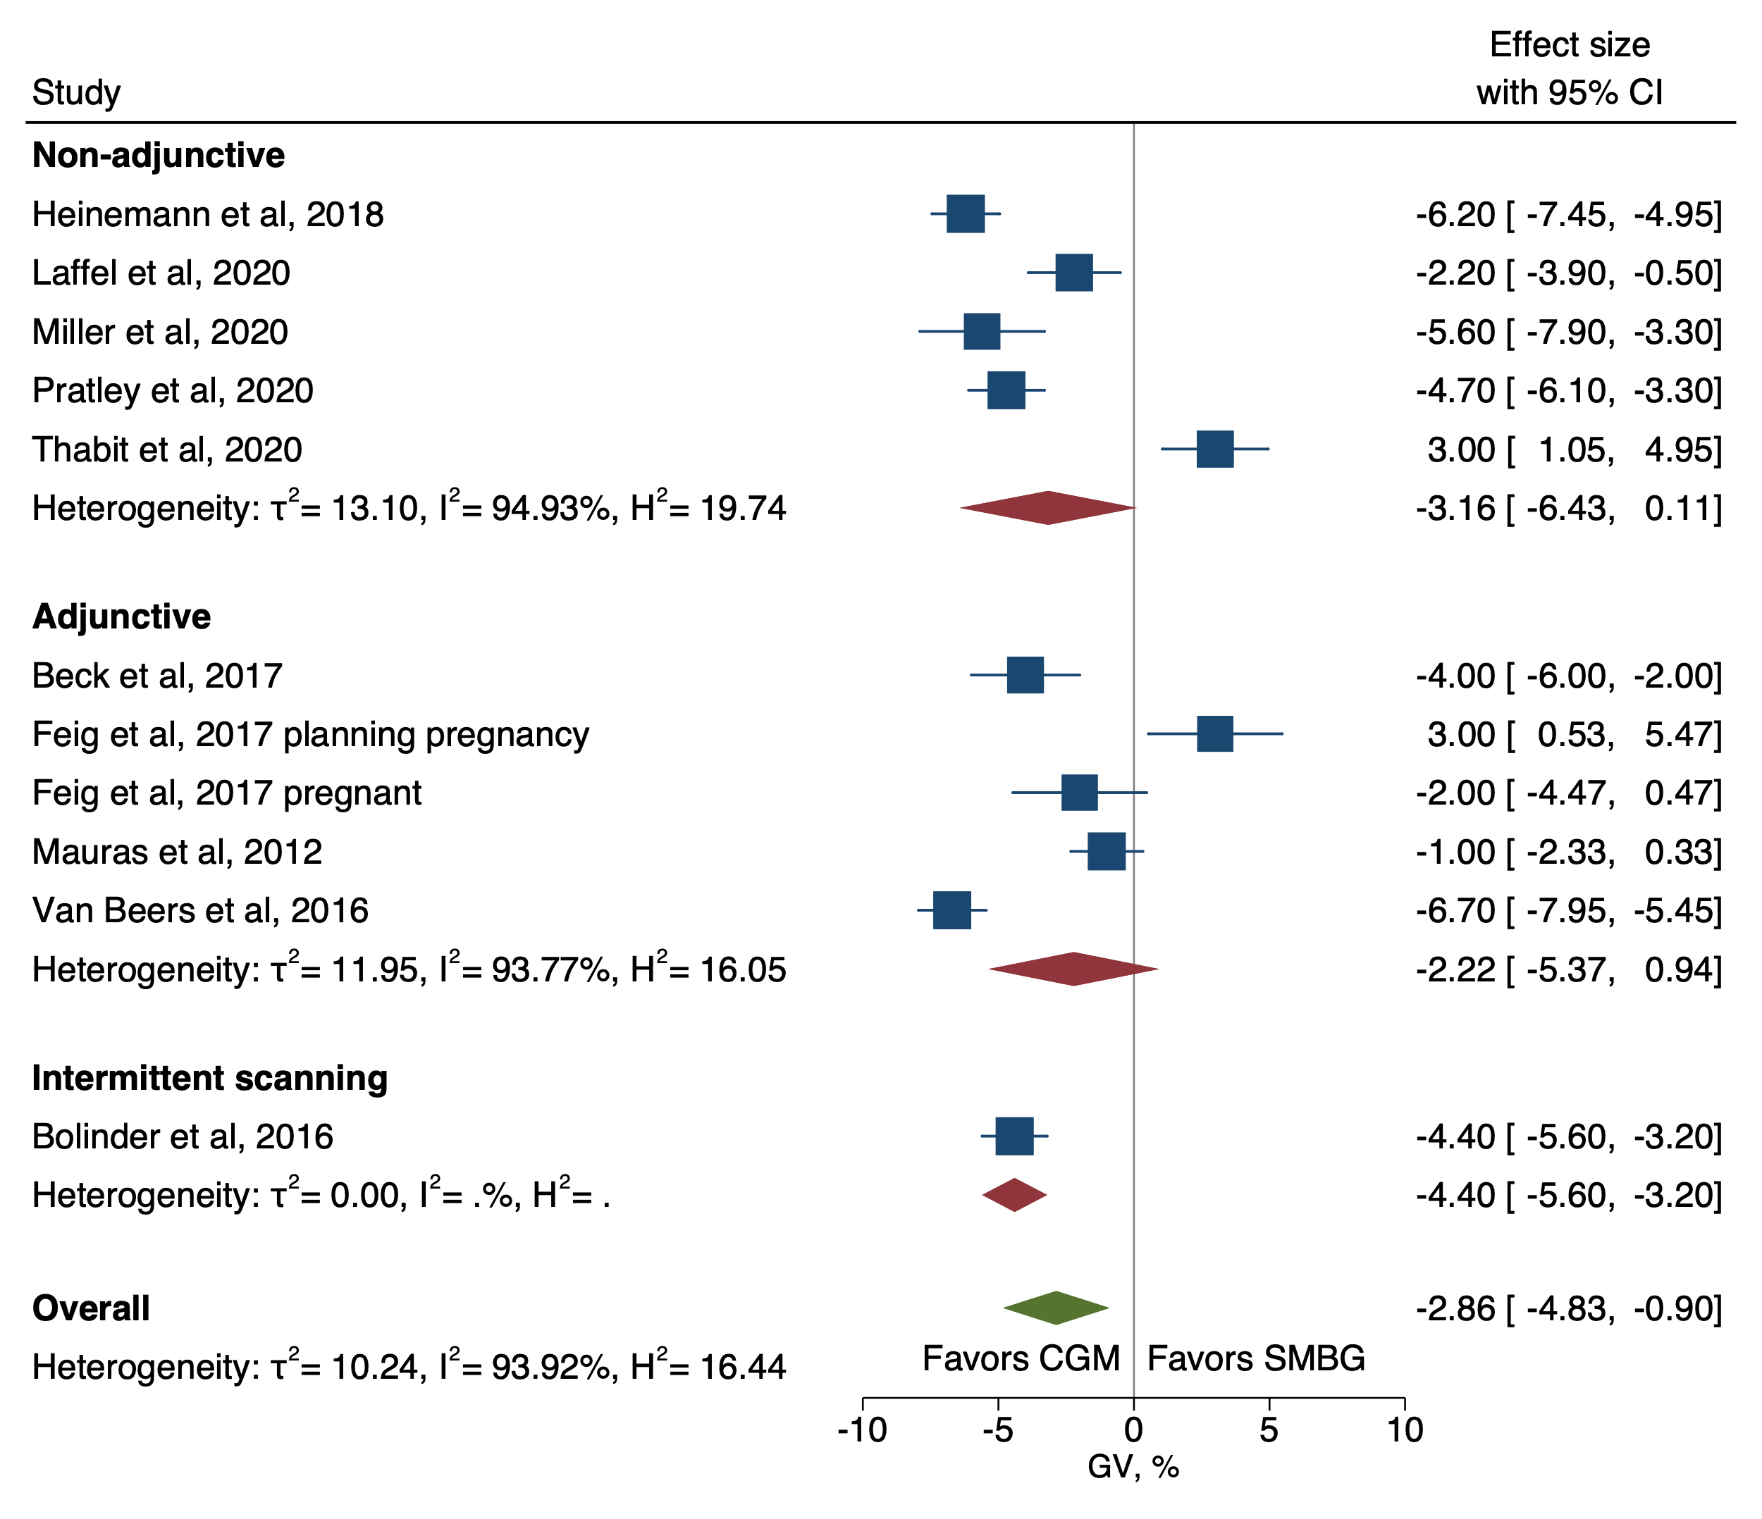
Supplementary Figure 2. Forest plot of meta-analysis of RCTs for glucose variability (GV).

Supplementary Table 1- Characteristics of the trials included in meta-analyses
Study |  | Study design | Subjects |  |  | Study duration (weeks) |  | Intervention/control (N) |  | Mean age, intervention/ control (years) |  | Baseline HbA1c intervention/ control, % (mmol/mol) |  | Intervention/ sensor/control |  | Insulin regimen |  | Primary outcome |  | Sponsors & authors contributions
Non-adjunctive CGM
Heinemann et al., 2018 (43) |  | Parallel | Adults |  |  | 24 |  | 75/74 |  | 45.8/47.3 |  | 7.6/7.3 (60/56) |  | RT-CGM/Dexcom G5  Mobile/SMBG |  | MDI |  | Number of hypoglycaemic events during the follow up phase compared with the baseline |  | Dexcom, Inc.
Laffel et al., 2020 (41) |  | Parallel | Youth and adults |  |  | 26 |  | 74/79 |  | 17/18 |  | 8.9/8.9  (73.8/73.8) |  | RT-CGM/Dexcom G5/SMBG |  | CSII & MDI |  | The change of HbA1c from baseline to 26 weeks |  | Dexcom, Inc., Medtronic, and others
SENCE study group, 2020 (44) |  | Parallel | Paediatric |  |  | 26 |  | 44/49 |  | 5.2/6.2 |  | 8.2/8.2  (66.1/66.1) |  | RT-CGM/Dexcom G5/SMBG |  | CSII & MDI |  | Percentage of time spent in target range 70-180 mg/dl |  | Dexcom, Inc., Leona M and Harry B Helmsley Charitable trust.
Pratley et al., 2020 (42) |  | Parallel | Adults |  |  | 26 |  | 103/100 |  | 68/67* |  | 7.6/7.5  (59.6/58.5) |  | RT-CGM/Dexcom G5/SMBG |  | CSII & MDI |  | Percentage of time measured below 70 mg/dl during 26 months follow up |  | Dexcom, Inc., others
Thabit et al., 2020 (45) |  | Cross-over | Teenagers, adults# |  |  | 22 ** |  | 30 |  | 21.2 |  | 9.3  (78.1) |  | RT-CGM/Dexcom G6/SMBG |  | CSII & MDI |  | Percentage of time spent in target range (70 to 180 mg/dl) during the 8-week study period. |  | Dexcom, Inc.
Adjunctive CGM
Kordonouri et al, 2010 (38) |  | Parallel | Paediatric |  |  | 52 |  | 76/78 |  | 8.5/9.1 |  | 11.2/11.5  (98.9/102.2) |  | RT-CGM/Paradigm REAL-Time insulin pump/pump& SMBG |  | CSII |  | The level of HbA1c after 12 months |  | Medtronic, Abbott Diabetes Care, Dexcom, Inc., others
Battelino et al., 2011 (30) |  | Parallel | Adults & paediatric |  |  | 26 |  | 62/58 |  | 25.7/26.0 |  | 6.9/6.9  (52/52) |  | RT-CGM/FreeStyle Navigator/SMBG |  | CSII & MDI |  | Time spent in hypoglycaemia below 63 mg/dl by the end of 26 weeks |  | Abbott Diabetes Care
Battelino et al., 2012 (31) |  | Cross-over | Adults & paediatric |  |  | 68¹ |  | 77/76 |  | 28/28 |  | 8.3/8.5  (63/69) |  | RT-CGM/Guardian REAL-Time/CGM sensor off SMBG |  | CSII |  | Difference in HbA1c level after a follow up period of 6 months between the sensor-on and sensor-off arms. |  | Medtronic
Beck et al., 2017 (35) |  | Parallel | Adults |  |  | 24 |  | 105/53 |  | 46/51 |  | 8.6/8.6  (70/70) |  | RT-CGM/Dexcom G4 Platinum CGM system/SMBG |  | MDI |  | The difference in change in HbA1c levels from baseline to 24 weeks. |  | Dexcom, Inc.
Deiss et al., 2006 (32) |  | Parallel | Adults & paediatric |  |  | 12 |  | 150² |  | 14.4  39.1³ |  | 9.5/9.7  (80.3/82.5) |  | RT-CGM/ Guardian RT/SMBG |  | MDI & CSII |  | Change in HbA1c after 3 months. |  | Medtronic, Abbott.
Feig et al., 2017 (33) |  | Parallel | Adults: planning to be pregnant;  pregnant |  |  | 24  36 |  | 53/57  108/107 |  | 33.5/32.4  31.4/31.5 |  | 7.9/7.8  (63/62)  7.4/7.4  (57/57) |  | RT-CGM/Guardian REAL Time or MiniMed MiniLink/SMBG |  | MDI & CSII |  | Difference in change in HbA1c from baseline to 34 weeks gestation in the pregnancy trial, and to 24 weeks of conception in the planning pregnancy trial |  | JDRF, Medtronic
Hirsch et al., 2008 (26) |  | Parallel |  | Adults | 26 |  | 66/72 |  | 33/33.2 |  | 8.5/8.4  (69.4/68.3) |  | RT-CGM/ Paradigm 722 System (Medtronic)/SMBG |  | CSII |  | Change in HbA1c from baseline to the end of 26 weeks |  | Medtronic, Abbott Diabetes Care, Dexcom, others
JDRF, 2008 (27) |  | Parallel | Adults & paediatric |  |  | 26 |  |  |  |  |  |  |  | RT-CGM/Dexcom SEVEN, MiniMed Paradigm REAL-Time Insulin Pump or FreeStyle Navigator/SMBG |  | MDI & CSII |  | Change in HbA1c level at 26 weeks |  | JDRF
 |  |  | >25 years |  |  |  |  | 52/46 |  | 41.2/44.6 |  | 7.6/7.6  (60/60)
 |  |  | 15-24 years |  |  |  |  | 57/53 |  | 18.8/18.2 |  | 8/7.9  (64/63)
 |  |  | 8-14 years |  |  |  |  | 56/58 |  | 11.4/11.6 |  | 8/7.9  (64/63)
JDRF, 2009 (28) |  | Parallel | Adults, paediatric |  |  | 26 |  | 67/62 |  | 29.3/32.0 |  | 6.4/6.5  (46.4/47.5) |  | RT-CGM/DexCom SEVEN, MiniMed Paradigm REAL-Time Insulin Pump, or FreeStyle Navigator/SMBG |  | CSII,MDI |  | Change in time per day (from baseline and at 26 weeks) with glucose ≤ 70 mg/dl |  | JDRF
Lind et al., 2017 (34) |  | Cross-over | Adults |  |  | 49⁴ |  | 69/73 |  | 46.7/42.6 |  | 8.5/8.5  (69.4/69.4) |  | RT-CGM/Dexcom G4 Platinum Stand-alone System/SBGM |  | MDI |  | Difference in HbA1c at weeks 26 and week 69 for the two treatments arms |  | NU Hospital Group Sweden, Dexcom, Inc, Medtronic, others
Little et al., 2014 (40) |  | Parallel | Adults |  |  | 24 |  | 42/41 |  | 50.1/47.1 |  | 8.2/8.3  (66/67) |  | RT-CGM/ CE-marked RT-CGM (Medtronic)/SMBG |  | CSII/MDI |  | Difference in hypoglycaemia awareness at 24 weeks |  | Diabetes UK, NIH, Cambridge NIHR
Mauras et al., 2012 (29) |  | Parallel | Paediatric |  |  | 26 |  | 74/72 |  | 7.5/7.5 |  | 7.9/7.9  (62.8/62.8) |  | RT-CGM/ Freestyle Navigator unless already using a Medtronic Paradigm insulin pump, in which a MiniMed MiniLink REAL-Time Transmitter could be used/SMBG |  | CSII/MDI |  | Reduction in HbA1c by ≥ 0.5% from baseline at 26 weeks, and  no severe hypoglycaemic events |  | National Institute of Health (NIH), Medtronic, Abbott Diabetes Care, others
O'Connell et al., 2009 (36) |  | Parallel | Adults & paediatric |  |  | 12 |  | 31/31 |  | 23.4/23.0 |  | 7.3/7.5  (56/58) |  | RT-CGM SAP⁵/MiniMed Paradigm REAL-Time/SMBG |  | CSII |  | Difference in the proportion of TIR (70-180 mg/dl) |  | Medtronic
Raccah et al., 2009 (37) |  | Parallel | Adults & paediatric |  |  | 24 |  | 55/60 |  | 28.1/28.8 |  | 9.1/9.3  (76/78.1) |  | RT-CGM/MiniMed Paradigm REAL-Time insulin pump/SMBG |  | CSII⁶ |  | Change of HbA1c after 24 weeks of treatment with sensor augmented insulin pump compared to conventional insulin pump |  | Medtronic
Van Beers et al., 2017 (39) |  | Cross-over | Adults |  |  | 50⁷ |  | 26/26 |  | 48.6/48.6 |  | 7.5/7.5  (58/58) |  | RT-CGM/ Paradigm Veo system with a MiniLink transmitter and an Enlite glucose sensor/SMBG |  | MDI & CSII |  | Mean difference in percentage of time spent in normoglycaemia (72-180 mg/dl) |  | Eli Lilly, Sanofi, Medtronic
Intermittent CGM

Bolinder et al., 2016 (47) |  | Parallel | Adults |  |  | 24 |  | 119/120 |  | 42/45* |  | 6.8/6.8  (51/51) |  | RT-CGM/ Paradigm Veo system with a MiniLink transmitter and an Enlite glucose sensor/SMBG |  | MDI & CSII |  | Mean difference in percentage of time spent in normoglycaemia (72-180 mg/dl) |  | Eli Lilly, Sanofi, Medtronic
Boucher et al., 2020 (46) |  | Parallel | Adults & paediatric |  |  | 24 |  | 33/31 |  | 16.5/16.7 |  | 10.8/11.2  (94.5/98.9) |  | isCGM/FreeStyle Libre/SMBG |  | MDI, SCII |  | Difference in change in HbA1c from baseline to 6 months |  | Cure Kids Grant and others.
CGM - Continuous Glucose Monitoring; SMBG - Self-monitored capillary blood glucose; isCGM - intermittently scanned continuous glucose monitoring.
*Reported as median
**2-week run-in period, 8 weeks of intervention and 4 weeks wash-out period
#Age range was from 16 to 24 years old
¹24 weeks of intervention, one-month run-in and 4 months wash-out period.
²Reported as total number for all participants included
³Mean age for children and adults was 14.4 and 39.1 years respectively
⁴26 weeks intervention, separated by a 17-week wash-out period and a 6 week run-in period
⁵Sensor augmented pump
⁶Originally used MDI, then for the purpose of the study, all participants used CSII
⁷16 weeks intervention, 12 weeks wash-out and 6 weeks run-in period.

Supplementary Table 2. Meta-regressions for subgroups that used non-adjunctive or adjunctive technology
 | N_{a} | N_{b} | Mean difference (95% CI)
HbA1c, %
Adults compared to children | 9 | 6 | -0.08 (-0.38, 0.22)
Parallel trial compared to cross-over trial | 20 | 4 | 0.11 (-0.13, 0.35)
Uncontrolled baseline HbA1c compared to controlled baseline HbA1c | 17 | 7 | -0.05 (-0.25, 0.16)
Adjusted for baseline compared to no adjustment | 12 | 12 | 0.03 (-0.17, 0.22)
Time in range,ª %
Adults compared to children | 6 | 3 | 6.3 (-0.1, 12.6)
Parallel trial compared to cross-over trial | 14 | 3 | -5.3 (-9.5, -1.1)
Uncontrolled baseline HbA1c compared to controlled baseline HbA1c | 11 | 6 | -2.2 (-6.5, 2.1)
Outcome measured as % compared to outcome measured in units of time | 12 | 5 | 0.5 (-4.6, 5.6)
Adjusted for baseline compared to no adjustment | 7 | 10 | -2.7 (-6.7, 1.3)
Time above rangeª, %
Adults compared to children | 6 | 3 | -6.4 (-11.8, -1.0)
Parallel trial compared to cross-over trial | 13 | 3 | 5.0 (-0.3, 10.2)
Uncontrolled baseline HbA1c compared to controlled baseline HbA1c | 10 | 6 | 0.1 (-5.4, 5.5)
Outcome measured as % compared to outcome measured in units of time | 10 | 6 | 0.7 (-5.0, 6.3)
Adjusted for baseline compared to no adjustment | 7 | 9 | 1.9 (-3.4, 7.1)
Time below rangeª, %
Adults compared to children | 6 | 3 | -1.0 (-4.1, 2.0)
Parallel trial compared to cross-over trial | 14 | 3 | 0.0 (-2.4, 2.3)
Uncontrolled baseline HbA1c compared to controlled baseline HbA1c | 11 | 6 | 2.1 (0.4, 3.9)
Outcome measured as difference in medians compared to means | 8 | 9 | 0.6 (-1.4, 2.5)
Outcome measured as % compared to outcome measured in units of time | 10 | 7 | 0.3 (-1.9, 2.5)
Adjusted for baseline compared to no adjustment | 7 | 10 | -0.4 (-2.4, 1.6)
Glucose variability, %
Uncontrolled baseline HbA1c compared to controlled baseline HbA1c | 6 | 4 | 3.8 (-0.7, 8.4)
N_{a}: the number of studies in adults; number of parallel studies; number of studies in participants with uncontrolled HbA1c at baseline (>58mmol/mol); number of studies with time measured as %; number of studies that reported effects adjusted for baseline.
N_{b}: the number of studies in children; number of cross-over studies; number of studies in participants with controlled HbA1c at baseline (≤58mmol/mol); number of studies with time measured in minutes or hours; number of studies that did not report effects adjusted for baseline.
ª Time in Range: 70 – 180 mg/L or 3.9 – 10.0 mmol/L

Supplementary table 3: Search terms for each database

Scopus

( TITLE-ABS-KEY ( ( {type 1 diabetes} OR {type 1 diabetic} OR iddm OR {insulin dependent diabetes} OR {insulin dependent diabetic} OR t1d ) ) AND TITLE-ABS-KEY ( {continuous glucose monitoring} OR {continuous glucose monitor} OR {flash glucose monitoring} OR {flash glucose monitor} OR {continuous subcutaneous glucose} OR {glucose sensor} OR {glucose-sensor} OR {glucose sensing} OR {glucose-sensing} OR {sensor guided} OR {sensor-guided} OR cgm OR rtcgm OR fgm OR icgm OR iscgm OR {sensor augmented} OR {sensor-augmented} OR sap OR {diabetes technology} OR dexcom OR medtronic OR abbott OR senseonics ) AND TITLE-ABS-KEY ( randomised OR randomized OR rct OR {blind method} OR {random allocation} ) ) AND ( LIMIT-TO ( DOCTYPE , "ar" ) )
Cochrane

1728 Trials matching "insulin dependent diabetes" OR "insulin dependent diabetic" OR "type 1 diabetes" OR "type 1 diabetic" OR iddm OR t1d in Title Abstract Keyword AND "continuous glucose monitor" OR "continuous glucose monitoring" OR "flash glucose monitor" OR "flash glucose monitoring" OR "continuous subcutaneous glucose" OR "glucose sensor" OR "glucose-sensor" OR "glucose sensing" OR "glucose-sensing" OR cgm OR rtcgm OR fgm OR icgm OR iscgm OR "sensor guided" OR "sensor-guided" OR "sensor augmented" OR "sensor-augmented" OR sap OR "diabetes technology" OR dexcom OR medtronic OR abbott OR senseonics in Title Abstract Keyword AND “Randomised” OR “randomized” OR RCT OR “clinical trial” OR “blind method” OR “random allocation” in Title Abstract Keyword - (Word variations have been searched)
Web of science

TOPIC: ("type 1 diabetes" OR "type 1 diabetic" OR iddm OR "insulin dependent diabetes" OR "insulin dependent diabetic" OR t1d) AND TOPIC: ("continuous glucose monitoring" OR "continuous glucose monitor" OR "flash glucose monitoring" OR "flash glucose monitor" OR "continuous subcutaneous glucose" OR "glucose sensor" OR "glucose-sensor" OR "glucose sensing" OR "glucose-sensing" OR "sensor guided" OR "sensor-guided" OR cgm OR rtcgm OR fgm OR icgm OR iscgm OR "sensor augmented" OR "sensor-augmented" OR sap OR "diabetes technology" OR dexcom OR medtronic OR abbott OR senseonics) AND TOPIC: ("Randomised" OR "randomized" OR RCT OR "clinical trial" OR "blind method" OR "random allocation") Refined by: DOCUMENT TYPES: ( ARTICLE )
PubMed

("type 1 diabetes” OR "type 1 diabetic" OR iddm OR “insulin dependent diabetes” OR "insulin dependent diabetic" OR t1d) AND ("continuous glucose monitoring" OR “continuous glucose monitor" OR “flash glucose monitoring" OR “flash glucose monitor” OR "continuous subcutaneous glucose" OR "glucose sensor" OR “glucose-sensor” OR “glucose sensing” OR "glucose-sensing" OR "sensor guided" OR "sensor-guided" OR cgm OR rtcgm OR fgm OR icgm OR iscgm OR "sensor augmented" OR "sensor-augmented" OR sap OR "diabetes technology" OR dexcom OR medtronic OR abbott OR senseonics) with filters for randomised controlled trial or clinical trial.

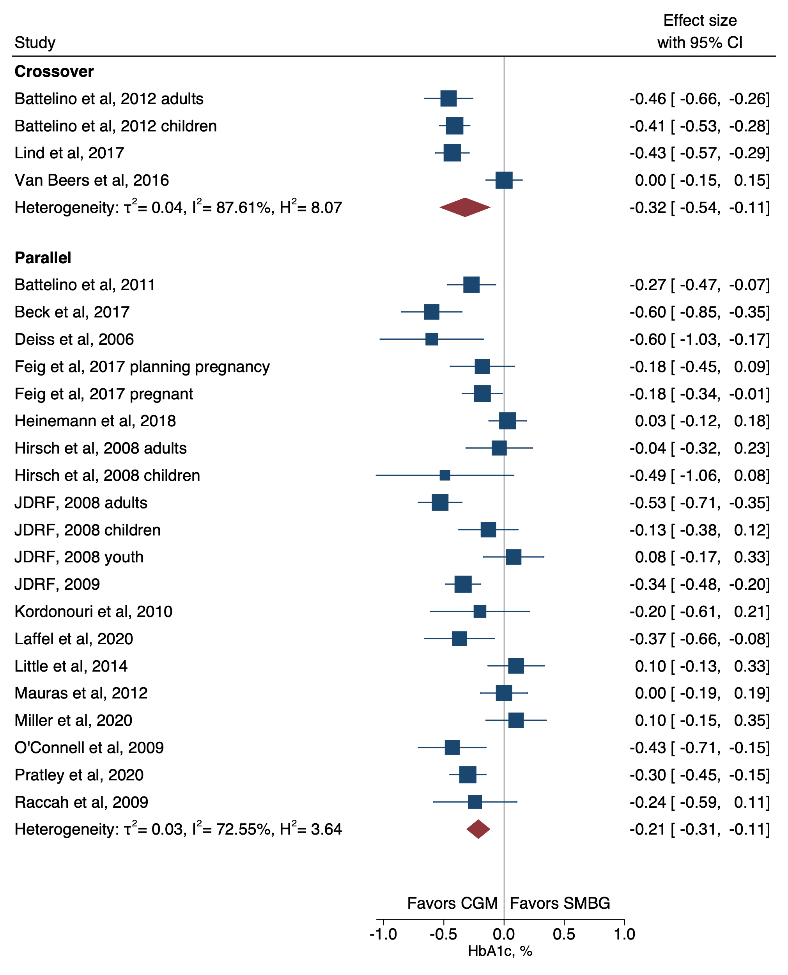
Supplementary Figure 3. Forest plot of meta-analysis of RCTs for HbA1c by study design.

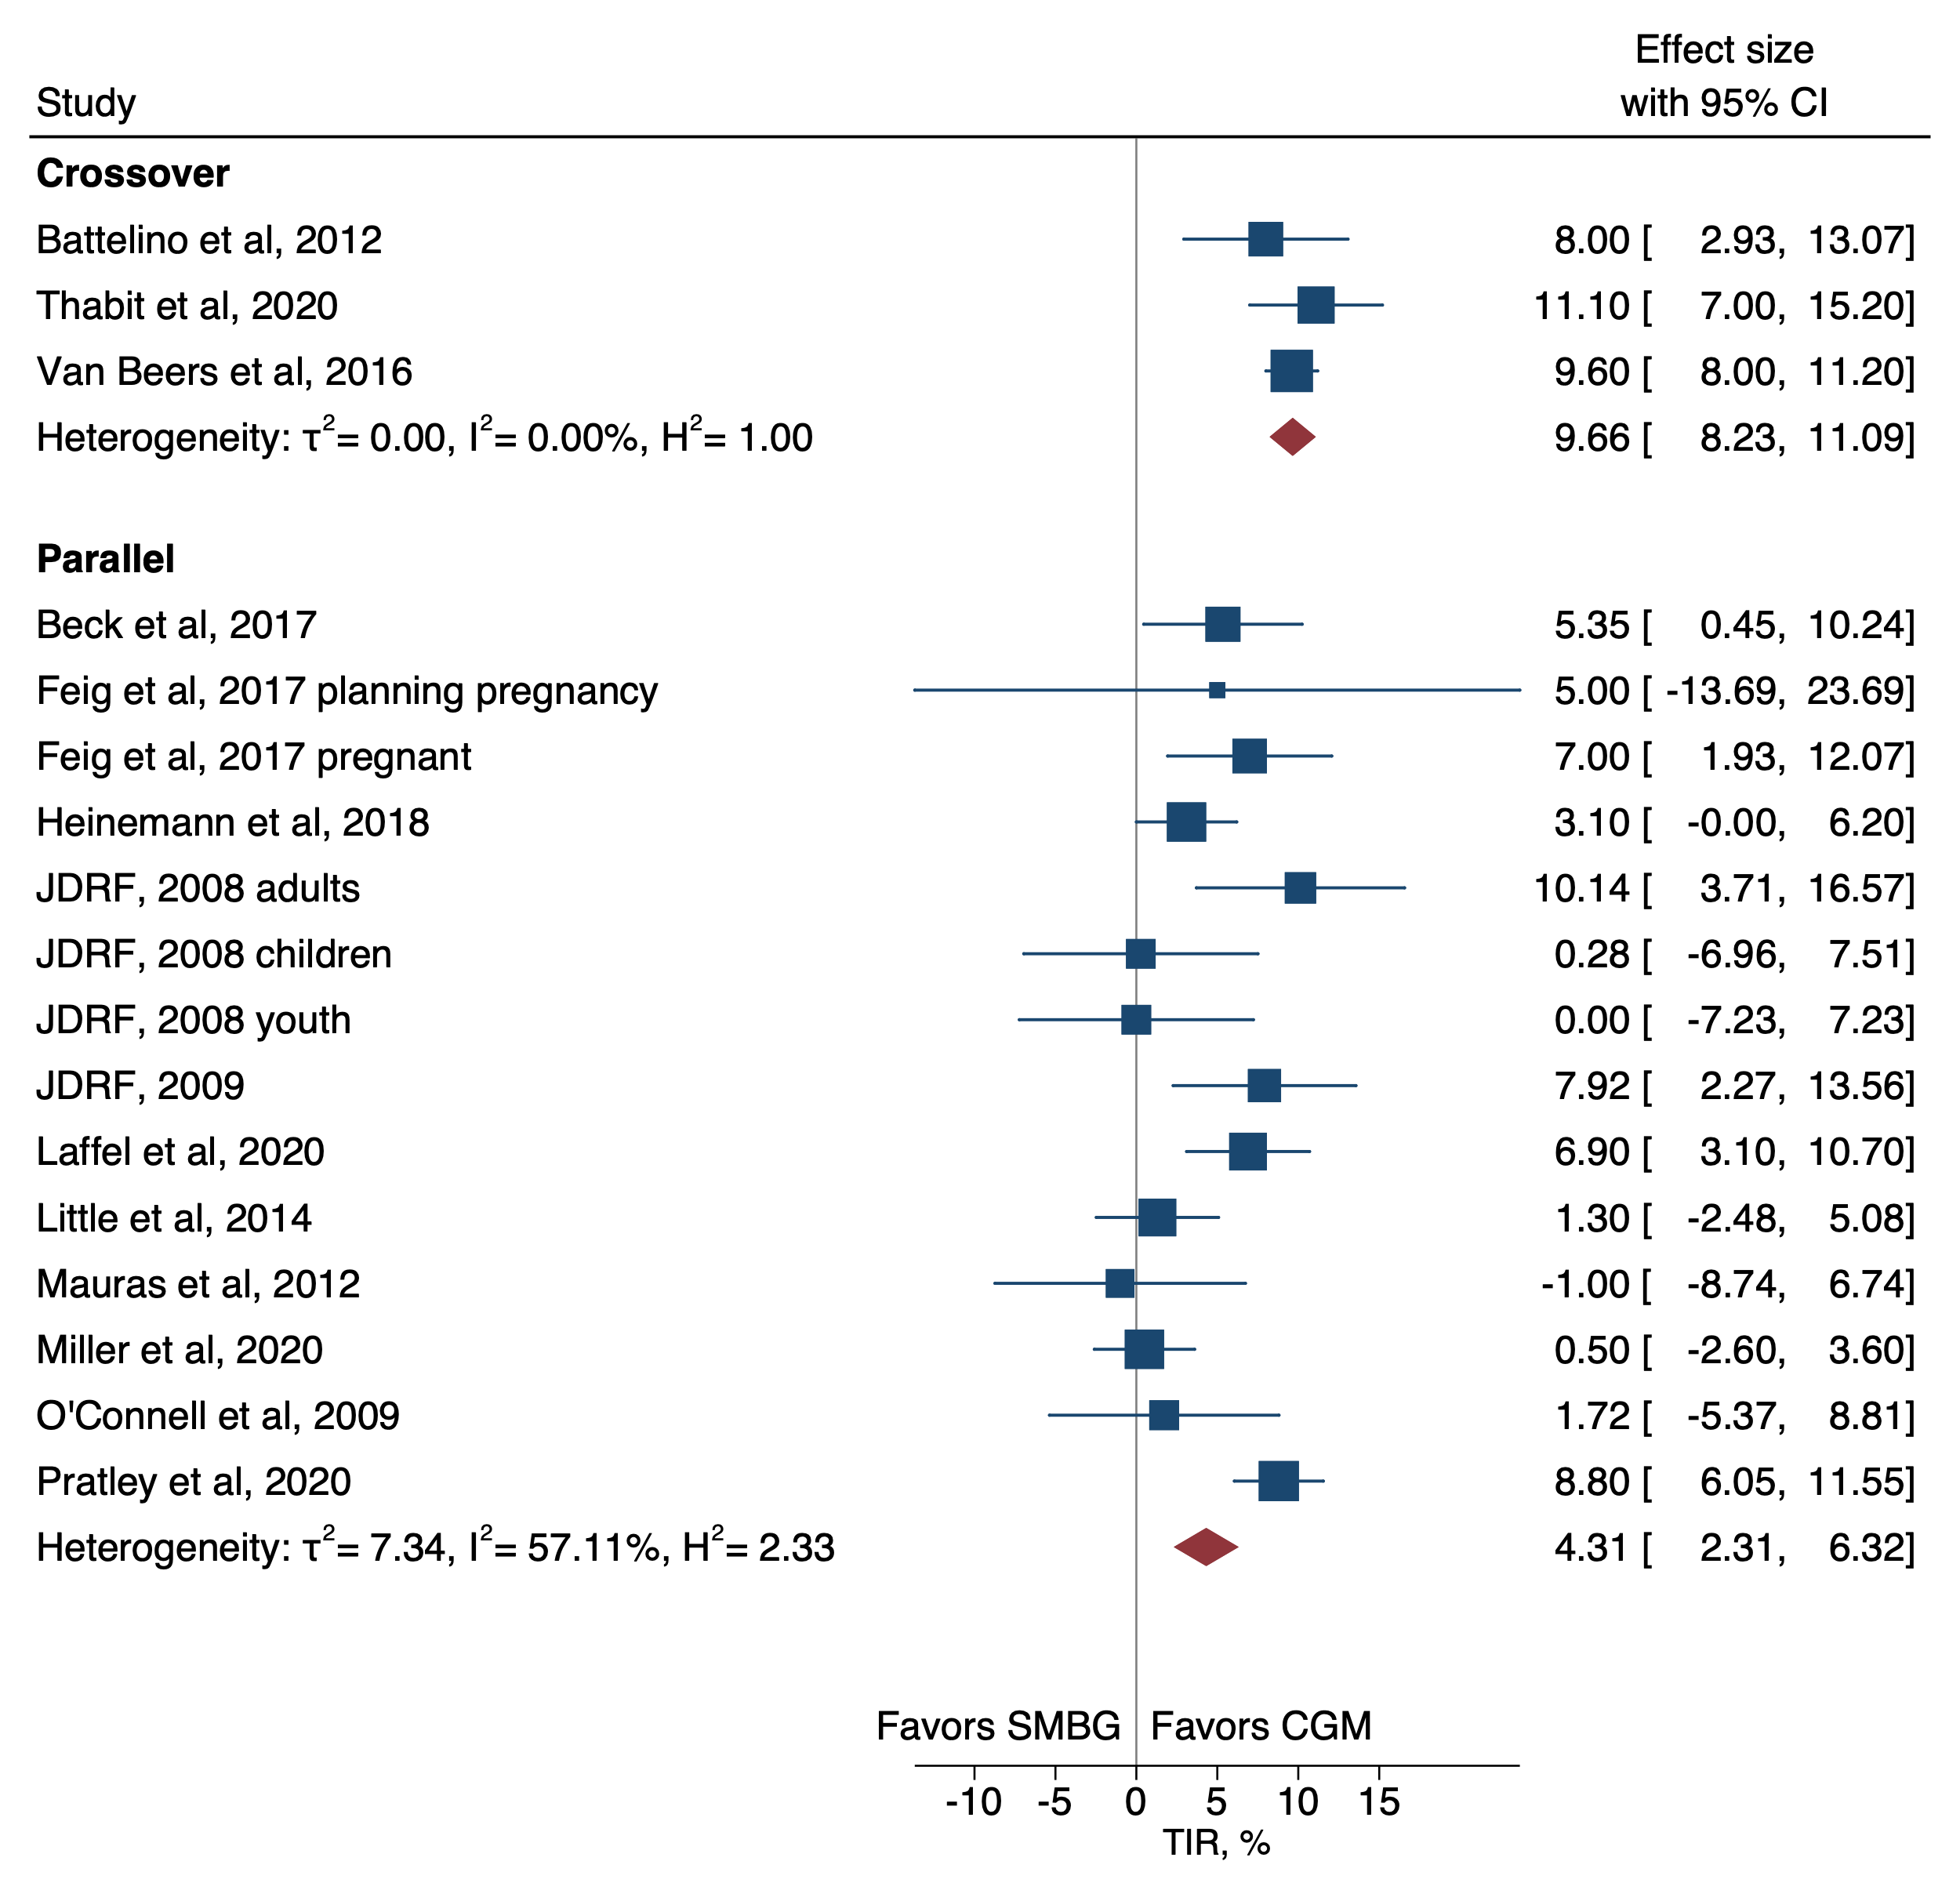
Supplementary Figure 4. Forest plot of meta-analysis of RCTs for time in range (TIR) by study design.

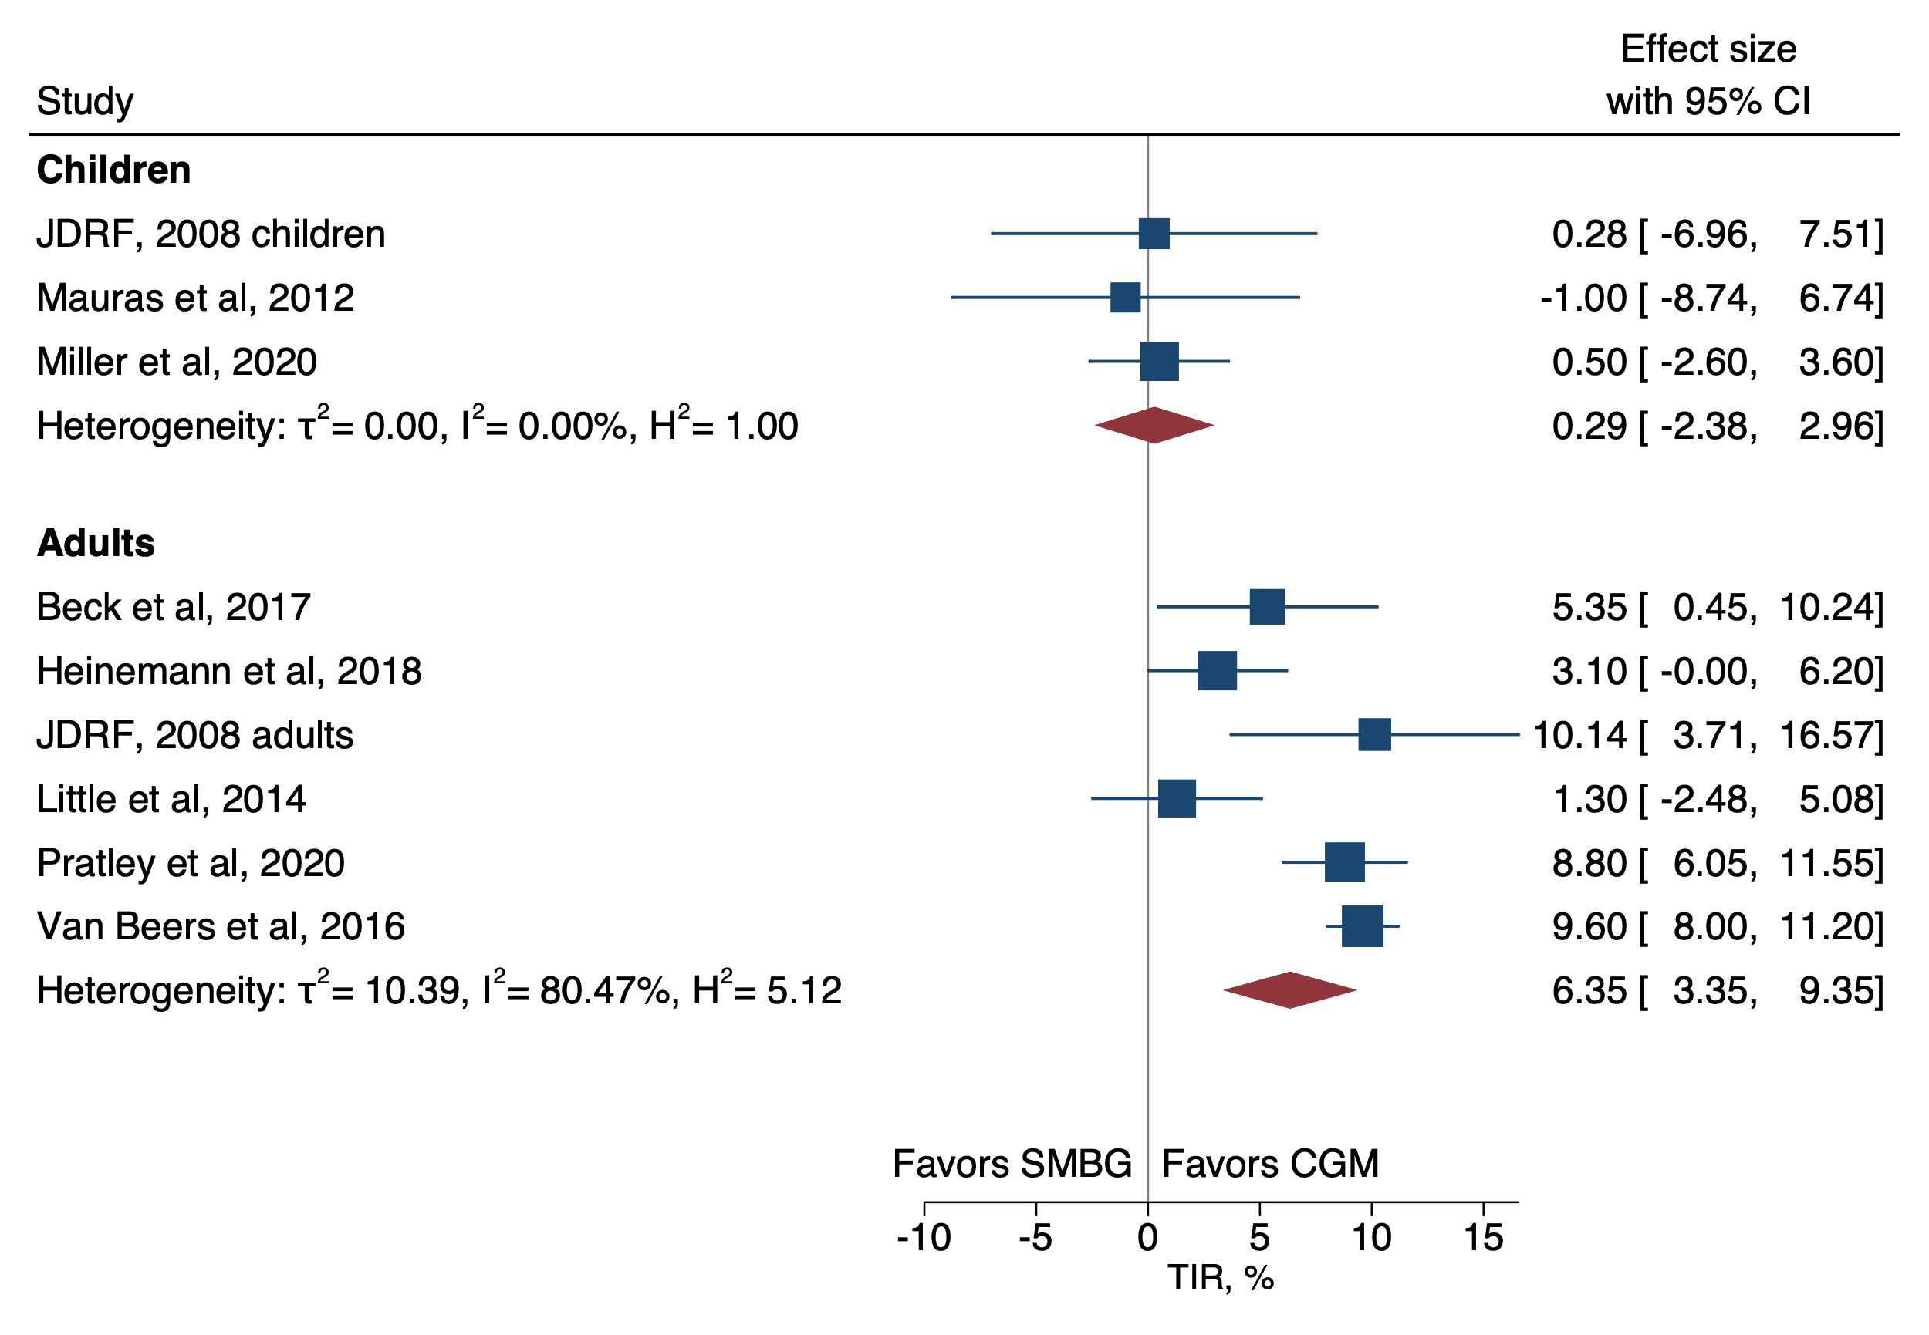
Supplementary Figure 5. Forest plot of meta-analysis of RCTs for time in range (TIR) by whether the studies were only in children or adults.

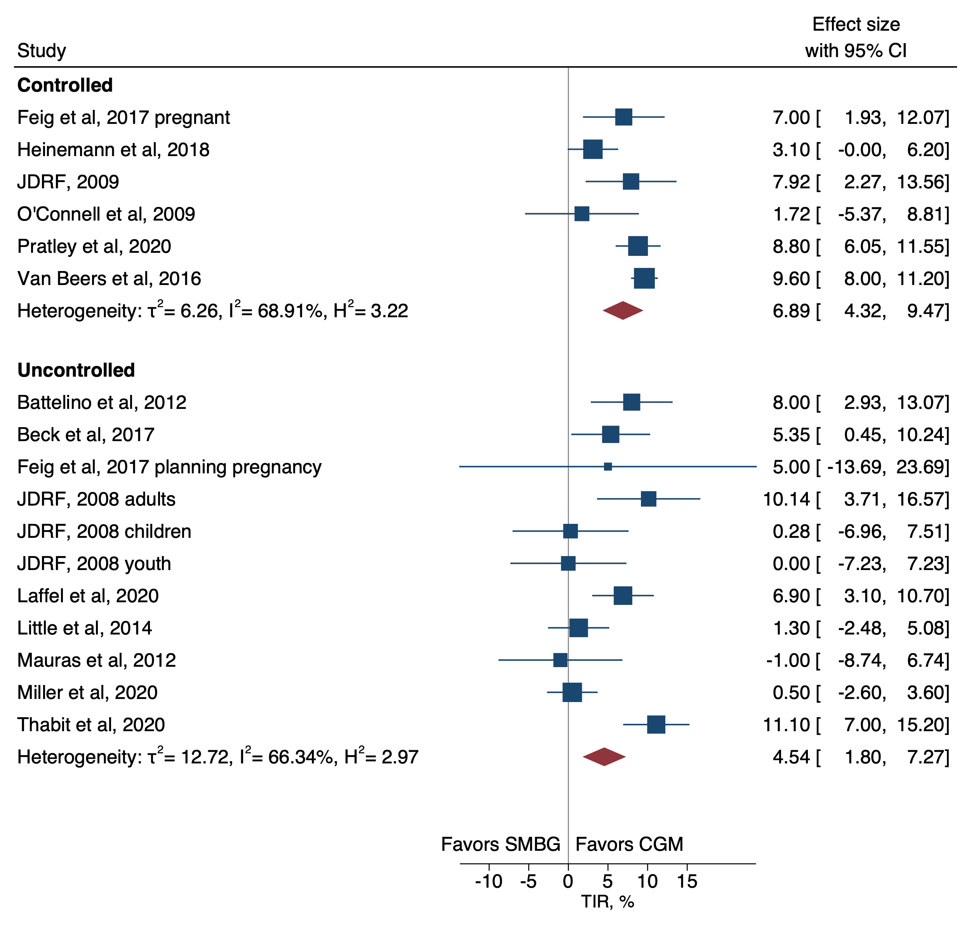
Supplementary Figure 6. Forest plot of meta-analysis of RCTs for time in range (TIR) by whether participants HbA1c was within target level (≤58 mmol/mol, ‘controlled’) at baseline or not (>58 mmol/mol, ‘uncontrolled’).

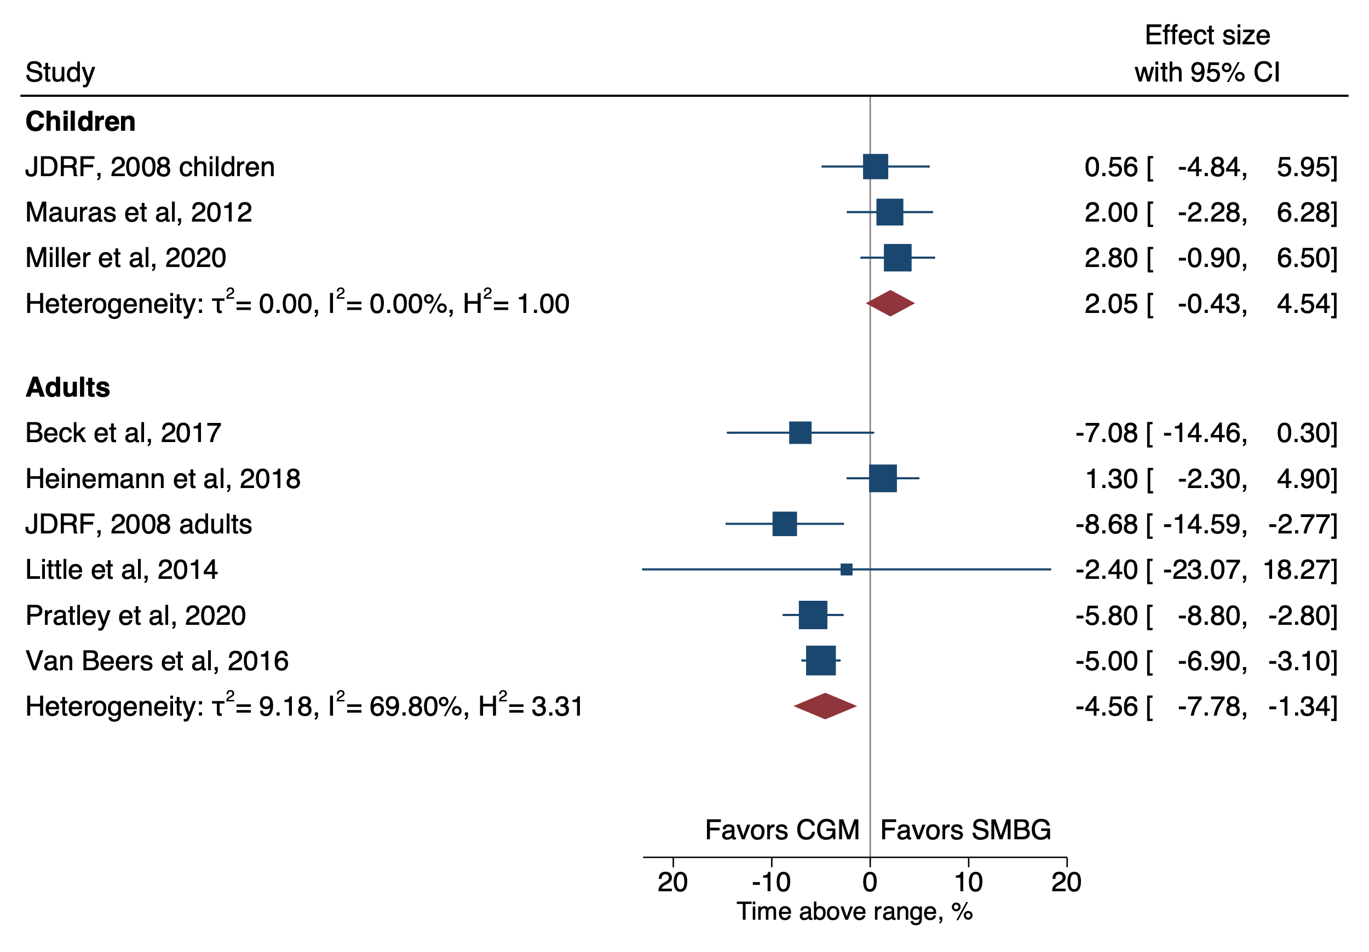
Supplementary Figure 7. Forest plot of meta-analysis of RCTs for time above range (TAR; >10 mmol/L) by whether the studies were only in children or adults.

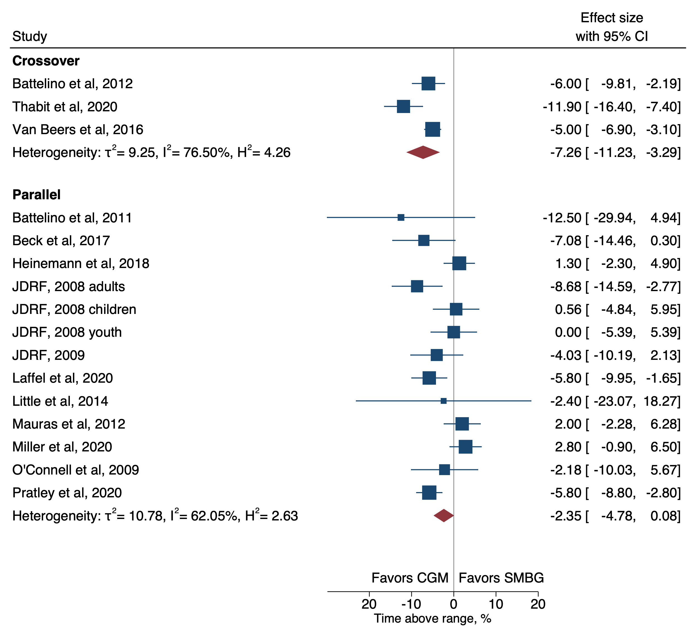
Supplementary Figure 8. Forest plot of meta-analysis of RCTs for time above range (TAR, >10 mmol/L) by study design.

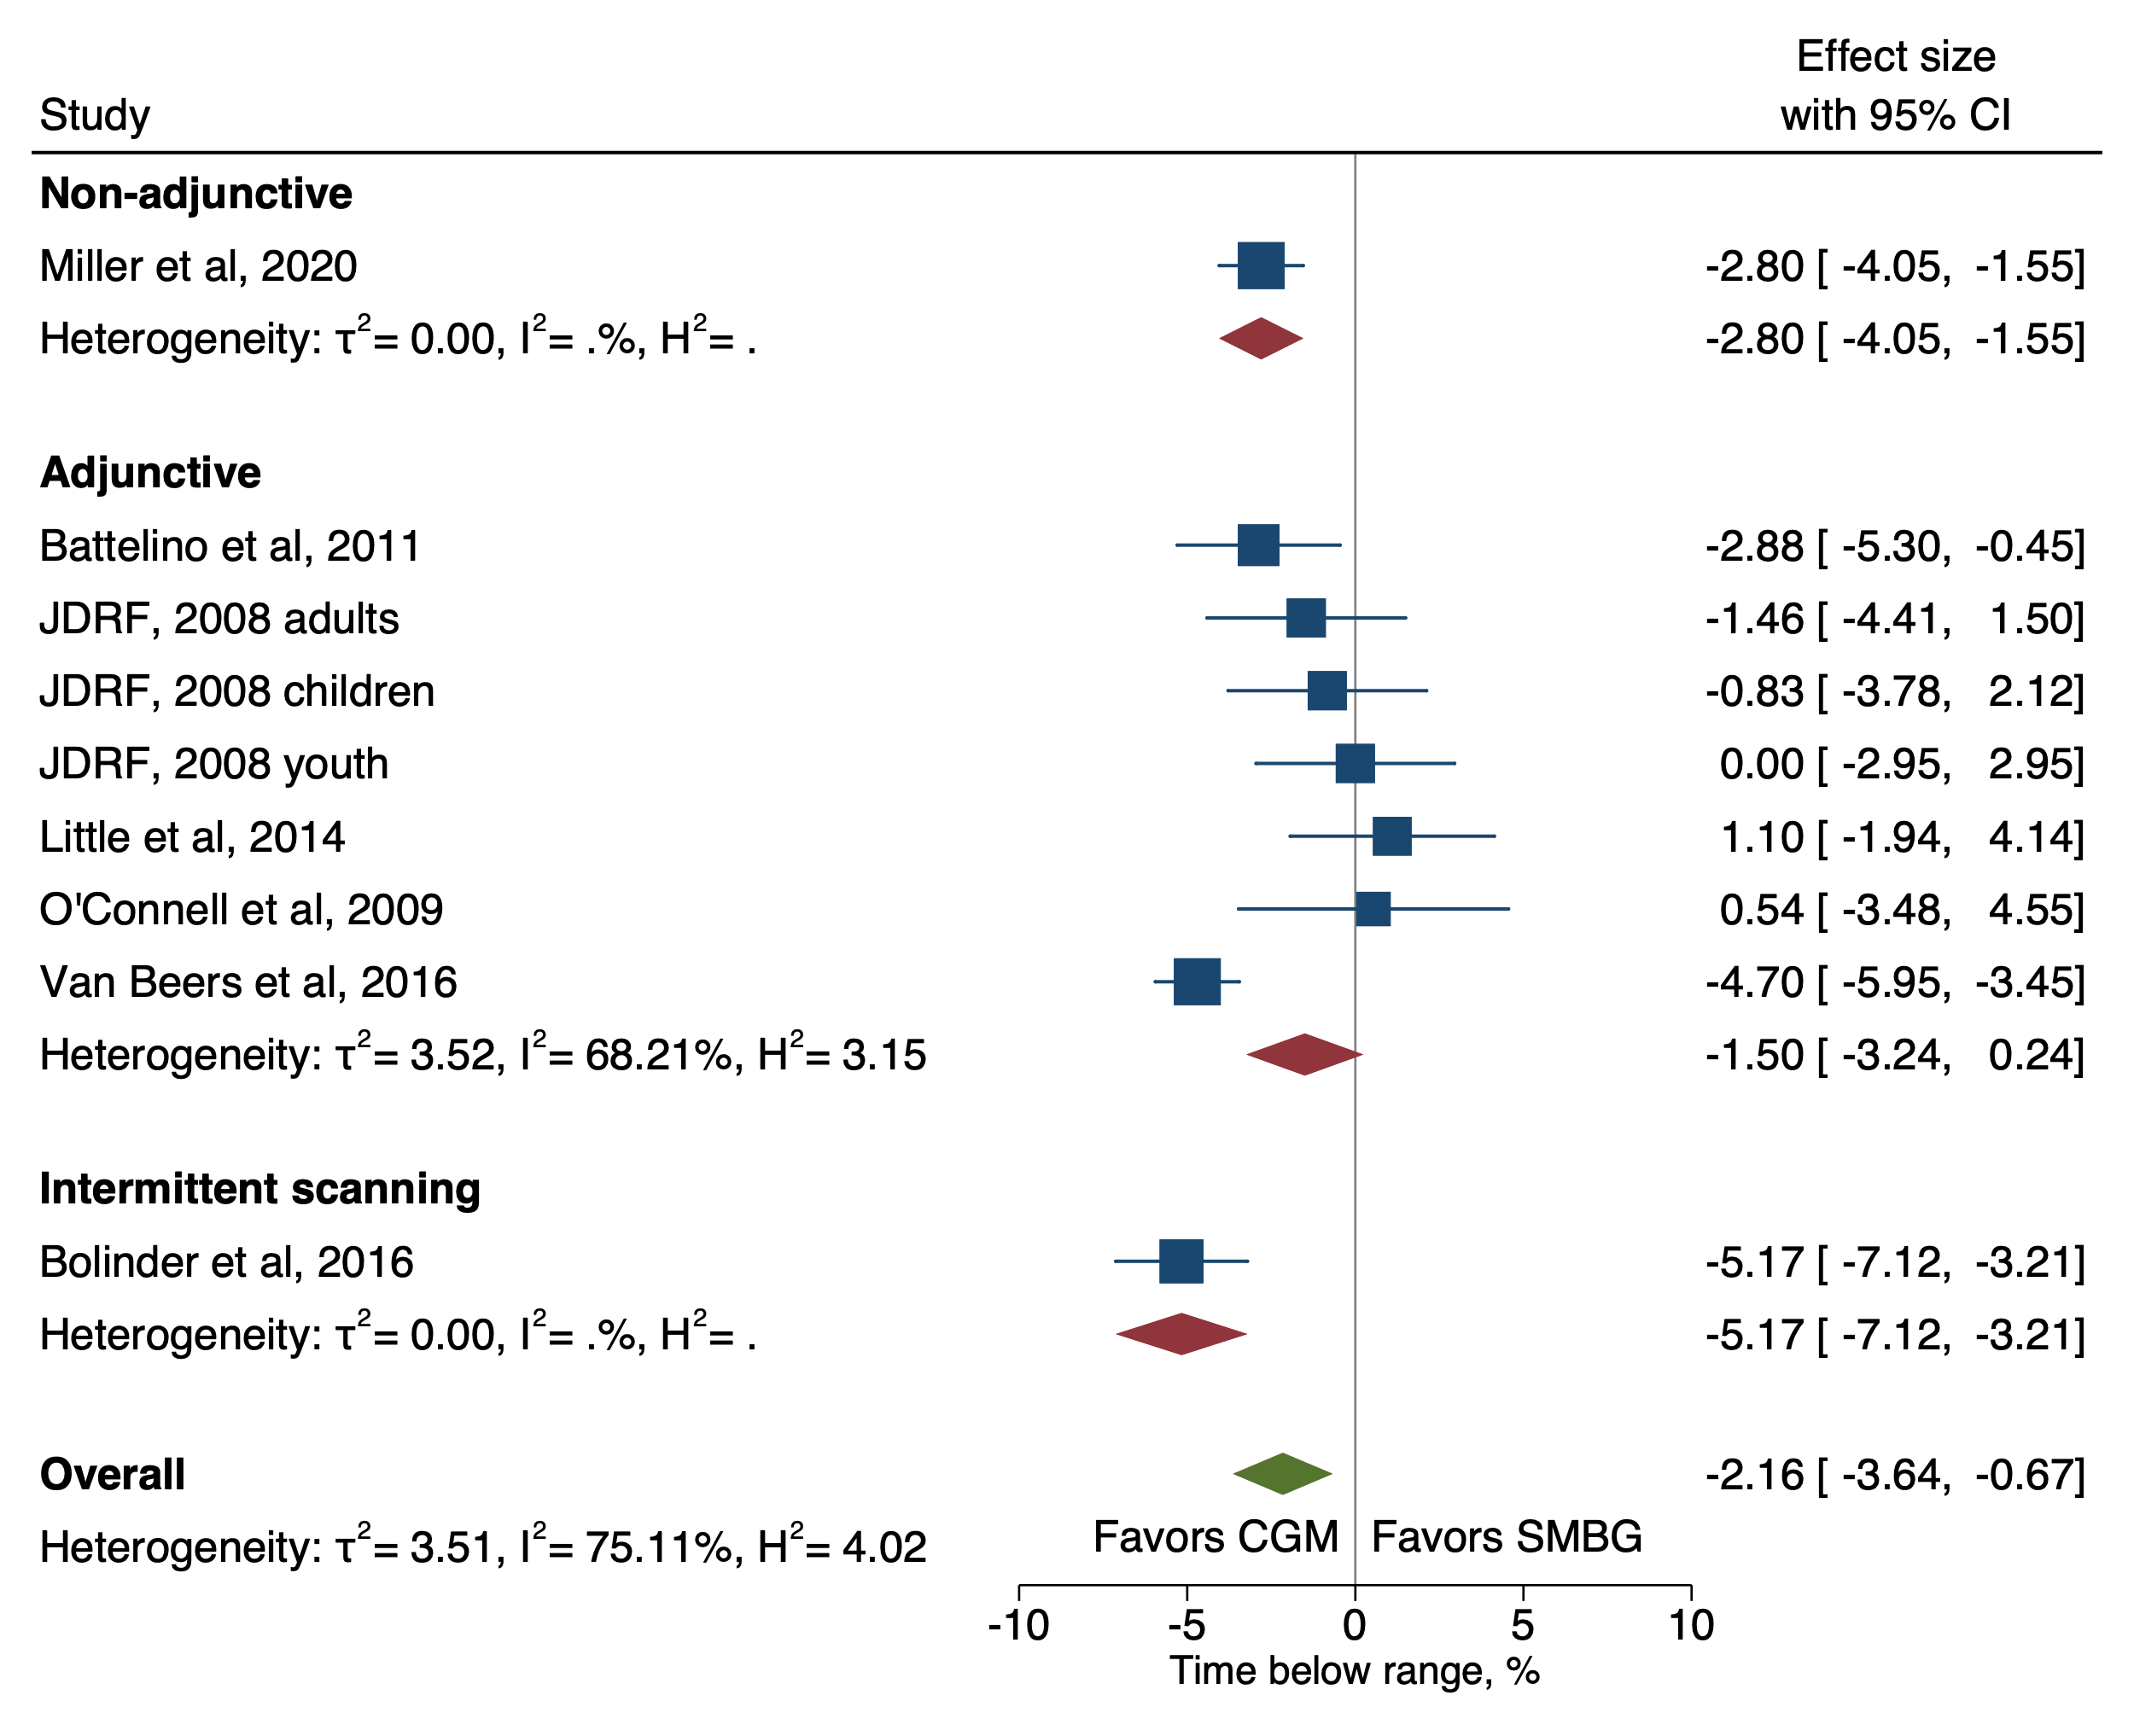
Supplementary Figure 9. Forest plot of meta-analysis of RCTs for time below range (TBR, <3.9 mmol/L) only including studies that reported mean differences.

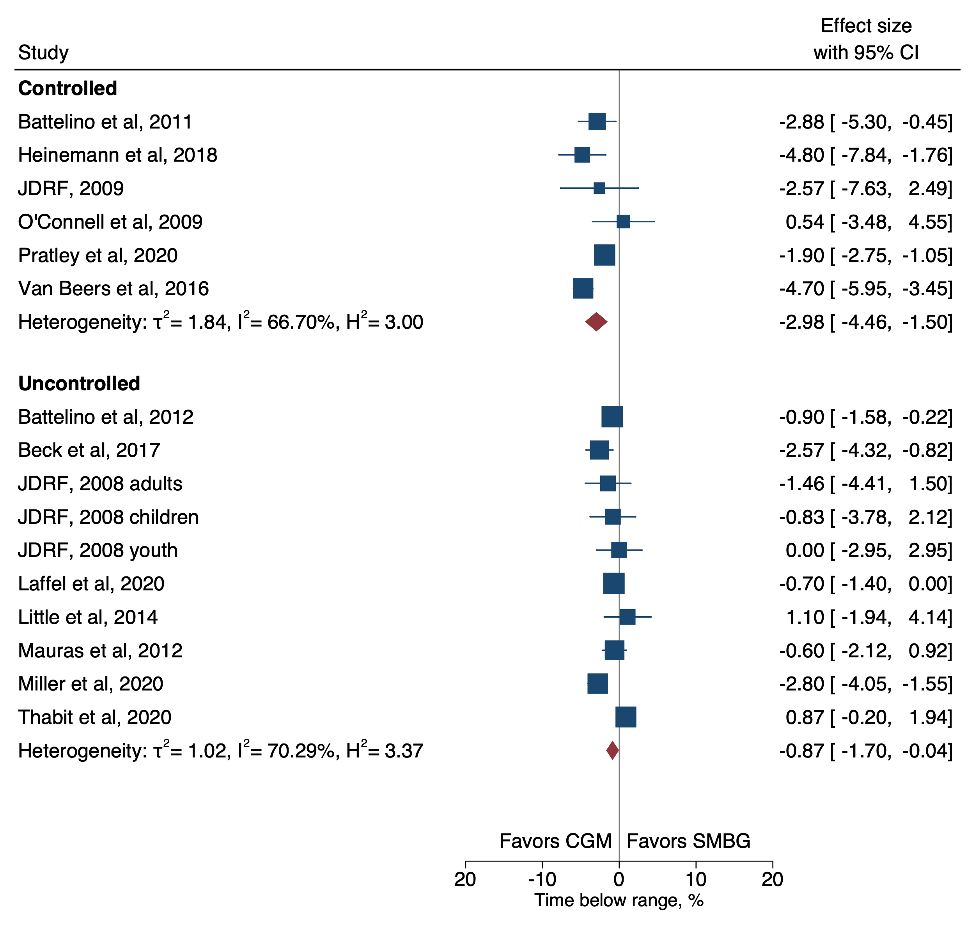
Supplementary Figure 10. Forest plot of meta-analysis of RCTs for time below range (TBR, <3.9 mmol/L) by whether participants HbA1c was within target level (≤58 mmol/mol / ≤7.5%, ‘controlled’) at baseline or not (>58 mmol/mol / >7.5%, ‘uncontrolled’).

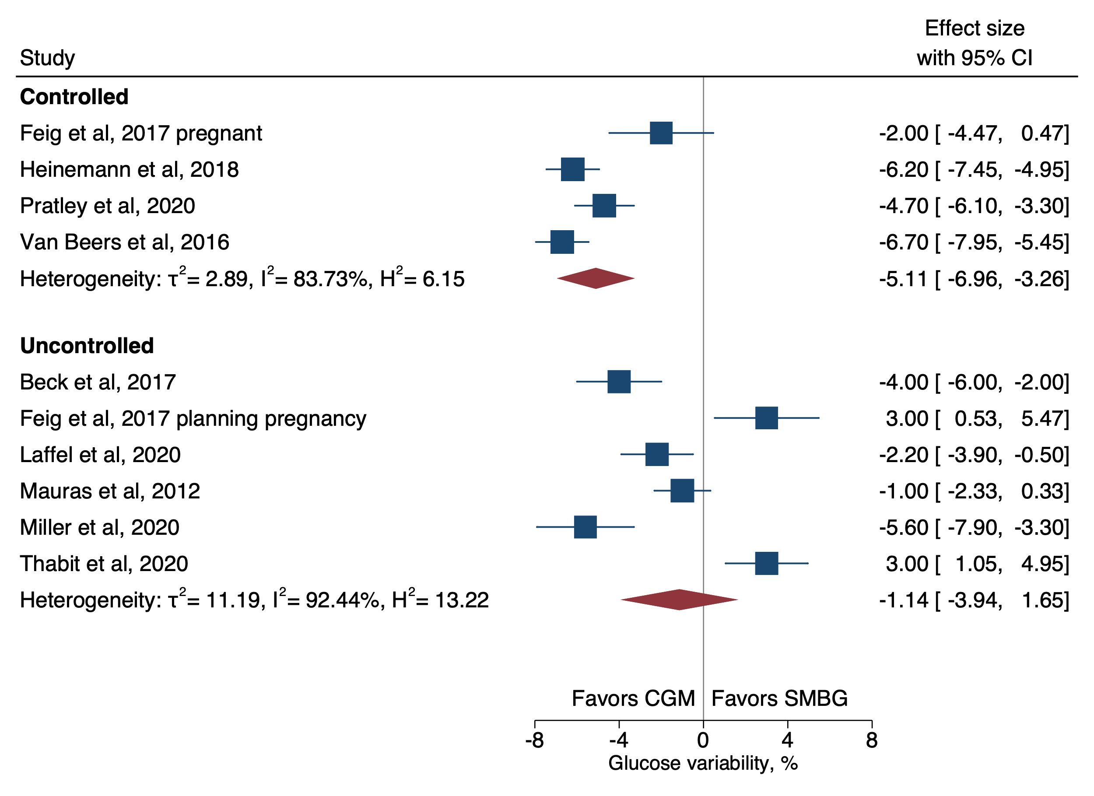Supplementary Figure 11. Forest plot of meta-analysis of RCTs for glucose variability (%CV) by whether participants HbA1c was within target level (≤58 mmol/mol, ‘controlled’) at baseline or not (>58 mmol/mol, ‘uncontrolled’).

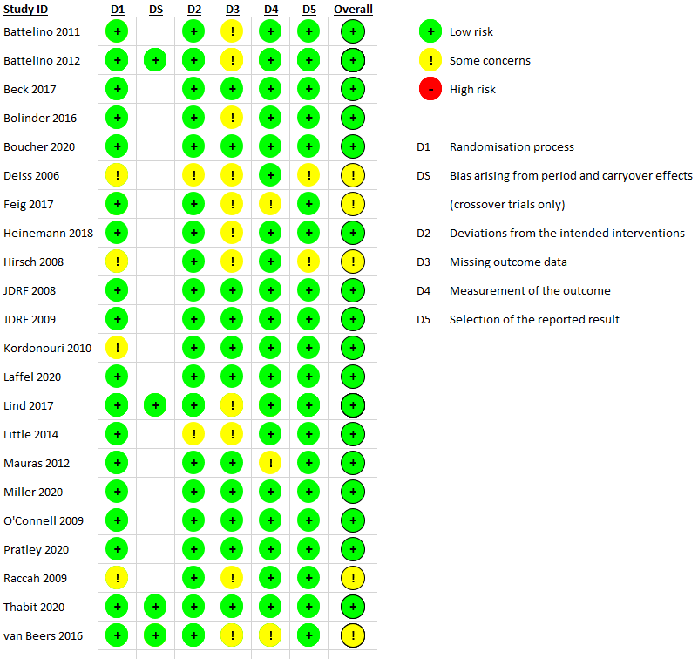
Supplementary Figure 12. Risk of bias judgements by review authors for all studies included in review.

