Appendix S4: Statistical heterogeneity and funnel plot
1) Birth weight z-score, ALL CHD
I² = 95.45143
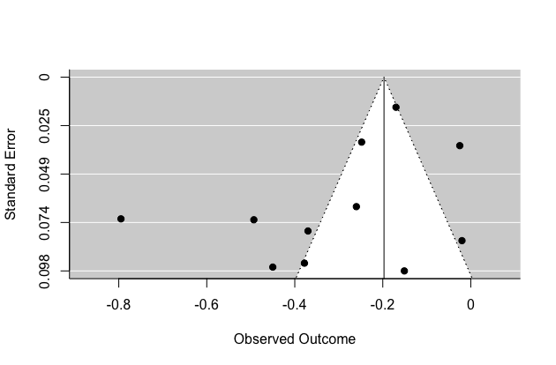
2) Birth weight z-score, MAJOR CHD
I² = 96.30053
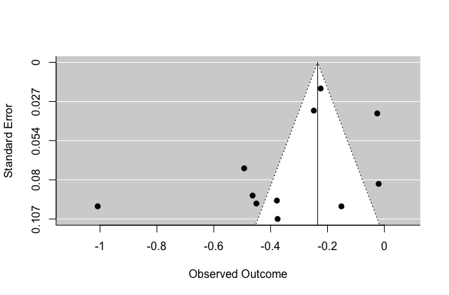
3) Percentage SGA <p10, ALL CHD
I² = 93.6891
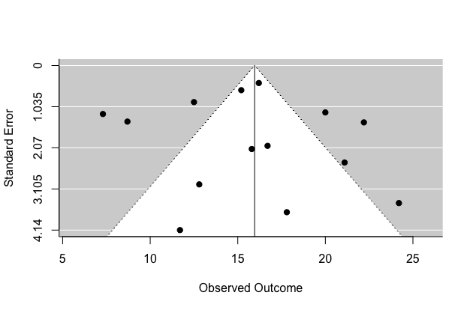

4) Percentage SGA <p10, MAJOR CHD
I² = 94.01223


